**Reading Groups Collection**

**Multiple Copy Titles Available for Loan**

**Additions August 2023**

**Claire ALEXANDER – Meredith Alone (2022, 361p)**

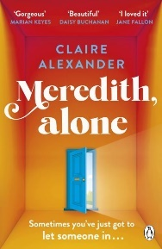Meredith Maggs hasn't left her house in 1214 days. But she insists she isn't alone. She has her cat Fred. Her friend Sadie visits when she can. There's her online support group, StrengthInNumbers. She has her jigsaws, favourite recipes, her beloved Emily Dickinson, the internet, the Tesco delivery man and her treacherous memories for company. But something's about to change. Whether Meredith likes it or not, the world is coming to her door. Does she have the courage to overcome what's been keeping her inside all this time?

**Joanna CANNON – A Tidy Ending (2022, 415p)**

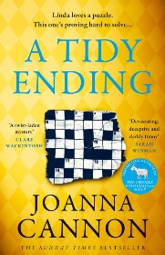Meet Linda. Linda lives a nice, normal life, on a nice, normal street with Terry, her perfectly ordinary husband. Linda's not like everyone else, she keeps herself to herself. But she's good at solving puzzles and there are times she sees things other people might have overlooked. Because nothing on Cavendish Avenue is quite as it seems. People have started to go missing in the neighbourhood and Linda will soon discover that some secrets can't stay buried forever.

**Jessamine CHAN – The School for Good Mothers (2022, 319p)**

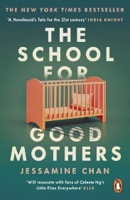Frida Liu is a 39-year-old single mom, reported when she is reported for leaving her daughter, Harriet, alone for a stretch of time. The state's increasingly empowered Child Protective Services set about surveilling Frida's home. After a series of almost comically bad supervised visits, a judge deems Frida temporarily unfit. Her only hope for continuing to share custody of Harriet with her ex (and his doting girlfriend) is to pass exams meted out by a prized new government program. This 12-month, live-in program, a 'school' situated on an abandoned college campus, will retrain Frida in how best to parent. **Longlisted for The Andrew Carnegie Medal for Excellence in Fiction**

**Richard COLES – Murder before Evensong (2022, 371p)**

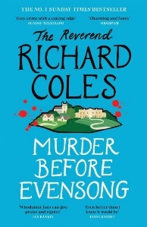Canon Daniel Clement is Rector of Champton. He has been there for eight years, at the invitation of the patron and landowner, Bernard, Baron de Floures, of Champton House. Daniel's previous post was curate at a smart central London parish, where he got to know the de Floures family through his brother Theo. Audrey Clement, his widowed mother, lives with him at the Rectory on the estate. He has two dachshunds, Cosmo and Hilda. The story begins with Daniel announcing from the pulpit a plan to install a lavatory in church. This is long overdue, he thinks and so does Bernard de Floures, but the announcement goes down badly with the parish. Firm opposition comes from Mrs Harper and Mrs Dollinger of the Flower Guild and others who do not like the thought of matters lavatorial in church.

**Hernan DIAZ - Trust (2022, 402p)**

Even through the roar and effervescence of the 1920s, everyone in New York has heard of Benjamin and Helen Rask. He is a legendary Wall Street tycoon; she is the daughter of eccentric aristocrats. Together, they have risen to the very top of a world of seemingly endless wealth - all as a decade of excess and speculation draws to an end. But at what cost have they acquired their immense fortune? **Winner of the Pulitzer Prize for fiction 2023, Booker Prize longlisted**

**Nikki ERLICK – The Measure (2022, 352p)**

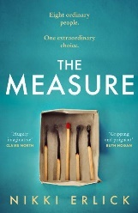It seems like just another morning. You make a cup of tea. Check the news. Open the front door. On your doorstep is a box. Inside the box is the exact number of years you have left to live. The same box appears on every doorstep across the world. Do you open yours?

**C M EWAN – The Interview (2022, 450p)**

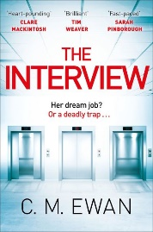It's 5 p.m. on a Friday. You have been called to an interview for your dream job. In a stunning office 13 floors above the city below, you are all alone with the man interviewing you. Everyone else has gone home for the weekend. The interview gets more and more disturbing. You're feeling scared. Your only way out is to answer a seemingly impossible question. If you can't - what happens next? **Librarian recommended**

**Bonnie GARMUS – Lessons in Chemistry (2022, 390p)**

Chemist Elizabeth Zott is not your average woman. But it's the early 1960s and her all-male team at Hastings Research Institute take a very unscientific view of equality. Except for one: Calvin Evans, who falls in love with - of all things - her mind. True chemistry results. Like science, life is unpredictable. Which is why a few years later, Elizabeth Zott finds herself not only a single mother, but the reluctant star of America's most beloved cooking show, Supper at Six. Elizabeth's unusual approach to cooking ('combine one tablespoon acetic acid with a pinch of sodium chloride') proves revolutionary. But as her following grows, not everyone is happy. Because as it turns out, Elizabeth Zott isn't just teaching women to cook. 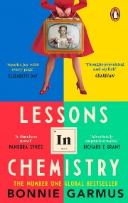

**Georgi GOSPODINOV– Time Shelter (2022, 302p)**

In 'Time Shelter', an unnamed narrator meets Gaustine, a 'flaneur through time,' who is the mind behind the first 'clinic for the past,' an institution based in Zurich that offers an inspired treatment for Alzheimer's sufferers: each floor reproduces a past decade in minute detail, allowing patients to transport themselves back in time and find comfort in their fading memories. Yet an increasing number of healthy people are interested in seeking out the clinic as a form of 'time shelter,' hoping to escape from the horrors of our present, a development that results in an unexpected conundrum, when the past beings to invade the present. **Winner of the International Booker Prize.**

**Sheila HANCOCK – Old Rage (NF 2022, 283p)**

In 'Old Rage', one of Britain's best loved actors opens up about her ninth decade. Funny, feisty, honest, she makes for brilliant company as she talks about her life as a daughter, a sister, a mother, a widow, an actor, a friend and looks at a world so different from the wartime world of her childhood. And yet - despite age, despite rage - she finds there are always reasons for joy.

**Claire MACKINTOSH – A Cotswold Life (NF 2019, 336p)**

For eight years, Clare Mackintosh wrote for 'Cotswold Life' about the ups and downs of life with a young family in the countryside. In this memoir she brings together all of those stories - and more - for the first time. From keeping chickens to getting the WI drunk, longing for an Aga to dealing with nits, Clare opens the door to family life with warmth and humour and heart.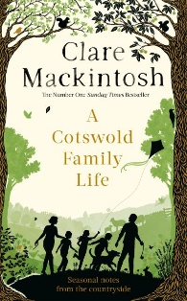

**Bob MORTIMER – The Satsuma Complex (2022, 298p)**



Gary Thorn goes for a pint with a work acquaintance called Brendan. When Brendan leaves early, Gary meets a girl in the pub. He doesn't catch her name, but falls for her anyway. When she suddenly disappears without saying goodbye, all Gary has to remember her by is the book she was reading: 'The Satsuma Complex'. But when Brendan goes missing, Gary needs to track down the girl he now calls Satsuma to get some answers. And so begins Gary's quest, through the estates and pie shops of South London, to finally bring some love and excitement into his unremarkable life.

**Clare POOLEY – The People on Platform 5 (2022, 378p)**



Nobody ever talks to strangers on the train. It's a rule. But what would happen if they did? Every day at 8:05, Iona Iverson boards the train to go to work. Every day, she sees the same people and makes assumptions about them, even giving them nicknames. But they never speak. Obviously. Then, one morning, Smart-but-Sexist Surbiton chokes on a grape right in front of Iona. Probably-a-Psychopath-New-Malden steps up to help and saves his life, and this one event sparks a chain reaction. With nothing in common but their commute, an eclectic group of people learn that their assumptions about each other don't match reality. But when Iona's life begins to fall apart, will her new friends be there when she needs them most?

**Rebecca ROGERS – The Purgatory Poisoning (2023, 400p)**

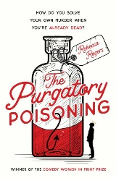

How do you solve your own murder when you're already dead? Purgatory (noun): 1. Where the dead are sent to atone. 2. A place of suffering or torment. 3. A youth hostel where the occupants play Scrabble and the mattresses are paper thin. When Dave wakes up in his own personal purgatory (St Ives Youth Hostel circa 1992), he's shocked to discover he's dead. And worse - he was murdered. Heaven doesn't know who did it so, with the help of two rogue angels, Dave must uncover the truth.

**Winner of the Comedy Women in Print Prize 2023. Librarian recommended.**

**Katherine RUNDELL – Super-infinite – The transformations of John Donne (NF 2022, 344p)**

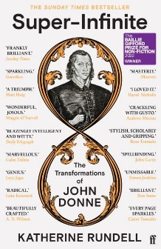

Sometime religious outsider and social disaster, sometime celebrity preacher and establishment darling, John Donne was incapable of being just one thing. In his myriad lives he was a scholar of law, a sea adventurer, a priest, an MP - and perhaps the greatest love poet in the history of the English language. Along the way he converted from Catholicism to Protestantism, was imprisoned for marrying a sixteen-year old girl without her father's consent; struggled to feed a family of ten children; and was often ill and in pain. He was a man who suffered from black surges of misery, yet expressed in his verse many breathtaking impressions of electric joy and love. **Winner of the Baillie Gifford Prize for Non-Fiction**

**Elizabeth SMART – By Grand Central Station I sat down and wept (1945, 112p)**

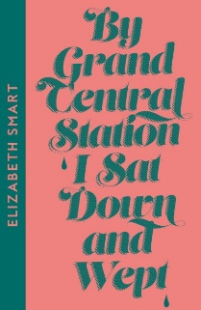Whilst browsing in a London bookshop, Elizabeth Smart chanced upon a slim volume of poetry by George Barker - and fell passionately in love with him through the printed word. Eventually they communicated directly and, as a result of Barker's impecunious circumstances, Elizabeth Smart flew both him and his wife from Japan, where he was teaching, to join her in the United States. Thus began one of the most extraordinary, intense and ultimately tragic love affairs of our time. They never married but Elizabeth bore George Barker four children and their relationship provided the impassioned inspiration for one of the most moving and immediate chronicles of a love affair ever written.