Course | Provider | Dates | Location
Foundation GPN course | Bournemouth university | Sept 2019- Portsmouth location  Jan 2020- Bournemouth Location  May 2020- Winchester location  Sept 2020- Portsmouth location  Apply to: Marianne.brown@hee.nhs | Portsmouth  Bournemouth  Winchester  Bournemouth
Long Term conditions | Bournemouth university | 12,18,27 September & 3,9,16 October 2019  Apply to: Marianne.brown@hee.nhs | Bournemouth
Minor Illness | Bournemouth  University | 12,13,19,20,26 November 2019  February 2020 TBC  Apply to: Marianne.brown@hee.nhs | Bournemouth
COPD Diploma | Education for Health | July 23rd –Nov 4th 2019  https://store.educationforhealth.org/product?catalog=COPD5C1907XA | Winchester
Diabetes Diploma | Education for Health | 2020-TBC | Winchester
Leadership course | HEE/TVLA/F&G&  SE HANTS CCG | 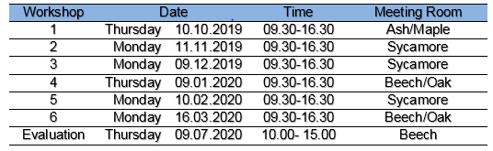 | Winchester
Immunisation,  Cytology & screening | HEE Wessex, Wessex LMC,  NHSE &PHE | June – July 2020 Click here to book  - 3rd June – Otterbourne  - 11th June – Basingstoke  - 24th June – Otterbourne  - 3rd July – Fareham (Full)  - 15th July – Otterbourne  - 17th July – IOW | Hampshire & IOW
GPN Conference | HEE Wessex / Wessex LMC | June 19 2019  Click on the link below to book  here | Winchester
Modules for Advanced Practice | Southampton & Bournemouth Universities | Cohorts throughout the year  Apply to: Marianne.brown@hee.nhs | Southampton, Portsmouth and Bournemouth
Practice Nurse Asthma Study Day & Practice Nurse COPD Study Day |  | Asthma Study 1/2 Day 17th September 2019 9am – 12:30 pm  Click here to book Practice Nurse Asthma Study Day  COPD ½ Study Day 17th September 2019 1pm – 4:30 pm  Click here to book Practice Nurse COPD Study Day

