**Choosing the right education and development providers**

**for general practice**

The most valuable resource within any practice is the people who work within it.

General practices make use of a wide variety of learning methods, facilitators and trainers, to meet the development needs of their teams. Most people benefit from a range of approaches and opportunities.

Focused on commissioning and delivering excellent education, in line with the Health Education England Outcomes Framework1, Health Education Thames Valley (HETV) is keen to assist practices to source excellent Continuing Professional Development (CPD) by promoting the highest standards.

Drawing on our experience as CPDtutors, we have compiled these two simple checklists as a prompt to help CCGs and general practices consider standards and criteria that you might want to use as you assess and choose between potential education and training providers.

**Continuing Professional Development defined**

*"A process of lifelong learning for all individuals and teams which enables professionals to expand and fulfil their potential and which also meets the needs of patients and delivers the health and health care priorities of the NHS."*2

Individual practitioners have a responsibility to anticipate development needs relevant to their own role. Demonstrating CPD is a major component of the appraisal system and hence of revalidation. Meanwhile, partnerships will be identifying staff training needs as they develop and implement their business plans. The two strands should come together, often through the appraisal process, via the preparation of a Personal Development Plan for each member of the practice team, which can be reviewed over time.

**Criteria for assessing providers of CPD activities**

As you consider how best to resource the training and development needs of primary care teams, CCGs and practices can choose from a mix of accredited and non-accredited CPD activities offered by a variety of providers.

There are some formal accreditation schemes in place, such as the RCGP accreditation Quality Mark which is designed to give GPs confidence that the education they select has been independently assessed to ensure a consistent and high quality.3 For the most part, however, it is down to your judgment as you choose between facilitators, trainers and course organisers. The checklists here are designed to help you make that choice.

We look at standards in terms of:

* educational and competence standards (Checklist 1)
* organisational standards (Checklist 2)

These *standards* are qualitative characteristics against which you may assess what is on offer, and also evaluate the quality of the programmes delivered. For each standard we suggest a number of criteria. These are practical descriptions of what you might be looking for to satisfy yourself that the provider meets a standard.

You may also wish to seek recommendations through your networks, and also request testimonials from the provider.

**CPD – a shared responsibility**

Continuing professional development is vital “to help improve the safety and quality of care provided for patients and the public”.4  As practices reshape clinical services to bring care closer to home and strengthen prevention, while meeting growing demand within limited resource, a well trained workforce is ever more critical.

Taking responsibility for our continuing personal and professional development is important at an individual level - for our confidence and job satisfaction, and to help us fulfil our potential.

**Visit the CPD zone - http://www.oxfordhealth.nhs.uk/library/cpd-zone/**

The CPD zone is for everyone working in general practice across Thames Valley.

* Check out learning resources - by Topic and by Profession
* Keep up to date with hot topics – via the Blog and news items
* Share experiences of new roles and ways of working to modernise general practice
* See details of upcoming events in the CPD Calendar.

**Contact the team**

We are committed to supporting the professional development of the local workforce, and the development of new roles and new ways of working in primary care while expanding the multi-professional training capacity of primary care. Our small team of part-time workforce development tutors is responsible for signposting colleagues in primary care to resources, promoting innovation and facilitation plus delivering CPD on some specific topics.

You are welcome to contact the team of workforce development tutors. Please contact either Maggie Woods or Sue Lacey Bryant in the first instance: -

Maggie Woods, Associate GP Dean, Health Education Thames Valley

e-mail: [Maggie.Woods@tvwleadershipacademy.nhs.uk](mailto:Maggie.Woods@tvwleadershipacademy.nhs.uk)

Sue Lacey Bryant, Primary Care CPD Tutor

e-mail: [Sue.LaceyBryant@thamesvalley.hee.nhs.uk](mailto:Sue.LaceyBryant@thamesvalley.hee.nhs.uk)

January 2015

*Sue Lacey Bryant*

Primary Care CPD Tutor, Health Education Thames Valley

**Checklist 1: Educational and Competence Standards**

|  |  |  |
| --- | --- | --- |
| **Standard** | **Criteria** | ✓ |
|  |  |  |
| **Target Audience**  The target audience/s should be clearly defined | Is the event appropriate for the participating healthcare discipline/s? |  |
|  | Is the intended audience and content clearly specified? |  |
|  | | |
| **Learning outcomes**  There should be clearly defined learning aim(s) which reflect the overall purpose of the activity | Is there a clear statement of what a participant is expected to learn, and of how the learning is to be demonstrated? |  |
|  | Are the learning aims specifically defined to indicate what knowledge and/or skills participants are expected to obtain as a result of taking part? |  |
|  | Can any specific objectives be measured? |  |
|  | | |
| **Programme content and structure**  There should be a detailed statement outlining the content and structure. The content of the event must be relevant to the CPD needs of participating healthcare staff | Does the proposal/programme list all the topics to be covered? |  |
|  | Does the activity relate to the priorities of the practice? |  |
|  | Is the activity relevant to the delegate’s job role? |  |
|
|  | Is the event/course well structured, with appropriate breaks for delegates? |  |
|  | Is it clear that educational content will be authoritative, up-to-date, accurate, based on balanced evidence (e.g. NICE guidance) and free from unjustifiable claims or bias? |  |
|  | Does the organiser confirm that all clinical content will follow all appropriate patient consent and confidentiality policies? |  |
|  | | |
| **Delivery methods**  Delivery methods need to be appropriate to the learning aims set for participants. | Is there a clear statement about what delivery methods are used (lectures, presentations, discussions, master-classes, small group work, peer learning etc)? |  |
|  | Can you assess whether the language, style and pace will be appropriate to the topic and audience? |  |
|  | Are the teaching methods to be used appropriate for the defined learning aims, and suitable for the audience? |  |
|  | Are there are processes in place to encourage self-reflective learning |  |
| **Supporting information**  Information and materials should be clear, relevant and accessible. | Are materials/products/ technologies to be used listed? |  |
|  | Do the supporting materials appear up-to-date, accurate and, where appropriate, referenced? |  |
|  | For any external content - is the name and contact details of the publisher/copyright owner, country of publication and date of the activity or production shown? |  |
|  |  |  |
| **Knowledge and expertise**  Organisers should demonstrate that facilitators, trainers and teaching staff hold the appropriate qualifications and experience to deliver the programme. | Are short biographies provided for presenters, teachers and facilitators? |  |
|  | Can you confirm that they have the necessary qualifications, expertise, knowledge and skills to deliver the education /development programme on the specific subject/s? |  |

**Checklist 2: Organisational Standards**

|  |  |  |
| --- | --- | --- |
| **Standard** | **Criteria** |  |
|  | | |
| **Organiser’s details**  Organisers must have the relevant expertise and facilities to conduct the activity | Has the planning team demonstrated the relevant professional and/or clinical work experience? |  |
|  | Is the organiser experienced in delivering similar educational and development programmes? |  |
|  | Is there a clear statement about the facilities and organisational arrangements for the activity? |  |
|  | Have you got details of the organiser’s address (and invoicing address, if different)? |  |
|  | | |
| **Commercial sponsorship**  Educational programmes should not be influenced or biased by commercial interests. | Is any commercial sponsorship of the activity explicit? |  |
| Practices are advised to satisfy themselves that there is no bias or conflict of interest evident in the planning or delivery of the course. | Is commercial sponsorship influencing the content or structure of the educational /developmental programme? |  |
|  | Is any sponsoring company acknowledged on supporting materials as having provided sponsorship? |  |
|  | Can the organiser confirm that no product advertising or promotional material will occur within the educational/ developmental product, or within the physical area in which the education is delivered? |  |
|  | The organiser must confirm that ‘Declaration of Interest’ forms have been/will be completed by individuals involved in developing and presenting the event. |  |
|  | Do you see a need to advise participants that they may wish to consider their professional guidance/ standards related to working with the commercial sector? |  |
|  | | |
| **Administrative arrangements**  Organisers should have an efficient and transparent administrative process in place. | Have you been provided with information regarding administrative/secretariat support and contact details? |  |
| We recommend that individuals each sign and date the attendance register and that this should be provided to the client practice on request. | Can the organiser confirm that an attendance register will be maintained? |  |
| It is up to the individual professional to keep personal records of their CPD activity, and reflections on that activity. | In line with best practice, will the attendance list and programme materials be kept for at least 24 months? |  |
| Certificates of attendance are recommended but not compulsory. | Will the provider give participants a Certificate of attendance? |  |
|  | | |
| **Legislative and policy compliance**  Organisers must comply with current regulatory and legislative requirements. | Has the provider demonstrated that clinical content will follow all appropriate policies – including those relating to patient consent, data protection, governance and confidentiality - plus relevant professional guidelines? |  |

**References**

1. Education outcomes framework

<http://hee.nhs.uk/work-programmes/education-outcomes/>

1. Calman, K. *A review of continuing professional development in general practice: a report by the Chief Medical Officer*. London: Department of Health, 1998.

<http://webarchive.nationalarchives.gov.uk/+/www.dh.gov.uk/en/Publicationsandstatistics/Publications/PublicationsPolicyAndGuidance/DH_4121565>

1. RCGP accreditation process

<http://www.rcgp.org.uk/professional-development/rcgp-educational-accreditation-for-education-providers.aspx>

1. Continuing Professional Development, Guidance for all doctors, GMC 2012.

<http://www.gmc-uk.org/Continuing_professional_development___guidance_for_all_doctors_1114.pdf_56438625.pdf>



**The CPD Zone: the 'Go To' place for CPD for general practice staff**

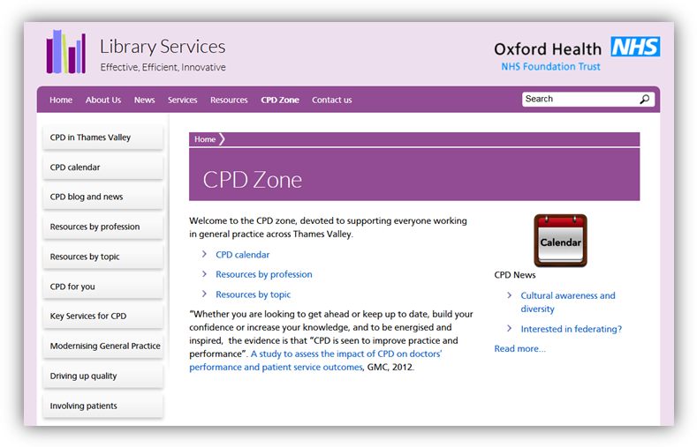

[**http://www.oxfordhealth.nhs.uk/library/cpd-zone/**](http://www.oxfordhealth.nhs.uk/library/cpd-zone/)

* Calendar of CPD events for general practice
* CPD resources by Topic, and by profession
* Blog and news for primary care
* Share best practice; new roles and ways of working