CG 07/2016
(agenda item: 13)

Report to the Meeting of the

Oxford Health NHS Foundation Trust

Council of Governors

09 March 2016

Workforce Performance Report – February 2016

For Information

This report and the attached information shows the position on the workforce performance indicators as at the end of January 2015, except for sickness absence which is a month in arrears.

Overall, staff turnover, the ability to recruit the required numbers at the required speed and the consequential impact on the high useage of temporary staff resource remains the main concern and hence the focus of high levels of activity.

Headline KPIs

Bank & Agency Spend %: 7.41% TARGET: 5.00%

The Trust Agency and Bank spend has been above the 5% target since May 2015. Whilst there has been a gradual improvement in the Trust’s position since September 2015, which may reflect the combined impact of (i) implementing and embedding a new Agency Framework and (ii) lower vacancies, this month has seen an increase in the rate to now stand at 7.41%. This constitutes an 11.8% increase from the December value of 6.63%. The increase has been driven primarily by spend in MSK Physiotherapy, Kingfisher Ward, Oxon Assessment & Treatment teams and Winter Pressures, with the top 10 units (by month-on-month increase) generating an additional £267,328 in Agency spend alone.

Vacancy % Rate: 9.60% TARGET: 9.00%

After the increase in December, the vacancy rate has dropped to 9.6% in January. Without the new round of recruitment in the Children & Young People’s Directorate for Student Health Visitors and Student School Nurses it is likely that the Trust would have achieved its target of 9.0%.

Trust Turnover % Rate: 14.20% TARGET: 12.00%

After a steady increase over the last few months, the Turnover rate has leveled off at 14.22% in December and 14.20% in January. In January, Adult Services (15.03%) have the highest followed by Older Peoples Directorate (14.58%) and Children & Young People (14.47%); all show an increasing trend throughout FY16 with Children and Younger Peoples the steepest.

The high rate of Turnover will prolong the high requirement for agency staff and continue to challenge recruitment in a difficult labour market.

Sickness Absence % Rate: 4.21% TARGET: 3.50%

The Trust Sickness Absence rate remains above the Trust target. The seasonal trend is consistent showing an increase through the winter months and the 4.36% rate in December 15 is the same as last year. However, January has seen a notable decline to stand at 4.21% compared to a December figure of 4.36%. This decline results from a mild winter and combined HR and management pressure to reduce periods of short term sickness.

The Children & Young People and Corporate directorates have driven the decrease, particularly through the significant reduction in short-term sickness rates.

Anxiety/Stress/Depression/Other Psychiatric illnesses continue to be the highest reported reason for sickness absence followed by musculoskeletal and gastrointestinal problems. Focus has continued on a large number of Capability – Health cases, particularly in the Older Peoples Directorate, where staff are placed in a structured programme so that absence can be pro-actively managed.

Other actions taken include:
- Stress awareness courses arranged for 5th and 29th February in partnership with S&P Care being trialled.
- Proactive Health promotion visits increased and additional satellite clinics implemented and well received
- Proactive walk through and workplace assessments (not to be confused with DSE assessments) in response to teams relocating.

Flu vaccination uptake has reduced this year to 50.3% from 56.4% despite an increase in available clinics across all sites, the ability to have vaccine externally at a local chemist and agreements with OUH, Buckingham Hospital and GWH to enable vaccination at all their Occupational Health clinics. This decline is in line with that seen for local and national trusts and GP practices.

Recruitment Activity

Apprenticeships

Following a successful recruitment pilot in September for Business and Administration Apprentices, we are now rolling out the apprenticeship programme trust wide.
We held an apprenticeship assessment day on 9 Feb for Business and Administration apprentices and will be offering four young people and apprenticeship with us. We are holding another assessment day on 11 Feb for clinical apprentices and have five young people attending this session.
For the first cohort, we will be looking for individuals to undertake either a Business and Administration or Clinical Support Worker Apprenticeship with successful candidates commencing the programme on the 11th April 2016.

Careers Event
We held an event aimed at young people who are considering a career in the NHS on the 10th February 2016 at the McInnis Room, Warneford Hospital between 4.00pm and 8.00pm. This was very well attended by approximately seventy young people and was a successful evening.

Open Days
We held an Open Day on 6 February at Abingdon Hospital aimed at recruiting clinical staff for the Older People’s Directorate. This was well attended particularly by people looking for HCA roles with some fifty people attending.
We have an Open Day planned on 27 February for the Highfield Unit to attract children’s mental health nurses.

Work Experience
We are working with the Learning & Development team to hold two taster weeks for young people during the summer, these will be a week long programme that will involve an introduction to the NHS (how it works, the different service, partnership working etc) followed by three days of work shadowing in various areas before the final day of evaluation/next steps.
For this pilot the weeks will be based in Oxford, if this proves to be successful we will then look at rolling it out the following year to cover Bucks, Wilts, BaNES and Swindon.

National & Local Recruitment Events

We are compiling a calendar of national and local events so that we have time to assess the suitability and associated costs of attending and organising service attendees.

School Careers Events

We will increase our presence at local school careers events with representatives from our services to publicise the benefits/rewards of a career in OHFT and the NHS.

Health & Wellbeing

OHFT won the Most Active Workplace Award for 2015 which will be the second year in a row that the organisation has won this award based on innovative ways of engaging staff in physical activity.

Physical Wellbeing

Bike User Group breakfasts have taken place at locations throughout the organisation during the last quarter – coinciding with National Cycle to Work day.
Oxonbikes previously located at Chancellor Court are in the process of being moved to Redbridge park and ride. There is a cycle route from Redbridge to Littlemore which will enable staff relocating to Littlemore to park at Redbridge and cycle in to Littlemore.
Additional funding has been acquired from an external source to fund ElectricBikes to help support staff who are not regular cyclists.

Emotional & Psychological Wellbeing

There are now mindfulness sessions taking place (by invitation) at various meetings across the organisation to introduce teams to the concept. There are plans in place to roll out taster sessions for staff to book onto. This will include practical exercises for possible use by staff groups for example at team meetings or at the beginning or end of reflective practice.

Organisational Wellbeing

The first Health & Wellbeing Champions networking session took place during December. Positive outcomes were; A newly created Purpose Statement and the creation of an online network for champions to discuss and exchange ideas. There are a total of 54 Champions exist across the organisation, with representation from each directorate – a further event will take place in April 2016.

Directorate Performance

Older Peoples Directorate

Turnover: 14.58% v 12.0% Trust Target

- Turnover % has plateaued at 14.66% in December and 14.58% in January.
- Increased slightly from last month and remains above target across the Directorate. Of 31 leavers in the month, the main reason for leaving was Voluntary Resignation. The services with the highest numbers of leavers are podiatry and district nursing.
- District Nursing Services in Older People’s Directorate in which turnover/retention has been a concern, have developed support for new entrants. It is hoped that in addition to enhancing the induction of new staff members this will aid retention and therefore reduce turnover.

Sickness: 5.58% v 3.5% Trust Target

- Although the trend has increased since the summer (and has increased since last month), there has been an overall reduction in sickness absence. HR continue to work with managers to manage attendance. There are currently 26 formal sickness cases.
- January has seen an increase in both short term and long term sickness rates with the long term increase most significant over the last two months.

Bank and Agency: 6.6% v 5.0% Trust Target

- Bank & agency use has increased since last month, presumably in line with the increase in sickness absence and vacancy rate. Due to a shortage of domiciliary care workers, sessional arrangements are being developed in the Oxfordshire Reablement Service alongside the OUH’s SHDS service.
- This has increased in January driven by MSK Physiotherapy, Podiatry and the Out Of Hours Medical Service.

Agency Spend – Top 10 Units (Older)

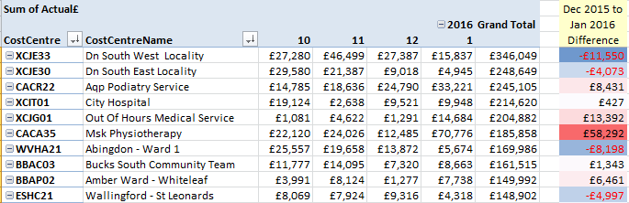

[NB: The ‘Grand Total’ is for 13 months from January 2015 to January 2016 inclusive.]

Children & Young People Directorate

Turnover: 14.47% v 12.0% Trust Target

- Turnover % remains above Trust target and has increased slightly since September.
- Turnover has been impacted by the new round of vacancies for student health visitors and student school nurses following the last seasonal intake in August.

Sickness: 2.67% v 3.5% Trust Target

- Sickness absence has decreased slightly to 2.67% due to a significant decline in short term and medium term sickness absence, which takes it below the Trust target.
- As part of actions to reduce sickness levels the CYP Directorate is developing an approach to the high levels of ‘Anxiety and Stress’ using the model of six key contributors as researched by the Health, Safety and Wellbeing Partnership. Examples of this being triangulating sickness data against turnover. We will also look to analyse data by age/disability/ethnicity/sex/sexual orientation with a view to identifying any trends that merit further investigation.

- Focusing on ‘Anxiety and Stress’, the CYP management has also highlighted the control demand aspect specifically around the issue with CareNotes. A balanced approach to communications and number of meetings has been adopted – for example we will have a weekly email to staff to update on key issues and will trial having key meetings on one day. The Directorate is also aware that anxiety is being felt by staff with regard to the upcoming review of all services and recent experiences of outsourcing and service transfers. To minimise the impact on staff we are working closely with commissioners to seek preferred provider status and rolling out tried and tested service delivery models.

Bank and Agency: 5.2% v 5.0% Trust Target

- Bank & Agency % has decreased to 5.2% as part of a significant decline since August. Large reductions in Agency spend are visible in 4 of the top 10 spending units (see table below).
- Inpatient units have been using non agency framework suppliers and this practice is being targeted to replace the non-framework supply with Framework Agency workers.
- The Resourcing Department is working closely with recruitment managers, in particular, meeting with the Modern Matron at Highfield Oxford in the next 2 weeks to discuss vacancies.
- There are recruitment difficulties within the consultant group – OSCA – for which there is a national shortage of Consultants. The proposal is to over recruit in this area, and also look at skill mixing within the Consultant /Specialty doctor group. Wendy Woodhouse, Clinical Director is leading this project.

Agency Spend – Top 10 Units (CYP)

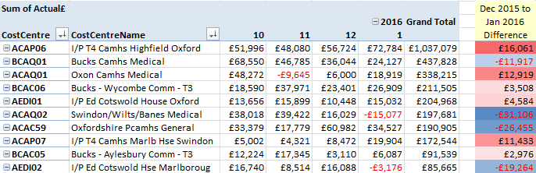

[NB: The ‘Grand Total’ is for 13 months from January 2015 to January 2016 inclusive.]

Agency Spend at Highfield Oxford

Agency spend at the Highfield is linked to vacancies, a recent increase in short term sickness and in the past significant acuity challenges. The unit still has ongoing relationships with non-framework agencies, with permission being sought prior to their use, due to unavailability of appropriate staff however they have recently established some good relationships with framework agency staff and are in weekly liaison with Staffing Solutions to feedback on their experiences.
The unit is currently looking to recruit approx. 6 WTE of Staff Nurses and 8 WTE of Health Care Assistants, which is in line with the level of agency spend. The unit is hosting a recruitment open day on the 27th February in response to staff vacancies. Turnover is currently approximately 17%, with 2 leaver in December. This is in line with some of the other inpatient units within CYP, e.g. Cotswold House Marlborough = 22%, Marlborough House Swindon = 19%

Adult Services Directorate

Turnover: 15.03% v 12.0% Trust Target

- The Turnover rate has plateaued at 15.01% in December and 15.03% in January.
- The percentage of vacancies has increased although there have been many more new starters in January 23 compared to 10 in December. Leavers slightly decreased to 18. Vacancies have increased due to ensuring that managers place adverts promptly, the new intake of trainee PWP’s and roles that remain unfilled after advert or interview.
- A Careers Open day for qualified staff was held at the Warneford on January 12th. 58 candidates attended and although the major advertising was done on Nursing publications and websites the breakdown of attendees was 11 Nurses, 12 Social Worker and 21 O/T’s and the remainder looking for unqualified positions. The majority of attendees were currently students qualifying later this year. All of the nurses have been either offered roles or have interviews set up in the next few days. Discussions are ongoing regarding additional roles for S/W’s and O/T’s where there are currently no vacancies.
- An advert is out to Band 5 inpatient staff in MH to step up to the Band 6 Deputy ward manager role for 12 months with the option of returning to their substantive post if the role is not to their liking or if we consider they would be more effective as a Band 5. Specific training will be given in the first 9 months to develop staff in the role. We have 5 roles to fill and this will create 5 Band 5 vacancies.
- In the first 2016 tranche of apprentices for the Trust 2 roles were offered for Business & Administration roles in Adult MH but of the 4 candidates who attended none of them lived in the locality of the vacancies.
- A School event is being held on 12th February and MH will have a stand. An Careers day is being held in Aylesbury for Student Nurses attending Bedfordshire University and qualifying shortly. Approximately 20 candidates will attend and will be encouraged to attend interviews for Band 5 roles the following week. MH is attending a Social Workers career’s day for Buckinghamshire New University in March.

Sickness: 3.97% v 3.5% Trust Target

- Sickness remains unchanged at 3.97%.
- All long term cases are being managed with the support of Occupational Health and the number of cases being managed through a formal process has increased.

Bank & Agency: 10.1% v 5.0% Trust Target

- Agency spend in increasing particularly in Thames House, Oxford City and Chiltern AMHT’s. Chiltern are having difficulty recruiting Band 6 Social Workers and are covering vacancies with long lines of work through agencies. Oxford City recruited 3 staff from the Open day who are currently going through employment checks. There was little interest by candidates attending the Open day for Forensic services. They currently have an advert out and we are working on a recruitment drive for their services.

Agency Spend – Top 10 Units (Adult)

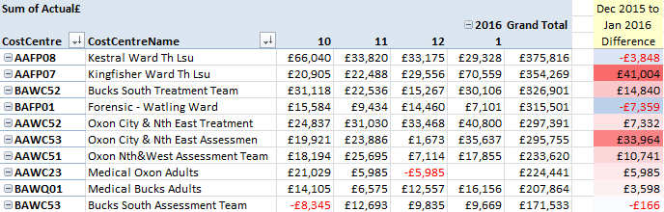

[NB: The ‘Grand Total’ is for 13 months from January 2015 to January 2016 inclusive.]

Corporate

Turnover October 11.93% V 12.0% Trust Target

- Turnover has reduced to below the Trust target to stand at 11.93%.

Sickness January 4.0% V 3.5% Trust Target

- Sickness absence has decreased from 4.36% in December to 4.0% in January.

- The overall trend is improving however the trainee doctor staff group continues to present a challenge, particularly with Long Term Sickness. Key areas requiring further improvement have been identified and are being worked through currently. Sickness absence is being managed in line with current trust policy and is focusing on; ensuring line managers and supervisors are clear on roles and responsibilities, developing and coaching managers to ensure they are confident in the management of absence and transparent team level ‘dashboards’ enabling focused planning to support in teams or departments of concern.

Bank & Agency October 7.1% V 5.0% Trust Target

- Bank & Agency spend has increased to 7.1% in January from 6.7% in December.
- OPS have the biggest challenge in the use of temporary staffing. They are currently working to full substantive vacancies which will considerably reduce their use of temporary staff. High levels of scrutiny remain essential in this area. OPS currently have 8 posts that are at various stages of the recruitment process which will provide a stable base at operational level of the department. The next phase of this project will be to consider the supervisory level posts and recruit substantively at this level.
- Estates and Facilities are recruiting to 17 posts (within soft facilities) currently which should reduce their reliance on temporary staff.

Agency Spend – Top 10 Units (Corporate)

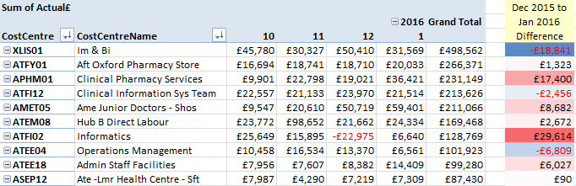

[NB: The ‘Grand Total’ is for 13 months from January 2015 to January 2016 inclusive.]

Recommendation

The Council is asked to note the report for information.

Author and Title: Jayne Halford, Deputy Director of HR

Lead Executive Director: Mike McEnaney, Director of Finance

- A risk assessment has been undertaken around the legal issues that this paper presents and there are no issues that need to be referred to the Trust Solicitors.

- This paper (including all appendices) has been assessed against the Freedom of Information Act and the following applies: [delete as appropriate]

- THIS PAPER MAY BE PUBLISHED UNDER FOI

- This paper provides assurance and evidence against the Care Quality Commission Outcome: [Input Outcome number – i.e. 12,13,14]

