

# PAPER

MC 10/2012

# Report to the Meeting of the

# Members’ Council

**9 February 2012**

**Quality & Safety Report**

**For: Information**

**Executive Summary**

The last Members Council report in November provided a briefing on the three domains of Quality and Safety, Effectiveness and Patient Experience. This report focuses predominantly on Safety and gives more detail for Members Council to review on aspects of the Quality Account.

**Recommendation: The Members Council is asked to note this report.**

**Author and Title: Ros Alstead, Director of Nursing & Clinical Standards**

**Lead Executive Director: Ros Alstead, Director of Nursing & Clinical Standards**

**Introduction**

The Report gives information on the total number of incidents, Serious Incidents Requiring Investigation (SIRIs) and high level trends that have occurred over the last 4 quarters.

**Total Number of Incidents by Quarter**

|  |  |  |  |
| --- | --- | --- | --- |
| **Q4 2010/11** | **Q1 2011/12** | **Q2 2011/12** | **Q3 2011/12** |
| 1542 | 1620 | 1481 | 2072 |

**Incidents by Risk Rating for the last 4 quarters**

The number of incidents initially graded as red by staff completing incident forms has gradually risen over the last year. This reflects training in the use of the Risk Matrix. The recent increase in overall numbers however is due to a large increase in green rated incidents (see chart below).

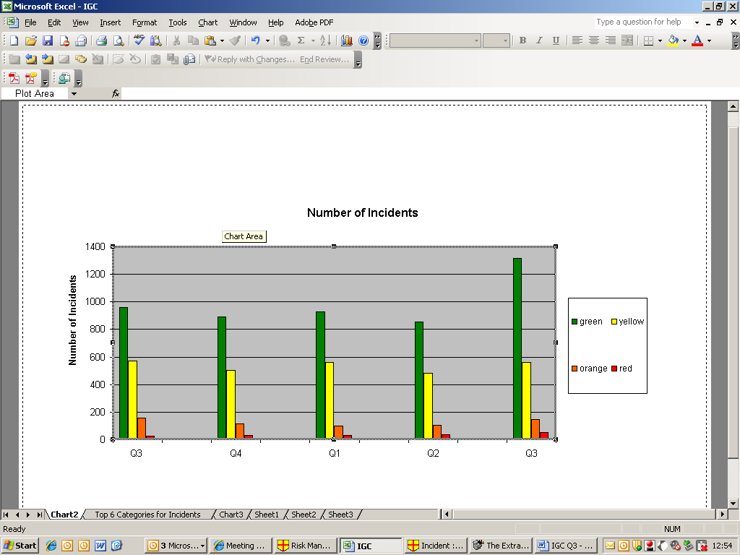

**Progress against LIPS targets**

In 2009, we set a target of an increase of 50% in the number of less serious (green and yellow) incidents we reported by March 2012. It is expected that a Trust with a good safety culture will report high levels of low level incidents and work to learn from incidents and reduce the number of serious incidents. The table below shows the figures for green and yellow reported incidents from 2009 to date.

|  |  |
| --- | --- |
| **Year** | **Total (Mental Health and CHO combined)** |
| **2009/2010** | **5981** |
| **2010/2011** | **6230** |
| **2011/2012** | **4704** |
| **2011/2012 Projection** | **6776** |
| **Target by March 2012 (increase of 50% on 2009 figure)** | **8972** |

The Trust is considerably short of hitting this target. It was expected that the widespread training programme that was delivered as part of introducing a new version of Safeguard across the new organisation would assist in encouraging reporting. The number of reported incidents has increased considerably in quarter 3 – a rise of 40% on quarter two. As over 4,000 incidents would need to be reported in the next quarter to reach the target it is highly unlikely that it will be met. The last quarter rise is encouraging, but is not yet a trend.

**Top 6 Categories of Incidents by Month over the last 4 quarters**

The chart below shows reporting numbers for the main categories of incident over the last 15 months. The types of incident broadly show random variation over the months. Self harm has dropped in the last two months but in a way consistent with previous months’ erratic levels of reporting. The numbers of Absent without Leave (AWOLs) have dropped in the last two months, hopefully reflecting an improvement in physical security on acute wards. However, the top 3 reporters of AWOLs have remained the same. The one apparent significant change is a rise in reported incidents of violence in October and November 2011.

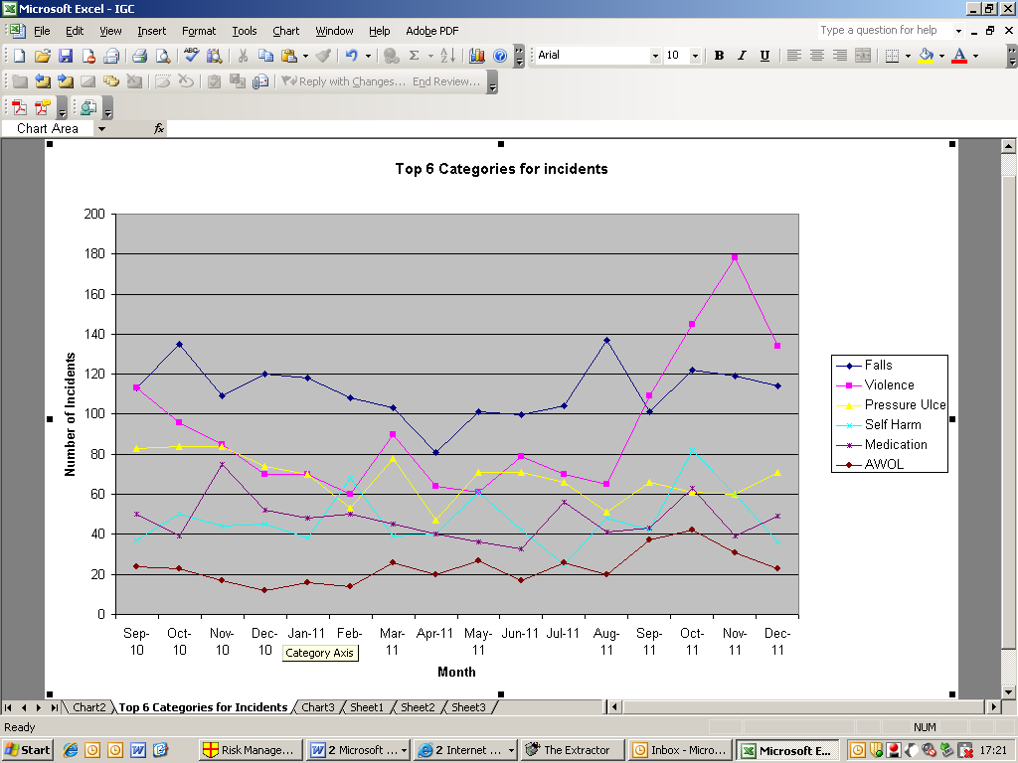

**SIRIs**

**Total number of SIRIs by the last 4 quarters**

The table below shows the total number of red SIRIs by quarter. Part of the decrease from quarter 2 onwards is because from June 2011, it was agreed (in the then CHO) to only progress **avoidable** pressure ulcers as SIRIs. Grade 3 and 4 pressure ulcers are assessed against national criteria, with only the avoidable ulcers progressing through the SIRI process.

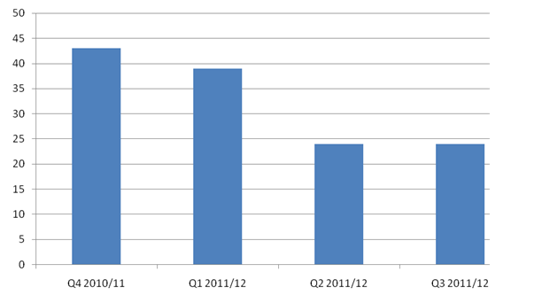

**Type of SIRI – Q1/2 2011/12**

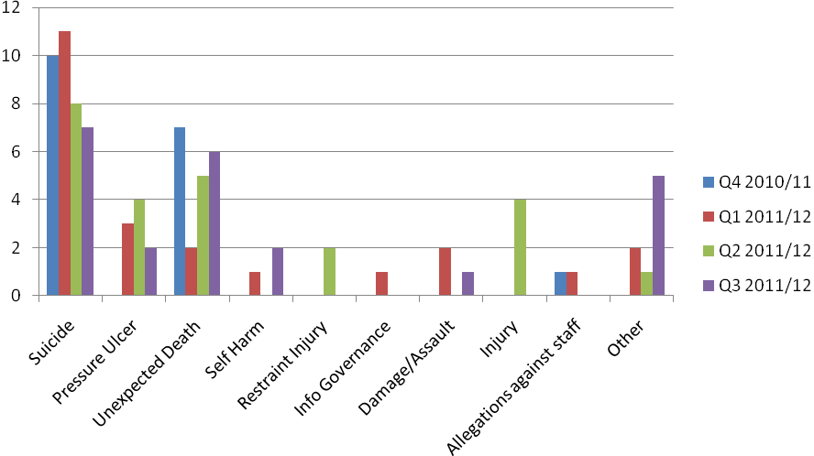

**Apparent suicides by quarter for the last 2 years**

The chart below shows apparent suicides. They are apparent in that many will not yet have an inquest verdict.

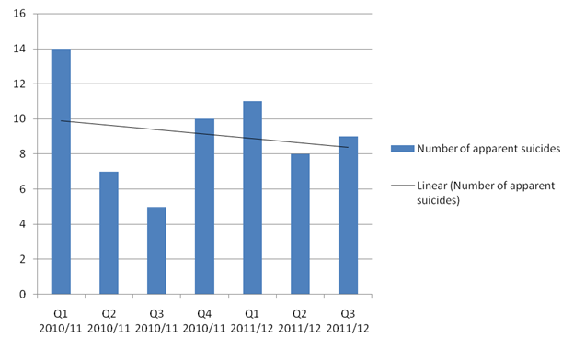

**Leading Improvement in Patient Safety (LIPS) Target: reducing suicides**

The LIPs programme has set a target to reduce both community and in-patient deaths towards zero.

The below figures are based on deaths that appear to be suicides. Not all these have been confirmed as ‘took own life’, or an open verdict by the coroner. Both the inpatient suicides were patients who were either Absent without Leave (AWOL) or on Section 17 leave.

|  |  |  |
| --- | --- | --- |
| **Year** | **Inpatient** | **Community** |
| **2009/10** | **1** | **24** |
| **2010/11** | **1** | **36** |
| **2011/12** | **0** | **28** |
| **Projection for 2011/12** | **0** | **37** |

The rate of apparent suicides has fallen over the last two years. With 28 apparent suicides this year already, a projection for the full year is around 37, so may be close to last year’s total.

The LIPS Project Board, chaired by the Director of Nursing and Clinical Standards has now had its first meeting. Another dozen staff from Bucks adult services have attended LIPS training. A number of initiatives and the creation of a wide ranging dashboard that covers many areas of patient safety as well as Suicide are under preparation. All community teams have progressed implementing one service improvement aimed at reducing suicide (a CQUIN target).

**Pressure Sores: October 2010 – December 2011**



There is a comprehensive over-arching pressure ulcer prevention action plan being monitored with the PCT. We are currently reviewing the number of pressure sores over time with the PCT to see whether numbers have fallen, bearing in mind that definitions and follow up arrangements have changed in the last year.

**Location of SIRIs by Division**

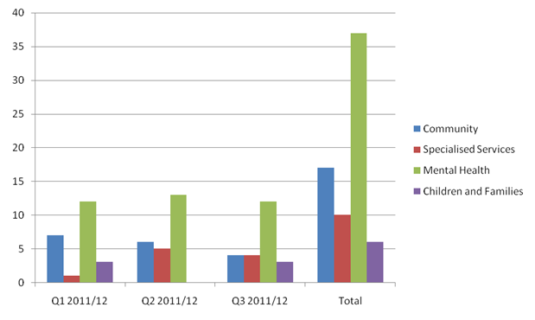

**Emerging themes 2010/11**

Following the review of themes reported in the last report, four additional recommendations and actions have been added all of which are currently being addressed. They include:

* Addressing referral waiting times in particular for psychological therapies.
* Ensuring rigorous governance processes are in place in Prisons through a range of targeted work streams.
* Increasing the level of safeguarding awareness and reporting.
* Improving the continuity of care co-ordination.

**Bucks Safety Workshop**

A second Safety Workshop was held in November in Bucks with community and in-patient teams from the mental health division. The workshop offered an opportunity for managers to share local patient safety initiatives and discuss issues impacting on safe working.

**Newsletter**

The Fourth Learning from Incidents Newsletter was published in October 2011. The contents included an article on Human Factors and accident causation, resuscitation developments, divisional updates and some of the findings from the Trust clinical audit programme that resonate with findings from SIRIs.

**Risk Notes**

There have been a further 4 risk notes issued since the last report. They have related to physical health monitoring (examinations and assessments); a recall notice for a particular brand of fire heater; follow up of patients who have failed to attend appointments and preventing injury when using PMVA.

**Being Open**

In Q3 of 2011/12 there were 18 RCA investigations completed that went to panel, all actively involved or considered the involvement of family, carers or patients.

**Quality Risk Profile (QRP) Summary**

**CQC’s QRP November 2011 (published 8th December 2011).**

The Trust’s profile now includes Oxfordshire Community Services. The CQC published the latest Quality Risk Profile (QRP) in November 2011.

The following are key data sources used within the QRP:

* 2010/ 2011 Staff Survey
* NHSLA Risk Standard as at April 2011
* 2010 National Community Patient Survey
* 2011 Annual PEAT Assessment

The QRP is a risk rating of the Trust by CQC Outcome based on a scale from reducing risk of non-compliance (green) to increasing risk of non-compliance (red), see figure 1.

*Figure 1.*



Figure 2 shows a summary of the CQC’s risk ratings over time from May to November 2011, showing the number of outcomes (16 in total) rated against each of the areas of the risk rating scale.

*Figure 2.*



Figure 3 shows the CQC’s risk rating for the Trust by outcome over time from March to October 2011. The scale is the same as used in figure 1. None of the risk ratings for the outcomes has worsened between September and October 2011. Where insufficient data or no data is shown this means the CQC has none or some data available but it is not sufficient to make a risk estimate and assessment.

*Figure 3.*



**NHS Litigation Authority Assessment**

We are preparing for this Level 1 assessment which will take place in March 2012. Achievement of a minimum of Level 1 is important for Monitor Governance compliance and reduces the premiums paid to the Litigation Authority, who manage claims on behalf of NHS organisations. As a new organization this assessment has required a significant number of policies to be developed, reviewed and approved through Oxford Health NHS FT Governance Committees.