PAPER
BOD 162/2011

Report to the Meeting of the

Oxford Health NHS Foundation Trust

Board of Directors

14 December 2011

Q2 Quality Account Update

For: Information

The accompanying document is the 2nd quarter's update to the targets and objectives defined in the Quality Account. This report is produced as a guide to the Board, Governors and other partners to give assurance in how we are progressing in our declared intentions to improve clinical quality.

This quarter's update shows considerable progress from the 1st quarter, both in the nature and quality of the reporting, but also in the actual progress being achieved.

Recommendation
The document is formally approved by the Board and may be shared with our partners.

Author and Title: David Allen, Management Consultant
Lead Executive Director: Ros Alstead, Director of Nursing and Clinical Standards

- A risk assessment has been undertaken around the legal issues that this paper presents and there are no issues that need to be referred to the Trust Solicitors.
- This paper provides assurance and evidence against the Care Quality Commission Outcome: [Input Outcome number – ie 7]

Quality Account 2011/12

Report for 2nd Quarter 2011/12

October 2011

Introduction

This report represents an update on progress on the quality aims, actions and targets described in the 2010/11 Quality Account for the second quarter.

The intention is that a similar report is produced at the end of every quarter so that progress can be tracked throughout the year and controlled by the Executive Team. Furthermore, it should help give assurance to the Board to help with their quarterly declaration on Quality Assurance as well as Governors and other partners such as LINk, OSC and the PCT. Compiling the final Quality Report at the end of the year should also be made considerably easier.

In the second quarter, a lot of work has gone into ensuring the people responsible for delivering the quality objectives are now regularly reporting in a timely manner and also that the information needed to monitor targets is being captured.

As the second quarter’s report, this document fills in a number of gaps that were evident from the first quarter. Unfortunately, some information is still lacking and the people responsible are being encouraged to be able to respond suitably in the 3rd quarter account. Nevertheless, it is encouraging to see that people are seeing the importance of continually monitoring the actions specified in the quality account and are able to change the status of each from “amber” to “green” as the year progresses.

In this report, a colour code has been adopted to denote progress against the planned actions:

Green: Action has been completed
Amber: Actions are underway but not yet completed
Red: Actions not yet started
Black: No information available at present

A risk assessment has been undertaken around the legal issues that this paper presents and there are no issues that need to be referred to the Trust Solicitors

Patient Safety: Preventing people from dying prematurely

Aims
- To reduce towards zero the number of inpatient deaths from suicide by 2012

Note: 2011/12 show zero suicides in the 1st & 2nd quarter

- To reduce towards zero preventable community suicides by 2014

Important note: These figures are unverified and may be subject to change. However, the general trend is believed to be accurate.

- Increase reporting of no or minimal harm incidents by 50% by March 2012

In the second quarter, there was a 1.4% increase in the number of no or minimal harm incidents (green and yellow) reported in the previous year, compared with the first quarter.

There was also a 7.2% increase on the equivalent period (2010 Q2) last year.

Actions | Present Situation
Increase the number of staff who have completed the Trust’s clinical risk assessment training from 79% to a minimum of 85% by August 2011 | - At end of quarter 2 82.5% of staff had undertaken clinical risk assessment training (81% in Q1).
Senior Managers and clinicians to receive training in the LIPS programme | - Training in LIPS has now concluded with a final day of presentations on 6th October.
 | - We have approached the LIPS team at the Institute with a proposal that a course is put on locally, specifically for Oxford Health. This remains under discussion.
- Cost of LIPS training has been re-negotiated with the Institute for a small cohort. Agreement for funding is awaited.
Note: bespoke training delivered locally is not currently available

Implement the use of SBARD (Situation, Background, Assessment, Recommendation, and Decision) in clinical teams. SBARD is a communication tool to assist staff in succinct and focused relaying of information | - Every clinical team has had SBARD training.  - SBARD awareness raised during training by physical healthcare nurse.  - SBARD has been implemented in Oxon older adult team. Ashurst and Marlborough House Swindon are leading as showcase wards.  - Funding for 12 participants from the MH Division has been agreed, plus two places from the I&I team starting at the end of November. The focus of the MH Division’s work will be the reduction of deaths by suicide and will target the community setting. The programme takes 9months.
Implement guidelines to prevent absconding from inpatient mental health wards | - AWOL policy has been reviewed to incorporate guidance in prevention of AWOLs and is presently out to consultation with CEC members.
Implement new initiatives in every Community Mental Health Team to prevent suicide | - All teams have been asked to identify their initiative. Workshop held with Bucks teams on suicide prevention with follow up date booked for 11/11/11.
 | - Buckinghamshire CMHTS are running the Advanced Assessment Skills training as well as ASIST (Applied Suicide Intervention Skills) training in suicide prevention programme. The plan in the division is to roll the this Advanced Assessment Skills training across the Oxford teams as well
Audit against NICE guidelines and learn from the care of patients who present to A&E after self harming | - Audit on self harm NICE CG completed in Oxon last year and implementing action plan now with re-audit in Dec 2011  - Bucks completed audit in September 2011 - need to finalise action plan.
Integrate the work on developing care clusters with the LIPS programme | - LIPS overlap with Improvement and Innovation team's work has been mapped. Overlap is principally with Productive Wards rather than Care clusters. Three steering boards to operate for: PW, Care Clusters and LIPS.
 | - LIPS lead and Productive Lead working together to develop local and board level outcomes for both programmes to reflect the shared aspirations of both programme contacts. Steering board now arranged for 23rd Nov to be chaired by Ros Alstead.
 | - The LIPS dashboard is under development to interface with the Productives dashboard. The LIPS lead is also leading work to develop the Board level dashboard in collaboration with the Productive Care lead to provide information at a glance on key LIPS and PC outcomes
Implement a schedule of Executive Safety Walkabouts | - These have started with all Exec Directors now having a list of sites to visits. Individual PAs are setting up the visits for their respective Exec Directors and these are being logged on a central spreadsheet.  - NEDs are being informed of the dates and can book to attend visits with Execs.  - The feedback from any visits is reported back to the weekly Executive Board meeting.
Improve the quality of engagement with Carers | - Following the Carer Survey last year, the resultant action plan is being implemented (note: adult & older people Ox & Bucks, not CAMHS & Forensic)  - A 6-monthly report is now prepared for Governors (from September 2011)

Patient Safety: Treating and caring for people in a safe environment and protecting them from avoidable harm

Aims

- Preventing avoidable skin breakdown which can lead to pressure ulcers. 85% of patients will be assessed for pressure ulcer risk on first visit or within 6 hours of admission, and will have actions identified on the key risk factors and preventative measures implemented within 2 days (commissioning priority)

- Preventing avoidable serious drug errors in Community Health by 15% from baseline 32 in 2010-11, target 27 (commissioning priority)

There has been a 16% decrease in the number of serious drug errors in the previous 12 months after the 2nd quarter (18), compared to the previous 12 months after the 1st quarter (21).

- Reduce the number of falls in community hospitals and older people’s mental health wards by 10% by March 2013 (national priority)

Note that since 7th August, the same reporting system (Safeguard) is used for both mental health and community falls, replacing the previous separate statistics. The number of falls after that date is represented by the “combined” figure in the second quarter for 2011/12.

Actions | Present Situation
Preventing avoidable skin breakdown which can lead to pressure ulcers. 85% of patients will be assessed for pressure ulcer risk on first visit or within 6 hours of admission, and will have actions identified on the key risk factors and preventative measures implemented within 2 days (commissioning priority) | - Community Nursing: 95% of patients were assessed for PU risk on their first visit in Q2
- Community Hospitals: 84% of patients were assessed for PU risk within 6 hours of admission
- Quarterly documentation audit (30 sets of notes) being carried out to identify compliance with this target. The KPI for this was set at 75%.
- The Q1 audit has just been completed – Out of the 30 sets of notes only 33% of patients had been assessed within the recommended timescale’. Key risk factors were not always addressed or there was no evidence of this in the notes.
- An action plan is in place to address these issues. Previous audits (pre 2011/12) demonstrated compliance of 78% and 56% respectively.
- The new risk tool format which will ‘simplify’ the risk assessment process may improve compliance figures.

Preventing avoidable serious drug errors in Community Health by 15% from baseline 32 in 2010-11, target 27 (commissioning priority) | - There have been 15 severe drug error incidents at Q2 which represents a YTD reduction of 6% against last year’s baseline. Performance in Q2 was affected by a comparatively high number of incidents in August (6).  - It is anticipated that performance will reconcile against plan in Q3.  - An action plan is in place to support a reduction in errors which includes four key elements:  (1) Strategy and Policy,  (2) Workforce/Training and Competencies,  (3) Communication, Management Discussion and Reviews and  (4) Information and Audit.
Reduce the number of falls in community hospitals and older people’s mental health wards by 10% by March 2013 (national priority) | - Community Hospital falls have reduced by 6% YTD against the 10/11 baseline. This is a positive achievement as the number of reported falls per 1000 bed days is significantly below the national average.
To achieve falls prevention that is better than the national comparison for falls to 8.6 falls per 1000 bed days by 2014 | - All patients with 2 or more falls are referred to falls team for assessment.  - Figures as above
 | - Mental Health – MH older adults falls risk assessed on admission. Falls prevention planning in place.
At least 85% of all patients over 75 years of age are assessed for falls and nutrition risks in Community Hospitals and Older Adult Mental Health wards (commissioning priority) | - Quarterly MUST audit has been completed with 93% of patients having been scored and monitored.  - Figures as above
 | - Mental Health – All Older adults assessed for falls risk on admission reviewed weekly or if status changes
At least 85% of patients over 75 years old in Community Hospitals have been assessed for dementia and depression (commissioning priority) | - On-going work around dementia pathway. Looking to appoint dual trained nurses with appropriate skills to assess for dementia and depression.
 | - Still need to clarify what assessment tool is required by the trust to meet this aim - currently assessing if FIM assessment and care pathway is sufficient
PEAT (patient environment action team) scores to remain at good or excellent (national priority) | - PEAT scores remain at good or excellent
 | - The PEAT scores for the 13 wards in the Mental Health Division for Q2 are all at 95% or above, the average score being 97%.
Ensure 100% of patients admitted to psychiatric wards have a physical health examination within 24 hours of admission (LINks priority) | - 82% at the end of Q2
All patients subject to CPA living in the community are monitored to ensure their physical healthcare needs are being met by primary care, and when this is not the case action is taken to address the need (LINks priority) | - This is part of the CPA care plan. All patients will have a GP prior to discharge with regular contact with GP regarding medication (GPs carry out their own regular checks regarding medication for mental health patients). If there are any health concerns the patient is supported to attend GP/Dentist in whichever way is appropriate for them i.e. checking that they attended and receiving feedback or going with them to see GP.
Reduce to 30 from 34 (the previous target) the number of cases of Clostridium Difficile by March 2012 | - There have been 11 cases of C Diff this year, RCA's completed on all in 2 cases the antimicrobial prescribing was outside the guidelines. Cdiff recovery plan in place  - The PCT internal target is 13 and the CQUIN target is 20. if the current level continues the Trust will just be inside the CQUIN target
Maintain no cases of MRSA across the Trust (national priority) | - MRSA and MSSA bacteraemias require mandatory reporting to the HPA. There are no targets for these, but we are monitoring and investigating any cases in the Trust accordingly.  - There have been 2 MSSA bacteraemias (April and September) and 1 MRSA bacteraemia in September. Full RCA’s have been completed and the cases investigated. As with often with these cases no single root cause has been identified.

Actions we said we’d take | Present Situation
Introduce ward based falls training programmes | - Since January 2009, 298 staff members from community hospitals have been receiving falls training.  - Data has been collated per hospital site in order to compare this data to the recent audit findings as this may help us to identify sites that require greater input from the falls service.  - In Q2 a further 4 ward based programmes have been delivered  - Mental Health – All Older adults assessed for falls risk on admission reviewed weekly or if status changes
All patients are referred to the Falls Prevention service following two falls, continue monitoring timeliness of referral of patients at risk from falls to the falls prevention service across the community hospitals | - OCS CH have just completed an audit of all the hospital wards in Q1 and produced a report. The results showed 95% of patients had a Falls Risk Assessment Tool in their records: an improvement of 1% on last year. However 78% were completed within 24hrs of admission, with the remaining 17% after 24hrs. That still leaves 5% of patients without his tool completed and therefore risk of falls not identified.  - Since February 2011 we have seen a significant increase (25%) in the number of communication sheets sent through to the falls team.  - The TV service has seen a 56% increase in referrals for April-September 2011 compared to the same period last year
Introduce an early warning observation tool (“track and trigger”) to ensure effective monitoring of physical health in all inpatient areas | - Track and Trigger (T&T) was fully implemented in Community Hospitals in 2009. 10 sets of notes per ward are audited monthly to ensure compliance with T&T.  - YTD compliance is 94%
Audit the use of MUST (nutrition assessment) and Falls assessments through the Essence of Care benchmarking standards (six monthly) and the Productive programme and then actively mange shortfalls | - CH: MUST is now audited through the CHAT audit tool monthly as from July.
 | - MH: Essence of Care regarding nutrition in place since August
 | - MH: Falls is not actually in Essence of Care, but is being audited through local audits
To ensure additional training for at least one nurse per ward in each of the 8 community hospitals in the detection of dementia and depression | - Dementia link nurses exist
 | - On-going training continues to be rolled out
 | - Some wards have additionally employed dual trained nurses
Staff competency assessments will be developed and introduced for nursing staff in Community Division prescribing and/or administering medicines to further enhance current training programmes. This approach will also be implemented for other potential high risk clinical nursing interventions | - Induction programme has been updated to include medicine’s management
 | - The divisional competency framework has now been completed and implementation approach agreed. To commence roll out in Dec /Jan 2011-1
 | - Overall framework for HII for OCS ratified by the division, implementation plan in progress
Implement outcomes resulting from investigation of all identified grade 3 and 4 pressure sores | - All learning is reviewed and the overarching PU action plan is updates to reflect any additional learning action points.

3. Effectiveness: Enhancing quality of life for people with long-term conditions

Aims
- To increase by 10% the number of mental health patients who have Advanced Statements in place (Trust Priority)

NOTE: The decline in Q1 2011 is due to a peculiarity caused by the introduction of RiO. This is being addressed, but will not give reliable results until at least Q4

- 100% of mental health patients on CPA have a current care plan, had care reviewed in the last 6 months; a care coordinator and a risk assessment which has been reviewed in the last 12 months (national and local priority)

NOTE: Figures are very dependent on the size and nature of the sampling. In later quarters, it is anticipated that RiO will be used to provide metrics on 100% sampling.

- 100% of mental health patients have a copy of their care plan and were engaged in its development (service user priority)

NOTE: This information is not currently being captured. RiO will be used to report on this at a later date

Actions | Present Situation
To increase by 10% the number of mental health patients who have Advanced Statements in place (Trust Priority) | - The advance statement leaflet has been subject to consultation across the trust. Progress on the leaflet is stalled while a decision is taken on whether to have separate policies between Mental Health and Community or whether to adapt end of life planning for mental health.  - The community side have independently completed a large piece of work around end of life planning which has some clear cross-overs with advance statements.  - Consequently there has been no further progress on training though the need for a standard operating procedure in RIO to ensure statements are correctly recorded has been identified and the development requested. It is anticipated that this guidance will go out with the new leaflet when agreed.
100% of mental health patients on CPA have a current care plan, had care reviewed in the last 6 months; a care coordinator and a risk assessment which has been reviewed in the last 12 months (national and local priority) | - The team managers CPA metric for the 2nd quarter was 76% (79% June 11). A CPA Management group comprising Informatics, performance and clinical is working to provide accurate and timely CPA metric reporting shortly. Additional RIO super user training is being arranged for key clinicians and business managers. Service managers are identifying what additional support they may require from CPA lead manager. Directorates have their own CPA action plans to address shortfalls.
100% of mental health patients have a copy of their care plan and were engaged in its development (service user priority) | - CPA mandatory training covers involving the service user in drawing up the care plan and that they are given a copy. The RiO CPA care plan can record that a copy has been given to the service user and their signature or comments. This means that this can be reviewed once RiO reporting is operating.
Implement the use of Patient Reported Outcome Measures as part of the stroke care pathway (commissioning priority) | - Literature review has commenced. Task and finish group still to be established awaiting identification of clinical lead
Further reduce the incidence of emergency readmission in mental health within 28 days of discharge (2.9% March 2011) by careful discharge planning and assertive follow up (commissioning priority) | - Adult 28 day readmissions dropped from 7.4% in July to 3.4% in September, against a target of 10.3%  - There were no OA 28 day readmissions in Q2.  - All emergency readmissions have been monitored over several months. No cause for concern has been identified relating to patients discharged too early due to bed pressure, inadequate discharge planning or lack of appropriate follow up contacts.
Reduce emergency admissions to acute hospitals by 800 per year (commissioning priority) | - TBA
To work with Commissioners to develop a multi agency mental health recovery strategy | - All areas now have identified recovery leads. Each recovery star is evaluated during the CPA process.  - The nursing and OT staff are in the process of creating a recovery group which is attended by all disciplines.  - During wider patient council meetings updates are given to the commissioners regarding the progress.  - Chaffron ward has been asked to present the current recovery model at the Royal College of Psychiatry Quality Network conference.  - Working in partnership with PCT and OCC to develop a recovery pathway through the Supporting People in independent living. This work looks at accommodation (all types) and how people with mental health needs move through to independently living  - Restore provide a pathway from CMHT back to recovery within the community. This includes a pathway from Restore to MIND (wellbeing groups)  - Better mental health for Oxfordshire is a group that includes all partners in looking at mental health and recovery.

Actions we said we’d take | Present Situation
All patients will be given information on advance statements as part of their care | - When the advance statement leaflet is finalised it will be distributed to all clinical areas with advice that all patients are given a copy and invited to draw up an advance statement.
That all care coordinators and key-workers are fully informed of the importance of advance statements in care delivery | - Training (literature or face to face) will need to be provided for clinicians about advance directives, ensuring service users are informed and how to best record their existence and whereabouts.
Establish suitable baselines for determining future targets and trajectories within the diabetes service | - Methods are in place to capture and monitor activity and performance against specified indicators in order to inform future targets for the service The Trust is on trajectory to achieve a reduction in acute non-elective and non-elective short stay admissions by 2528 against the 10/11 outturn
Systems will be developed to support the implementation of patient reported outcome measures (PROMS), commencing with the patients on the ‘stroke care pathway’. | - Literature review has commenced. Task and finish group to be established awaiting identification of a clinical lead
Create a seamless pathway for adults with Diabetes living in Oxfordshire with more patients managed through primary and community services | - OCS is contracted to support patient education to assist patients in the management of their condition, as part of the Oxford approach to the care of patients with Diabetes.  - In addition education and support is provided to primary care providers of diabetic care.
Implement full use of Personalised Care Planning | - District Nurses have reviewed and updated the patients’ Personalised Care Planning. This has now been implemented.
Provide local education programmes for people with Type 2 Diabetes. To include an advanced insulin skills group course for people with Type 2 Diabetes treated with insulin | - The education courses have been implemented and a schedule is in place for the year both for Diabetes2Gether (newly diagnosed patients) and Diabetes4Ward (refresher course). 366 people have been through the course to date
 | - Advanced insulin courses have also been developed and are being rolled out to practices in collaboration with OCDEM (Oxford Centre for Diabetes, Endocrinology and Metabolism). These have been well received to date and scheduled courses are fully booked.
To work with health advocates to develop and deliver education programmes for BME groups with diabetes | - There has been a significant amount of work progressed with health advocates this year. Plans are in place to adapt the Diabetes2Gether programme for BME groups and pilots will be underway by Christmas. 2 BME roadshows with health advocates have taken place in Templar Square and Stanley Road mosque. These informed the impending pilots.
To support patients through case management by developing the role of the case managers to ensure access to all sources of care and support. This will improve quality of life for people with long term conditions and reduce disruption through hospital admission and also reduce demand for secondary care services by avoiding admissions and facilitating early discharge | - A county wide service is in place and is delivered in collaboration with another provider PML (north locality).  - Referral pathway agreed based upon PARR assessment for at risk patients with LTC’s.  - Service can now also take direct referrals for GPs, urgent care including Hospital at Home to ensure appropriate patients access the service as timely as possible.
 | - Related performance data not yet available
Reduce admissions to acute hospital by development of Out of Hours; Minor Injury Units; Hospital at Home; Integrated Teams; Community Hospitals; Case Management and Assessment and Enablement Services (AES) | - Extending delivery of Hospital at Home (see later)  - See case management development  - Community hospital development – to provide short term intervention over 24-48 hours to prevent acute hospital admission through step up beds available at Abingdon CH and soon to be provided at Witney CH (date to be advised)

Effectiveness: Helping people to recover from episodes of ill-health or following injury

Aims

- Increase by 5% the number of patients who report in the National Mental Health Community patients survey wanting and receiving help to return to work

The National Survey is annual. The last one in 2011 produced a figure of 5.9 out of 10. The target for the next survey in 2012 is therefore 6.4.

- 75% of Adults receiving care under the CPA are in settled accommodation (service user priority)

- To increase to 72% by year end the number of patients who have been receiving care for 9 months or more, that have a baseline and follow-up HoNOS rating (commissioning priority)

Paired HoNOS scores at the end of quarter 2: 47.7%

Actions | Present Situation
Deliver Hospital at Home services for the population of Oxfordshire (Trust Priority) | - The Hospital at Home service is in place in South Oxfordshire and is in the process of being implemented in the West of the County. Provision in the North of the County will be in conjunction with PML.
Additional training and emphasis on this target through the preparatory work with developing care clusters and care packages for care clusters under the Payment by Results work. Continue the ongoing monitoring and management of use of HoNOS | - The Mental Health Division is now receiving weekly reports on numbers of patients clustered. At the time of writing this report the latest percentage figure stood at 83%.
Ensure that the development of the care packages includes an assessment of occupational needs and interventions to support meeting those needs and carers assessments | - Care packages are currently being developed for the clusters. Support with employment goals is included within them as is carers’ assessments.
Tender for all Hospital at Home opportunities | - Oxford Health tendered for all Hospital at Home opportunities. Provision in the North of the County will be in conjunction with PML

Patient Experience: Ensuring people have a positive experience of care

Aims

- Improve the % of mental health patients who positively respond to the question “Overall how do you rate the care you are receiving from Mental Health Services?” by reporting it is good or excellent (service user priority).
Within two years achieve a score which is equal to or above the average of other Trusts, and within five years to be within the top 20% of mental health trusts.

The figures above are from our own Mental Health Services Real Time Feedback Surveys

- The Trust aims to score better than the average of other organisations in the National Survey (Community) in the following areas (Trust priority);

- Service users knowing who their care coordinator was | Worse
- Service users being offered a copy of the care plan | Same
- Service users had had a care plan review meeting in the past 12 months | Same
- Physical health of service users checked | Not asked
- Having a contact number out of hours | Same

The results above are from the 2011 CQC Community Mental Health Service User Survey. It is not possible to tell whether we are “above average”, only “Better”, “About the Same” or “Worse” compared with other comparable organisations

- Community Services aim to improve the percentage of patients who rate their care good, very good or excellent. To achieve results comparable to the national top 20% of acute trusts satisfaction rating for both out-patients and in-patients as there is no comparable national survey for community services (Trust priority)

- Each service who did not achieve a 90% overall satisfaction of care rating has committed to an improvement target based upon the results achieved in 2010-11

This Aim has been moved to Actions as it is not a measurable target.

Actions | Present Situation
Each service who did not achieve a 90% overall satisfaction of care rating has committed to an improvement target based upon the results achieved in 2010-11 | - Completed and published in the Patient Experience Report for Quarter 1
Participate in the required National survey (Community Mental Health) and internally repeat the Inpatient National survey | - Quality Health fed back results in May 2011, and presented to an audience from the divisions and corporate clinical governance in June 2011.Draft action plan developed and being consulted on with divisions. CQC published standardised results September 2011.
Publish bi-annual updates in clinical areas of what patients told us and what changes we made as a result of this feedback | - Mental Health: there is an ongoing programme of surveys across the mental health and children's divisions with action plans developed from those surveys. The feedback to patients needs further development. The Forensic Services use the patients councils as the main vehicle to identify and feedback changes on an ongoing basis.
- CSO: Quarterly divisional reports have been produced and shared with services
- All services within OCS Division have a survey planned for 2011-12
Enhance management of caseload supervision and ensure monthly monitoring takes place | - Monthly monitoring of caseload issues occurs through the clinical team process. All charge nurses are allocated protected time for their teams to meet and address current need within the patient group. Within monthly senior meetings this information is fed back to management who will action any points.  - Monthly case management discussions are also facilitated by the modern matrons and psychologists, particularly in complex cases.
Implement previous actions relating to CPA and physical health care | - All forensic inpatients have an activity planner that is produced at least a week in advance. This document will contain all information related to meaningful activity and is designed to provide structure through the week as well as encourage the patient to accept responsibility for planning their recovery. The OT department continue to run a modular 12 week programme which is published on each ward. The participation in activity programmes is monitored through the clinical team meeting process
Increase uptake in patient activity programmes in inpatient environments | - All forensic inpatients have an activity planner that is produced at least a week in advance. This document will contain all information related to meaningful activity and is designed to provide structure through the week as well as encourage the patient to accept responsibility for planning their recovery.  - The OT department continue to run a modular 12 week programme which is published on each ward. The participation in activity programmes is monitored through the clinical team meeting process
Expand the patient experience survey programme to include all community general health services not included in the national survey | - All services within OCS Division have a survey planned for 2011-12
Focus improvement on those services not achieving 90% satisfaction through implementation of robust action plans identified from 2010-11 survey results | - All action plans have been monitored for implementation.  - Each service has an improvement target based upon the previous year results, if there has been no previous survey then the baseline will be set in 11-12.  - These results inform the CQUIN results. Actual performance for surveys completed to end of Sept can be provided as well as the CQIUN linked ones – not all services have achieved their target.
Review available patient information and access to information about their specific condition for those with long term conditions via the case managers | - A range of patient information has been produced in collaboration with the divisional communications officer
Deliver patient education programmes for patients with Diabetes | - Education courses have been implemented and a schedule is in place for the year both for Diabetes2Gether (newly diagnosed patients) and Diabetes4Ward (refresher course). 366 people have been through the course to date.
 | - Advanced insulin courses have also been developed and are being rolled out to practices in collaboration with OCDEM (Oxford Centre for Diabetes, Endocrinology and Metabolism). These have been well received to date and scheduled courses are fully booked.
Review the arrangements for the provision of community equipment to ensure it is provided in a timely manner to meet changing patient needs or to facilitate timely discharge from Community Hospitals | - An equipment review is currently underway within the Community Services Division
Review discharge planning arrangements with partner agencies in the Oxfordshire Community Division | - The service is currently scoping the issues and is using the ‘productive series’ tools to assist, this includes the potential establishment of a single point of access for referrals and service specific referral documentation
Promote staff attendance at ‘customer care’ training, focussing on those services where staff attitude has been identified as not meeting patient expectation | - Customer Service training has been offered over the past 12 months but uptake has been low due to staff capacity. Now that the merger has come into effect the plan going forward is to address this issue more corporately. i.e. Customer service training to be provided which involves all job roles across specific divisions with an expectation of staff attendance particularly in areas where concerns have been identified. Wide spread training is planned for the New Year.
Continue to demonstrate learning as a result of feedback from complaints and compliments | - Report weekly to Clinical Gov meeting then onto Exec meeting  - Quarterly report presented to Services and estates QUIC and PCT  - Board report produced quarterly

STAFF

Aims
Within two years to achieve a score in the annual staff survey that is at least the average of other Trusts, and within five years to achieve a score within the top 20% of Trusts, with particular emphasis on the lowest 3 elements (Trust and Governors priority)

Note: The 2011 results will not be published until March 2012

CQUINS
 | Q1 Progress | Q1 Milestone
Oxfordshire and Buckinghamshire Adult and Older Adult
To participate in the Leading Improvements in Patient Safety Programme and agreement of action plan to deliver project | Q2 participated in all relevant LIPs modules.  A programme plan is in place to deliver the project and a new Steering Board was established by September 2011, chaired by the Director of Nursing and Clinical Standards, to monitor progress with the programme. A new lead for the project has been identified from within the Improvement and Innovation team. | Met
Audit risk assessment of patients who have presented to A&E hospital for self harm against key recommendations in Self Harm NICE Clinical Guideline | Q2 Oxon- action plan being implemented and progress updates produced.  Q1 Bucks – Audit completed by 30th Sept 2011. | Met
Each CMHT to implement one new service improvement to reduce community deaths. | Additional modules for mandatory staff training have been rolled out regarding advanced assessment skills | Met
Review through patient interview the person’s experience of being cared for while on level 2, 3 or 4 patient observations. | Survey carried out and action plan being produced | Met
% of patients who have 2 HoNOS scores within the last 12 months as part of mental health clustering tool following being open for 9 months or more | Q1 46%  Q2 48% (target 55%)
% of patients open to Trust for longer than 2 months identified to a mental health cluster | Q1 53%  Q2 82% (target 77%)  An action plan is in place to ensure clustering is in place for all patients by 31st Dec 2011.
Urgent community referrals from GPs for people with Dementia are seen and assessed within 48 hours and accepted referrals plan of care in place within 1 week of assessment | Audit tool developed and implemented | Met
Asking carers/ relatives for the preferences of the person they care for with dementia whilst they are on the ward | Audit tool to be implemented by end of March. New form rolled out on 1st September 2011 | Met
Carry out POMH-UK audit on use of antipsychotics in older adult CMHTs and implement an action plan around identified areas | Audit carried out and action plan produced | Completed
Purpose of admission documented within 72 hours of admission date. | Audit carried out. Action plan being drafted | Met
Inpatient discharge summaries/ letter to GP within 1 week of discharge date and that contain the basic requirements as set out in the SIGN Guidance 65 | Audit carried out. Action plan being drafted | Met
Evidence of improving the services following feedback from service users | Action plans being finalised for implementation in 3Q | Met
Forensic Specialist Commissioning Group
Continue to implement ESSEN Scale | Action plan being implemented | Met
HoNOS – patient level detail of scores and reporting to allow 6 monthly monitoring of improvements, same and worsening scores | Reporting commenced in Q2 | Met
Length of Stay | Recording and reporting system in place | Completed
25 hours of meaningful activity | Q1 25 hour a week activity plans and recording system to be assessed against national definition. | Met
Involvement, Choice and Responsibility | Q1 identify service user and staff involvement leads | Met
Recovery planning | Q1 identify service users and staff recovery leads that will organise a workshop to explore learning from use of recovery tools from 2010-2011. | Met
Wiltshire and BaNES CAMHS
Using patient experience to directly influence service provision | Q2 milestone achieved | Met
% of discharge summaries/ notifications audited that have 90% of recommended dataset and sent out within 24 hours of discharge to the GP. | Q2 milestone achieved | Met
Reduction of ALOS from contract commencement- through working with the Level 3 teams to ensure effective and timely transition back to local community services (work towards 50 days). | Qtr 1 position- 42 ALOS YTD  Qtr 2 position- 37 ALOS YTD  ALOS is monitored monthly and quarterly but it is the year end position which is the final indicator. | Met
Swindon CAMHS
Audit inpatient physical health assessments and identify any improvements | Audit carried out in August 2011 | Completed
Community audit against Consent and Confidentiality Policy | Audit carried out in August 2011 | Completed
Copying letters to patients, parents and GPs | Audit deferred to later this year. | Met
Quality and timeliness of inpatient discharge summaries  (see Wiltshire and BaNES CQUIN goal) | Audit carried out in August 2011 | Completed
Timeliness of clinic letters sent to GP/ patients | Audit carried out in August 2011 | Completed

PARTICIPATION IN CLINICAL AUDITS

National Clinical Audits & National Confidential Enquiries
Audit or Inquiry | Participation (Yes/No) | Number of Cases Required by Terms | Number of Cases Submitted
Eliminating Mixed Sex Accommodation – audit data quality | YES | TBA | TBA
Back pain management by NHS Occupational Health Services in England | YES | TBA | TBA
POMH-UK Topic 1 Proscribing high dose and combined antipsychotics on Adult & PICU wards | YES | TBA | TBA
POMH-UK Topic 6 Assessment of side effects of depot antipsychotic medication | YES | TBA | TBA
POMH-UK Topic 7 Monitoring of patients prescribed lithium | YES | TBA | TBA
POMH-UK Topic 10 Use of antipsychotic medicine in CAMHS | YES | TBA | TBA
POMH-UK Topic 11 Dementia | YES | TBA | TBA
National Audit of Schizophrenia (NAS) | YES | TBA | TBA
Infection Control Programme:  - Hand hygiene audit  - Survey of staff knowledge and training needs on infection prevention and control  - Environmental audit | YES | TBA | TBA

National Clinical Audit Improvements
Title of National Audit | Agreed actions to improve the quality of healthcare
POMH-UK Topic 11 Dementia | - Guidelines for managing BPSD to be drawn up  - Better liaison between GP & secondary care  - Develop forms to be used before prescribing antipsychotics
Others TBA

National Quality Improvement Programmes
CCQI Programme | Participation by Oxford Health NHS FT | National Participation
[To be completed]

CARE QUALITY COMMISSION

Quality & Risk Profile
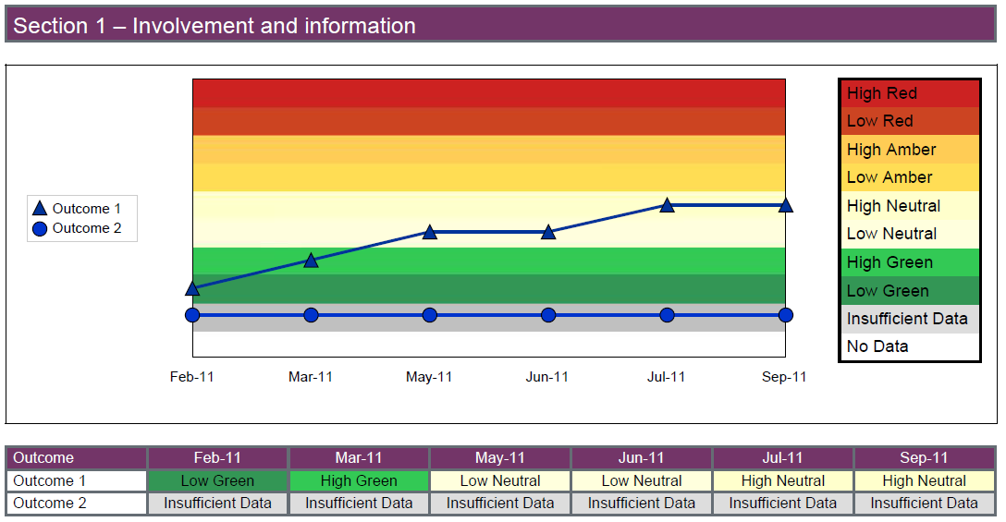

Outcome 1: Respecting and involving people who use services
Outcome 2: Consent to care and treatment

- The decline in the rating for Outcome 1 is due to the inclusion of results of 2010 National Community Survey and some negative results from Mental Health visits.
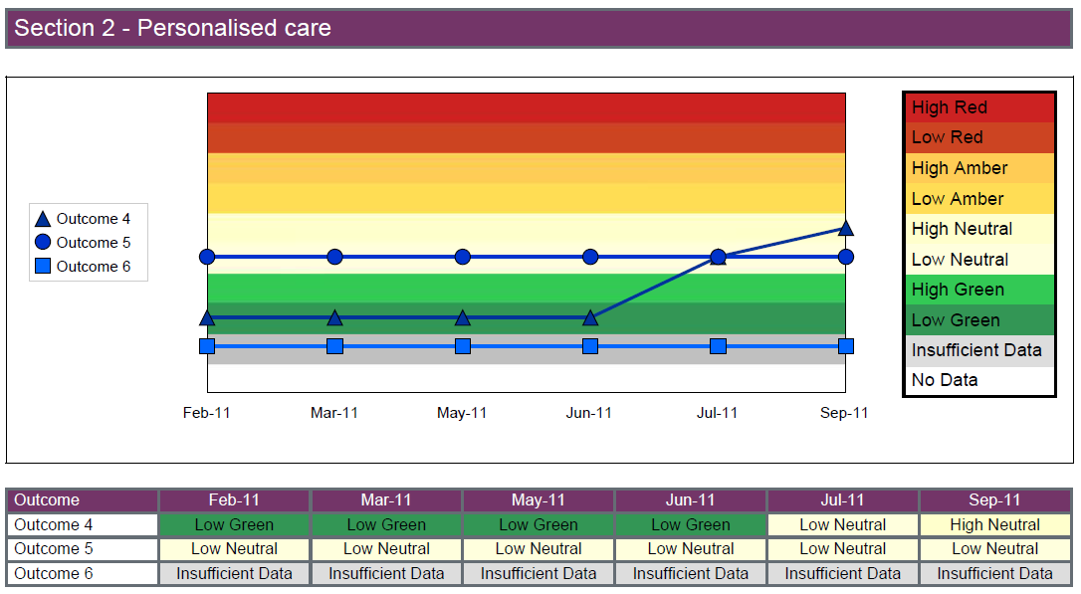

Outcome 4: Care and welfare of people who use services
Outcome 5: Meeting nutritional needs
Outcome 6: Cooperating with other providers

- Outcome 4 has similarly suffered from the results of the 2010 Community Survey
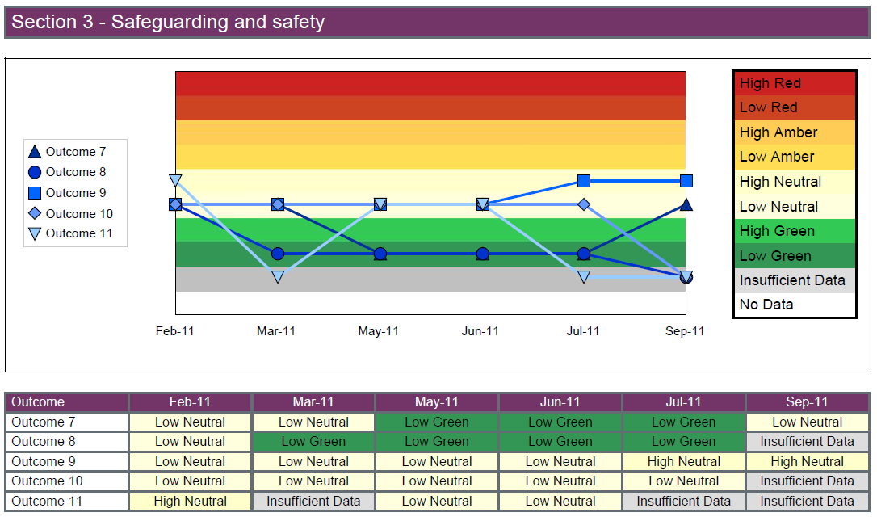

Outcome 7:Safeguarding people who use services from abuse
Outcome 8: Cleanliness and infection Control
Outcome 9: Management of medicines
Outcome 10: Safety and suitability of premises
Outcome 11: Safety, availability and suitability of equipment

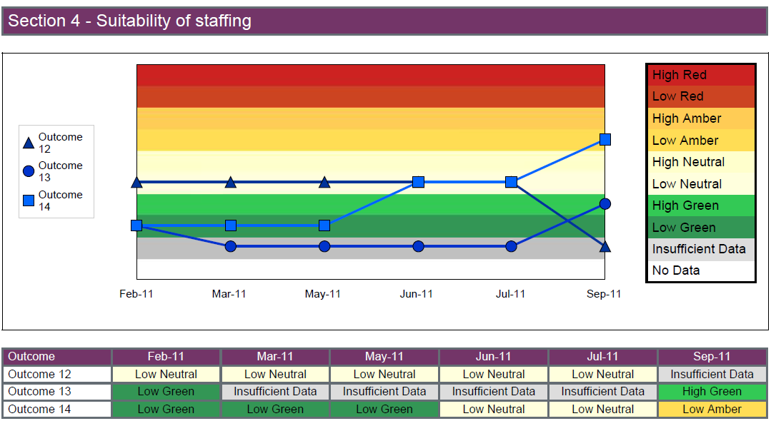

Outcome 12: Requirements relating to Workers
Outcome 13: Staffing
Outcome 14: Supporting staff

- The decline in the grading for Outcome 14 is due to the inclusion of the results of the 2010 National Staff Survey
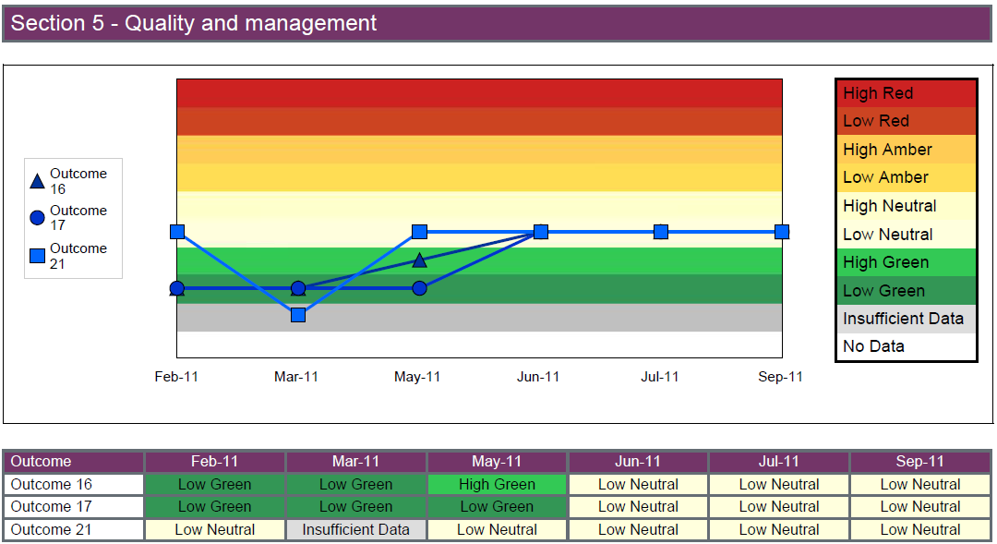

Outcome 16: Assessing and monitoring the quality of service provision
Outcome 17: Complaints
Outcome 21: Records

