

Report to the Meeting of the

Oxford Health NHS Foundation Trust

Council of Governors

For Approval
PAPER
CG17/2016
(Agenda item: 11)

8 June 2016

Procurement of External Audit Services

Introduction

This paper sets out the process for the procurement of External Audit services. It is the responsibility of the Council of Governors to make this appointment based on the recommendations of the Audit Committee. The Audit Committee, informed by the executives of the Finance and Procurement departments, considered the procurement process at the Audit Committee on 20 April 2016, and recommends the procurement process set out in this paper to the Council of Governors for approval.

Background

External Audit services are currently provided by Deloitte. They were appointed on a three year contract from 9 October 2012 to 8 October 2015. In February 2015, the Audit Committee recommended an extension to the contract to October 2017 which was approved by the Council of Governors. This is the maximum possible extension permitted under the contract.

Tender process

It is proposed to follow a similar process to that used in 2012 when Deloitte were appointed. This would involve running a competitive tender process using the Crown Commercial Services national framework (Appendix A).

A draft timetable is at Appendix B. The process would start in April 2017 and conclude in October 2017, and incorporate the following main stages:

- Prepare contract documentation and marketing Apr-May
- External Audit tender process May-Aug
- Approval of External Auditors by 8 Aug
- External Audit mobilisation Aug-Oct

A two month mobilisation period has been built into the timetable. Following the appointment of External Auditors, the appointment process for Internal Audit and Counter Fraud services will commence (to be in place from 1 April 2018).

The procurement process will be led by Peter Smith, Purchasing Manager, and it is proposed that the evaluation panel is comprised of the following:

- Mike McEnaney (Director of Finance)
- Alyson Coates (Chair of Audit Committee)
- two representatives of the Council of Governors (to be confirmed)

Recommendation

The Council of Governors is asked to confirm the approach for the procurement of External Audit services as outlined in this paper, and to nominate two representatives for the Evaluation Panel.

Author and title: Paul Dodd, Deputy Director of Finance
Peter Smith, Purchasing Manager
Lead Executive Director: Mike McEnaney, Director of Finance

Appendix A

National Framework – Crown Commercial Services
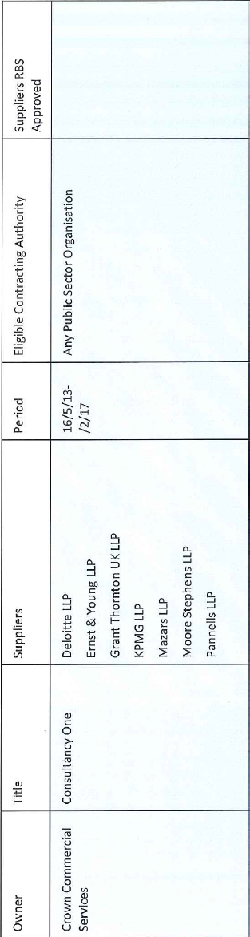
Appendix B

