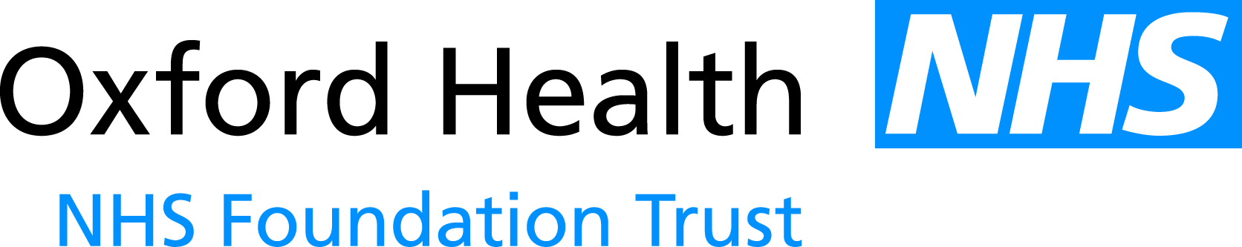

PAPER
CG 35/16

Report to the Meeting of the Council of Governors

2 November 2016

Performance Report to the Board – FY17 Month 6

For: Information

This is the Performance report for Oxford Health NHS FT reporting on Month 6 of FY17.

Executive Summary

12 out of 12 the NHS Improvement indicators have been achieved in September and for Quarter 2.

NHS Improvement published the new Single Oversight Framework on 30 September. The framework is designed to help NHS providers attain and maintain Care Quality Commission ratings of ‘Good’ or ‘Outstanding’. The framework applies from 1 October 2016 and replaces the Monitor ‘Risk Assessment Framework’.

From next month the Performance report to the Board will detail the new Single Oversight Framework indicators.

Recommendation

The Council of Governors is asked to note the report.

Author and Title: Charlotte Hunt, Performance Information Manger

