
INVOLVEMENT..
Involvement Survey
Tell us what you think

PLEASE SHARE YOUR IDEAS!

Please spare a moment to answer a few questions about your views on involvement in Oxford Health NHS FT and help to improve your local mental health services

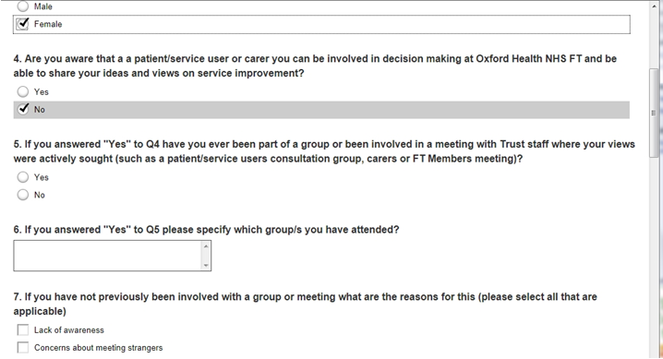
Visit: http://www.surveymonkey.com/s/GRMGD5W

If it’s easier for you please email us and we can send you a hard copy of the questionnaire: enquiries@oxfordhealth.nhs.uk
Developed in collaboration with Oxford Mental Health Forum

