Patient and Carer Involvement in Oxford Health NHS FT mental health services

1. Introduction
Oxford Health NHS FT and Oxford Mental Health Forum are working collaboratively to carry out research into service user and carer involvement. An online survey was devised to find out more about patient and carer views on involvement in Oxford Health NHS FT services. This report details the results of the survey.

The link to the online survey was provided on the Oxford Health NHS FT and Oxford Mental Health Forum websites, and also distributed to Oxford Health NHS FT teams to share with patients and carers and was advertised using social media and via posters in receptions and outpatient departments.

2.1. Demographics

The survey had thirty one responses, of which there were a similar number of patients/service users and carers who completed the survey. There were slightly more carers: 18 in total in comparison to the 13 patients/service users.
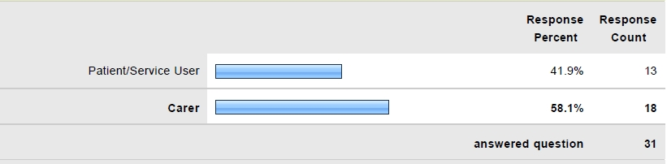
There were 20 respondents in the 18-35 age category, 10 over the age of 65, and one person under 18. The respondents were predominantly female (77%).

2.2. Types of involvement
Approximately half of those surveyed had previously been involved at groups or meetings where patient/service user and carer views were actively sought. These included the Trustwide Service User and Carer Forum, Service User Consultation Group, Information Governance and Caldicott Committee, Acute Care Forum, Carers’ Governors’ Group and Specialist Community Addictions Service (SCAS). Other responses included involvement as a governor, and giving feedback on the trust’s website questionnaires.

2.3. Barriers to involvement

Lack of awareness was the most common reason given for those surveyed who had not previously been involved with a group or meeting (ten out of the eighteen respondents who answered this question; 55.6%), followed by concerns about the commitment involved,
travel/journey time, and the time of the meeting/s not being suitable. Concerns about confidentiality issues and meeting strangers scored much lower.

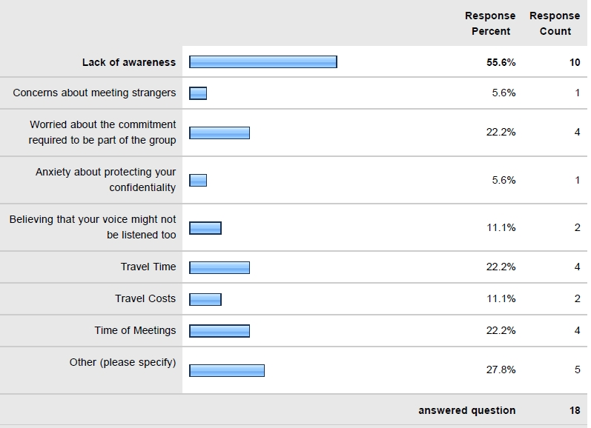

2.4. Level of interest
Nearly all of those surveyed were interested in being involved (90%). For the three respondents who specified that they were not interested, these were due to other commitments, such as family commitments (‘time being taken up with children’); one respondent stated that they were already a governor, and another respondent felt they were too old to be involved.

2.5. Preferences for different types of involvement

The favoured type of involvement was being asked or having the opportunity to provide feedback via email (67.9%), closely followed by attending groups or meetings (60.7%). Around 32% would welcome the opportunity to give feedback via phone. Other responses included receiving a hard copy of questionnaires, and patient/service user and carer involvement in staff training.

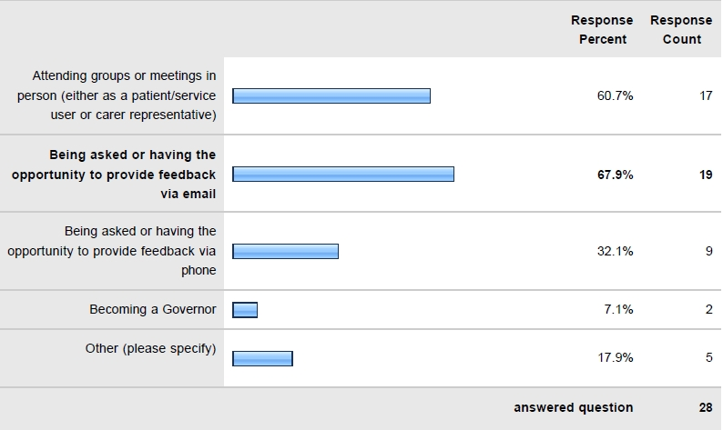

2.6. Motivators to involvement

In an answer to the question on what would encourage you to become involved, there were a range of responses, including: to be actually listened to, not ‘just to be there as part of trust legal obligation’, and ‘to see how others have made changes in the NHS’. The common themes were being listened to and being specifically invited.

2.7. Additional comments

Some comments suggested respondents were unhappy that they felt they were not listened to, that they were unhappy about mental health services provision for patients/service users in general, and what was also concerning was that they felt feedback given was not taken on board. In relation to comments on the subject of involvement, there was evidence of the real benefits that involvement can bring, with comments highlighting its therapeutic power; one service user said they felt it had helped them more than CBT or medication: ‘It is therapeutic and has done me a power of good. More good, for instance, than CBT or perhaps even medication’.

3. Conclusions
Due to the low response rate it is difficult to draw any conclusions that would be fully representative of all the patients/service users and carers who are involved in services provided by Oxford Health NHS Foundation Trust. However, there are some key points and themes that do seem to be evident from this survey:
- The low number of responses would support the responses that state that lack of awareness was raised as one of the main barriers. The Trust needs to look into additional ways of increasing awareness about involvement and promoting the different ways patients/service users and carers are able to be involved. Traditionally this has always been led corporately by the Communications and Involvement Team, but this would suggest that involvement might need to be driven at team and service level and ensure that Trust clinical staff are more actively engaged with the involvement agenda and supporting patients/service users and carers to become involved. The Communications and Involvement Team would still need to have a role in promoting events, but need to consider whether their existing methods of communication are contributing to some of the lack of awareness.
- The Trust does need to be more flexible in terms of planning the time and location of meetings. As these have been led corporately there have been occasions where these have been planned during the working hours and held on Trust sites. The organisation does need to be mindful of the high number of people who either due to work or caring commitments are not able to meet during working hours, and that many patients/service users in particular do not feel comfortable visiting a hospital site for meetings not relating directly to their care.

- More needs to be done to support patients/service users and carers who want to become involved, and to ensure that they do not feel that their involvement is merely the Trust needing to fulfil a statutory duty. Patients/service users and carers who are prepared to give up their time to become involved need to be communicated with throughout the process and made to feel a valued member of any group they are a member of. Papers for meetings need to be sent in a timely manner, and the Chair of the group needs to be available to address any barriers or concerns both in and outside of the meeting forum to ensure that they are fully supported throughout their involvement.
- The feedback does suggest that some promotion of the work that has already been done within the organisation with patient/service user involvement would be beneficial (e.g. case studies on posters and leaflets about involvement). The feedback has suggested that people are unsure as to whether they are listened to, and whether changes will be made as a result of their feedback. The Trust needs to be clear when setting expectations as there will always be some decisions that cannot be reversed, but need to demonstrate their commitment to being able to make some decisions and changes as a result of direct feedback. There are plenty of examples where patient/service user and carer involvement has brought about change and improvement, for example: the style and content of the patient information packs on the inpatient wards, involvement in capital projects design and colour concepts, changes to a reception area in one of the community team bases, and introducing new ways of gathering service user and carer feedback.
- The Trust needs to ensure that there are a variety of different ways for interested parties to become involved, and not rely on existing forums to do this. There are a number of areas that patients/service users and carers could become involved where they are not at present and the organisation needs to consider whether there is any work that could be done to support this.

Oxford Health NHS FT and Oxford Mental Health Forum would like to thank everyone who took part in the survey.

Contact details

Oxford Health NHS Foundation Trust Oxford Mental Health Forum
E-mail: enquiries@oxfordhealth.nhs.uk E-mail: enquiries@oxfordmhf.org.uk
Website: www.oxfordhealth.nhs.uk Website: www.oxfordmhf.org.uk
Appendix: online survey questionnaire

1. Are you answering these questions as a:
Patient/service user
Carer

2. Please indicate your age
Under 18
18-65
Over 65

3. Are you:
Male
Female

4. Are you aware that a a patient/service user or carer you can be involved in decision making at Oxford Health NHS FT and be able to share your ideas and views on service improvement?
Yes
No

5. If you answered "Yes" to Q4 have you ever been part of a group or been involved in a meeting with Trust staff where your views were actively sought (such as a patient/service users consultation group, carers or FT Members meeting)?
Yes
No

6. If you answered "Yes" to Q5 please specify which group/s you have attended?

7. If you have not previously been involved with a group or meeting what are the reasons for this (please select all that are applicable)
Lack of awareness
Concerns about meeting strangers
Worried about the commitment required to be part of the group
Anxiety about protecting your confidentiality
Believing that your voice might not be listened to
Travel time
Travel costs
Time of meetings
Other (please specify)

8. Are you interested in being involved with decision making at Oxford Health NHS FT and sharing your ideas, views and experiences?
Yes
No

9. If you answered "Yes" to Q8 in what ways would you like to be involved (please select all that are applicable)?
Attending groups or meetings in person (either as a patient/service user or carer representative)
Being asked or having the opportunity to provide feedback via email
Being asked or having the opportunity to provide feedback via phone
Becoming a Governor
Other (please specify)

10. If you answered "No" to Q9 and you are not interested in becoming involved what are the reasons for this?

11. What do you think would encourage you to become involved?

12. Do you have any feedback about involvement that you would like to share with us?

