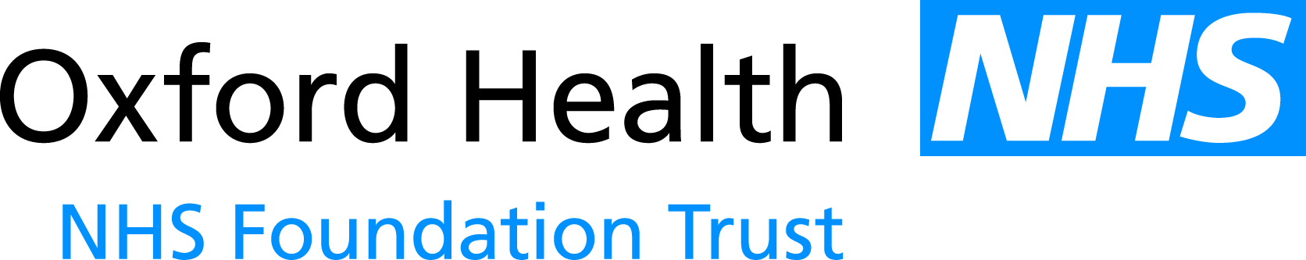

# Report to the Meeting of the Oxford Health NHS Foundation Trust

# Board of Directors

**For Receipt**

BoD 107/2013

(Agenda item: 16)

**25 September 2013**

**Finance and Investment Committee Annual Report 2012/13**

**Executive Summary**

Attached is the Finance and Investment Committee Annual Report covering the period 1 April 2012 to 31 March 2013. The annual report summarises the performance and work programme of the Finance and Investment Committee during the period specified. The annual report was approved by the Finance and Investment Committee at its meeting on 09 September 2013.

As part of reviewing the work of the Finance and Investment Committee, the Terms of Reference have been reviewed but no amendments are proposed at the current point in time. It is noted that a review of the Integrated Governance Framework is currently underway and acknowledged this may result in changes to the role and remit of the Committee in due course.

**Recommendation**

The Board is asked to receive the annual report.

**Author and title:** Lyn Williams, Chair of the Finance and Investment Committee

*A risk assessment has been undertaken around the legal issues that this paper presents and there are no issues that need to be referred to the Trust Solicitors.*