

# PAPER

BOD 63/2013

(Agenda Item: 14)

# Report to the Meeting of the

# Oxford Health NHS Foundation Trust

# Board of Directors

**29 May 2013**

**Research and Development Report**

**For: Information**

This is the first Research and Development (R&D) paper being presented to the Board of Directors. Its primary aim is to provide, for information, an overview of current R&D activity within the Trust and to recommend that further such reports be provided to the Board on a six monthly basis.

**Report**

# Clinical Quality and Care

It is increasingly recognised that participation in research produces widespread benefits for patients and, more generally, improvements in quality of care. Research active clinical services are more likely both to generate and speed access to innovations in health care. The high levels of quality assurance required in research governance and ethical approval procedures can drive up the rigour and quality of routine clinical care. Research often requires cutting edge scientific infrastructure – for example brain imaging facilities - which can also be used for routine clinical care. There is also evidence that more academic clinical organisations are more successful in effectively recruiting and retaining high quality staff. Engagement in R&D activity can increase staff morale, help attract and protect resources and improve the status and profile of a healthcare provider.

# Networks and Collaborations

Although the Trust has been engaged in research activity, especially in the mental health field where it has been rated in this regard in the top three trusts nationally, it is now instituting, alongside its service remodelling, a step-change in its academic activity and profile across all areas of care, including, importantly, physical and integrated healthcare services. In order to do this successfully, effective involvement in networks and collaborations is key.

There have been a number of major NHS initiatives aimed at increasing research productivity and accelerating the adoption and diffusion of innovation into clinical practice including:

* The creation of Academic Health Sciences Networks (AHSN), which followed the publication of *Innovation Health and Wealth*. The Thames Valley AHSN has recently successfully been authorised and the Trust is closely involved in the Network which brings a range of new opportunities.
* The creation of Collaboration for Leadership in Applied Health Research and Care (CLAHRC) centres. The Trust is the lead Trust in an application for an Oxford CLAHRC which has just been submitted.
* The creation of Clinical Research Networks and Academic Health Sciences Centres (AHSC). The Trust has played an important role in the development of the Oxford Academic Health Consortium (OAHC) and, leading on from that, is now a key part of the application for an Oxford AHSC.

All the above collaborations bring benefits to the Trust and offer much potential. They all involve physical and mental health care. Having been involved in some specific direct research activity in the physical health care field (e.g. diabetes, COPD), the Trust’s rapidly increasing links with the Department of Primary Health Care (PHC), University of Oxford, has resulted in proposals for more extensive research in the physical healthcare arena, such as the recent Trust led bid to the NIHR, with the PHC, for a Diagnostic Evidence Cooperative (DEC). The Trust has also just begun hosting the Thames Valley Primary Care Research Partnership.

# Studies and Participant Recruitment

The Trust currently hosts a number of different research studies, from small student projects to complex commercially sponsored clinical trials of investigational medicinal products (CTIMPs).

The table below shows current research activity ongoing within the Trust. The figures are transient due to projects starting and completing at different times.



Key: PIC – Participant identification centre

CTIMP – Clinical Trial of Investigational Medicinal Product

NIHR – National Institute for Health Research

UKCRN – UK Clinical Research Network

CSP – Coordinated System for gaining NHS Permission

The Trust typically hosts between 90 and 100 research studies at any one time, this has been consistent over the past four years. The number of NIHR portfolio adopted studies has increased during this period from 28 in 2008/2009 to 50. Of these studies, the number for which the Trust lead and provide study wide governance assurances for, has increased from 6 in January 2011 to 19 as of March 2013.

The number of participants (patients, carers, staff etc) recruited to studies ongoing within the Trust is a key issue and reasonably consistent at approximately 2000 as shown in the table below:



Key: * because of previous years' inaccuracies this may be higher than actual

** incomplete return

*** return for March 2013 not yet included

e estimate as submitted to the NIHR

One of the metrics that the NIHR is capturing is the time to target for recruitment of study participants. This is shown in the table below



Key: * Some of these studies have only just started the recruitment process

* Some of these studies have been abandoned

# Finances

R&D income derives from a variety of different streams.

## Thames Valley Comprehensive Local Research Network (TV CLRN)

R&D is supported with funding from the TV CLRN. The money is used to support the core R&D team, in particular management and governance functions, specific research nurses and medical input, in addition to service supports costs for key people such as pharmacy support. Money is awarded based on local need and participant recruitment to NIHR portfolio studies during the previous year. In 2011/2012, some named DENDRON posts, where employment contracts are held with Oxford Health NHS FT, were included in the Trust’s TV CLRN allocation.

## Flexibility and Sustainability Funding (FSF) and Research Capability Funding (RCF)

NIHR FSF is allocated to NHS organizations based on NIHR grant funded income during the previous year, in addition to funding for senior investigators. It is intended to support research-active organisations within the NHS, including via attracting, developing and retaining high-quality research, clinical and support staff. In 2012 this was replaced by RCF, with essentially the same purpose, but which now allows NHS organisations to use some of the money to cover overheads. In 2010/2011 for every £1 of NIHR grant received the Trust was awarded 50 pence, this figure has been decreased and now stands at 41p for every £1 of NIHR grant money received the previous year. The money awarded for senior investigators has remained constant at £75,000 per post. The Trust currently has two senior investigators, with a third being transferred. The money is currently being used strategically within the research environment to generate further income from the NIHR grant funded research.

## Department of Health (DoH) Mental Health Initiative

Funding from the DoH to the Trust, in recognition that recruitment to mental health studies was particularly difficult, did occur, however this funding ceased in 2010/2011.

The table below shows a summary of R&D income over the past few years

|  |  |  |  |  |
| --- | --- | --- | --- | --- |
| **Income Source** | **2010/2011** | **2011/2012** | **2012/2013** | **2013/2014** |
| TV CLRN | £626,292 | £624,004 | £648,319 | £705,824* |
| TV CLRN for DeNDRON posts | NA | £182,880 | £186,681 | £196,620** |
| Flexibility and Sustainability Funding (FSF) | £358,788 | £630,644 | NA | NA |
| Research Capability Funding (RCF) | NA | NA | £1,129,625 | £945,441# |
| DoH Mental Health Initiative | £312,297 | NA | NA | NA |

Key: * Anticipated funding as yet to be confirmed. Includes £98,000 for two research nurses previously funding via the TV CLRN to the Primary Care Research Network

** Anticipated funding as yet to be confirmed

# Indicative funding

## Commercial Research Study Income

The table below shows research income generated from commercial studies ongoing within the CRF from September 2011 and December 2012. Income for work undertaken within the CRF from January 2013 to date is invoiced during April 2013.



## Research Study Grant Income

The table below shows Trust income generated from research studies with grant funding:



Key:

* £116,430 of funding withheld until completion of final study report submission and publication

** Initial payment for study preparation and ethics submission

## NIHR Clinical Research Facility (RCF) Funding

In December 2011 the Trust, in partnership with the University of Oxford and Oxford University Hospitals NHS Trust (OUH) submitted an application to the NIHR for CRF funding. The bid was successful with £3.75 million being awarded over the next five years. The money is to support research across the four sites included in the application, the CRF at the Warneford site, Oxford Centre for Anxiety Disorders and Trauma (OXCADAT), Oxford Cognitive Neuropsychology Centre and Charles Wolfson Clinical Neuroscience Facility.

# Estates

The Trust R&D Department, including the CRF, is based at the Warneford hospital site. The CRF is now fully operational and eight research rooms are open for researchers to utilise.

In collaboration with the Department of Psychiatry in the University of Oxford, the Trust is installing an MRI scanner in the Oxford Centre for Human Brain Activity (OHBA) which, in combination with the existing magnetoencephalography (MEG) scanner and the technical and scientific expertise in the FMRIB facility, will give leading edge scientific and clinical imaging capacity on the Warneford site.

# Staffing

## R&D Department

The current Trust R&D organisational structure is shown below. The R&D department encompasses both nursing and medical support for the CRF and a management/governance office to provide assurances that all appropriate checks and documentation are in place prior to NHS permission being granted to undertake a study within the Trust. A Lead Research Nurse Manager will soon commence in post.

## Support Staff

R&D support a number of additional posts, but are not managed by the Head of R&D. These include a clinical trials pharmacist and support, as well as various research nurses across the Trust.

The support funding which accrues from our successful NIHR research programmes has allowed the creation of new clinical academic posts. The first appointment – Dr Matthew Broome, an academic consultant psychiatrist – will join Dr Tony James in the new Highfield Unit in June 2013.

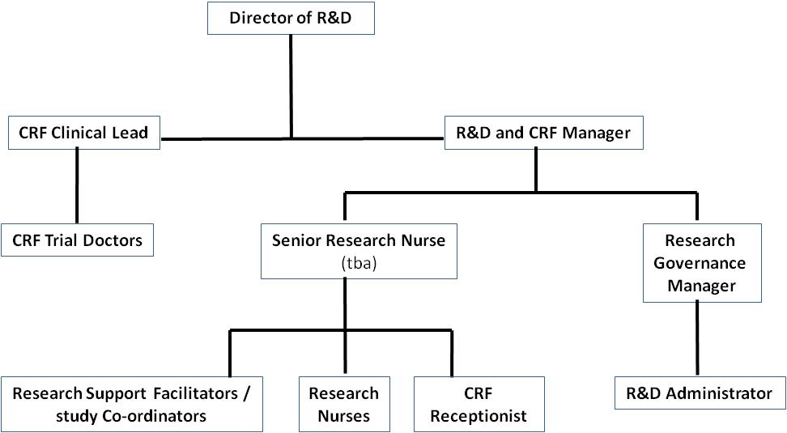

# Official Opening of the CRF

The NIHR Oxford cognitive health Clinical Research Facility was opened in March 2013 by Professor Dame Sally Davies, Chief Medical Officer.

**Conclusion**

Through expanding academic collaboration, the Trust is embarking upon a step change in its R&D activity and profile. The planned increases in grant income and patient recruitment into research studies will be helped by evolving IT support. The enhanced R&D activity aligns strategically with the aspirations of the Trust and with the current service remodeling. Most importantly, it will benefit patient care.

**Recommendation**

It is recommended that further such R&D reports be provided to the Board of Directors on a six monthly basis. Any comment regarding future content or emphasis would be welcomed.

**Author and Title:** Professor John Geddes, Emma Stratful & Dr Clive Meux

**Lead Executive Director:** Dr Clive Meux

[ Drafting Note: The following statements must be attached to every report. ]

1. *A risk assessment has been undertaken around the legal issues that this paper presents and there are no issues that need to be referred to the Trust Solicitors.*
2. *This paper (including all appendices) has been assessed against the Freedom of Information Act and the following applies: [delete as appropriate]*

* *THIS PAPER MAY BE PUBLISHED UNDER FOI*
* *THIS PAPER, IN ITS ENTIRETY, MUST NOT BE PUBLISHED UNDER FOI AND THE FOLLOWING EXEMPTION(S) APPLY:*
  + [*Section 21*](http://www.legislation.gov.uk/ukpga/2000/36/section/21)*: Information accessible to public by other means*
  + [*Section 22*](http://www.legislation.gov.uk/ukpga/2000/36/section/22)*: Information intended for future publication*
  + [*Section 33*](http://www.legislation.gov.uk/ukpga/2000/36/section/33)*: Audit functions*
  + [*Section 36*](http://www.legislation.gov.uk/ukpga/2000/36/section/36)*: Prejudice to effective conduct of public affairs*
  + [*Section 38*](http://www.legislation.gov.uk/ukpga/2000/36/section/38)*: Health and safety*
  + [*Section 40*](http://www.legislation.gov.uk/ukpga/2000/36/section/40)*: Personal information*
  + [*Section 41*](http://www.legislation.gov.uk/ukpga/2000/36/section/41)*: Information provided in confidence*
  + [*Section 42*](http://www.legislation.gov.uk/ukpga/2000/36/section/42)*: Legal professional privilege*
  + [*Section 43*](http://www.legislation.gov.uk/ukpga/2000/36/section/43)*: Commercial interests*
* *SECTIONS MARKED IN THIS PAPER MUST NOT BE PUBLISHED UNDER FOI AND THE FOLLOWING EXEMPTION(S) APPLY:*
  + [*Section 21*](http://www.legislation.gov.uk/ukpga/2000/36/section/21)*: Information accessible to public by other means*
  + [*Section 22*](http://www.legislation.gov.uk/ukpga/2000/36/section/22)*: Information intended for future publication*
  + [*Section 33*](http://www.legislation.gov.uk/ukpga/2000/36/section/33)*: Audit functions*
  + [*Section 36*](http://www.legislation.gov.uk/ukpga/2000/36/section/36)*: Prejudice to effective conduct of public affairs*
  + [*Section 38*](http://www.legislation.gov.uk/ukpga/2000/36/section/38)*: Health and safety*
  + [*Section 40*](http://www.legislation.gov.uk/ukpga/2000/36/section/40)*: Personal information*
  + [*Section 41*](http://www.legislation.gov.uk/ukpga/2000/36/section/41)*: Information provided in confidence*
  + [*Section 42*](http://www.legislation.gov.uk/ukpga/2000/36/section/42)*: Legal professional privilege*
  + [*Section 43*](http://www.legislation.gov.uk/ukpga/2000/36/section/43)*: Commercial interests*

1. *This paper provides assurance and evidence against the Care Quality Commission Outcome: [Input Outcome number – ie 7]*