PAPER
BOD 71/2013

Report to the Meeting of the

Oxford Health NHS Foundation Trust

Board of Directors

26 June 2013

Quarterly Safety Report

For Information

This report outlines quality priorities and exceptions in relation to Patient Safety for Quarter 4 2012/13. It is the sixth report with this format which will change in the next Quarter to reflect greater detail within each care pathway. It draws on reports on incidents that have been submitted to the Integrated Governance Committee and Safety Committee. The areas covered are:

- Measurement of harm
Patterns of Reported Incidents
The implementation of the National Safety Thermometer

- Investigation and learning
Serious Incidents Requiring Investigation

- Safety Improvement and reducing harm
Safer Care Collaborative

The Safer Care Collaborative work streams have developed baselines and will commence reporting data in the Q1 2013/4 Safety Report.

- Infection Prevention and Control

- CQC Compliance & Inspections
Recommendation
The Board is asked to note the report.

Author and Title: Gavin Garman, Head of Nursing, Specialised Services; Helen Bosley, Infection Prevention and Control Matron; Jill Addis, Safer Care Lead, Consultant Nurse and Jeanette Wilding, Community Health Division Head of Governance and Clinical Standards.

Lead Executive Director: Ros Alstead, Director of Nursing and Clinical Standards

- A risk assessment has been undertaken around the legal issues that this paper presents and there are no issues that need to be referred to the Trust Solicitors.
- This paper provides assurance and evidence against the Care Quality Commission Outcome: 4.7.8.9.10.16

- Measurement of incidents and harm

Patterns of reported Incidents

Total Number of Incidents

There were a total of 2613 incidents reported in quarter four and 9881 for the whole year, a mean of 2470 per quarter (7302 incidents were reported in the whole of 2011/12, a mean of 1825 per quarter).

Total Number of Incidents by Quarter

Q1 2012/13 | Q2 2012/13 | Q3 2012/13 | Q4 2012/13
2226 | 2529 | 2513 | 2613

Incidents by Risk Rating for the last 4 quarters

The number of incidents graded as orange and red by staff remains stable. The steady increase in green and yellow rated incidents has plateaued, this is hampered by the large number of ungraded incidents awaiting sign off by managers. The number of these incidents in ‘web holding’ has risen. Health and Safety advisers remind managers and reports have been sent fortnightly to senior managers and divisional directors. This has become one of the Quality Performance indicators reviewed in the Quarterly performance Reviews with Divisions.

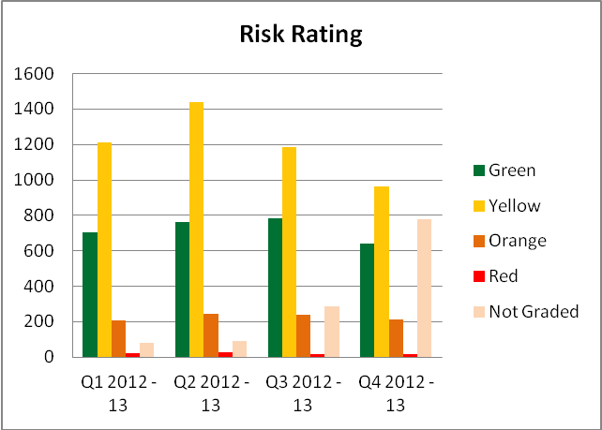

Progress against Safer Care targets

In 2009, we set a target of increasing the number of less serious (green and yellow) incidents we reported by 50% by March of 2012. It is expected that a Trust with a good safety culture will report high levels of low level incidents and work to learn from incidents and reduce the number of serious incidents. In 2009/10 5981 incidents were reported. In 2012/13 there were 9069, so the target increase has now been achieved.

Top 6 Categories of Incidents by Month over the last 4 quarters

The chart below shows reporting numbers for the main categories of incident over the last 15 months. The types of incident broadly show normal cause variation over the months.
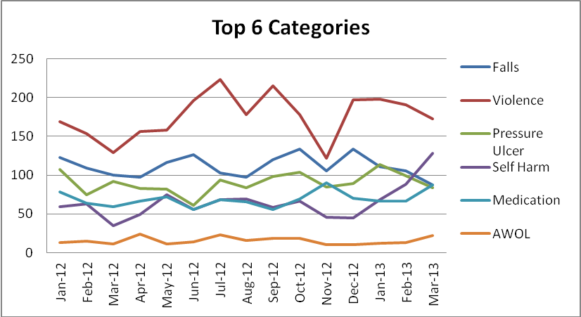

*Falls include all fall incident patient and staff

Violent incidents continue to be the highest reported category. Wards in the mental health division remain the highest reporters. Changes in the number of incidents on wards are usually due to the presence of individual patients who account for a large number of incidents. Patterns are examined in detail within each service and at the Integrated Governance Committee. More detail on incidents using physical restraint and seclusion is given below.

The number of reported falls has fallen since a peak in December. It is too early to identify whether this is due to improvement in practice or normal cause variation.

An increase in reported incidents of self -harm is reported this quarter, which has increased each month since December 2013. This is showing special cause variation where it is relating to individual patients who have exceptional clinical needs. The areas with the largest increase have been Portland and Ashurst wards, which account for most of this increase. The increase in Ashurst Ward was mainly accounted for by one patient who self-harmed 38 times, which is 84% of the Ashurst’s self-harm incidents in total for Q4. This patient is on a highly individualized care package with intensive staffing. The increase on Portland Ward was due to incidents from 13 patients, four of whom had 5 or more self-harm incidents in March alone. The interaction between patients has been the focus for clinical management by the ward team and complex needs service.

High Reporting Areas for the top categories of incidents for Quarter 4 2012/13

Type of Incident | Highest Reporter | Second Highest | Third Highest
Falls Q4 | Cherwell Ward | Harding | Linfoot Ward
 | 28 | 27 | 24
Falls Q3 | Abingdon Ward 2 | St Leonard's Ward Wallingford) | Linfoot Ward
 | 40 | 39 | 33
Violence Q4 | Ashurst | Kestrel Ward | Highfield (Oxon)
 | 61 | 46 | 42
Violence Q3 | Ashurst | Highfield (Oxon) | Kestrel Ward
 | 68 | 52 | 38
Self Harm Q4 | Portland | Ashurst | Kestrel Ward
 | 49 | 45 | 26
Self Harm Q3 | Kestrel | Highfield (Oxon)/Portland | Ashurst
 | 28 | 27 | 12
Medication Q4 | Bullingdon | Portland Ward | Ashurst
 | 15 | 14 | 10
Medication Q3 | Bullingdon | Kimmeridge | Wintle Ward
 | 19 | 12 | 11
AWOL Q4 | Phoenix | Kimmeridge | Wintle Ward
 | 8 | 7 | 6
AWOL Q3 | Mandalay House | Kimmeridge | Chaffron Ward
 | 12 | 5 | 4

Cherwell and Harding older adult mental health wards are the highest reporters of falls this quarter, partly due to community hospitals reporting fewer falls. Out of the 28 falls reported on Cherwell ward this quarter, 50% of them were accounted for by 2 patients. A number of these falls appear to have occurred in patients recovering from physical problems and mobilising when still unwell.

In assessing the care of these patients, expected processes appear to be in place, such as blood pressure monitoring, the use of MeWs, falls risk assessments on admission, falls/mobility care plans, physiotherapy involvement, use of hip protectors, regular reviews of medication, the use of regularly assessed levels of observations, appropriate use of low profile beds, using mattresses placed on the floor and a daily review of bed use. Individual patient factors cannot prevent all falls.

Falls reduction forms one of the safer care work streams. Older adult services are holding workshops on falls in May and June to present data from falls research, to develop guidelines and to feed information in to the safer care collaborative. Service user and carer information on falls will also be prepared, with the input of service users.

The table below indicates the highest reporting areas for incidents for the whole year rather than by quarter.

High Reporting Areas for the top categories of incidents for the year 2012/13

Type of Incident | Highest Reporter | Second Highest | Third Highest
Falls | Abingdon Ward 2 | Linfoot Warf | Sandford Ward
 | 118 | 117 | 104
Violence | Ashurst | Highfield (Oxon) | Kestrel Ward
 | 281 | 197 | 162
Self Harm | Kestrel Ward | Portland | Ashurst
 | 153 | 96 | 93
Medication | Bullingdon | Kimmeridge | Portland
 | 84 | 40 | 30
AWOL | Phoenix | Mandalay | Wintle Ward
 | 32 | 25 | 20

These demonstrate familiar patterns. The wards reporting most violent incidents have been the same all year. Ashurst is our 13 bedded psychiatric intensive care Unit and admits acutely ill people requiring intensive care and treatment. Highfield Oxford admits acutely unwell young people from across 5 counties two wards for women patients report most self-harm. This will be a focus for harm reduction starting in women’s forensic wards. Bullingdon Prison has featured as the highest reporter of medication related incidents which have been discussed in previous reports. The Trust is no longer providing the primary health care service to Bullingdon, as this was taken over by Virgin Health Care on the 1st April. We do however still provide the pharmacy service in the prison until September 2013, so some medication related incidents may continue to feature.

Pressure Ulcers

There were 6 pressure ulcer SIRI’s reported during Q4. Over the year, 17.5% of all grade 3 and 4 pressure ulcers that developed within Oxfordshire Community Health Division were deemed as avoidable and 82.5% unavoidable. The overall number of reported grade 3 and 4 pressure ulcers has been higher when compared with previous years.

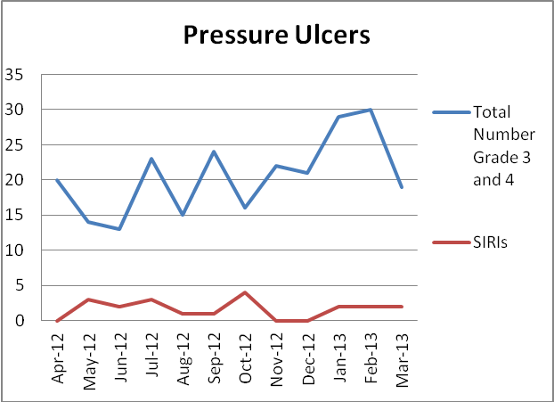

There were 131 IIRs requested relating to pressure damage between April 2012 and March 2013. 103 IIRs were requested for pressure ulcers grade 3 and 4 in 2011/12, and 112 pressure in the 2010/11.

Recurrent themes throughout the year have found a lack of a holistic assessment, timeliness of assessments/re-assessments, poor standard of documentation and communication between services. In a high percentage of SIRI’s equipment is a factor, either in non-provision or inappropriate prescribing of equipment. It has been requested as an action from an investigation that clinicians have more guidance on how to decide which mattress to prescribe. Attendance at training on equipment has been low.
A comprehensive Pressure ulcer prevention Action Plan has been agreed with OCCG and the safer Care work focusses on reliability of care processes in line with best practice as well as implementing PDSAs on small cycle improvements from clinical teams

Actions include:
• All patients to have a lower limb assessment when presenting with wounds in this area
• Staff to ensure that all relevant documentation and risk assessments are carried out during the initial assessment and then repeated thereafter at regular intervals
• That all pressure damage is treated holistically, with causes identified & documented
• Relevant clinical staff working in Community Health Division to attend pressure damage prevention and management training and equipment training. Levels of attendance will be reported in future learning and Development Reports.

Integrated working with Oxford University Hospital has been encouraged and includes:
- Exploring linking our education programmes so there is increased flexibility with more venues and more episodes of training
- Linking formularies together so patients have parity of service and clinical staff has the same understanding about what wound dressings the patient requires.
- The discharge procedure from secondary care to primary and vice versa is being reviewed - this will focus on joint communications systems and to improve the patient journey.
- Re-evaluating the risk tools in use in each trust to see if the same tool can be established as there is confusion as to what level of risk a patient is and there is poor understanding to the numerical weighting given to a patient on handover.

Number of Absent Without Leave incidents per month

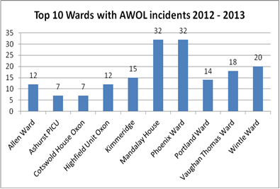

Mandalay and Phoenix are the highest reporters for the year. Mandalay are lower reporters in quarter 4 but high in previous quarters. The Integrated Governance Committee has received a more detailed report on the individual wards to understand the issues and actions being taken to reduce the number of patients leaving wards without permission.

The time that missing patients are reported to have left wards appears to have three peaks in the day – at 11.00am-12pm, 3.00-500pm and 9.00-11.00pm. This may well be due to the timings of leave, with patients due back to the ward at these times and failing to return.

53% of absent without leave incidents this quarter involved male patients and 47% females (a usual pattern).

10 patients were reported awol more than once this quarter, involving seven different wards (all from the mental health division or CAMHS).

A small number of informal patients are also reported missing, if there are concerns for their welfare. The numbers each month are shown below.

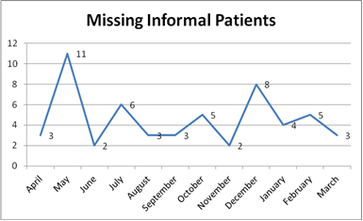

This includes reports from Marlborough House Wiltshire (3), Cotswold House Oxon (2) and Oxfordshire Crisis service (2). Community hospitals have also reported missing patients, but low numbers 1.e. Wantage (1).

The Trust is participating in the South of England Safety Collaborative, aimed at improving safety in mental health and community services. One of the work streams in that project will be focus on reducing AWOL and related harm. The mental health division has the detailed breakdown of awol incidents and is discussing rates and strategies for reduction n at team level. Mandalay is an open rehabilitation ward with less immediate controls over awols as the purpose of longer term rehabilitation is to offer individuals often who are detained under the Mental health Act the opportunity to have greater freedoms as part of an agreed care plan.

Violence and Aggression

Our trust is required to return annual Violence Against Staff (VAS) figures to NHS Protect. There is a strict definition of what constitutes VAS. The figures indicate that the total number of physical assaults for the year 2012/13 was 277, for all of which, a medical condition was deemed as a contributing factor. 31 of these were reported to the police. (More than 31 incidents may have been reported to the police, but only 31 of the incidents that meet the VAS definition were passed on.)

Restraint and Seclusion.

A recent update has been submitted to the IGC on physical restraint and seclusion of patients. There were 391reported incidents of physical restraint in quarter four. There are two main categories of restraint, planned and responsive restraint. Totals for the previous three quarters were 278, 426 and 276. The total for the year was therefore 1371 with a mean of 114 per month. The graph below shows that the number of reported incidents increased gradually until August before falling for three months and then steadily climbing again for the last four months. It is likely this is normal cause variation however each clinical team reviews the use of restraint examining the rationale for and levels of use of restraint which is an intervention which is used as a last resort when other interventions have not been effective. The standard to offer patients the opportunity to record their experience of restraint in the patient record is being inconsistently applied across wards. This is working well in one of the female forensic wards.

Number of restraints by month

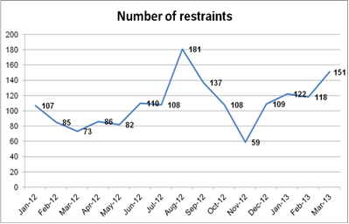

The gender of restrained patients has been a consistent finding with around 65% involving female patients. In quarter four this was higher with 75% of restraints involving female patients.

A special cause variation in this quarter reported an unusually high number of patients were restrained four times. In each of the previous three quarters, there were 16-19 such patients. In quarter 4 this rose to 30. These issues are examined in detail at clinical team level

Reduction in use and type of restraint will be included in the Safer Care work once the work on reducing the number of missing patients from wards is underway.

Restraints by Ward

All mental health wards reported some restraints over the year, though some had very low numbers (e.g. 2) and some had quarters with no restraints at all (e.g. Lambourn House, Harding and Chaffron). The number of restraints on the remaining wards ranged from 1 to 74 in a quarter (see charts below for number of restraints for the ten wards reporting most incidents).

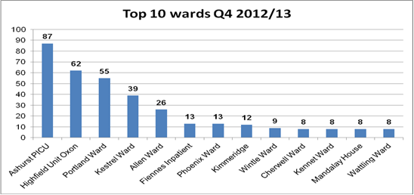
The three wards with the highest number of restraints have usually been Highfield, Ashurst and Kestrel. Portland have however reported more than Kestrel in the last quarter. The high reporters, as would be expected, are linked to the presence of individual patients who required multiple restraints (corresponding to the table of individual patient restraints above). Linfoot Ward in the community division unusually reported one restraint of an aggressive male patient in March.

The number of incident forms detailing the level of restraint has been steadily climbing from 61% to 86% in previous reports.

The number of incident forms detailing the position of restraint has also been steadily climbing in previous reports from 61% to 85%.

Use of Seclusion

The total number of reported seclusions in Quarter 4 was 35, compared to 44, 57 and 46 in previous quarters. The mean per month for the year of 2012 was 17.5. Numbers appear to have changed a little, with a steady fall since their peak in January.2012.
Seclusion is an intervention used only when other interventions have not been effective and there is an imminent risk to the individual or others if no intervention is made.

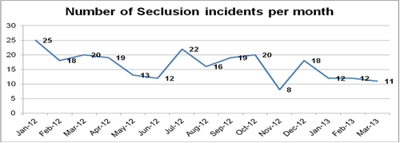

The highest reporting ward has consistently been Ashurst, but this quarter Kennet and Kestrel had an equivalent number of incidents.

On 26.05.13, the CQC carried out a themed visit to forensic wards at Oxford Clinic and other forensic wards at Littlemore Hospital to look at our practice of seclusion. Issues raised in the subsequent report were the immediate attendance of duty doctors to seclusion out of hours (Drs attend but not within 20 minutes) the lack of a central seclusion recording system – (records are kept in individual patient records but not on a central log), access for ward staff to reports summarising use of seclusion, the ability for patients to make a record of their experience of an incident on Rio,( this is in place routinely in one ward and not in others) updating of seclusion care plans, the transfer of female patients to a male ward for seclusion and the handover of patients between consultants. The full report was received in early June and our formal response is being prepared.

The Implementation of the Safety Thermometer

In March the Trust repeated the audits and made submission by the required date
for those teams involved in the programme to date and to provide the end of year position for all services included in the audit.

Our Trust is meeting the CQUIN requirements to date

Results are available via the national information centre website www.ic.nhs.uk/services/nhs-safety-thermometer through the viewer tool. Teams are able to access their results and how these progress over time and how they compare to other teams across the trust.

The audit results for Oxford Health compared to previous reported trend and at year end is as follows:
 | Harm (%)
Location | Harm Free |  | All  PU’s |  | New  PU’s |  | Falls with Harm |  | Catheter  /UTI |  | Catheter/  new UTI |  | New  VTE |  | All Harm |  | New  harm |  | VTE risk assess.
National position | 92.49  (92.25) |  | 5.32  (5.57) |  | 1.27  (1.23) |  | 0.91  (0.99) |  | 0.96  (0.97) |  | 0.45  (0.45) |  | 0.62  (0.70) |  | 7.51  (7.64) |  | 3.19  (3.25)
Trust overall | 90.70  (90.51) |  | 7.02  (9.30) |  | 2.20  (1.94) |  | 1.27  (1.47) |  | 1.18  (1.11) |  | 0.85  (0.83) |  | 0.17  (0.09) |  | 9.30  (9.49) |  | 4.40  (4.15) |  | 97.5%
Community  Hospitals  203 | 92.12  (90.31) |  | 5.91  (10.27) |  | 0  (1.02) |  | 0  0 |  | 1.97  (3.06) |  | 1.48  (3.06) |  | 0 |  | 7.88  (9.69) |  | 1.48  (4.08) |  | 86.2%
 | 190 |  | 12 |  | 0 |  | 0 |  | 4 |  | 3 |  | 0 |  | 16 |  | 3
Older Adult  In-patients  83 | 91.57  (92.41) |  | 2.41  (2.56) |  | 0 |  | 1.2  (2.53) |  | 2.41  (1.27) |  | 2.41  (1.27) |  | 2.41  (1.27) |  | 8.43  (7.59) |  | 6.02  (3.08) |  | 98.8%
 | 76 |  | 2 |  | 0 |  | 1 |  | 2 |  | 2 |  | 2 |  | 7 |  | 5
Community  Nursing  701 | 89.02  (89.58) |  | 8.99  (11.03) |  | 3.71  (2.68) |  | 1.57  (1.55) |  | 0.86  (0.56) |  | 0.71  (0.28) |  | 0 |  | 10.98  (10.42) |  | 5.85  (4.37) |  | N/A
 | 624 |  | 63 |  | 26 |  | 11 |  | 6 |  | 5 |  |  |  | 77 |  | 41
Older Adult  CMHT  75 | 96.0  (95.56) |  | 1.33  (1.22) |  | 0  0 |  | 1.33  (3.33) |  | 1.33  (1.11) |  | 0 |  | 0 |  | 4.0  (4.44) |  | 1.33  (3.33) |  | N/A
 | 72 |  | 1 |  |  |  | 1 |  | 1 |  |  |  |  |  | 3 |  | 1
Specialist Nursing  30 | 93.33  (100) |  | 3.33  (6.25) |  | 0  (6.25) |  | 3.33  0 |  | 0 |  | 0 |  | 0 |  | 6.67  (12.50) |  | 3.33  (12.50) |  | N/A
 | 28 |  | 1 |  |  |  | 1 |  |  |  |  |  |  |  | 2 |  | 1
Community  Nursing  Mixed  14 | 92.86  (75.0) |  | 7.14  (15.0) |  | 0 |  | 0 |  | 7.14  (15.0) |  | 0  (10.0) |  | 0 |  | 7.14  (25.0) |  | 0  (10.0) |  | N/A
 | 13 |  | 1 |  |  |  |  |  |  |  |  |  |  |  | 1 |  | 0
Physio  7 | 100  (86.69) |  | 0 |  | 0 |  | 0 |  | 0 |  | 0 |  | 0 |  | 0  (13.33) |  | 0 |  | N/A
 | 13
Rehab  70 | 94.29  (93.41) |  | 4.29  (5.49) |  | 0  (2.20) |  | 1.43  (1.10) |  | 0 |  | 0 |  | 0 |  | 5.71  (6.59) |  | 1.43  (3.30) |  | N/A
 | 66 |  | 3 |  |  |  | 1 |  |  |  |  |  |  |  | 4 |  | 1
( ) = previous result. Actual numbers have been included to give clearer perspective.
VTE risk assessment compliance this month remained the same at 97.51% completed across the Trust; however community hospitals result was 86.2%. The notable changes in previous performance included:

Positive improvement:
- All pressure ulcers across the trust reduced to 7.02% from 9.30%
- Community hospitals saw improvement in all pressure ulcers, all harm and new harms
- Older adult in-patients saw improvement in falls with harm
- Community nursing, specialist nursing and community nursing mixed saw improvement in all pressure ulcers
- Older adult CMHT’s results improved for new harm and falls with harm
- Specialist nursing saw improvement in all harm and new harm as did community nursing mixed
- Physiotherapy achieved 100% harm free care from previous result of 86.6%
- Rehabilitation saw a reduction in new harm
Negative change in results:
- Older adult in-patients new VTE increased to 2.41% and 2 patients had a VTE and this impacted on an increase in new harm.
- Community nursing saw a reduction in harm free care to 89% which was as a result of new pressure ulcers (2.68% increased to 3.71%).
- Specialist nursing also saw a reduction in harm free care form 100% to 93.33%.
Work continues to be undertaken with these services to ensure the variation is not due to interpretation of the audit criterion and definitions, especially for the teams recently commencing use of the audit. The CQUIN target of a 50% improvement in all pressure ulcers has been confirmed by the commissioners.

The Trust has included the harm categories that form the safety thermometer audit in the safer care programme physical health care work streams.

- Investigation of Safety Incidents and Learning

Serious Incidents Requiring Investigation (SIRIs)

Total Number of SIRIs by the last 4 quarters

The table below shows the total number of red SIRIs by quarter. This quarter has seen the number of SIRIs increasing again to a similar number as seen in Q2 2012/3.

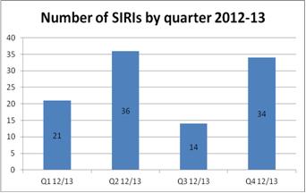

There have been two cases of possible homicide in quarter 4. One patient has recently been formally charged, following a long delay. In one case the RCA has been undertaken and demonstrated good care from the clinical team. In the other case the patient has been bailed and is it unclear what if any role they may have played in the death. We are waiting for further information before proceeding with further investigation in this case.

There were 3 incidents in Q4 that although not identified as SIRIs were still serious incidents that merited further investigation and for which 2 had RCA investigations requested and 1 a record review.
- 1 was a cluster of 4 unexpected deaths by natural causes in the community
- 1 was an alleged incident of indecent exposure by a male community patient
- One was damage to property by a patient referred by Out of Hours service to the Warneford for a MHA assessment.

Apparent suicides by quarter for the last 8 quarters

The chart below shows apparent suicides. This report calculates its numbers of suicides on the basis of deaths that appear likely to have been suicides on the basis of the information available. These figures have been adjusted after a review of all possible suicides over the last two years, reconciling incident data against information from legal services on coroner’s verdicts. This has resulted in a change in previously reported numbers. Some incidents have moved quarter or indeed year, adjusting the overall figures for this and last year (see table below). The trend indicates an overall rise in the apparent suicide rate over this three year period but not a consistent month by month trend. The 2012/13 total shows a rise of one death over the previous year 2011/12. This is in keeping with national trends; the National Confidential Inquiry reports a similar increase in suicides nationally over the same period.

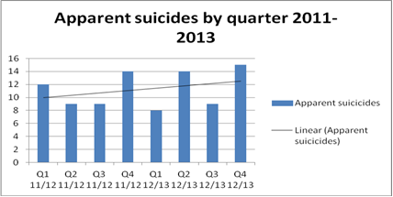

The Quality account retains the Safer Care target of reducing community suicides towards zero and having no inpatient suicides this year.

Community and In-Patient Suicides by year

The possible inpatient suicide noted in 2012/13 was the case of a man who went missing as an informal patient from a ward in Oxford whilst on planned leave. However it seems likely that he died a short time after leaving the ward so has been identified in figures as an inpatient suicide, The Coroners Verdict regarding Cause of Death is still pending so this classification is provisional.

 | Inpatient | Community
2009/10 | 1 | 24
2010/11 | 1 | 36
2011/12 | 0 | 44
2012/13 | ?1 | 45

Location of SIRIs by Division

The mental health division has had the greatest number of SIRIs over the year. The majority of these are apparent community suicides. Particular peaks in SIRIs are notable in Q 2 and 4 of this year in three of the Divisions. The Specialised Division has seen an increase in SIRIs in both Q 3 and 4.

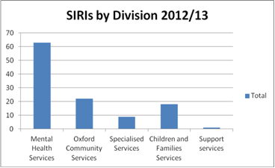

- An update on the Safer Care Programme

Summary of progress since last report

- Return visit to Devon Partnership NHS Trust completed and relationships established to share good practice in crisis teams and wards.

- Successful visit to Community Acute Services (Oxon and Bucks ) from NHS Institute for Innovation and Improvement by Kate Jones, Interim Director and Professor Tony Butterworth, Chairperson March 20th 2013. Visit report appeared in the final NHS Institute report.

- The Suicide Prevention Project commenced 7th January. This is a collaborative involving all 8 organisations providing NHS Mental health services in the former South Central SHA working together to benchmark and make recommendations to prevent suicide and improve practice and education.

- South of England Safety Collaborative commenced in Basingstoke on 26th and 27th March with learning Session 1. Our Collaborative’s aims and project plan agreed. Project areas are being identified. The second learning session took place on June 10th and 11th.

- Baseline cultural survey commenced (IHI Devon adapted version) with Mental Health Division. Sample to include Safer Care Project Teams and random selection of divisional teams. Survey available in both e-version or paper format and anonymised.

- Oxford Health Safety Conference took place May 15th 2013. Chaired by Ros Alstead. Speakers included Stuart Bell, Pete McGrane, Professor Hawton, Professor Vincent and Professor Llewelyn, plus six clinician-led workshops. Conference was over-subscribed and feedback has been excellent.

- PICU HDA Safer Care Review has engaged Positive Options for discussion about piloting enhanced training in verbal skills and de-celeration approaches.

- CAS Safer care Project is a finalist in the HSJ Patient Safety Awards. Presentation to judges in London 24th May 2013. Crisis Services have achieved 372 days between deaths since last death by suicide or narrative verdict.

- Patient safety pages should go live on the intranet in this quarter.

- A Board Seminar on the Safer Care work Programme took place in May.

- Infection Prevention and Control
There is a programme of mandatory Infection control training in place in accordance with our trusts learning and development training matrix. Target attendance is set at 100%. Overall the number of staff trained has increased from 73% in quarter 2 to 79% in quarter 3.

Training | Q4 2012/13  % trained
Clinical High risk staff groups | 90%
Clinical Medium risk staff groups | 90%
Non clinical medium risk staff groups | 83%
New starters induction | 72%
Infection Control Workbook Clinical –high risk (Refresh Annually) | 73%
Infection Control Workbook Clinical- medium risk (Refresh Annually) | 80%
Infection Control Workbook Non Clinical (Refresh Annually) | 75%
Infection Control Workbook Non Clinical (Refresh Two Yearly) | 81%

Hand Hygiene Audits

Average for March 2013 within Mental Health wards = 95%
Average for December 2012 for Community Hospitals = 99%

Environmental Infection prevention and control audits
Wards and departments are visited on an unannounced basis by the Infection Prevention and Control Team. An infection prevention and control audit is carried out using a national tool. The pass mark is set at 85%.

During Quarter 4 a total of 13 of the 14 audits were re-audits following an overall score of <85% on self-assessment. All areas re-audited met the set pass mark and they will continue to be monitored as per the annual audit work programme.

- Shrublands Day Hospital will not achieve a pass of above 85% without the provision of a cleaners cupboard -funding has been agreed.

- Harlow House – concerns noted regarding the cleaning contract this is being addressed. A further assessment is planned regarding refurbishment.

- CASH services- concerns noted regarding the cleaning contract. The environment of these services needs to be refurbished, and this is reflected in the score. This has been put forward in the Capital Works programme as a priority.

Overall average compliance for Quarter 3 was 91% across the Trust, compared to 86% and 77% in the previous two quarters.

Outbreaks

Location | Dates | Management | Cause | No. of cases
Townlands | 6.1.2013 - 14.1.13 | Ward remained open to admissions with affected patients nursed in designated cohort bay with restrictions in place | Suspected norovirus | 5 patients  1 staff
Wallingford | 6.1.2013- 11.1.13 | Ward remained open to admissions with affected patients nursed in designated cohort bay with restrictions in place | Suspected norovirus | 9 patients 1 staff
City | 17.2.13- 23.3.13 | Ward remained open to admissions with affected patients nursed in designated cohort bay with restrictions in place | Confirmed norovirus | 9 patients  14 staff
Wenrisc ward, Witney | 21.2.2013- 6.3.13 | Ward remained open to admissions with affected patients nursed in designated cohort bay with restrictions in place | Viral respiratory illness | 18 patients 6 staff

3 outbreaks of diarrhoea and vomiting in Q4, 1 confirmed norovirus.
1 outbreak of a viral respiratory illness, not influenza

C. difficile

The total number of cases to date last year in community hospitals was 10 against an end of year target of 10, therefore this was achieved.
This target contributes to the overall health economy target. Further reduction in numbers remains extremely challenging. There have been no cases of CDI in mental health wards in Q4.

There were two cases of CDI in April previously reported to the Board.

There was one case of Clostridium difficile infection (CDI) in community hospitals in May.
This case occurred on City ward (19.5.13), however the patient was admitted from the Oxford University Hospitals on 17.5.13 and was tested for CDI before the fourth day of admission and therefore according the DH allocation falls outside our numbers into the CCG’s. A full RCA was however completed.

There have been no further cases in June to date. The revised proposal for the CDI target has been discussed with Oxfordshire CCG and a revised proposal is awaited for agreement by the Executive.

MRSA Bacteraemia and MSSA Bacteraemia – no cases

Group A Streptococcal infection

There has been 1 patient with invasive group A Streptococcal infection who was admitted to Stoke Mandeville hospital from Cromwell ward. An investigation is in progress but the patient had recently been discharged from Wycombe hospital following insertion of a pacemaker.

- CQC Visits/ Inspections
An announced visit took place to forensic wards in the Oxford Clinic and Littlemore site the draft report has been made available. The full report will be available to the public once it has been released by the CQC. Practice recommendations are identified in an earlier section of this report.

