PAPER
BOD 84/2013
(Agenda Item 7)

Report to the Meeting of the

Oxford Health NHS Foundation Trust

Board of Directors

31st July 2013

Quality and Safety Report

For Information

This Quality and Safety report has a focus on Clinical Effectiveness over the period of Q1 2013/4.

It covers:
- Consent to care and treatment
- Essential standards of care including clinical audits
- Medicines management
- CQC Inspection of Oxford Clinic
- MIND report on Restraint
- The Keogh Report on the Quality of care and treatment provided by 14 hospitals in England.
- Performance of PPST
- Performance of PDRs

The Integrated Governance Committee and Division Performance Reviews are being used to review and focus on improvement in poorly performing clinical audits
The level of PDR’s is 72% showing some signs of improvement. This part of the year is when most PDRs are scheduled to take place and some may not yet be recorded as having taken place on the system. Drill down to services where performance is dipping will be picked up through the Operational Management.

Recommendation

The Board is asked to note the report.

Author and Title: Sue Haynes Head of Nursing for Adults of Working Age; Helen Bosley, Infection Prevention and Control Matron; and Jeanette Wilding, Community Health Division Head of Governance and Clinical Standards.

Lead Executive Director: Ros Alstead, Director of Nursing and Clinical Standards

- A risk assessment has been undertaken around the legal issues that this paper presents and there are no issues that need to be referred to the Trust Solicitors.

- This paper (including all appendices) has been assessed against the Freedom of Information Act and the following applies:
- THIS PAPER MAY BE PUBLISHED UNDER FOI

- This paper provides assurance and evidence against the Care Quality Commission Outcome: 2, 4, 9, and 16.

- Clinical Effectiveness Report – Q 1

The Clinical Effectiveness Quality Improvement Committee (CEC) is responsible for four CQC outcomes:
- Outcome 2, Consent to your care and treatment
- Outcome 4, Care and welfare of people who use services
- Outcome 9, Management of medicines
- Outcome 16, Assessing the monitoring the quality of service provision

Detailed below are some of the areas that the CEC has been working on to provide assurance regarding CQC compliance. A summary of the status on each outcome and detailed assurance reports for each outcome are reviewed at each CEC meeting.

- Outcome 2: Consent to your care and treatment

The application of the Mental Health Act in acute in-patient services.

A report on Mental Health Act detention was reviewed. The increased number of detained patients was noted particularly in relation to the increasing trend of people attending informally and then being detained.

In response CEC has appointed a sub group to undertake an email exercise looking at the 10 standards for adult inpatient mental healthcare as detailed in the publication the Royal College of Psychiatrists standards (OP79 – Do the Right Thing).

- Outcome 4: Care and welfare of people who use services
  - Audit Programme – Community Division

Audit programme progress
The audit programme for 2013-14 has been agreed, with two outstanding queries requiring confirmation from commissioners. There are 48 confirmed audits on the audit programme. Of these 31 are confirmed Trust-wide, national or contract audits; there may be a further two Hospital at Home contract audits as above.

At the end of Q1, as anticipated, only one audit report has been received, the first bimonthly audit on Hand Hygiene in Community Hospitals.

  - Audit programme 2012-13

5 audits from the 2012-13 schedule have not yet been completed, or fully reported, these are have been followed up:

- Falls & Bone Health – Community Hospitals – awaiting report from the Corporate Audit Team as it was a cross-Divisional audit.
- Documentation – Urgent Care – to be completed 2013-14
- Documentation – Community Therapy - to be completed 2013-14
- Documentation – Continuing Care - to be completed 2013-14
- Supervision - awaiting report from the Corporate Audit Team as it was a cross-Divisional audit.

There are two further audits that were not undertaken and have been moved to the 2013-14 schedule.

  - Clinical Audit ratings

Below is a summary of the Trust wide clinical audit results approved by CEC in July 013. Of the seven audits rated, four were rated as satisfactory and three as poor. The committee has requested that action plans are developed within the relevant divisions and confirmation recived at the next CE meeting. Action plans have been developed within the Mental Health Division for; Participation in Child protection conferences, POMH-UK 12a and POMH-UK Topic 2f. Clinical Directors attending ICT are expected to respond to poor/satisfactory with clear action plans for improvement. The Chairman as Chair of IGC has clearly stated significant improvements against audit standards is required. For audits with poor or satisfactory ratings re-audits will be carried out. The Executives will also discuss poor audit results in detail at performance meetings.

Audit Name | Rating by Clinical Audit Committee
Medicines management- Quality of Prescription Chart | Requires improvement
Medicines Management- Safe and Secure Handling of Medicine | Requires improvement
Staff Supervision Survey | Poor
Audit of pressure ulcers and MEWS | Poor
Health records | Good
Nutrition Screening | Poor
Violence and Aggression | Satisfactory
Medical Devices Audit | Satisfactory
Trust Wide CPA Audit Q4 | Satisfactory
Medicines management- Controlled Drugs Audit | Poor

- CPA – Care Programme Approach (Community Mental Health) Board Metrics

CPA Compliance is made up of 4 components. Forensic services only collect data on the care coordinator component as data on the other 3 components is collected as part of the Essential Standards audit.

The CPA audit results have shown an increase in the first four domains and have remained stable at 98% for the fourth domain (care coordinator identified). The results for quarter 1 2012-13 are outlined in the table below.

Board Metrics – Indicator 44 | Quarter 3 Results | Quarter 4 Results
Components
Current CPA care plan completed <12 months old | 179/225 (80%) | 200/232 (86%)
Care plan been reviewed in past 6 months | 155/225 (69%) | 173/232 (75%)
Current risk assessment <12 months old | 185/225 (82%) | 199/232 (86%)
Care coordinator identified | 246/251 (98%) | 228/232 (98%)

- Outcome 9: Management of medicines

Medicines Management and Training
The Medication Management Annual Report was approved at the IGC. Audit has highlighted that the biggest risk to medication management presently, is in relation to training. An e-learning package is being launched over in Q2.

- Outcome 16: Assessing and monitoring the quality of service provision

Trust Position against CQC Outcomes
Patient Experience
The table below outlines the results to the 4 Trust wide core questions both from postal surveys and electronic surveys. The results show a substantial increase in response rate from patients in June 2013, which is largely due to the start of the postal survey programme, which in total received 644 responses in June 2013.

 |  | Were you involved as much as you wanted to be in decisions about your care and treatment?  (Yes definitely and Yes some extent/ sometimes) | Do you feel you have trust and confidence in the service and/or your key clinician/worker?  (Yes definitely and Yes some extent/ sometimes) | How much information about your condition and treatment has been given to you?  (right amount) | Overall how would you rate  the care you have received?  (good and excellent)
April 2013 | Overall | 55/67 = 82.1% | 55/66 = 83.3% | 34/66 = 51.5% | 44/65 = 68%
May 2013 | Overall | 44/54 = 81% | 42/54 = 77.6% | 30/54 = 56% | 29/53 = 50%
June 2013 | Overall | 637/685= 93% | 673/693=97% | 545/689=79% | 623/694 = 90%

- Essential Standards of Care (Mental Health in Patients)

The essential standards audit is completed by each modern matron in all mental health areas on a bi-monthly basis. The results are reported by ward area and the modern matrons (together with ward managers) complete an action plan against each of the areas which have been identified for improvement. The table below outlines the results of the essential standards audit for March and May 2103, together with previously reported results for November 12 and January 2013.

As seen, the main areas for improvement highlighted over the past four months, relate to:
- consent,
- patient involvement in care planning
- risk assessment and care plans being up to date.

Each modern matron is ensuring that these areas for improvement are communicated to ward staff and are monitoring the required interventions against the agreed action plans for each area.

 | Key = |  | Excellent = 100% |  |  |  | Good = 90-99% |  | Fair = 75%-89% |  |  |  | Poor = <74%
Orientation |  |  |  |  |  |  |  |  |  | Nov 12 |  | Jan  13 |  | Mar 13 |  | May  13
Patient information given out on admission to the ward (n=74) |  |  |  |  |  |  |  |  |  | 88% |  | 89% |  | 88% |  | 89%
Patients state that they have been orientated to the ward and are aware of ward routine including rights and restrictions (n=78) |  |  |  |  |  |  |  |  |  | 92% |  | 91% |  | 89% |  | 94%
Physical Health
Patient has received a physical health assessment |  |  |  |  |  |  |  |  |  | 85% |  | 92% |  | 94% |  | 91%
completed within 24 hours of admission (n=92)
Patients physical health needs are being considered and identified in care plan (n=95) |  |  |  |  |  |  |  |  |  | 90% |  | 94% |  | 83% |  | 79%
Patient has been screened for VTE within 24 hours of admission (n=83) |  |  |  |  |  |  |  |  |  | 83% |  | 90% |  | 93% |  | 86%
Capacity and Consent
Is it documented the patients capacity has been assessed/ reviewed either at or since the last ward round? (n=89) |  |  |  |  |  |  |  |  |  | 45% |  | 54% |  | 62% |  | 51%
Is it documented consent to treatment/medication has been discussed with the patient either at or since the last ward round(n=86) |  |  |  |  |  |  |  |  |  | 59% |  | 67% |  | 77% |  | 71%
Care Planning
Evidence of Family / Carer / Next of Kin involvement in care as appropriate (n=88) |  |  |  |  |  |  |  |  |  | 94% |  | 87% |  | 83% |  | 92%
Patient reports being involved in care planning (n=83) |  |  |  |  |  |  |  |  |  | 58% |  | 73% |  | 84% |  | 73%
Care plan is up to date and relevant to the current needs of the patient (n=95) |  |  |  |  |  |  |  |  |  | 75% |  | 79% |  | 81% |  | 79%
Does the patient have a "knowing me form" completed as part of assessment process (OA only) (n=14) |  |  |  |  |  |  |  |  |  | 36% |  | 80% |  | 63% |  | 50%
Risk Assessment
Risk assessment AND management plan are up to date and relevant to current needs of the patient (n=95) |  |  |  |  |  |  |  |  |  | 78% |  | 82% |  | 86% |  | 74%
Current level of risk highlighted through patient status at a glance/ safety board (excludes Forensics) (n=70) |  |  |  |  |  |  |  |  |  | 92% |  | 97% |  | 93% |  | 97%
Safety
Patients report they feel staff have done everything they can to make them feel safe on the ward? (n=89) |  |  |  |  |  |  |  |  |  | 86% |  | 88% |  | 91% |  | 92%
Medication (separated into 2 questions from Jan 13)
Do the patients recall ever being told why they are taking medication? (n=83) |  |  |  |  |  |  |  |  |  | 85% |  | 86%  82% |  | 95% |  | 93%
Do they know what the side effects are? (n=77) |  |  |  |  |  |  |  |  |  |  |  |  |  | 72% |  | 83%
Communication
Patients report that they are spending individual time with staff on a regular basis (n=88) |  |  |  |  |  |  |  |  |  | 72% |  | 84% |  | 82% |  | 88%
Evidence of one to one meetings with patients are clearly documented in the nursing notes (n=95) |  |  |  |  |  |  |  |  |  | 76% |  | 90% |  | 83% |  | 91%
Patients are able to state who their key nurse is (n=84) |  |  |  |  |  |  |  |  |  |  |  |  |  | 78% |  | 79%

- Activity Follow Results - Wenric Ward Littlemore Hospital

Attached below, are the activity Follow totalisers from Wenric for May 2013. The direct care times are high, 59% for an RMN and 72% for an HCA; however the contributions from Wenric in the form of observations and directions for improvement should be noted. This page is displayed openly in the nursing office for all the team to see, and the narrative serves as a reminder when improvement are needed and also praises the team for their achievements. This evidences the benefit of activity follows: Productive Care is all about continuous improvement, reducing waste and innovative thinking, and this is clearly evidenced in the information provided by the Wenric team.

- CQC Inspection of Oxford Clinic – Littlemore Hospital

This inspection report was carried out in April by the CQC. It was an unannounced themed inspection on the use of seclusion and ran alongside a Mental Health Act Inspection. It focussed predominantly on Kennet ward however the inspection applies to all wards on the site including all the forensic medium and low secure wards and the open forensic ward Lambourn House and two adult mental health wards Ashurst (PICU) and Phoenix. The report highlighted many aspects of good care in respect of the use of seclusion as well as notifying two minor compliance concerns which have already been addressed.
The full report can be found at CQC or our link to it.
The inspection examined three standards
9.1 Standard 7 - Safeguarding people from abuse
Was found to be fully compliant. The inspection report highlighted staff understood safeguarding practice and were well trained. It also highlighted that health care assistants protect patients from the use of excessive or unlawful force and applied their training to practice.

With regards to the other two standards there were many aspects that were compliant however two minor concerns were highlighted.

9.2 Standard 10 - Safety and suitability of premises
The compliance action was in respect of an unlocked refuse area on the Littlemore site away from the wards which has since been secured and a process for monitoring this put in place.
The narrative also highlighted that one room in Kennet on the day of inspection had objects in it that were lying around and were a safety risk this was rectified immediately. There was also a concern about the window handle in this communal room.

9.3 Standard 21 - Records.
Inspectors found that recording of seclusion was held in the patient record. However it was not easy to pull off a list of patients who have been subject to seclusion. The Minor concern arose from a small number of patients who did had additional care plans stored in a different part of the RIO record as they had lengthy complex care plans. As such it was felt this was a potential risk as not all care workers would be aware of these plans that were not in the care planning sections. This was put right immediately and all care plans are now only in the care planning section.

Given the current focus on the NHS and most recently on Buckinghamshire Hospitals the Littlemore inspection report has attracted considerable interest from the local media.

The process for briefing MPs will be strengthened prior to publication of CQC reports in future.

9.4 The concurrent Mental Health Act monitoring inspection of Littlemore Mental Health Centre made a number of recommendations and the Trust has taken action to address them. The particular areas of concern raised were:

- Immediacy of medical review when seclusion is initiated
- Quality of seclusion records on RiO and analysis of seclusion information
- Seclusion policy accurately quoting the Code of Practice
- Consistency of recording of patient perspective post-disturbed behaviour incidents
- Review of care plans post-incident
- Staff attitude to seclusion
- Environmental issues on Kennet relating to noise reduction and Wenric relating to seclusion room
- Transfer of female patient to seclusion room in male ward
- Review of consent documentation for patients transferred to new responsible clinician

- MIND Report on Restraint

This Report was published by MIND on 19th June. The campaigning report uses FOI information from 2011/12 from mental health NHS Trusts and draws a comparison between Trusts which record the use face down restraint to a greater extent than others.

The report highlights significant variation in the recording and use of restraint generally between organisations. From 42,000 physical restraints there were 1,000 injuries incurred in 2011/12. The report showed since 2000 there have been 13 restraint related deaths of patients detailed under the Mental Health Act. Oxford Health NHS FT is not directly referred to in the report although one service user vignette features a service user who was restrained as an inpatient in Oxford and had an adverse experience ten years ago. It uses the FOI information which for Oxford Health NHS FT included the use of all types of restraint and particularly prone restraint from all mental health inpatients wards across Oxfordshire Buckinghamshire, CAMHS and forensic and other specialty wards. The report used these figures for all services and set this as a rate using only the adult population of Oxfordshire as the denominator. Not surprisingly this placed Oxford Health as a high reporter for using this type of restraint per head of population as this is incorrectly calculated within the report. We will be discussing the accuracy of this information with MIND.

Our desire to understand then reduce the use of restraint and seclusion lies behind the encouragement of reporting and measurement. We are also setting expectations for every service user to record their experience of restraint and seclusion. There is variability in this at present. One of the Safer Care strands of work is to minimise the use of restraint and seclusion and increase the safety of such physical interventions. Two wards have already commenced this work and we will are seeking to review and probably replace our current training to prevent and manage violence. Progress on this work stream will be reported in the coming months. A timescale of completing the review within the next four months has been set.

The MIND report also surveyed 375 frontline healthcare staff 22% reported not having training within 12 months, this is our standard and we achieve in excess of 80%. MIND reported four in ten staff saying they thought that restraint was sometimes used inappropriately. In our recent CQC inspection staff informed inspectors that they were felt their training helped them manage the risk of violence and they conveyed an understanding of the need and risks associated with physical interventions.

- Review into the quality of care and treatment provided by 14 hospital trusts in England:
An overview report
Professor Sir Bruce Keogh’s report of 14 hospitals that had safety and quality concerns including persistently high Mortality Rates and concerns about the quality of care was published on 19th July. These hospitals have had difficulties over a lengthy period and have not been improving.
There are a number of interesting facets of the report all of which are relevant to all NHS organisations aspiring to be safe and reliable for every patient. This report and some of the quality indicators within it will be used to examine our performance and it is proposed to be part of a Quality Seminar in the near future.
The methodology used patients, carers, nurses and doctors, AHPs and managers working in teams to undertake two day site visits. A similar model will be adopted by the new Chief Inspector for the CQC.
The Trusts selected which included FTs had been outliers for the last two years for two consecutive years using standard mortality ratios.
The methodology gathered hard and soft information which was tested out by a visiting team of patient, carers, nurses, doctors, AHPs and managers in 15-20 multidisciplinary review teams. The review gained insight on the insight gained listening to patients carers staff, the public and commissioners and MPs transaction a cultural assessment as well as a technical assessment.

Common themes and barriers were identified which are highly relevant to the wider NHS

- The importance of genuinely listening to the views of patients acres staff and engaging them in improving services
- The importance of embedding early warning system and have clinical escalation procedures for deteriorating high risk patients in particular at weekends and out of hours
- There is a link between well engaged staff and mortality rates
- Capability of hospital boards and their leadership to use data to drive quality improvement. More needs to be done to equip boards with the necessary skills to grip the quality agenda
- The complexity of using and interpreting aggregate measures of quality
- Some hospital trusts are operating in geographical, professional or academic isolation, this can lead to difficulties recruiting high quality staff and a overreliance on agency and locums
- The lack of value and support being given to front line staff particularly junior Drs and nurses their constant interaction with patients and their naturally creative tendencies make them the best champions for patients and their energy musty not be sapped.
- The imbalance existing around the use of transparency for the purpose of accountability and blame rather than support and improvement. Some Boards use data for reassurances rather than the forensic, sometimes uncomfortable pursuit of improvement

- SKINtelligence Network

This Clinical network has been set up by the Thames Valley HEIC and comprises of nurses and AHPs working in acute and community provider organisations within the Thames Valley including Oxford Health NHSFT, OUH, Oxford Brookes University, Berkshire Acute and Community providers and nurses working in residential care and nursing homes and in general practice. The ambition of this clinical network is to reduce avoidable skin breakdown suffered by patients across the system.

An audit of patients in residential care looked at pressure tissue damage and other risks was completed, led by Sarah Gardner and colleagues from the company 3M included just over 40% of residential homes. This highlighted a gap in prevention practice, a lack of standardisation of risk tools, and gaps in training and knowledge and confidence in using the right interventions and techniques. The network is seeking funds to ensure that there is standardisation in tools, improve access to advice, and increase the use of SOPs and evidence based pathways and improvements to training. There is potential to influence and prevent pressure tissue damage at an early stage and this will reduce the number of cases that DN are involved with through the care home support service and on caseloads, as early intervention and the right interventions would be applied in a timely way.

- Infection Prevention and Control Update Report – June 2013

Community health services
There was one case of Clostridium difficile infection (CDI) in community hospitals in June.
This case occurred at Bicester community hospital (26.6.13), however the patient was admitted from the JR on 22.5.13 and was tested for CDI before the fourth day of admission and therefore according the DH allocation falls outside our numbers into the CCG’s. A full RCA was however completed.

We remain on 2 cases so far this year. The target for 2013/14 has been agreed at 8 cases. We have also agreed across the health economy to conduct a post infection review of all CDI cases with a view to identifying if any can be removed from our official numbers. A set of criteria has been agreed and all cases across Oxfordshire will be reviewed monthly by Oxford Health, Oxford University hospitals and commissioners. The first meeting has taken place.

There has been an E.Coli bacteraemia identified (1.7.2013) in a patient on Linfoot ward at Witney. This infection requires mandatory reporting and a full RCA is underway.

Mental health services
There have been no CDI cases in June 2013.

Outbreaks
There have been no outbreaks in community or mental health wards.

There have been no MRSA or MSSA bacteraemias in either community or mental health services.

Appendix 1
Patient & Personal Safety Training (PPST) – Trust by Division

Trust performance – Qtr1 June 2013
The Trust has replaced Statutory and Mandatory training with a new training framework called Patient & Personal Safety Training (PPST). PPST is designed to enhance patient safety and ensure safe working practices. There are 3 categories of risk for the training subject areas which broadly reflect the former ‘statutory’, ‘mandatory’ and ‘individual nominated’ groups.
PPST Level 1 – Target 100%
Overall improvement of 8 percentage points
PPST Level 2 – Target 85%
Overall improvement of 4 percentage points to 94% of Target
PPST Level 3 (Individual nominated) – Target 100%
Overall improvement of 19 percentage points

Patient & Personal Safety Training (PPST) – Action Plan
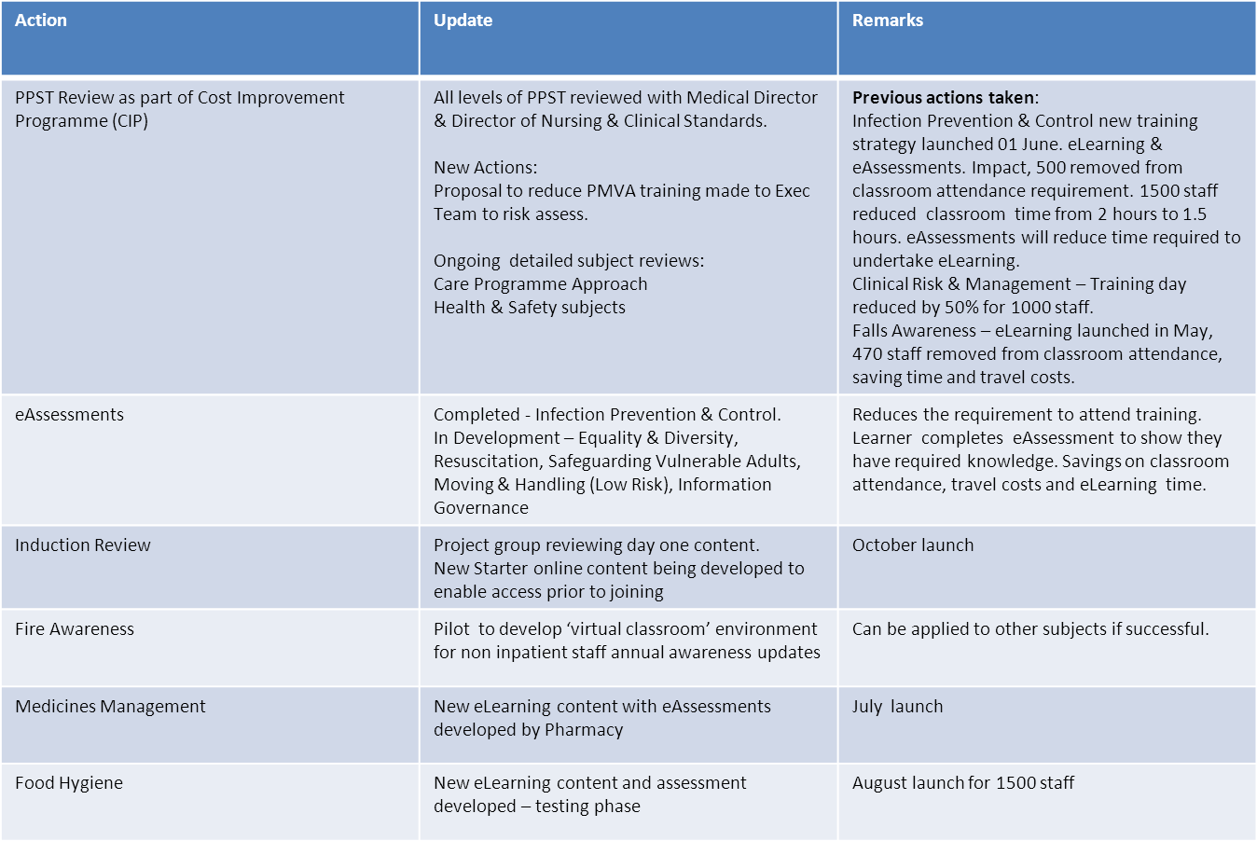

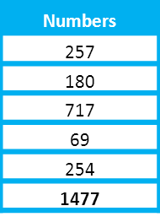
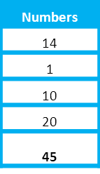
Performance & Development Reviews (PDRs)
Position at end of Qtr 1 June 2013
PDR cycle - April to June
Medical Staff & Dentists have annual appraisal reviews and are outside the PDR cycle
Target 100% - Position at 9thJuly showing improvement at 72%
Target 100% - Position at 9th July showing improvement at 74%
Actions taken
- Ongoing monthly report reminders to individuals and line managers. Intranet announcements to urge PDR completion.
- Update to Divisional Directors meeting and HR QIC to emphasise the need for performance improvement.
- PDR project initiated to cover new requirements from Agenda for Change which may require move from 3 month PDR cycle.

