PAPER
BOD 03/2014
(Agenda Item: 5)

Report to the Meeting of the

Oxford Health NHS Foundation Trust

Board of Directors

Board Meeting

29 January 2014

Chief Operating Officer’s Report

.
For Information

This month’s report provides the Board with an update on:
- Winter pressures
- Emergency Multi-disciplinary Unit developments
- District Nursing
- Service Remodelling and Service Developments
- Aston Team Working

Recommendations

The Board is asked to note the report.

Lead Executive Director: Yvonne Taylor, Chief Operating Officer

- WINTER PRESSURES

Oxfordshire was awarded £10.2m winter pressures monies this year to help address significant additional urgent care demand (specifically in A&E attendances and non-elective medical admissions, particularly for older people).

This has been allocated across NHS and Social Care in Oxfordshire aligned to a plan of increased capacity at different parts of the urgent care pathway to smooth patient flow, and drive transformational change across the system to achieve sustainable delivery.

For Oxford Health Foundation Trust, monies have focused on additional community hospital beds (8 rising to 12 from January), district nursing capacity to deliver flu vaccinations to house bound patients, additional therapy capacity to enable 7/7 working and increased rapid (same day) response, additional capacity to enable end of life fast track (part of continuing health care) to provide weekend service and additional capacity in the Single Point of Access to support discharge from acute settings.

The Trust is on track in its delivery of all of its KPIs relating to these winter monies. Staff have worked very hard to maximise use of bed-based and home care capacity to maintain patient flow during the periods of peak demand (late December to date).

However, as a system we did not achieve the 95% against the 4 hour A&E access standard for Q3 (94.1%) and delayed transfers of care have remained static at circa 150. This performance to date reflects the commencement date of some winter schemes across organisations, which have come on line during December as additional staff are in place (winter funding confirmed in October).

All NHS and Social Care organisations met on 17th January to review progress to date and to agree immediate actions to accelerate improved patient flow through the urgent care pathway. One of the most significant of these affecting Oxford Health NHS Foundation Trust is the approach to tackling patient choice delays for patients in an acute bed awaiting a community hospital bed.

Currently patients can exert choice in which community hospital they transfer to, and given the geographic spread of community hospitals beds in this county, this means that there are circa 10-20 patients remaining in an acute bed when they are ready for rehabilitation or post-acute care in a community hospital.

Although bed occupancy in community hospitals is high (average 90% year to date), this means that at time of peak patient demand patients can be delayed in A&E awaiting an acute bed whilst community beds are not being used to their maximum. This is a poor experience of care for all patients affected.

This Trust has always offered following transfer to a community hospital bed for patients who have agreed to a less local bed to be moved to their local community hospital as soon as a bed becomes available. Oxfordshire County Council have an agreement that a one off individual payment via a personal budget payment can be made where the cost of visiting a relative who has been transferred to a non-local community hospital and where transport costs, form a major objection to a transfer out of acute care.

Oxfordshire has a choice policy (approved by this Board in 2013) but in legal terms choice does not apply for transfer from one NHS bed to another. We are awaiting confirmation that Oxfordshire CCG it requires OUH and OHFT to comply with the national requirements for patient choice, and thus remove choice of community hospital for patients no longer requiring an acute bed. The Board will be updated in February along with any amendment required to the Oxfordshire Choice Policy.

- EMERGENCY MULTI-DISCIPLINARY UNIT DEVELOPMENTS

Witney EMU fully opened on 6th January, following the induction of all medical and clinical staff. There have been a good number of referrals from all areas of the community – SCAS, GP practices across the locality, outpatients and MIU within the community hospital. There is some further review to take place on the types of referrals being sent through to insure that the EMU capability is utilised appropriately for the patients.

During its first two weeks of operation referrals have risen daily from 3 to circa 9 (9 is a comparable figure for the average daily attendance at Abingdon EMU). Currently the EMU is operating 10-6pm Monday to Friday – recruitment is underway to enable 7/7 opening by April.

The decor of the facility meets the new evidence for dementia-friendly environment design (King's Fund), and has been influenced by patients and carers through a recent joint workshop with Age UK.

The greatest risk to sustainable delivery of the EMU lies in ongoing successful medical recruitment. Currently the general market for capable medical staff across both primary care and acute (EMU straddling both) is very difficult. Focused advertising and recruitment is ongoing.

The Trust is also working in partnership with the OUH and OCC to further develop our ambulatory care pathway for older people with complex co-morbidities attending EAU and A&E at the John Radcliffe and Horton Hospitals. This joint work aims to embed the clinical and patient experience principles developed in Abingdon EMU into these existing cross-organisational ambulatory care pathways.

- District Nursing
This service continues to be under pressure, caused primarily by the gap between demand and funded (block) capacity, which is averaging 19% per month for the number of home visits undertaken. This figure does not reflect the time pressures within home visits caused both by the increasing complexity and instability of patient presentations and pressure to reduce time per visit to achieve the all visits required each day. The increasing activity profile is shown in the diagram below:

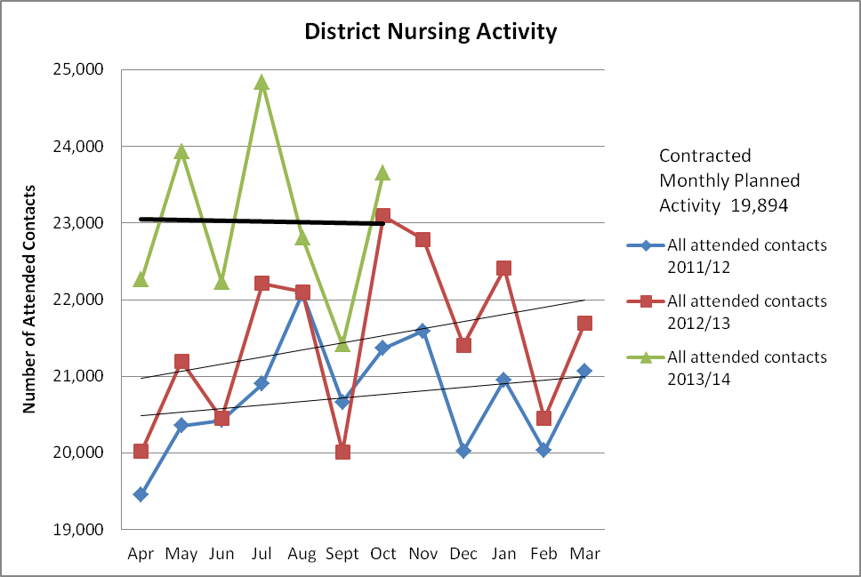

This escalating situation is driving high turnover and sickness in teams, with the city and south east localities particularly affected. The profile of turnover and sickness as at November 2013 was:
      - Sickness levels remain high with stress and anxiety being the top reason at 35% of overall sickness followed by gynaecological reasons at 9%.

      - Staff turnover remains above the Trust target at 15.60%. Exit interviews show ‘insufficient staff has resulted in lack of support’ as the main reason to leave.

      - The net effect of high sickness and turnover means that there is a general staff resource shortfall of over 23% with some localities peaking at 30% during November 2013.

A significant number of actions have been undertaken to address this:

- Internal action plan which includes:

- Implementation of preceptorship programme (commencing late January)
- Targeted recruitment campaign, including YouTube film of DN service and personal contact from service to all shortlisted candidates. By mid-December this had reduced the unfilled vacancies in the service from 27 to 9.
- Standardisation of demand and capacity planning and reporting across the service, giving senior managers a clear overview of service pressures; this will be rolled forward into a workforce plan that reflects seasonal variation in patient demand (as diagram above).
- Former case management staff supporting city locality district nursing teams.
- Review of continuity of care arrangements, and development of caseload nursing (pending sufficient capacity to re-embed named nursing).
- Proactive joint working with acute providers to address instances of poor discharge communication.

- Joint Action Plan with OCCG

This centres out addressing three areas negatively impacting upon the effective delivery of the DN service
- Quantifying the gap between commissioned resource and actual need and demand: this is underpinning contract negotiations for FY15.
- Addressing clinical and financial impact of changes to wider care pathways which have a negative impact on the DN service, i.e. care moved from acute to community settings without disaggregation of PBR funding to allow money to follow the patient, poor discharge planning and notification from acute to the DN service, non-compliance with agreed care pathways (for example patients discharged to DN for fragmin administration).
- Effective working with primary care, for example exploring the apparent correlation between GP practices whose patients report poor access to primary care and DN teams with high staff turnover, effective shared care (addressing arbitrary reallocation of roles from practice nursing to DN teams) as well as building effective working relationships between DN teams and GP practices.

- SERVICE REMODELLING AND SERVICE DEVELOPMENTS

Adult Services
The remodeling of adult mental health services has moved into the implementation phase. In order to support the change to the new service a development programme has been developed to support the new leadership teams.
The planning for the future (PFTF) programme will be bringing together our leadership teams on the wards (Consultant, Modern Matron and Ward Manager) and our community management teams (Consultants, Team Managers and Community Leads). The programme aim is to aid working together, leadership concepts, leadership style and developing a quality plan which you will be coached through with the senior leadership trios following the programme to deliver a successful locality service and safe, caring and excellent patient care.

The programme will run for 5 days, once a week covering the following areas:
- Team Identity & Role clarity and Responsibilities
- Motivating and valuing individuals and a team
- Coaching + Situational Leadership
- Developing Plans
Adult psychological therapies, including IAPT and our adult specialist eating disorder services will be moving to the Mental Health Division on 4 February to the Mental Health Division. This move has been discussed fully with staff and is in line with changes taking across the adult care pathways and will lead to a more seamless transfer across adult services for patients.

Older People’s Services
The Buckinghamshire staff consultation process has been completed and in general staff feedback on the proposed model of care and service delivery plan was very positive.
Concerns raised focused on:
- Impact of change to Band 3 HCA staff displaced by the service remodelling
- Process of change to reduce inpatient beds and increase community capacity (extended hours and weekend working)
- Suggestion for inpatient OT provision to be made 7 days / week
- Concerns about impact of extended hours / flexible working process for individual staff

The feedback from the staff consultation was jointly reviewed by the service Team, Divisional Director, Chief Operating Officer, Director of Nursing and Clinical Standards and Deputy Director of Finance, as well as HR representation. Changes were agreed in response to feedback which have been set out in a formal response to the consultation.

The consultation with respect to changes in Oxfordshire Older People’s Services will commence in February 2014.
Children and Families Services

The Division was pleased to have been awarded the contract to provide the healthy weight management service for children and young people in Oxfordshire. This was following a competitive tender process where they were competing against others providers. The Division has been providing a healthy weights service as a pilot and are particularly pleased that this important public health service will remain within the Trust.

The contract to provide Integrated Sexual Health Services in Oxfordshire has been awarded to the Oxford University Hospitals Trust. The senior management team and HR business partner are working with the OUH as a number of staff who currently work within the Trust’s contraception and sexual health service will TUPE on the first of April to OUH.

Two young people from Article 12 and Donna Mackenzie, the divisional involvement lead were invited to attend a recent conference on mental health led by the Deputy Prime Minister Nick Clegg. The young people, who have been actively involved in service development and have had a key role in developing the use of routine outcome measures within our CAMH Services, were excited to have the opportunity to influence at this level and after the conference met with Norman Lamb MP, Minister for Care and Support.

Restructuring of the Operations Directorate

Following the programme of remodelling clinical services which has taken place over the past 18 months, we have now begun a process of restructuring the Operations Directorate of the Trust to support the new service models. There are some key changes to our current operating model:

- Operations will move from four to three clinical directorates – Children and Young People, Adult and Older People
- Each Directorate will headed by a Service Director and a Clinical Director
- Clinical Director posts will be at least 0.7 wte
- Clinical Directors can be from any profession and will have appropriate senior clinical and leadership experience and expertise in relevant care group
- There will be parity of responsibility and accountability for Service and Clinical Directors with all reporting to the Chief Operating Officer
- There will be a new Directorate of Business Development and Partnerships within Operations to ensure we are able to continue to develop and retain our services within the current competitive environment of the NHS.
- Following appointment the new Service Directors and Clinical Directors will review and propose structures which ensure appropriate operational and clinical management and leadership for each of their Directorates.

The restructuring process will involve a number of internal and external processes and we hope to have completed Service Director and Clinical Director appointments by the end of March 2014.

- Aston Team Working
It was agreed in August 2013 that the Improvement and Innovation Team would take over leadership of the next phase of the Aston Team Based Working development programme in November 2013.
Progress to date
- An intranet site has been developed to advertise the work to teams and to act as a source of references and materials to guide effective team based working
- Publicity posters and leaflets have been produced and circulated to teams explaining the programme and the support offered
- The two day orientation to effective team based working sessions have been designed (with approvals from Aston OD and the previous programme lead) and 7 cohorts planned and advertised
- Over 130 managers and team leads have been invited to undertake the two-day orientation. To date over half of the invited managers have booked places and the first three cohorts have completed their first day session. The two sessions for each cohort are split over three months with interim telephone support from the facilitators.
- Since October 2013 17 different teams have approached the facilitators for tailor made team development support and work has been completed or is ongoing with all of these teams. This work has ranged from one-off advice/coaching to facilitated away days and development sessions to ongoing support programmes that will continue over several months.
All orientation sessions and tailor-made support are subject to evaluation so that the facilitators can assess the impact of the work and continuously improve the support offered. Feedback received to date has been very positive and a detailed evaluation is being undertaken.

