
BOD 22/2014
(Agenda Item: 6)

Report to the Meeting of the

Oxford Health NHS Foundation Trust

Board of Directors

26 February 2014

Quality and Safety Report

For Information

The following report outlines current areas of concern or priorities across our Trust in relation to Patient Safety for Quarter 3, and Quality for January/ February 2014. 2013/14. It draws on reports on incidents that have been submitted to the Integrated Governance Committee on 12/02/14 and Safety Committee where these reports were reviewed in detail. The areas covered are:

- Patterns of Reported Incidents (including pressure ulcer prevention and AWOLs)
- Restraint and Seclusion Reporting
- Serious Incidents Requiring Investigation
- Physical and Mental Health Safety Thermometers
- Safer Care Programme
- Infection Prevention and Control
- General Quality Update
- Learning and Development Report Q3
- Leadership, Team and Individual Skills (LTIS) Q3
- Patient & Personal Safety Training (PPST) Q3

Recommendation

The Board is asked to note the report.

Author and Title:
Tehmeena Ajmal, Head of Quality and Safety; Rebecca Kelly, Learning from Incidents Lead; Gavin Garman, Head of Nursing, Specialised Services; Helen Bosley, Infection Prevention Control Matron; Jill Bailey, Consultant Nurse and Safer Care Lead, Jeanette Wilding, Head of Governance and Clinical Standards, and David Slingo Head of Learning and Development

Lead Executive Director: Ros Alstead, Director of Nursing and Clinical Standards

- A risk assessment has been undertaken around the legal issues that this paper presents and there are no issues that need to be referred to the Trust Solicitors.
- This paper provides assurance and evidence against the Care Quality Commission Outcome: 4, 5, 7, 8 and 16.

Safety Report

1. Patterns of reported Incidents (including pressure ulcer prevention and AWOLS)

  - Total Number of Incidents by quarter
There were a total of 2946 incidents reported in quarter three. In 2012/13 there was a mean of 2470 per quarter (in 2011/12, the mean was 1825 per quarter). So far this year the mean is 2905 per quarter. Overall, therefore, the level of incident reporting has increased quarter on quarter which reflects the work undertaken in Oxford Health FT to encourage reporting of any and every safety incident. The National Patient Safety Agency (NPSA) identifies a higher level of reporting demonstrates an improved safety culture where staff see the value and importance of reporting and where improvements are implemented as a result.

Q3 2012/13 | Q4 2012/13 | Q1 2013/14 | Q2 2013/14 | Q3 2013/14
2498 | 2615 | 2791 | 2979 | 2946

1.2 Incidents by Risk Rating for the last 4 quarters
The overall incident reporting has remained at a similar level to Q2. Numbers of green incidents (low harm) reported are higher than in Q2 and there has been an increase in reported orange incidents. The number of incidents in “web holding” (awaiting assessment and risk rating) has decreased from 508 last quarter to 337 bringing it to the lowest level so far this year. This indicates the effort made by managers to reduce the numbers of incidents that require review and represents a smaller proportion of incidents overall that remain in web holding, there is still more to do. The Health and Safety team continues to remind managers to sign off these incidents. In addition the numbers of incidents in web holding are reported fortnightly to senior managers and divisional directors.

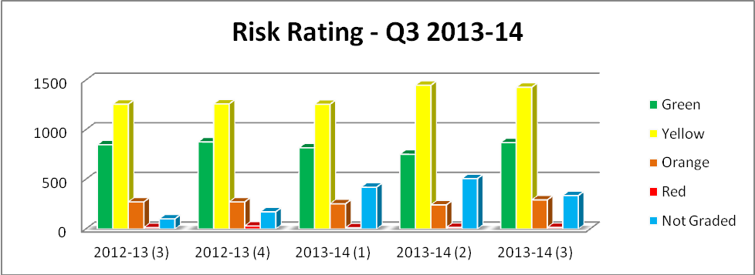

1.3 Incidents by Division
Community Services and Mental Health continue to remain the 2 highest reporting directorates of incidents.

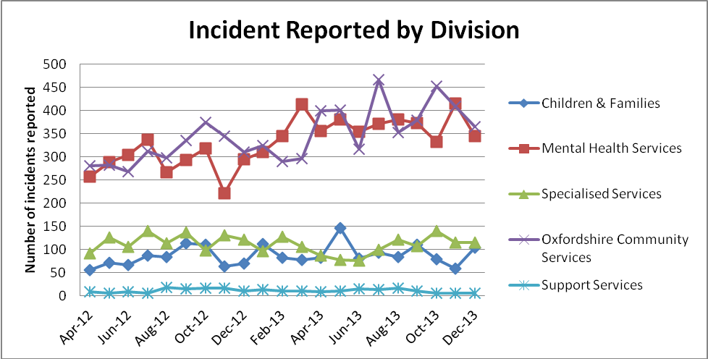

1.4 Top 6 Categories of Incidents by Month
1.4.1 The chart below shows the main categories of reported incidents over the last 21 months. There is common cause variation quarter by quarter. All of these top 6 are part of The Safer Care collaborative aims, but not all are active programmes of reduction. The falls project is due to start in Quarter 4 2013-4 and the medication project has been scoped but has paused while the team address pharmacy staffing issues.

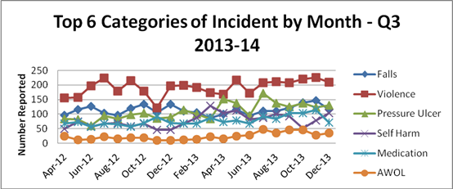
*Falls include all falls incidents for both patients and staff

1.4.2 Violence continues to be the most commonly reported incident.

1.4.3 Sandford ward was the highest reporter of incidents this quarter. This is due to the admission of a patient who has Parkinson’s disease and who presents a high falls risk but is requiring therapeutic holding which we record as restraint daily for his personal care needs. Ashurst, who was the highest reporter last quarter, is the second highest in Q3 with a slight increase in reported incidents. Kestrel is the third highest reporter. They have had a small group of 3 women who have each required restraint 8-9 times each over the last quarter to maintain their own safety and staff safety.

1.4.4 Reported falls have reduced slightly over the last quarter, still showing common cause variation. The top 3 highest reporters of falls continue to be the older adult mental health wards; Harding ward and Cromwell wards remain the first and second highest reporter with Cherwell reporting a similar number of falls as Cromwell this quarter. On these wards there are a small number of patients accounting for the majority of falls.

1.4.5 Compared to the same quarter last year, the number of patients reported as Absent Without Leave or AWOL (including informal patients going missing) continues to remain high. A significant factor is the tightening of reporting criteria to include any patient who is more than 10 minutes later than their due time of return. Allen ward reported the largest number of AWOLs (21) although 9 of these were attempted AWOLS. Chaffron, Kimmeridge and Phoenix ward staff are all engaged in a safer care ward programme to reduce AWOLs including “failure to return”. Phoenix staff in particular have reduced their AWOLs by 30%. This reduction demonstrates the safer care approaches are having a positive impact and provide impetus to the other wards to engage in safer care work.

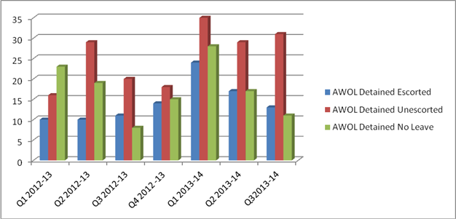

1.4.6 The number of reported pressure ulcers shows common cause variation over October, November and December with a median of 28. The graph below show an increase in the number of reported pressure ulcers (blue line) but a decrease in the number of avoidable grade 3 or 4 pressure ulcers reported as SIRIs (red line), which remain at a rate of between 0 and 1 a month (see chart below).

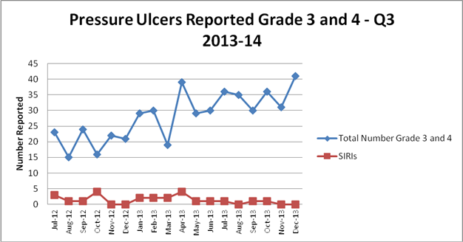

1.6 High Reporting Areas for the most commonly reported incidents (by category)

Type of Incident | Highest Reporter | Second Highest | Third Highest
Falls | Harding | Cromwell | Fiennes
Q2 2013-2014 | 44 | 26 | 24
Falls Q3 2013 - 2014 | Harding | Cromwell/Cherwell | Abingdon Hospital Ward 2
Falls Q3 2013 - 2014 | 42 | 31 | 27
Violence | Ashurst PICU | Fiennes | Highfield Unit Oxon
Q2 2013-2014 | 73 | 40 | 37
Violence | Sandford Ward | Ashurst PICU | Kestrel Ward
Q3 2013 - 2014 | 83 | 80 | 49
Self Harm | Wintle Ward | Highfield Unit Oxon | Marlborough House, Wilts
Q2 2013-2014 | 49 | 43 | 30
Self Harm Q3 2013 -2014 | Portland Ward | Highfield Unit Oxon | Kingfisher Ward/Wintle Ward
Self Harm Q3 2013 -2014 | 38 | 34 | 22
Medication | City Community | St Leornard's Ward/Vaughan Thomas Ward | Linfoot Ward
Q2 2013-2014 | 17 | 13 | 12
Medication | Abingdon Hospital Ward 2 | St Leornad's Ward | City Community Hospital
Q3 2013 - 2014 | 27 | 18 | 15
AWOL | Phoenix | Kimmeridge/Wintle Ward | Ashurts PICU/Vaughan Thomas Ward
Q2 2013- 2014 | 14 | 11 | 6
AWOL | Allen Ward | Portland Ward | Wintle Ward
Q3 2013 - 2014 | 21 | 16 | 9

2. Restraint and Seclusion Reporting

2.1 Physical Restraint
2.1.1 There were 338 reported incidents of physical restraint in quarter four. In Oxford Health we define a restraint as any patient receiving hands on intervention. This definition is not necessary comparable with other Trusts who use different and often narrower definitions. Our definition includes hands on physical interventions used to prevent self-harm, planned and unplanned restraints and hands on interventions where there is self-neglect for example an urgent personal care need. Totals for the previous four quarters were 276, 370 and 406 and 293. The mean number per month for the last eighteen months is 117. The graph below shows common cause variation.

2.1.2 Number of restraints by month and quarter

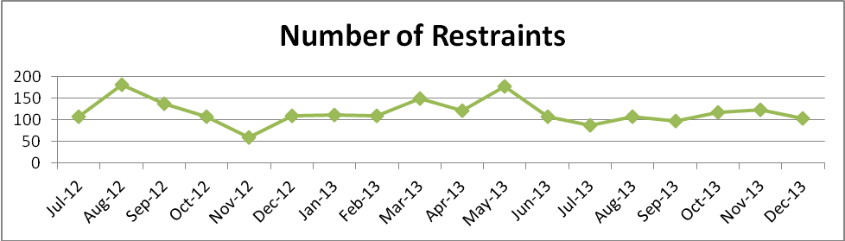

2.1.3 The pattern by quarter shows a random variation.

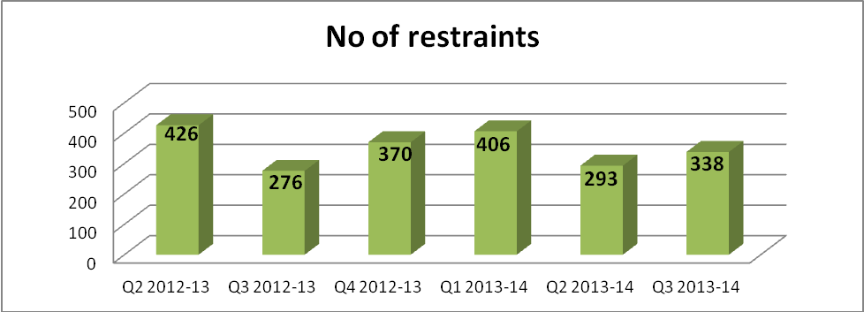

2.1.4 The gender of restrained patients has been a consistent finding with around 65% involving female patients. In quarter two this was a little lower at 58%. We intend to improve recording by ethnic origin as this field shows a high level of data incompleteness.

2.1.5 The number of patients restrained five times or more is 15 this quarter (a figure that is within the usual quarterly variation). Where more than one ward is given, the patient moved between the wards and was restrained whilst staying on both.

2.1.6 Eleven of these fifteen patients were female, which is consistent with previous quarters. Highfield Oxon and Ashurst are associated individuals who have needed to be restrained on a number of occasions.

2.2 Restraints by Ward
2.2.1 All mental health wards, including all older adult, adolescent and eating disorder services reported some restraints over the quarter except for Glyme, Chaffron and Lambourn House (all forensic units). The number of restraints ranged from 0 to 51 (nearly identical to the last quarter). See charts below for the ten wards reporting most incidents.

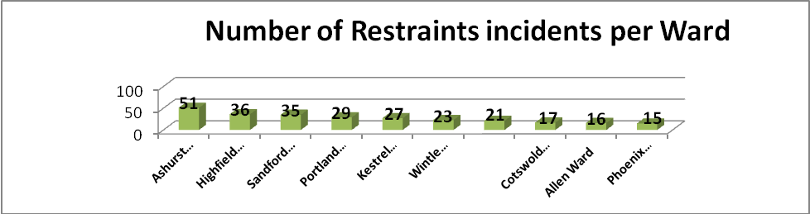

2.2.2 The four wards with the highest number of restraints are Ashurst, Highfield, Sandford and Portland. Sandford is not usually a high reporter. The high reporters, as would be expected, are related to the presence of individual patients who required restraint including hands on holding to enable physical catre needs to be met as an agreed part of their care plan.

2.2.3 Wenrisc and Linfoot each reported one incident of restraint. Both involved agitated older adult patients who were assaulting visitors or staff.

2.2.4 The incident form requires a ‘cause group’ to be selected for each incident. Many different types of cause group were selected but violence and aggression (72% of all incidents)

2.2.5 The staff reporting incidents rate the actual impact of the incident. 94% of the incidents were graded as yellow or green (moderate or low risk) or were not yet graded. An unusually high 21 forms were graded orange this quarter. It is notable that these are wards that usually experience use less restraint, which has perhaps led to them rating the incidents as serious when they occur. Also, the incidents on Sandford have resulted in staff injury.

2.2.6 Looking at the wards that have consistently reported most episodes of restraint, we broke down the use of a high level of restraint by ward (see table below). The figures were generally remarkably stable compared to last quarters. Flexion is not frequently used but figures are a little higher this quarter, though not as a percentage of all incidents, as the total number of incidents has risen.

2.2.7 As with the use of flexion, the percentage prone figures are consistent with the last quarter, usually these figures show fairly random variation. Prone is a position that is allowed for in the training staff receive.

2.2.8 In quarter two, the recorded duration of restraint ranged from 1 minute to 4 and ½ hours. 3% of restraints (10 incidents) lasted over 1 hour (compared to 2.9% -13% in previous reports).

2.3 Use of Seclusion
2.3.1 The total number of reported seclusions in Quarter 1 was 59, compared to 57, 44 and 66 in the previous three quarters. The mean per month for the year of 2012 was 17.5 and for 2013 it was 19. Numbers appear to have changed little overall.

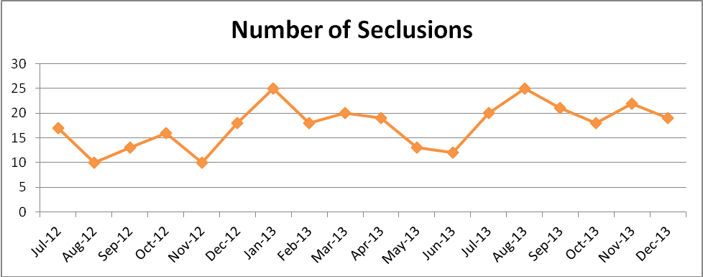

2.3.2 The highest reporting ward has consistently been Ashurst, but for this quarter and last, Kimmeridge and Kestrel have had a similar level of incidents. Lambourn, Chaffron, VT, Wintle, Allen, Phoenix, the Highfields, Mandalay and the older adult mental health wards reported no seclusions. Portland and Kingfisher do not have seclusion rooms but reported using seclusion facilities on Kimmeridge and Kestrel respectively.

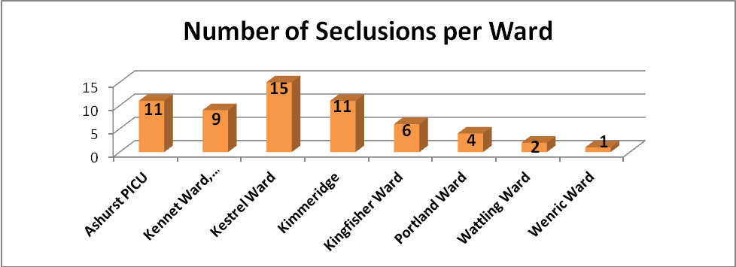

2.3.3 Nearly all incident reports continue to detail violence and aggression as the cause for seclusion. The other reasons over the last 3 months primarily related to attempts to abscond. In 54% of seclusion incidents, the patients were male (51 - 66% in previous reports).

- All SIRIs

  - Serious Incidents Requiring Investigation (SIRIs)
The table below shows the total number of red SIRIs by quarter. This quarter has seen a decrease in the number of SIRIs compared with Quarter 2. The reduction in suspected suicides and refreshing figures for Q2 has accounted for this difference. Nevertheless the number of reported SIRIs has fallen to the lowest numbers in 18 months.

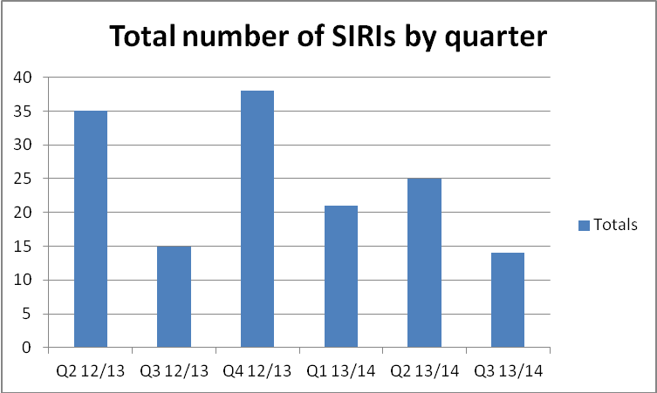

  - SIRIs by type
Suspected suicides are the main cause of SIRIs reported in Quarter 3. This is a consistent finding. The categories listed in the chart below correspond to the cause recorded on STEIS. As detailed in 2.3, reported suspected suicides have decreased this quarter (5) to lower than any time in the preceding 9 quarters. Avoidable pressure ulcers have also reduced to the lowest numbers over the same timeframe.

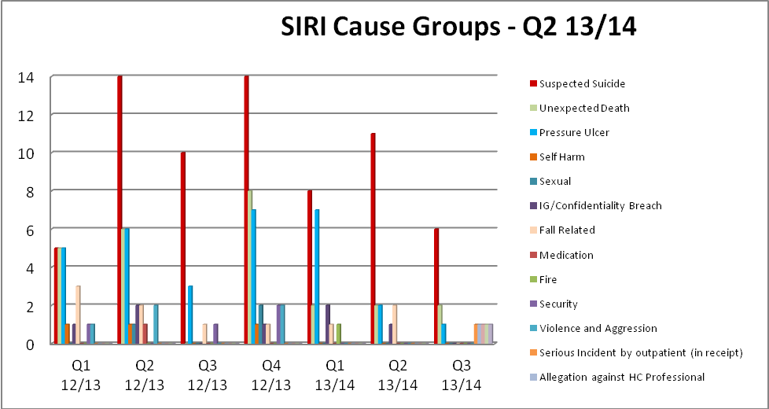
.

  - Suspected suicides by quarter for the last 10 quarters
3.3.1 The chart below shows suspected suicides. This report calculates its numbers of suicides on the basis of deaths that are suspected to have been suicides given the information available. There is common cause variation over the last 11 quarters.

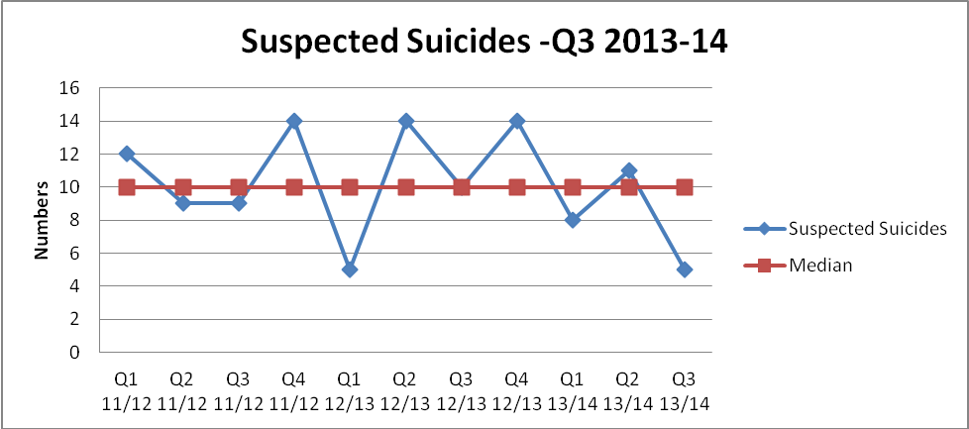

3.3.2 So far this year there have been 24 suspected suicides reported. Twenty three of these have been in the community. There has been 1 death of a patient who went AWOL from Lambourn House and died by suspected suicide in Prison in Poland having received healthcare in this setting in August 2013 (this was reported as an AWOL rather than a suspected suicide). This was widely reported in the press at the time. Of note the numbers of suspected suicides has fallen to a low of 5 this quarter although it is possible that this number may rise if further reports come in over the next year, as we report suspected suicides for all patients who have been under our care within the last year.

3.3.3 Community and In-Patient Suicides by year.

 | Inpatient | Community
2009/10 | 1 | 24
2010/11 | 1 | 36
2011/12 | 0 | 44
2012/13 | 1 | 45
2013/14 | 1 | 23

  - Location of SIRIs by Division
3.4.1 There has been a reduction across all divisions in the number of reported SIRIs this quarter. The reduction in suspected suicides and avoidable pressure ulcers account for the reduction in the mental health and community division. Quarter 3 this year has seen a rise in the number of SIRIs reported in the Children and Families Division who reported 3 SIRIs. Two of these were unexpected deaths of community patients who were in receipt of care by IAPT services in Oxford and were in addition to the suspected suicides discussed in section 2.3.

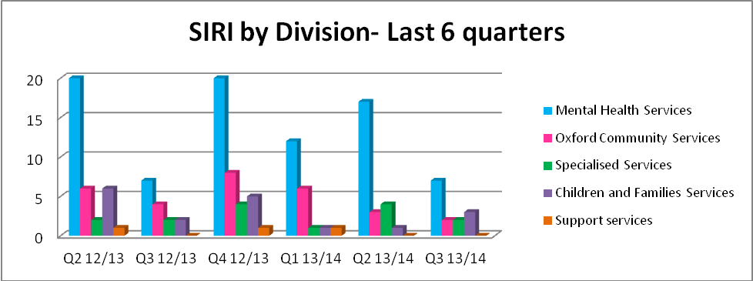

- Physical and Mental Health Safety Thermometers

4.1 Safety Thermometer (Physical Health)
Within OHFT the amount of harm free care has increased over the past three months, but is still slightly below the national average. The Safety Thermometer is a point prevalence measure which takes the incidence of harm at a fixed point in time. These charts below are taken from the national system.

OHFT figures
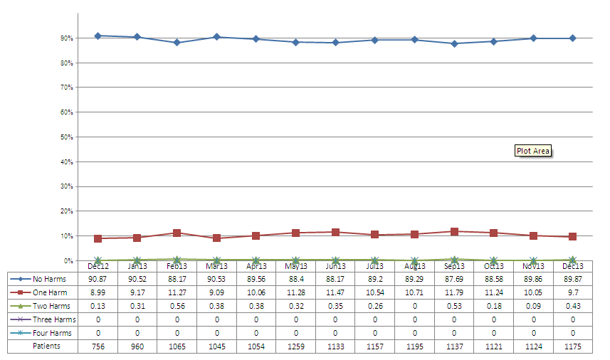

National figures
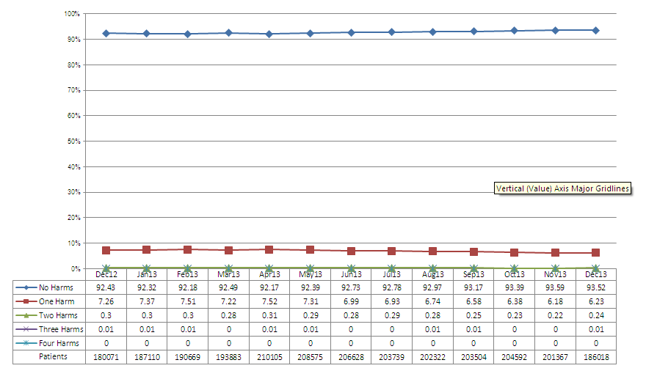
4.2 Positive improvements include:
- Harm free care percentage increased to 89.87%
- There was a reduction in all harm and all of the harm categories with the exception of new VTE. The data shows 2 patients with new VTE for community nursing which is in fact a data entry error as this is a not applicable category for non- inpatient teams
- Community hospitals, community nursing and older adult CMHT’s saw a reduction across nearly all of the harm categories

4.3 Negative changes in results include:
- There was a slight reduction in VTE risk assessments, this was due to a slight decrease across community hospitals
- Community nursing mixed teams saw a slight increase in all harm which was attributable to an slight increase in catheter/UTI’s
- Rehabilitation saw an increase in all harm and was solely attributable to pressure ulcers.

4.4 Safety Thermometer (Mental Health)
We have agreed to pilot the proposed Mental Health Safety Thermometer and have joined a small number of Trusts working with the Department of Health to develop it.

5. Safer Care Programme

5.1 AWOLS
The Safer care Programme has four wards working on AWOLs with a specific focus on failure to return from Section 17 leave as the largest category of patients reported AWOL. Chaffron is counting ‘days since...’ and has achieved 330 days since the last reported AWOL. Patient information leaflets provide information about taking leave from the ward, and of the expectations of the ward with respect to informal patients. Phoenix is testing a signing in and out book and contact cards. They have achieved a 30% reduction in failure to return, and a maximum of 11 days between AWOLs in December. Kimmeridge is using a questionnaire with patients when they return from leave and they achieved a maximum of 47 days with no AWOL between 21st Nov 2013 and 8th Jan 2014. Allen Ward is testing planned therapeutic leave in their ward review and has achieved a maximum of 6 days between AWOLs.

5.2 Medication omissions and medication reconciliation
Work on the Fiennes Unit has addressed unattributed blank boxes on medication forms. In their July/ Aug 2013 audit, there were 203 unattributed blank boxes on the medication forms. In December/ January the audit revealed only 8 blank boxes, the remaining 166 were clearly coded. The reduction has been achieved by daily monitoring of all medications charts

5.3 Self-harm
Work is now underway on Kestrel Ward. Approaches include training programmes, restriction of harmful items and changes to the environments including lighting and power points.

5.4 Restraint reduction
The Highfield Unit is currently working on improving assessment information and care planning. Run charts show a reduction in the weekly median (all types of restraint) from 4.9 in Jan 2012-Jan 2013 to 1.78 Jan 2013-Jan 2014 since moving to purpose built unit.

6. Infection Prevention and Control

6.1 Surveillance
6.1.1 Clostridium difficile infection

 | October 2013 | November 2013 | December 2013
Total number of cases per month | 2 | 3 | 1
Total cases in year | 8 | 11 | 12

All the cases have been fully reviewed by the monthly health economy CDI meeting, with representation from the OUH, Public Health England and commissioners. Ten of the twelve cases have been assessed as unavoidable. The patients were identified as high risk and had received antimicrobial necessary treatment. A comprehensive action plan has been implemented and is being monitored for the avoidable cases.

6.1.2 MRSA
There were no cases of MRSA bacteraemia or MSSA bacteraemia in any Trust
services. There was a patient identified with MSSAA bacteraemia on admission
to the OUH from Sandford ward. The likely source was the urinary tract and
further work is being undertaken to review management of urinary catheters.

6.1.3 E. Coli bacteraemias
There were eight cases of E. Coli bacteraemia in Q3. In October there were four cases, of which were tested within 48 hours of admission and not attributable to the Trust. In November there were three cases, of which one was tested within 48 hours of admission and not attributable to the Trust. In December there was one case. All cases have had a thorough RCA completed and no definitive source/cause has been identified. These infections require mandatory reporting but do not have a threshold.

6.1.4 Outbreaks

Location | Dates | Management | Cause | No. of cases
Kimmeridge Ward, Tindal Centre | 1.12.13-8.12.13 | Ward closed to admissions with restrictions in place. Managed and reviewed daily by IPCT | Confirmed norovirus | 10 patients and 10 staff
Portland Ward, Tindal Centre | 3.12.13-12.2.13 | Ward closed to admissions with restrictions in place. Managed and reviewed daily by IPCT. | Suspected norovirus | 9 patients  2 staff
Phoenix Ward, Littlemore Hospital | 4.12.13-10.12.13 | Ward closed to admissions with restrictions in place. Managed and reviewed daily by IPCT | Suspected norovirus | 7 patients  1 staff

6.2 Audit programme

6.2.1 Environmental Audits
Environmental audits continue and overall demonstrate good compliance with infection prevention control standards.

6.2.2 Hand hygiene
Hand hygiene audits in the community hospitals in November continue to demonstrate excellent compliance of 99.9%. Bare below the elbows was 100%. Hand hygiene in mental health wards is also continuing bi monthly. The overall compliance score for the hand washing technique for November 2013 was 94 %. Bare below the elbows was 93%.

6.3. Training
Training numbers continue to be a challenge. The Trust has set the target of 100% of all eligible staff to complete infection prevention control training. The current figure is 72% of staff are in date with training requirements. To date an additional 8 training sessions have been provided and further planned and available if requested for staff groups. Training is also available via the e-learning programme and work book for staff to access.

6.4 Policies and procedures
As per the rolling programme of review several procedures have been reviewed in Q3 including chicken pox and environmental cleaning, linen and laundry.

6.5 CQC compliance/national directives
Outcome 8 Cleanliness and Infection Control is monitored quarterly via the IPCT, Safety Committee and governance team. Overall, areas are demonstrating good compliance with this outcome, except the numbers of staff trained in infection prevention and control remain below the target of 100%. There are also some concerns regarding audit results and decontamination record keeping. Decontamination compliance remains high with appropriate processes in place including external contracts. One area of non-compliance remains poor documentation of cleaning records.

- General Quality Update
7.1 Adult Mental Health Community Services has begun to implement the new Community Model of care. Recruitment to the new teams has taken place and staff development for new roles is underway. The transition of patients between teams requires careful planning and oversight and the senior management team are reviewing impact on a daily basis to prevent and if necessary respond to service pressures. One pressure in staffing the Crisis Service has emerged and has been urgently addressed.
7.2 Preparation to move into the new Whiteleaf Centre in Aylesbury, Buckinghamshire continues apace. The commissioning and equipping programme remains on target. Staff orientation and education to prepare to work in the new wards is well underway. The first patient moves will occur on 25th February.
7.3 The Executive and Clinical Advisory Board has discussed and signed off the Adult Mental Health Inpatient and Community models of care. A forum to give oversight to the implementation plan as it unfolds is in place.
7.4 The Older Adult Inpatient model of care in Buckinghamshire including the new inpatient model in the Whiteleaf Centre was also discussed and approved. The transition from two wards to one ward will be carefully managed with both nursing teams moving to the one ward initially to settle patients. Length of stay for older adults has improved from over 100 days to 60 days which improves capacity and patient experience.
7.5 During the time of change the impact will be given careful consideration and oversight.

- Learning and Development Report Q3
Clinical & Professional Development (CPD) activity Q3
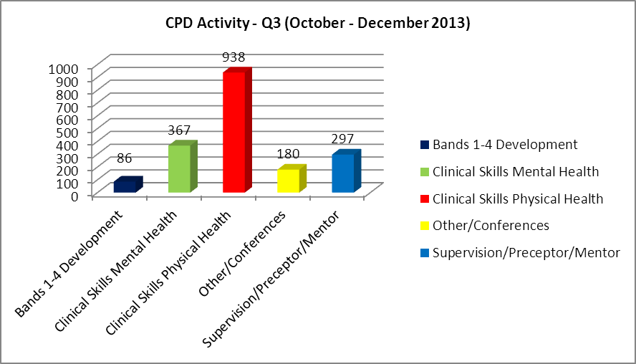

  - Bands 1 to 4 Development
New Level 3 apprenticeships have been started by 2 individuals in Health & Social Care and in Business and Administration.

Other training undertaken includes:

- Health Care Assistant Development programme
- Medical Terminology
- VRQ study days including: Promoting the mental health and well being of older adults / working in Community mental health.
- Assistant Practitioners (OCSD) study days in: Injection technique, catheter care, wound care and medicines management.

  - Clinical Skills Mental health
Delivery of 2 Psycho-social Family Interventions courses in Oxford and Aylesbury.

  - Clinical Skills updates
- Physical Health Skills for mental health nurses four day course with another planned for Q 4.
- A wide range of clinical updates and study days and courses across the divisions which include; Dementia Leaders programmes; Aural care; beyond prescribing for non medical prescribers; bladder symptoms and continence; blood glucose monitoring; catheter skills; chronic oedema; HIV updates; early language development; fundamentals of leg ulcer management; immunisation updates; IV study days; safe handling of cytotoxics; manual blood pressure; tissue viability; oral health promotion; paediatric continence; breastfeeding; pre-natal mental health; phlebotomy; pressure damage; pressure relieving equipment; syringe driver training; contraception and sexual health; wound assessment and management.

Many of the clinical updates outlined address key priorities from service divisions and support action to be taken in response to SIRIs.

  - Other training activities
Other activities include: sessions on ‘Communicating our values’; Conference for Children & Families Universal Services; and an event to raise awareness of dementia.

8.5 Clinical Supervision / preceptorship / mentorship
8.5.1 There has been continued provision of regular training sessions, and ongoing support and guidance to clinical services, departments and teams in order to embed clinical supervision within the clinical work environment.

8.5.2 The rolling 12 month preceptorship programme for newly qualified health care practitioners has evolved over time as a result of participant feedback, and is delivered by Learning Environment Leads.

8.5.3 We are preparing to pilot several Action Learning Sets for newly qualified staff. The plan is for these sessions to commence early in the new financial year.

CPD forward plans
Action | Update
Review training and development opportunities for HCAs and support workers in bands 1 to 4. To ensure that the trust is responsive to recommendations set out in the Cavendish review. | Scoping exercise has been completed to establish current local induction practice and initial training. The plan is to ensure that new HCAs / support workers meet the national minimum standards / competencies and are appropriately prepared for their job role by:  - strengthening local induction practices;  - working with HETV to apply the national training standards;  - developing a competency tracking tool and reporting system.  Working with Community and Older Adults services to review HCA / SW training requirements and career development opportunities.  Training needs identified across the trust for this staff group include: routine physical health observations, the HCA as a first responder and an understanding of diabetes.
Delivery of the Physical Health skills course for mental health nurses. | 1 x four day programme delivered December 2013 with another planned for March 14. The course has been well evaluated with anecdotal feedback suggesting that the skills learned are becoming well embedded in practice.  The plan longer term is to provide this programme internally using expertise within the trust and not relying on a local university.
Introduction of new Clinical Practice Educator posts | Appointed four out of five new Clinical Practice Educator posts created with HETV funding to support the learning experiences of under graduate / post graduate students on placement. Post holders will work in clinical practice alongside students, their mentors and other clinical practitioners to support the delivery of evidence based practice and to model the Trust values and behaviours.
New Trust Induction programme | The new style corporate induction programme was implemented in October 2013. Day one is firmly based around the Trust values and expectations of the new employee. Evaluation has been very positive with feedback used to further refine the delivery.

- Leadership, Team & Individual Skills (LTIS) activity Q3

9.1 Overview
The LTIS team delivers a wide variety of non-clinical development programmes for all staff (clinical & non-clinical) in the Trust including Team days which are designed specifically to meet team needs using a mixture of MBTI and Belbin accredited programmes. This supports one of the key strategic objectives to improve team-working.

9.2 Update on specific development programmes
9.2.1 Health Visitors Safer Recruiting Skills was delivered in November 2013 to 18 Health Visitors to ensure that the recruitment adhered to safer recruiting guidelines.

9.2.2 Twelve Bladder & Bowel staff attended a Managing Conflict during difficult phone conversations training to develop skills to deal with difficult phone conversations with patients, carers and others to ensure a professional and competent manner is maintained and a high level of customer service is delivered.

9.2.3 Two Customer Care sessions have been designed and delivered to North West Bucks CMHT during December with further sessions planned for 2014.

9.2.4 Swindon Community CAMHS Minute Taking Skills Development Programme was scheduled for and completed in October 2013 for 12 staff.

9.2.5 Interview Skills and CV Skills have been delivered to support the new Mental Health Pathway process in November.

9.3 LTIS Forward Plans

9.3.1 PDR review
- The Trust PDR process is under review to incorporate a values based approach. A new on-line system is being developed to support the new PDR process.

9.3.2 Project work currently developing:
- Learning & Development Centre – conversion of existing space to create additional training room and reduce external room hire expenditure.
- A programme for new managers (either new into the Trust or internally promoted) linked to the new Probationary period policy to equip all new Managers with the skills required for a manager in the Trust within 6 months of appointment. This includes the following sessions: Essential PDR Training, Disciplinary & Grievance, Managing Sickness Absence, Recruiting Successfully and Introduction to Management.

9.3.3 Further specific development programmes currently being designed include:
- Stress Awareness Training in conjunction with HR & Occupational Health scheduled from February 2014.
- Customer Care sessions for each pathway/service scheduled from March 2014
- Team-based Step 2 MBTI development to support teams going through change.
- Receptionist Development programme to develop administration and customer service levels in the Trust scheduled for March 2014
- Dietetic Team Leadership Development Skills modular programme.
- Health Visitors Managing conflict in the workplace Programme scheduled for February 2014
- Tissue Viability Resource Nurse Development Programme Pilot to develop leadership and competency skills scheduled for January 2014
- School Health Nurses 3 day leadership programme scheduled for January 2014.
- Therapists Leadership Skills Awareness for bands 7-8 from June 2014.
- Efficient administration pilot (accredited by ILM)

9.3.4 Bespoke LTIS initiatives
LTIS team has also delivered Retirement Workshops and supported the Innovations team in setting up and providing administration support for the Champions Programme, Aston Team working and Productive Wards - Service User feedback workshops.

9.3.5 LTIS Yearly comparison

PDR | Team Days | Coaching
Essential PDR Skills Training  PDR Masterclass  Me & my Appraisal  Appraisee workshop  E-KSF workshop  KSF workshop  PDR Refresher | MBTI Team day  Belbin Team day  Specific Request Team days | Coaching Skills for Managers (in collaboration with Oxford Brookes)  Advanced Coaching Skills for Managers (ILM Accredited)
Bands 1-4 | Leadership
Time Management  Assertiveness  Personal Effectiveness  Communication Skills  Touch Typing  Minute Taking  IT Skills – including Word, Excel, PowerPoint | Managers as Leaders  Introduction to Management  First Line Managers Programme (Accredited with Oxford Brookes)  Personal Effectiveness  Managing Conflict  Managing Self & Others Masterclass  Managing Meetings  Working & Managing Change  Successful Communication Skills  Working Relationship Management  Managing Sickness Absence  Disciplinary & Grievance  Managing Sickness Absence

- Patient & Personal Safety Training (PPST) Q3

PPST is a framework designed to enhance patient safety and ensure safe working practices. Each of us has a duty to meet the standards required through PPST, either through completing training or demonstrating competence. There are 6 categories of risk for groups of staff reflecting the types of role performed. The risk based approach is to ensure that training is more relevant and better focused on the right roles within the Trust.

Level 1  UK Core Skills Training Framework |  | Level 2 |  | Level 3  Individual Nominated
Equality & Diversity  Fire  Health & Safety  Induction  Infection Prevention & Control (IPC)  Prevention & Management of Violence & Aggression (PMVA)  Moving & Handling  Resuscitation  Safeguarding |  | Care Programme Approach (CPA)  Clinical Risk & Management (CRAM)  Complaints  Dual Diagnosis  Falls Awareness  Food Hygiene  Information Governance  Medicines Management  Mental Capacity Act  Mental Health Act  Safe & Supportive Observations  Security Awareness  Supervision |  | Medical Educational & Clinical Supervision  Medical Educational Supervisors Annual Review of Competence Progression  Medical Educational Supervisors Supporting the Trainee  Medical Workplace Based Assessment  Fire Marshal  First Aid – Appointed Person  H&S Care Risk & Safety Management  H&S Working Safely  Root Cause Analysis
Risk Group 1 | Risk Group 2 | Risk Group 3 | Risk Group 4 | Risk Group 5 | Risk Group 6
Ward Based Registered | Community Based Registered | Ward Based Non Registered | Community Based Non Registered | Non Clinical Patient contact | Others

10.1 PPST Level 1 – Target 100%. The introduction of new medicines management eLearning for 2400 staff in October has impacted performance but has partly recovered to 86% at end of Q3.

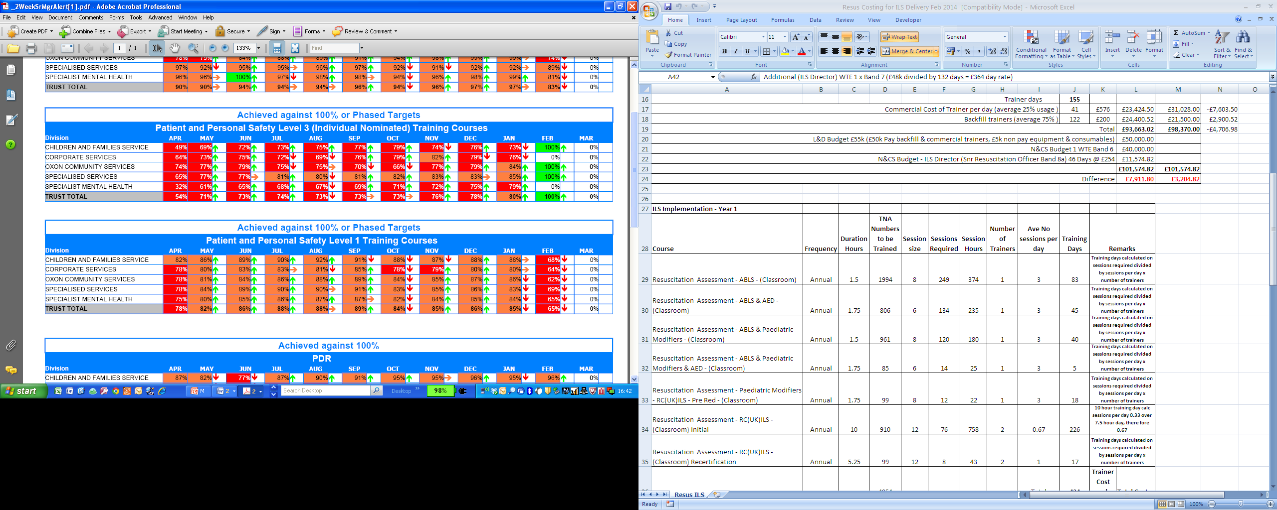

10.2 PPST Level 2 - Target 85%. Overall improvement of 1 percentage points to 97% of target

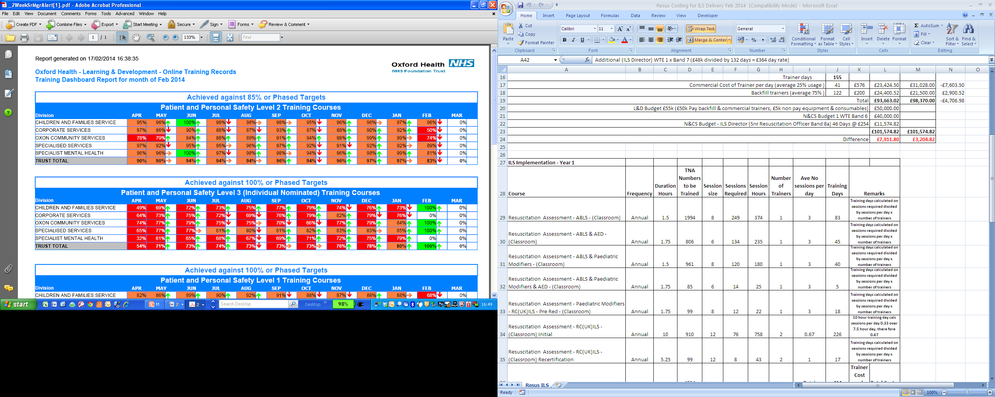

10.3 PPST Level 3 (Individual nominated) – Target 100%. An overall improvement of 5 percentage points to 78% of target.

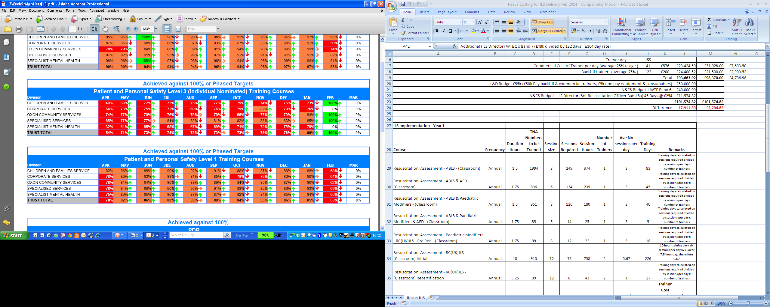

10.4 Technology Enhanced Learning (TEL)

Over 50% of PPST is now available via eLearning, reducing costs on travel and time away from patient care. E-Assessments have been introduced to further reduce the time required to demonstrate knowledge. The L&D TEL team have delivered/are working on the following:

TEL Development Project | Comments | Delivery
TEL Content Developed and Implemented
Induction landing portal for new starters | Providing new starters online access to information /learning materials before starting Induction programme | Qtr 3
Resuscitation eLearning (4000 | Learning content improvements (for 4000 staff) | Qtr 3
TEL Forward Plans
Safeguarding eAssessments | Development with HE TV for all staff groups. | Qtr 4
Supervision | Date and type of clinical supervision activity to be recorded by supervisee on L&D portal in order to evidence that appropriate supervision is taking place. | Qtr 4
Develop virtual learning environment | A project to create a virtual learning environment is being developed aiming to reduce costs associated with travelling and improve the efficiency and effectiveness of learning events.  Pilot - Fire training for non inpatient staff annual awareness updates. | Qtr 4

10.5 Performance and Development Reviews (PDRs) PDR cycle is April to June

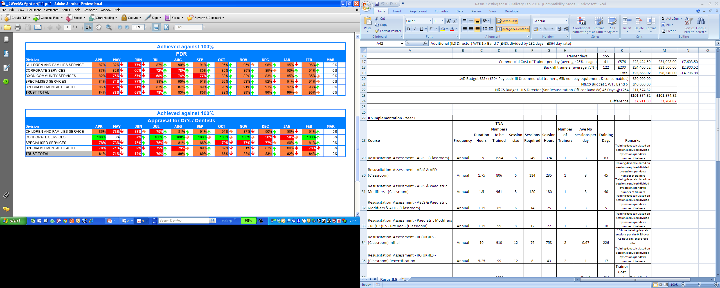

10.6 Medical Staff & Dentists have annual appraisal reviews and are outside the PDR cycle

The suspected suicide figures in the chart above include 1 attempted suicide of an outpatient in receipt

