

Oxford Health NHS Foundation Trust

Quality Account 2013/14

Report for the 3rd Quarter 2013

January 2014

1. Oxford Health NHS Foundation Trust

1.1 Oxford Health NHS Foundation Trust is a community-focused organisation that provides physical and mental health services and social care with the aim of improving the health and wellbeing of all our patients and their families.

1.2 Our Trust provides community health, mental health and specialised health services. We operate across Oxfordshire, Buckinghamshire, Berkshire, Swindon, Wiltshire, Bath and North East Somerset. In Oxfordshire we are the main provider of community health services and deliver these in a range of community and inpatient settings, including eight community hospitals. Our mental health teams provide a range of specialist healthcare in the community and from inpatient settings across the geographic areas of Milton Keynes, Buckinghamshire, Oxfordshire, Wiltshire and Bath and North East Somerset (BaNES). We also provide a range of specialised health services that include forensic mental health and eating disorder services across a wider geographic area including support for patients in Berkshire and from Wales.

2. Quality Account 2013/14 – what we said we would do

2.1 The annual Quality Account details our approach to delivering safe services, avoiding harm and ensuring clinical effectiveness and quality. It describes specific quality activities and objectives, linked to the organisation’s strategic framework. Each set of activities is supported by a number of specific objectives and a range of metrics to measure and evaluate progress over the year.

2.2 The quality account is organised around the following four quality goals:

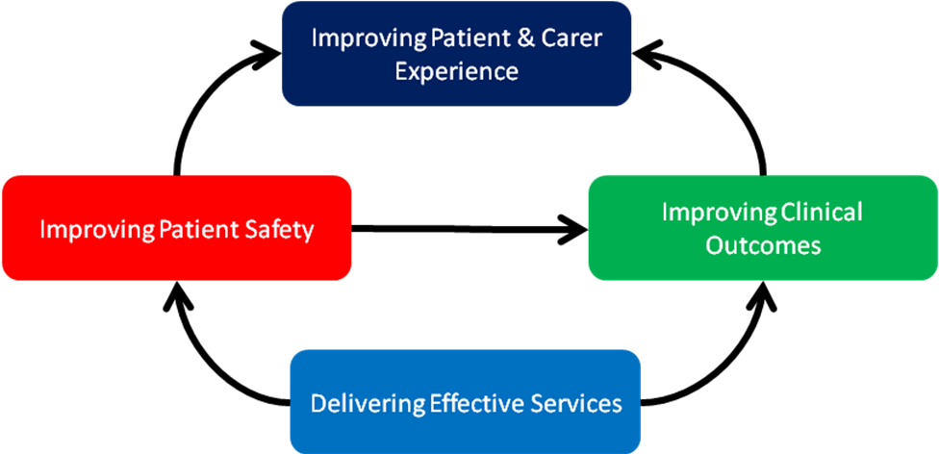

2.3 For 2013/14 the Trust set itself the following 12 key quality activities and 12 associated quality objectives:

Quality Goal | Quality Activity | Quality objective
Improving Patient Safety | - Specific improvements in patient safety  - Prevention of suicides  - Infection Control improvements  - Environmental Improvements | - People will not die prematurely.  - Patients will be protected from harm.  - Patients will be treated and cared for in a safe environment.
Improving Clinical Outcomes | - Develop & implement integrated care pathways for children and young people  - Develop & implement integrated care pathways for adults  - Develop & implement integrated care pathways for older adults | - The quality of life for people with long-term conditions will improve.  - Patients/service users will feel supported to manage their own conditions.  - People with long-term conditions will spend less time in hospital
Improving Patient and Carer Experience | - Trust-wide improvement of culture of care  - Improve patient & public engagement  - Measuring and Improving Patient, Carer and Commissioner Feedback | - Patients’ experiences of inpatient/outpatient services will improve.  - Responsiveness to patients' needs will improve.  - Patients’ access to community-based services will improve
Delivering Efficient & Effective Services | - Productive Care  - Use of technology to support care | - Utilisation of resources will be maximised.  - Time spent on patient care will be maximised.  - Patients/service users will progress through the care system in a timely way
2.4 To monitor progress against these activities and objectives, quality and safety metrics and measures are reported each quarter, some of which are nationally proscribed and some of which have been developed locally. Specific safety and quality improvement initiatives or projects underway within the Trust are reported every six months. Audits are reported on a six monthly cycle (at six and twelve months). Those measures with a specific target have been rated as red, amber or green (RAG) reflecting the Trust’s performance in achieving these. Measures without a target are not RAG rated.

2.5 Running alongside the Quality Account the Trust has been developing a safety and quality dashboard linked to our corporate objectives. These dashboards will describe the key indicators associated with quality and safety, and a range of measures to help us understand not only how effectively we are avoiding harm to patients but also how we are maintaining quality and improving outcomes.

3. Quarter 3 progress report: key highlights from Quarter 3

3.1 Improving Patient Safety

3.1.1 The Trust has sustained the increase in reporting of patient safety incidents, but there has been a substantial decrease in serious incidents reported in Quarter 3 compared with the previous 2 quarters.

3.1.2 The number of patients reported as absent without leave has dropped in comparison to the previous quarter

3.1.3 The number of medication near misses in Quarter 3 was 9 which shows a reduction since the last quarter.

3.1.4 The Community division has sustained the reduction in avoidable grade 3 or 4 pressure ulcers in the quarter

3.1.5 There were 50% fewer apparent community suicides compared with the previous quarter

3.1.6 There have been 12 confirmed cases of Clostridium Difficile Infection in the year to date, although only 1 has been deemed avoidable

3.1.7 Although the incidence of no harm according to the safety thermometer has remained at 90%, for quarter 3, this is still lower than the national results. Those areas with poorer results are developing specific actions for improvement.

3.2 Improving clinical outcomes

3.2.1 The number of patients being referred and being accepted for treatment in IAPT (psychological therapy) services continues to increase.

3.2.2 There was an increase in the percentage patients readmitted within 28 days of discharge in both adult and older adult mental health services.

3.2.3 The number of patients with a personal health budget continues to increase and the team has secured additional funding to expand the scheme and training.

3.3 Improving patient and carer experience

3.3.1 There is an encouraging increase in the number of local concerns being recorded, supporting an ambition to identify and resolve concerns as close to the patient and the event of concern as possible. This has been achieved by offering local PALS surgeries for inpatients and through local Have Your Say meetings for patients.

3.3.2 The net promoter score for Community Hospital wards has improved from +72.3 in Q1 to +85.3 in Q3. The nearest comparison is acute inpatient wards nationally at a score of 72 in Dec 2013. The net promoter score for the MIUs has remained about the same with +64.1 in Q1 +60.3 in Q3. The nearest comparison is the A&E departments nationally at a score of 56 in Dec 2013.

3.4 Delivering effective services

3.4.1 The choose and book programme has seen a roll out of this functionality across a number of services

3.4.2 The Trust has achieved all of its CQUINs with the exception of grade 2 and 3 pressure ulcers in community services (including older adult mental health). This does not measure where the pressure damage was acquired.

4. Improving Patient Safety: Quarter 3 progress report

4.1 Objectives for 2013/14
- People will not die prematurely.
- Patients will be protected from harm.
- Patients will be treated and cared for in a safe environment.

4.2 Progress against the detailed measures, with some commentary is contained in the table below

Measures and Targets | April-June | July-September | October -December | RAG rating
Unexpected deaths in inpatients (mental health services) reduced to 0, or greater than 300 days between deaths over 2 years | 0 | 0 | 0
Absence from wards without permission reduced by 50% from 192 detained patients in 2012/13 to 96 in 2013/14 | 66 | 67 | 55
The Safer care Programme has 4 wards working on AWOLs with a specific focus on failure to return from Section 17 leave as the largest category of patients reported AWOL. Chaffron is counting days since the last incident and has achieved 330 days since the last reported AWOL. Patient information leaflets for all patients have been ‘approved’ by the CQC and provide information about taking leave from the ward, and of the expectations of the ward with respect to informal patients. Phoenix is testing a signing in and out book and contact cards. They have achieved a 30% reduction in failure to return, and a maximum of 11 days between AWOLs in December. Kimmeridge is using a questionnaire with patients when they return from leave and they have achieved a maximum of 47 days with no AWOL between 21st Nov 2013 and 8th Jan 2014. Allen is testing planned therapeutic leave in ward review and has achieved a maximum of 6 days between AWOLs.
Reduction in number of medication near miss events which results in harm (defined as 3, 4 or 5 in severity) | 6 (28 in 12/13) | 12 | 9
Action on the Fiennes Unit to reduce medication events has looked at unattributed blank boxes on medication forms. In their July/ Aug 2013 audit, there were 203 unattributed blank boxes on the medication forms. In Dec/ Jan the audit revealed only 8 blank boxes, with the remaining 166 being clearly coded. The reduction has been achieved by daily monitoring of all medications charts

Harm from falls (defined as 3, 4 or 5 in severity of outcome) reduced by 50% from 5.1 per 1,000 bed days in Mental Health Hospitals and 10.1 per 1,000 bed days in Community Hospitals in 2012/13 to 2.6% and 5.6% respectively in 2013/14 | Mental health 5.1%  Community services 10.1% | Mental health 6.9%  Community services 9.9% | Mental health 4.6%  Community services 9.7%
Avoidable pressure ulcers (grade 3-4) reduced to 0 | 7 (19 in 2012/13) | 3 | 3
100% of patients treated by the district nursing services to be assessed for pressure ulcers on first visit (Walsall assessment) | N/A | 100% | N/A
% of patients with (MUST) nutritional assessment (Target 85%) | N/A | 100% (district nursing) | N/A
% of patients admitted to psychiatric wards with a complete physical health assessment (target 98%) | N/A | Essential Standards audit results for July 13 show 97% compliance across mental health wards and units | Essential Standards audit results for October 13 show 97% compliance across mental health wards and units
95% compliance with VTE (venous thromboembolism) risk assessment and appropriate prophylaxis in all Trust services | 97.51% trust wide  Community hospitals 93%  OA inpatients 87.5% | 96.68% trust wide  Community hospitals  Older adult inpatients 98.63% | Community Hospitals 92.3%  Older Adult inpatients 100%
95% compliance with triggering of physical deterioration intervention in all community services | 95% | 94.1% | 97%
Number of new catheter associated urinary tract infections (UTIs) infections across all Trust services | 6 | 7 | 7
No inpatients to commit suicide | 0 | 0 | 0
Reduction in the number of (apparent) community suicides towards 0 or greater than 300 days between deaths | 8 | 11 | 5
The Community Acute Services achieved 483 days between deaths by probably suicide after commencing a specific safer care project. Following a death in the previous quarter they have subsequently achieved a further 140 days since. The current “days since...” stand in comparison to a mean of 62 days between deaths prior to the safer care project in May 2012. Plan now agreed with Mental Health Safer Care lead to develop the work in the new Assessment Teams for Emergency referrals.
Level of hand hygiene scores maintained at greater than 95% in inpatient settings | Overall compliance in mental health was 93% and 100% in community hospitals (conducted in May 2013) | Average for July and September 2013 within Mental Health wards = 92%  Average for July and September 2013 for Community Hospitals = 100% | Average for November 2013 within Mental Health wards = 93%  Average for November 2013 for Community Hospitals = 100%
Bare below the elbows audit | n/a | Average for July and September 2013 within Mental Health wards = 92%  Average for July and September 2013 for Community Hospitals = 99% | Average for November 2013 within Mental Health wards = 93%  Average for November 2013 for Community Hospitals =100 %
Number of unsatisfactory environmental infection control audits and number of re-audits | N/A | 40 completed,  11 were unsatisfactory and will require re-auditing | 26 completed,  8 were unsatisfactory and require re-auditing
Environmental audits | n/a | 86% | 86%
Number of bacteraemia infections developed 48 hours post-admission should not exceed 2 | 0 | 0 | 0
Reduce overall number of Clostridium Difficile infections (CDI) developed 72 hours post admission (should not exceed 8) | 2 | 4 | 6
There have been 12 cases of CDI for the year to date and each case is reviewed at a monthly health economy meeting. Of the 11 cases reviewed
- 9 were deemed unavoidable
- 1 was avoidable as this patient was already known to be positive and was inappropriately retested
- 1 case was not classified due to insufficient data, however management was correct and antibiotic prescribing was within guidelines
Number of incidents reported (with a view to improving incident reporting and therefore increasing the number of incidents reported) | 2763 | 2979 | 2946
Number of serious incidents requiring investigation | 21 | 25 | 14

4.3 The overall number of reported incidents remains at more than 2900, supporting the continued drive within the Trust to create a good reporting culture. Overall the number of serious incidents in the same time period has reduced considerably.

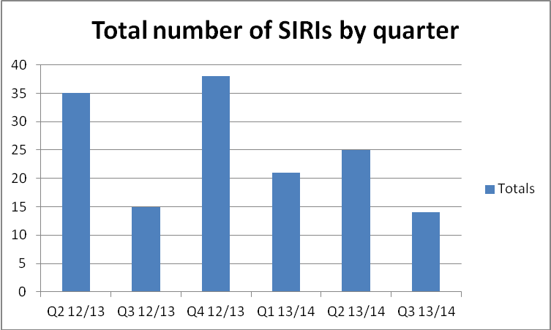

4.4 Safety Thermometer
4.4.1 Within OHFT the amount of harm free care has increased over the past three months, but is still slightly below the national average. The Safety Thermometer is a point prevalence measure which takes the incidence of harm at a fixed point in time.

OHFT:
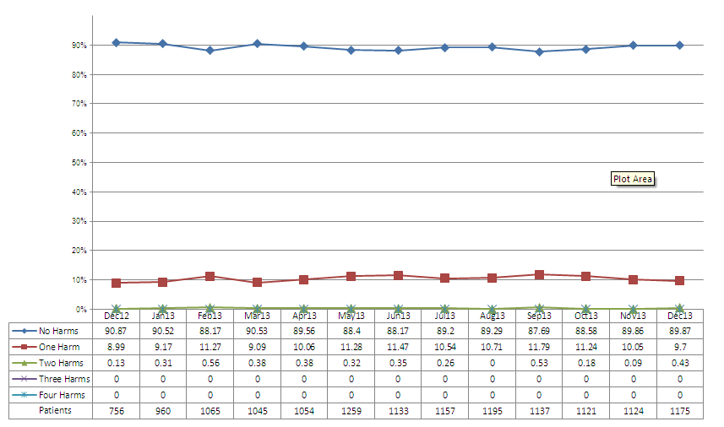

National figures
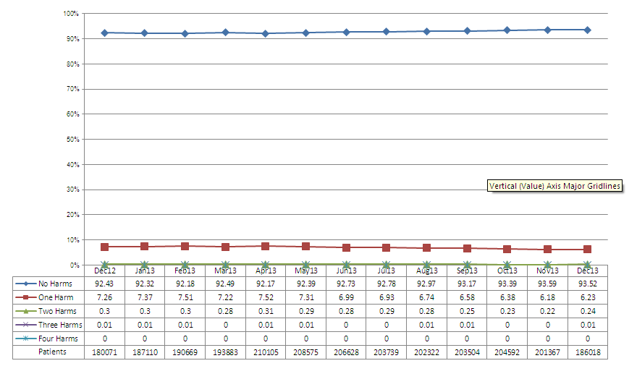
4.4.2 Positive improvement:
- Harm free care percentage increased to 89.87%
- There was a reduction in all harm and all of the harm categories with the exception of new VTE. The data shows 2 patients with new VTE for community nursing which is in fact a data entry error as this is a not applicable category for non- inpatient teams
- Community hospitals, community nursing and older adult CMHT’s saw a reduction across nearly all of the harm categories

4.4.3 Negative change in results:
- There was a slight reduction in VTE risk assessments, this was due to a slight decrease across community hospitals
- Community nursing mixed teams saw a slight increase in all harm which was attributable to an slight increase in catheter/UTI’s
- Rehabilitation saw an increase in all harm and was solely attributable to pressure ulcers.

5. Improving Clinical Outcomes: Quarter 3 progress report

5.1 Objectives for 2013/14
- The quality of life for people with long-term conditions will improve.
- Patients/service users will feel supported to manage their own conditions.
- People with long-term conditions will spend less time in hospital.

5.2 Progress against the detailed measures with some commentary is contained in the table below

Measures and Targets | April-June | July-September | October-December
% of adult service users on CPA in settled accommodation | 77.8% | 79.1% | 79%
% of adult service users on CPA in employment | 13.1% | 13.6% | 13.3%
Number and % of patients receiving follow-up contact within seven days of discharge from mental health wards | 96.4% | 98% | 96.6%
Number of patients with long term conditions (LTC) receiving psychological therapies (IAPT) | Bucks Healthy Minds  Referrals with LTC  357 = 19.48%  Entered Treatment with LTC 383 = 26%  Talking Space  Referrals with LTC  433 = 24.55%  Entered Treatment with LTC 322 = 26.70% | Bucks Healthy Minds  Referrals with LTC 422 = 21.44%  Entered Treatment with LTC 364 = 26.73%  Taking Space  Referrals with LTC  482 = 28.55%  Entered Treatment with LTC 360 = 26.85% | Bucks Healthy Minds  Referrals with LTC 543 = 26.67%  Entered Treatment with LTC 443 = 30.49%  Talking Space Referrals with LTC 441 = 23.48%  Entered Treatment with LTC 381 = 26.02%
Healthy Minds - Improving access to psychological therapies for people with LTC continues to be a key priority for the Healthy Minds service. In 2013-4 the service was successful in receiving Department of Health funding for the Breathe Well project year 2 to continue the roll-out of services for people with Chronic Obstructive Pulmonary Disease (COPD). Funding was also received from Aylesbury Vale CCG to develop an innovative pilot primary care based service for people with LTC in 5 GP practices – the Live Well project. As can be seen from the data the percentage and absolute numbers of people with LTC referred and entering treatment in the service continues to increase

Talking Space - Talking Space has received greater numbers of referrals this year , and greater numbers of those referrals are people with LTC. Last year we received a total of 1034 referrals with LTC, and already by end of Q3 we had received 1356, indicating a predicted in year increase of over 7%. Likewise last year a total of 906 people with LTC entered treatment, and already by end of Q3 we have treated 1063, indicating a predicted increase of over 50%.

These positive trends reflect the additional investment from the CCG for LTC work and the pilot project for the DH IAPT pathfinder site Heart2Heart for people in cardiac rehabilitation (shortlisted in Secondary Care Innovation and Redesign HSJ Awards November 2013). We also undertook local development work to stream line pathways for patients with diabetes, stroke and chronic fatigue. Next year we aim to increase our offer to those with COPD as Healthy Minds has done.

Number and % of patients readmitted within 28 days of discharge (mental health services) | Adults - 7.6%  Older adults - 3.4% | Adults - 8%  Older adults - 3% | Adults - 11.3%  Older adults - 5.2%
Number of patients admitted to acute wards who had access to crisis resolution home treatment teams acting as gatekeeper | 99.1% | 98% | 98.4%
Number of patients/service users with Personal Health Budgets (PHB) – figures current rather than cumulative | Total = 95 | Total = 98 | Total = 107
- The personal health budget team was successful in becoming the Peer Support team in SE England for NHS England for the roll out of personal health budget. It has been successful in gaining support from NHS England to lead on their behalf the development of accredited training for Personal Assistance. The team has linked with Skills for Health and Oxford Brooks University and have found an approved centre of an awarding organisation offering QCF regulated qualifications in health
- OHFT have applied to be a pilot site with NHS England to deliver personal health budgets in Children’s continuing healthcare, having been working closely with In Control over the past 6 months and successfully already moved 5 families across to a personal health budget
- The pilot in physiotherapy has been evaluated and shown to be successful and very well received by users. The team is now working with commissioners on how to make the learning substantive and is presenting at the Physical Disability Partnership Board on January 20th.

6. Improving Patient and Carer Experience: Quarter 3 progress report

“Seeking and acting on patient feedback is key to improving the quality of healthcare services and putting patients at the centre of everything we do.”

6.1 Objectives for 2013/14
- Patients’ experiences of inpatient/outpatient services will improve.
- Responsiveness to patients' needs will improve.
- Patients’ access to community-based services will improve.

Measures and Targets | April-June | July-September | October-December
Number of complaints | 48 excluding MP queries and local concerns. | 57 excluding MP queries and local concerns | 56 excluding MP queries and local concerns
Number of complaints responded to within an agreed timescale | 36 | 31 (22 remain open) | 36 (17 remain open)
Number of PALS cases | 114 | 234 | 322
Delayed Transfers of Care (DTOC) Community hospitals snapshot | April 35,  May 44,  June 26 | July 32  August 35  September 33 | Not yet available
Friends and Family measures | Overall 331 people responded in Q1, giving a response rate of 3.8%  F&F Test net promoter score  Community Hospitals = 72.3  MIUs =64.1 | Overall 548 people responded in Q2, giving a response rate of 5.9%.  F&F Test net promoter score  Community Hospitals = 75.7  MIUs =55.9 | Overall 696 people responded in Q3, giving a response rate of 8.7%.  F&F Test net promoter score  Community Hospitals = 85.3  MIUs =60.3
Responses Rate
The response rate for the MIUs has been increasing from May-Dec 2013, with the highest number of responses in one month in Dec 2013 at 232. The response rate for the Community Hospital wards has been fairly consistent, however the highest number of responses in one month was received in Dec 2013 at 25.

Net Promoter
The net promoter score for the Community Hospital wards has improved with Q1 at +72.3 and Q3 at +85.3. The nearest comparison is the acute inpatient wards nationally at a score of 72 in Dec 2013.

The net promoter score for the MIUs has remained about the same with Q1 at +64.1, Q2 at +55.9 and Q3 at +60.3. The nearest comparison is the A&E departments nationally at a score of 56 in Dec 2013.

The main area identified by patients for improvement is communication about waiting times at two of the busiest MIUs. Actions taken include ensuring waiting time indication boards are updated, staff informing patients of current waiting times when they check in, and posters/ leaflets developed to explain the difference for those people who have gone via the out of hours services so have a booked appointment and people who have walked straight into the MIU.
100% of mental health service users to have opportunity to be engaged in development of care plan | N/A | 48/51 (94%) | Not yet available
100% of MH service users on CPA to have:  - Current care plan  - Care reviewed in last 6 months  - Care co-ordinator  - Risk assessment reviewed in last 12 months | N/A  N/A  N/A  N/A | 5089/5790 (88%)  4116/5790 (71%)  5790/5790 (100%)  5144/5790 (89%) | Not yet available

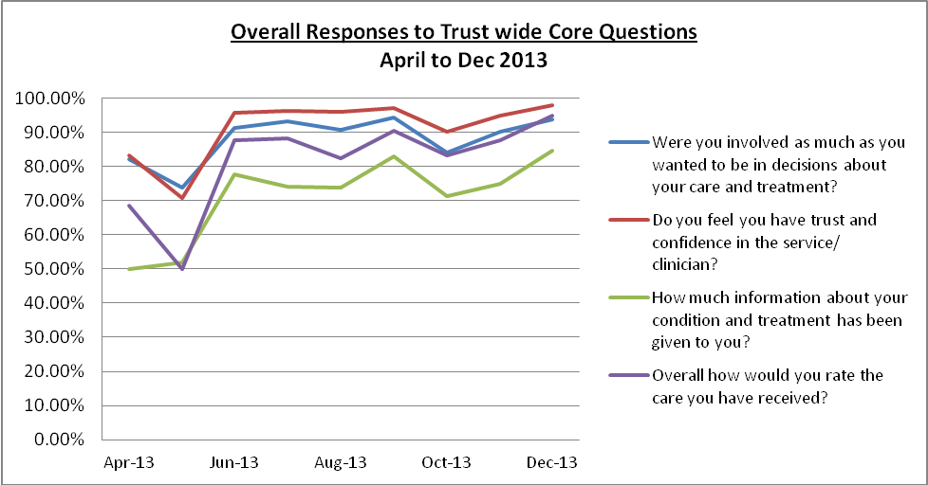

For all four questions the number of positive responses has increased from April 2013 to November 2013, and this is reflected for all the Divisions. The question where most improvement is still required is around patients being given the right amount of information; for a large number of patients they feel they are not receiving enough information.
6.2 Community Services patient survey
6.2.1 Patient feedback is essential for monitoring whether patients feel involved in their care. Patient feedback for Oxfordshire Community Services between October 2013 and December 2013 is summarised below (Q3 results):

6.2.2 The Trust has sent out 7,766 surveys to date in 2013-14, from which there has been a 28% response rate. This is an encouraging figure.
- When patients were asked if they were as involved in decisions about their care as they wanted to be, 72% reported being as involved as they wanted to be, 22% reported being involved to some extent and 6% reported that they were not as involved as they wanted to be. These figures have not changed since the end of Quarter 2.
- 85% reported having received the right amount of information about their condition and treatment, 15% reported not having received enough and fewer than 0.01% reported having received too much. These figures have not changed since the end of the previous quarter.
- 83% of patients reported that they definitely had trust and confidence in their caregiver/member of staff, 14% had trust and confidence to some extent and 2% reported that they did not. These figures have not changed materially since the previous quarter.
- With regard to overall satisfaction, 62% of patients rated their care as excellent, 30% rated it as good, 6rated it as fair, 2% rated it as poor and 1% rated their care as very poor. These figures are similar to those from the end of 2012-2013.
6.9.3 All services who have received survey results up to December 2013 are scheduled to complete an action plan, if issues arise, which will be based on results of individual questions and comments made by respondents.
Action plans have identified 3 major themes across the Division
- Communication (eg explanation of waiting times in MIU; hospital discharge information)
- Staffing levels/service frequency (eg ward staff numbers; MIU waiting times; frequency of District nursing visits)
- Involvement (eg knowledge of/involvement in creating care plans)

Remedial actions have generally been designed using 3 broad approaches:
- Communication/Reinforcement of best practice (eg discussion of results at staff meetings, email reminders to staff; closer management of statutory and mandatory training)
- Changes to literature (eg (re)design of patient leaflets; (re)design of service website)
- Staff tools/documents (eg creation of form for communicating meal preferences to hospital caterers; creation of Re-ablement first visit checklist)

There are further, more specific, actions planned, such as an investigation to confirm that ward call bells are functioning, and activity dealing with cleanliness in Out Of Hours waiting rooms.

7 Delivering Efficient & Effective Services: Quarter 3 progress report

7.1 Objectives for 2013/14
- Utilisation of resources will be maximised.
- Time spent on patient care will be maximised.
- Patients/service users will progress through the care system in a timely way.

7.2 Productive Care

Reasons for inclusion
To release increasing amounts of time to care, thus improving quality and patient/service user experience.
Aims | Current Position
Roll out improvement programme to clinical services within the remaining parts of Community Services Division | Supporting Pressure damage prevention strategy .Agreed and implementing handover framework and referral into service form.
Implement the Productive Care foundation module in Universal , Children and Families Division | Introduced to CAMHS teams .
Implement the Productive Care sustainability model in Mental Health | AMHT’s improvement work supported in improving handover and duty desk rostering
Support Specialised Services Division: Forensic Wards and Mental Health services in prisons | Dentistry service to launch in Q2
Host events to promote learning across organisation | 3 events held in Banbury, Thame and Oxford  Post event newsletter circulated

7.3 Choose and book update

7.3.1 Background
Oxford Health NHS FT has chosen to implement the directly bookable method as we believe this provides the most benefits to the GP Practice, the patient and Oxford Health services.

7.3.2 Directly bookable appointment means the patient is able to leave the surgery with an appointment location, date and time or have the information to book their own appointment at a later time.

7.3.3 The key benefits of a directly bookable system are identified as follows:
 | Benefits
GP Practice | - Fewer phone call queries from patients chasing referrals  - Fewer patients making repeat appointments to find out about the progress of their referral  - Immediate documented information about the progress of an individual patient’s referral  - Full directory of all services available  - No lost referral letters  - Simple referral process – reduces the amount of paperwork
Patient | - Certainty of having an appointment immediately rather than having to wait for a letter from the service they have been referred to  - Choice of a place, date and time that suits them, fitting in with childcare, carers, work and other responsibilities  - Minimises the need for follow up visits to GP to check referral status  - Easy to change appointment date and time
Service | - The service can save administration time as patients do not need to contact the service to book an appointment or change an appointment  - There is reduced risk of referral correspondence going missing in the post or being faxed to the wrong location as the referral process is electronic

7.3.4 The following services are currently live on Choose and Book:

- Podiatry - go live 01/12/2012
- MSK Physiotherapy - go live 21/01/2013
- Community Dietetics - go live 09/09/2013
- Enhanced Care Diabetes Service - go live 09/09/2013
- Memory Clinics Oxfordshire - go live 23/09/2013
- Memory Clinics Buckinghamshire - go live 06/01/2014
7.3.5 The following services are currently being explored as being potentially suitable for Choose and Book:
- Older Adult Community Mental Health Teams - planned for 2014/15
- Adult Community Mental Health Teams - planned for 2014/15

7.4 Participation in Audits

Audit or Inquiry | Participation (Yes or No) | Number of cases required by Teams | Number of cases submitted
POMH-UK Topic 4b: Prescribing of anti-dementia drugs | Yes | n/a | N=183
National Audit of Schizophrenia | Yes | 80 | 96

7.5 CQC Quality Risk profile
Outcome | Q1 June 2013 | Q2 Nov 2013  (as no profiles for Sept & Oct 2013) | Dec 2013  (latest profile)
Section 1 - Involvement & Information
1. Respecting and involving people who use services | High Yellow | High Yellow | High Yellow
2. Consent to care and treatment | Low Yellow | Low Yellow | Low Yellow
Section 2 - Personalised Care
4. Care and welfare of people who use services | Low Green | High Green | High Green
5. Meeting nutritional needs | Low Yellow | Low Yellow | Low Yellow
6. Cooperating with other providers | Low amber* | Low Amber* | Low Amber*
Section 3 - Safeguarding and Safety
7. Safeguarding people who use services from abuse | High Yellow | High Yellow | High Yellow
8. Cleanliness and infection Control | Low Green | Low Green | Low Green
9. Management of medicines | High Yellow | High Yellow | High Yellow
10. Safety and suitability of premises | Low Yellow | Low Yellow | Low Yellow
11. Safety, availability and suitability of equipment | Low Yellow | Low Yellow | Low Yellow
Section 4 - Suitability of Staffing
12. Requirements relating to Workers | Low Yellow | Low Yellow | Low Yellow
13. Staffing | High Yellow | High Yellow | High Yellow
14. Supporting staff | Low Yellow | Low Yellow | Low Yellow
Section 5 - Quality & Management
16. Assessing and monitoring the quality of service provision | Low Yellow | Low Yellow | Low Yellow
17. Complaints | Low Yellow | Low Yellow | Low Yellow
21. Records | Low Green | Low Green | Low Green
* risk rating due to delayed transfers of care in Community Hospitals attributable to social care, negative comments from Children Serious Case Reviews from 2011 and negative comments from Children’s Service (whole system)

7.6 CQUINs
7.6.1 Fully achieved with the exception of the Safety Thermometer – grade 2 and 3 pressure ulcers in the community division, including older adult mental health.

7.6.2 The CQUIN for this is based upon reducing the prevalence of pressure ulcers based on the year out turn 2012-13. The following provides an overview of pressure ulcers. The national trend shows a reduction, however the trust has recorded a higher prevalence of pressure ulcers in nearly every category.

Percentages | Grade 2-4 | Grade 2 | Grade 3 | Grade 4
All organisations (Q4 1213)
All | 4.67 (5.32) | 3.05 (3.50) | 1.03 (1.17) | 0.58 (0.64)
Old | 3.66 (4.13) | 2.3 (2.61) | 0.83 (0.96) | 0.51 (0.56)
New | 1.01(1.27) | 0.75(0.96) | 0.2(0.23) | 0.07 (0.08)
Oxford Health (Q4 1213)
All | 7.74(7.01) | 5.62(5.24) | 0.77 (0.68) | 1.36 (1.10)
Old | 6.29 (5.07) | 4.51 (3.63) | 0.68 (0.51) | 1.1 (0.93 )
New | 1.45 (2.20 ) | 1.11(1.61) | 0.09 (0.34) | 0.26 (0.25)

7.6.3 It is worth noting that these figures cover all pressure ulcers (including pressure damage already sustained prior to admission to our services) and is therefore not indicative of the damage occurring whist the patient was in receipt of our care.

