
Children’s Community Occupational Therapy
Crossing Midline
What is it? Crossing midline means that one hand spontaneously moves over to the other side of the body to work there. Before this ability is established, you may have noticed that the young child tends to use the left hand on the left side of the body and the right hand on the right side of the body. Crossing midline is the ability to use each limb/eye on both sides of the body to cross the midline.
Midline: imaginary line drawn vertically down dividing the body in to two equal parts.
Why is it important? : When your child spontaneously crosses the midline with the dominant hand, then the dominant hand is going to get the practice that it needs to develop good fine motor skills. If your child avoids crossing the midline, then both hands will tend to get equal practice at developing skills, and your child’s true hand dominance may be apparently delayed. This skill is necessary to be able to write and read from left to right, to establish a dominant hand and to take part in gross motor activities such as bat and ball games.
How you can help: Encourage the child to sit straight in their chair and to not twist whilst sitting at a desk.

- Offer you child plenty of every day opportunities to handle small objects (if safe and appropriate) to practice using their index finger to point and isolate fingers for play e.g. play finger soccer, use key pad gadgets see activities below

How to help development of midline crossing: (children typically develop this skill from the age of 6 months).
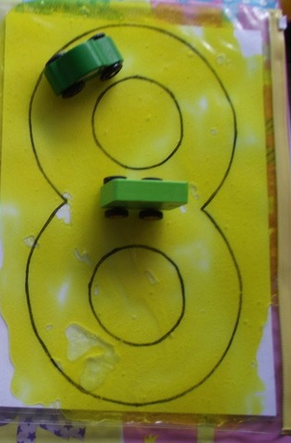
- Do not let the child swap hands when drawing, reaching, etc. Hold the other hand or have it stabilising the activity.
- Position objects so the child has to cross the midline when reaching.
- Ensure your child is sitting with a comfortable and supported posture (e.g. feet on the floor, and elbows resting on the table at a 90 degree angle) or is standing up at a vertical surface.

The following is a list of games and activities to help develop crossing midline:
- Race cars around a figure 8 picture with one hand and then the other
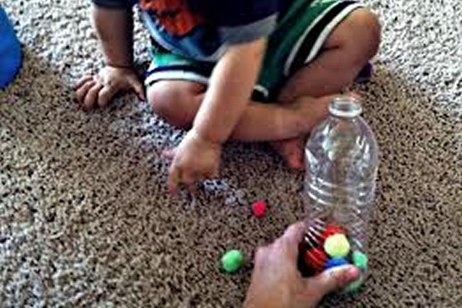
- Container play- place the containers about a metre apart the child sits or stands in the middle and moves objects from one container to the other. Left to right and vice versa.
- Simon says- ask the children to copy your body positions e.g. left hand on right knee, left hand on right ear etc.
- Hand clapping songs which involve crossing midline ‘ A sailor went to sea, sea ,sea ‘
- Printing either rubber stamps or potato prints. Have a strip of paper running horizontally in front of child and stamp left to right and vice versa.
- Doing a Brain Gym cross crawl activity helps to develop better coordination of the two body sides. It is said to activate full mind and body function.
- Drawing large shapes on a blackboard or whiteboard where the child crosses the body midline (must be standing directly in front of board with no movement of the feet). This can be a chasing game with an adult drawing a line and the child having to follow. Or, you could fill a large area with lots of swirling shapes and patterns and ask the child to colour them in.

