Children’s Community Occupational Therapy

Pre-Scissor Skills
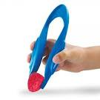
To develop a scissor grasp prior to using scissors:
Pick it up
- Using salad tongs or other tong-type tools ( e.g. tweezers) get the child to pick up objects (e.g. marshmallows, cotton wools balls, plastic blocks etc.) and drop them into a bucket. Make it a race between two who can collect the most items in one minute. Try using different texture/firmness of objects
Squirting games
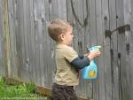
- Using water pistols or bulb-squeezing squirters get the child to spray balloons that have face drawn on them with shaving cream.
- In the bath or outside, squirt at each other / target e.g. boat using squirting toys / fish or washing up bottle
- Squirt water into a pan of soapsuds to make more bubbles
Sponge games
- Squeeze soaked sponges to wipe / clean car and windows.
- Squeeze sponges in soapy water to make bubbles, pop bubbles by pinching / snipping with fingers.
- Squeezing sponges to move the water from one bucket to another, as quickly as possible.
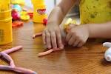
Play dough
- Rolling into a snake and pinch the head off!
- Pulling snake to make him longer and poke holes for eyes.
- Poking snake to make a creature e.g. worm
Paper games
- Tearing and shredding paper into strip with both hands, one moving forwards and the other backwards. The tear may need to be started by adult.
- Scrunching up paper into ball, initially using two hands then one hand.
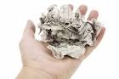
- Flick paper balls into target, using whole hand initially then finger and thumb flick.
- Using a hole puncher, punch holes in paper. Try punching holes around the edges of an A4 sheet of paper. Try using card, foil and other materials.
Hand games
- Action songs Incy Wincy Spider, finger puppet games, finger cymbals

