Children’s Community Occupational Therapy

Hand Warm Ups
Why is it important?: It is important to warm up the hands prior to do fine motor activities and handwriting to help give the body an increased awareness of where the hands are in order to aid coordination and control.

- Rub your hands together until they’re warm – up and down and round in circles.

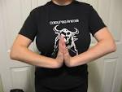
- Push your hands together in a prayer position and hold for 5 seconds…then try again.

- Open hands wide and stretch out your fingers and close them tight to hide them away.

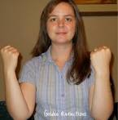
- Drum your fingers on table top like thunder - tap just your index finger, then your middle finger, ring finger etc. Maybe you could try and make a tune?

- Using the other hand, squeeze down each forearm and hand firmly
.

- Pull down each finger like taking off a glove – wrap other fingers over finger and run down fingers.

- Oppose thumb to each fingertip in turn (may need hand over hand assistance on some fingers). Increase the difficulty by doing both hands together, or with eyes closed.

- Make a circle using your thumb and index finger, then do the same with the other hand but connect it through the circle already there…now pull them against each other.

- Place hands either side of chair seat and lift bottom up in the air

