Children’s Community Occupational Therapy

Writing Posture
It is essential that before the child starts to write they are sat with a good symmetrical posture, with correct height table, see below:
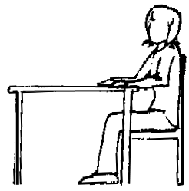
- Bottom well back in the chair
- Knees in line with the hips
- Feet flat on the floor, a stable footrest may be used
- Both arms resting comfortably on the desk, without causing the shoulders to shrug

- When copying from the blackboard or observing a demonstration, the child should sit facing straight on.
- The paper should be angled correctly for left or right hand function
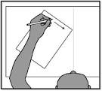
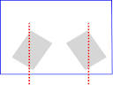

Left Left Right

- Encourage child to stabilise paper with the free hand

- A writing slope may be beneficial for children who often lean on the desk, it can help to promote better head, body, arm and wrist position. An empty lever arch file can be used.
