

**Children’s Integrated Therapies North/South/Central**

**Admin Contact:**

**Developing cutlery skills:**

**Recommendations for**: **Date:**

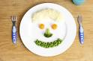

Using cutlery is a daily living activity that needs to be practiced on a regular basis to develop efficient skills. Here are some tips.

* 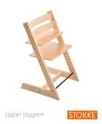Ensure your child’s chair is at a good height and their feet are supported. Also ensure their elbows are resting comfortably, allowing easy forearm movement across the table surface. Adjustable height chairs wooden chairs for children such as a Tripp Trapp (Stokke) chair offer a good stable position.
* Consider your child’s position at the table in relation to other people – where is the best position for him/her to limit distractions.
* Try using a non-slip Dycem or other non-sip matting under the plate or even on the seat (this often helps to minimise slipping and sliding and wriggling on the chair). If a cushion is used ,it should be firm and supportive.

[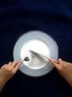](http://www.google.co.uk/imgres?imgurl=http://citymama.typepad.com/.a/6a00d8341c933a53ef0134850fe238970c-320wi&imgrefurl=http://www.citymama.com/tutorials/&usg=__h6R5vvnlKG5ssi0sLzdJcUABkIc=&h=427&w=320&sz=13&hl=en&start=26&zoom=1&tbnid=sA8cYabuo8aoRM:&tbnh=126&tbnw=94&ei=9d1vUdK2IKmJ0AWv3YCQBw&prev=/search?q=children+using+a+knife+and+fork&start=20&safe=active&sa=N&hl=en-GB&gbv=2&tbm=isch&itbs=1&sa=X&ved=0CDYQrQMwBTgU)

* Show your child how to hold the cutlery in the correct hands and position. Use cutlery with thicker or ergonomically designed handles to assist your child’s grip
  + for younger children (3 – 7) try the steady cutlery [www.steadyco.com](http://www.steadyco.com)

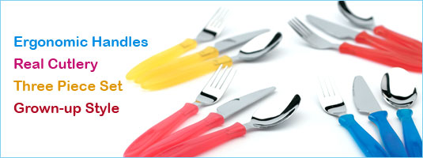or junior caring cutlery. 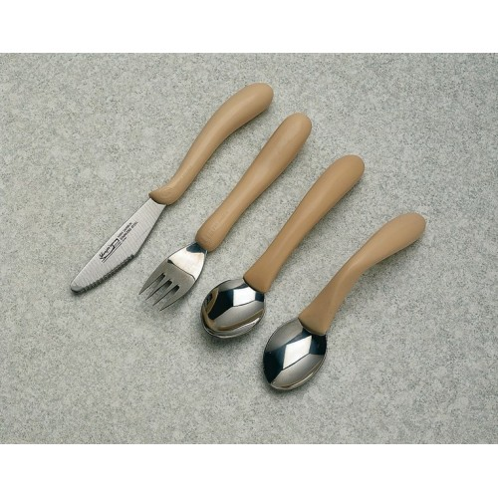

* + for older children the adult **caring cutlery range** available for purchase through Amazon.
  + Sometimes using a **steak knife** with a serrated edge is helpful as this cuts food more easily requiring less pressure for the child and gives quicker reward for effort. Adult supervision is recommended as this type of knife is much sharper of course.
* Practice using a knife and fork at times other than mealtimes. Practice with play dough – roll into a sausage and cut through. You could hide little beads in the dough and when a section is cut squeeze the dough to see how many beads are in the section cut – take turns. Alternatively practice using a knife to cut up bananas for a fruit salad or milk shake. Cut up biscuit dough. Cut mushrooms.

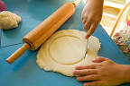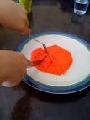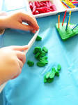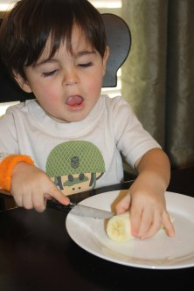

**Therapist Name: Children’s Community Occupational Therapist**

**Contact details: mobile/office**