

BOD 103/2014
(Agenda item: 7)

Report to the Meeting of the

Oxford Health NHS Foundation Trust

Board of Directors

24 September 2014

Quality and Safety Report
Quarter 1 2014/15

For Information
This report outlines current progress, including areas of concern or priorities across our trust in relation to quality and patient safety for quarter 1 (2014/15). It draws on reports on incidents that have been submitted to the Integrated Governance Committee and the Safety Committee where these reports were reviewed in detail. The areas covered are:

- Patterns of reported incidents (including pressure ulcer prevention and AWOLs)
- Restraint and seclusion reporting
- Serious incidents requiring investigation
- Safer care and productive care programmes
- Infection prevention and control
- General quality update
- Trust wide status report against CQC Outcomes
- Learning and development report
- Leadership, team and individual skills (LTIS)
- Patient and personal safety training (PPST)

Recommendation

The Board is asked to note the report.

Author and Title:
Tehmeena Ajmal, Head of Quality and Safety; Rebecca Kelly, Learning from Incidents Lead; Gavin Garman, Head of Nursing, Specialised Services; Helen Bosley, Infection Prevention Control Matron; Jill Bailey, Consultant Nurse and Safer Care Lead, and David Slingo, Head of Learning and Development

Lead Executive Director: Ros Alstead, Director of Nursing and Clinical Standards

- A risk assessment has been undertaken around the legal issues that this paper presents and there are no issues that need to be referred to the Trust Solicitors.
- This paper provides assurance and evidence against the Care Quality Commission Outcome: 4, 5, 7, 8 and 16.

Summary of report

Incidents and serious incidents requiring investigation

Quarter 1 has shown an increased number of reported incidents, with the increase being represented by incidents which have been graded as green and yellow (no or minor harm or damage to property). The increase in incidents does not therefore equate to an overall increase in the level of harm. There has been a significant improvement in the number of incidents in web holding awaiting managerial review which have decreased by 60%.

Health related incidents are now one of the top six reported incidents along with violence and aggression, self-harm, medication incidents, fall-related incidents and communication/confidentiality.

This quarter there were seventeen reported SIRIs which is a slight increase on the previous two quarters, although this remains much lower than the majority of the preceding six quarters. If the reported numbers remain at the level seen this quarter then the trajectory would see an end of year report indicating further (albeit slight) reduction over the last 3 years. There were fewer suspected suicides in quarter 1 and no inpatient suicides reported.

Reporting on incidents using the new teams and directorate structures has still not been made to the Safeguard system, therefore the report continues to use the historical team structure. The revised completion date for migrating data is now October 2014.

Restraint and seclusion
There were 358 reported incidents of physical restraint in quarter 1. Totals for the previous four quarters were 406, 293, 338 and 351. The mean number per month for the last eighteen months is 117.

The pattern by quarter shows a common cause, though the figure has risen now for four consecutive quarters. However, there has been a sustained decline in the use of prone restraint and the use of pain.

Violence and aggression (55% of all incidents) followed by self harm (30%) were the primary reasons for restraint.

The total number of reported seclusions in Quarter 1 was 68, compared to 44, 66, 59 and 77 in the previous four quarters. The mean per month for the year of 2013/14 was 20.5, for this quarter it was 23. Nearly all incident reports continue to detail violence and aggression as the cause for seclusion. The other reasons over the last 3 months related to self-harm and attempts to abscond.

The data does not suggest that ethnicity is a factor in whether or not a patient is likely to be restrained; however, there may be further work required to understand the impact of ethnicity on the decision to seclude.

The PEACE Team have concluded its project to identify alternative training and has decided to develop a new training programme in-house. A Business Case is being developed for approval by the Executive in September.

Infection prevention and control
There was one case of Clostridium Difficile Infection in the first quarter which was peer reviewed as being unavoidable. There were no cases of MRSA and MSSA bacteraemia in the Trust and four cases of E.Coli bacteraemia. Hand hygiene and bare below the audits demonstrate good compliance. The target of 100% of eligible staff completing the infection prevention and control training has not been met.

Safer Care and Productive programmes
A number of safer care projects are underway in each of the three directorates focusing on reduction in the use of restraints; reduction in failure to return; improved nutrition for inpatients; reduction in self-harm and suspected suicide; reduction in harm from falls; and reduction in medication omissions.

Productive care projects are taking place in all three directorates and include supporting the move to the new Whiteleaf building; demand and capacity and a single assessment process in CAMHS; and work on continuing care, venous leg ulcer pathway and community hospitals.

Learning and Development
A wide range of clinical and professional programmes have been delivered including a first person on scene course for HCAs; a physical skills course for mental health nurses; and clinical updates and study days for all professions. Our trust wide preceptorship programme continues to offer support to newly qualified employees.

A range of courses to develop specific skills and leadership have been offered including tissue viability; dietetic team leadership; interview skills for staff displaced by the closure of the Fiennes Unit; therapist leadership skills; and bespoke team development. The PDR system is being reviewed to support a values-based approach to performance review. Development has commenced on a programme for new managers along with a senior managers development programme and an internal coaching programme.

At the end of 2013/14 our overall performance for all levels of patient and personal safety training (PPST) was 88%. This excludes staff not available for training for example due to long term sickness, maternity leave or secondments. At the end quarter 1, 2014/15 the overall PPST performance was 84% as a result of directorate restructuring and the removal of phased training targets.
The target for performance development reviews is 100%; however the position at the end of the first quarter was 56%. The requirement to complete all PDRs within three months does affect the reported percentage at the end of the first quarter and this will be reviewed for the next financial year. Current performance is being reviewed weekly with operational managers.
Quality and Safety Report
1. Incidents and serious incidents requiring investigation (SIRIs)
The current report continues to be based on the old divisional structure as the data is drawn from the safeguard reporting system which has not yet been updated with the new directorate structure and teams. The information project to reallocate and align services with new directorates is not yet complete. It is currently anticipated that the project will be complete by October 2014. This report will therefore refer to divisions which reflect the historical organisation of services rather than to directorates.

1.1 Number of reported incidents
Overall, the level of incident reporting broadly continues to increase quarter on quarter. Following a small decrease in reporting in quarter 4 (2013/14), the level of reporting in quarter 1 (2014-15) is at the highest level in over a year. This continues to reflect the work undertaken in the Trust to encourage reporting of any and every safety incident. A higher level of reporting demonstrates an improved safety culture where staff see the value and importance of reporting and where improvements are implemented as a result.

Total number of incidents by quarter
Q4 2012/13 | Q1 2013/14 | Q2 2013/14 | Q3 2013/14 | Q4 2013-14 | Q1 2014-15
2621 | 2792 | 3004 | 2960 | 2750 | 3020

1.2 Incidents by risk rating for the last four quarters
Numbers of reported green and yellow incidents (low/minor injury or property damage) continue, as expected, to be the largest numbers of incidents reported. The increase in reporting this quarter is primarily accounted for by an increase in low harm incidents. This reflects greater reporting rather than an increase in levels of harm.

The number of incidents in “web holding” (awaiting assessment and risk rating) has reduced from 455 to 191. The Health and Safety team continues to remind managers to sign off these incidents. In addition the numbers of incidents in web holding are reported fortnightly to senior managers and divisional directors. This appears to be having a positive impact.

1.3 Incidents by division
Community Services and Mental Health continue to remain the two highest reporters of incidents (Chart 3). This is to be expected as they are the two largest divisions in the Trust.

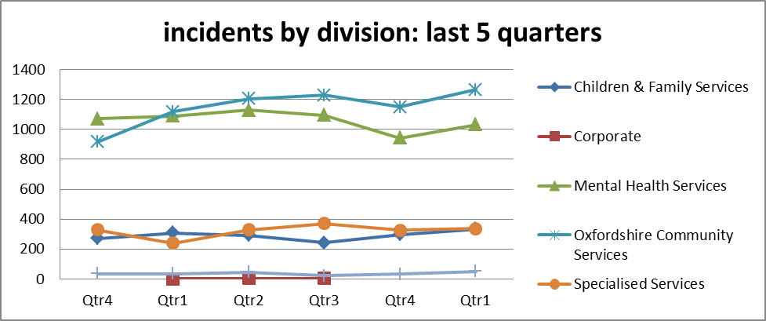

1.4 Top 6 categories of incidents by month
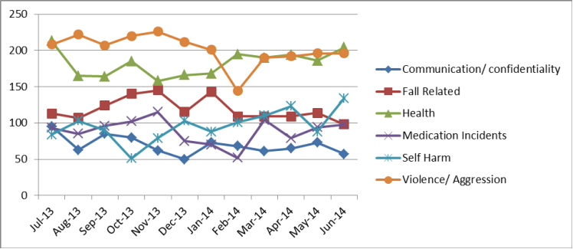
*Falls include all falls incidents for both patients and staff

Health was the most commonly reported incident and the first time it has featured as one of the top six incidents. This cause group is used primarily for reporting pressure ulcers (avoidable and unavoidable). A total of one hundred category 3 and 4 pressure ulcers were reported during this period in older peoples services. Four of these were assessed as avoidable and the remainder as unavoidable.

Abingdon community nursing was the highest reporter of pressure ulcers again this quarter with forty seven incidents reported compared with thirty last quarter. Nine were either orange of red rated incidents. One of these was assessed as avoidable and eight rated as orange (unavoidable).

Wantage community nursing team reported twenty seven incidents. None of these were assessed as avoidable pressure ulcers and further interrogation of the incident detail on safeguard indicate that there were two category 3 ulcers neither of which had developed whilst the patient was under the care of the community nurses.

Nuffield community nursing team reported twenty three pressure ulcers. The community nursing team provide treatment to promote healing. Four of these were graded as orange category four as they were assessed as unavoidable and one had developed prior to community nursing involvement, all now being appropriately treated.

Violence and aggression is for the first time not the most common type of reported incident. The cause groups within this include a range of options including verbal aggression, violence no injury/ violence with injury. The majority of incidents reported were of verbal aggression and physical aggression, some of which led to differing levels of restraint. Overall there were five hundred and eighty five incidents reported in this cause group with one being rated as red and twenty two as orange.

Ashurst PICU continues to be the highest reporter in Q1 with 95 incidents compared with 96 in Q4 last year. Approximately one quarter of these incidents was in relation to one very disturbed patient. A further 10 patients were involved in between 3 and 5 incidents each. Of note there were more incidents involving women than men and 3 of the reported incident involved family member being verbally aggressive towards staff.

Sapphire Ward was the second highest report of violence and aggression this quarter with 49 incidents. One patient was involved in almost one quarter of all incidents with 3 other involved in between three and six incidents.

Allen Ward was the third highest reporter of violence and aggression in quarter one with thirty four incidents. Nine of these incidents involved one patient.

Watling Ward are testing a project entitled ‘Don’t say No’ to encourage staff to use more positive responses to patients requests. The team is working with psychology colleagues to develop ways of conveying unwelcome news to patients on the ward. The PDSA (plan, do, study, act) test will be evaluated through patient feedback and violence and aggression outcome data.
Fall related incidents were the third most common reported type of incident taking over from self-harm last quarter. Falls in this cause group range from slips and trips, falls from bed/commode/wheelchair, being found on the floor and falling from a height. There were a total of 321 fall-related incidents reported this quarter with eleven being rated as orange. None have been assessed as SIRIs although at the current time one incident occurring on Cherwell resulting in a fracture is under review. A further fall on St Leonards ward resulting in a fracture was assessed as unavoidable.

Self Harm was the fourth most commonly reported type of incident. Of these, thirty incidents were reported as orange and one as red. Just under half of these (fourteen) were relating to incidents with inpatients and half of these inpatient incidents occurred in Cotswold House, Oxon.

Ruby ward has become the highest overall reporter of self-harm incidents and Marlborough House Wiltshire is the second highest reporter. Levels of self-harm incidents in June were at the highest point over the last year.

Medication related incidents were the fifth highest type of reported incident. The types of medication error cover a wide range of types of incidents with twenty seven possible cause options. It covers the medication process from prescribing through to administration. There was a total of two hundred and seventy two medication incidents in quarter one with Linfoot, Ruby and Wenrisc being this quarter’s highest reporters. Linfoot and Wenrisc (co-located at Witney community hospital) both featured in last quarter’s top three. Twelve of these incidents were rated orange incidents but did not result in major harm for the patient. The primary types of incidents were related to medication being not given/omitted and/or not signed for.

Communication/confidentiality was the sixth highest type of reported incidents in quarter one. These types of incidents relate to a range of issues including breach of confidentiality, record keeping, admission and discharge problems. Although small in number, the main issues that came up three or more times were where either the reception phones were reported as being ‘down’ or there were problems contacting on-call doctors by telephone.

Security related Incidents were not in the top six of the annual report figures but did feature in the top six incidents reported this quarter.

Phoenix ward were the highest reporters with Phoenix ward reporting a total of 46 incidents with thirty seven of these relating to patients failing to return from leave or managing to escape from the ward. The latter included an incident report that raised an issue about the vulnerability of two areas in the ward garden where it was relatively easy to gain access to the ward roof and escape via this route. There were five incidents reported where patient had either managed to escape via the roof or had been found on the roof. Physical and relational security measures are being put in place to reduce this risk.

Highfield was the second highest reporter of security related incidents with twenty incidents. A number of these were related to patients attempting to leave via the fire escapes on the ward. The latter has been recognised as a weak point and is being addressed. A further theme was of patients trying to forcibly take keys and proximity badges from staff to leave the ward. Training on safe key management has been undertaken.

Marlborough House Wiltshire reported 18 security incidents, six of these related to the discovery of contraband items (usually razor blades) either on the patient’s person or in their room. This was managed immediately.

2. Serious incidents requiring investigation
Data for quarter 4 (2013/14) was drawn from the local SIRI spreadsheet rather than safeguard or STEIS (downgraded incidents must be removed by the CCG and there can be a delay from the request being made, the evidence being reviewed and the action being taken) as a result of data quality issues. Considerable work has been completed on ensuring all of the sources for which we have control are consistently reliable for SIRI reporting. This quarter’s data has consequently been drawn from Safeguard and cross matched for accuracy from our local spreadsheet.

2.1 Reported SIRIs
This quarter there were seventeen reported SIRIs which is a slight increase on the previous two quarters, although this remains much lower than the majority of the preceding six quarters. If the reported numbers remain at the level seen this quarter then the trajectory would see an end of year report indicating further (albeit slight) reduction over the last 3 years.

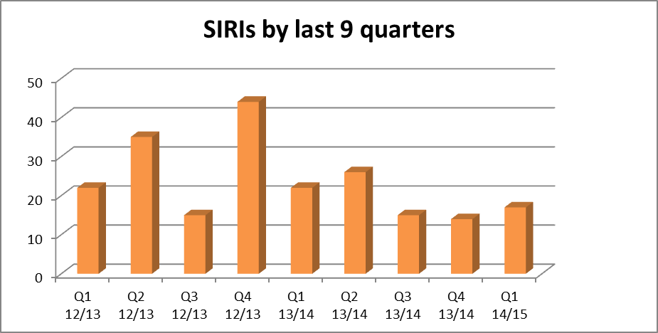

2.2 SIRIs by type
Suspected and confirmed suicides (six suspected) are the main cause of SIRIs reported in Quarter 1 followed by unexpected death (total 4) and avoidable pressure ulcers (2 each of category 3 and 4).

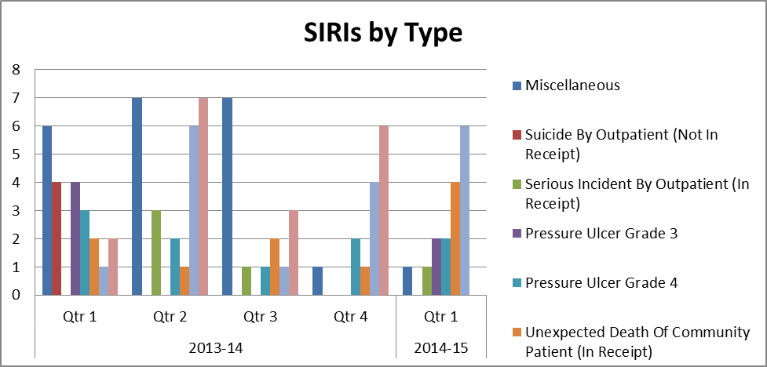

It is of note that the number of avoidable pressure ulcers has increased in number from one in the third quarter of 2013/14 to four in quarter one.

We have been advised and are cooperating with an independent homicide review that has now been commissioned following a domestic homicide in 2011. The patient was under the care of another provider at the time but Oxford Health and several other providers had had varying levels of contact either with the patient or other services in relation to him. This was not formally reported as an Oxford Health SIRI in agreement with the commissioners however we did undertake a detailed root cause analysis investigation at the time and participated in the commissioning of an external reviewer to collate all of the provider reports into one overarching report and action plan.

This quarter there has been a further incident of note after the death of a nine week old child. The mother was arrested and bailed but has not been charged. A serious case review has been commissioned. At this stage the death has not been reported as a homicide but this may change if she is later charged.

2.3 Suspected and confirmed suicides by quarter for the last three years
Numbers of suspected suicides reported over this period include those which were thought to be apparent suicides at the time of reporting and all those that will have subsequently been confirmed as suicides by the coroner. Last year, of the thirty six suspected suicides reported, the coroner has confirmed twenty one deaths by suicide and we still have eight that remain suspected. These will consist of those where the inquest has still not happened and some where a narrative verdict has been given. The remaining seven will have either been found to be natural causes or the coroner will have given other verdicts.

If numbers of sucides remain at the current rate over the remaining year we will be anticipating a further reduction on last year.

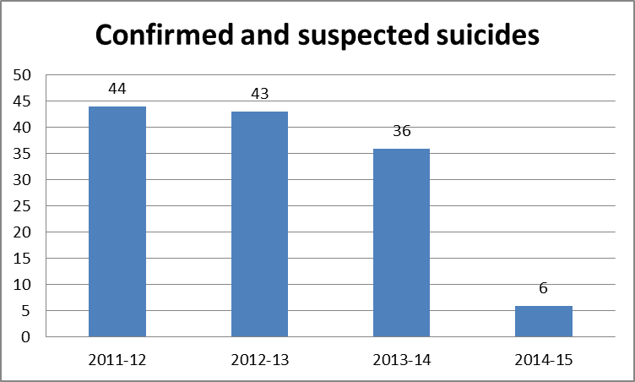

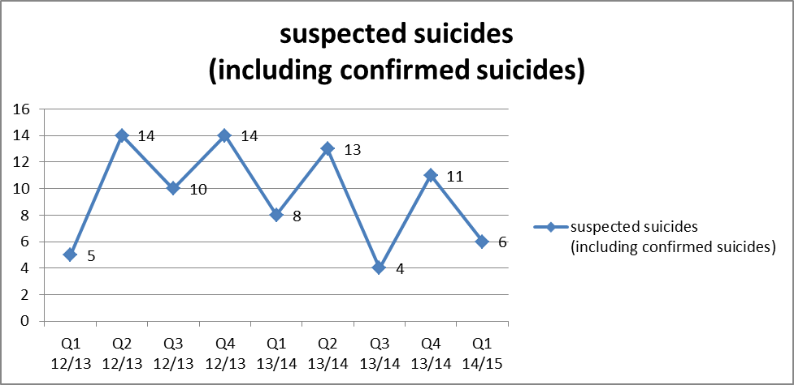

Outside of hospital so far this year there have been six suspected suicides. All of these have occurred with one being a prison death, two incidents occurred in Bucks and three in Oxford. None of the incidents involved patients in the older adult mental health service.

Days between suspected/confirmed suicides in AMHTs
Previously this report highlighted incidents which involved crisis teams/day hospitals. Following the reorganisation in adult and older adult services the crisis teams are no longer operating as dedicated teams and the crisis function has been absorbed into the assessment and treatment pathways in the new adult mental health teams (AMHTs). Of the incidents reported this quarter, five occurred with patients under the care of the new AMHTs with one team (South Oxfordshire AMHT) reporting two incidents.

Team | Q 1 2014-15 Days since death up to 30/06/2014
North & West AMHT | No deaths in Q1
South AMHT | 27 days and counting ( 2 deaths this quarter)
Oxford City & NE AMHT | 65 days and counting
Chiltern AMHT | 55 days and counting
Aylesbury AMHT | 41 days and counting

In-Patient Suicides by year.
There have been no reported inpatient suicides in quarter 1.
2.4 Completed Root Cause Analysis (RCA) Actions
Current safeguard reports indicate that since 2011 there have been a total of three hundred and ninety one actions arising from SIRI investigations. Of these five hundred and fifty six (81%) have been completed.

2.5 Learning Events
A learning event took place on the 5th June 2014 at the Whiteleaf centre with almost fifty delegates. The event brought together themes and learning from serious incidents, complaints and PALs and clinical audit that related to family and friends and carers.

2.6 Themes from SIRIs
In Quarter 1 there have been eleven SIRI panels. Ten of these have been for RCAs carried out for SIRIs and one from an orange rated incident.

In the majority of cases the investigations found no significant lapses in care that could have been root causes to the incident. However issues that have emerged from investigations include:
- Involvement of carers and in particular in with care planning at the point of discharge from inpatient services. This was an issue raised more than once both in the findings of the investigations and in the feedback that families gave as part of the investigation process. It is also the primary theme that was reported here last quarter.
- Discharge planning in general and in relation to communication between different parts of the service.
- Documentation of contingency and crisis planning and clinical decision-making.
- Issues within district nursing services including lack of coordinated care , care planning and documentation, leadership and staffing issues relating to lack of qualified nurses available.

Areas of good practice included:
- Responsive and timely assessments
- Good communication with carers
- Flexibility and responsiveness demonstrating client centred care.
- Strong leadership

3. Restraint and Seclusion
There were 358 reported incidents of physical restraint in quarter four. Totals for the previous four quarters were 406, 293, 338 and 351. The mean number per month for the last eighteen months is 117.

The pattern by quarter shows a random variation, though the figure has risen now for four consecutive quarters.
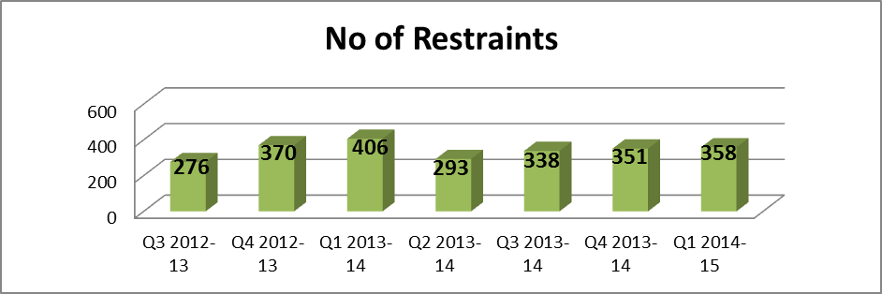

Female patients are more likely to be restrained than male patients; this quarter 65% of restraints involved female patients. In quarter four this was higher at 79%, partly due to the repeated restraint of a number of female patients (described below).

The number of patients restrained four times or more is 14 this quarter (a figure that is within the usual quarterly variation). All of these patients were female and all but 2 were white. The patients being restrained multiple times present with high levels of aggression towards staff and/or patients and/or are at significant risk of self-harm.

3.1 Restraints by Ward
All mental health wards, including older adult, adolescent and eating disorder services reported some restraints over the quarter except for Glyme and Wenric (both forensic units). The number of restraints ranged from 0 to 62.

Restraints by Ward
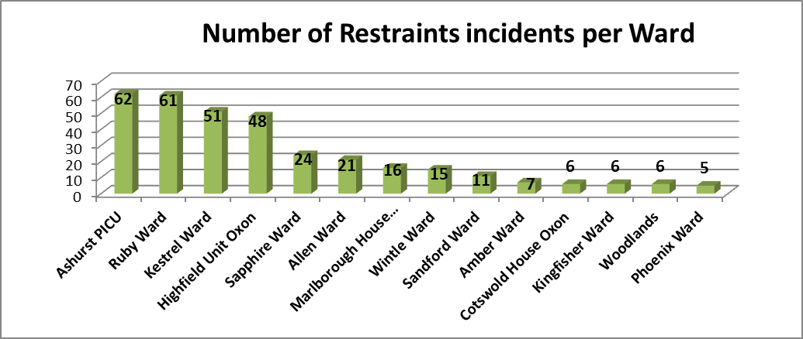

The four wards with the highest number of restraints are Ashurst, Highfield, Kestrel and Ruby. The high reporters, as would be expected, are related to the presence of individual patients who required multiple restraints.
Community hospitals did not report any restraints this quarter. The new wards at White Leaf have now been added to the incident reporting. Mandalay moved to Opal ward during quarter 1.

3.2 Reasons and Causes
The incident form requires a ‘cause group’ to be selected for each incident. Many different types of cause group were selected but violence and aggression (55% of all incidents) followed by self harm (30%) were as usual the main reasons for restraint.

The incident form includes a tab for entering further information specific to restraints. This is now always completed. The pattern does not vary from previous quarters.
Reason | Number of incident
Administer Prescribed Medication | 37
Attempts To Abscond | 28
Dangerous, Threatening Or Destructive behaviour | 135
Extreme / Prolonged Over-Activity | 15
Harm To Others / Physical Assault | 49
Self Harm / Risk Of Physical Injury by Accident | 88
Self Neglect | 6
Grand Total | 358

3.3 Rating the level of incidents
The staff reporting incidents rate the actual impact of the incident. Ninety seven percent of the incidents were graded as yellow or green (moderate or low risk) or were not yet graded. Twelve forms were graded orange this quarter relating to the potential impact of the incident rather than the actual harm.

3.4 Type and level of restraint
The restraint tab requests the names of the staff involved and their role in the restraint, the degree of restraint (high, medium or low), the position the patient was restrained in (seated, standing, prone or supine) and the duration of the restraint are all requested.

The number of forms recording the use of ‘pain compliance’ is 6% having been 4.8 - 24% in the last six quarters. This maintans the fall in its use highlighted last quarter and represents 22 of 358 incidents in total over the quarter.

The percentage of restraints recorded as prone has remained steady at 26% in compared to 22% last quarter (the figures in the previous quarters were 33%, 29% and 25%).Further detailed analysis is available in the ICG report. Having until recently been unavailable, the category of supine is now again an option on the incident form and has increased in frequency from last quarter. The new category of kneeling was rarely selected.

In quarter two, the recorded duration of restraint ranged from one minute to four hours. Of these 5% (19 incidents) lasted an hour or more (compared to 2.9% -13% in previous reports).

An analysis of the ethnic group of patients who are restrained or secluded has now been completed. Ethnic group is rarely entered onto incident forms. The ethnic group for the patients reported on in this quarter was therefore gathered from each patient’s Rio record. The table below describes the profile of the patients being restrained. The pattern of restraint (number, type) does not appear to be affected by ethnicity.

Ethnic Group | Female | Male | Total
White | 251 | 62 | 313
Non white | 29 | 13 | 42

4. Use of Seclusion
The total number of reported seclusions in Quarter 1 was 68, compared to 44, 66, 59 and 77 in the previous four quarters. The mean per month for the year of 2013/14 was 20.5, for this quarter it was 23.

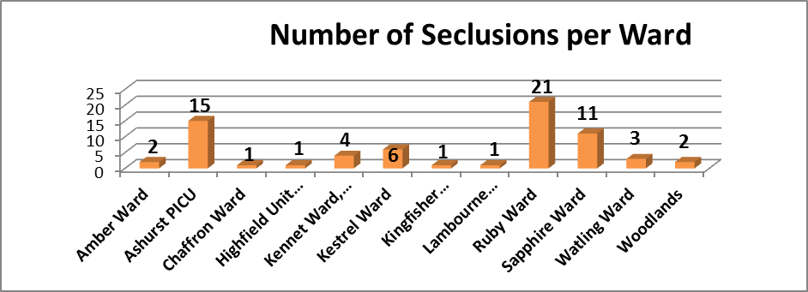

4.1 Reasons
Nearly all incident reports continue to detail violence and aggression as the cause for seclusion. The other reasons over the last 3 months related to self-harm and attempts to abscond.

In Quarter one, a total of 35 different patients were secluded (compared to 32, 23 and 46 in the last three quarters). 15 patients were secluded more than once (compared to 6, 7 and 12 in the last three quarters). Only five patients were secluded more than twice. Three of these were secluded 5 times each, two women on Ruby and one woman on Ashurst.

4.2 Profile of secluded patients
Forty per cent of seclusion incidents involved a male patient as many of the patients secluded once or twice were men (Male patients have previously made up up 28 - 66% of seclusions). Fifty-three of the 68 secluded patients were white. This shows a slight over representation of patients who are from black and minority ethnic backgrounds

4.3 Time in seclusion: The recorded duration ranged from 15 minutes to 118 hours but not all forms detailed the start and end tomes. More complete data is being gathered from an audit of seclusion documentation that is currently underway.

5. Project on Prevention Management of Violence and Aggression training and practice
A review of our training and practice around the physical restraint of patients is nearing completion. Its aims are to ensure teams are providing the highest standard of evidence based care, to reduce the use of restraint and ensure we are using the best form of training and techniques. The project team have recommended that as no external provider completely meets the latest guidance and the needs of our Trust, and that we should invest in developing our own training programme which will run over two years.

6. Infection Prevention and Control

6.1 Surveillance
There has been 1 confirmed case of Clostridium Difficile infection in the first quarter which was in Abingdon community hospital. A robust root cause analysis was completed and any learning identified communicated back to clinical teams and discussed in training and supervision. There were no cases of CDI in mental health.

There were no cases of MRSA and MSSA bacteraemia in the Trust.

There have been four cases of E.Coli bacteraemia; two were in May (community physical health) and two were in June (one in community physical health and one on City community hospital ward). All cases have had a thorough RCA completed and no definitive source/cause has been identified. These infections require mandatory reporting but do not have a threshold..

6.2 Environmental Audits
Environmental audits continue and overall demonstrate acceptable compliance with infection prevention control standards.

Hand hygiene
Hand hygiene audits in the community hospitals in May 2014 continue to demonstrate excellent compliance of 97%. Bare below the elbows was 99%.

Hand hygiene in mental health wards is continuing bi monthly as well. The overall compliance score for the hand washing technique for May 2014 was 96 %. Bare below the elbows was 92%.

6.3 Training
The Trust has set the target of 100% of all eligible staff to complete infection prevention control training. The current figure is 69% of staff are in date with training requirements. Training is also available via the E learning programme and work book for staff to access.

6.4 CQC compliance/national directives
Outcome 8 Cleanliness and Infection Control is monitored quarterly via the IPCT and governance team. Overall, areas are demonstrating good compliance with this outcome, except the numbers of staff trained in infection prevention and control remain below the target of 100%. There are also some concerns regarding audit results and decontamination record keeping.

6.5 Environmental cleanliness
ATP environmental cleanliness monitoring continues monthly in community hospitals and older adult mental health wards.

6.6 Decontamination
Decontamination compliance remains generally high with appropriate processes in place including external contracts. One area of non-compliance remains poor documentation of cleaning records.

7. Improvement programmes

7.1 Safer Care programme

7.1.1 Adult Services
Failure to return from leave project
Five adult wards have commenced baseline data collection over one month. Each ward has received training to use Baseline software to prepare run charts. The harm reduction aim for each ward is to reduce failure to return from leave or time away from the ward by 50% by April 2014. Re-testing of the successful interventions on Phoenix Ward are planned with some minor adjustments to reflect local contexts. Phoenix ward continues to sustain harm reduction at 74% patients returning on time.

Safer Care and AIMS
Safer Care is also aligned with AIMS accreditation for Level 1 for each ward. Harm identification process mapping has been completed for the referral of patients to the ward. Areas for improvement are to focus upon the reception of newly admitted patients onto wards and the admission process.

Chaffron Nutrition Project (SC)
The ‘Tooty Fruity’ group on Chaffron Ward is testing the introduction of preparing fruit salads with patients to improve their fruit intake. Questionnaires were used to gather information from patients about fruit consumption and preferences. The first PDSA test will take place every week with feedback from patients over a three month period.

Watling Violence and Aggression Project (SC)
Watling Ward are testing ‘Don’t say No’ to encourage staff to use more positive responses to patients requests. The team is working with psychology colleagues to develop ways of conveying unwelcome news to patients on the ward. The PDSA test will be evaluated through patient feedback and violence and aggression outcome data.

Community Services Suicide Reduction Project using CRHT Always Events (SC)
Adult Mental Health services have recently gone through a remodelling process. As part of this the both the crisis and home treatment functions have been integrated within the newly configured Adult Mental Health Teams (AMHTs). Training has been provided to these new teams in particular the assessment function. Due to the large scale change associated with the remodelling, the AMHTs have as yet been unable to systematically introduce and evidence process measures using the Always events adapted from those used in the Crisis Resolution Home Treatment Teams. There is however evidence within teams that staff are aware of the always events and teams have been made aware of the requirement for data collection. This has started in the Chiltern AMHT but it is not as yet consistently recorded. Ongoing plans are in place to address this within the team and will be monitored through the Directorate governance meeting.

7.1.2 Children and Young People
The Highfield Unit Restraint Reduction Project
The project has sustained a 50% reduction in all restraints over the first year of intervention. Tests of change are now focused on sensory interventions including weighted blankets and individualised calm boxes. The Matron has secured a small grant for the purchase of these items.

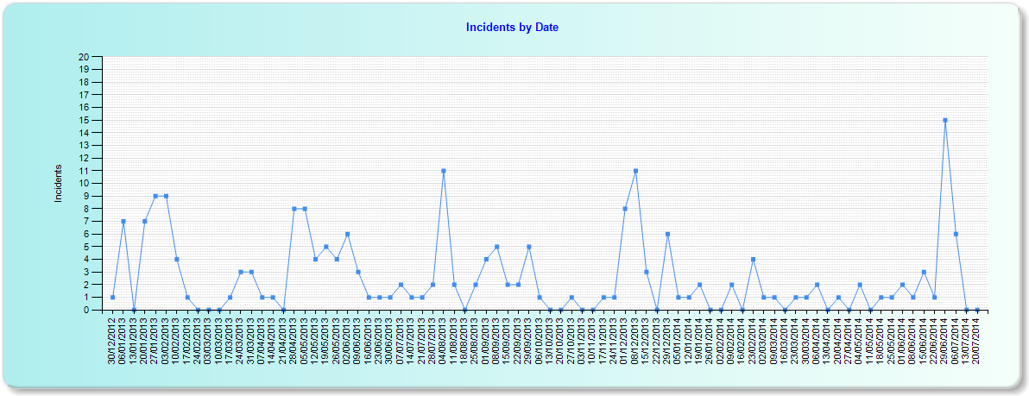
The peak data points shown in the table below during July reflect a single patient in need of alternative care provision.
OSCA Crisis Team Self Harm Reduction Project
The Oxford OSCA Team have developed their driver diagram, process mapped their referral process from Tier 3 services and designed their first PDSA test of change. The team manager has adjusted the staffing to respond to referral demands. Each of the Oxford Tier 3 teams is using the new SBARD Referral form for discussion of patient needs with the OSCA team.

Marlborough house, Swindon Self Harm Reduction Project
The team have completed their driver diagram. The first PDSA test of change is underway following four weeks of baseline information. The test is designed as an Always Event to improve the reliability of staff presence in communal areas of the ward 11-12.00hrs, 5-6.00hrs and 8-9.00 hrs. During these times staff identify a heightened risk of behavioural disturbance in these areas. A ramp of PDSA tests is also planned to reduce the number of individual patient sessions taking place after supper. The plan is to bring together a bundle of events that increase nursing presence and normalise evening activities prior to bedtime to address rates of self-harm incidents after 5pm that are particularly high.

7.1.3 Older People’s Services
Community Nursing
The successful work in relation to reduction in medication omissions is being applied at Abingdon Community Hospital and work is continuing with Abingdon District Nurses to develop safety briefings. It remains a significant challenge for Community services to produce run charts as data is held in several different places. Safer care work is currently focussed on ensuring effective utilisation of the Skintelligence programme

Cherwell Ward
Cherwell Ward is planning to test the introduction of intentional rounding to ensure patients’ and carers’ feel safe on the ward. Their task work includes gathering the views of patients and carers about what helps them to feel safe. This information will provide the basic structure for the questions included on the round.

Sandford Ward
Sandford ward is planning work to reduce falls. The work from 2Gether NHS Foundation Trust using walking frames in primary colours is likely to be tested.

7.2 Productive Care programme

7.2.1 Adult Services

Whiteleaf Centre
Support was provided to services moving into the Whiteleaf Centre including a detailed review of the security nurse role and identifying opportunities to further release direct care time for therapeutic interventions. Selected processes have been standardised to promote greater flexibility for staff to move between wards. Patients have been offered increased one to one therapeutic time with their named nurse.

Forensic Services
Glyme ward has now introduced an electronic handover and direct care time has increased in Woodlands and Kestrel wards as a result of improvement activities – this has been re-invested in therapeutic activities. This has equated to an average of 3.8 days annually for each member of staff. The time has been used to offer more communal cooking time, trips to cinema, museums and bowling.

7.2.2 Children and Young People
CAMHS
The team has facilitated a review of demand and capacity within the CAMHS team and agreed a single assessment process for patients.

Community Children’s Nursing
Work has been undertaken with them team to improve role clarity, daily diary allocation and improved documentation on RiO.

Bucks Speech and language Therapy
The team has mapped out a new pathway and reviewed the role of rehabilitation assistants to reduce waiting list times. This has better prepared the team to meet the demands of the new specification for the school age service.

7.2.3 Older People’s Services
Community nursing
The community nursing service has now adopted Patient Status at A Glance (PSAG) to support the Venous Leg Ulcer Pathway in seven pilot teams across the county. A monthly audit is in progress to support a further review in October 2014. Work has also been completed on the district nurse ‘referral into service’ form which has reduced the number of incomplete and inappropriate referrals and an associated reduction in the time required to respond to and manage these. Improvement measured before and after change showed incomplete referrals have reduced by 68%

Continuing Care
There has been a comprehensive review of all processes and a review of roles to ensure greater clarity and a more timely response to referrals and inquiries. This has reduced the average response time for referrals from six working days to two working days.

Community Hospitals
The annual sustainability reviews for ten community hospital wards have been completed with a score of 64.2. Any score of 55% or above indicates that changes implemented will be sustained longer term.

8. Trust wide status report against CQC Outcomes

The monthly report to share the internal position by Directorate and location against the CQCs essential quality and safety standards as of September 2014 has been discussed in the Extended Executive on 16/09/14. The report is produced and circulated to the Directorates monthly to show exceptions where internal concerns have been identified and are being resolved. There are five areas for imporvement which were discussed in detail.

The only significant risk to possible non-compliance identified by the CQC in their last Quality and Risk Profile (last updated in April 2014) was a low amber risk for cooperating with other providers which relates to Delayed Transfers of Care (DTC), specifically across Community Hospital. Across the 10 community hospital wards there are usually between 25-30 delays at any one time. A number of these delays are out of the patients choice and a large % relate to patients with social care needs. A senior group of clinicians from the Older Peoples Directorate review the DTCs weekly to support complex discharge plans.The Trust is also working with the whole health system in Oxfordshire to reduce DTCs and since the begining of the year they are reducing compared to last year.

9. Learning & Development

9.1 Clinical & Professional Development

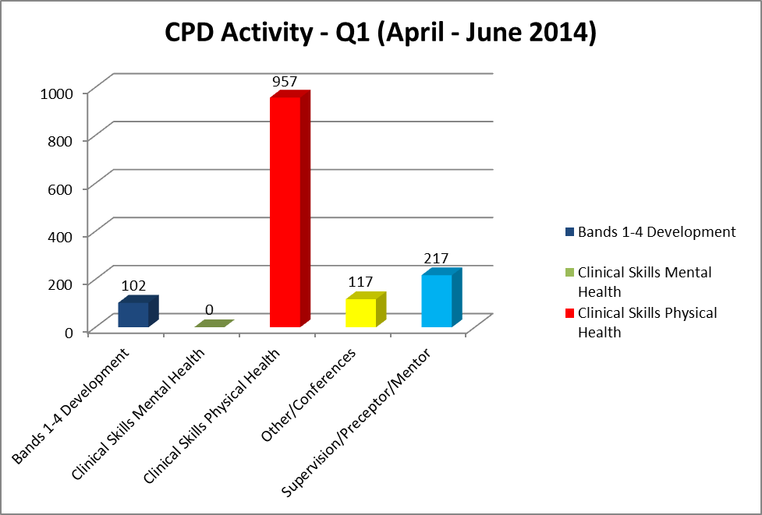

Bands 1 to 4 Development
We are currently piloting a series of Emergency First Aid study days –“first person on the scene” - for HCAs. The study days have been designed specifically for staff who are often the primary healthcare worker visiting a person in their own home and would be expected to deal competently with an unexpected first aid situation. The study days carry a qualification recognised by the Health & Safety Executive. The three workshops have been very well evaluated with a further four sessions planned.

Clinical Skills updates
The final four day Physical Health Skills course for mental health nurses was very well evaluated. The course will continue to be delivered in its current format but will in future be delivered internally in the Trust’s new ‘Skills Lab’ by the new clinical practice educator team.

A wide range of clinical updates and study days and courses have taken place across the directorates this quarter which include bowel / bladder symptoms and continence catheter care; chronic oedema; IV study days; phlebotomy; tissue viability; pressure ulcer management; wound assessment; leg ulcer management; recognising the deteriorating patient; oral health promotion; immunisation; syringe driver T34; and challenging communications within community nursing.

Clinical supervision / preceptorship / mentorship.
Training for clinical supervisors is on-going as is the support from the CPD team to help embed effective supervision within practice.

The Trust wide preceptorship programme continues to offer support to newly qualified employees and their preceptors, supported by train the trainer workshops on action learning set (ALS) to enable preceptors to set up ALS or reflective practice groups for preceptees working in their localities.

CPD forward plans
Action | Update
Care Certificate Framework for Health Care Assistants (HCA) & Support workers (SW) | National and regional pilots of the new Care Certificate Framework (CCF) are due to complete in September. The original plan was for trusts to implement the CCF from March 2015, although Skills for Health has indicated that implementation is likely to be delayed.  Progress within the trust  - Currently mapping CCF knowledge components with internal training provision.  - Early indication suggests that all new HCAs / SWs will need to undertake a two day induction programme to address knowledge gaps explicit within the care certificate.  - L&D working with directorates to prepare for this new national requirement.  - Four pilot areas have been identified to trial the new CCF handbook and portfolio with new HCAs in post. Purpose to evaluate suitability for the trusts diverse un-registered workforce.  - L&D engaged with Skills for Health project team to influence future developments.
Physical Health skills course for mental health nurses. | All future cohorts of this well evaluated course will be delivered within the Trust’s new Skills Lab by the new Clinical Practice Educators (CPEs).
Clinical Practice Educator posts | Six CPEs are now in post. Initial focus includes:  - Meet key individuals and attend relevant meetings to establish service and clinical priorities  - Contributing significantly to the under graduate student learning experience, placement support and wider service improvement initiatives.  - Working with clinicians across the trust to improve and develop physical health skills, in particular taking and recording manual blood pressures.
Psycho-social Family Interventions  training programme | Two further 5 day training programmes to be delivered internally in the autumn for mental health clinicians.
Vocational Qualification Award ceremony | An award ceremony (held July) celebrated the achievements of 137 members of staff (mainly within bands 1 -4) who have successfully completed vocational qualifications over the past two years. The Trust Chair and Chief Executive presented awards.  The winner of the ‘outstanding achievement’ award went to Deborah Holman, administrator from Witney Community hospital. Five other nominees received highly commended certificates for their contributions to improving the work environment and the patient experience.

9.2 Leadership, Team & Individual Skills (LTIS)

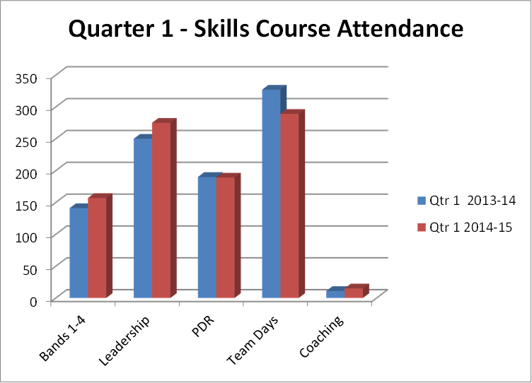

Skills & team development programmes
The following programmes have been available in quarter one:
- three new Customer Care sessions delivered following successful pilot for new Adult Pathway
- Dietetic Team Leadership Development Skills modular programme
- Tissue Viability Resource Nurse Development Programme Pilot was positively evaluated and will be offered again from October 2014
- interview skills and CV skills development workshops following the closure of the Fiennes Centre to support re-deployment to other sites
- A new Therapists Leadership Skills Awareness workshop for bands 7-8 delivered to upskill 15 managers during a 2 day programme in June.
- Three bespoke Team day using a mixture of Belbin and MBTI designed and delivered to 45 district nurses where the teams are having problems with communication and internal conflict
- Bespoke team days designed for Children’s and Families and Adult directorates to support newly formed teams
- Three more facilitators successfully completed MBTI accreditation to enhance the existing team to deliver 50% more MBTI team days and also deliver new sessions for teams with conflict, communication
- Follow-on team development days delivered to develop teams to be high performing teams

National Leadership Programmes
Eight staff applied for the National Leadership Academy Frontline Programme: starting in April 2014 and all successfully completed the sessions. Ten staff applied for the National Leadership Academy Leadership Programmes of Mary Seacole, Nye Bevan and Elizabeth Garret Anderson.

PDR review
The Trust PDR process is under review to incorporate a values based approach. A new on-line system is being developed to support the new PDR process. A new format designed for the 8C and above in line with the Agenda for Change for pay review incorporating ratings, values and behaviours. The PDR policy and Gateway policy has been updated to support the new procedure. Staff PDR online system has been scoped and ready to be put out for tender as part of the overall L&D Leaning Management System.

9.3 Project work:
- Development of a programme for new managers (either into the Trust or internally promoted) linked to the new Probationary Period Policy to equip all new Managers with the skills required for a manager in the Trust within 6 months of appointment. This includes the following sessions: Essential PDR Training, Disciplinary & Grievance, Managing Sickness Absence, Recruiting Successfully and Introduction to Management. Link is in place with HR and tracking has begun on managers during their 6 months probationary period.
- Design of a new Leadership Development Centre specifically for mental health and community trusts in conjunction with Berkshire Healthcare NHS Foundation Trust and supported by the Thames Valley & Wessex Leadership Academy, with three cohorts scheduled to start in October 2014.
- Senior managers development programme.
- Coaching strategy and internal pool of coaches to support the coaching culture.

9.4 Accredited programmes in design:
Further specific development programmes currently being designed include:
- Certified development pathway for Administrators with a Level 3 NVQ qualification.
- Certified development pathway for Team Leaders with a Level 3 NVQ qualification.
- Certified development pathway for delivering high quality Customer Service with a Level 2 & 3 NVQ qualification.
- Certified development pathway for IT skills with a Level 2 & 3 NVQ qualification.
- ILM Certified development pathway for Management & Leadership.

LTIS twelve month comparison

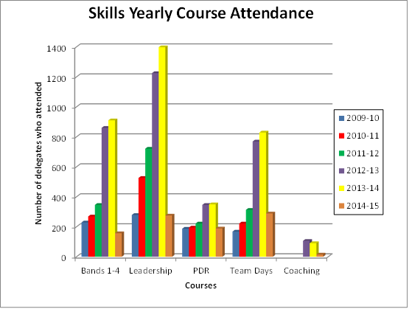

9.5 Patient and personal safety training (PPST)
At the end of FY13/14 the Trust performance for all levels of PPST was 88%. This excludes staff not available for training for example due to long term sickness, maternity leave or secondments. At the end FY14/15 Q1 the overall PPST performance was 84%.
At a Trust level there are two main factors affecting performance during Q1:
- significant focus on directorate restructuring and the introduction of care pathways, often resulting in changes to and within teams
- the introduction of higher performance targets with the removal of phased targets in several key subject areas for PPST

As requested by the Board an analysis of lowest performing teams has been conducted between the L&D function and operational directorates. This shows a variety of specific local factors as contributing causes, often involving low numbers of staff skewing results for smaller teams.

PPST Level 1 – progression FY1415 Q1 – 100% target
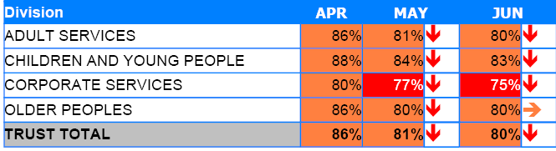
PPST Level 1 Phased Targets
- Equality & diversity –The target was set to 100%. For new starters full training is now integrated into the first day of the new Trust Induction programme.
- Fire awareness & evacuation for inpatient areas – an initial phased target of 50% was set to enable all staff (1300) to be trained annually; having exceeded this at 63%, a new target was set at 100%.
- Resuscitation – following the 2 year implementation of the new training strategy a target of 100% was set in May 2014.
PPST Level 2 – progression 1415 quarter 1 – 85% target
PPST Level 2 training achieved 94% of the 85% target, representing 80% of available staff trained.
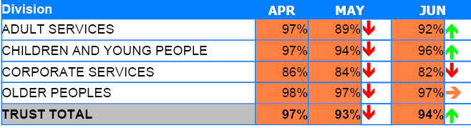
PPST Level 2 Phased Targets
Falls awareness - a new target of 85% was set during May 2014. Additionally, the eLearning requirement was added to the matrix for inpatient nursing staff working on mental health wards.
PPST Level 3 – progression quarter 1 100% target
Of the 100% target for PPST Level 3 training 80% has been achieved overall. Level 3 reports on the number of staff that have been nominated for a specific role, e.g. health & safety, medical educational supervisor, root cause analysis (RCA) training.
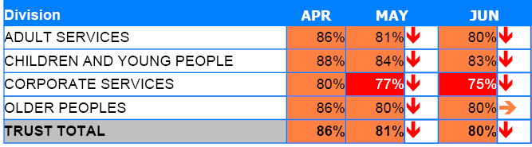
Currently 1361 employees are nominated for specific roles of which 1110 are trained and 92 are booked to attend training. Of the remaining training gap there are 87 fire marshals that require their refresher training and are being encouraged to attend.
L&D continue to identify and support teams that achieve less than 80% (red) against the PPST framework. Circumstances at team and individual level are many and varied. The approach is to seek to understand these and work together with service and team managers to overcome and/or document the challenges.
The summary table below shows the status and number of teams by Directorate. For this purpose, a team is defined as ‘staff attached to a cost centre’.
Directorate | Quarter | Overall % | Number of Teams | Red less than 80% | Amber greater than 80% | Green target achieved
Older People | 1 | 84% | 122 | 22 | 87 | 13
Adult | 1 | 84% | 94 | 27 | 61 | 6
C&YP | 1 | 86% | 92 | 25 | 62 | 5
Corporate | 1 | 76% | 94 | 38 | 35 | 21
 |  | Totals | 402 | 112 | 245 | 45
The lowest 10 teams, by percentage performance, are listed for each Directorate at Appendix 1.
9.6 New and/or improved training solutions delivery by the L&D Technology Enhanced Learning team
TEL Development Project | Comments | Delivery
New eAssessments  Ability for staff to demonstrate the required level of knowledge and understanding via on online assessment process.  (Avoids the need to attend a training course through robust competence assessment which can improve patient safety, save staff time, and increase organisational compliance with training targets.) | Developed with HE TV for all staff groups:  Information Governance  Equality, Diversity & Human Rights  Fire safety  Alerter / Level 1 for;  Moving & Handling  Safeguarding Adults  Safeguarding Children | Q1
Develop virtual learning environment (VLE)  The VLE involves a remote tutor and delegates linked by a web based service, able to exchange questions and seek feedback.  (Aims to reduce costs associated with travelling and improve the efficiency and effectiveness of learning events.) | Pilot - Fire training non inpatient staff annual awareness updates. Produces an average saving of £39 per learner. Therefore it is estimated that this will produce £78,000 of savings every year in the time required for travelling to and from training, thus allowing more time to be spent delivering and supporting patient care. Additionally, Finance department estimates that a further £20,000 per annum will be saved in travel expenses, a total of £98,000 per annum. | Q4

This pilot demonstrates significant potential for CIP if applied more widely.
9.7 Performance & Development Reviews (PDR)
The target is 100%, however the position at the end of quarter 1 was 56%. The current PDR cycle runs for three months April to June. Operational services report that having to complete all PDRs within a three month period places an unachievable burden on managers. Similar pressure was evident last year at the end of the first quarter when 68% was reported. The position has improved for July and August. The current PDR review acknowledges this and will be recommending a different approach for the next financial year, based on undertaking PDRs before any incremental point is due.
Non medical Staff
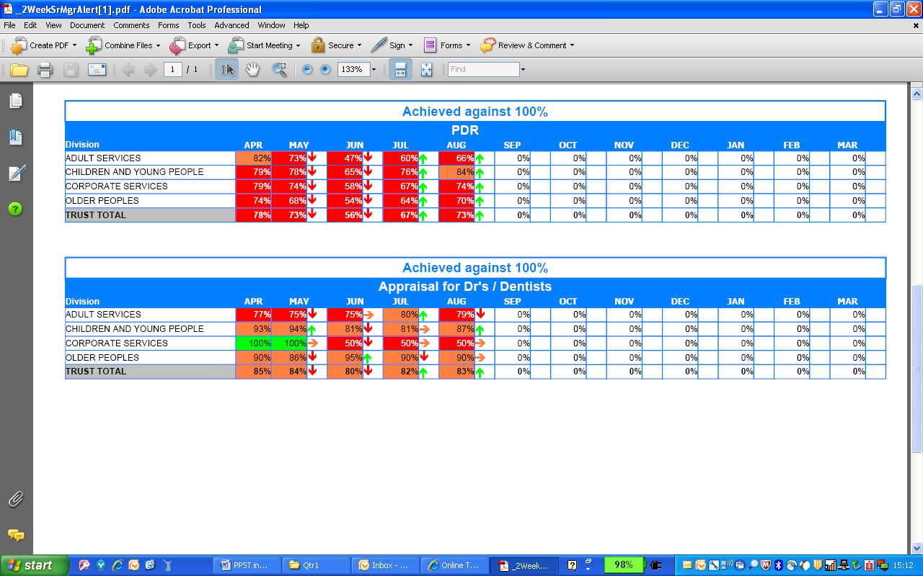
Medical staff and dentists have annual appraisal reviews and are outside the PDR cycle. Against a target of 100% the position was 80% for quarter 1.
Medical staff and dentists

On safeguard there are 20 main incident cause groups. These include: collisions, communication/confidentiality, conveyance, COSHH, death, dispensary – pharmacy supply error, equipment/property/medical devices, fall related, fire (including near miss), general/other, health, infection control, manual handling, medication incidents, security, self harm, sexual, sharps/needlestick, staffing, violence and aggression. When an incident occurs the staff member reporting the incident will make a judgement about which main cause group is most appropriate. Once the cause group has been selected the staff member will then narrow the details down further by selecting a further cause group from a range provided. For example, selecting a cause group of self harm then further selecting ligature as a second cause group.

