

BOD 105/2014
(Agenda item: 9)

Report to the Meeting of the

Oxford Health NHS Foundation Trust

Board of Directors

24 September 2014

For Information

Quality Account 2014/15 Quarter 1 report on progress

Executive Summary
This report outlines progress in the first quarter on the eight quality priorities agreed for 2014/15.

The primary aim of this first report is to agree the reporting format and approach for future quality account quarterly reports and the final report at the end of the year.

There are some gaps in the required data which is due in part to organising appropriate ways of collecting new data which has not previously been reported; and the delays in migrating the new teams/directorate structures to the Safeguard system.

Future reports will also contain an analysis of whether our services are safe, effective, caring, responsive and well led as we develop our approach internally to using the new regulatory framework. Specifically the report will include a full discussion of compliance with the five CQC domains; cross referencing between the five CQC domains and the eight quality priorities; and a comparison with the beginning of the year to assess the impact of development and improvement activities.

Recommendation

The Board is asked to note the report.

Author and Title:
Tehmeena Ajmal, Head of Quality and Risk

Lead Executive Director: Ros Alstead, Director of Nursing and Clinical Standards

- A risk assessment has been undertaken around the legal issues that this paper presents and there are no issues that need to be referred to the Trust Solicitors.
- This paper provides assurance and evidence against the Care Quality Commission Outcome: 4, 5, 7, 8 and 16.
www.oxfordhealth.nhs.uk

Quality Account 2014/15

Quarter 1 Report

1. Summary
1.1 The 2014/15 Quality Account is organised around the five CQC questions which form the basis of future inspections. The intention in future reports is to assess whether our services are safe, effective, caring, responsive and well-led. A taskforce has been established which comprises representatives from services across the Trust to ensure that the key lines of enquiry are understood and communicated; to enable staff at the point of care delivery to know how well their service is doing against the five questions; to identify areas of good practice and areas of risk; and to set up peer reviews across all services.

2. We have also identified eight quality improvement priorities which together address the areas requiring further improvement from 2013/14 and support the recommendations from national inquiries including the Francis, Keogh and Berwick reports. Progress is summarised below.

2.1 Workforce
2.1.1 We have set up a weekly reporting process to monitor nursing staffing levels in our inpatient units, identify areas of potential risk (e.g. a high level of vacancies or sickness etc.) and to support activities to maintain safe staffing levels. In the first three months of reporting some wards were identified as being at high or moderate risk because of difficulties filling daytime and might time shifts; however, no link has been found between staffing constraints and adverse events or patient harm.

2.1.2 The first set of results from the staff friends and family test is available; however the response rate was very low. There were some very positive comments relating to the level of support available to staff but a recurring theme concerning the workload and levels of stress being experienced by staff currently.

2.1.3 The Aston teamwork model continues to be rolled out across the trust and managers are reporting tangible improvements in how their teams are working as a result.

2.1.4 The level of attendance at skills development courses is approximately the same as the same quarter last year; however the % of staff who have received a performance development review has dropped from 68% to 56% in comparison to the same period last year.

2.2 Data quality
This will be reported in quarter two; work is underway to develop and agree a core set of indicators which will be available at a team, service, directorate and trust level

2.3 Service remodelling
The programme for service remodelling in the older people’s and adult directorates is on track. A formal evaluation is being carried out from September 2014 to assess the impact of the changes. Seven day extended working is in place in adult services and will be in place in the autumn for older adults. The new leadership model is in place for adult inpatient wards. Both adults and older adults are moving towards measurement of cluster outcomes in collaboration with patients, carers and commissioners.

2.4 Staff engagement with the quality agenda
2.4.1 There are some excellent and positive examples of staff involvement in improvement activities which are detailed in the report. These include the use of the productive ward in forensic services to increase the time spent directly with patients; improving the management of section 17 leave and using the 15 steps challenge to improve the ward environment and staff receptiveness.

2.4.2 District nursing services have been involved in improving the quality and appropriateness of referrals to increase time to care.

2.4.3 Progress is being made on values based recruitment and a set of behavioural competencies will be developed in the autumn with supporting recruitment material towards the end of December.

2.5 Reducing harm from suicide; pressure ulcers; absence without leave; violence and aggression and falls
The suicide awareness and prevention training is being rolled out across different teams. Until the Safeguard incident management system reflects the new teams we will not be able accurately to report “days between suspected suicide ….” by team. The number of suspected or probable suicides reported as serious incidents was 8 in the first quarter. We currently do not have sufficient data on the risk assessments for falls and pressure ulcers. However, the number of harm from falls (by 1000 bed days) was 0.8 across the whole trust in the first quarter which is within the target set. The number of prone restraints has remained fairly consistent for the previous few quarters; however the use of hyperflexion has reduced.

2.6 Patient experience
The patient experience strategy is being rolled out across the organisation and future quality account updates will include a variety of examples from across all services. Most recently the forensic and district nursing services have filmed patients giving feedback on their experiences to enable staff to learn from and improve the care they provide.

2.7 Developing outcome measures
Opportunities to monitor and learn from co creating outcome measures with patients have been identified in adult mental health (clusters), speech and language therapy services in Buckinghamshire and community hospital wards in Oxfordshire.

2.8 Using the new CQC regulatory framework
We have established a task force which is leading the development of this new approach to how we understand our services, including detailed examination of the key lines of enquiry, setting up peer reviews across services and learning from best practice as well as identifying areas of risk.

3. Quality Account 2014/15 Quarter 1 report
3.1 For our quality account 2014/15 we have taken the opportunity to consider the five questions posed by the Care Quality Commission (CQC) which will form the basis of their future reviews and inspections of NHS services, namely

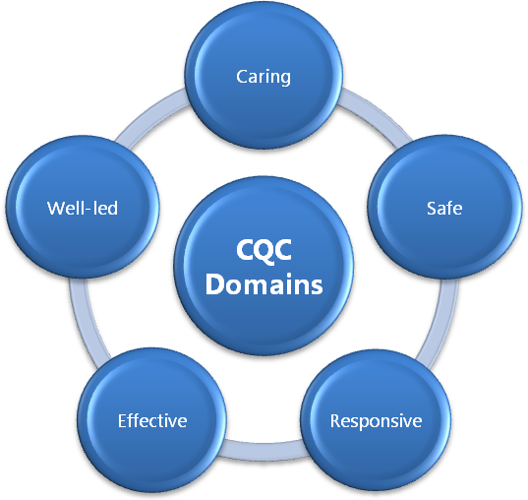

Is the service safe?

Is the service effective?

Is the service caring?

Is the service responsive?

Is the service well led?

3.2 As we develop our approach to using the five CQC questions to review our services, we will build a detailed assessment over the year of whether our services are safe, effective, caring, responsive and well led, using specific examples of good practice, as well as identifying areas where we will need to improve or develop. This assessment will commence in the quarter 2 quality account report and will consider the following:

3.3 Is the service safe?

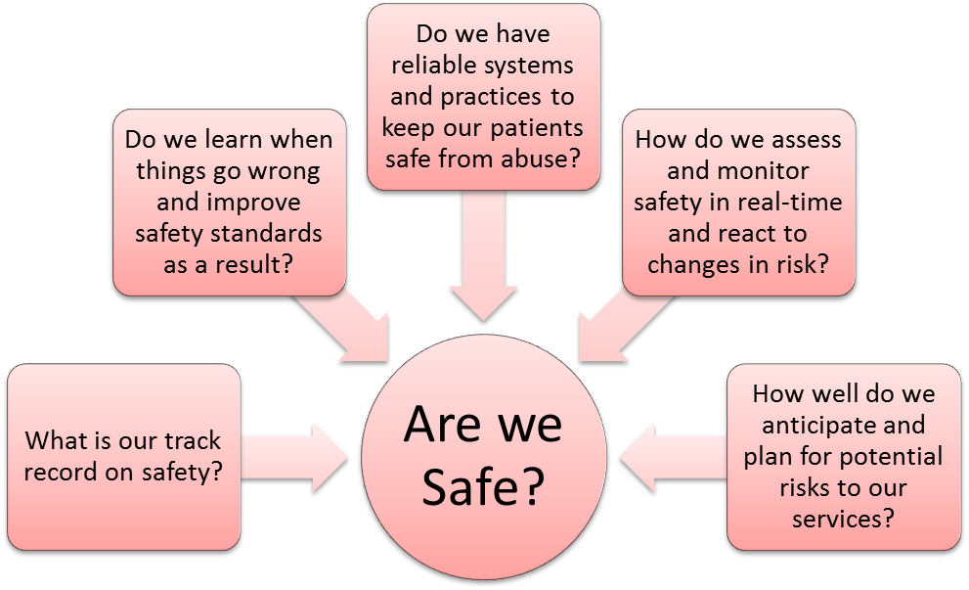
3.4 Is the service effective?
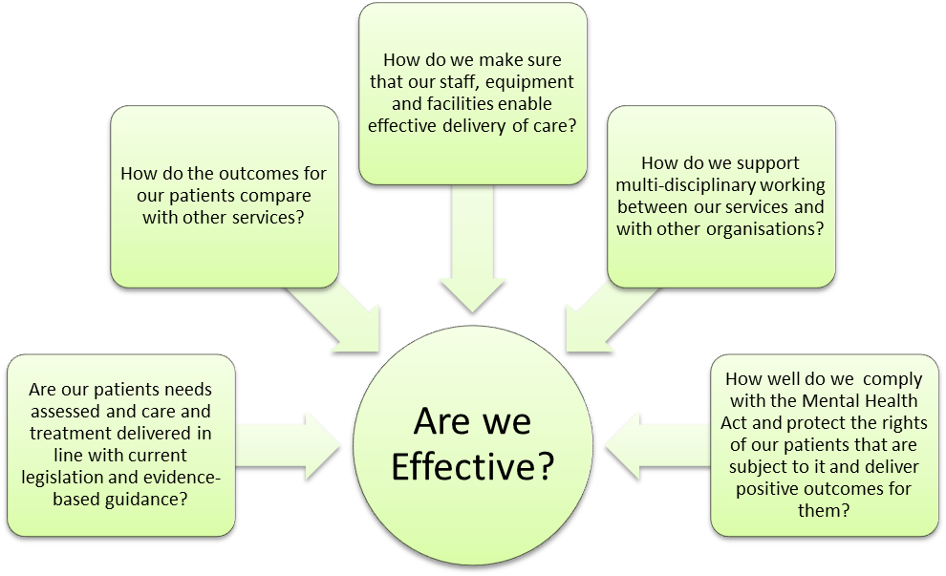

3.5 Is the service caring?

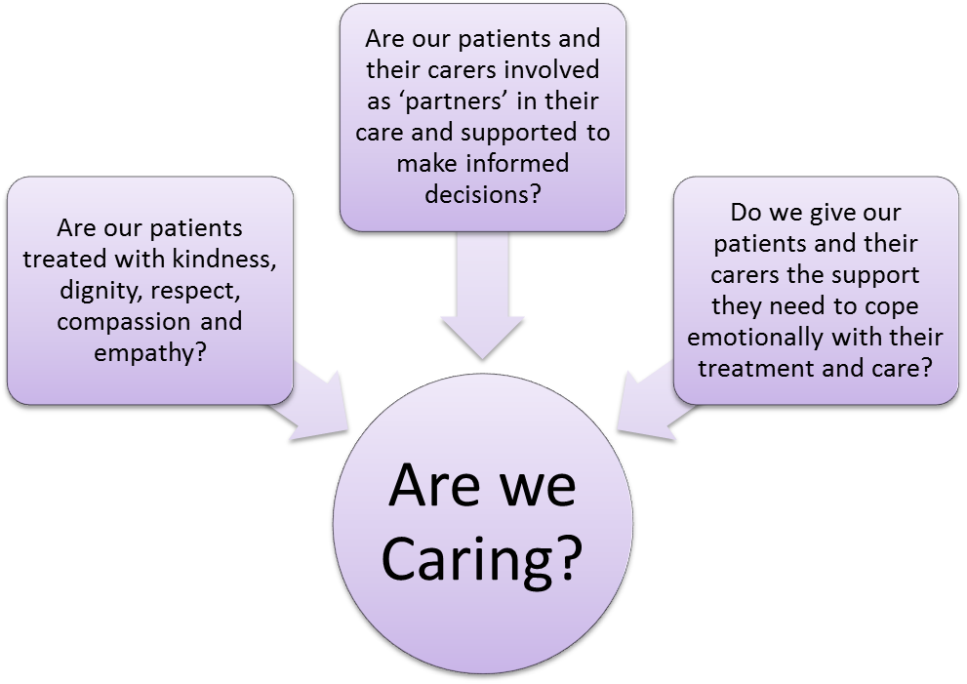

3.6 Is the service responsive?

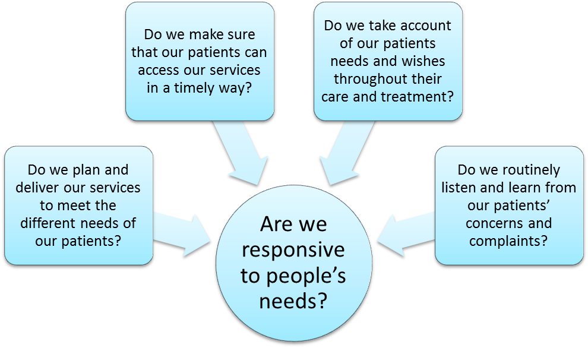

3.7 Is the service well led?

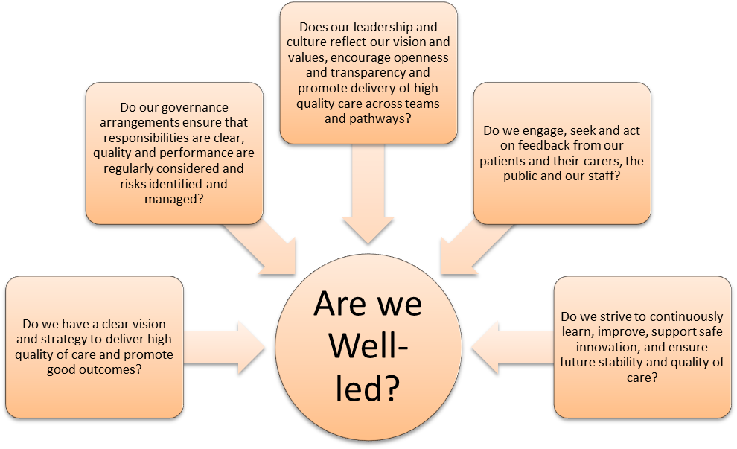

4. Quality priorities and indicators 2014/15
We have also set ourselves eight quality priorities for 2014/15. These are based on a review of our progress against our quality objectives for 2013/14; a consideration of patient and staff feedback, and an on-going assessment of the relevant recommendations from the Francis, Keogh and Berwick reports. These priorities will represent the key areas we monitor and report on through the quality account. Some of these will feature in each quarterly update; some will be reported in Q2 and the final report; and some will be reported in the final report at the end of the year.

5. Quality priority 1: workforce
Ensuring we have the right number of staff with appropriate training and experience, supported by effective clinical and managerial leadership, working effectively within teams. This will support our aspiration to be an excellent employer, caring for staff, supporting staff development, supporting teams and individuals to be able to work more effectively, developing our professional leadership and supporting new interventions. This work will be co-ordinated through our organisational development strategy. This will enable the service to be caring, safe, effective, responsive and well-led.

Update on progress:
5.1. Deliver expected nursing staffing levels on inpatient wards
Staffing levels by ward are reviewed shift by shift by ward staff and immediate managers, daily by Matrons and Heads of Nursing, and weekly by the Director of Nursing and Chief Operating Officer to ensure there is appropriate escalation and that staffing levels match the acuity and needs of patients to provide safe and effective care. There is also a monthly review by the Board of Directors.

5.1.2 In May, the majority of wards reported no or low level concerns about achieving expected staffing levels. Data is reported via Unify.
- 96.2% of day shifts filled by registered staff
- 94.5% of day shifts filled by unregistered staff
- 99.5% of night shifts filled by registered staff
- 99.8% of night shifts filled by unregistered staff

5.1.3 The wards identified as struggling to achieve their expected staffing levels and therefore requiring closer monitoring by senior staff were: Cotswold House Oxford, Wenric, Phoenix, Cotswold House Marlborough, Ruby, Allen, Wintle, Vaughan Thomas, Highfield unit, Kingfisher, Kestrel, Cherwell, Abingdon ward 1 and Abingdon ward 2. The main reasons were recently increased planned staffing levels, and recruitment difficulties in some geographical areas/specialties which resulted in specific action plans.

5.1.4 In June over 50% of wards are reported to have no or low level concerns about achieving expected staffing levels.
- 96.9% of day shifts filled by registered staff (better than last month)
- 97.3% of day shifts filled by unregistered staff (better than last month)
- 95.6% of night shifts filled by registered staff (worse than last month)
- 97.7% of night shifts filled by unregistered staff (worse than last month)
5.1.5 The following wards were identified as high risk. This means a higher proportion of shifts did not meet planned staffing levels, posing a higher risk of an adverse impact on patient care. Allen, Wintle, Phoenix, Cherwell, and Wenric. All are mental health wards.

5.1.6 The following wards were identified as moderate risk. This means planned staffing levels were not met regularly posing a moderate risk of an adverse impact on patient care. Ruby, Opal, Vaughan Thomas, Ashurst, Sandford, Abingdon ward 1, Abingdon ward 2, City, Linfoot Witney, Wenrisc Witney, Highfield and Cotswold House Oxford.

5.1.7 Using the existing range of quality, safety and workforce measures in our matrix, we did not identified a link between actual staffing levels achieved and any adverse outcomes for patients.

5.1.8 In July half of the wards reported no or low level concerns about achieving expected staffing levels.
- 98.7% of day shifts filled by registered staff (improvement on both the last 2 months)
- 96.3% of day shifts filled by unregistered staff (worse than last month)
- 92.5% of night shifts filled by registered staff (worse than both the last 2 months)
- 98.6% of night shifts filled by unregistered staff (improvement on the last month)

5.1.9 The following wards were identified as high risk. Cotswold House Marlborough, Kingfisher, Wenric, Ruby, Opal, Allen, Vaughan Thomas, Phoenix, Ashurst, Sandford, Cherwell and Witney Wenrisc community hospital ward.

5.1.10 The following wards were identified as moderate risk. Highfield, Cotswold House Oxford, Lambourne, Sapphire, Wintle and Amber wards.

Again no link between staffing levels and adverse events were identified.

5.2 Roll-out of the Aston Teamwork model across the organisation to nominated managers
5.2.1 The programme continues to provide managers with the core skills and approaches contained within the Aston teamwork model. The innovation team has nearly met its target for number of managers to be trained for the year in the first quarter; and also offers more specific support and facilitation for individual teams. The following is some feedback from working with district nursing teams in Oxfordshire.

5.2.3 “The main thing for both the West and SE teams that I have worked through Aston with, has been working as a true team across the whole locality instead of individual surgery teams or clusters. In both localities, I have worked with all of the Band 6 team leaders and the Continuing Development Leads at the same time and they have described themselves as ‘The Leadership Team’.

5.2.4 So in terms of the key issues before we started:
- Consistency across the teams – in terms of approach to worksharing, mechanisms for helping other teams, team culture, role models
- Understanding of other teams, which can lead to a lack of trust
- Communication between teams
- Problem solving as a locality so that solutions are owned by all
- A supportive and healthy environment for challenge and recognition of differences

5.2.5 The position now in the West, with regard to the above issues:
- By agreeing the team purpose initially, some of the inconsistencies started to be ironed out. The Team Leaders are clear about their role and it is the same across all the teams. They support each other with worksharing and they have developed and implemented their version of the hub working for weekends. Staff know that the same approach and systems are in place in each team so it doesn’t matter who they go to for advice and guidance – the answer will be consistent.
- As the leadership team comes together specifically to work on the Aston model together, they have a deep understanding of the challenges and issues across all of the locality and implicitly trust one another on every level.
- We have worked particularly on communication, both within the leadership team and outside it.
- Operational and other issues are brought to the meetings and the team have become very skilled at problem solving together. The own the issues and then own the solutions which is great to see
- There have been thorny issues to resolve, and some heated debate at times. This has been healthy and constructive and shows that they are now able to have those difficult discussions without damaging their team relationships.

5.2.6 In many ways, the SE team are working through similar concerns. We have done some work on communication already and they are starting to problem solve together. In particular, they have implemented a good weekend working model which supports new staff, makes the most of the talents and skills of the Team Leaders and experienced staff. For them, there have been some different challenges about consistency of leadership; however, the commitment is there and we are continuing to work hard together to become an effective, cohesive team.”

indicator | Data source | purpose | 13/14 | Q1 14/15
a) additional team leaders trained in Aston teamwork principles – target 250 leaders in 2014/15  b) 100% attendees reporting they are equipped to lead team working effectiveness improvements | Improvement and innovation team attendance records | Monitor spread of skills development | 178  86% | 238  90%

5.3 Maintain existing levels of access to staff training and development, including clinical practice, improvement skills and professional leadership

indicator | source | purpose | 13/14 baseline Q1 | Q1 2014/15
Performance development  review completed in last 12 months (target 95%) | Learning and development records | Support staff development, performance review | 90% | 56%.
Skills courses attendance | Learning and development records | Ensure staff develop and update clinical and leadership skills | 900 | 880

5.4 Friends and Family staff survey “how likely are you to recommend this organisation to friends and family as a place to work/if they needed care or treatment?”
5.4.1 The Staff Friends and Family test was introduced on 1st April 2014 and asked two questions: how likely are you to recommend OHFT to friends and family if they needed care and treatment? How likely are you to recommend OHFT to friends and family as a place to work?
5.4.2 The first results were based on a 6% response rate and are therefore not statistically robust; the HR team are therefore reviewing ways of increasing the response rate for future surveys. The key comments have been summarised below.

Theme | Positive | Requires improvement
Quality of Care | Staff felt that the Trust was forward-thinking and continually striving to do better, whilst learning from past mistakes. | Staff were concerned that due to staff shortages, there was a danger of good quality care being spread too thinly.
First hand / family / friend experience | Staff want the best for their friends and family and those who had experience of using the services described the care as outstanding. | Staff had experienced negative staff attitudes towards patients
Resources | Staff were felt to be dedicated to patient care and to providing the best possible service. | Staff felt that due to departments being short staffed, workloads were becoming unmanageable which could compromise the standards of care being given.
Service | Staff felt that the Trust offered a broad range of services which were committed to excellence. | Due to recent restructuring, staff felt that areas of services felt stretched and fragmented.
Oxford Health as an employer | Staff felt supported and valued, with clear support structures in place for staff. | Due to the size of the Trust, staff did not feel valued as Individuals and a felt a lack of recognition of staff achievements.
Learning and Development | Good training opportunities were highlighted and staff felt encouraged to develop their professional skills. | Staff felt there were limited career development opportunities for staff working in low bands.
Wellbeing | Staff described a great working atmosphere at the Trust, supported by a proactive approach to staff wellbeing and family support. | Restructuring and heavy workloads has left staff stressed and with low morale.

6. Quality priority 2: data on quality (and quality of data)
Ensuring we have reliable, accurate and relevant data on the quality and safety of our services. This will enable the service to be safe, effective and well-led.

Update on progress will be reported in quarter 2

7. Quality priority 3: service remodelling
To continue the service redesign and pathway remodelling programme, specifically focusing on its benefits in terms of quality and safety. This will enable the service to be caring, safe, effective, responsive and well-led.

Update on progress
7.1 Fully implement a new model of care based on cluster packages, care programme approach and the recovery star; ensuring patients and their families are clear about who is providing their care, what the care is and what to expect throughout their time in the service; supporting the patient (and/or family) to set their own goals

7.1.1 Adult services
The new model of care for the Adult Mental Health Teams (AMHTs) was implemented in April 2014 across Oxfordshire and Buckinghamshire. The care cluster packages have been agreed with Oxfordshire and Buckinghamshire CCGs and a workshop was held within the directorate in August to develop the summary documents attached to these for staff to use on the frontline with patients.

7.1.2 The Recovery Star is due to be rolled out across the teams once the copyright agreement has been confirmed; this will enable patients to develop their own goals and recovery plans. We will be implementing an electronic version of the Recovery Star within our new electronic health record (Jan 2015) which will enable a more interactive approach to care planning between our staff and patients.

7.1.3 Ahead of the changes being implemented in April and since then, we have been working alongside the carers reference group and service user forums to inform people about the changes which have been made and what they can now expect from the service. These regular sessions enable our staff to hear from carers and patients about their thoughts of the changes and whether these have made an improvement to the care they receive.

7.1.4 Older people’s services
The model of care for older people’s mental health services was consulted on with staff in August 2014. The first phase of implementation of the new model of care is formal organisational change. In Buckinghamshire this is nearly complete; and will be completed in Oxfordshire by the end of September 2014. In each county recruitment to vacant posts is underway.

7.1.5 The second phase of implementation of the new model of care will involve the delivery of the following new processes:
- Enhanced duty function and extended hours / 7-day working
- New memory clinic model
- Outcomes based clustering / treatment though needs-led cluster care packages
- Streamlined inpatient processes
- New ways of working

7.1.6 Memory clinics are in the process of changing to implement one stop shop model; teams are making significant improvements in meeting the 8 weeks to appointment target, although this is dependent on the number of referrals.

7.1.7 Staff are delivering cluster packages of care for older people within two pathways:
Pathway 1: Functional Mental Health conditions pathway
Pathway 2: Dementia conditions or Organic Mental Health pathway

7.1.8 Treatment is provided within these pathways following a specified cluster care package.
- The treatment for people with Functional Mental Health conditions will follow the care packages for clusters 4 to 8 and 10 to 17
- For people with early memory problems where Memory Assessment and Diagnosis is required the care packages for clusters 18 and 19 will followed
- Treatment for people with deteriorating Organic Mental Health conditions will follow clusters 19 to 21 depending upon the stage of the disease and the corresponding care needs

7.1.9 Clustering of patients is being maintained at a good rate within OPMH Services with 90% of all patients clustered. There are some patients for whom clinical work is being provided who are not assigned to a cluster, for example sign posting or undergoing assessment. The Trust is developing systems to identify those patients who would therefore be in an agreed assessment cluster.

7.1.10 Cluster outcomes have been set by CCGs for each cluster. Work is ongoing to identify the most effective ways of evidencing these.

Indicator or measure | Data source | Purpose of measure | Q1 14/15
% of patients with a CPA to be in employment or meaningful activity | CPA audit | Measure quality of life goals as part of care planning | 11.7%
% of patients with a CPA in settled accommodation | CPA audit | Measure quality of life goals as part of care planning | 78.6%
100% of patients involved in setting and achieving goals | CPA audit | Assess levels of patient involvement in setting and meeting their personal care plans | 85%

7.2 Implement locality and ward based patient and carer forums
Each locality now has a patient and carer forum which is attended by either the modern matrons or community leads/team members.

7.3 Implement patient and carer outcome measures
The patient satisfaction questionnaire has been designed and implemented across the adult mental health teams and are undertaken at the point of the patient review. These are anonymous questionnaires which are supported by Patient Perspective (PP); each form is given to the patient who can complete and then seal before sending off to PP, the results are then collated and feedback to the teams. The first set of responses will be reported in quarter 2. The carers questionnaire is in development and will operate under the same principles.

7.4 Review and develop early intervention in psychosis services
The consultation has taken place across the EIP service and the final document will be circulated late August (w/e 22 Aug). Following this, the implementation will commence and it is envisaged that the new service model will be in place by September 2014.

7.5 Review and develop the complex needs services with CCG leads
7.5.1 The review of the services has commenced with Oxfordshire and Buckinghamshire CCG leads undertaking patient feedback sessions. The papers have been submitted to the CCGs though we are awaiting the financial costings from Buckinghamshire CCGs.

7.5.2 Oxfordshire CCG have agreed the full payment for FY14-15 with further payments to be made in line with the review outcome.

7.6 Develop, implement and evaluate new staffing models including seven day working and extended hours
7.6.1 The new staffing model and seven day working commenced in April 2014 for adult services and has been underway for now almost six months. The first review (at six months) is due to commence in September 2014 and will be conducted by external reviewers to ensure an independent process is followed.

7.6.2 Extended hours will begin in Buckinghamshire for older adult mental health services at weekends from 1st September and on weekday evenings from 1st October. In Oxfordshire teams plan to implement extended hours on the 1st October 2014.

7.7 Implement leadership teams in adult mental health wards
Each adult mental health inpatient ward now has a dedicated consultant and modern matron who together with the ward manager have been attending the ‘triumvirate’ planning for the future days to build the core leadership within the team.

8. Quality priority 4: staff engagement with the quality agenda
Ensuring a focus on quality from the front-line to the Board, improving quality management processes, and strengthening links between the Board and staff directly delivering patient care. This will enable the service to be caring, safe, effective, responsive and well-led.

Update on progress
8.1 Values based recruitment
8.1.1 The data gathering phase of the project is now complete with 160 completed questionnaires having been received. These represent the experiences of a cross-section of staff from across the Trust. The aim is to produce a draft behavioural framework by October 2014. The second phase of developing recruitment material will take place between October and December with roll out of training and implementation early in the New Year.

8.2 Provide opportunities for staff to engage in improvement activities and projects
8.2.1 Forensic services have been using a regular workshop-style approach with attendance from frontline nursing staff to support Productive Wards projects quarterly. These are attended by heads of service and other senior clinicians. There are a number of examples of ward-based projects and there is also a “Productive MDT Working” project led by Jason Jones.

- Gathering data on time spent on phone calls and signal issues with the buddi tracker to identify the impact of buddi trackers on patient clinical progress - looking at data on patient experience and statistics on progress. Encouraging more time for staff to spend with patients rather than in the office following 15 steps feedback. Reinstate ward achievement and information screen.

- Working to get electronic handover up and running - linking with other wards to build on what works well. Working on admission and discharge module - initial 24-72 hour care plan checklist to be done. Completed standard operating procedures (SOPs) for the process and working on benefits realisation. Updated SOPs for all recent WOW changes. Ensured that staff are aware of audits being undertaken and how to establish a baseline to ensure standardisation.

- Promoting the 6 C's of nursing through posters and notice board. Improved safety of medicines by the purchase of a locked cabinet for creams and inhalers.

- Productive Ward meetings. Analysing the amount of direct care time spent with patients by support workers (68%) and RMNs (78%) and identifying opportunities for further increasing patient facing activities. The team also took part in 15 steps challenge and is now working now on recommendations.. Completed banned items and search module which has resulted in policy amendments.

- Section 17 process - electronic document introduced to record use of leave and return from leave. Completed handover SOP

8.2.2 Glyme Ward was awarded a Certificate in recognition of the team’s achievements in Improving Care at the Productive Care Learning and Sharing Event on 11th June 2014. Two members of the team did poster presentations on the benefits of electronic handovers and other projects such as Smoking and Leave.

8.2.3 Improvement projects in older adults include:
Adoption of PSAG (Patient Status at A Glance) in the community nursing service to support the Venous Leg Ulcer Pathway – working with seven pilot teams across the county. A monthly audit is in progress and the pilots will be reviewed in October 2014.

8.2.4 The Continuing Care service has been supported to review all of their processes, enabling a greater clarity of role and a more timely response to referrals and inquiries. This has reduced the average turnaround time for referrals being responded to from six working days to two working days.

8.2.5 Annual sustainability reviews have been completed with ten community hospital wards –a score of 64.2% was successfully achieved. A score of 55% or above indicates that changes implemented will sustain over the longer term.

8.2.6 The District nurse ‘referral into service’ form has been reviewed to reduce the number of incomplete referrals and the time spent managing incomplete and inappropriate referrals. Improvements measured before and after the change showed that incomplete referrals were reduced by 68%

8.3 Implement actions to improve staff wellbeing and motivation at work
- The whistleblowing policy has been updated to include monitoring by the human resources quality committee of any recommendations or action plans following an investigation of a whistleblowing case. There is also a discussion of employee relations cases at the weekly review meeting so these can be considered alongside serious incidents, complaints, coroner’s reports and other harm reduction information.

- The Wellbeing Group and Health and Wellbeing co-ordinator have established a number of wellbeing activities. Wellbeing days at different locations include sessions on mindfulness, yoga, massage and interactive health promotion stalls. The trust has just launched its second pedometer and 5k run challenges to improve fitness. Flu clinics already being planned on a proactive, site visiting programme to enable maximum uptake. Stress management courses are being run in recognition that stress and anxiety is one of the top three reasons for sickness absence. The pilot was well received and will be rolled out to further areas.

- A business case has been submitted for additional funding for musculoskeletal and counselling support as musculoskeletal problems and mental health issues are two of the highest causes of sickness absence.

9. Quality priority 5: reduction in harm

9.1 There were 3020 incidents reported in the first quarter of 2014/15.
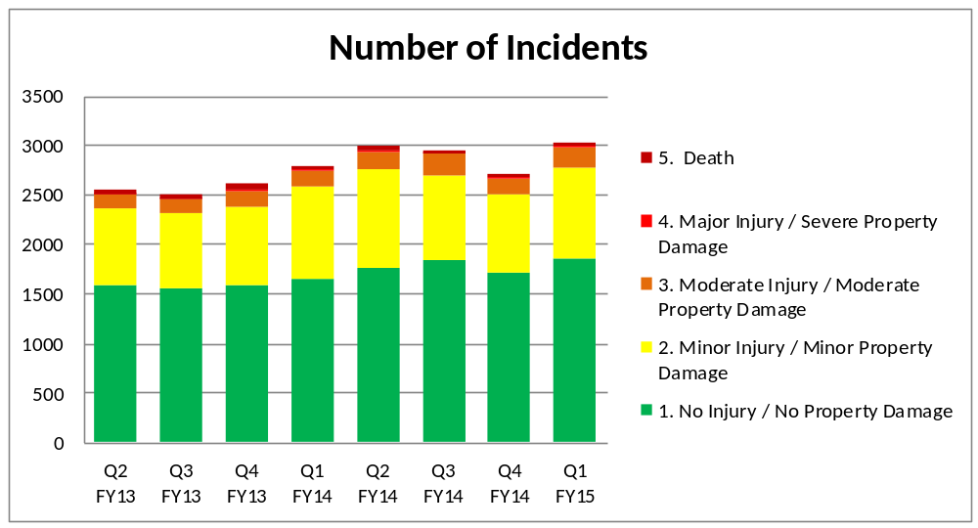
- overall, the level of incident reporting broadly continues to increase quarter on quarter
- the number of green and yellow incidents (low/minor injury or property damage) reported continue, as expected, to be the largest numbers of incidents reported and the overall increase in number reflects greater reporting rather than an increase in levels of harm
- this quarter seventeen SIRIs have been reported which shows a slight increase on the last two quarters, although this remains much lower than the majority of the preceding 6 quarters

- suspected suicides are the main cause of SIRIs reported in Quarter 1 followed by unexpected death and avoidable pressure ulcers

- there was one case of Clostridium Difficile Infection in April which was peer reviewed and assessed as being unavoidable

5a: prevention of suicide
This will enable the service to be safe.

Update on progress
9.2 Agree suicide awareness and prevention strategies in teams across the trust and review the impact on practice, benchmarking against other providers for common indicators
9.2.1 Forensic services have been implementing a self-harm project in Thames House to try and gain a better understanding of the function of self-harm and to look at trends to try to predict and ultimately reduce acts of self-harm. It is clear that self-harm is a complex issue and the reasons behind it are multi-faceted. Data is being collected on a monthly basis looking at frequency of self-harm – annotation will be provided for any peaks in frequency once a baseline mean can be assessed following six months’ data collection. Guidance has been formulated which will inform care planning for those who exhibit self-harming behaviours, and will be audited.

9.2.2 A suicide awareness and prevention training programme is underway across the Trust and the following teams have been trained: Amber ward; Vaughn Thomas ward; Wenric ward; Chiltern AMHT; Chipping Norton older adult CMHT; Early Diagnosis and Prevention Service; urgent care/out of hours; Ruby ward. Sessions have consisted of suicide awareness and Joiner’s interpersonal theory of suicide supported by reflective practice. An over view of the interpersonal theory of suicide has also been provided to senior managers/directors and to Oxford Cruse.

9.2.3 The interpersonal theory of suicide has been incorporated into the advanced assessment skills training and had already been included in the mandatory risk training.

9.3 Suspected suicides
9.3.1 If numbers of sucides remain at the current rate over the next three quarters we will be anticipating a further reduction on last yearin the first quarter there were six suspected suicides. All of these occurred in the community with one being a prison death. Two incidents occurred in Buckinghamshire and three in Oxford. None of the incidents involved patients in the older adult mental health service. Of the incidents reported this quarter, five occurred with patients under the care of the new AMHTs with 1 team (South Oxfordshire AMHT) reporting two incidents

9.3.2 There have been no inpatient deaths in quarter 1. Between 01/04/2012 and 30/06/2014 there have been 3 deaths that would meet the criteria for an inpatient death. None of these deaths occurred in an OHFT inpatient area as report in the last IGC report. The days between deaths that meet the criteria for inpatient deaths are 192, 153 and 165.

9.3.3 The number of days between probable suicide by individual team will be reported in quarter 2 as the Safeguard system does not have the new teams fully established.

5b: reduction in the number of missing patients from inpatient services
This will enable the service to be safe.

Update on progress
9.4 Review and evaluate absence without leave (AWOL) projects in three wards
Chaffron ward are continuing to monitor the days in between AWOLs for the safer care project and this stands at 483 from the start of the project.

Indicator or measure | Data source | Purpose of measure | Baseline 13/14 | Q1 2014/15
Number of incidents of absence without permission (target 50% reduction) | Safeguard | Measure reduction in incidence of AWOLs | 230 | 77
Number of patients absent without permission (target 25% reduction) | Safeguard | Measure number of patients generating AWOL incidents | 174 | 41
0 patients to experience harm (rated 3, 4 or 5 in impact) as a result of being absent without permission | Safeguard | Measuring reduction in harm resulting from incidents of absence without permission | 2 | 1 (3, moderate harm)

5c: reduction in the number of avoidable pressure ulcers
This will enable the service to be safe.

9.5 Awaiting data on avoidable pressure ulcers and skin integrity risk assessments

Indicator or measure | Data source | Frequency of reporting | Purpose of measure | Baseline 13/14
Number of patients with avoidable pressure ulcers graded 2-4 (target 0) | Safeguard | Quarterly | Measure reduction in avoidable pressure ulcers | 15
100% of patients managed by the district nursing service to have a skin integrity risk assessment | RiO | Quarterly | Reduce risk of avoidable pressure damage | 96% (Walsall)
100% of patients managed by the district nursing service to have a nutritional status assessment | RiO | Quarterly | Reduce risk of avoidable pressure damage | 93%

5d: reduction in the number of patients harmed by falls
This will enable the service to be safe.

9.6 Awaiting data on falls risk assessments

Indicator or measure | Data source | Purpose of measure | Baseline 13/14 | Q1 2014/15
Number of falls/number resulting in harm (rated as 3, 4 or 5 in impact) by 1000 bed days (target to reduce to 3.8/0.2 in mental health and 8.6/0.2 in physical health) | Safeguard | Measure reduction in harm from falls | Number of falls 4.8 MH (harm 0.3) and 10.6 PH (harm 0.3) by 1000 bed days | 321 (10.6/1000 bed days) of which 16 (0.8/1000 bed days) resulted in harm
100% of patients in older adult inpatient services to have a falls risk assessment on admission | RiO | Reduce the risk of falls | 87.75% | Data not available
100% of patients in older adult inpatient services to have a further falls risk assessment after 28 days | RiO | Reduce the risk of falls | Baseline set Q1 | Data not available
% of patients to have a review of care plan after a fall (target 100%) | RiO | Reduce the risk of falls | Baseline set Q1 | Data not available
100% of patients to be referred to falls service after 2 or more falls | RiO | Reduce the risk of harm from falls | Baseline set Q1 | Data not available

5e: reduction in violence and aggression
This will enable the service to be safe.

Update on progress
9.7 Watling ward are implementing a project which aims to reduce incidents of violence and aggression by 20% by April 2015. The ward has been piloting intentional rounding and will continue the approach of offering planned therapeutic activities to each individual patient. Following the first month of data collection it was noted that the approach to the four set questions wasn’t deemed to be helpful for the patients (following feedback) and the approach to asking questions has been re-formulated. During the week of the intervention the participation in formal activities rose from 40% to 44%.

9.8 Use of restraints
There were 358 reported incidents of physical restraint in quarter four. Totals for the previous four quarters were 406, 293, 338 and 351. The mean number per month for the last eighteen months is 117. The graph below shows a fairly steady rate of incidents with occasional peaks and troughs.

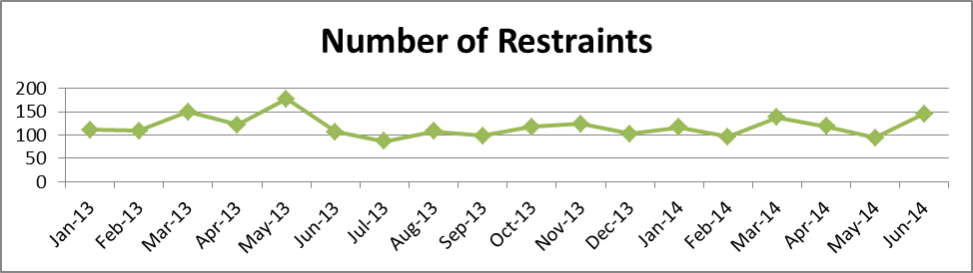

9.8.1 The four wards with the highest number of restraints are Ashurst, Highfield, Kestrel and Ruby. The high reporters, as would be expected, are related to the presence of individual patients who required multiple restraints (corresponding to the table of individual patient restraints above).

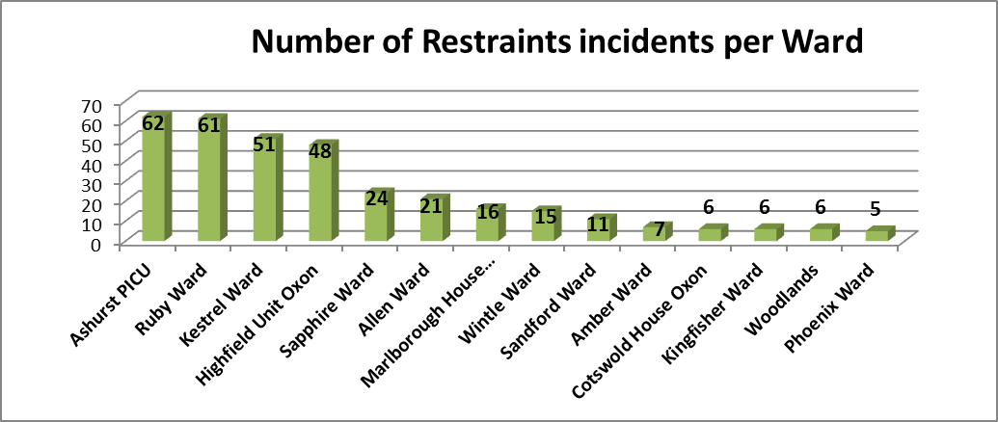

9.8.2 The number of prone restraints remained consistent with previous quarters. The number of restraints involving hyperflexion suggests a significant reduction; however this will need to monitored over the year before any conclusions can be drawn.

Indicator or measure | Data source | Purpose of measure | Baseline 13/14 | Q1 2014/15
Reduce number of reported incidents of violence and aggression resulting in harm (3, 4 or 5 in impact) by 25% | Safeguard | Measure reduction in incidence of violence and aggression | 28 (incidents in our inpatient units only) | 22 (all incidents including those in the community)*
Number of (avoidable) prone restraints (target towards 0) | Safeguard | Measure reduction in incidence of prone restraints | 392 (all prone restraints) | 94
Number of restraints involving hyper-flexion (target towards 0) | Safeguard | Measure reduction in incidence of hyper-flexion | 1187 | 22
*More comparable data will be available once the new teams and locations are set up on Safeguard
10. Quality priority 6: implement patient experience strategy
Ensuring a focus on delivering a positive experience, which meets the needs of patients and those close to them. This will enable the service to be caring.

Update on progress
10.1 Examples of implementing the patient experience strategy in forensic services include:
10.1.1 Groups of service users have been involved in making a film about their experiences being in hospital and their recovery journey. This has been used to form part of the forensic induction for all new staff. Glyme ward patients and staff have been producing a joint newsletter on a monthly basis, this has proven very popular and a positive way to celebrate patient success and keep parties informed of developments. A number of service users have been involved in planning an event across the Littlemore site and a football tournament will take place in August.

10.1.2 The Patients council continues to happen in units across the service with a quarterly wider patient’s council attended by advocates, commissioners and heads of service. In the last quarter the following issues have been addressed:

10.1.3 You Said…
Show which staff are on duty and who the shift coordinator is; new footstools; curfew time to be extended; make the visitors room family friendly by getting smaller chairs; make bathrooms on Thames house more private; oral health training for patients; see-through bags for moving patient possessions; low water pressure in female showers and aerial plug sockets in bedroom for better T.V signal

10.1.4 We Did...
- staff board now updated to include all disciplines per shift and actual/planned nursing staff members
- curfew time extended to 8pm and regularly reviewed
- new footstools ordered for Woodlands ward
- chairs replaced with new ones in the visitors room
- work completed on Kestrel ward for privatising bathrooms
- oral health training has been offered to patients

10.1.5 Work in Progress...
- clear bags to be purchased for possessions
- privatising bathrooms on Kingfisher ward
- money allocated for female showers, start date to be set
- plug sockets being installed for TV aerials

10.2 In district nursing services the teams have recently completed making a film which has targeted engaging service users who are difficult to reach. The film is to be used to facilitate changes to practice and care where needed and therefore improve the experience for patients.
10.3 Friends and family results
10.3.1 The Trust agreed to revise one of the four questions to change ‘overall how would you rate the care you have received’ to the national Friends and Family Test (FFT) question ‘how likely are you to recommend this *unit/ ward/ service* to friends and family if they needed similar care or treatment’ which has to be introduced across all NHS services by December 2014. We were an early adopter of the FFT across the community hospital wards and minor injury units (MIU) from April 2013, and from June 2014 have started to introduce the question across all services through existing feedback mechanisms.

10.3.2 For quarter 1 2014/15 the overall results are shown in graph 2 (n=1295 responses).

.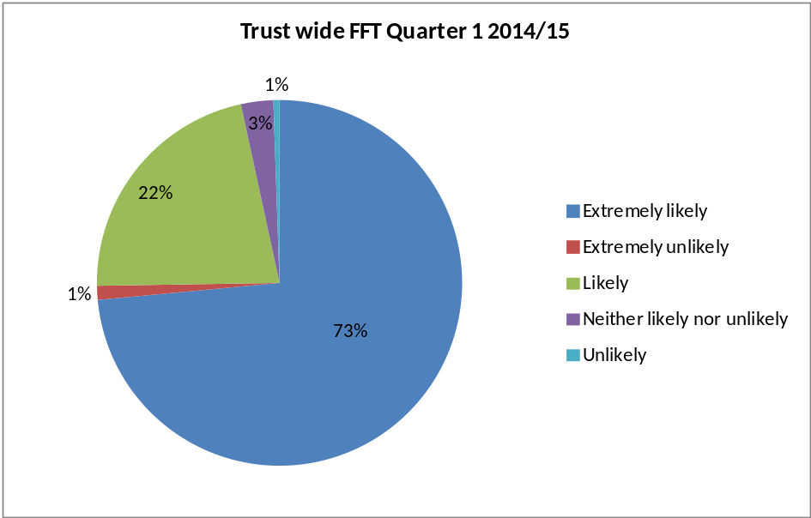
10.3.3 The table below shows the results for the community hospitals and minor injury units which have been collecting data since 2013.

 | Extremely likely | Likely | Neither likely nor unlikely | Unlikely | Extremely unlikely
 |  |  | 
Community Hospital Wards | 83% | 15% | 0.7% | 0.7% | 0.7%
Minor Injury Units | 76% | 21% | 2% | 0.2% | 1.3%

10.3.4 For quarter 1 2014/15 the net promoter score for community hospital wards was 80.9 (the nearest comparator is the national average for acute inpatient wards which was 74 for May 14). For MIUs the score was 72.5 (the nearest comparator is the national average for A&E departments which was 54 for May 14). This constitutes an improving trend on the net promoter score for both the community hospital wards and MIUs for the last 16 months. The improvement across the MIUs has been as a result of actions introduced e.g. a review of staffing levels and allocations by shift, the whiteboard in the entrance foyer which now shows the current waiting time, patients being notified of the waiting time when they book in at reception, and staff attending a tailor made customer service course.

11. Quality priority 7: development of outcome measures
Ensuring a focus on how services support patients to manage their condition and/or recover. This will enable the service to be effective.

11.1 Select two new areas (pathways or services) for development of outcomes measures and report on progress during the year by 31 July 2014
Discussions have been held with each directorate to identify appropriate services and pathways to monitor the development of outcome measures. These will include development of outcome measures in adult and older people’s mental health services; implementation of co-created outcomes with patients in community hospital services; development of outcome measures with young people in speech and language therapy services in Buckinghamshire.

12. Quality priority 8: using the new CQC regulatory framework
Ensuring we assess and, where necessary, make quality improvements to our services to ensure they are safe, effective, caring, responsive and well-led.

12.1 Ensure staff across the organisation are familiar with the changes to the regulatory framework by 31 July 2014; adapt the Trust’s approach to quality in recognition of changes in regulation by 31 July 2014

There is a project with the oversight of a project board to embed the Trust’s new approach to quality which mirrors the CQC’s five domains. A project plan has been drawn up and the taskforce has now met on four occasions. Part of the role of the directorate and department leads is to raise awareness of this new approach within their areas in addition to taking actions to embed the new approach. Briefings are taking place with directorate senior management teams and other staff groups. Other actions that have been taken include: members of the project team liaising with and attending briefing sessions with Trust that have been inspected; the Director of Nursing of Devon Partnership Trust briefing the project team and other leaders in the organisation on their CQC inspection; a session at the Senior Leaders Conference in July on the new CQC inspections and our approach within the organisation. The emphasis is on how we use these five questions to asses our services as part of our business as usual.

