

# PAPER

BOD 118/2014

(Agenda Item: 5)

# Report to the Meeting of the

# Oxford Health NHS Foundation Trust

# Board of Directors

**Board Meeting**

**24 October 2014**

**Chief Operating Officer’s Report**

.

**For Information**

This month’s report provides the Board with an update on:

* Services for Looked After Children
* Outcome Based Contract for Adult Mental Health Services
* Performance of Community Hospitals

**Recommendations**

The Board is asked to note the report.

**Lead Executive Director: Yvonne Taylor, Chief Operating Officer**

1. **Children and Young People’s Services**

It is well evidenced that Looked after Children and young people are particularly vulnerable to poorer health outcomes than their peers and are more likely to experience physical, emotional and mental health problems than the general children population in England. Their health needs are often linked to their life experiences, including the circumstances through which they became looked after and their experience of care. For example Looked after children and young people are more likely than their peers to have experienced the death of a parent or sibling and nearly a quarter of looked after young people aged 11-17 reporting having experienced some kind of sexual abuse. Some 5 per cent of looked after children are unaccompanied asylum seekers. They are more likely to engage in risky behaviours and are more likely to become teenage parents than their peers.

A child is looked after by Local Authority if he or she has been provided with accommodation for a continuous period of more than 24 hours in the circumstances set out in Sections 20 and 21 of the Children Act 1989, or is placed in the care of the Local Authority by virtue of a care order. What this means is that a child is looked after by a Local Authority either under a Court Order or through a voluntary arrangement made with the child’s parents. A child will also become looked after if he/she is being held in council accommodation on a court-ordered secure remand – e.g. he/she is looked after under a compulsory order. Children who receive respite for more than 120 days in any year are also considered looked after under Section 20 of the Children Act.

In order to ensure that the health needs of looked after children and young people are met in a timely way, the Children and Young People’s Directorate works with partner agencies and commissioners. The arrangements differ in each of the 5 counties where we provide services but in each looked after children are viewed as a priority.

Oxfordshire. In Oxfordshire the Trust is commissioned to lead on the LAC health assessments. The aims of the looked after service are:

* To contribute to the improvement of the health outcomes forlooked after children and young people.
* To ensure their health and emotional well-being needs are identified and met through the actions identified in the health care plan, in partnership with other agencies.
* To provide professional consultation and support to all looked after young people, carers, health and social care professionals in Oxfordshire.
* To co-ordinate health provision for looked after children in the care of Oxfordshire County Council.
* To contribute to the strategic planning of services for looked after children.
* To assess and monitor the emotional health of looked after children at the point of entry into care and annually thereafter for a specified cohort, using the Strengths and Difficulties Questionnaire (SDQ).

The Children and Young People’s Directorate is working with partner agencies in delivering the placement strategy with the aim of keeping young people as close to home as possible. The strategy also aims to meet the needs of young people who are on the edge of care and health and social care partners are seeking to intervene more rapidly in order to support families. The increase in the number of looked after children has not been met with an increase in resource but this issue is being raised with commissioners.

The Outreach service for young people is now commissioned to provide an extended service up to age 25 for a small number of young people most of who are looked after or are on the edge of care and whose ongoing mental health issues are best met by continuing intensive support through CAMHS rather than transferring as would be usual to adult services at age 18.

Buckinghamshire. All children and young people who are subject to looked after status are prioritised through the single point of access which sits locality CAMHS teams. This means that looked after children are always assessed, and then may receive interventions from CAMHS, the primary mental health service (PCAMHS) or another agency as appropriate to their needs.

CAMHS also provide regular consultation to R u Safe, social care and YOS ensuring that there is ready access to advice and support for partners working with looked after children. Whilst we do not lead on the health assessments for looked after young people in Buckinghamshire, experienced CAMHS staff provide clinical supervision to the Buckinghamshire Looked after Children’s nurses who are employed by Buckinghamshire Hospitals NHS Trust.

Swindon. All young people who are looked after status are referred directly to Specialist CAMHS for assessment without going through single point of access which is hosted by the Local Authority. Following assessment they may have intervention from CAMHS, the primary mental health service (TaMHS which is provided by the Local Authority) or another agency.  CAMHS also provides regular consultation and advice to social care regarding looked after children.

Wiltshire. Our Outreach Service (OSCA) provides consultation sessions per month to social workers and foster carers.  This is used to understand issues for child and carers, and identify when a CAMHS intervention would be helpful.  Referrals can still be made directly through our single point of access and be seen by PCAMHS or CAMHS according to need. In addition, two CAMHS therapists are seconded to work within the county’s family placement teams.  Their role is to work directly with foster carers and adopters providing direct interventions, training and consultation to social care staff.  Early indications suggest a reduction in placement breakdown and out of area placements. The Directorate has recently agreed to run a 1 year pilot for OSCA to continue to work with care leavers up to 24 years where they do not meet the criteria for adult mental health services, but have ongoing emotional needs.

Bath and North East Somerset (BaNES). CAMHS provides regular consultation to social workers for looked after children and again they are prioritised in the referrals system. OSCA predominantly works with those young people in placements and here again the Directorate is working with commissioners and the development of a pilot of continued service for 18 – 24r old for care leavers is in the early stages of development.

Across Swindon, Wiltshire and BaNES, our CAMH Services offer training in attachment theory with the largest take up from colleagues in social care.

1. **Adult Services**

The Oxfordshire Mental Health Partnership was delighted to be designated ‘most capable provider’ at the September Governing Body meeting of the Oxfordshire Clinical Commissioning Group. There are 6 partners within the partnership – Oxfordshire Mind, Response, Restore, Elmore, Connection and OHFT. The process has now moved into contract negotiation stage and we will be meeting with commissioners shortly.

In the meantime all partners are fully engaged in the planning and implementation of the overall plan of work for year 1. There are a number of key workstreams in development

* Partnership Management
* Outcomes/KPI development
* Pathway Development
* Recovery College
* Workforce Development
* Support Services

The overall implementation will be overseen by the Partnership Management Group led by Yvonne Taylor supported by the operational Delivery Group, led by John McLaughlin. Jackie Gough will provide Programme Management and the Business and Performance Team will provide project management support to the various work streams.

This is a very exciting development in the proWe will report back to the Board again once contracts have been signed.

1. **Older People’s Services**

This section provides a summary briefing on the current delivery of inpatient services in Oxfordshire’s community hospitals. It outlines the current performance and quality position.

Oxford Health NHS Foundation Trust currently provides around 195 community hospitals beds over eight sites in Oxfordshire (Abingdon, Bicester, Didcot, Henley, Oxford City, Wallingford, Wantage and Witney). Community hospitals provide sub-acute and rehabilitation care, as well as palliative care for people who are not able / do not wish to die at home and stroke rehabilitation via a number of beds at Abingdon and Witney community hospitals.

OHFT is contracted by Oxfordshire CCG to provide 2,450 episodes of inpatient care through community hospitals each year. This output-focused contracting approach does not specify the numbers of beds required to provide these inpatient episodes.

Over the past two years improvements in the model of care (including discharge planning) means that OHFT has significantly exceeded its contracted number of inpatient episodes in community hospitals, averaging circa 2,650 episodes per annum for both 2012-13 and 2013-14. The key reasons for this increased productivity are:

* Reduction in the duration of delayed transfers of care in community hospitals (down from an average of 22 days for each delay in 2012 to an average of 12 days for each delay in 2013).
* Improvements to the model of care, which have shortened the time taken for patients to recover / rehabilitate.
* Provision of an Emergency Multi-disciplinary Unit (EMU) at Abingdon, increasing the number of short inpatient episodes directly from the local community (rather than transferred out from OUH inpatient settings). This has been further enhanced by the opening of Witney EMU in January 2014.

**Performance**

Graph 1 below illustrates that the service has become more productive with activity remaining high despite a reduction in actual bed numbers. Furthermore, the variance between bed numbers and occupied beds has reduced which also illustrates more effective bed and resource usage.

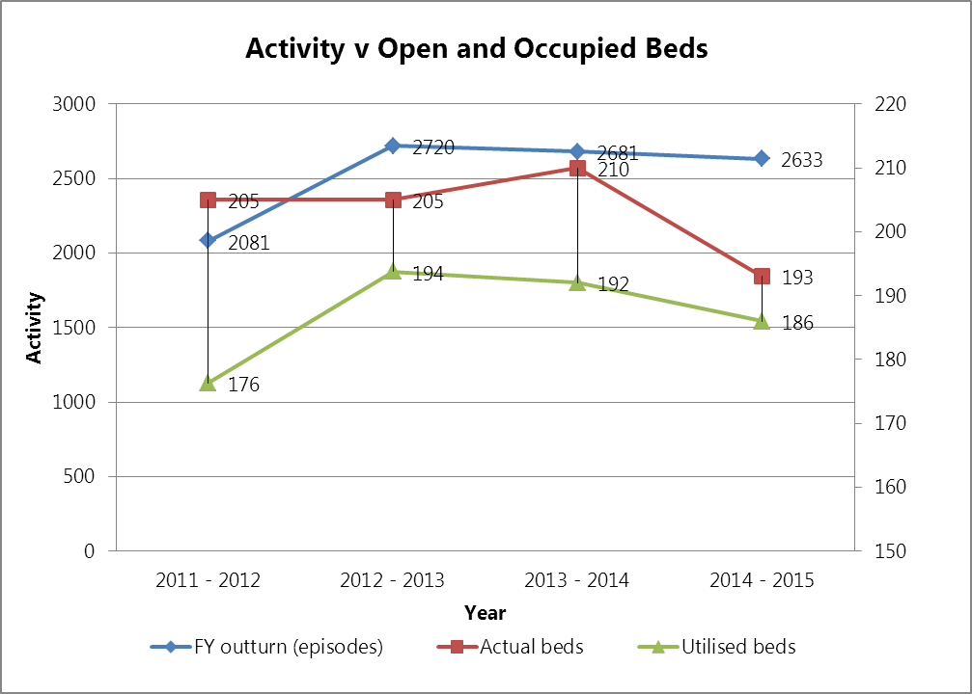

This has been achieved by reducing the average patient length of stay from 31 days to 26 days, increased bed occupancy from 86% to 95% and reducing the outbound delayed transfers of care.

**Quality**

The service has seen no detrimental impact on patient safety, quality, patient satisfaction or staff satisfaction as a result of reduced bed numbers, reduced patient length of stay or increased bed occupancy. Conversely, patient and staff satisfaction have continued to increase and the number of serious incidents requiring investigation (SIRIs) has significantly reduced;

