# Logo

# Report to the Meeting of the

# Oxford Health NHS Foundation Trust

**BOD 48/2017**  
(Agenda item: 10)

# Board of Directors

**Staffing 27th February to 26th March 2017**

**Inpatient Safer Staffing Report**

**For Information**

**Introduction**

This is the monthly report to the Board of Directors presenting the actual staffing levels (registered and unregistered) on each ward against their required need on a shift by shift basis for a 4 week period from 27th February to 26th March 2017. The paper also identifies the percentage of agency usage, sickness and vacancy rates for all in-patient areas.

There is a national requirement on providers to be transparent regarding monitoring and reporting of staffing levels. Ensuring sufficient staffing levels are in place is crucial to deliver safe, effective and high quality care.

**Management of Staffing Levels**

Staffing levels are monitored each week at the weekly review meeting (WRM). Table 1 in the body of the report summarises the staffing position by ward. Each ward is taking a range of immediate actions on a daily basis to ensure safe staffing levels are maintained appropriate to the needs of patients.

This month eight wards have not met 85% or over staffing levels. When looking at the number of shifts which were fully staffed to expected levels, eight wards were identified as having the most difficulties across the last three months in achieving expected staffing levels on every shift. However all wards did maintain minimum staffing levels to provide a safe standard of care.

The eight wards identified as not meeting above 85% planned staffing cover were; Cotswold House Oxon, Chaffron, Glyme, Kingfisher, Phoenix, Sandford, Sapphire and Vaughan Thomas. More detail of the staffing on each of these wards is provided in the report.

The main reason wards have been unable to fully staff every shift is due to sickness rates, vacancies and patient acuity levels. Recruitment difficulties continue to be an issue in a number of areas details of the actions being undertaken are detailed in the report driven by the Workforce and Nursing Strategies.

**Recommendations**

The Board is asked to note:

* The processes in place to ensure safe staffing levels on all the wards in the organisation, those wards where there are concerns and the actions being taken to ensure safe staffing

**Author and Title:** Susan Haynes, Deputy Director of Nursing and Clinical Standards

**Lead Executive Director:** Ros Alstead, Director of Nursing and Clinical Standards

*A risk assessment has been undertaken around the legal issues that this paper presents and there are no issues that need to be referred to the Trust Solicitors. This paper links to all of the five CQC Domains.*

**Inpatient Safer Staffing**

Period: 27th February to 26th March 2017

**Introduction**

This is a monthly report to the Board of Directors presenting the actual staff levels (registered and unregistered) on each ward against their required need on a shift by shift basis for a 4 week period from 27th February to 26th March 2017 .

This report will be published on our website with a link from NHS Choices website.

**Management of Staffing Levels**

Each service area has agreed escalation processes in place in order to manage staffing safely on a shift by shift basis, with senior staff giving appropriate support to ward teams as and when required. Senior ward staff and immediate managers continually review ward staffing levels by shift and where there are changes in patient acuity and Matrons review staffing daily as a minimum.

The staffing figures are reviewed weekly by the Heads of Nursing, Deputy Director and Director of Nursing at the Weekly Review Meeting (WRM) in order to assess the current position, to ensure there is an appropriate level and skill mix of nursing staff, and to match the acuity and needs of patients in order to provide safe and effective care.

Patient feedback data through PALs and complaints, details of any orange rated incidents, Serious Incidents (SIs), and Human Resources issues which could indicate a concern are reviewed weekly. The information from these sources is triangulated in order to assess if there is any indication that current staffing levels is having an adverse effect on the quality of patient care or the experience patients receive. Where a concern is highlighted consideration is made by the Director of Nursing and Medical Director, together with the Clinical and Service Director as to the most appropriate course of action required, in order to address the identified issue/s. This can include a range of option including an increase in staffing levels in order to cover patient acuity, closure to admissions (for a limited or prolonged period) and the provision of additional senior support to the ward.

During the reported period there were two serious incidents reported on Ruby ward. Whilst staffing levels at this time were not under the 85% threshold, it was clear that the amount of agency usage, the number of vacancies and sickness levels were of concern. As a result a decision was made to close the ward to admissions. Senior staff have been able to provide on-going support and supervision to staff and team/1:1 support provided to staff.

Details of these actions have been shared with both the CQC and CCG and an action plan has been developed in order to support the clinical team and ensure safe practice. This situation was reviewed on the 10th April and currently the ward has 15 out of the 20 beds open. This situation is being reviewed by the Executive on a weekly basis

Throughout March 2017 all other wards were staffed to achieve safe staffing levels; however this continues to be achieved in some wards by our staff working additional hours and shifts, the high use of temporary staff both from the trusts internal bank ‘staffing solutions’ and external agencies. Where there is high use of agency this is generally long term use of agency cover (especially in forensic services) which provides continuity of care. Wantage Community Hospital ward was temporarily closed in early July 2016 and remains closed at the time of reporting.

**SafeCare**

In order to assist nursing staff to improve the day to day management of staffing levels, the Trust has recently approved the adoption of the SafeCare IT solution in order to provide live staffing data in the hands of ward managers, matrons, senior nurses and ops. This will clearly show how safe each ward is on a shift-by-shift basis.

SafeCare will allow staff to:

* Capture actual patient numbers by acuity and dependency
* See if their staffing levels match the demand.
* Action day-to-day staffing movements
* Inform longer-term resource and establishment plans
* Use different models or multipliers for different wards
* Use reports to identify trends and causes, highlighting changes needed to ensure safe staffing levels.

SafeCare also provides clear visibility of staffing issues Trust wide where staffing may not match the required patient demand:

* in nursing hours
* skills
* temporary staff usage
* charge cover

The roll out of SafeCare will be undertaken via a phased approach. Phase 1 units include Ashurst, Adult Acute, PICU – Littlemore, Phoenix: Adult Acute – Littlemore, Kennett: Adult Medium Secure Forensic – Littlemore and Glyme: Adult Medium Secure Forensic – Littlemore. As part of this the Deputy Director of Nursing together with the Heads of Nursing will be agreeing an acuity model for use across the Trust. This piece of work will be commenced on the 12th May 2017.

**Summary Position**

Table 1 below shows the staffing levels by ward for 27th February to 26th March together with the previous 4 and 8 week period. The data includes a breakdown by day/ night shifts, alongside skill mix, agency, sickness and vacancy figures. The thresholds indicated are based on trust/ national targets and used to highlight particular wards for further review.

During the reporting period eight wards were highlighted as having fallen below 85% of shifts filled to the required numbers during this period; this is an increase of one ward from the previous report. The seven wards which fell below the threshold are Glyme, Chaffron, Kingfisher, Phoenix, Vaughan Thomas, Sapphire, Cotswold House (Oxford) and Sandford wards.

For each of the highlighted wards two trend graphs are used below to show performance over time (regarding the % of roster shifts unfilled and % agency usage) on a week by week basis from to 27th February to 26th March 2017.

**Children and Younger Peoples Directorate**

**Cotswold House (Oxon):**

Only one ward in the CYP Directorate (Cotswold House Oxon) fell below the agreed threshold of 85% shifts filled. The overall number of shifts which were fully staffed was 83.3%– this is an improvement from the previous month when the figure was 82.2%. The ward used more unregistered staff with only 40.5% of shifts meeting the required 50% registered to unregistered ratio, and employed people from agencies (5.4% average agency use) to meet vacancies. The overall vacancies are currently are 3 WTE.

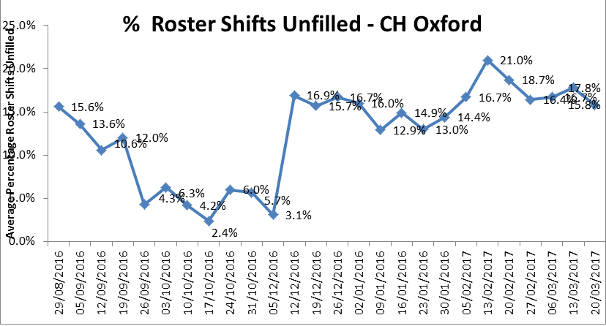

**Table 1: CH Oxon Shifts unfilled**

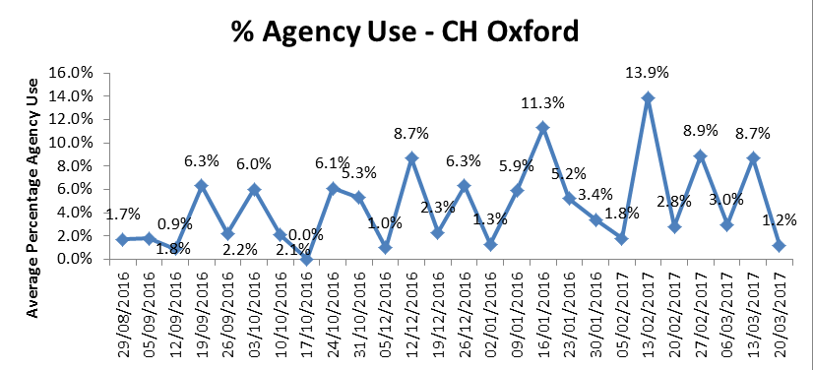

**Table 2: CH Oxon – Agency Usage**

**Adult Directorate**

**Forensic Services**

**Chaffron Ward:** overall 83.8% of shifts on Chaffron ward were fully staffed, which is an increase in staffing of 1.9% from the previous month. The figures shown for by registered and unregistered nurses indicate that show the ward has continue to struggle with registered nurse cover, (40.5% compared with 47. % shifts registered last month). Sickness has however decreased from 6.2% to 4.5%. During the reported period there was no use of agency cover.

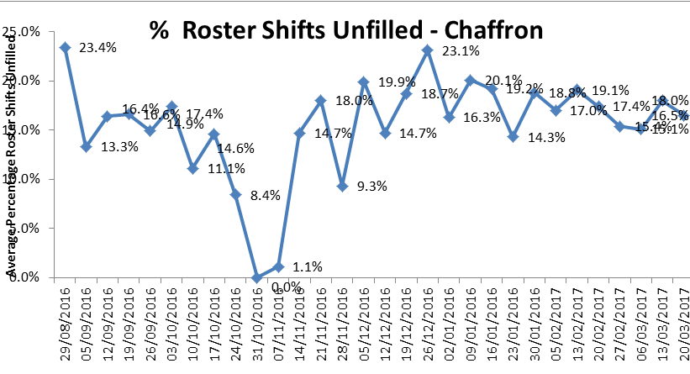

**Table 3: Chaffron Ward – Shifts unfilled**

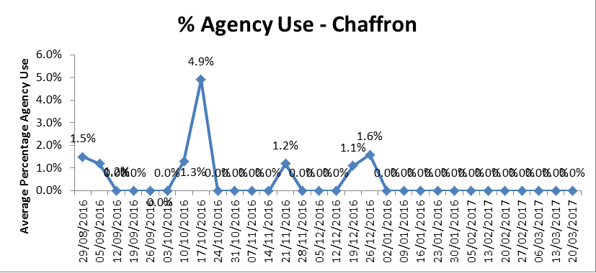

**Table 4: Chaffron Ward – Agency Usage**

**Glyme Ward -** (overall 79.9% of shifts were fully staffed, a 0.9% increase from last month. The ward has used more unregistered staff (with 41.5 % 43.4% of shifts covered by registered nurses, a further reduction of 1.9% registered cover from last month). The percentage agency use during this period was 0.6% 1.5 % which is a decrease of 0.9% from the previous month.

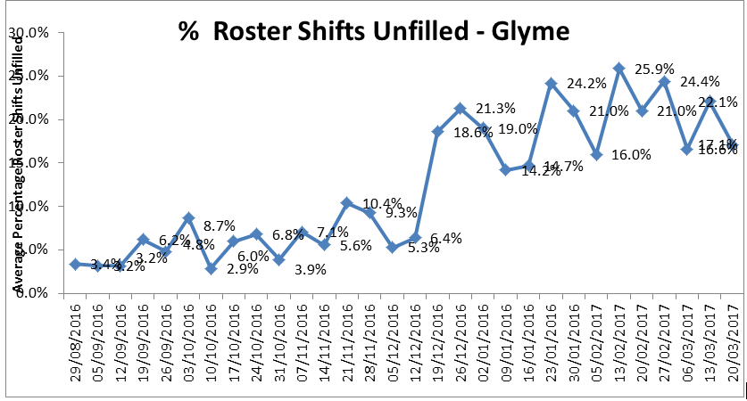

**Table 5: Glyme Ward – Shifts unfilled**

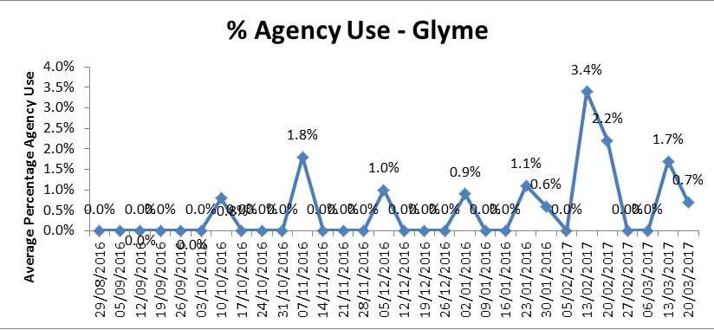

**Table 6: Glyme Ward – Agency Usage**

**Kingfisher Ward**

The overall number of shifts which were fully staffed was 84.8% a reduction from last month when the figure was 86.9%. The number of shifts with registered cover was 40.5%, and ward has high levels of agency 34.5%, which is the highest percentage across the Trust. The overall sickness on the ward is 10.7% and the current numbers of vacancies are high at 14.4 WTE.

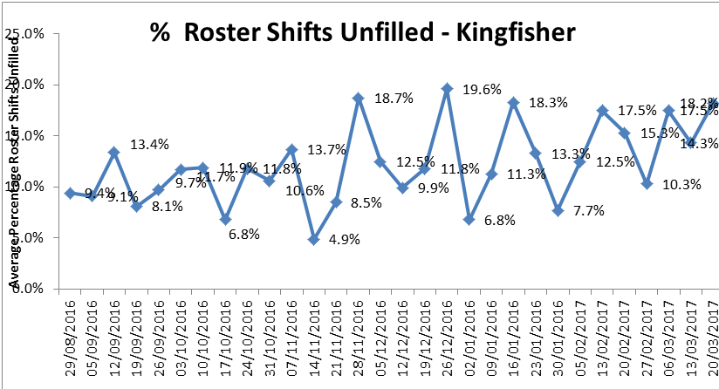

**Table 7: Kingfisher Ward – Shifts unfilled**

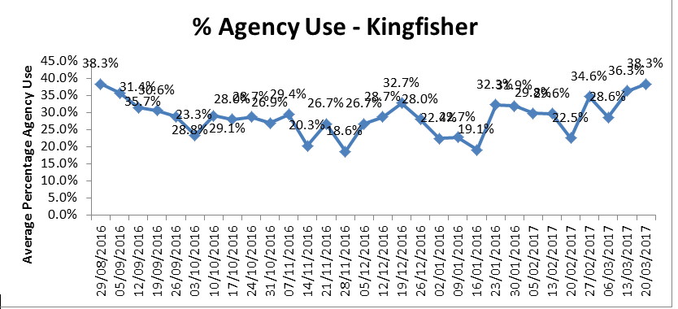

**Table 8: Kingfisher Ward – Agency Usage**

**Phoenix Ward:** overall 80.3% of shifts were fully staffed. The ward has used more unregistered to unregistered staff (with 49.6% of shifts meeting the required 50% registered to unregistered ratio), and has employed some nurse agency (8.7% average agency use). The sickness rate on Phoenix is currently 5.7% and the overall vacancies are currently 8.5 WTE (a reduction of 1.8WTE from last month when the figure was 9.3WTE).

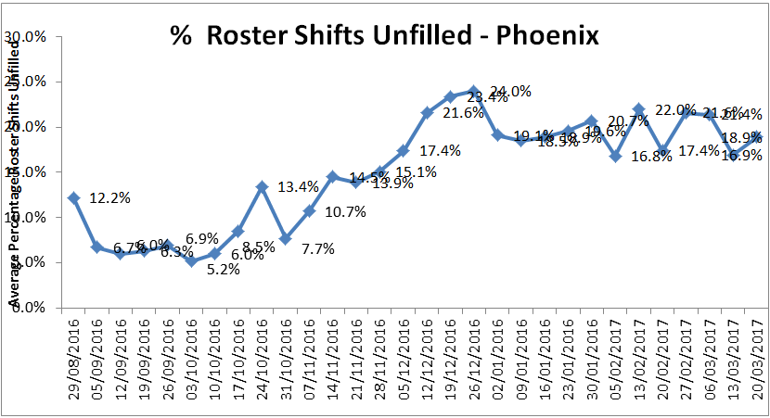

**Table 9: Phoenix Ward – Shifts unfilled**

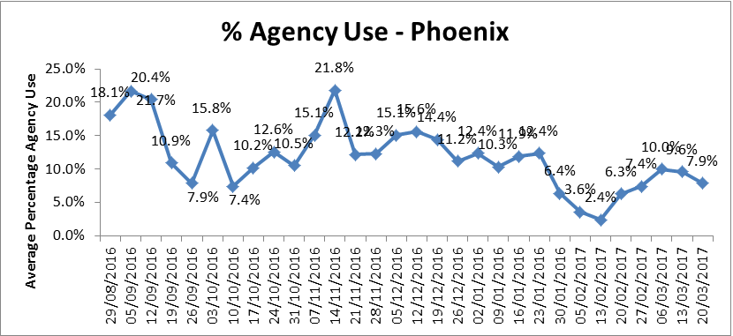

**Table 10: Phoenix – Agency Usage**

**Sapphire Ward: O**verall 74.7% of shifts were fully staffed (the lowest percentage this month). The ward has used more unregistered to unregistered staff (with 42.3% of shifts meeting the required 50% registered to unregistered ratio), and has employed some nurse agency cover (25.3% average agency use). The sickness rate on Sapphire is currently 7.3% and the overall vacancies are currently 12.9 WTE.

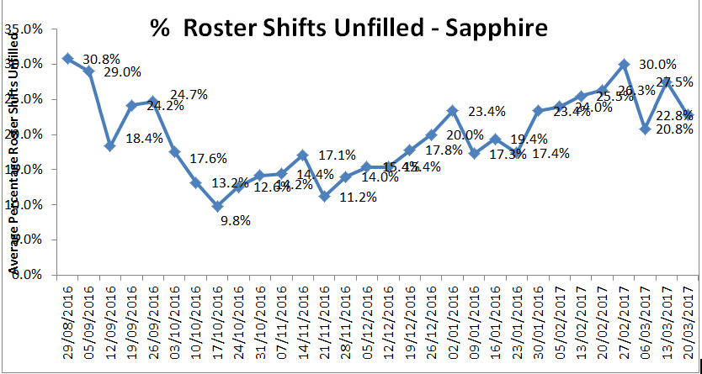

**Table 11: Sapphire Ward – Shifts unfilled**

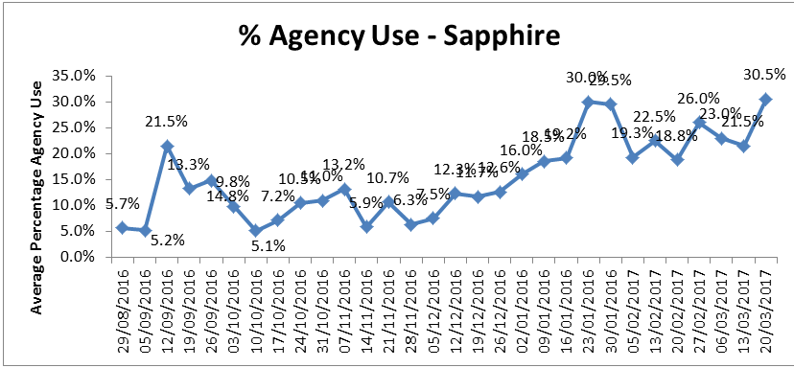

**Table 12: Sapphire Ward – Agency Usage**

**Vaughan Thomas Ward:** overall 82% of shifts were fully staffed. This is a reduction of 4.2% from last month when the figure was 86.2%. The ward has used more unregistered to unregistered staff (with only 39.5% of shifts meeting the required 50% registered to unregistered ratio and the ward has employed nurse agency cover (27.1% average agency use).

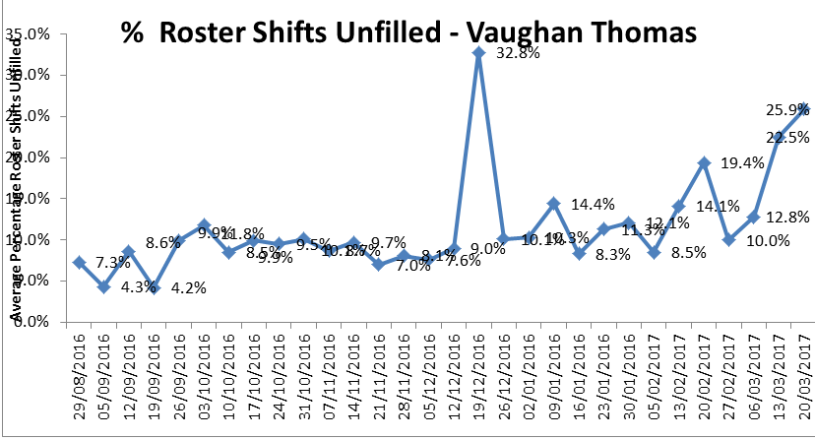

**Table 13: Vaughan Thomas Ward – Shifts unfilled**

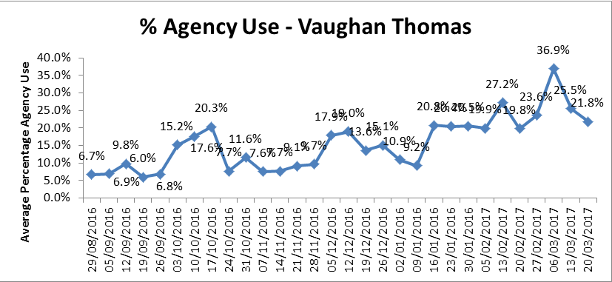

**Table 14: Vaughan Thomas – Agency Usage**

**Sandford Ward:** The overall number of shifts which were fully staffed was 82.8% which is a reduction of 1.7% when the figure was 81.1%). The ward used more unregistered staff (with only 43.4% of shifts meeting the required 50% registered to unregistered ratio), and employed people on long working lines from agencies (28.6%) The sickness rate is high at 12.6% and the current number of vacancies are currently are 10.3.

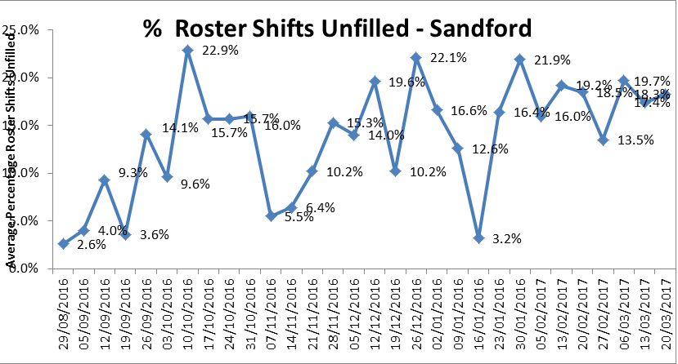

**Table 14: Sandford Ward – Shifts unfilled**

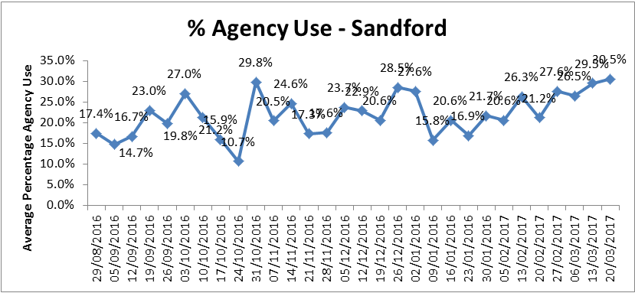

**Table 11: Agency Usage**

**Threshold targets**

There are agreed threshold targets for ward staffing levels. For agency usage the target is 5%, sickness 3.5% and vacancies 9%. Wards not mentioned above which are performing adversely against these targets are as follows.

* Abingdon Ward 1 – Agency use – 13.8% and 5.5 WTE vacancies
* Abingdon Ward 2 - Agency use – 13.1% and 10.5 WTE vacancies
* Allen ward - Agency use – 18.4%, sickness 4.6% and 13.1 WTE vacancies
* Amber ward - Agency use – 19.7%, sickness 14.5% (highest percentage this month) 4e
* and 11.6 WTE vacancies
* Ashurst ward - Agency use – 35.2% and 14.1 WTE vacancies
* Bicester Community Hospital – sickness 10.6%
* City Community Hospital - Agency use – 19.8% and 9.2 WTE vacancies
* Cherwell - sickness 4.8%
* Highfield CAMHS –Agency use –32.2% and 17.8 WTE vacancies (highest number this month)
* Kennet ward - –Agency use –10.5%
* Kestral ward - –Agency use –34.5% (highest percentage this month) and 14.4 WTE vacancies
* Linfoot ward Witney - Agency use –11.5% and 10.3 WTE vacancies
* Marlborough House Swindon (CAMHS) - Agency use –23.6% and 7.8 WTE vacancies
* Opal Ward – 8.1 vacancies
* Ruby Ward - - Agency use –23.9%, sickness 5.2% and 8.8 WTE vacancies
* St Leonards Wallingford - Agency use –24.5%, sickness.
* Watling - Agency use –14.9%, sickness 4.8% and 11WTE vacancies
* Wenric - Agency use –16.6%, sickness 5.9% and 8.6WTE vacancies
* Wenrisc Witney – vacancies 5.8WTE.
* Wintle - vacancies 8.1WTE.
* Woodlands – sickness 4.5%.

Table 1. Staffing 27th February to 26th March 2017

Data source: electronic rostering system

|  |  |  |  |  |  |  |  |  |  |  |  |  |  |  |
| --- | --- | --- | --- | --- | --- | --- | --- | --- | --- | --- | --- | --- | --- | --- |
|  | % of shifts filled against required numbers (highlighted amber if less than 85%) | | | | | | | |  |  |  |  |  |  |
|  | Latest 4 week period - 27th Feb to 26th Mar 17 | 4 week period - 30th Jan to 26th Feb 17 | 4 week period - 2nd Jan 17 to 29th Jan 17 |  | Latest 4 week period - Feb 27th to March 26th 2017 | | | | | | | | | |
| Ward |  | % Registered day shifts filled by nurses (submitted to NHS England) | % Unregistered day shifts filled by nurses (submitted to NHS England) | % Registered night shift filled by nurses (submitted to NHS England) | % Unregistered night shifts filled by nurses (submitted to NHS England) |  | % Registered Skill Mix (target 50% or more) |  | % Agency Use   (thresholds based on Trust targets, 5%) | % Sickness   (thresholds based on Trust targets, 3.5%) | Vacancies Vs Budget (WTE)   (thresholds based on Trust targets, 9%) |
| Abingdon Ward 1 | 93.7% | 97.3% | 94.4% |  | 102% | 100% | 100% | 100% |  | 51.3% |  | 13.8% | 1.6% | 5.5 |
| Abingdon Ward 2 | 99.6% | 99.0% | 98.4% |  | 104% | 96% | 100% | 102% |  | 51.2% |  | 13.1% | 2.7% | 10.5 |
| Allen | 94.2% | 92.8% | 94.1% |  | 90% | 94% | 100% | 99% |  | 50.6% |  | 18.4% | 4.6% | 13.1 |
| Amber | 100.0% | 93.6% | 93.5% |  | 112% | 98% | 100% | 103% |  | 40.8% |  | 19.7% | 14.5% | 11.6 |
| Ashurst (PICU) | 90.6% | 93.7% | 91.7% |  | 84% | 108% | 80% | 110% |  | 35.6% |  | 35.2% | 4.0% | 14.1 |
| Bicester | 98.0% | 98.8% | 98.1% |  | 99% | 89% | 100% | 100% |  | 53.3% |  | 3.8% | 10.6% | 3.9 |
| Cotswold House Marlborough | 97.0% | 95.0% | 99.7% |  | 99% | 99% | 122% | 88% |  | 47.7% |  | 9.0% | 1.2% | 8 |
| Cotswold House Oxford | 83.3% | 82.2% | 85.9% |  | 96% | 97% | 115% | 93% |  | 40.5% |  | 5.4% | 6.9% | 3 |
| Chaffron | 83.8% | 81.9% | 82.5% |  | 153% | 65% | 101% | 100% |  | 50.3% |  | 0.0% | 4.5% | 3.7 |
| Cherwell | 89.7% | 89.0% | 91.4% |  | 74% | 94% | 96% | 102% |  | 42.6% |  | 8.4% | 4.8% | 2.7 |
| City | 97.8% | 92.2% | 98.7% |  | 103% | 103% | 100% | 102% |  | 49.6% |  | 19.8% | 1.1% | 9.2 |
| Didcot | 96.7% | 95.7% | 98.3% |  | 100% | 103% | 100% | 100% |  | 52.2% |  | 9.4% | 3.8% | 0.3 |
| Glyme | 79.9% | 79.0% | 82.0% |  | 81% | 96% | 75% | 154% |  | 41.5% |  | 0.6% | 1.9% | 4.4 |
| Highfield (CAMHS) | 85.6% | 85.6% | 84.0% |  | 78% | 106% | 110% | 90% |  | 33.6% |  | 32.2% | 1.9% | 17.8 |
| Kennet | 99.4% | 97.8% | 98.4% |  | 103% | 99% | 100% | 100% |  | 34.2% |  | 10.5% | 2.2% | 4.8 |
| Kestrel | 94.0% | 94.6% | 91.8% |  | 115% | 87% | 105% | 96% |  | 36.2% |  | 45.5% | 3.3% | 18.6 |
| Kingfisher | 84.8% | 86.9% | 87.5% |  | 113% | 70% | 90% | 94% |  | 40.5% |  | 34.5% | 10.7% | 14.4 |
| Lambourne House | 93.7% | 94.6% | 86.8% |  | 98% | 96% | 100% | 100% |  | 43.3% |  | 1.0% | 3.2% | 0.8 |
| Linfoot Witney | 98.3% | 98.2% | 97.5% |  | 100% | 96% | 102% | 98% |  | 52.5% |  | 11.5% | 3.7% | 10.3 |
| Marlborough House Swindon (CAMHS) | 97.7% | 98.0% | 98.2% |  | 105% | 98% | 99% | 101% |  | 46.9% |  | 23.6% | 4.4% | 7.8 |
| Opal (Rehabilitation) | 93.1% | 92.5% | 90.1% |  | 75% | 103% | 73% | 126% |  | 44.2% |  | 1.1% | 4.1% | 8.1 |
| Phoenix | 80.3% | 80.8% | 81.0% |  | 93% | 98% | 97% | 100% |  | 49.6% |  | 8.7% | 5.7% | 8.5 |
| Ruby | 94.1% | 76.8% | 75.0% |  | 93% | 95% | 98% | 101% |  | 42.2% |  | 23.9% | 5.2% | 8.8 |
| Sandford | 82.8% | 81.1% | 87.5% |  | 74% | 102% | 96% | 102% |  | 43.4% |  | 28.6% | 12.6% | 10.3 |
| Sapphire | 74.7% | 75.2% | 80.7% |  | 79% | 100% | 64% | 116% |  | 42.3% |  | 25.3% | 7.3% | 12.9 |
| Vaughan Thomas | 82.0% | 86.2% | 89.0% |  | 82% | 109% | 95% | 109% |  | 39.5% |  | 27.1% | 2.1% | 10.5 |
| St Leonards Wallingford | 98.5% | 98.0% | 99.0% |  | 102% | 98% | 100% | 99% |  | 45.9% |  | 24.5% | 1.2% | 0.1 |
| Watling | 86.1% | 95.3% | 92.7% |  | 69% | 101% | 78% | 97% |  | 30.3% |  | 14.9% | 4.8% | 11 |
| Wenric | 93.8% | 86.6% | 95.4% |  | 100% | 102% | 98% | 101% |  | 36.0% |  | 16.6% | 5.9% | 8.6 |
| Wenrisc Witney | 93.9% | 96.0% | 93.8% |  | 94% | 95% | 101% | 96% |  | 59.2% |  | 4.9% | 3.9% | 5.8 |
| Wintle | 93.4% | 98.2% | 94.8% |  | 63% | 130% | 100% | 94% |  | 42.2% |  | 5.6% | 2.0% | 8.1 |
| Woodlands | 98.9% | 98.2% | 98.6% |  | 108% | 97% | 111% | 92% |  | 43.5% |  | 4.3% | 4.5% | 3.8 |