

Report to the Meeting of the
BOD 77/2014
(Agenda item: 9)

Oxford Health NHS Foundation Trust

Board of Directors
25 June 2014

Complaints & PALS Annual Report
1 April 2013 to 31 March 2014

For Information.

Executive Summary
This is the Annual Report on formal complaints, PALS contacts and compliments received by Oxford Health NHS Foundation Trust during 1 April 2013 to 31 March 2013. This paper provides assurance that the Trust is meeting the legal regulations for the Care Quality Commission’s outcome 17: complaints, Local Authority Social Services and NHS Complaints (England) Regulations 2009, the NHS Constitution and patient’s rights, and the Ombudsman’s principles of good complaint handling 2008.
Complaints are reported on a quarterly basis in detail to the Integrated Governance committee and summarised in Patient Experience Board Reports. This report provides the Board overview for the full year. Following approval by the Integrated Governance Committee it was agreed this could be published and sent to the Board of Directors for Information.

Recommendation
The Board is requested to note the report prior to publication.

Author and title: Claire Price, Complaints & PALS Manager
Lead Executive Director: Ros Alstead, Director of Nursing & Clinical Standards

A risk assessment has been undertaken around the legal issues that this paper presents and there are no issues that need to be referred to the Trust Solicitors.
Complaints & PALS Annual Report: 1 April 2013 to 31 March 2014
Themes and Outcome

COMPLAINTS
Number of complaints received
In 2013’14, the Trust received 226 complaints (excluding withdrawn complaints), following treating over 111,000 patients and over 3,500 patient admissions. This is a 3% reduction when compared to the 232 complaints received in the previous year. This can be attributed to an increase in PALS dealing with concerns at a local level to resolve problems quickly. During this period of time, sixteen complaints were withdrawn by complainants and were resolved informally through PALS. If a complaint is re-opened, because the complainant is dissatisfied with the response and outcome of the investigation into their concerns, this is not counted as a new complaint case but a continuation of the initial complaint registered. The number of complaints received by quarter is broken down as follows; 60 complaints in Quarter One (April to June 2013), 55 complaints were received in Quarter Two (July to September 2013), 56 complaints in Quarter Three (October to December 2013) and 55 complaints were received in Quarter Four (January to March 2014). In 2013’14, 48 concerns were also received via an MP with peaks in both September 2013 and February 2014 where 8 (17%) cases were received in each month.

Graph 1 shows the number of complaints and MP cases received by month over the last three years. The average number of complaints received since 1 April 2013 is 18 per month.

Graph 1
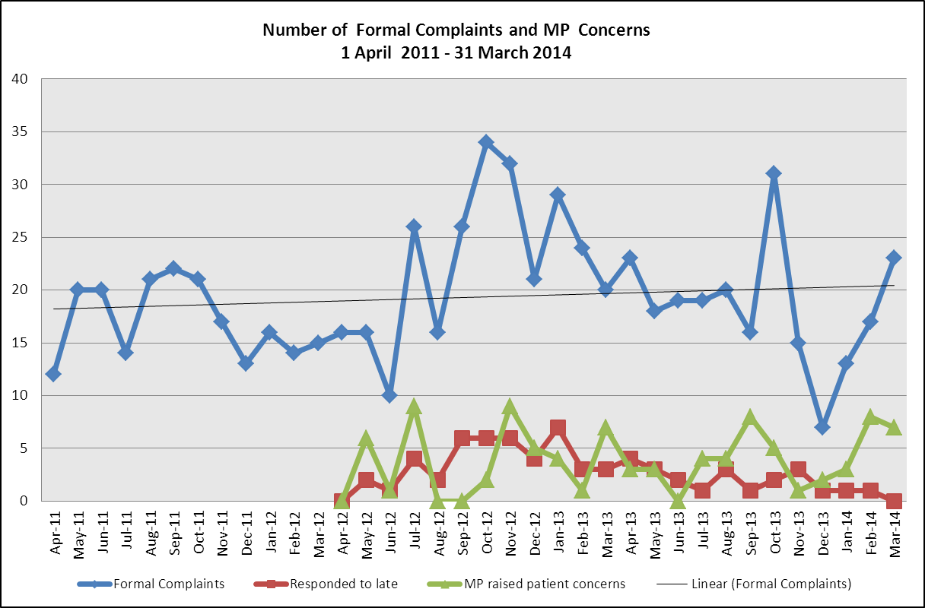

Timeliness of managing complaints
Acknowledgement times:
Between 1 April 2013 and 31 March 2014, 226 cases have been received of which 100% were acknowledged by the Complaints & PALS Team within the NHS Complaints Regulations (2009) of three working days.

Response Times:
At the time of writing this report, of the 188 complaints were received, investigated and closed during 1 April 2013 to 31 March 2014, 166 (88%) complaints were responded to within a timescale agreed with the complainant. Twenty one (12%) complaints were responded to outside of the agreed timescale due to either a delay in the complaints papers being provided or a delay in the Divisional Directors signing and sending out the final letter of response. Thirty seven complaints are still open and in time, and one complaint remains “on hold” at the request of the complainants.

Table 1 gives a breakdown of the number of complaints responded to late by month and Division since 1 April 2013.

Table 1
Month complaint received | Specialised Division | Oxon Community Services Division | Mental Health Service Division | Children and Family Services Division | Trust wide Total
April 2013 | 1 | 1 | 2 | 0 | 4
May 2013 | 0 | 0 | 3 | 0 | 3
June 2013 | 1 | 0 | 1 | 0 | 2
July 2013 | 1 | 0 | 0 | 0 | 1
August 2013 | 0 | 2 | 1 | 0 | 3
September 2013 | 0 | 0 | 1 | 0 | 1
October 2013 | 0 | 0 | 1 | 1 | 2
November 2013 | 0 | 1 | 1 | 0 | 2
December 2013 | 0 | 0 | 0 | 1 | 1
January 2014 | 0 | 1 | 0 | 0 | 1
February 2014 | 0 | 1 | 0 | 0 | 1
March 2014 | 0 | 0 | 0 | 0 | 0
Total responded to late | 3 | 6 | 10 | 2 | 21
% of total complaints closed which were responded to late | 2% | 4% | 5% | 1% | 12%

Complaints by Division
In 2013’14, each Division received the following number of formal complaints.

Children & Families Division 52
Oxfordshire Community Services Division 69
Mental Health Division 79
Specialised Services Division 23
Support Services 3

*Please note that Older Adult Mental Health Services have been included within the Community Services Division. Within the 12 month period, 11 complaints were received about these services.

Graph 2 shows the number of complaints received by each Division over the last two years, since April 2012.

Graph 2 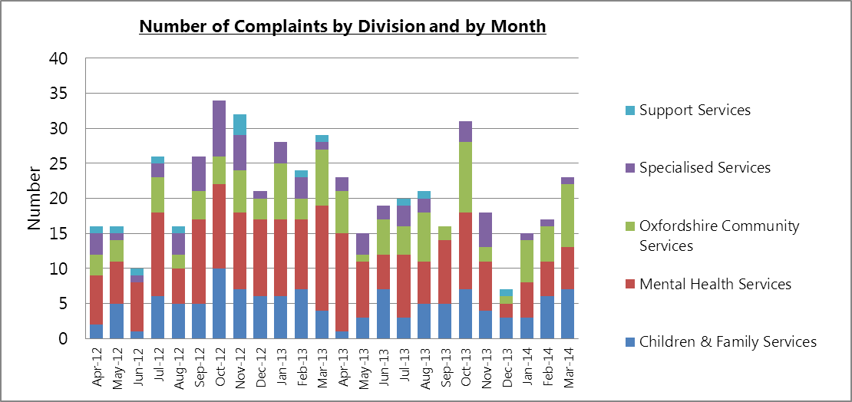

Equality and Inclusion
In 2013’14, two out of the 226 complaints received have an element relating to equality and inclusion. Both complaints related to Portland Ward. One complaint related to restricted access to outdoor space for a person with a physical disability and one related to how a transgender person felt treated and understood by staff. The ward moved in February 2014 to a new purpose built environment which enables full unrestricted access to outdoor space for physically disabled patients. The concerns raised by the lady were discussed with the ward team to learn from her experience so that staff are more aware and sensitive in the future.

Benchmark with other NHS Trusts
The Trust has developed a reciprocal arrangement with Northampton Healthcare NHS Foundation Trust (who provide a similar range of services) to share information about the number of complaints received. Graph 3 shows a comparison by each quarter. The graph shows that Northampton Healthcare NHS Foundation Trust has an average of 80 complaints per quarter, whereas Oxford Health NHS Foundation Trust has received an average of 61 complaints per quarter. The top five categories of complaint within Northampton Healthcare NHS Foundation Trust were staff attitude (8), Access to Services (6), Appointments (5), Attitude (4) and Aid, Equipment & Appliances (4).

Graph 3
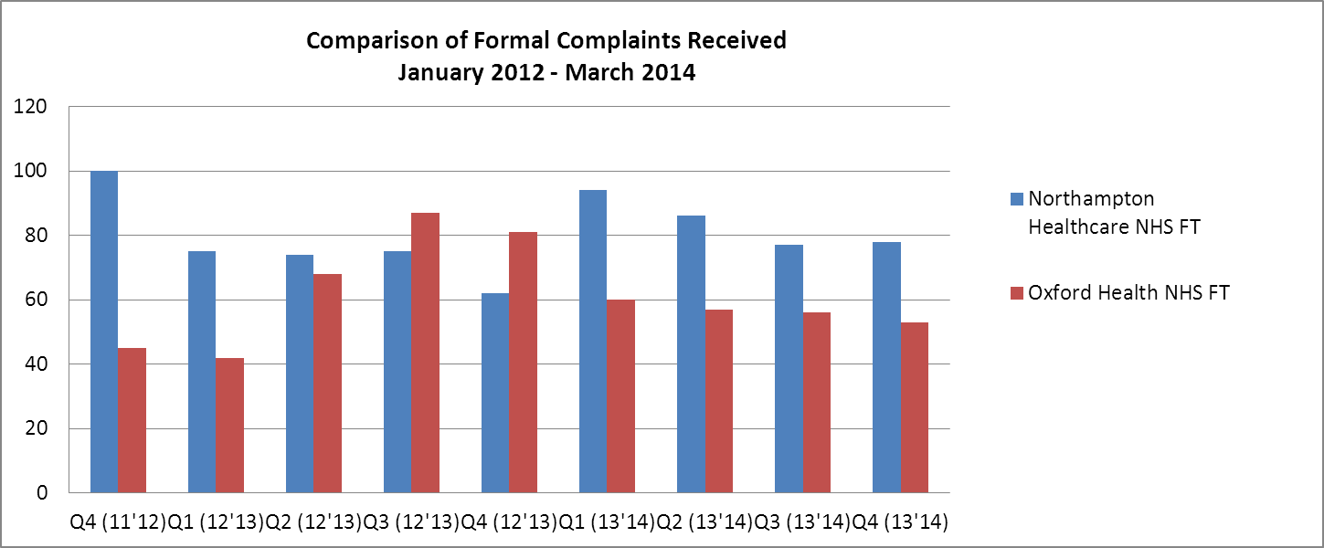

Source of complaints
The pie chart (graph 4) shows the sources of complaints received in 2013’14. The largest group (112) of complaints is from carers/relatives, the number from this group has increased from 2012’13 and the second largest group (77) of complaints were from patients/service users.

Graph 4
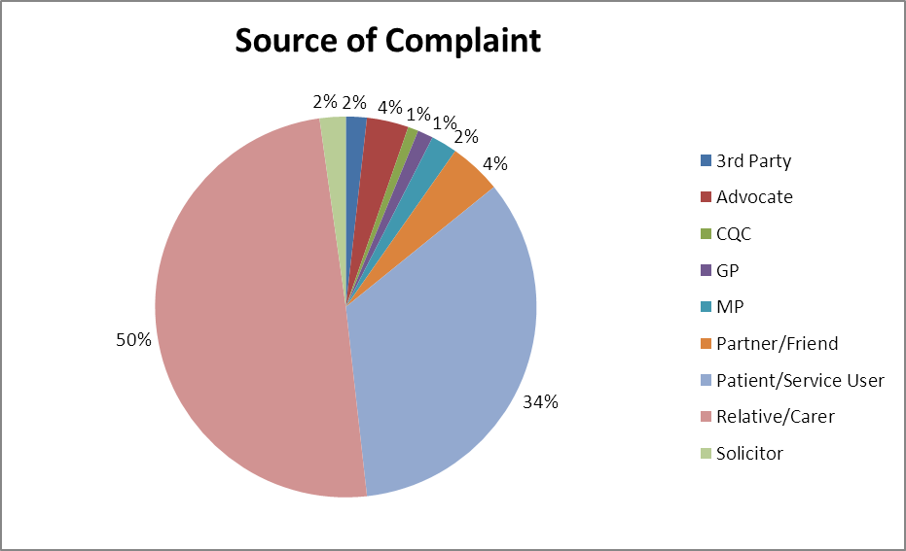

Grading of complaints
All complaints are graded using the NPSA risk matrix based on likelihood of reoccurrence and impact to patient(s) with a rating of green, yellow, orange or red, which are reviewed by senior clinicians. From the 226 complaints received, 152 (67%) were graded green, 50 (22%) were graded yellow, 19 (9%) complaints were graded as orange and 5 (2%) were graded as red during this time period.

In total there were 24 complaints risk rated as either orange or red. The majority of the severe complaints (13) related to the Community Services Division. The themes of these complaints related to care in the community and incorrect diagnosis. The Division received 54% of the total complaints received by the Trust.

Complaints by Category
The primary categories of the complaints (upheld and not upheld) received across the Trust in 2013’14 were:

- All aspects of clinical treatment (109), particularly feeling unsupported in the community
- Attitude of members of staff (36).
- Poor/ or inappropriate communication or sharing of information (29).
- Difficulties with admission, transfer or discharge from a ward (19).

The common themes from complaints do correlate to those coming out of Serious Incident Requiring Investigation (SIRI) such as communication and involvement with carers.

Breakdown of complaints made about aspects of clinical care
In 2013’14, 109 primary concerns relating to issues around aspects of clinical care. Graph 5 below shows the breakdown.

Graph 5
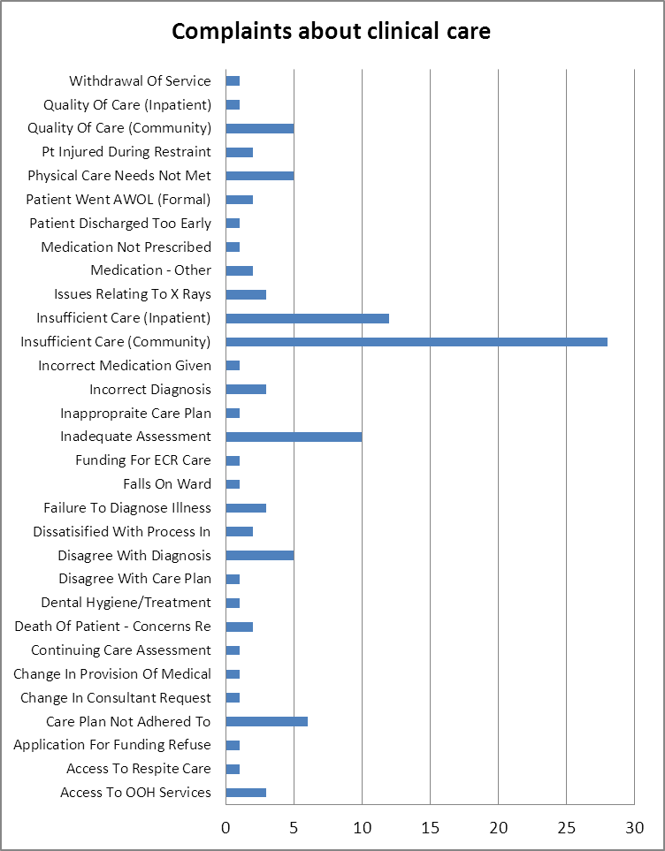

Of the 28 complaints received about care in the community, 15 related to the Children & Families Division, eight related to the Mental Health Division, four related to the Community Services Division and one related to Specialised Services Division. Although all of these related to different services, complainants described similar experiences of feeling unsupported and raised concerns about communication and information sharing.

Analysis of Themes
Table 3 shows the nine teams which received five or more complaints in the last 12 months (1 April 2013 to 31 March 2014) or more than three complaints in the last three months, highlighting any common themes and the outcomes of complaints.

Table 3
Team | Number | Any common themes | Outcomes
Allen Ward | 5 | 3 complaints mention communication/information issues and 2 complaints mention issues of concerns about staff attitude. | 4 out of the 5 complaints are closed. For the closed complaints the following elements have been upheld: 1 complaint was that a patient should not have been allowed leave and 1 was that the doorbell was not working on ward which has now been resolved.
Chiltern CMHT Older Adults | 5 | 4 complaints mention communication/information sharing. | All 5 complaints are closed. For the closed complaints the following elements have been upheld: information was shared with the patient via letter when they had expressly requested that they did not receive this. For 1 complaint information was not shared with the family, although this had been agreed.
Complex Needs Bucks | 7 | 4 complaints mention communication/information sharing, 3 complaints mention staff attitude and 2 complaints mention being discharged from a TC. | 6 of the 7 complaint are closed. For the closed complaints, no elements were upheld. However, a review has been undertaken and the Division are monitoring future complaints/concerns raised.
Continuing Care Services | 8 | 4 of the complaints mention the length of time the assessment has taken and 2 mention communication issues. | All 8 complaints are closed. For the closed complaints the following elements were upheld: 1 complaint was that a decision following an assessment had not been appropriately communicated, for 2 cases there was no communication, 1 related to information sharing and 1 was that a further checklist had not been completed and 3 related to significant delays in the assessment being undertaken.
Kimmeridge Ward | 7 | 3 complaints mention discharge planning arrangements, 3 complaints relate to communications issues and 2 complaints mention being admitted to inappropriate wards due to bed availability. | All 7 complaints are closed. For the closed complaints the following elements have been upheld: information breach with sharing information wife gave with patient, more frequent review of patient observations may have avoided an incident and a bed was not available due to bed pressures. For 1 complaint there had been poor communication around discharge arrangements.
Melksham CAMHS | 7 | 4 complaints mention communication/information with families. 3 complaints mention insufficient care in the community. | 5 out of the 7 complaint are closed. For the closed complaints the following elements have been upheld: there was a cancellation of an appointment which did in fact affect a patient’s care. There was also a delay in an assessment being undertaken.
Portland Ward | 11 | 2 complaints mention communication, 2 complaints raise concerns about attitude of staff, 2 complaints raise concerns about being restrained and 2 mention discharge arrangements. | All 11 complaints are closed. For the closed complaints the following elements have been upheld: a patient’s property had been lost on the ward, there was poor communication with the family, the ward telephone had been out of order for some time and facilitating smoking breaks was poorly managed by staff. There had also been poor communication with a patient in relation to discharge arrangements.

Urgent Care Services (5 service areas) | 22 | 4 complaints related to an inadequate assessment. 3 of the complaints raise concerns in relation to either access to have an x-ray or a misdiagnosis following an x-ray. 3 complaints relate to staff attitude/behaviour and 2 complaints relate to poor communication. 2 complaints raised concerns about access to the Out of Hours services. | 18 out of the 22 complaints are closed. For the closed complaints the following elements were upheld: 1 complaint related to more time being taken to listen to the patient, 1 was about a delay in a telephone call being returned and 1 was that elements of the initial telephone call had been missed, 1 was that the rational for a site visit should have been explained further and 1 was that more consideration should have been given for an x-ray at the time. A review of the complaints raised about x-rays has been undertaken by the Division and feedback has been shared with relevant staff.
Wycombe Community CAMHS | 5 | 3 complaints related to a poor assessment. 2 complaints related to communication issues. | 3 out of the 5 complaints are closed. For the closed complaints, the following elements were upheld: 1 case had no care plan in place and there was poor communication with the parents and 1 was that further information should have been gathered before a referral was declined.

Learning from complaints
After the investigation into each complaint, if there are any upheld elements or any improvements in practice identified then a complaints improvement plan is developed by the investigating officer in liaison with the relevant service manager and senior clinicians. In 2014’15 the focus will be to produce monthly reports on the progress of action to enable monitoring and to publish the actions being taken. The following actions have been taken or will be taken:

- CAMHS has developed an Autism strategy to ensure that there is an effective care pathway for assessment and diagnosis of ASD.

- A patient was offered a re-assessment.

- The Services MAPPA (Multi Agency Public Protection Arrangements) Lead to raise an issue to the MAPPA panel that there should be better sharing of information when someone has been placed under MAPPA previously

- Community Children’s Nursing to liaise with the lead pharmacist to develop an additional resource to the Trust Medicine Management Policy specifically for the administration of medication to children in the home environment.

- Urgent Care further training is being provided to staff within the service on the management of suspected stress fractures.

- Reminder to all teams that referral criteria is based upon GP address and not patient’s home address.

- Training to be provided to staff on particular ward in relation to accurate note writing.

- A review is being undertaken in Urgent Care service to ensure that the current x-ray referral pathway is functioning.

- On the particular ward patient’s property is now being logged into the property book and a working group has been set up to look at the issues around loss of property.

Parliamentary Health Service Ombudsman (PHSO)
The level of review and involvement from the PHSO varies between cases. This can be from the PHSO requesting the Trust’s complaints investigation report and then closing the case, to a full investigation being undertaken which can involve interviewing staff and the complainant.

During 2013’14, three cases were referred to the PHSO for review and one case has been closed with no further action required. Currently four cases are open with the PHSO, and in one case the investigation has been completed and recommendations to improve the handing of complaints were made and are currently being actioned.

Francis Report: Overview and Recommendations
Following the quarterly report to the committee in February 2014 when our position against a review of 13 recommendations from the Francis Report relating to listening, investigation and learning from complaints were presented, table 4 provides an update on the actions identified.

The Complaints & PALS Manager is in the process of undertaking further self-assessments against the other national recommendations made about complaints from the Patient Associations Good Practice Standards and the Governments review of NHS Hospitals Complaints System.

Table 4
Francis Report Recommendation | Action | Responsible Person | Target Completion Date | Progress
Actual or intended litigation should not be a barrier to complaining | The Trust’s Complaints Policy needs to be updated to ensure that complainants are advised of the options available to them and that we would not stop the complaints process, even if litigation issues were on-going. | Claire Price | 30.06.14 | In hand
Provider organisations must constantly promote their desire to receive and learn from comments and complaints | The Complaints Department need to work with Divisions to promote an open culture and to look at ways of ensuring that we are constantly looking to receive feedback about people’s experiences. Further promotional work needs to be undertaken to ensure that we are appropriately advertising the Complaints & PALS Services and how these can be accessed. To discuss with Divisions the possibility of having standard lines within correspondence letters which offer the opportunity to approach the Complaints & PALS Service if they would like to comment, raise a concern or make a complaint. | Claire Price/  Divisional Directors | 31.07.14 | In hand
Feedback that is not in the form of a complaint but suggests a cause for concern should also be the subject of an investigation | The Complaints & PALS Service needs to look at what is happening at a local level and we need to encourage teams/wards to ensure that they are appropriately looking into issues of concern.  Ensure that this is included as part of the Complaints Training and also the Induction Training. | Stephen Finnie/  Rebecca Agnew | 31.03.2014 | Completed
Arm’s length investigations should be initiated by the provider where appropriate | Arm’s length investigations should be initiated by the provider where appropriate, either internally or externally. Heads of Service should be responsible for considering this on an individual basis for all complaints and advice will be provided by the Complaints Department. | Heads of Service/  Complaints Department | 31.03.2014 | Completed
An anonymised summary of each upheld complaint relating to patient care should be published on the Trusts website. However, this must be in agreement with the complainant. If this is not possible then a summary must be shared with the Commissioner and the CQC | The number of upheld complaints for each service area will be published on the Trust’s website, along with details relating to a sample from each service area. | Claire Price | 31.07.14 | In hand

PATIENT ADVICE AND LIASION SERVICE (PALS)
The Trust’s Patient Advice and Liaison Service is a service for patients, their relative/carers and members of the public. The service provides advice and information; works with staff across the organisation to resolves concerns and problems at a local level and receives comments, suggestions and compliments about the Trust’s services. PALS contacts take the form of face to face discussions, telephone calls to the 0800 number, letters and emails.

In 2013’14 the PALS Team has handled 1172 cases. The Trust has expanded the availability of the Patient Advice and Liaison Service to resolve concerns and issues at a local level, if possible, before a complaint is raised.

Graph 6 shows the number of telephone calls made to the PALS free phone to seek some general advice or information, raise an informal concern or make a formal complaint from February 2012 to March 2014.

Graph 6
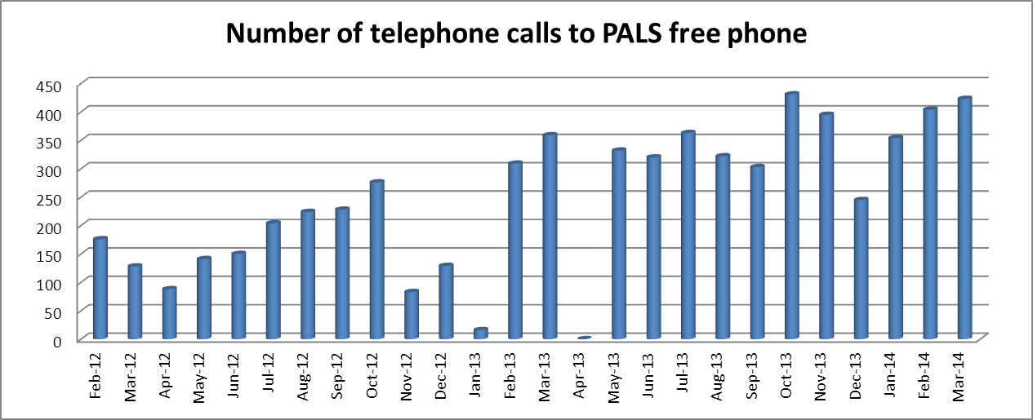

*Please note that the system crashed in January 2013 and therefore the figures are incorrect. Information is not available for April 2013 due to a system failure.

Table 4 shows the number of contacts with PALS where advice has been provided or issues have been resolved locally by month from 1 April 2012 to 31 March 2013.

Table 4
Ward/Team | Q1  12’13 | Q2  12’13 | Q3  12’13 | Q4  12’13 | Q1  13’14 | Q2  13’14 | Q3  13’14 | Q4  13’14
Specialised Division | 9 | 23 | 14 | 19 | 14 | 15 | 33 | 42
Children & Families Division | 12 | 16 | 26 | 30 | 10 | 22 | 44 | 52
Oxfordshire Community Services Division | 34 | 49 | 31 | 53 | 38 | 69 | 98 | 116
Mental Health Division | 47 | 70 | 70 | 131 | 63 | 80 | 133 | 117
Support Services | 14 | 32 | 27 | 5 | 7 | 18 | 11 | 14
Trust wide | 116 | 190 | 168 | 238 | 132 | 204 | 319 | 341

The themes from concerns received by the PALS over the last 12 months are consistent with those received from formal complaints. The primary categories of concerns received were:

Children and Families Division:
- Length of wait for an appointments or cancelled appointment
- Attitude/behaviour of staff
- Inadequate care in the community
- Communication/Information

Mental Health Division:
- Admissions/Discharge/Transfer
- Appointments/referrals
- Attitude/behaviour of staff
- Communication/Information

Oxfordshire Community Services Division:
- Appointment/Referral
- Communication/Information
- Physical care needs not being met
- Poor discharge arrangements

Specialised Division:
- Attitude/behaviour of staff
- Environment/Facilities
- Medication

PALS Surgeries
The PALS Team currently runs 36 PALS surgeries across the inpatient areas of the Trust on at least a monthly basis. PALS surgeries are a valuable way of seeking feedback about people’s experiences, both positive and negative, and also about working with ward staff in resolving issues of concern at a local level, in a timely and positive manner. Below are some examples of feedback received from PALS Surgeries:

Ashurst PICU
- Staff are really accommodating when it comes to escorted leave and this was appreciated by patients.
- There were concerns raised about staff not adhering the medication times which was felt to be unhelpful.
- Lack of activities on the ward.

Vaughan Thomas Ward
- Concerns raised about a patient disagreeing with the Consultants/care teams decision for admission and requested a tribunal.
- Staff are really kind and caring. All questions are always answered.

Portland Ward
- All of the staff here are brilliant, once we move many of the issues you get will be gone.
- Comments on smoking facilities on the new hospital site, wanted to know what would happen.

Amber Ward
- Concerns raised about the ward environment; temperature, signage, drinks making facilities.
- Staff are really caring and compassionate
- Lack of OT activities on the ward.

Abingdon (Wards 1 & 2)
- A patient raised a concern about the communication about future care as the patient was very anxious to go home.
- Another patient also raised a concern about her clothing, but this was very quickly seen to by staff.
- A family of a deceased patient donated £700 to ward 1.
- A family popped onto the ward during my PALS surgery to donate some flowers to ward 2.

Wantage Community Hospital
- This is the best hospital I have been in and I have been in many over my life.
- The staff couldn’t do more if they tried.
- The staff are really good at what they do.

Woodlands House
- Patient raised concerns about hallucinations, but staff very quickly offered support.

Watling Ward
- Concern raised about the reason for admission to the ward. Patient does not believe he is unwell and should return to prison.
- Another concern about a patient being returned to prison who disagreed with this as he felt very unwell.

Cotswold House, Marlborough
- Patient led groups are happening and they seem to be working really well.
- The shift patterns have now changed and this has improved the staffing level on the ward, it seems like there are people available to speak with now and staff have more time.
- Concerns that staff are not always consistent with messages and rules – has been discussed by ward manager in community meetings.

Marlborough House, Swindon
- General concerns about food, heating, activities.

They told PALS and we did…...
Wintle Ward
“I was admitted suddenly to the ward from the JR Hospital and during the process my house keys were mislaid”.

PALS spoke to members of staff on the ward who were unable to locate the keys, so PALS contacted other departments and ascertained that the keys were being held by the Housing Department at Oxfordshire County Council. PALS arranged for the keys to be delivered to the ward to enable the patient/staff to access belongings and check that the property was secure.

Highfield Unit
“I need a wardrobe as the previous occupant had damaged the wardrobe which had to be removed. I know that a new wardrobe has already been ordered but I am struggling to store my clothes”.

PALS spoke to staff on the ward who confirmed that a new wardrobe had been ordered but that it would take a number of weeks to be delivered. PALS therefore arranged for a wardrobe to be brought over from one of the wards on another site which could be used until the new wardrobe was delivered.

Witney Community Hospital – Linfoot Ward
“The toaster that they use are a total waste of time, it doesn’t do anything to the bread. I understand that it is like one of those toasters in a hotel, however with this one, you put bread in and you get bread out, it never looks like toast. Also there are not enough fresh vegetables.”

PALS contacted both the Head of Catering and the Head of Community Hospitals to share the feedback received. Following this, the ward purchased a new toaster and a member of staff from the Catering Department visited the enquirer to discuss the catering issues. At the following PALS surgery, an update was provided by the patient who described the situation as “much improved”.
Vaughan Thomas Ward
“I am seeking information about solicitors available over the Christmas period, the mental health act and tribunal. I am also concerned that my partner is currently in hospital and his sick note is due to expire shortly and I need this to be extended”.

PALS contacted the Trust’s Mental Health Act Manager who was able to provide details of solicitors available over the Christmas and New Year period and these contact details, along with information about the mental health act and tribunals were shared with the enquirer. PALS also encouraged the enquirer to discuss their concerns in relation to their partner’s sick note with the Consultant Psychiatrist, at their pre-arranged meeting that afternoon. The enquirer was very grateful for the advice and information provided.

St Barnabas, Podiatry Clinic
“I am concerned that I paid £100 for insoles through the St Barnabas Podiatry Clinic, which are causing pain to my feet and I am therefore unable to use these. I am concerned that I have been discharged from the service, when I am still in pain. I am also concerned that it to 6-8 weeks for the insoles to arrive.”

PALS contacted the Operational/Professional Lead for the Podiatry Service who arranged for the matter to be investigated. Apologises were provided to the enquirer for the delays in the insoles being manufactured and fitted and the enquirer was refunded for the insoles that he could not wear due to the pain. Enquirer was offered a review appointment, although this was declined.

East Oxford Dental Clinic
“I am concerned that my appointment for an initial assessment, prior to a tooth extraction, was cancelled and that this will result in surgery being delayed. This is of particular concern as I am going on holiday shortly and needed the surgery prior to going away”.

PALS were able to liaise with the clinic and as a result, the initial assessment and surgery were completed at the same appointment to ensure the patient had the treatment before they left on holiday.

Compliments received from 1 April 2013 to 31 March 2014
The Complaints and PALS Team collects the compliments sent to teams within the Trust including thank you letters and cards. The number of compliments received can be seen in table 5 below, work continues to ensure all teams share the compliments they receive as there seems to be under-reporting.

Table 5
Ward/Team | Q1  12’13 | Q2  12’14 | Q3  12’13 | Q4  12’13 | Q1  13’14 | Q2  13’14 | Q3  13’14 | Q4  13’14
Specialised Division | 30 | 59 | 122 | 103 | 113 | 134 | 114 | 69
Children & Families Division | 78 | 127 | 166 | 152 | 196 | 249 | 266 | 156
Oxfordshire Community Services Division | 420 | 593 | 685 | 630 | 253 | 481 | 633 | 354
Mental Health Division | 41 | 101 | 201 | 129 | 96 | 90 | 150 | 114
Trust wide | 569 | 826 | 1174 | 1014 | 658 | 954 | 1163 | 693

Extracts from compliments

“I am really happy here; it is like a hotel I don’t want to go home”
Fiennes Centre

“Appreciate your calmness, patience and expertise”
Early Intervention Service, Bucks

“Thanks for believing in me and encouraging me”
Kimmeridge Ward

“Your understanding gave me the much needed confidence to cope with the situation”
Vaughan Thomas Ward

“It’s all going very well, the food, the care it’s all going really well. It’s absolutely wonderful, they're very helpful, really wonderful”
Townlands Community Hospital

“First class treatment has taken away the pain and improved my condition 99.9%”
Podiatry

“Members of staff are so caring, patients are called by their name and not a bed number and it makes a huge difference”
Witney Community Hospital

“The ward couldn’t be better. I have been in many hospitals all my life and this is really wonderful, even the food is fantastic”
Wantage Community Hospital

“Very happy with care provided and that the drop in service can be used to help to relieve anxiety”
Harm minimisation

“You have been great supporting clients which enables them to keep their accommodation which keeps them safe”
Luther Street

“The food is good, the ward is clean and the rooms are being decorated, overall I’m satisfied with my care”.
Wenric Ward
“One thing I have learned is the darkest night will end and the sun will rise – thank you”
Marlborough House, Marlborough

“I found the service great, the therapist listened and helped with my difficulties very well”
Talking Space:

“We have worked together for a long time and it is going to be strange without you but your wisdom and compassion will never leave my mind”
Bucks Adult Eating Disorders:

