

**BOD 05/2015**

(Agenda item: 7)

# Report to the Meeting of the

# Oxford Health NHS Foundation Trust

# Board of Directors

**28 January 2014**

**Quality and Safety Report**

**For Information**

This report outlines current progress, including areas of concern or priorities across our trust in relation to quality and patient safety for quarter 2 (2014/15). It draws on reports that have been submitted to the Integrated Governance (Quality) Committee and the Safety Committee where these reports were reviewed in detail. The report also includes some quarter three data where this was available. The areas covered are:

1. Patterns of reported incidents and serious incidents requiring investigation (including pressure ulcer prevention, AWOLs, restraints and seclusion).
2. Infection prevention and control
3. Safety thermometer (older people’s services)
4. Improvement programmes and Safer Care and Productive Care
5. Trust wide status report against CQC Outcomes
6. Learning and development report (Q2)

Our focus over the coming months will be to ensure we are running increasingly effective incident and SIRI processes including closing down promptly of open incidents. Ensuring that systemic learning from incidents is evident in all teams. Ensuring we are using robust measurement and improvement methodologies to reduce harms in more teams . Currently it is well embedded where there is local clinical and operational leadership however this is not yet embedded as business as usual – the daily job of every clinician and manager.

Our focus on continuous quality improvement at team service and organisational  level, with  local responsibility for high quality care is being peer reviewed team by team. This is contributing towards preparing for our forthcoming CQC Inspection which is expected in Q2 or Q3 of 2015/6.

**Recommendation**

The Board is asked to note the report.

**Author and Title:**

Tehmeena Ajmal, Head of Quality and Safety; Rebecca Kelly, Learning from Incidents Lead; Gavin Garman, Head of Nursing, Specialised Services; Marie Pritchard, Head of Information and Governance; Helen Bosley, Infection Prevention Control Matron; Jill Bailey, Consultant Nurse and Safer Care Lead, and David Slingo, Head of Learning and Development

**Lead Executive Director:** Ros Alstead, Director of Nursing and Clinical Standards

1. *A risk assessment has been undertaken around the legal issues that this paper presents and there are no issues that need to be referred to the Trust Solicitors.*
2. *This paper provides assurance and evidence against the Care Quality Commission Outcome: 4, 5, 7, 8 and 16.*

**QUALITY AND SAFETY REPORT**

1. **INCIDENTS AND SERIOUS INCIDENTS REQUIRING INVESTIGATION (SIRIS)**
   1. **Realignment of Safeguard to the new teams**

The project to reallocate and align services with new directorates is now complete and data for the new directorates will be accurate in Quarter 4 and going forward.

Where numbers of incidents differ from previous reports it is because all of the numbers have been refreshed on Safeguard. Over time incidents may be retrospectively reported, amended, removed, merged (where one incident is reported on more than one occasion) and/or upgraded or downgraded. These differences are not significant and do not change the overall interpretation of the data.

* 1. **Data on Deaths**

In Q3 49 deaths were reported. Twenty seven of these were reported as expected deaths with twenty two being reported as either unexpected deaths in acute hospital (7) or the community (14) or after the patient had been discharged from services (1).  All unexpected deaths are investigated and will either be reported immediately as a SIRI or following further information to determine cause of death and circumstances.  The majority of these deaths will be either drug related deaths or natural causes.  All suspected suicides will automatically be reported as SIRIs. In Q3 seven of these 22 deaths have been assessed as meeting SIRI criteria.

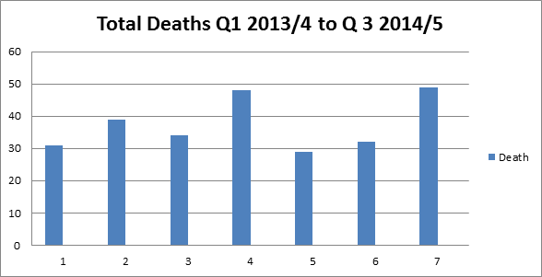

**1.3 Reported Incidents**

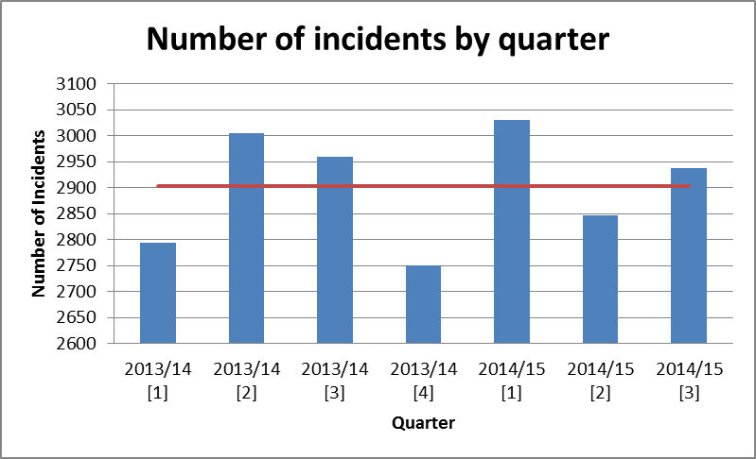

Figure 1

The level of incident reporting continues to vary close to the mean value of 2903 incidents per quarter. There has been no significant variation in the level of incident reporting over the last seven quarters.

|  |  |  |  |  |  |  |
| --- | --- | --- | --- | --- | --- | --- |
| Q1 2013/14 | Q2  2013/14 | Q3 2013/14 | Q4 2013-14 | Q1  2014-15 | Q2  2014-15 | Q3  2014-15 |
|  |  |  |  |  |  |  |
| 2793 | 3004 | 2960 | 2751 | 3031 | 2858 | 2937 |

**1.4 Incidents by actual impact**

The numbers of reported green and yellow incidents (low/minor injury or property damage) continues to represent the highest proportion of total reported incidents. There has been an increase in the number of deaths reported this quarter, 52, compared to 32 for the last two quarters.

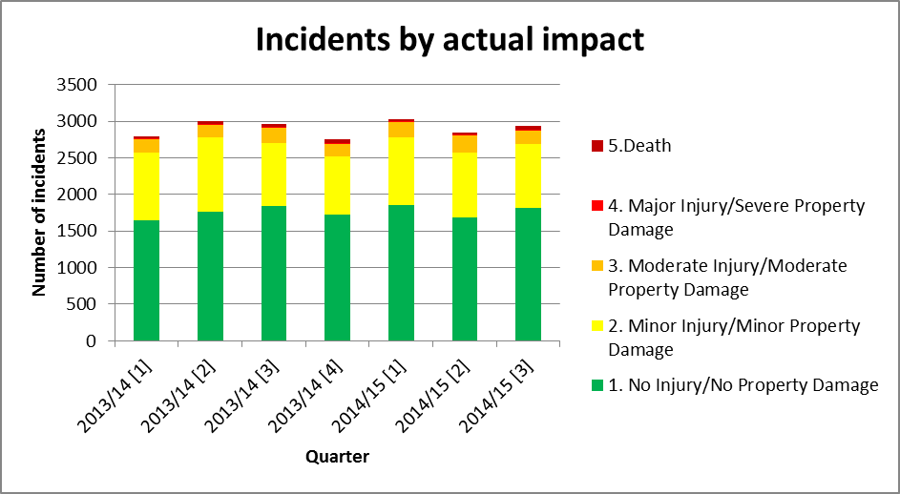

**Figure 2**

**1.5 Incidents in web holding**

Managers have five days to review incidents reported in their team(s). The number of incidents waiting more than five days is currently in web holding is 1109. This may be due, in part, to the delay in mapping new teams and managers on to the system (and therefore the system identifying the correct manager from whom to request a review); and the situation should improve now this is complete.

|  |  |
| --- | --- |
| **Days** | **Number of incidents** |
| 0 to 5 | 47 |
| 6 to 10 | 123 |
| 11 to 15 | 108 |
| 16+ | 878 |

**1.6 Incidents by division**

Community Services and Mental Health continue to remain the two highest reporters of incidents. Mental health services have reported 852 incidents in quarter 3, in comparison to 853 in quarter 2. However this value remains below the mean value for the last seven quarters of 992.

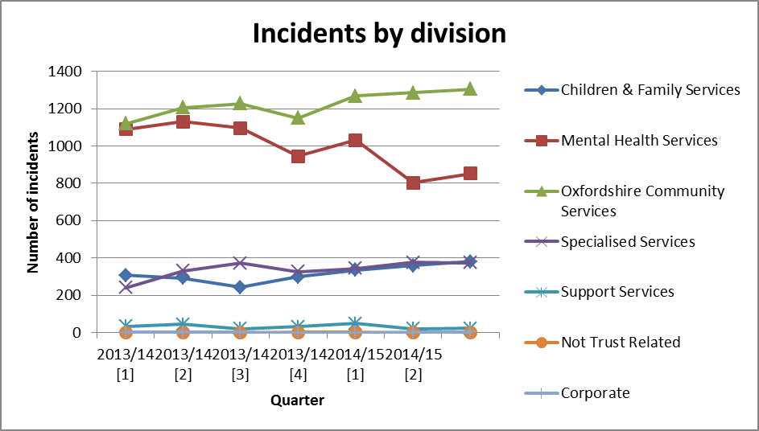

**Figure 4**

**1.7 Top seven cause groups by quarter**

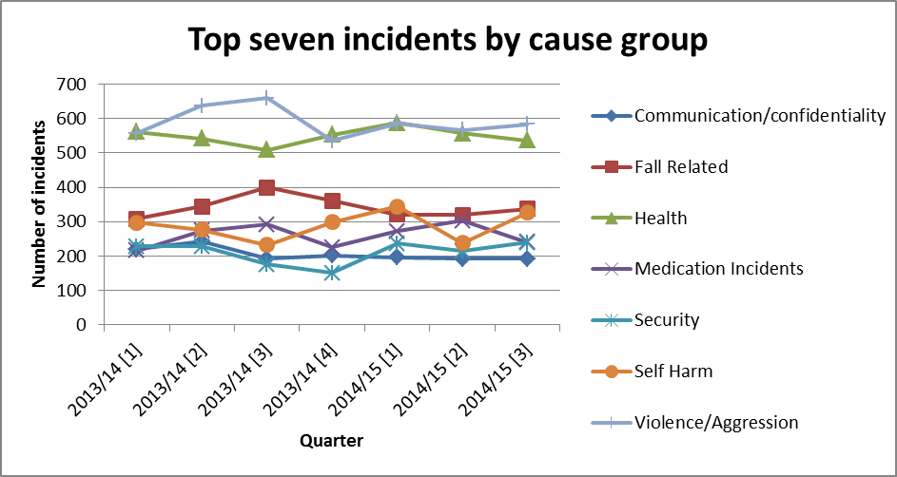

**Figure 5**

The number of reported pressure ulcers has dropped in the last three quarters whilst the number of incidents relating to self-harm has increased in Q3. The Quality and Risk team will be working with directorates to understand the cause of this increase. The number of incidents relating to the remaining cause groups have remained fairly similar over the past two or three quarters.

**1.8 Serious incidents requiring investigation (SIRIs)**Figure 6 shows the total number of SIRIs per quarter. The total number of SIRIs in quarter 3 is twelve, which is the lowest over the last seven quarters.

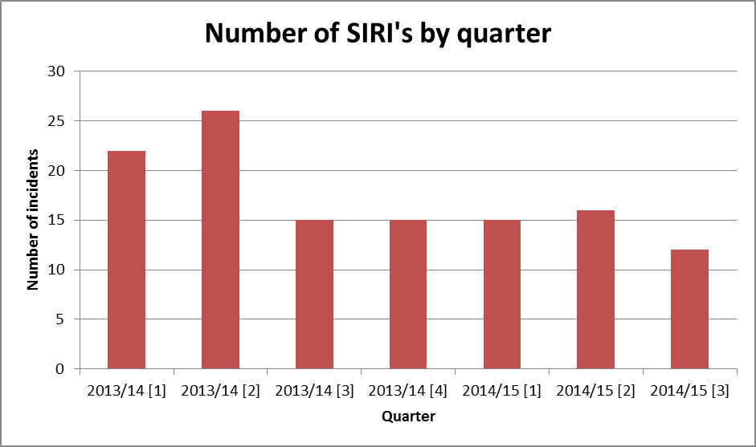

Figure 6

There has also been a year by year reduction in the total number of SIRIs over the last three years.

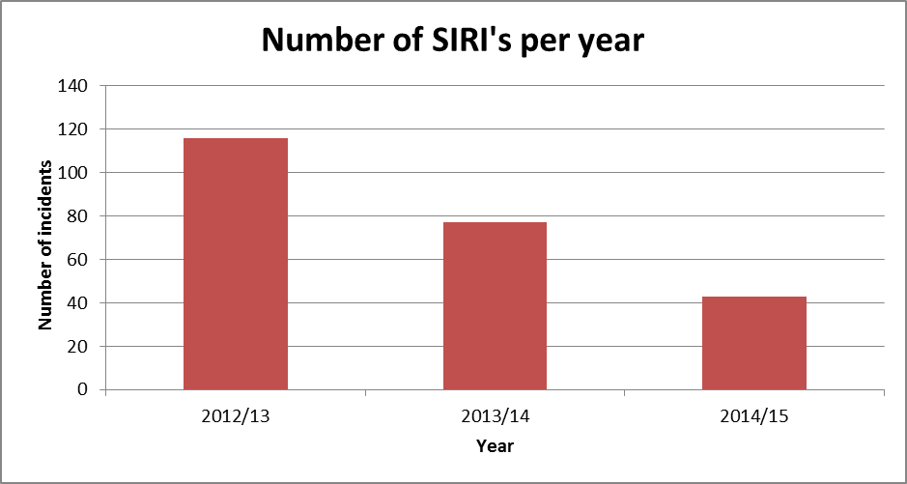

Figure 7

**1.9 SIRIs by type** In quarter 3 there have been:

* Six suspected suicides
* One unexpected death in Oxfordshire of an outpatient in receipt where a 3 month old baby suffered injuries and died. This is being managed through the serious case review process.
* One alleged homicide by a patient who was not in receipt of services at the time of the incident. This resulted in the death of another patient who was also not in receipt of care.

**1.10 Completed Root Cause Analysis (RCA) Actions**

The actions from RCAs are recorded on the Safeguard incident reporting system. For actions to be reported as completed, they must be recorded on Safeguard by Health and Safety administrators. The figures given do not account for actions completed but which are not yet reported on Safeguard. Current Safeguard reports indicate that since 2011 there have been a total of 800 actions arising from SIRI investigations. Of these 688 (84%) have been completed. Closure of outstanding actions is a further area for improvement by managers. Non completion of actions was picked up by the CQC during the themed inspection of crisis services.

The breadth of actions is too great to report here in any detail. However in the last year there have been some recurrent themes including:

* Communication related actions such as establishing formal meetings and introduction of the use of SBARD as a structured communication tool
* Training for staff in pressure ulcer prevention
* Caseload reviews, recruitment and skill mix reviews
* Management of transitional periods
* Audits of contacts with carers
* Delivery of suicide awareness training to teams
* Embedding safer care methodology.

**1.11 Themes from SIRIs**

Issues that have emerged from investigations include:

* Similar themes as reported previously in relation to pressure ulcers. Of the five avoidable pressure ulcers that went to panel in Q2 themes such as documentation, named nursing, communication, training and leadership were raised on one or more occasions.
* Access/waiting times for psychological services was noted on two occasions. This has been a theme in the past.
* General issues with communication and transfers of care were raised on more than one occasion. This was a particularly significant issue in one case where poor communication between the OUH and OHFT contributed to the death of a patient at the John Radcliffe.
* For the first time since the introduction of the AMHTs the management of referral and transitional issues between the assessment and treatment functions in one of the AMHTs was noted.
* Documentation of contingency planning was noted in one case. This was reported last quarter as an issue and is supported by findings from the CPA audits that are undertaken.

There were a number of areas of good and notable practice highlighted during the course of the investigations. These included:

* Some good practice in relation to timely and consistent step up care and contact with care coordinators. Some of these practices were highlighted in the last IGC report.
* Effective MDT and multi-agency working.
* Effective management of transitions along mental health pathways.
* In relation to district nursing services there were some examples of timely provision of PU relieving equipment, involvement of tissue viability and in one case a notable example of a whole team actively engaged in post incident learning with a culture of staff feeling able to escalate concerns. These issues have been raised as concerns in the past offering some indication that positive changes are being made.

**1.12 Restraint and Seclusion (Quarter 2)**

**Restraint and Seclusion**

There were 412 reported incidents of physical restraint in quarter two. Totals for the previous four quarters were 293, 338 and 351 and 358. The mean number per month for the last eighteen months is 119.

The trend by quarter (below) shows common course variation influenced by variation relating to individual patients over five quarters. The figure of 412 is unusual but not unprecedented. On two occasions in the last two years, there have been more than 400 incidents in one quarter.

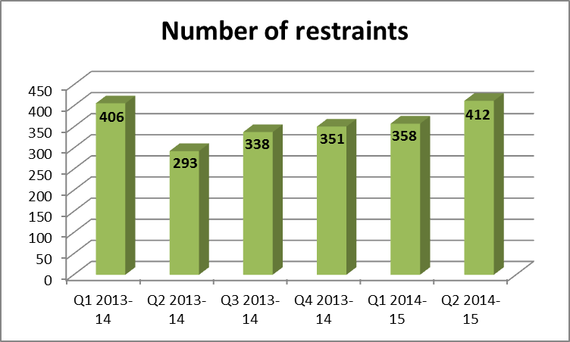

The gender of restrained patients has been a consistent finding with around 65% involving female patients. In quarter two this remained higher at 75%, partly due to the repeated restraint of a number of female patients (described below).

The number of patients restrained five times or more is 19 this quarter (a figure that is also high but within normal limits of variation). The patients being restrained multiple times present with high levels of aggression towards staff and/or patients and/or are at significant risk of self-harm.

**1.13 Restraints by Ward**

All mental health wards, including older adult, adolescent and eating disorder services reported some restraints over the quarter except for Glyme, Chaffron, Lambourn House Wenric (all forensic units) and Opal (at the Whiteleaf). The number of restraints ranged from 0 to 107.

The four wards with the highest number of restraints are Ashurst, Highfield, Kestrel and Ruby. This was the same last quarter. The high reporters are related to the presence of individual patients who required multiple restraints (corresponding to the table of individual patient restraints above).

**1.14 Reasons and Causes**

The incident form requires a ‘cause group’ to be selected for each incident. Many different types of cause group were selected but violence and aggression (62% of all incidents) followed by self harm (21%) were as usual the main reasons for restraint. The other causes relate to restraints for administering medication and to prevent absconding. The pattern does not vary from previous quarters.

|  |  |
| --- | --- |
| Type of incident | Percentage of incidents |
| **Health** | 3% |
| **Medication Incidents** | 5% |
| **Security** | 9% |
| **Self Harm** | 21% |
| **Violence/Aggression** | 62% |

**1.15 Rating the level of incidents**

The staff reporting incidents rate the actual impact of the incident. 94% of the incidents were graded as yellow or green (moderate or low risk) or were not yet graded. 24 forms were graded orange (high risk) this quarter. These did not however detail incidents that resulted in serious harm.

**1.16 Type and level of restraint**

The restraint tab requests the names of the staff involved and their role in the restraint, the degree of restraint (high, medium or low), the position the patient was restrained in (seated, standing, prone or supine) and the duration of the restraint are all requested.

The number of forms recording the use of ‘pain compliance’ is 2% having been 4.8 - 24% in the last eight quarters. This indicates that the fall in its use has been maintained (one caveat being that 6% of forms did not state the level of hold).

The percentage of restraints recorded as prone has remained steady at 30% in compared to 26% last quarter (the figures in the previous quarters were 33%, 29% 25% and 22%). The new category of kneeling is rarely selected. The rise in prone reflects a fall in the use of seated restraint, the other categories remained constant. One patient at the Highfield accounts for 35 of the 116 prone incidents. Her care has been peer reviewed.

In quarter two, the recorded **duration** of restraint ranged from 1 minute to 4 hours. 5% of restraints (16 incidents) lasted an hour or more (compared to 2.9% -13% in previous reports). These restraints are peer reviewed.

There are two work streams to reduce the incidence of restraints – safer care work in CAMHS wards, and forensic wards and the development of the new PEACE engagement and intervention training to replace PMVA.

**1.17 Use of Seclusion**

The total number of reported seclusions in Quarter 2 was 75, compared to 66, 59, 77 and 68 in the previous four quarters. The mean per month for the year of 2013/14 was 20.5, for this year’s two quarters it is 29.

**1.18 Reasons**

Nearly all incident reports continue to detail violence and aggression as the cause for seclusion. One incident was categorised as primarily self-harm. In Quarter two, a total of 34 different patients were secluded (compared to 23, 46 and 35 in the last three quarters). 15 patients were secluded more than once (compared to 7, 12 and 15 in the last three quarters). Nine patients were secluded more than twice, the highest being one patient on the Highfield who was secluded 9 times. This patient’s care has been peer reviewed.

**1.19 Profile of secluded patients**

Fifty percent of seclusion incidents involved a male patient as many of the patients secluded once or twice were men (Male patients have previously made up 28 - 66% of seclusions).

**1.20 Time in seclusion**

The recorded duration ranged from 15 minutes to 59 hours but not all forms detailed the start and end times.

**1.21 Project on Physical restraint practice in Oxford Health Foundation Trust**

A review of our Trust’s training and practice around prevention and deployment of physical restraint techniques has been completed. Its aims are to ensure teams are providing the highest standard of evidence based care, to reduce the use of restraint and ensure we are using the best form of training and techniques. The project team have recommended that as no external provider completely meets the latest guidance and the needs of our Trust, and that we should invest in developing our own training programme. This has been named PEACE (Positive Engagement and Caring Environments). This has been approved by the Executive and the new training curriculum is under development.

This quarter, our Trust was also one of two pilot sites for a Department of Health project to increase the detail of data available centrally on prone restraints. Our Trust’s incident reporting system (Safeguard) feeds into a national reporting system the NRLS (National Reporting and Learning System). Whilst we can locally choose to report on only prone restraints, the NRLS is unable to separate out prone restraints. We were asked to fill in a second incident form with additional information after any prone restraint, including the antecedents to the restraint, whether patients physical observations were taken whilst restrained and whether the patient came to any physical or psychological harm as a result of the restraint.

Those taking part reported that positive outcomes were having more context to incidents, that the matron met with the patients and staff involved in the incidents and that it had highlighted the absence of observations. Negative outcomes were the time taken, the repetition of information and only physical harm could be easily reported with more guidance required on how to assess psychological harm.

The feedback from other Trusts was strongly that they wished to find a technological solution to providing the NRLS with the data they require rather than asking clinicians to complete additional forms (something we had asked for on our first meeting in relation to the project). This is being explored prior to any roll out of the pilot.

1. **INFECTION PREVENTION AND CONTROL**

**2.1 C. difficile**

The 2014/15 threshold for *Clostridium difficile* cases in community hospitals has been set at eight. This target contributes to the overall health economy target.

**Mental health**

There have been no cases of CDI in mental health wards in Q3.

**Community Hospitals**

There were no attributable Trust cases in Q3. There have been four cases in total since April 2014, including two in December 2014.

**October 2014 –no cases**.

**November 2014—no cases**

**December 2014 – 2 cases**

1 CDI case attributable to CCG as not admitted to Oxford Health and seen in EMU Abingdon hospital.

1 CDI case identified in a patient on Wenrisc ward, Witney hospital and assessed as being unavoidable.

**2.2 MRSA Bacteraemia**- no cases

**MSSA Bacteraemia** – 1 case identified in November on admission to Abingdon hospital via EMU. Pre 48 hour and not Trust attributable.

**2.3 Audits**

A total of six environmental re-audits were undertaken during quarter 3 and one self-assessment. Two areas failed to achieve an overall score of more than 85% on re-audit; Warneford Day Hospital and The Elms Day Hospital and actions are being developed with those teams. The overall average score for Q3 was 89%.

In Quarter 3 80% of staff attended their required infection prevention and control training

Hand hygiene audits in mental health inpatient wards and units and community hospitals achieved required standards.

**2.4 Outbreaks**

There was one possible norovirus outbreak in adult mental health directorate (Phoenix ward). All appropriate precautions were put in place.

1. **CLASSIC SAFETY THERMOMETER**

**3.1 Use of the Classic Safety Thermometer**

The safety thermometer is a point prevalence measure which takes a snapshot view of harms on a given day. In each case there is a national comparison, although it should be borne in mind that many participants will not be direct analogues of Oxford Health Foundation Trust (providing mental health & community services but not acute services.)

The tool does not allow an assessment of avoidability where a harm has occurred. It is also not possible to compare *individual teams* across organisations – e.g. a team of DNs in Witney can’t compare their results with a team of DNs in Reading.

All results are presented as percentage of patients seen by the services on the audit date. Caution should be applied when considering results for teams with low patient numbers: for example, for a service that audit only 5 patients in a month, such as Physiotherapy Out patients, a single patient with harm will affect the overall result by 20%. On average 1100 patients are audited each month: the largest contributing caseload is that of the District Nursing (DN) service.

**3.2 New Harms – Safety Thermometer**

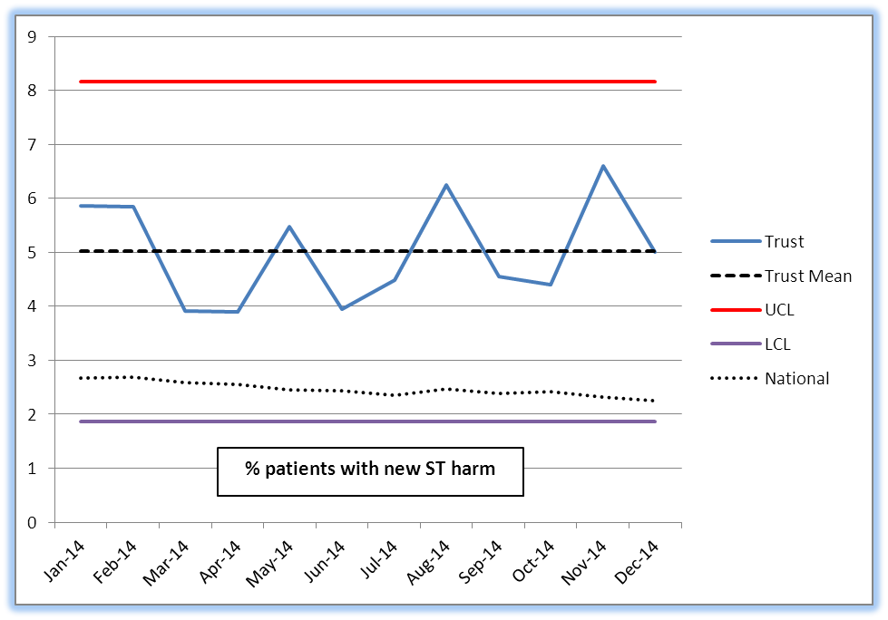

*New in this instance means harm that has occurred whilst the patient is under our care. All harms included, from minor (1st aid, treatment, extra observations or medication) upwards.

Whilst November saw the highest prevalence of new harms identified during the ST audit, over the year the levels of new harm have remained within the control limits.

It is recognised that the DN service is frequently managing patients of high risk who may have been discharged early from Hospital and with increasing higher acuity or complexity than previous years due to the rising elderly population. To support the demand for care and vacancy factor across the District Nursing Teams a Capacity Tool allocating units of time for specific tasks has been introduced since October 2014 to support effective working practice and share workload across a Locality Cluster. The impact has been greater consistency and capacity productivity.

Harm-free care above the mean for all 3 months of Q3 was seen in community wards; specialist nursing, physiotherapy and ORS, but the numbers within the audit means this is very few individuals.

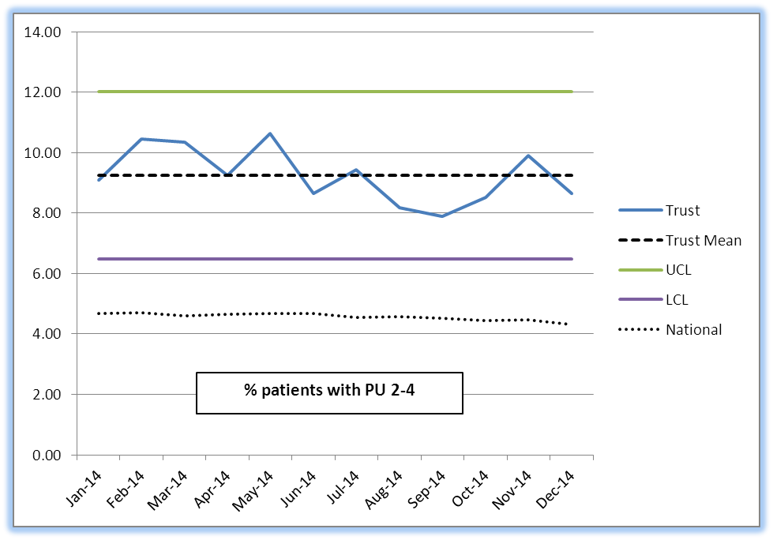**3.3 All Pressure Ulcers – Safety Thermometer**

Community Hospital Wards were below the Trust mean in all 3 months of Q3.

In comparison, of the 175 Community Hospitals patients audited for October, 8% (4 patients) had pressure damage against a mean service average of 9.16%. This is part of an improving trend.

In District Nursing 10.93% of the 723 patients had recordable pressure damage: a reduction against the service mean of 11.07%. In DN services long term caseload management means that certain patients will be counted twice in different months; this may imply a higher prevalence when there may have been no new harms.

**3.4 New Pressure Ulcers – Safety Thermometer**

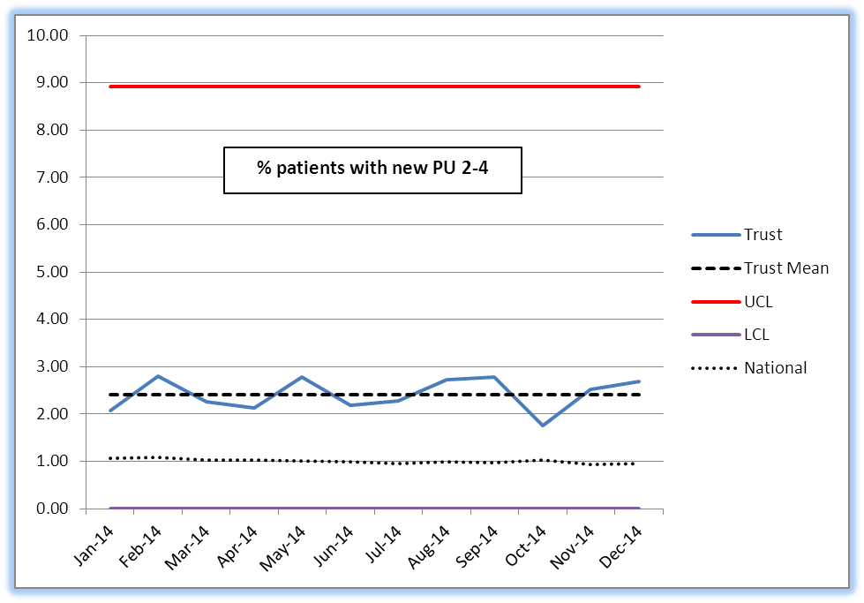

New Pressure Ulcers (grades 2-4) are above the Trust mean in all three months of Q2, although the actual number is only higher by two compared to the previous quarter (83 new PUs in Q1, 85 in Q2).

October shows a 1% reduction and is close to the national mean. There are currently a total of 26 new pressure ulcers year to date reported using the safety thermometer (23 DN teams and 2 Community Hospitals). This includes all the non-avoidable harms in addition to the small number of avoidable new pressure ulcers which are all subject to SIRI reviews.

At the end of Q3 a review of the last twelve months of pressure ulcer incidents determines that only 0.5% of all reported ulcers are grade 3-4, not inherited and avoidable.

There is a comprehensive work programme to address a range of underlying issues across the system and within the Trust. These include training and development programmes, SKINtelligence Safety Programme, improved working with tissue viability services, the implementation of the Braden risk assessment tool, and assessment of staff against competency frameworks.

Team level run charts have now been established and will be reported in future.

**3.5 Falls with harm – Safety Thermometer**

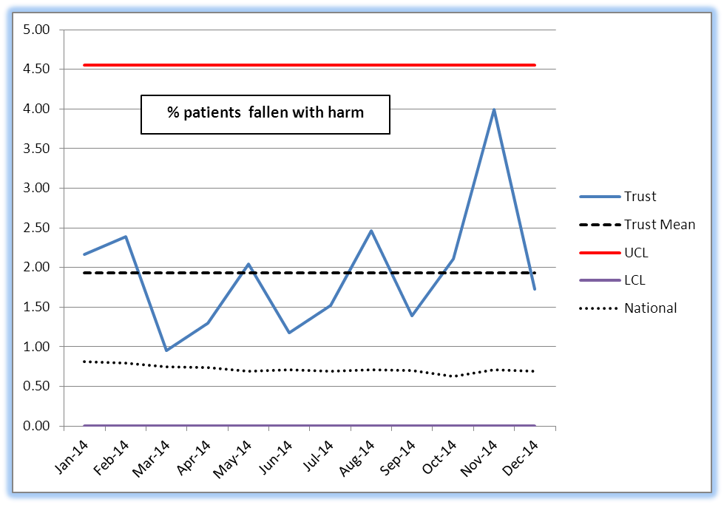

November saw the highest Directorate-wide percentage of falls with harm (4%) in the past 12 months, although December fell below the mean. Older adult mental health wards identified no falls in all three months of Q3 for the safety thermometer. We measure harm from falls by 1000 bed days as part of the harm reduction priority in the quality account. It is anticipated reduction in harm from falls will be the next area of safer care work in the directorates.

**3.6 Catheter & UTI – Safety Thermometer**

The Patient Safety Thermometer determines that only UTIs that are currently being treated with antibiotics are counted. Urinary catheters must be in place or have been in place within 3 days of the audit; only indwelling urethral urinary catheters are relevant, supra-pubic catheters and other stents are not counted.

In October the OH mean average was 0.62% against the National Mean of 0.4 %

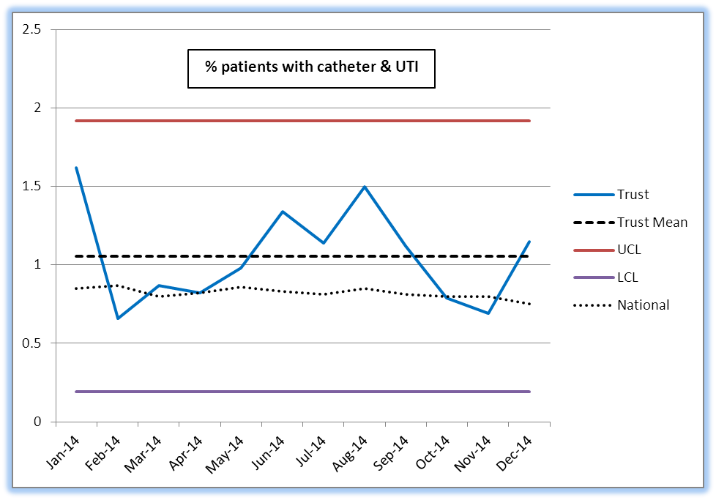

**Catheter & New UTI – Safety Thermometer**

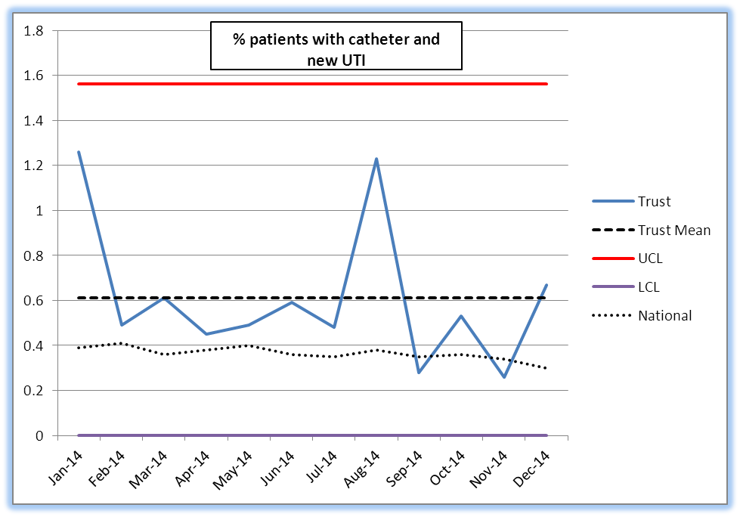

Catheters & UTIs are above the 12 month mean for the past 4 months, although the greatest monthly variance is 0.7%. Patients or clients who arrive within our service or post operatively are counted within these figures if a catheter is removed within the 72 hours following arrival at within our service this is still counted by the safety thermometer.

Catheters & New UTI September figures are the lowest for 12 months, and below the national figure for the first time: of 1076 patient audited, 3 had a UTI that developed during our service’s care delivery.

The Patient Safety Thermometer counts catheterised patients that have a diagnosed UTI, but not those un-catheterised patients who might have developed a UTI. In community hospitals this data is collated using the Productive Ward dashboard and through safeguard reporting which affords a more robust reporting mechanism and local action plans to support reductions in Urinary Tract Infections- such as the Heatwave plans and strategies to support hydration. By far the largest impact such as imbedding intentional rounding has supported a reduction in Pressure Ulcers Falls and Urinary Tract Infections.

**3.7 VTE Risk Assessment – Safety Thermometer**

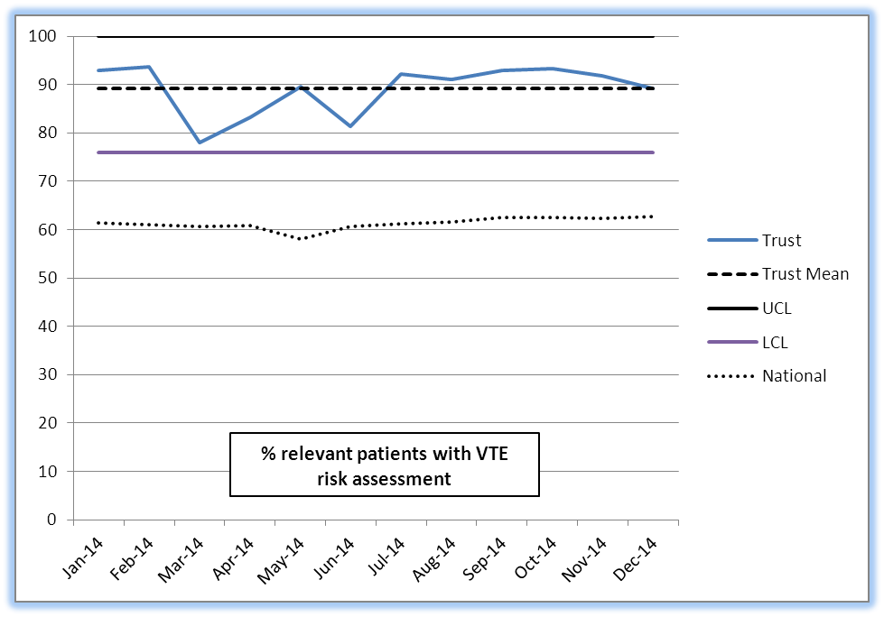

VTE risk assessments were above the 12 month Trust wide mean for all 3 months of Q3, and the trend of performing better than the national figure. During Q2 practice has supported this change in the community wards in particular by attaching VTE assessment forms to drug charts, to encourage medics to complete the assessment.

**3.8 New VTE – Safety Thermometer**

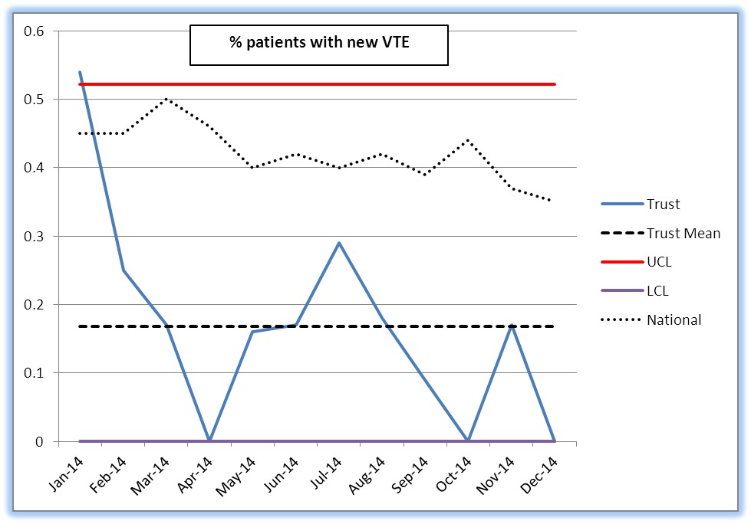

Over Q3 the care of 3329 patients was reviewed as part of the Safety Thermometer audit, 88% of whom had no harm. Less than half of the harm identified occurred during care delivered by our services.

The ST prevalence data provides an indication of areas for improvement that require further investigation using the Directorate’s more detailed incidence data.

The primary areas of prevalence, pressure ulcers and falls, are monitored by the Trust’s Pressure Ulcer Action Group and Falls Prevention work stream. Any high risk incident is managed according to the Trust’s incident management policy.

**3.9** Analysis and use of the Safety Thermometer data is improving and will be used in future detailed reports to the safety sub-committee and Board of Directors, in particular to probe in more detail harms at an individual team level and compare the data with similar trusts.

1. **IMPROVEMENT PROGRAMMES**

**Update on Safer Care and Productive Care Programmes**

**4.1 AWOL Project. Failure to return to the ward following agreed time away (Formal and informal patients)**

All adult wards are engaged in the project to test interventions to ensure that patients return from time off the ward at the agreed time, and safe and well. Phoenix ward provided the first test site and introduced systematic tests of change using IHI methodology including the use of a signing in and out book, multidisciplinary discussion with the service user on the therapeutic aims of leave and the time required to achieve these, cards with ward contact details and agreed time of return, and intentional rounding to check safe return. The ward initially improved the rates of return on time from 30% to 74%. With further consolidation, the ward is now sustaining 93% of service users returning to the ward on time.

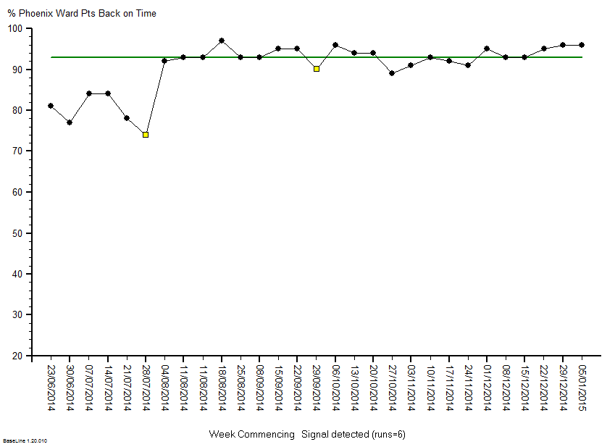

Allen ward is one of the wards now re-testing the interventions and is showing good improvement over time. Work continues towards achieving sustained improvements.



The work will now extend to include a collaboration between Oxford Health NHS Foundation Trust and Berkshire NHS Foundation Trust to work towards wider systems improvement in the reduction of AWOL.

**4.2 Reduction of self-harm incidents in Tier Four Services, Marlborough House, Swindon**

Marlborough House Swindon commenced their Safer care Project using IHI Methodology to reduce the rate of self-harm incidents in young people on the ward in June 2014. Initial diagnostics informed a change in the allocation of resources on the ward during the evenings. Tests of change have included systematically increasing the nursing presence in communal areas, and the introduction of dedicated nursing time to the multidisciplinary review meeting and consistent approaches to communicating outcomes to the young person, their family and the staff team. Both young people on the ward and the nursing team have found the increased nursing presence in communal areas to provide a greater sense of psychological safety and the number of timed nursing observations has decreased. Further work is planned to test new clinical approaches to the reduction of self-harm.

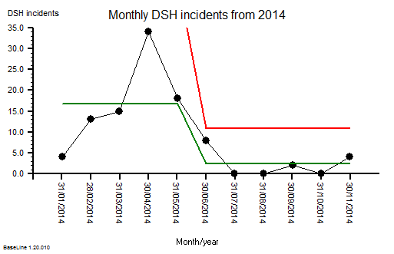

**Productive Care Programme**

**4.3 Adult Directorate**

Productive Care facilitators have been supporting the Oxon and Buckinghamshire adult mental health wards to achieve accreditation with the AIMS (Accreditation for Inpatient Mental Health services standards) with specific focus on a shared medication competency framework and planning for a smoke free environment. Within the specialised services the Harm Minimisation team have developed methods of capturing client experience with a new ‘you said, we did ‘board and by holding a regular drop in brunch club. Woodlands and Lambourne House have worked on improving the experience of patients returning from leave and the environment for carers and visitors. Lambourne House have introduced an electronic document to record accurately patients returning from leave and have achieved 98% completion. Woodlands secured funds to improve their ‘airlock’ space and have put in place a photo board of staff, defining roles and have updated the information leaflets for clients and visitors.

**4.4 Older People’s Directorate**

*Community Nursing*

There are several work streams within the directorate with community services. The Venous Leg Ulcer Pathway has been introduced to a further 30 District Nursing teams, using a visual Patient Status at A Glance tool to highlight the pathway milestones. Early reporting indicates enhanced healing rates, improved patient satisfaction and a release in ‘time to care’ for nursing staff by reducing visit frequency. Nurses have also identified previously undiagnosed conditions in several patients as a result of the lower leg assessment process.

*Community Hospitals*

All wards have undertaken the annual sustainability review. The average score was 64.2 %. A score of 55% or above strongly suggests that improvements undertaken will embed and sustain. This is an overall improvement on the score for 2013.

Two community hospitals have been supported with the planned moves to new premises and this support will continue during and after the moves. Staff have been looking at ways of delivering person centred care in the new wards with a focus on safety, privacy and dignity. Away days have been supported including work on purpose statements, effective team working and managing transitions.

**4.5 Children and Young People’s Directorate**

Children and Young People’s Directorate Productive Care facilitation has supported the Productivity project in several areas including the community dental service.

Cotswold House, Oxford is being assisted with work on the QED (Quality Eating Disorders) accreditation project. Actions are in progress in looking at information and communication pre-admission, during stay in unit and upon discharge as well as the move towards smoke free environment by April 2015.

A comprehensive tool for the Health Visitors SIG’s (Special Interest Groups) has been developed and is in use. This captures in one place all the evaluations received from attendees at all the groups run by Health Visitors such as breast feeding and weaning advice groups. The results can be reviewed by team locality and across the county wide service.

Bucks SLT (Speech and Language) team for children have re-designed the pathway and using innovative tools such as internet and phone apps for accessing advice

Activities for Q3 will include:

* Complete the 15 Steps challenge on Sandford ward for Older Adults during Dec 14
* Support the Venous Ulcer Pathway PSAG rollout with district nursing teams through Q3 and Q4 .
* Review and embed performance dashboards in Community Nursing service and Forensic wards, ensuring compatibility for future transfer to the Business Intelligence Cube.
* Support the preceptorship programme for newly qualified nurses and allied health professionals in Buckinghamshire and Oxfordshire.
* Pilot new ‘service improvement tools in practice’ session in Jan 2015.
* Support the Productivity project within the Older People’s and Children and Young People’s directorates.
* Continue To support AIMS and QED accreditation
* Provide project management support for the ASD pathway in the Children and Young People directorate.

1. **TRUST WIDE STATUS REPORT AGAINST CQC OUTCOMES**

The monthly report to share the internal position by Directorate and location against the CQCs essential quality and safety standards as of September 2014 has been discussed in the Extended Executive. The report is produced and circulated to the Directorates monthly to show exceptions where internal concerns have been identified and are being resolved. There are eight areas for improvement which were reviewed in the Extended Executive held in January.

The only significant risk to possible non-compliance identified by the CQC in their last Quality and Risk Profile (last updated in April 2014) was a low amber risk for co-operating with other providers which relates to Delayed Transfers of Care (DTC), specifically across Community Hospital. Across the 10 community hospital wards there are usually between 25-30 delays at any one time. A number of these delays are out of the patients choice and a large % relate to patients with social care needs. A senior group of clinicians from the Older Peoples Directorate review the DTCs weekly to support complex discharge plans.The Trust is also working with the whole health system in Oxfordshire to reduce DTCs and since the begining of the year they are reducing compared to last year.

**5.1 Internal assessment of compliance with the five new CQC key lines of enquiry**

This project is well established and detailed project plan is reviewed at Extended Executive with fortnightly Project Team meetings. Testing of the Peer Review Process has been successful and the three Clinical Directors are on schedule to complete the first phase of reviews at the end of the month. A Board Seminar on Preparation and findings is planned for April 2015.

**5.2 CQC Intelligent Monitoring**

The CQC regulates in four key ways; registration, intelligent monitoring, expert inspection and judgement/rating of quality.

From June 2014 the CQC started to consult on the development of new intelligent monitoring indicators which would form the basis of new quarterly intelligence reports for mental health service providers to replace the previous quality risk profiles (last updated in April 2014). Similar intelligent monitoring reports have been introduced for the acute sector providers and GP practices in 2014.

In September 2014 the trust was selected as one of five trusts to be part of the development of the indicators and format of the report prior to the first publication. The lead for registration and quality has been invited to join a national reference group chaired by the CQC to continue to develop the tool, with the first meeting in January 2015.

The trust has shared a number of issues and concerns with the report from our first involvement in June 2014 up until feedback after the first report was published in November 2014. The main comments which have been fed back to the CQC are:

* Should the report not reflect each provider and when a trust is integrated the report should be on performance across all services. There is currently no date to produce a similar intelligence report for community based physical health services.
* The report mostly shows indicators for the mental health services however there will be some indicators e.g. around incidents and staff survey results, which will represent the whole trust. The report does not indicate this to help explain to the user when the trust is compared to some trusts which only provide mental health services.
* A number of data sources used are over two years old and a lot of annual data sets are used.
* The indicators are adult inpatient mental health focused.
* Thresholds are set different to national targets.
* Difficult to carry out factual accuracy checks as we have struggled to identify the figures from those submitted nationally.
* Report format is not user friendly for providers or the general public
* Information on how comprehensive inspections will inform the intelligence monitoring reports.

In November 2014 the first intelligent monitoring reports for every mental health provider were published. The report shows the CQCs risk assessment for each provider which will help guide them to decide when, where and what areas to inspect. The key sources used for the intelligence include; the NHS staff survey, MHMDS, MHA visits, PLACE visits, ESR, the national community health survey and concerns raised by trust staff. Based on the report the CQC has placed each mental health provider into apriority band from one (high perceived concern) to four (lowest perceived concern) which helps decide when a trust will be inspected.

In Oxford Health’s first report (November 2014) 57 indicators are reported of which one indicator was identified as a risk. The risk identified is around high delayed transfers of care based on data between April-June 2014. No elevated risks were identified. Here is a link to the full report

<http://www.cqc.org.uk/sites/default/files/RNU_101_WV.pdf>

The second quarterly report is due to be published in February 2015.

**5.3** **CQC Consultation on Fees** In December 2014 the CQC consulted on their annual fees for registration and regulation for 2015/16, starting from 1st April 2015. The proposal is a 9% increase from last year which is still based on annual turnover. The trusts annual fee for 2015/16 is likely to be £94,996.

The CQC also mentions in the consultation their plan for 1st April 2016 to re-introduce separate fees for any changes providers want to make to their registration e.g. locations, new regulated activities, trust name, etc… although there will be a separate consultation for this later in the year.

**5.4 CQC Inspections**

* **Thematic review of Crisis Services in Mental Health**  
  Oxfordshire local authority area was selected for the national thematic review on mental health crisis care, the trust was the lead agency in organising the announced site visit from 5-7 January 2015. The review took a care pathway approach to assess the help, care and support available to people during a crisis with a focus on how services and agencies work in partnership to deliver this. The three main pathways reviewed were how people accesses services via the emergency department, the Police and through secondary mental health services. Providers will not be rated following the review rather the intelligence gathered will be used to inform future inspections. This was not an inspection of a local authority but an assessment of people’s experiences of crisis care provided.

Oxfordshire local authority should receive a draft local report in mid February 2015 identifying areas of good practice or where improvements could be made. The local report will not be published. The national report with themes from all the reviews across the selected 15 local authority areas is planned to be published at the end of March 2015.

* **Henry Cornish House – Intermediate Care Centre**Henry Cornish House Care Centre received an unannounced inspection by the CQC in November 2014. The Centre is currently provided by the Order of St Johns Care Trust although the trust is in a transition period to start a contract with the commissioners and registration with the CQC to provide and manage a 14 bed intermediate care unit which is currently part of the centre. The elements of the inspection report which relate to the intermediate care unit identify some very good practice as well as one area for improvement. The area for improvement is to ensure accurate and comprehensive information about patients care is always recorded. This issue had been identified by the ward managed and matron for the unit in an audit completed a week before the inspection visit and a local action plan had been developed which was discussed with eh CQC. The inspection identified no recommended actions or enforcements.

1. **LEARNING AND DEVELOPMENT**

**6.1 Clinical & Professional Development**

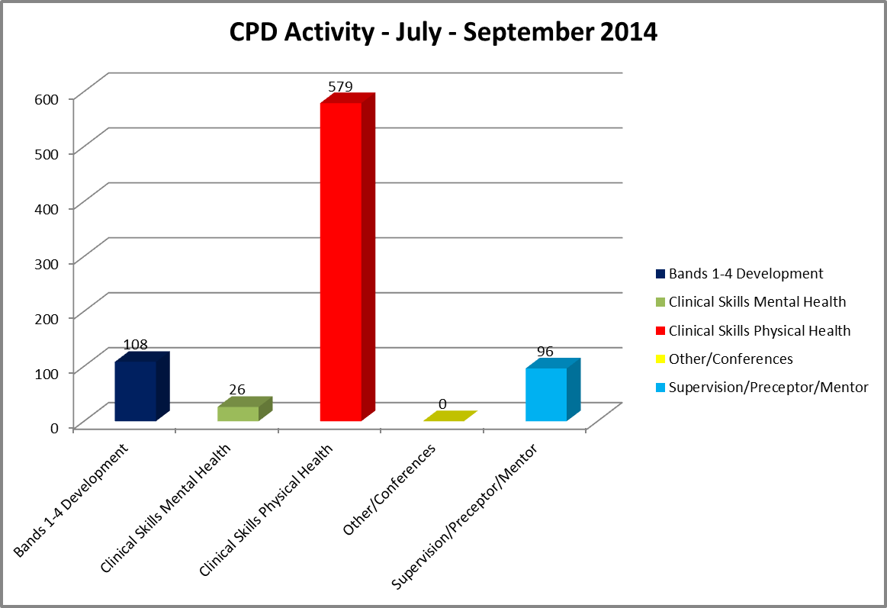

NB: The lower level of activity reflects an increasing number of ‘did not attends’ (DNAs) i.e. 117 staff who failed to attend training they had committed to in Q2. This is related to capacity and staffing pressures, however it means more sessions have to be planned. This adds to the cost of providing clinical training. Staff need to be able to demonstrate attendance of clinical training for revalidation.

**6.2 Bands 1 to 4 Development**

* five more Apprenticeships commenced in Q2 covering Health & Social Care, Business & Administration and Customer Service, all at Level 2
* the VRQ Dementia programme has 7 new learners registered at Level 2
* English at Work programmes involve 10 learners through local Colleges of Further Education
* other programmes delivered to upskill HCAs / support workers include physical health skills, HCA development programme and Emergency First Aid – first responder & Measuring Vital Signs

**6.3 Clinical Skills updates**

The final 4 day Physical Health Skills course for mental health nurses took place in partnership with Oxford Brookes University. The next course will be facilitated by our Clinical Practice Educators and will take place in the new ‘Clinical Skills Lab’ formally opened in Q2.

A wide range of clinical updates and study days have taken place across the directorates in Q2, including bowel / bladder symptoms and continence catheter care, chronic oedema, IV study days, phlebotomy, tissue viability, pressure ulcer prevention & management, wound assessment, leg ulcer management, recognising the deteriorating patient, oral health promotion, immunisation, challenging communications within community nursing, minor illness course.

Work is completed within Directorates to define the specific occupational staff groups and frequency of training including Pressure Ulcer prevention/management to ensure staff are competent.

Staff undertaking university accredited modules/awards at local universities includes Oxford Brookes University: 29; University of West London: 27; University of Bedfordshire: 9.

**6.4 Clinical Supervision / preceptorship / mentorship.**

Support to develop newly qualified staff and their mentors/preceptors continues to be provided by the Learning Environment Leads (LELs) and now includes:

**6.5 Clinical Practice Educators (CPE)**

The Learning Advisory Committee endorsed the work of the newly appointed CPEs, which includes working with clinicians to improve / refresh physical health skills e.g. to ensure that all mental health nurses can competently undertake a manual blood pressure and can report results appropriately; supporting delivery of clinical training within directorates; supporting undergraduate and preceptorship placements.

**Leadership, Team & Individual Skills (LTIS)**

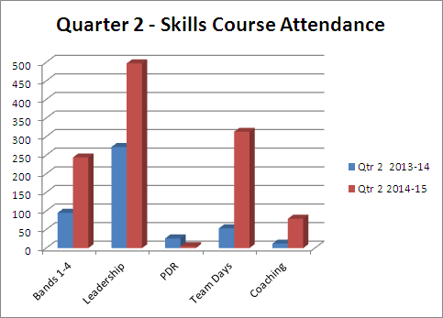

An increase of over 50% in Skills activity compared to the same quarter last year.

**6.6 Skills & team development programmes:**

* Team development for the entire Buckinghamshire Speech & Language Therapy service included an MBTI Step 1 session for more than 70 staff and a follow-up MBTI Step 2 session for their senior team as part of embedding their new service model.
* 2 bespoke Team days using a mixture of Belbin and MBTI designed and delivered to staff in the Adult and Older People’s pathways where the teams are having problems with communication and internal conflict.
* Certified Administration Development Pathways designed to upskill Bands 1-4 and gain a Level 3 Apprenticeship over 12 months using a mixture of workshops to gain new skills and coaching and assessment to embed the learnt skills.
* A new Customer service session delivered to multidisciplinary staff.
* 3 further Customer Care sessions delivered following successful pilot for new Adult Pathway.
* New Tissue Viability Resource Nurse Development Programme cohort to develop leadership and competency skills following successful pilot cohort to 15 District Nurses and End of Life care Nurses in September.
* Microsoft Project courses delivered to 8 Estates staff.
* Support to the Innovations team in the roll-out of Aston Team events.

**6.7 Leadership Development**

* A new Leadership Development Centre (LDC) programme using dementia and community based scenarios in partnership with Berkshire Healthcare NHS Foundation Trust has been established. Two cohorts scheduled for Q3 and a further cohort in Q4, offering 48 places across the two Trusts. The LDC uses a model originally delivered as part of national leadership programmes.
* The Adult Directorate funds and supports the ‘Leading the Way’ and ‘Planning for the Future’ programmes.
* The thirteenth cohort of the highly successful First Line Management 6 day programme commenced in Q2 with a full complement of 20 recently appointed or developing managers. This leads to credits at Masters Level with Oxford Brookes University.

**6.8 National Leadership Programmes**

* Successful applicants for National Leadership Academy programmes include 3 placed on the Mary Seacole programme and 1 placed on the Nye Bevan programme.
* Seven nominations from the Trust have progressed to the Regional Leadership Awards to be held in Q3.
  1. **LTIS Yearly Comparison**

**6.10 Patient & Personal Safety Training (PPST)**

Trust performance for all levels of PPST at Q2 was **85%**, compared with the Q1 performance of 84%. This excludes staff not available for training for example due to long term sickness, maternity leave or secondments.

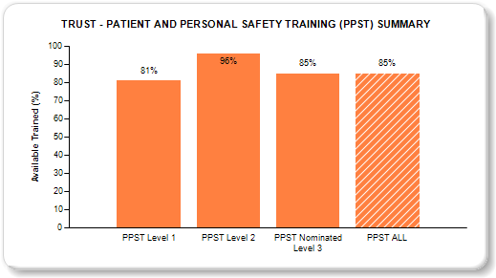

There were two significant factors affecting performance during Q2:

* the high number of staff vacancies that prohibit staff being released for training
* the continuing focus on directorate restructuring with the introduction of care
* pathways, often resulting in changes to and within teams.

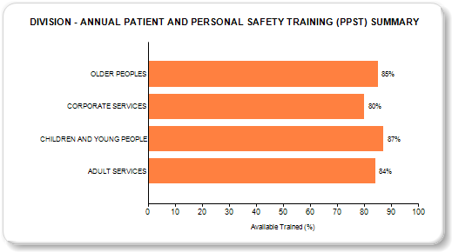

An analysis of lowest performing teams was introduced in Q1. This involves the L&D function working closely with operational directorates to understand and then support improvements to PPST performance. In Q2, this again shows a variety of specific local factors as contributing causes.

**6.11 PPST Level 1 – Progression FY1415 Q2 – 100% target**

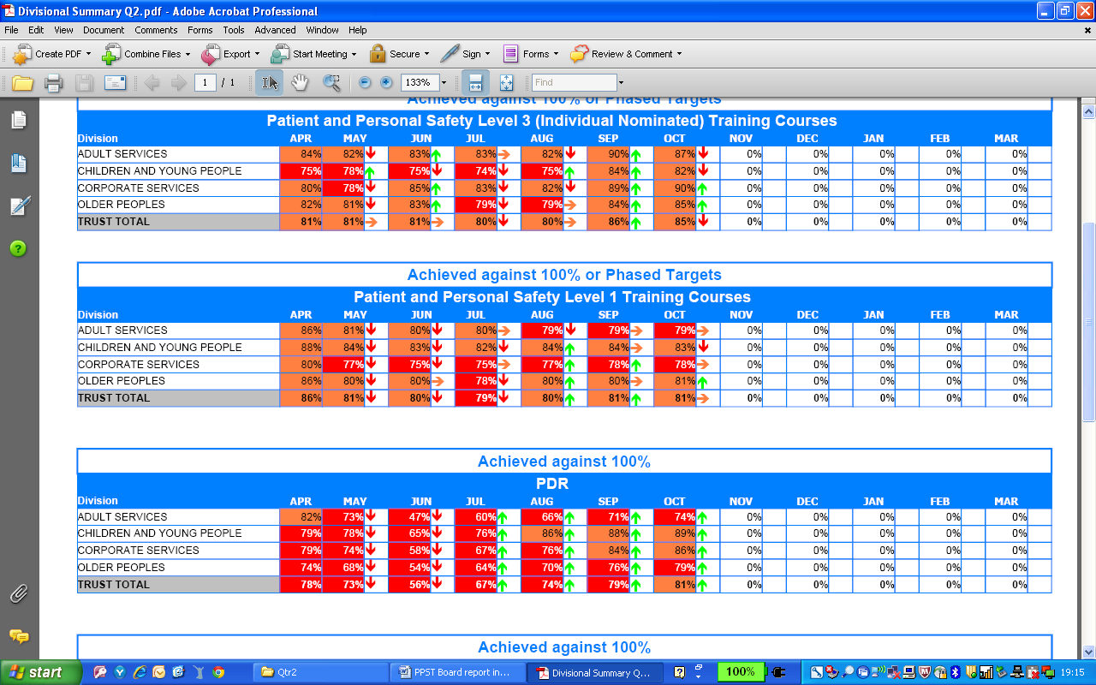

**PPST Level 1 Phased Targets**

PPST Level 1 was **81%** at Q2, compared with the Q1 performance of 80%. As previously reported, phased targets were reset to 100% during May for three key subject areas. The need to sustain current performance during Q2 together with this additional requirement has been a challenge for directorates.

**PPST Level 2 – progression FY1415 Q2 – 85% target**

PPST Level 2 has achieved **96%** of the 85% target, representing **82%** of available staff trained, compared with 94% in Q1.

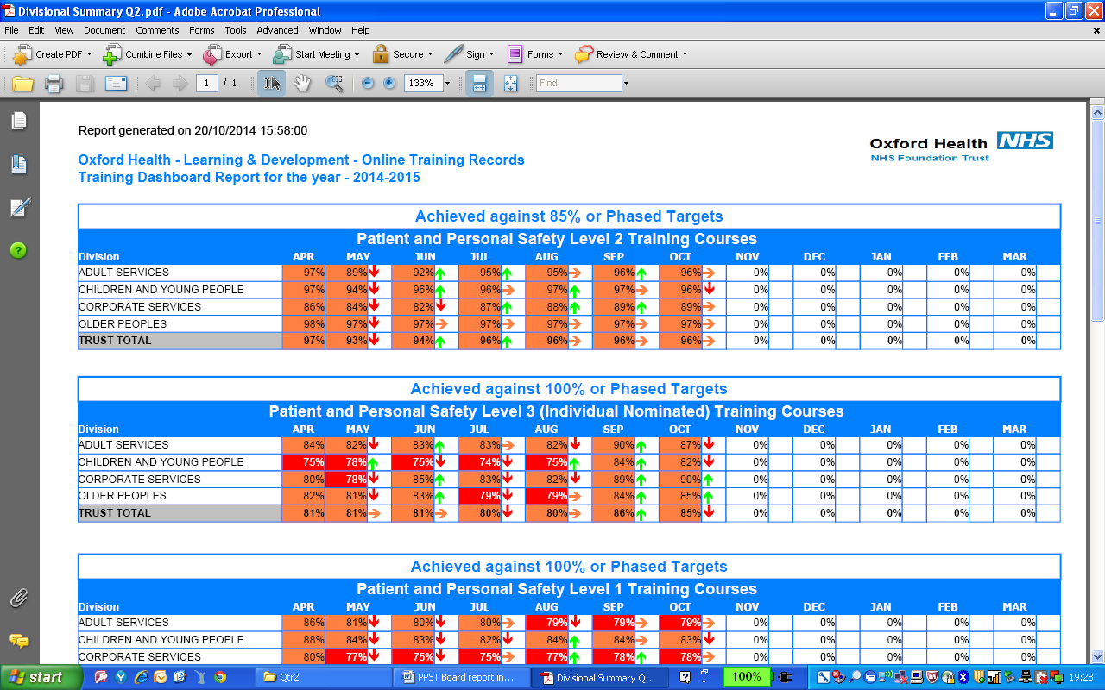

**PPST Level 2 Phased Targets**

**Falls Awareness –** In support of the focus on reducing harm to patients, the completion of ‘falls awareness’ training shows a 92% achievement against the phased target which was set during May 2014.

|  |  |  |  |  |  |  |  |
| --- | --- | --- | --- | --- | --- | --- | --- |
| **Directorate** | **Staff** | **Trained** | **% of Available Trained** | **Phased**  **Target %** | **Phased Target to Train** | **% of Phased Target** | **Training Gap** |
|
| ADULT SERVICES | 528 | 374 | 71% | 85% | 449 | 83% | 154 |
| CHILDREN AND YOUNG PEOPLE | 132 | 94 | 71% | 85% | 112 | 84% | 38 |
| CORPORATE SERVICES | 5 | 4 | 80% | 85% | 4 | 94% | 1 |
| OLDER PEOPLES | 1238 | 1015 | 82% | 85% | 1055 | 96% | 223 |
| **TOTAL SESSIONS** | **1903** | **1487** | **78%** | **85%** | **1620** | **92%** | **416** |

**6.12 PPST Level 3 – progression FY1415 Q2 – 100% target**

PPST Level 3 was **86%** at Q2 compared with the Q1 performance of 81% (with a 100% target). Level 3 relates to the number of staff that have been nominated for a **specific role**, e.g. health & safety, medical educational supervisor, root cause analysis (RCA) training.

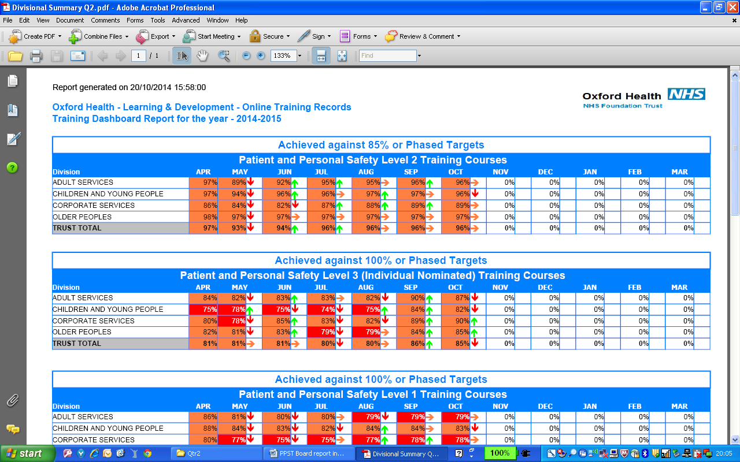

Currently **1338 employees** are nominated for specific roles at Level 3 of which **1076 are trained** and **111** are booked to attend training.

**6.13 Targeting Team PPST Performance**

L&D continue to identify and support teams that achieve less than 80% (red) against the PPST framework. Circumstances at team and individual level are many and varied. The approach is to seek to understand these and work together with service and team managers to overcome and/or document the challenges. PPST 395 teams, 187 exceeding 100%, 10 less than 50%.

**6.14 Performance & Development Reviews (PDRs)**

Trust performance for all PDR completion at Q2 was **79%** compared with 56% at Q1.   
(Target 100%)

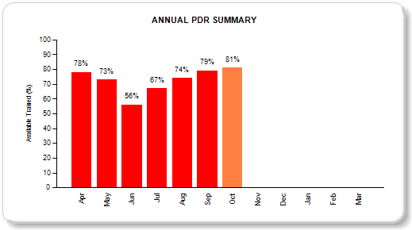

The current PDR cycle runs for 3 months April to June. Operational services report that having to complete all PDRs within a 3 month period places an unachievable burden on managers. The current PDR review acknowledges this and will be recommending a different approach for the next financial year.

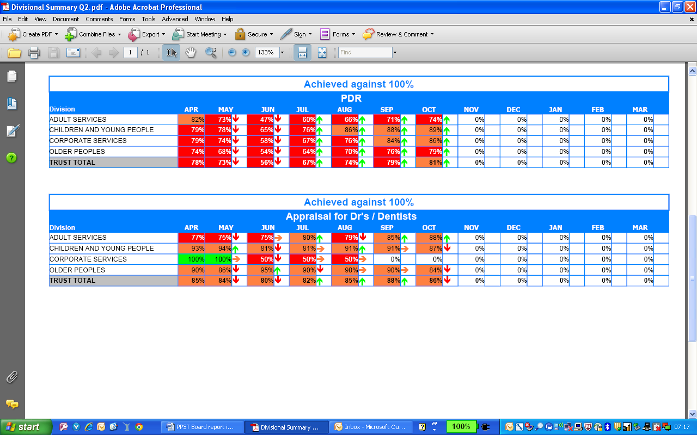

PDT’s 390 teams, 189 joint top up with 100%, 20 joint bottom with 0%.

**6.15 Numbers outstanding**:

Adult = 341; C&YP = 160; Corporate = 81; Older Peoples =511. Total = 1093

Medical staff and dentists have annual appraisal reviews and are outside the PDR cycle. At the end of Q2 performance was **88%** compared with 80% at Q1.



**Numbers outstanding**:

Adult = 9; C&YP = 4; Corporate = 1; Older Peoples =2. Total = 16

**6.16 Technology Enhanced Learning (TEL)**

The L&D team is exploring a range of opportunities for using technology to enhance earning, including virtual classrooms, webinars and e-learning. A pilot for fire awareness training for non inpatient staff annual awareness updates produced an average saving of £39 per learner. We estimate a saving of £78,000 per annum in time saved from travelling to and from training and creating more time to care. Additionally, we estimate that a further £20,000 per annum could be saved in travel expenses, giving a total of £98,000 per annum.