Report to the Meeting of the
BOD 123/2015
(Agenda item: 8)

Oxford Health NHS Foundation Trust

Board of Directors

30 September 2015

Quality and Safety Report

Quarterly Clinical Effectiveness Report

For: Information
Executive Summary
This report provides a summary of the Trusts’ position, primarily in Quarter 2 (April – June 2015), and more recently, in relation to a range of clinical standards and risks considered by the Trust’s Quality Sub-Committee - Effectiveness (QSCE) and reported, as appropriate, to the September 2015 Trust’s Quality Committee.
The work of the Trust’s QSCE continues to evolve well. Following the last Quarterly Clinical Effectiveness Report to the Board in May 2015, the committee has now fully established the full representation required to cover its wide remit. The re-established Public Health Group have held their inaugural meeting and are now reporting to the sub-committee. Issues around patient flow/DTOC which are under the committees remit require fuller consideration and the sub-committee Chair has liaised with the Chief Operating Officer to agree how best this can be done.
The QSCE has considered a range of reports relating to its various key lines of enquiry. The following issues are highlighted to the Board:
Areas of compliance/good practice
Clinical audit
The significant improvements in the governance processes around clinical audit have been maintained. It is encouraging that there are efforts to enhance patient engagement in clinical audit. The attached report includes a number of positive aspects in relation to 4 clinical re-audits which have been rated as good.
The audit team and directorates are working on reducing the number of improvement memos that are past their time frame for completion. The number of improvement memos outstanding has been reduced from 46 to 31 and it is worth noting that further work is being undertaken by the directorates to address both the number of outstanding improvement memos and the number of out-of-date audit actions. The report to Clinical Audit Group in October will reflect the substantial reduction in the number now outstanding.
In addition both the clinical audit policy and strategy have been finalised.
Clinical Policies
Considerable efforts have been made by the Clinical Policy Review Group (which reports to QSCE) to ensure all necessary clinical policies are up to date and fit for purpose. The current status of clinical policies is now much improved with the review process on track.
End of Life Care
Good progress has been made in this area and a range of reports have provided assurance to the relevant committees.
AIMS Accreditation
During Q1 2015-16 all Adult acute and rehabilitation in-patient services received AIMs accreditation.
Areas of unsatisfactory compliance/risk/concern
Mental Health Act
During Quarter 1 the CQC conducted a total of 6 MHA inspections and raised a range of statutory and non-statutory issues which required local actions. The issues raised by the CQC were as follows:
Statutory matters: Patient rights (sec 132); Information about IMHAs; consideration of CTO; issues relating to patient leave forms & form not received by patient; absent without leave and CQC notification (Restriction Order patients), consent to treatment (omission of medication and being out of date)
Non-Statutory Matters: smoking and fire hazard; ligature risks; care plans recording patient views & patient participation; recording and update of risk assessments; consistency between care plans and risk assessments; confidentiality at nursing station; information about PALS.
All of the above issues have associated action plans in place which are being monitored by the Directorates.
Clinical Audit – Physical Health Care Issues
A number of key themes are arising from clinical audit and form the learning event held in June 2015. They include the following:

In keeping with findings from other audits such as the national audit of schizophrenia and reported incidents within the Trust we need to do more to improve the physical health care monitoring of our patients and this is being actively addressed by the Directorates. On the positive side the MEWS audit undertaken within older adults where the majority of risks lie has suggested that practice has remained good over the last 2 quarters.
However, past learning from incidents has highlighted that we had not been assessing the VTE risk for patients in inpatient services. Whilst this has improved very significantly and is monitored through the essential standards audit, recent audits have indicated that we are not always following the guidance for the treatment and management of those at risk. This also applies to the treatment and management of insulin dependent diabetics in mental health inpatients. This is being actively addressed.
Training levels in some key skills are not being maintained which presents risks for patient safety. Less than half of staff are trained in inpatient mental health wards to undertake effective resuscitation. This must be improved upon; previous serious incidents following an inpatient death a few years ago highlighted adequate staff training with role play to be essential.
Review of practice against NICE guidance
Although the QSCE is confident that NICE guidance is being received and then disseminated to and being processed by Directorates, it is not yet assured that it is being fully and efficiently implemented in all cases. A gap analysis is being completed and the Deputy Chair of QSCE and the Clinical Audit Group, which reports to QSCE, is addressing this area.
Medication Management
A Trust learning event was held which concentrated on medication management issues. The recommendations and comments that emanated from this (and from other sources) suggest that there are a number of key areas where developments would be appropriate. Capacity in Pharmacy is currently significantly stretched and a review of the staffing structure and resourcing is being undertaken so as to best establish how this can be rectified and thus support the work required.
Possible future Issues/concerns
PPST

It is important that completion of some aspects of PPST requirements are improved. The use of e-asseements and the reviews of some trainings are occurring. This area needs to continue to be carefully monitored.

In order to provide the Board with more detail on areas deemed to be of particular relevance, the attached report provides specific detailed information in relation to:

- Clinical audit
- The safety thermometers
- Mental health legislation issues

The report also provides an update on infection prevention and control.

Recommendation

This report is for information.
Author and Title: Susan Haynes, Head of Nursing; Sandra Parker, Clinical Audit Specialist; Rebecca Kelly, Learning from Incidents and Clinical Audit Lead; Mark Underwood, Head of Information Governance; Marie Pritchard, Head of Business and Performance (older peoples services); Helen Bosley, Infection Prevention & Control Matron.
Lead Executive Director: Dr. Clive Meux, Medical Director.
A risk assessment has been undertaken around the legal issues that this paper presents and there are no issues that need to be referred to the Trust Solicitors.
This paper (including all appendices) has been assessed against the Freedom of Information Act and the following applies:
THIS PAPER MAY BE PUBLISHED UNDER FOI

- Introduction

The Quality Sub-Committee Effectiveness (QSCE) is responsible for ensuring that patients’ needs are assessed and that care and treatment is delivered in line with current legislation, standards and evidence-based guidance. The Key lines of enquiry (KLOE) for the committee are aimed at ensuring that relevant and current evidence-based guidance, standards, best practice and legislation are identified and used to develop how services, care and treatment are delivered.

The focus of the QSCE is to seek assurance that the organisation is complaint with the KLOE which have been identified for the sub-committee. These are as follows:

- Are people’s needs assessed and care and treatment delivered, in line with current legislation, standards and evidence-based guidance?
- How are people’s care and treatment outcomes monitored and how do they compare with other similar services?
- Do staff have the skills, knowledge and experience to deliver effective care and treatment?
- How well do staff and services work together to deliver effective care and treatment?
- Do staff have all the information they need to deliver effective care and treatment to people who use services?
- Is people’s consent to care and treatment always sought in line with legislation and guidance?
- How are people supported to live healthier lives?
- Are people subject to the Mental Health Act 1983 (MHA) assessed, cared for and treated in line with the MHA and Code of Practice?

- Trust wide Clinical Audit
The following clinical audit update provides a summary of the full clinical audit report which was considered by the Clinical Audit Group (CAG) and reported to QSCE and the Quality Committee. It reviews progress against both the trust wide audit plan for last year and the current year; identifies which audits have yet to be initiated and any risks associated with this; and provides an update on actions which are closed and for which no update has been given.
2.1 Progress update against the Trust wide clinical audit plan for 2014/15
There are a total of five audits still to report from the 2014/15 clinical audit plan. Two of these are national audits and the Trust has no control over when the reports are produced:
- National audit - CQUIN MH Indicator 1 - Cardio metabolic risk factors
- National audit - POMH audit - Topic 9 - Antipsychotic prescribing in people with a Learning Disability (scheduled to report in July 2015)

A progress update on the remaining audits still to report from the 2014/15 clinical audit plan is provided in table 1 below:
Table 1
Audit | Status | Comments
Audit of drug prescription & administration chart which includes compliance to consent to treatment for patients subject to Section 58 of the Mental Health Act (T2 / T3) | Report writing stage | Delay with corporate audit team. Report has now been completed and will report to CAG in October 2015.
Meds Management - a) Quarterly audit of safe and secure storage of Controlled Drugs | Report writing stage | Delay with corporate audit team. Draft report for Q4 sent to Pharmacy to review on 3/8/15. Report has now been completed and will report to CAG in October 2015.
Pilot of the NPSA Suicide Prevention Toolkit | Report writing stage | A total of 5 suicides were reviewed using the toolkit prior to the transition to CareNotes. There are now problems accessing historic information as data from RiO is being migrated over in stages. It is planned to analyse the 5 cases and report to CAG in October 2015.

2.2 Progress update against the trust wide audit plan for 2015/16 for audits scheduled to be undertaken during Quarter 1
There were a total of 21 audits that were scheduled to be undertaken during quarter 1. A total of 14 are in progress and on schedule, 6 are in progress but behind schedule and 1 audit may be removed from the audit plan.
2.3 Changes to the Trust wide Clinical Audit plan for 2015/16
- Quarterly Controlled Drugs Audit
Data collection will remain quarterly and any areas of high risk identified will be addressed at the time of the audit. The results will be reported to the directorates every 6 months. This will allow time for improvement plans to be developed and implemented.
- Non-medical prescribing audit
There is a revised policy for non-medical prescribing that has recently been approved (MM2). This policy has significant changes and it is proposed that the audit be slightly delayed.
- Additions to the 2015/16 audit plan
Table 2 below provides details of audits to be added to the 2015/16 audit plan:
Table 2
Name of audit | Reason for inclusion on the 2015/16 audit plan
Audit of the quality of prescribing for high risk medicines - Warfarin & Low Molecular Weight Heparin | This audit was rated as unacceptable in 2014-15 so has gone back on this year’s plan
Audit of the prescribing and monitoring of patients on Insulin | This audit was rated as requires improvement in 2014-15 so has gone back on this year’s plan.
Sentinel Stroke National Audit Programme (SSNAP): Post-acute Provider Organisational Audit | Publication from Royal College of Physicians regarding a new national organisational audit requirement for 2015/16 which is in addition to the Trust’s participation in SSNAP. This audit applies to the Older People’s Directorate only.
Audit of the timeliness and quality of inpatient discharge summaries | Rated as requires improvement for 2014/15 for Older Adult Mental Health and Adult Mental Health. This was a late 2014/15 audit. Children & Young People’s Directorate have not yet participated due to capacity issues within the Clinical Audit Team and availability of trainee doctors to undertake data collection.
Mental Capacity Act audit 2014/15 | This audit was rated as non-compliant.
Re-audit of CQUIN Communication with GPs | This audit was rated as requires improvement.
Access to Healthcare for People with Learning Disabilities | Carried over from 2014/15 plan. Audit was scheduled to commence in June 2015 but has been delayed and will be undertaken in Quarter 2 of 2015/16.

2.4. Reported audits with no improvement plan in place

It was previously reported to the Quality Committee in June that there were a total of 46 improvement plans (some of which were quarterly reporting audits) where an improvement plan had not yet been completed and returned to the audit team by directorates. The directorates were asked by QSCE to address this as a matter of urgency and this figure was reduced to 31 in August.
Out of the 31 reported audits with no improvement plan in place, 24 improvement plans are outstanding and seven are still within date (within 6 week action planning time frame):
Table 3
 | Older People | C&YP | Adult | Total
Number of reported audits in date within the 6 week time frame for action planning | 3 | 2 | 2 | 7
Number of reported audits that have past the completion timeframe of 6 weeks | 16 | 4 | 4 | 24
Total | 19 | 6 | 6 | 31

It is worth noting that further work has since been undertaken within the directorates to address both the number of outstanding improvement memos and the number of out-of-date audit actions. The report to CAG in October will reflect the substantial reduction in the number now outstanding.
2.5 Monitoring of actions from improvement plans
Table 4 below provides a breakdown of the number of audit actions outstanding. The Information has been extracted from Ulysses and relies on the audit leads updating the information. The number of out of date actions is 11 compared with 23 reported in June 2015. This indicates further improvement.
Table 4
Directorate | Total number of actions outstanding | Number of actions in date | Number of actions out of date
Trust wide actions relating to all directorates | 6 | 6 | 0
Adult Services | 38 | 30 | 8
Older People’s Directorate | 12 | 9 | 3
Children & Young People | 13 | 13 | 0
TOTAL | 69 | 58 | 11

2.6 Summary of the results from the clinical audits reported and rated since the last QSCE
Six baseline audits were reported to QSCE as in Table 5:
Table 5
Audit Name | Directorate | Baseline / Re-audit | Audit rating
Baseline Audits
National audit of Intermediate Care | Older People | N/A no audit standards | Rating n/a as no audit standards
Sentinel Stroke National Audit Programme (SSNAP) 2014-15 Quarter 1-3 | Older People | Baseline | Not applicable
POMH-UK Topic 14: Prescribing for substance misuse: alcohol detoxification in adult acute & PICU wards | Adult | Baseline | Requires improvement
Audit of the quality of prescribing for high risk medicines - Warfarin & Low Molecular Weight Heparin | All | Baseline | Unacceptable
Management of Violence and Aggression NICE CG 25 | Mental Health | Baseline | Requires improvement
Assessment of current position in relation to NICE PH48 Smoking Cessation in Secondary Care: acute, maternity and mental health services | All | Gap analysis | N/A
Audit of NICE Clinical Guideline 133 Self – Harm : Longer term management | All | Baseline | Requires improvement

There were a total of seven re-audits reported to QSCE. Four of the seven re-audits were rated as good, one was rated as requires improvement, one was rated as unacceptable and one was not subject to the audit rating matrix. Table 6 below provides further details:
Table 6

Audit Name | Directorate | Baseline / Re-audit | Audit rating
Re-audits 2014/15 audit plan
Self-assessment of how ‘family friendly’ mental health wards are | Mental Health | Re-audit | 2013/14 |  | 2014/15
 |  |  | Unacceptable | Unacceptable
Re-audits 2015/16 audit plan
Infection Control Audit Summary Q1 results | All | Re-audit | Q4 2014/15 |  | Q1 2015/16
 |  |  | Good |  | Good
Essential Standards (May 15) | Mental Health | Re-audit | May 15 |  | July 15
 |  |  | Good |  | Good
Track and Trigger (Community Hospitals) Q4 and Q1 results | Community hospitals | Re-audit | Q4 2014/15 |  | Q1 2015/16
 |  |  | Good |  | Good
Audit of the Modified Early Warning System (MEWS) on older adult mental health wards – Quarter 2 results | Older Adult Mental Health | Re-audit | Q4 2014/15 |  | Q1 2015/16
 |  |  | Good |  | Good
Antimicrobial audit | Community Hospitals | Re-audit | Q3 14/15 |  | Q4 14/15
 |  |  | Requires improvement |  | Requires improvement
Mental Health Safety Thermometer – Q4 results | Mental health | Point prevalence audit | N/A not subject to rating

2.7 Mental Health Safety Thermometer
The Mental Health Safety Thermometer is a national benchmarking tool that has been designed to measure commonly occurring harms in people that engage with mental health services. It’s a point of care survey that is carried out on one day per month which supports improvements in patient care and patient experience, prompts immediate actions by healthcare staff and integrates measurement for improvement into daily routines. It enables teams to measure harm and the proportion of patients that are 'harm free' from self-harm, psychological safety, violence and aggression, omissions of medication and restraint (inpatients only). This is a point of care survey to be carried out on 100% of appropriate patients on one day each month.
Methodology
AMHTs, Adult MH inpatient wards and Adult Forensic teams and wards have been completing the Safety Thermometer audit since October 2014. All patients seen by each team/ward on the nationally defined monthly audit date should be audited, with relevant harms recorded.
The wards are: Allen, Ashurst, Opal, Phoenix, Ruby, Sapphire, Vaughan Thomas, Wintle, Chaffron, Glyme, Kennet, Kestrel, Kingfisher, Lambourne, Watling, Wenric and Woodlands.
The community teams are: Aylesbury AMHT, Chiltern AMHT, City & NE AMHT, North & West AMHT, South AMHT and Forensic Community.
National results are available monthly on the Safety Thermometer website. The Mental Health Safety Thermometer was designed to measure local improvement over time and should not be used to compare organisations, due to differences in patient mix and data collection methods. Safety Thermometer data should also not be used for attribution of causation as the tool is patient focussed.
There are a number of issues to be considered when looking at this data:
- This is a census and the data may come from different workers and patients from month to month.
- The data size differs greatly during the period being reported.
Sample size
The sample size will vary each month, depending on the number of cases seen. Overall sample sizes for the months covered by this report are:
2015/16 | Apr15 | May15 | June15 | YTD
Inpatients | 263 | 279 | 226 | 768
Community | 70 | 54 | 57 | 181
All | 333 | 333 | 283 | 949
Table 7

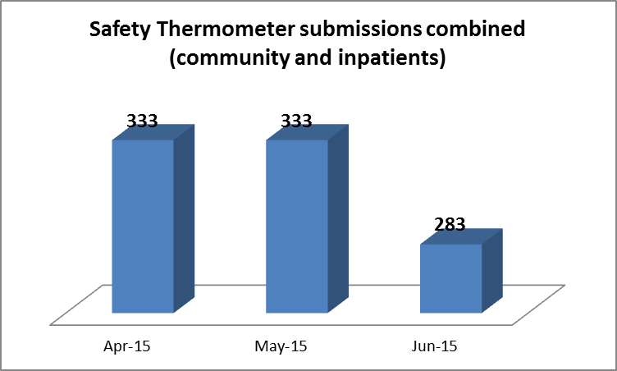 | 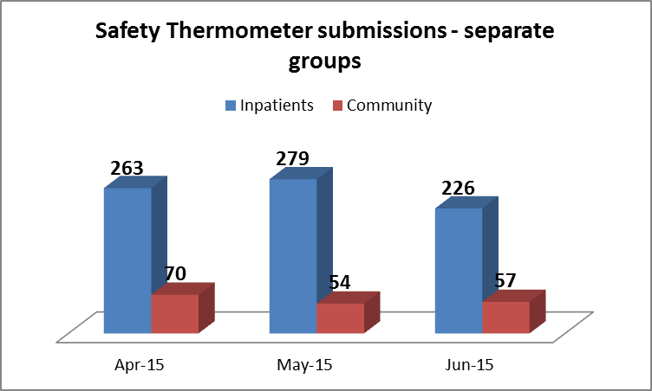
Tables 8&9
The 3 month mean sample size for inpatients and community combined is 316.
The mean sample size for inpatients only is 256, and for community only is 60.
Teams receive regular reminders to complete and submit the safety thermometer information, however clinical staff report that this creates a high level of additional work. Some patients have also reported a level of dissatisfaction reporting that the questions are repetitive.
Demographics:

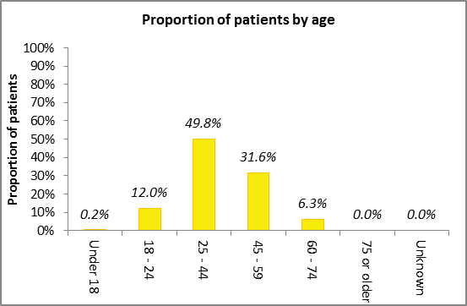
Table 10 & 11
Results – OH Adult MH: ALL (Inpatient and Community combined):

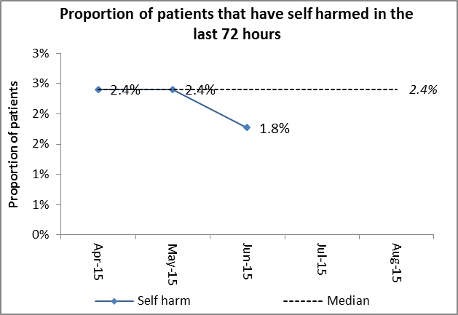 | 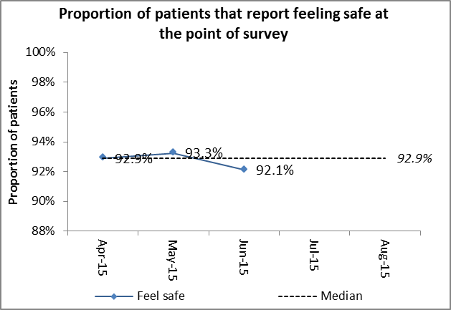 | 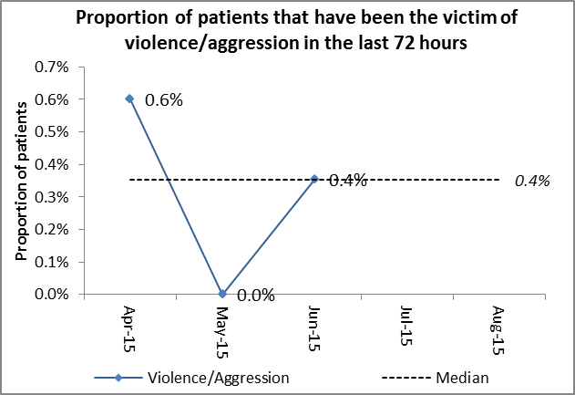
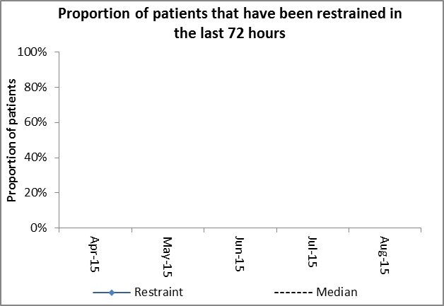  Only applicable for Inpatient setting. | 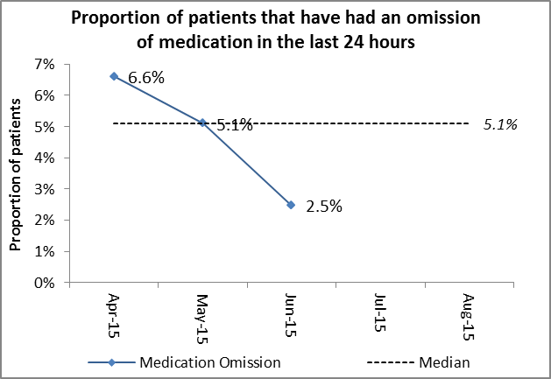 | 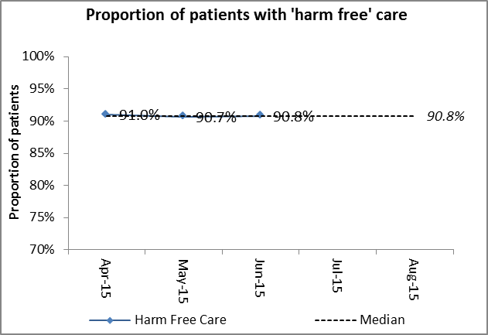  'Harm free' care defined as patients that did not self harm, do not feel unsafe, have not been a victim of violence or aggression and in Inpatient settings have not been restrained.
Table 12-17
The combined data for both in-patients and community services can be seen in tables 12-17. This data suggests that over the three months covered by this report there was an overall reduction in patient harm associated with self-harm and medication omissions. In addition patient reported feeling safer.
The data indicates that over the three month period there was an increase in the number of patients who had been a victim of violence in the previous hours. The Safety Thermometer has not as yet published a run chart on restraint.
Overall there was a slight reduction in patients receiving harm fee care from 91% in April 2015 to 90.8% in June 2015.
Results – OH Adult MH Inpatients only:

The results for in-patients services can be seen in tables 18-23. This data indicates that there has been a slight improvement in harm free care from 92% to 95%. There has been a reduction in the number of patients who reported having been a victim of violence in the previous 24 hours from 0.4% to zero, and medication omissions have reduced from 4.9% to 3.1%.
There has been a fluctuation in the number of patients who have self-harmed in the previous 24hours. This increased to 2.5% in May from 1.5% in April, and was reported as 1.8% in June. There was a reported increase in the number of restraints in May (0.8% to 3.2%), however in June this reduced to 0.9%.
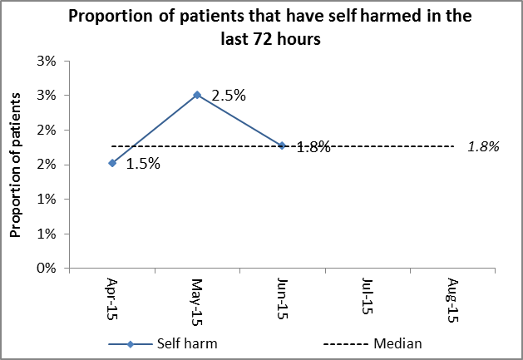 | 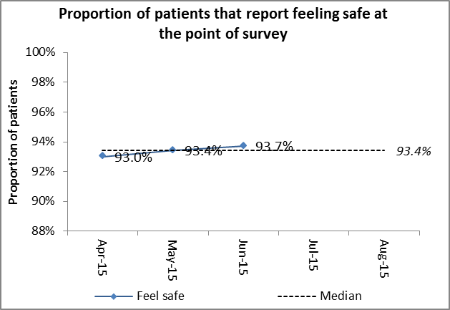 | 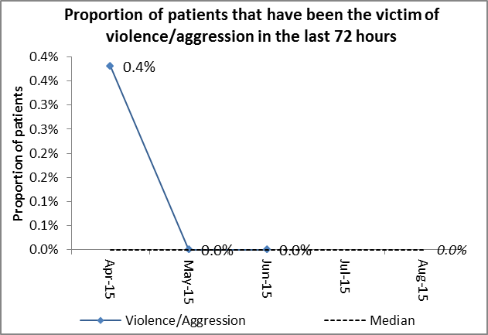
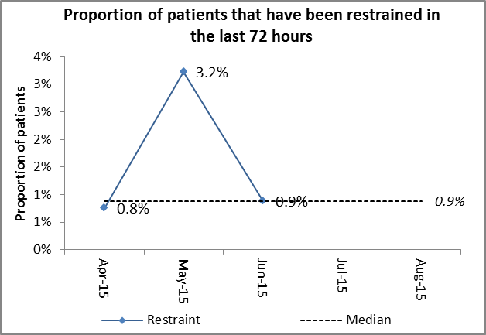 | 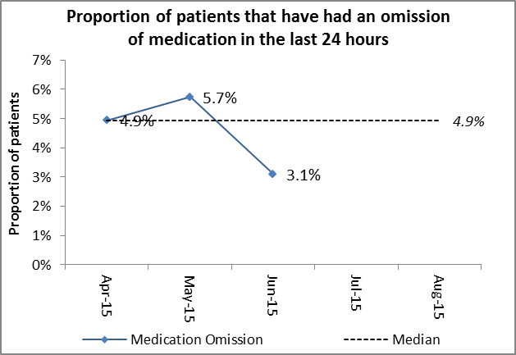 | 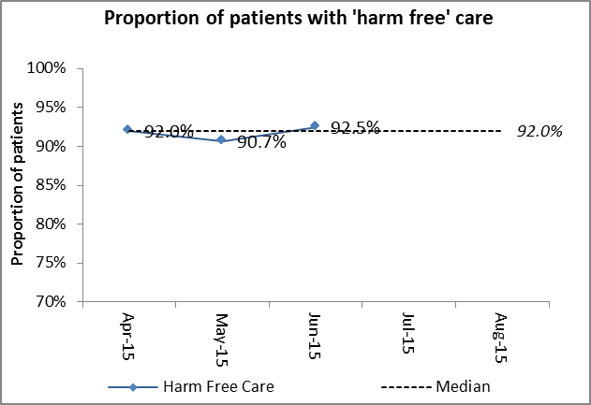  'Harm free' care defined as patients that did not self harm, do not feel unsafe, have not been a victim of violence or aggression and in Inpatient settings have not been restrained.
Table 18-23
Results – OH Adult MH Community only:
The results from the community indicate a mixed picture. There was a slight increase in the number of patients who had been a victim of violence from 1.4% in April to 1.8% in June. There were no victims of violence however in May 2015. There is a reduction in the patients who self-harmed during the previous 24 hours from 5.7% in April to 1.8% in June. The main improvement relates to the number of medication omissions during the period which has fallen from 12.9% in April to zero in June 2015. The main area of concern relates to the number of patient who felt safe. The data indicates a reduction during this period from 92.5% in April to 86%. Unfortunately the data does not provide any details of context so in this way is limited in its application.
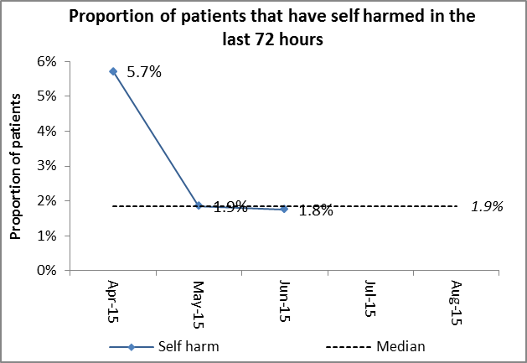 | 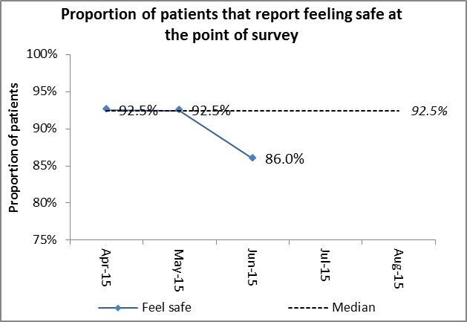 | 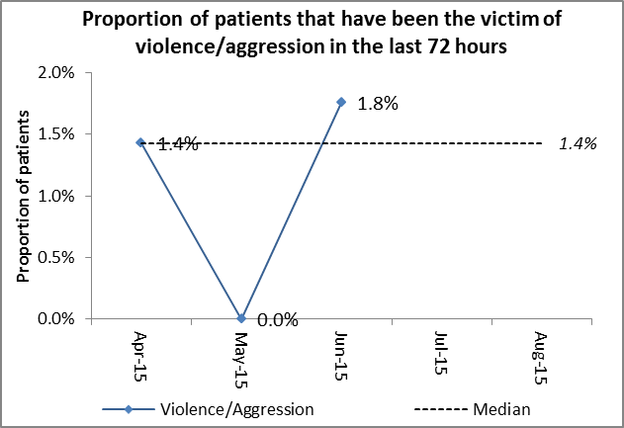
Only applicable for Inpatient setting. | 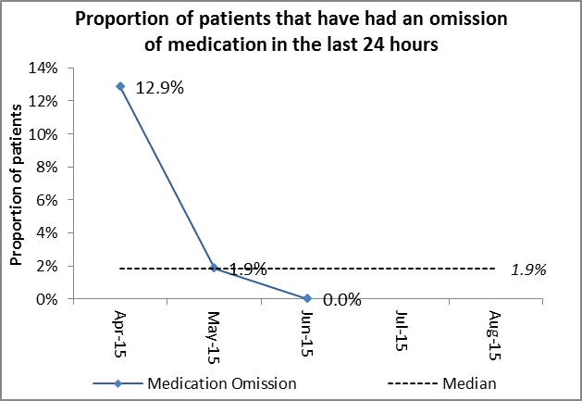 | 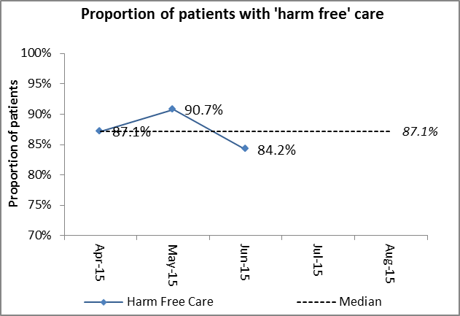  'Harm free' care defined as patients that did not self harm, do not feel unsafe, have not been a victim of violence or aggression and in Inpatient settings have not been restrained.
Table 24 - 29
Comparisons:
Submissions:
Period | Combined | Inpatient | Community
Q4 14/15 | 751 | 566 | 185
Q1 15/16 | 949 | 768 | 181
Table 30

Overall in Q1 15/16 there has been a 26% increase in the number of submissions compared to Q4 14/15. This has mainly due to an increase in inpatient submissions (36% increase). The community submissions saw a small decrease (2%) compared to Q4 14/16.
Comparison of Q1 15/16 combined results (inpatient and community) against previous quarter:
Areas for improvement:
- Q1 2015/16 saw a small increase in the proportion of patients that had been the victim of violence/aggression in the previous 72hours (Q1 15/16 was 0.4%, Q4 14/15 was 0.0%)
- April15 saw the highest proportion of medication omissions at 6.6%.
Positive findings:
- Q1 2015/16 saw a decrease in the proportion of patients that had self-harmed in the previous 72 hours (Q1 2015/16 was 2.4%, Q4 2014/15 was 4.7%)
- Q1 saw an increase in the proportion of patients feeling safe at the point of survey (Q1 15/16 was 92.9%, Q4 14/15 was 91.2%).
- June15 saw the lowest reported number of medication omissions at 2.5%.
- Q1 15/16 saw an increase in the proportion of patients with harm free care (Q1 15/16 was 90.8%, Q4 14/15 was 87.9%).
Comparison of Q1 15/16 Inpatient results against previous quarter:
Areas for improvement:
- The proportion of patients that had been the victim of violence/aggression in the previous 72 hours was highest in April15.
Positive findings:
- Q1 15/16 saw a decrease in the proportion of patients that self-harmed in the previous 72 hours (Q1 15/16 was 1.8%, Q4 14/15 was 4.0%)
- Q1 15/16 saw a slight decrease in the proportion of patients that had been restrained in the previous 72 hours (Q1 15/16 was 0.9%, Q4 14/15 was 1.0%)
- Q1 15/16 saw a decrease in the proportion of patients that had had a medication omission in the previous 24 hours (Q1 15/16 was 4.9%, Q4 14/15 was 5.6%)
- Q1 saw an increase in the proportion of patients with harm free care (Q1 15/16 was 92.0%, Q4 14/15 was 90.7%)
Comparison of Q1 15/16 Community results against previous months:
Negative findings:
- Q1 15/16 saw an increase in the proportion of patients that had been the victim of violence/aggression in the previous 72 hours (Q1 15/16 was 1.4%, Q4 14/15 was 0.0%).
Positive findings:
- Q1 15/16 saw a marked decrease in the proportion of patients that had self harmed in the previous 72 hours (Q1 15/16 was 1.9%, Q4 14/15 was 6.5%)
- Q1 15/16 saw an increase in the proportion of patients that reported feeling safe at the point of survey (Q1 15/16 was 92.5%, Q4 14/15 was 90.3%).
- Q1 15/16 saw a marked decrease in the proportion of patients that had had a medication omission in the previous 24 hours (Q1 15/16 was 1.9%, Q4 14/15 was 5.2%)
- Q1 15/15 saw a marked increase in the proportion of patients with harm free care (Q1 15/16 was 87.1%, Q4 14/15 was 80.6%)
External Accreditations and External Peer Reviews (Update).
During Q1 2015-16 all Adult acute and rehabilitation in-patient services received AIMs accreditation. At the time of reporting PICU was deferred on one area which relates to the environment. This is currently being addressed and the ward will be reassessed in 2016.

- Mental Health and Mental Capacity Acts

CQC Visits – Mental Health Act
The information below outlines the 6 CQC MHA visits which have taken place since the last report. Although a range of positive comments were received, details of the issues of concern raised by the CQC following these visits together with our responses are detailed below:
Date | Ward | Issue | Agreed Action
7 April 2015 | Vaughan Thomas Ward | Section 17 leave – expired forms in ward folder, some patients not given copies  Section 132 rights: patients given rights appropriately, but not always evidence of IMHA, posters and leaflets in place | Improved monitoring of folder and review of leave  Reminder issued to staff
15 April 2015 | Glyme Ward | Restricted patient AWOL, CQC not informed  Section 132 rights, patients were having rights represented but not after significant events  Consent to treatment: single medication not covered by consent form:  Care planning & risk assessment not always linked to care plan | Process reiterated to staff, monitoring by Directorate and Modern Matron  All patients had rights re-presented. Ward manager to ensure admission checklist followed and monitored  Immediately rectified. Clinical Lead reviewed with Responsible Clinician. All consent documentation to be reviewed weekly  Reinforced via handovers and ward rounds. Review done of consistency and coherence of documentation
28 April 2015 | Allen Ward | Section 132 rights, not re-presented in one case  CTO not considered on leave form  Smoking ban leading to hazard on ward,  Ligature risks: taps not yet remedied  Care plans: evidence of patient involvement, | Immediately rectified; reminder of process; monitoring by Ward Manager and Modern Matron  Responsible Clinician reminded. Prompt for staff added to ward round checklist  Patients to be given information prior to admission; reinforce smoking policy; environment checks by staff  Ligature risk assessment performed, replacement programme initiated in May 2015  Ensure patient involvement, emphasised via staff supervision. Monitor progress via Essential Standards Audit
12 May 2015 | Woodlands House | Section 17 leave: copies of forms not consistently given to patients  Information about Complaints & PALS and IMHA not evident  Consent to treatment: old certificate of second opinion in place for one patient (not unlawful or Code of Practice issue)  Care planning & risk assessment not always linked to care plan | A prompt added to Clinical Team Meeting; nurse in charge to check before patient proceeds on leave  A notice board was being replaced - information now available on ward  A new second opinion requested and Responsible Clinicians reminded of best practice  Issue reinforced via handovers and ward rounds; review of consistency and coherence of documentation undertaken
27 May 2015 | Sandford Ward | Consent to treatment: 2 patients receiving prescribed medication not authorised by correct process  Section 132 rights: patients not retaining information  Patient involvement in care planning care plans on new electronic health record not up to date  Ligature risks still in evidence 3 years after CQC first report  Ward station not sufficiently protecting patient information: staff reminded to ensure patient information is protected | Immediately rectified by Responsible Clinician; review at ward rounds; action on reminders from MHA Office  Repeat attempts to provide information; review at ward round of patients where capacity to retain rights information is an issue  Care plans reviewed and updated by staff; essential standards audit to be at 100%  Individual ligature risk assessments carried out; estates work programmed for May 2016  A business case under development for re-design of area.
4 June 2015 | Cotswold House Oxford | Section 17 leave forms: folder disorganised  Care plans: evidence of patient involvement  Section 132 rights: patients were having rights represented, but not after significant events | Folder immediately reorganised; ward standard operating procedure introduced; weekly monitoring by modern matron  Ensure patient involvement, including via staff supervision; monitor progress through Essential Standards Audit  All patients had rights re-presented. Ward manager to ensure admission checklist followed and monitored
Table 31
In summary, the statutory matters raised by the CQC during their visits included the following:
- Recording rights presentation and re-presentation
- Information about IMHAs
- Consideration of CTO
- Copies of leave forms: form not received by patient
- Expired leave forms in leave folder
- Absent without leave and CQC notification (Restriction Order patients)
- Consent to Treatment (omission of medication)
- Consent to treatment out of date
Non-Statutory Matters included the following issues:
- Smoking and fire hazard
- Ligature risks
- Care plans recording patient views
- Care planning, patient participation
- Recording and update of risk assessments
- Consistency between care plans and risk assessments
- Confidentiality at nursing station
- Information about PALS
All of the above issues have associated action plans in place which are being monitored by the Directorates.
The MHA/MCA Legislation Group is meeting monthly to increase efforts in improving compliance.

- Infection Prevention and Control
Clostridium difficile
The monthly health economy review meetings continue to review all cases for avoidability.
Below is a summary of the Q1 review meetings:
Month | Location | Running total of cases | Avoidable/Unavoidable | Running total of avoidable
April 2015 | Wenrisc Ward, Witney Hospital | 1 | Unavoidable | 0
May 2015 | No cases | 1 | n/a | 0
June 2015 | No cases | 1 | n/a | 0
Table 32
Subsequent to the above, a patient was transferred from Bicester Hospital to the OUH on 26th June 2015 following a deterioration in their general condition. The patient had developed loose stool on the morning of transfer and subsequently tested positive for CDI. This patient unfortunately died on 29th June 2015 and CDI was cited on Part 1a of the death certificate. A case review meeting is being held between the Trust and OUH and a RCA completed.
MRSA bacteraemia/MSSA bacteraemia
A community MRSA bacteraemia patient was identified when seen at EMU, Abingdon hospital. This patient was not admitted to the Trust and the case is attributable to the CCG who are leading the RCA and investigation.
E.Coli bacteraemias
There have been 3 E.Coli bacteraemias in June. One case was a community pre 48 hour patient identified in the EMU at Abingdon and the other two patients were inpatients on Ward 1, Abingdon Hospital and Linfoot Ward, Witney Hospital. RCA’s were completed on all 3 patients and the likely sources were urinary tract.
Group A Streptococcal bacteraemia
There was a patient identified on Linfoot Ward, Witney Hospital with a Group A streptococcal bacteraemia (07.05.15). An RCA was completed and no root cause found. Patient was treated, made a full recovery and has now been discharged home. One member of staff was off sick with a sore throat and tested positive via the GP for Group A streptococcus and treated.
Outbreaks
There were two possible Norovirus outbreaks reported in June. Bicester Hospital reported 4 patients and 1 staff member. Ashurst Ward, Littlemore MHC, reported 2 patients and 2 staff. Neither ward was closed to admissions; however precautions were implemented.

