

**Report to the Meeting of the**

**Oxford Health NHS Foundation Trust**

**Board of Directors**

**BOD** (Agenda item:)

**25th February 2015**

**Quality and Safety Report**

**Quarterly Clinical Effectiveness Report**

1. **New Integrated Governance Structure**
   1. **The impact of the new governance structure on assurance and monitoring of clinical effectiveness**

The Integrated Governance Committee has been reframed as the Quality Committee, into which new quality sub-committees will now report (replacing the previous Quality Improvement Committees or QUICs). The work of the sub-committees is accountable to the Board of Directors through the Quality Committee. The structure is organised to reflect the five new CQC domains or questions which now form the basis of the assessment of the quality of services delivered by NHS providers.

There will be four quality sub-committees**:**

* Safety
* Caring and Responsive
* Effectiveness
* Well-Led

Each of these will be responsible for providing assurance to the Quality Committee that we are compliant with all of the Key Lines of Enquiry which sit under their domain(s) and any other areas which fall within their responsibility. Each sub-committee will develop a work plan for the year and will produce a highlight report to the next Quality Committee which details areas of progress, areas of concern and any key risks.

The Clinical Effectiveness Committee (CEC) will become the Quality Sub-Committee Effectiveness (QSCE). It retains a large portion of its previous responsibilities but will also take on some additional areas of focus.

Its terms of reference are organised to provide assurance on the key lines of enquiry attached to the CQC question “Are your services effective?” Specifically:

1. Are people’s needs assessed and care and treatment delivered in line with current legislation, standards and evidence-based guidance?
2. How are people’s care and treatment outcomes monitored and how do they compare with other similar services?
3. Do staff have the skills, knowledge and experience to deliver effective care and treatment?
4. How well do staff and services work together to deliver effective care and treatment?
5. Do staff have all the information they need to deliver effective care and treatment to people who use services?
6. Is people’s consent to care and treatment always sought in line with legislation and guidance?
7. How are people supported to live healthier lives?
8. Are people subject to the Mental Health Act 1983 (MHA) assessed, cared for and treated in line with the MHA and Code of Practice?

The first meeting of the new (QSCE) considered in some detail the organisation and governance surrounding the new arrangements. Following wide discussion the final Terms of Reference of the QSCE were agreed and a work plan outlined which will be formally agreed at the next QSCE.

It was agreed that the Chairs of the groups reporting into the QSCE must actively assure themselves that the issues covered by their Group are being appropriately addressed, and either report compliance or escalate concerns to QSCE.

Other business undertaken by the QSCE included:

* Review of recent clinical audits (detailed separate report provided to Quality Committee) and an agreement that compliance with and action surrounding NICE guidelines will be covered in the Clinical Audit Group.
* Consideration of a proposal to offer Ketamine as a private treatment which had been supported in the Innovation Sub-Group of the Drugs & Therapeutics Group. It was agreed that the proposal was supported by QSCE and should be made to the Executive Team for consideration.
* Consideration of updates on other Drugs & Therapeutics Group issues
* Consideration of an update Research & Development report (an R&D six monthly report has subsequently been presented to the Trust Board).

**1.2 Areas of insufficient assurance**

The following areas are those where the QSCE is not currently satisfactorily assured and describes the action taken:

* Quality of Physical Healthcare. There is insufficient assurance that governance processes surrounding physical healthcare are adequately coordinated trust-wide. Recent issues highlighted that require greater attention include End of Life Care (internal audit) and metabolic testing of patients with schizophrenia (National Audit of Schizophrenia). **Action**: It was agreed that a new Physical Healthcare Group, reporting to QSCE, would be established, Chaired by the Head of Nursing, Older Peoples Directorate, to coordinate work in this area. The Group would incorporate the current Nutrition; Wound Care & Pressure Ulcer; End of Life Care; and Resuscitation groups as formal Sub-Groups.
* Public Health. There is insufficient assurance that governance processes surrounding public health issues are adequately coordinated trust-wide. **Action**: It was agreed that a new Public Health Group, reporting to QSCE, would be established. This was an area that was previously coordinated solely by the Head of Nursing, Children & Families Directorate, but greater capacity is required with representation of different professional disciplines and Directorates. A Chair and membership is being organised.
* Effective Group Working. Although some of the Groups reporting to QSCE are long established and are well managed, there are others which will need to significantly improve their functioning if they are to assure QSCE of the areas for which they are responsible. **Action**: Clear expectations were agreed with all Group Chairs as to the running of Groups, the responsibilities involved and reporting.

**2. Trust wide Clinical Audit Plan**

**2.1 Progress update against the Trust wide clinical audit plan for 2014/15**

There are a total of 39 audits on the Trust wide clinical audit plan for 2014/15. A project status update is provided in table 1 below.

**Table 1 – project status update**

|  |  |  |
| --- | --- | --- |
| **Status** | **Number of projects** | **Percentage** |
| Quarterly reporting (up-to-date) | 7 | 18% |
| Completed | 1 | 3% |
| In progress | 7 | 18% |
| **Not yet started** | **16** | **41%** |
| Awaiting report from Directorate | 1 | 3% |
| Data submission only | 1 | 3% |
| Not known | 2 | 5% |
| Report writing | 4 | 10% |
| **Total** | **39** |  |

Seven of the 39 projects report quarterly and are completed and up-to-date for Quarter 2. Quarter 3 quarterly reports are scheduled to be completed in January 2015.

There were sixteen audit projects (41%) still to commence. Of these 16 projects, seven (43%) were past the planned time frame for data collection to commence. None of the audits are national audits or CQUIN/Commissioning related.

The project status of all audits on the Trust wide audit plan was reviewed and updated at the Clinical Audit Group (CAG) meeting in January 2015. There are now nine audits (23%) still to commence. The Clinical Audit Group reviewed and prioritised which audits were considered to be of a higher risk and should remain on the plan for this year and which audits could be carried forward to the 2015/16 plan.

Four audits were considered to be of a higher risk and should remain on this year’s plan:

1. Audit of MEWS/Track & Trigger
2. Audit of the Safe & Supportive observations of patients at risk (policy CP03)
3. Baseline audit of the quality of Insulin prescribing and management of Insulin dependent patients
4. Mental Capacity Act

Four audits were agreed could be carried forward to the 2015/16 audit plan:

1. Care standards for non CPA cases
2. Health Records
3. Non-medical prescribing
4. Quality of part 2 discharge summaries to GPs

CAG agreed one audit could be removed from the audit plan: Audit of the Use of Time Out Policy. The rationale for removing this audit completely is that the use of time out is not an intervention used within Oxford Health.

**2.2 Action Plan Monitoring**

Monthly scheduled reports are now produced for the directorates to review their outstanding audit actions at their governance meetings. The number of outstanding audit actions has reduced from 47 in October 2014 to 36 in December 2014. A report on the number of actions outstanding was reviewed at the Clinical Audit Group in January 2015 and a number of actions were signed off. Further work is being undertaken within the Directorates to reduce the number of outstanding actions.

**Table 2 - Percentage of actions out of date – January 2015**

|  |  |  |  |  |
| --- | --- | --- | --- | --- |
| **Division** | **Total number of actions** | **Number of actions completed** | **Number of actions in date** | **Number of actions out of date** |
| Trust wide actions relating to all directorates | 43 | 37 | 6 | 0 |
| Adult Mental Health | 115 | 111 | 3 | 1 |
| Specialised Services | 35 | 27 | 3 | 5 |
| Oxon Community Services | 67 | 58 | 1 | 8 |
| Older Adult Mental Health | 43 | 33 | 4 | 6 |
| Children & Young People | 65 | 43 | 6 | 16 |
| **TOTAL** | **368** | **309** | **23** | **36** |

**2.3 Clinical audits reported to the Quality Sub-Committee: Effectiveness Committee (QSEC) report in January 2015.**

There were a total of six audits reported to QSCE in January 2015. All six audits were re-audits and the rating is provided in table 3 below. One was a national audit which was rated as poor in 2013 and requires improvement in 2014. One is a Department of Health national quality requirement in the delivery of Out-of-Hours Services which is a six monthly audit requirement and has been rated as requiring improvement from a previous rating of good.

The remaining four audits are quarterly reporting re-audits and three have maintained a rating of good, one audit (CPA audit) has maintained a rating of requiring improvement for quarter 2.

**Table 3 Audit Ratings**

|  |  |  |  |
| --- | --- | --- | --- |
| **Audit Name** | **Audit cycle** | **Previous audit rating** | **Current audit rating** |
| National Audit of Schizophrenia (2nd round) | Re-audit | Poor | Requires improvement |
| CPA audit results (Q2) | Re-audit | Requires improvement | Requires improvement |
| Urgent Care Service – National Quality Requirement 4 audit | Re-audit | Good | Requires improvement |
| Community Hospitals Documentation Audit (Q2) | Re-audit | Good | Good |
| Infection Control Audit Programme (Q2) | Re-audit | Good | Good |
| Essential Standards Oct 14 report | Re-audit | Good | Good |

**2.4 Key highlights from the summary of the results from the clinical audits reported and rated**

**2.4.1 National Audit of Schizophrenia (NAS) Round 2 (Adult Mental Health)**

The National Audit of Schizophrenia is managed by the Royal College of Psychiatrists as part of the National Clinical Audit Programme and is the first national audit report that has identified participating Trusts. This is a re-audit and the first round was undertaken in 2012/13. This audit relates to Adult Services only. The Trust has demonstrated improvement in many areas however there is significant work to be undertaken to demonstrate compliance across many of the standards audited.

A major finding for all participating Trusts from both rounds of the audit is the lack of monitoring and intervention for key physical health risk factors for this patient group.

Linked to the NAS audit is two national CQUIN audit requirements (Commissioning for Quality and Innovation 2014/15). These include a new national indicator on improving physical healthcare to reduce premature mortality in people with severe mental illness. Both CQUINs relate to all Directorates not just Adult Services.

There is a national requirement to take robust action to address practice in this area. To this end there are a number of actions that the Trust must take. These include:

* setting up a project group with a clinical lead and a project manager
* development of a local action plan
* publication of the local summary report and action plan on the Trust’s website
* facilitation of a feedback meeting to include clinicians, governors and service user representation

In addition to this, there are plans to develop a physical health sub group to report into the Quality Sub Committee: Effectiveness.

Progress thus far has been the set-up of a multi-disciplinary project team led by an Associate Medical Director to develop and drive an overarching action plan.

**2.5 CPA Quarter 2 results**

The CPA audit focuses on the quality of the current assessment and care plan.

There are a total of 17 standards relating to the CPA assessment and 17 standards relating to the CPA care plan. Twenty of the thirty four standards were rated as good or excellent. Not all of the standards were rated as requiring improvement or unacceptable across all services except evidence that the service user was offered/given a copy of their care plan and evidence that the service user has given consent to share care plan with family/carer. The key areas for improvement are listed below:

**2.5.1 CPA assessment**

* assessment of parental/childcare responsibility
* Employment / Education / Training needs
* Evidence that consent for sharing information is sought from service user
* Summary of assessment/formulation identifying strengths / needs within the last 6 months

**2.5.2 CPA care plan**

* Evidence that the service user was offered / given a copy of their care plan
* Evidence that the service user has given consent to share care plan with family/carer
* Evidence of family/carer involvement in developing care plan
* Evidence that the care plan was shared with GP
* Clear contingency / crisis plan

**2.6 Urgent Care Service – National Quality Requirement 4 audit**

The overall rating for this audit has declined from a rating of good to requires improvement in this re-audit. This may be due to the fact that the service has set a higher target for compliance. In previous audits an average score of 12 or below was deemed unacceptable. Since the last audit the clinical leads of the service have reviewed this level. The audits over the last 2-3 years have seen a steady increase in scores for clinicians as quality throughout is improving. Challenge from commissioners following complaints and serious incidents also prompted this review. After consideration, the clinical leads have increased the minimal acceptable level to 14. This ensures the service and the clinicians within strive to achieve improved quality each year.

**2.7 Community Hospitals Documentation Audit - Quarter 2 results**

The overall quarterly results for this audit have been rated as good for the last five quarters. However, there are areas that have not demonstrated improvement over time and have declined from a rating of good in quarter one to a rating of requires improvement in quarter two.

* Where a falls risk has been identified a care plan is in place
* Where a pressure ulcer risk has been identified a care plan is in place
* Where a nutrition risk has been identified a care plan is in place
* Evidence of care plans being reviewed weekly

**3. Mental Health Act Assessment**

There have been two inspections in Q3:

**3.1 Ashurst Ward, 4 December 2014**

|  |  |
| --- | --- |
| **Findings/Issues** | **Actions** |
| Rights re-presentation following ward transfer | checks and re-presentation, reinforced monitoring, training by MHA Service Manager. |
| Leave forms not always signed by patient | omissions rectified, checks at ward business meeting, reinforced monitoring |
| Seclusion records | staff reminded, item for consultant meeting, reinforced monitoring escalation procedures for missing record |
| Section 136 records | omissions rectified, staff addressed, reinforced monitoring, training by MHA service manager |
| Patient issue | television remote missing: confirmed as replaced |

**3.2 Kingfisher Ward, 25 November 2014**

|  |  |  |  |
| --- | --- | --- | --- |
| **Findings/Issues** | | **Actions** | |
| Rights re-presentation | | omission corrected, review of all patients, six monthly check introduced, monitoring by ward manager | |
| Second Opinion Appointed Doctor certificate T3 not invalid but old | | 2 year replacement introduced to support statutory review adhered to | |
| Patient issues - property stolen | | under investigation | |
| Patient issues - one patient treated differently to others | | under investigation | |
| Patient issues - patient threatening | | increased observations addressing this and discussed during visit and clinical requirements fedback to inspector | |
| **4. Effectiveness Report – Older Peoples Directorate** | |

There follows an update on the performance of the Older Peoples Directorate in regard to meeting quality standards to ensure that our services are effective. By effective we mean that people’s care, treatment and support achieves personalised outcomes, promotes good quality of life and is based upon the best available evidence.

**4.1 Effectiveness Scorecard – February 2015**

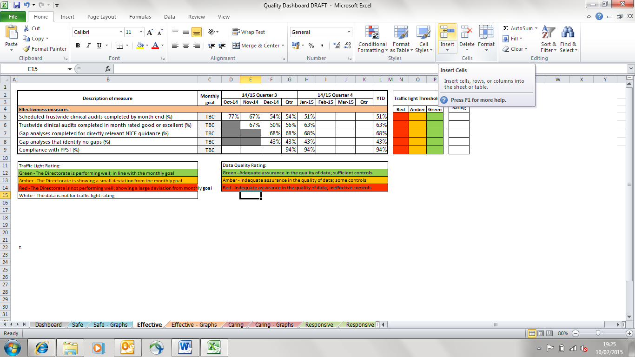

The Quality team are developing a quality dashboard for the Older People’s Directorate. The dashboard will include measures in-line with the Improving Care: 5 Questions. The table above shows a summary of the current effectiveness measures which will be part of the Quality Dashboard.

**4.2 Staff Skills and Training**

**4.2.1 Compliance with** **Patient and Personal Safety Training**

The Directorate is achieving 94 % compliance with Patient and Personal Safety Training (PPST). Following efforts to encourage and promote PPST across the directorate a sustained improvement in compliance can be seen from the end of quarter 3 into quarter 4 as illustrated in the graph below.

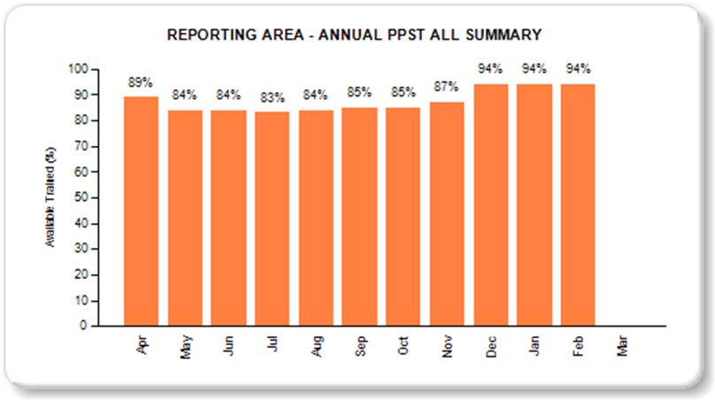

**4.2.2 Compliance with Trust Induction**

Further work is required to ensure the Older People’s Directorate achieves the target of 90% of new starters completing the Trust Induction. Currently 81% of the Directorate new starters complete the Trust Induction.

The table below provides a breakdown of performance by service areas identified by the Training Framework dashboard. This highlights areas where improvement is required.



The Quality team have ensured that all services requiring improvement are aware of the actions needed to achieve the target. Urgent Care, with a compliance level of 79%, has been identified as the team that has the lowest percentage of new starters attending the Trust Induction. The Quality Team is supporting to the service to ensure they are able to monitor and manage their compliance.

**4.2.3 Compliance with Mental Capacity Act Training**

All service areas within the OP Division have achieved Mental Capacity training requirements of 85%, apart from Oxford Community Management. However, this reflects a requirement for only one individual to complete this training to achieve the target.



Compliance with Mental Capacity Act training for new starters is similar to compliance with Trust induction for new starters. The Directorate currently achieves 78% against a target of 85%. Oxford Older Adult Mental Health and Urgent Care have been identified as the services required to make the largest improvements. Assurances have been sought to ensure staff are booked onto courses.

**4.3 Competency Framework**

The Directorate have undertaken work to support the training and development needs of staff to help deliver safe and effective care within the integrated locality teams. This involves the identification of core competencies that all clinical staff are expected to have regardless of professional role or registration status.

Nine skills have been identified and training sessions have been developed to support the competency framework and an on-going phased programme to embed these within teams. A priority area for development has been competency in identifying and assessing patients at risk of pressure damage.

**4.4 Clinical Skills Laboratories**

Many services across the Trust have reported an increased acuity and complexity of patients presenting or referred to their services. This particularly manifests in community services as policy initiatives to move care closer to home and to treat more frail elderly in their own home means that many more people with complex co-morbidities receive care in the community.

Although integration of physical and mental healthcare and the development of integrated locality teams means that community services are well placed to provide a high quality comprehensive service to this patient group, the pace of volume of change in patient demographics has meant that there is a growing sub-acute clinical skills gap amongst staff. There is evidence of this across urgent and out of hours care, district nursing and community hospitals and this is becoming an increasing problem for older adult mental health in both the community and in in-patient areas.

Older People’s Services have established a clinical skills laboratory to provide space for teaching both theoretical and practical aspects of sub-acute clinical skills. In addition to this, other Trust courses are being delivered from the lab such as Physical skills for mental health services and district nurse training. The primary target group for this initiative is healthcare professionals working within urgent and ambulatory care and staff in both community and in patient settings. However, as above, this has already been offered to wider services within the Trust and it is expected that our partners from SCAS/RBH will be joining the next intake of students.

There have already been examples of improved outcomes including recognition of early deterioration, alternative diagnoses and expediting treatment plans. The knowledge and skills of staff have positively enhanced patient experiences.

There is a risk to the continuation of this project associated with securing long-term funding. The Trust Executive has been advised of the risk.

**4.5 Consent to Care and Treatment**

The Older People’s Directorate is developing a process of assurance to ensure that consent to care and treatment is always sought in line with legislation and guidance. Currently all patients are asked to provide consent for care and treatment. The Directorate wish to confirm this is consistently managed through the clinical audit and patient experience mechanisms.

**4.6 Compliance with Mental Health Act and Mental Capacity Act**

**Mental Capacity Audit**

Assurances that our services comply with the Mental Capacity Act are sought through an audit completed by the Trust’s Adults Safeguarding Manager. The 13/14 audit was rated Not Compliant. The main areas of concern were enquiring whether patients have an advanced decision to refuse treatment or if they have a Last Power of Attorney, and documentation of a mental capacity assessment. Each Community Hospital has developed an action plan in response to the results. Actions taken included:

* Addition to the standard Community hospital admission pack has been to include a flag to document Advanced decisions and Last Power of Attorney
* Introduction a checklist, agreed with ward medics, for MDT and ward rounds that includes mental capacity assessments

The 14/15 audit is scheduled to be completed by the end of February. The results of the audit will be reviewed and an action plan will be developed.

**4.7 Deprivation of Liberty Safeguards (DoLS)**

Some areas of concern have been identified with the current DoLS process. The changes in legislation have led to an increase in DoLS applications the impact of this has been delays in the assessment and subsequent outcomes of applications.

It has also been observed that wards are failing to inform the MHA Office when an authorisation is in place. In response to this the Directorate will be taking a number of actions:

* Ensuring assessment of this process is included in Peer review programme
* Reviewing current training provided to ensure process is promoted
* Promoting consistent use of process through management meetings
* Request a flag be added to new Electronic Patient Record

**4.8 Compliance with Safeguarding Training**

The Directorate has achieved over the 90% target for staff to attend the once training for safeguarding vulnerable adults, and have also achieved the 91% target of staff attending their 3 yearly update.

Compliance with safeguarding vulnerable children’s training is on or just below target across the various levels of training. The exception is non-clinical staff level 1 training which is below target at 53% for once training, however this only pertains to six individuals. The relevant services have been asked to address this in order to achieve compliance and the Quality team are continuing to monitor compliance and further embed a culture of safeguarding.

**4.9 Clinical Audit and Review**

**4.9.1 Clinical Audit Programme**

At the end of January 2015, 51% of scheduled Trust-wide clinical audits had been completed and reported. Of the outstanding audits nine are coordinated by the Quality team and led by Older People’s Directorate. The Quality team continue to work closely with the Risk team to monitor the completion of overdue clinical audits. The Quality team has recognised clinical audit as an area of concern and has taken steps to review resource available in order to make this a priority.

Of the clinical audits reported in January 63% were rated Excellent or Good and there were no audits rated Unacceptable. Should an audit highlight any areas of concern then an action plan is requested. The action plans are monitored in line with the Trust’s Clinical Audit Policy.

At the end of January Ulysses showed 89% of listed actions had been completed by the target date. Completion of the remaining 8 overdue actions has been chased and mitigating actions are being taken or prepared. There were 8 audit reports for which the submission of a requested action plan was overdue. This has been flagged in the Directorate’s Governance meetings.

**4.9.2 Clinical Audit Training**

Training is provided which introduces staff to the audit process and effective audit techniques. The Quality team is liaising with the central team to develop a mechanism to enable monitoring and reporting of Older People’s Directorate staff attendance.

**4.10 Mortality Review**

The Mortality Review Audit provides an overview of the mortality cases within all Community Hospitals, with the tool being used by both Oxford Health and Oxford University Hospitals.

In quarter 3, 41% (20) of deaths were audited (minimum of 25% required), all of which were identified as unavoidable deaths/appropriate care.

Of those audited in quarter 3, 90% (18) of patients had a DNACPR form in place. For the remaining 10% (2) patients that did not this was treated as a high risk/orange incident and further investigations were completed in the form of an Initial Investigation Report (IIR).

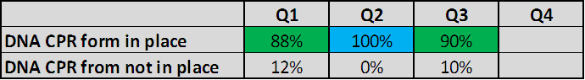

Although quarter 3 saw a positive increase in the number of deaths with no care quality concerns, learning was identified from the 3 cases with suboptimal care.

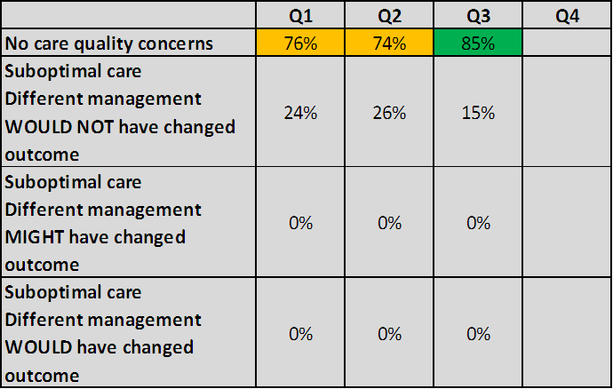

The themes of the areas that require attention are:

* The late transfer of patients to Community Hospitals from the Acute Trust
* Documentation by medics of Management Plans and assessments specifically on admission and following deterioration
* Improving the documentation of discussions with family of patients

These areas of concern have been addressed in an action plan. Action plans are managed through Ulysses software, in line with Trust policy on clinical audit and monitored by the Quality team.

**4.11 Meeting Nutritional Needs**

**4.11.1 Compliance with Nutritional Needs Risk Assessment**

We are currently unable to provide a single figure to indicate directorate performance. There are a number of audits which monitor the completion of nutritional risk assessments. The audit results are detailed below.

Compliance with nutritional risk assessment in Older Adult Mental Health inpatient wards is monitored through the Essential Standards audit. Q3 results were 80% compliant overall, which is in line with previous audits.

The quarterly Community Hospitals Documentation audit measures compliance with nutritional risk assessment through these three indicators:

* MUST (Malnutrition Universal Screening Tool) assessment within 72hrs of admission
* MUST assessment reviewed weekly
* Care plan been created where MUST assessment identifies a risk

The results for Q3 can be compared to previous audits below, graded using the Trust’s audit rating system. Whilst there has been improvement in the review of MUST assessments and appropriate actions being taken following assessment there has been a slight decrease in the compliance with MUST assessment on admission.



For each of these standards, there is a wide variance in results across sites:

* Assessment within 24 hours: between 40% (Linfoot) and 90% (Wallingford & Wantage)
* Weekly reassessment: between 70% (City) and 100% (Abingdon 1, Abingdon 2, Bicester, Didcot & Wallingford)
* Care plan: between 50% (City & Wenrisc) and 100% (Wallingford, Wantage & Linfoot)

During quarter 3 audit a project was completed to ensure that all sites were interpreting the tool correctly, therefore we can be certain for the first time that results reflect variance in activity rather than in implementation of the audit tool. An action plan has been requested to address these and other results, in line with trust audit policy.

The District Nursing service audits a selection of patients each quarter, to identify whether nutritional and skin integrity assessments are completed on the patient’s first visit (this measure forms part of the Quality Account). Although the result in Q3 was lower than previous results in 14/15, all were rated as Good using the trust’s audit rating tool.

|  |  |  |  |
| --- | --- | --- | --- |
| **1415 Q1** | **1415 Q2** | **1415 Q3** | **Mean** |
| 86% | 90% | 80% | 85% |

**4.11.2 Nutrition Action Group**

The Older peoples Directorate is leading work to improve nutritional care across the Trust. The Nutrition Action Group has been established and a reviewed Nutrition and Hydration Policy, which includes an updated Nutritional Assessment Tool, is being finalised and ratified.

**4.12 Procedural Documents and Guidance**

**4.12.1 Procedural Documents**

OP directorate have taken ownership of a number of divisional and Trust wide policies, mainly policies that have historically been produced by the previous organisation of Community Health Oxfordshire (CHO). There are approximately 65 policies on the OP division database, 28 of which are identified as past their view date. This risk has been escalated to the Senior Management Team.

The Quality team are developing a proposal for a Procedural Document Group as part of the Directorate’s new Governance Assurance Framework. The initial aim of this group would be to determine what policies are required, agree ownership and establish a Procedural Document Management Process.

**4.12.2 NICE Guidance**

All published NICE guidance is considered by the Directorate’s Head of Nursing to identify which are directly relevant to each service and then the guidelines are shared appropriately for services to complete a gap analysis to establish compliance.

There is currently a significant backlog in the review and dissemination of guidance to the services. This has been recognised and a working group is being established to address this. A review of the current process will be completed by 1st April 2015 to ensure the process enables robust and timely consideration and clinical application of new guidance.

At the end of January, gap analyses had been completed in 68% of cases where guidance had been considered directly relevant. Of these gap analyses, 43% show that services have achieved compliance.

**4.13 Governance Assurance Framework**

The Directorate is developing a new Governance Assurance Framework to provide assurance that the Directorate is meeting all of its obligations and managing risk appropriately by implementing appropriate policies, procedures, systems, processes and structures to ensure our services are safe, effective and efficient. The Framework will be in place by 1st April 2015.

A monthly report of the internal position by division and location against the CQC’s essential quality and safety standards is circulated to the executive, operational and clinical directors, heads of service, heads of nursing and outcome leads. The report identifies exceptions where internal concerns have been identified and actions to resolve.

**5. Children and Young People**

**5.1 Clinical Audit**

CAMHS contract audits were completed for Q2 as per commissioner deadlines and are being monitored and action planned against with local teams.

All quarter 2 CQUIN requirements relating to audit have been fulfilled.

New Local Audits

* Community Childrens’ Nursing service evaluation of interventions offered to chronic patients. Review of case notes, along with survey patient experience element to determine what is effective in keeping chronic patients out of hospital.
* Audit of Safeguarding referrals being completed by Safeguarding lead in the South West.

Other Developments

* New Audit Lead for the directorate appointed to oversee local audits conducted in the division and help review in light of quality and directorate objectives from Clinical Advisory Group (CAG).
* Individualised service audit plans (including associated action plans) are being developed ahead of CQC peer reviews, including details of which CQC domain they provide assurance/ evidence for. ‘User-friendly’ audit plan developed for Highfield unit, free of jargon and explaining requirements of each audit including timeframes. Looking to expand this to all teams and services to improve engagement in quality-improvement projects.
* Review of audits being planned for those where results have platitude. To be raised at clinical advisory group for review of approach.

**5.2 Oxford & Bucks children and young peoples’ CPA Audit Q2 2014/15 results**

The report provides information on the quarterly audit on CPA which reviews the quality of care provided to patients who are on CPA. The results are based on data collected from teams across Oxford and Bucks in Quarter 2. Data collection was co-ordinated by Quality and Audit Team and was collected by team managers. Data was analysed using Microsoft Excel. The sample size from each team is shown below. The sample was selected randomly by the team managers.

|  |  |  |
| --- | --- | --- |
|  | **Overall audit rating Q1** | **Overall audit rating Q2** |
| Trust wide | Requires improvement(n-370) | Requires improvement(n-350) |
| Children and Young people directorate -Oxford & Bucks CAMHS | Requires improvement(n-78) | Requires improvement(n-78) |

|  |  |  |
| --- | --- | --- |
| **Team** | **Overall rating by Team – Q1** | **Overall rating by Team – Q2** |
| Bucks LD | Requires Improvement(n-10) | Good(n - 5) |
| Bucks OSCA | Good(n-10) | Requires improvement(n - 10) |
| Central Oxon | Requires Improvement(n-9) | Requires improvement(n - 10) |
| North Bucks | Requires Improvement(n-10) | Requires improvement(n - 10) |
| North Oxon | Requires Improvement(n-10) | Requires improvement(n - 10) |
| Oxon LD | Requires Improvement(n-15) | Good(n - 4) |
| Oxon Neuro | No data in Q1 | Unacceptable(n - 4) |
| Oxon OSCA | Good(n-5) | Unacceptable(n - 5) |
| South Bucks | Unacceptable(n-6) | Requires improvement(n - 10) |
| South Oxon | Good(n-10) | Good(n - 10) |

More detailed results have been shared with CAMHs teams via Operational & governance meeting and quality leads

**5.3 Learning Beyond Registration (LBR) bids for 2015/16**

The Directorate bid will be submitted by 01/12/15; service leads are collating requests to inform training requirements for 2015/16

The key change this year is that there is more flexible funding, less tied to local universities which will enable increased options for in house courses and integrated training across services if learning needs are similar.

**6. Adult Services**

**6.1 Essential Standards audit**

Data was received from all adult wards. Essential Standards audit evaluates the care provided in the inpatient units against 40 standards of care. The audit involves 19 standards related to patient experience of care and 21 standards related to clinical care provided by staff.

The overall sample size is 40, although this varies from question to question. Some standards were not relevant to some patients because of factors like the specific nature of the mental health problem they are suffering from and the patients’ presentation at the time of data collection. The compliance to a standard is based on the number of patients to whom the standard is applicable at the time of data collection.

The tool has been reviewed in June 2014 and some new questions are added, for which previous data will not be available. Some of the wards have used the older version of the tool and this is noted. The directorate is concerned about the lack of progress with the essential standards audit and the Head of Nursing, Heads of Service and Service Managers are working closely with each modern matron to ensure that matrons fully understand their role in relation to clinical quality

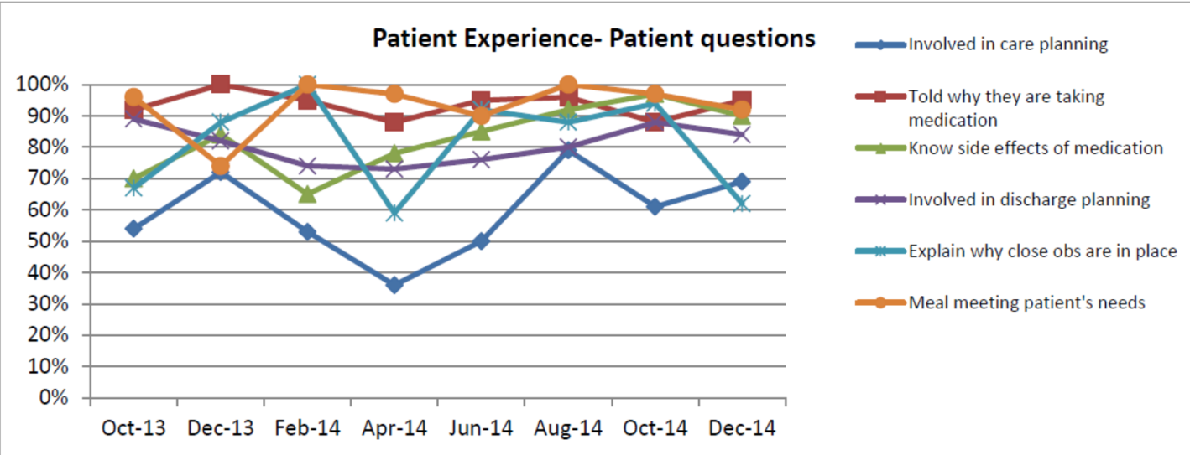



An additional question was added to the tool in November for adult wards following the request of Head of Nursing.



**6.2 CQC assessment of compliance (adult services)**

The below indicates the directorate position against the CQC outcomes relating to effectiveness. We have requested that all of the Prison services, except for HMP Huntercombe, which is already on its own, be group together instead of combined with Harm Minimisation and other services for future reporting.

|  |  |  |  |  |  |  |  |  |  |  |  |  |
| --- | --- | --- | --- | --- | --- | --- | --- | --- | --- | --- | --- | --- |
| **Outcome** | **New CQC Domains (from Oct 2014)** | **Adult Directorate** | | | | | | | | | | |
| **Warneford** | **Littlemore (PICU & Phoenix)** | **Whiteleaf Centre** | **OPAL** | **Adult Community Services** | **Littlemore (Forensic Wards)** | **Marlborough House)** | **Woodlands** | **HMP Huntercombe** | **Luther Street** | **Forensic and Addiction Community Services (Incl other Prisons)** |

|  |  |  |  |  |  |  |  |  |  |  |  |  |  |
| --- | --- | --- | --- | --- | --- | --- | --- | --- | --- | --- | --- | --- | --- |
| 2 | Consent to your care and treatment | Are we effective? |  |  |  |  |  |  |  |  |  |  |  |
| 4 | Care and welfare of people  who use services | Are we caring?  Are we effective? Are we responsive? |  |  |  |  |  |  |  |  |  |  |  |
| 5 | Meeting nutritional needs | Are we effective? |  |  |  |  |  |  |  |  |  |  |  |
| 6 | Cooperating with other providers | Are we effective? |  |  |  |  |  |  |  |  |  |  |  |
| 10 | Safety and suitability of  premises | Are we effective? |  |  |  |  |  |  |  |  |  |  |  |
| 11 | Safety, availability and suitability of equipment | Are we effective? |  |  |  |  |  |  |  |  |  |  |  |

**7. Internal assessment of compliance with Care Quality Commission standards (trust wide)**

The Care Quality Commission (CQC) has not yet undertaken a comprehensive inspection of the Trust and therefore we have not been rated on how well we meet their regulatory requirements. The CQC published the first of their quarterly Intelligence Monitoring Reports for mental health providers in November 2014. The Trust has been assessed as being in level 4 which is their lowest risk rating. Out of 57 applicable indicators only one indicator was identified as an area of risk around delayed transfers of care (DTOC). This an Oxfordshire wide issue and the Trust is working with its health and social care partners to improve the performance in this area.

The following concerns relating to effectiveness have been identified internally as areas requiring action or improvement.

| Issue | CQC standard | Context and Actions |
| --- | --- | --- |
| Documenting capacity and consent for mental health adult, forensic, older people and CAMHS inpatients  (moderate) | Are we effective? | * CQC visits have identified short comings in documenting and discussing assessment of capacity & patients consent with treatment. A number of MHA visits have also identified patients are not being re-presented their rights as appropriate (most recently in the visit to Ashurst in Dec 14). * Action: clearer escalation routes have been introduced to identify when the MHA office does not receive the appropriate completed ‘capacity and consent to treatment’ form from the responsible clinician. * Action: documentation is being monitored through the essential standards audit carried out by the Modern Matrons every other month, which includes looking at patients’ rights, Section 17 leave forms and considering capacity and consent. |
| Completeness of documentation around Section 17 leave across adult, older people and forensic mental health wards  (moderate) | Are we effective? | * This has been a reoccurring issue throughout 2013, 2014 and 2015 across the wards, highlighted by the CQC during their MHA visits. * Action: checks on Section 17 leave forms have been added to the mental health ward essential standards audit carried out by the Modern Matrons every other month. |
| Trust wide nutrition:  Screening, assessing needs and taking appropriate action, and patient feedback around food variety  (moderate) | Are we effective? | * Evidence from audits shows a lack of consistent assessment and monitoring of nutrition and hydration needs, and patient needs being fed through to care planning. Nutrition Action Group started from August 2014 to coordinate improvement work to include a new nutrition policy with clear nutrition standards and staff training to raise awareness and appropriate use of nutrition screening tools. |

Aa

1. **Infection Prevention and Control Update**

**8.1 Community health services**

**8.1.1 *Clostridium difficile***

There has been one case of *Clostridium difficile* infection (CDI) in January.

This patient was admitted to Didcot hospital from the OUH.

We have had 5 CDI cases so far this year against the end of year target of 8.

RCA’s have been completed and reviewed at the monthly CDI health economy review meetings and all cases classified unavoidable.

Below is a summary of the review meetings for the cases.

|  |  |  |  |  |
| --- | --- | --- | --- | --- |
| Month | Location | Running total of cases | Avoidable/  Unavoidable | Running total of Avoidable |
| April 2014 | Ward2, Abingdon | 1 | Unavoidable | 0 |
| Didcot CCG case | 1 | Unavoidable | 0 |
| May 2014 | No cases | 1 |  | 0 |
| June 2014 | No cases | 1 |  | 0 |
| July 2014 | Didcot hospital | 2 | Unavoidable | 0 |
| August 2014 | No cases | 2 |  |  |
| September 2014 | Didcot hospital | 3 | Unavoidable | 0 |
| October 2014 | No cases | 3 |  | 0 |
| November 2014 | No cases | 3 |  | 0 |
| December 2014 | EMU Abingdon CCG case | 3 |  | 0 |
| Wenrisc ward, Witney hospital | 4 | Unavoidable | 0 |
| January 2015 | Didcot hospital | 5 | Unavoidable | 0 |

The health economy review meetings are held on the 2nd Monday of every month and will continue to review all cases for avoidablitity.

**8.1.2MRSA bacteraemia/MSSA bacteraemia**

There has been a pre 48 hour MRSA bacteraemia patient identified on assessment in EMU on 6th January. The patient was admitted to ward 2, Abingdon. A post infection review meeting was held with the CCG and the case was deemed unavoidable. There are some actions points identified which are being addressed.

**8.1.3 E.Coli bacteraemias**

There have been no cases in January.

**8.1.4 Outbreaks**

There was a confirmed influenza A outbreak at Bicester hospital between 2nd – 8th January 2015.

**8.1.5 Ebola Preparedness**

Infection Prevention and Control team (IPCT) continue to review national guidance regarding Ebola preparedness working with the Emergency Planning Officer and Urgent care.

This situation remains closely under review and the IPCT continue to link where necessary, with Public Health England to ensure clear guidelines for staff are available.