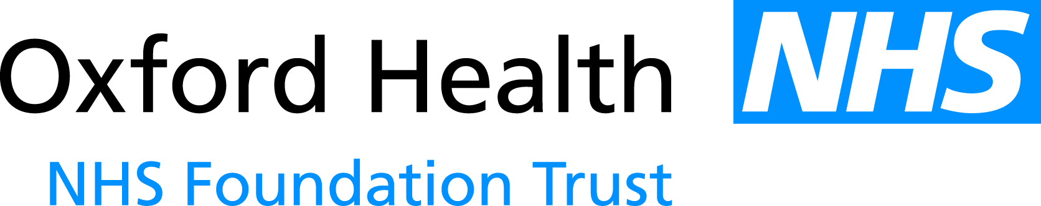

# PAPER

BOD 58/2015

# Report to the Meeting of the

# Oxford Health NHS Foundation Trust

# Board of Directors

**29 April 2015**

**NHS Staff Survey and Staff Friends and Family Test 2014**

**For Information**

The attached report shows the results from the NHS Staff Survey and a summary of the year one results from the Staff Friends and Family Test (SFFT) 2014.

2014 was the first time all 5,168 members of staff were surveyed as part of the NHS Staff Survey and also the first time the survey was administered by email. We had a response rate of 32% (1,646 members of staff), which put the trust in the lowest 20% when compared with similar trusts (the average was 44%).

To make sense of the results and to look in to activities going forward, this report focuses on our staff engagement score; looking at national, trust-wide and team level scores.

Actions from the survey results are being addressed on a team level and also trust-wide.

The SFFT was introduced in April 2014 and is conducted every quarter, except quarter three where it is replaced by the NHS Staff Survey. Our response rate has been improving every quarter and our most recent response rate was ahead of the national average (16% compared to 18%).

**Recommendation**

The Board is asked to note the report for information.

**Author and Title:** **Hannah Musson, Staff Health and Wellbeing Coordinator and** **Jayne Halford, Deputy Director of HR**

**Lead Executive Director: Mike McEnaney, Director of Finance**