**NHS STAFF SURVEY AND STAFF FRIENDS AND FAMILY TEST (SFFT) 2014**

**NHS Staff Survey**

The NHS National Staff Survey 2014 was carried out between October and December 2014.

This was the first time the trust had taken the opportunity to survey all 5,168 members of staff around the 29 key areas covered by the survey and also the first time for this to be carried out by email. It should be noted that whilst the questions asked in the survey had not changed from the previous year comparisons may be impacted by the change from a sample survey to full establishment.

The 2014 survey covers the largest number of staff we have ever had providing feedback to the trust in a survey of this type.

The survey consists of 29 key findings and an NHS measure of staff engagement.

In total 1,646 members of staff responded to the survey, which is four times the number of people who responded to the sample survey in 2013 (414 members of staff from a sample size of 850, a response rate of 49%). This figure represents a response rate of 32% of all staff, ranking the trust in the lowest 20% when compared to similar trusts (average was 44%).

The below table shows how this year’s high level results (2014) compared with last year’s (2013) against the national response for all trusts also in terms of how many issues have improved or deteriorated.

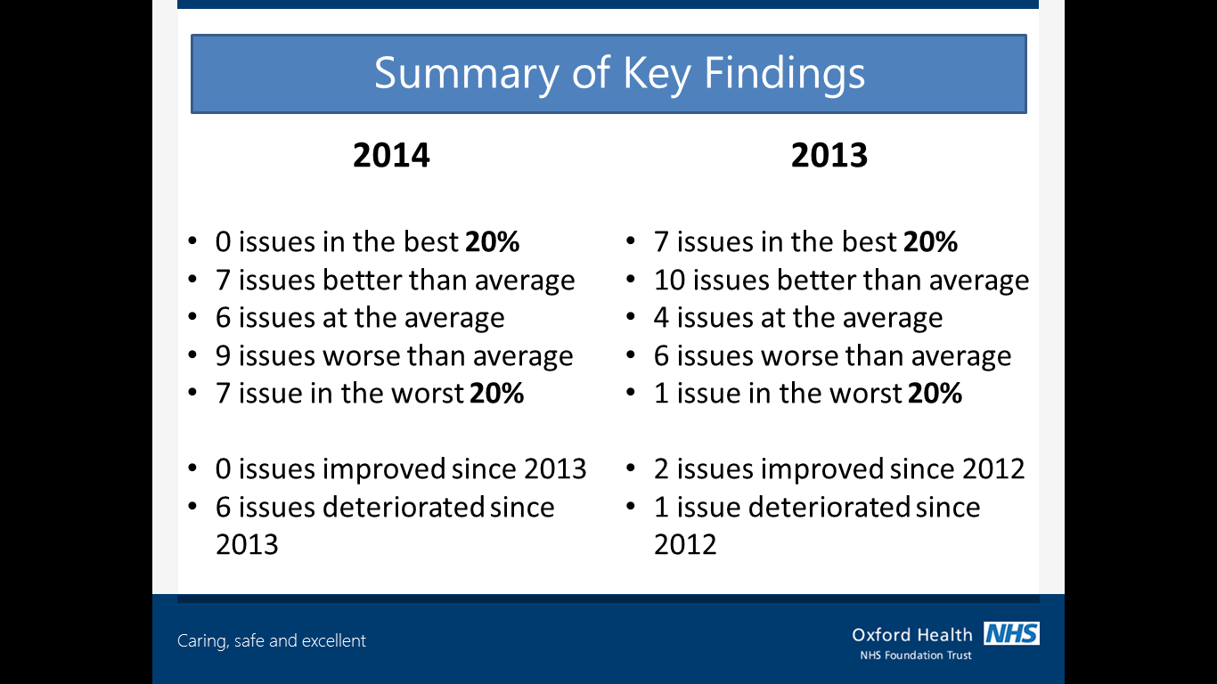

Overall, this shows a general downwards trend in our results compared with other trusts which is also reflected in a slightly worse result when compared year on year for OHFT.

% feeling satisfied with the quality of work and patient care they are able to deliver

Exact questions are shown in APPENDIX A

**Key findings where the trust is in the worst 20% of trusts (areas for improvement)**

Staff survey continued

% appraised in the last 12 months

% working extra hours

Work pressure felt by staff

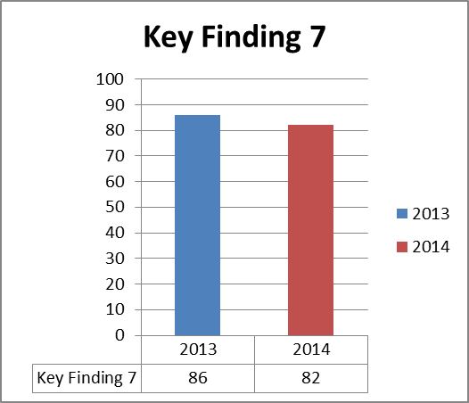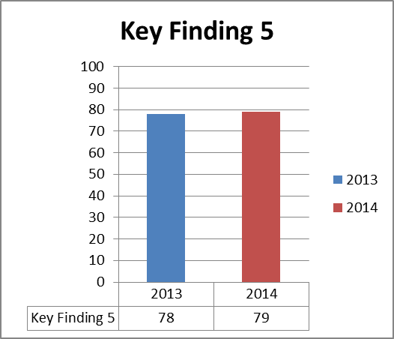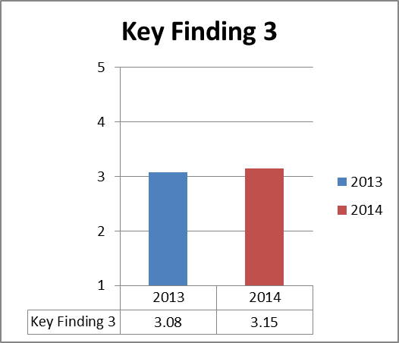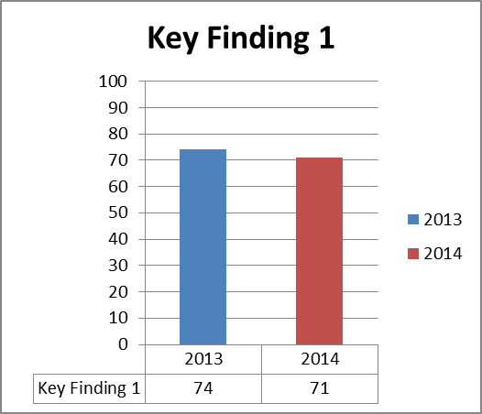

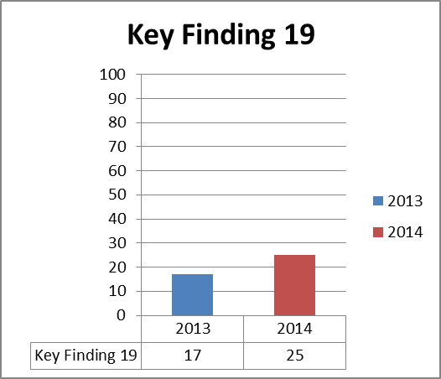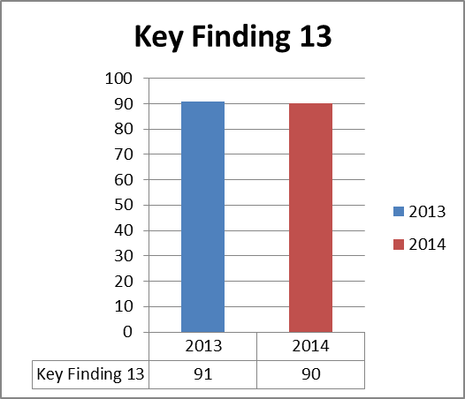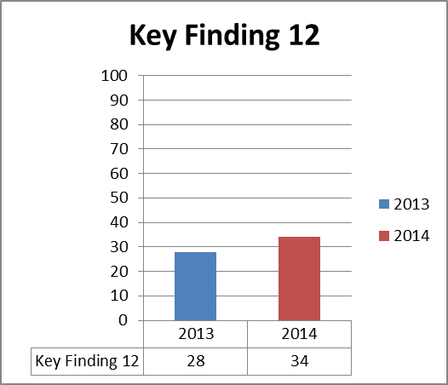

% experiencing harassment, bullying or abuse from staff in the last 12 months

% reporting errors, near misses or incidents witnessed in the last month

% witnessing potential harmful errors, near misses or incidents witnessed in the last month

Overall, the results show a general decrease in results for individual questions, which is a concern.

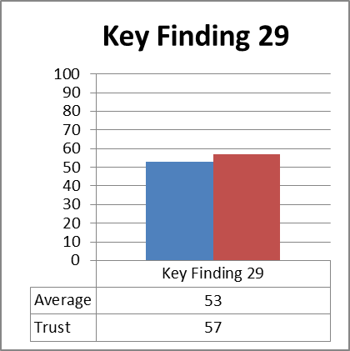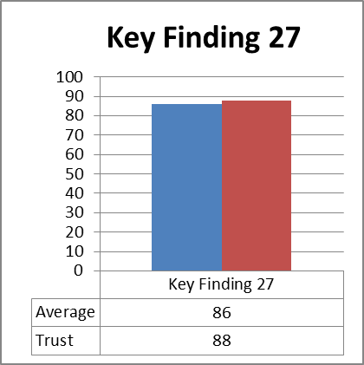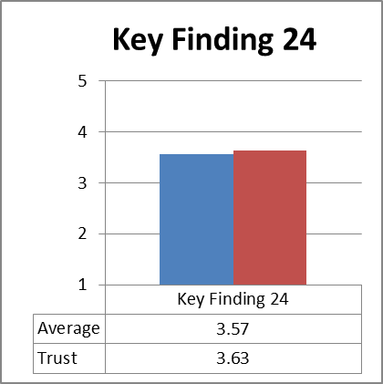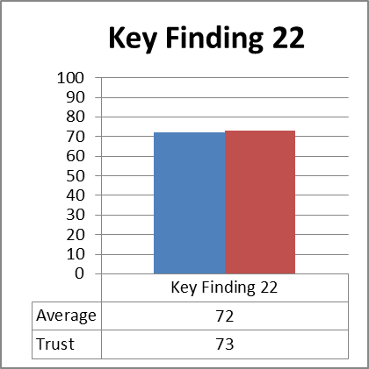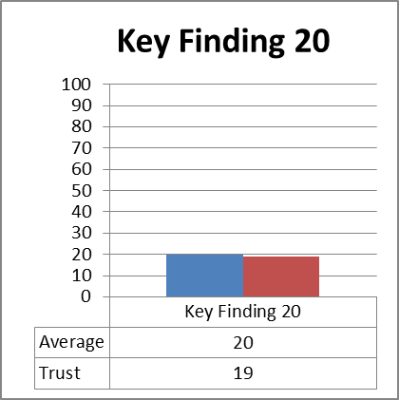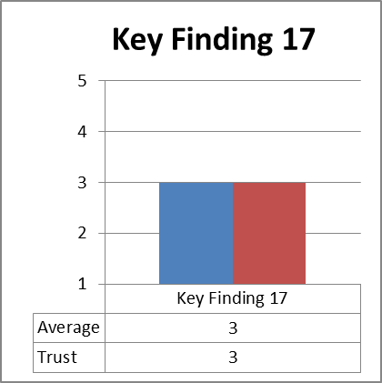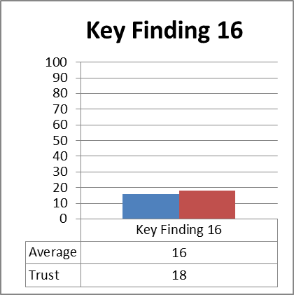

To make constructive sense of the results to focus activities going forward, we have selected the theme of staff engagement as a well-established and proven framework. 3

% agreeing feedback from patients / service users is used to make informed decisions in their directorate/department

% believing the trust provides equal opportunities for career progressions or promotion

Staff recommendation of the trust as a place to work or receive treatment

% able to contribute towards improvements at work

% feeling pressure in the last three months to attend work when feeling unwell

% experiencing physical violence from staff in the last 12 months

% experiencing physical violence from patients, relatives or the public in the last 12 months

**Key findings where the trust is better than average compared to other mental health / learning disability trusts in England**

Exact questions are shown in APPENDIX B

**Staff engagement**

The Chartered Institute of Personnel and Development (CIPD) define employee engagement as "a combination of employee commitment to the organisation and its values plus a willingness to help out colleagues." Since employee engagement goes beyond the levels of job satisfaction and motivation, it is something an employee has to offer and cannot be ‘required’ as part of the employment contract.

The Department of Health said "Motivated and involved staff are better placed to know what is working well and how to improve services for the benefit of patients and the public" in the NHS Operating Framework 2010/11, with the improvement of employee engagement being listed amongst the five national priorities for the NHS.

The CQC have posed five key questions which form the basis of their future reviews and inspections of health and social care providers to assess and improve the quality of services. One of the key questions for each team and service is “are we well led?” Under the question a series of key lines of enquiry have been developed by the CQC to look at whether there is effective leadership for quality at all levels of the organisation. The ‘well-led’ domain looks at whether our leadership and culture reflect our vision and values, whether our staffs feel listened to and supported and also how we act on feedback from service users, their families and the general public. Professor Michael West has proposed that the key measure of good leadership is staff engagement.

In high-performing organisations leaders work collaboratively with staff, involving them in decisions and empowering them to make changes in response to patient needs. This includes spending time working with and listening to staff and responding to their concerns. These organisations also focus on understanding the patients’ views and placing these at the centre of decisions about services. Evidence shows that organisations with consistently high levels of staff engagement also have better patient experiences and outcomes.

An important connection that has been highlighted by research is between staff engagement and the health and wellbeing of staff. An increasing body of evidence, such as the Boorman Review of health and wellbeing in the NHS, show that the level of general health and wellbeing of any workforce is a key indicator of, and contributor to, increasing organisational performance. Individuals with high levels of health and wellbeing have lower absence rates, are at a much lower risk of long term health factors and are more likely to display positive behaviour changes, such as increased morale.

**NHS Staff engagement score**

There are three key findings that make up the NHS staff engagement score and each key finding is made up of three questions from the staff survey as per the table below:

|  |  |
| --- | --- |
| **Key finding** | **Question** |
| **Key finding 22**  Staff ability to contribute towards improvement at work | 7a There are frequent opportunities for me to show initiative in my role |
| 7b I am able to make suggestions to improve the work of my team / department |
| 7d I am able to make improvements happen in my area of work |
| **Key finding 24**  Staff recommendation of the trust as a place to work or receive treatment | 12a Care of patients / service users is my organisation's top priority |
| 12c I would recommend my organisation as a place to work |
| 12d If a friend or relative needed treatment I would be happy with the standard of care provided by this organisation |
| **Key finding 25**  Staff motivation at work | 5a I look forward to going to work |
| 5b I am enthusiastic about my job |
| 5c Time passes quickly when I am working |

The below chart shows how our 2014 staff engagement score of 3.75 was above average compared to other mental health and learning disability trusts (the national average was 3.72) and there is no significant change from our 2013 staff engagement score.

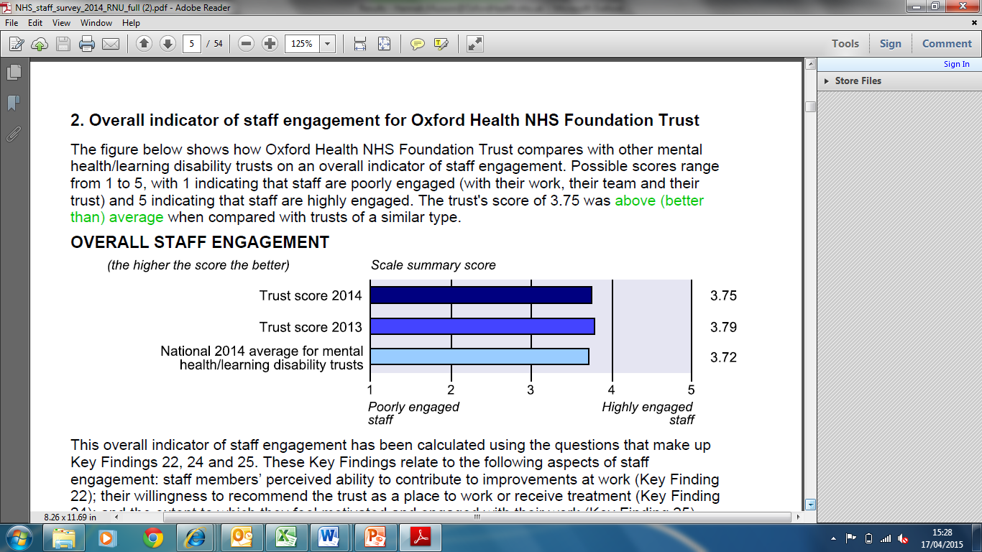

Possible scores range from 1 to 5, with 1 indicating that staffs are poorly engaged (with their work, their team and their trust) and 5 indicating that staff are highly engaged.

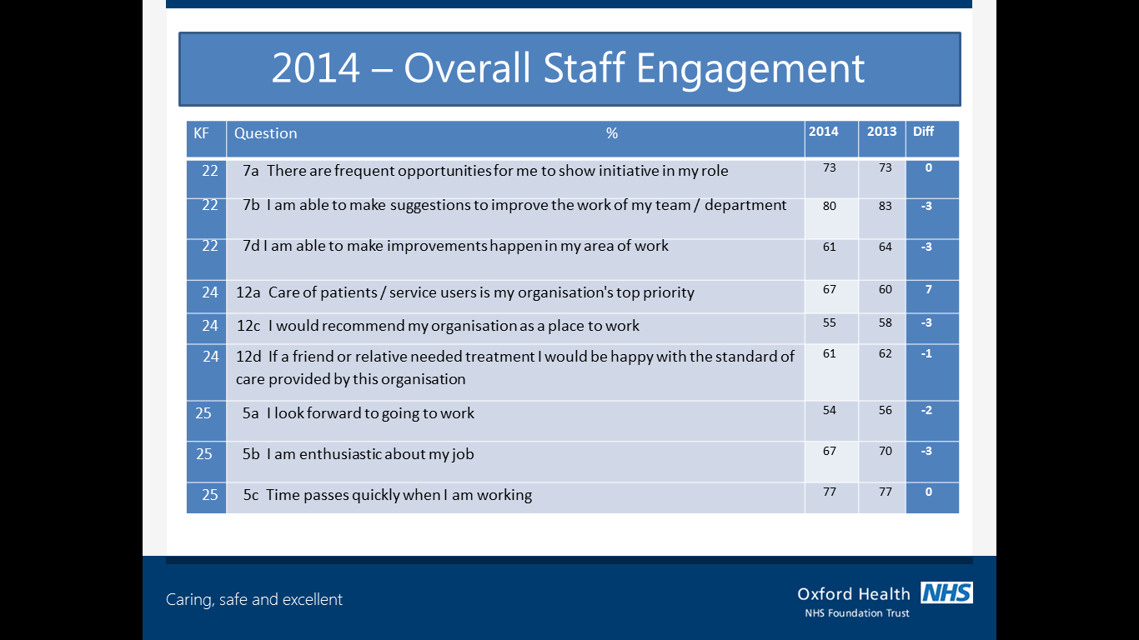Whilst there is a small deterioration in most questions, there is a significant improvement in the view that OHFT puts patients and services first.

**Year on year comparison of NHS staff engagement score, broken down by each question**

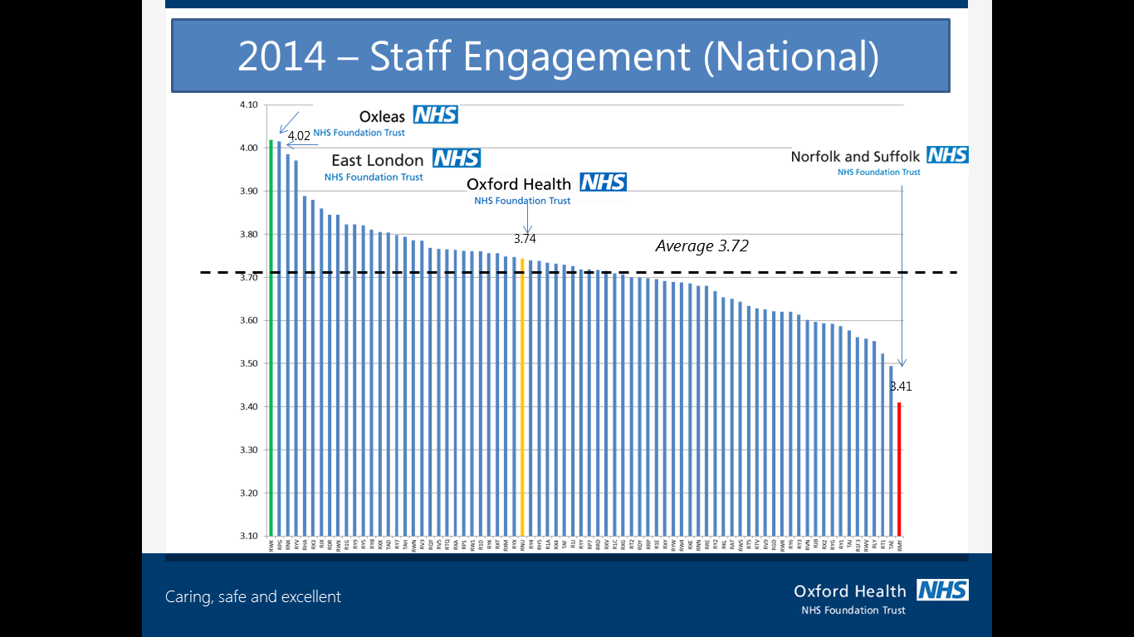

This graph shows a comparison against mental health / learning disability trusts and also other providers of NHS community health services. Whilst the variation across trusts is not wide we can consider an overall objective in terms of aiming for a score of 4 to be amongst the best.

The exact figures by provider are shown in APPENDIX C.

**NHS Staff Engagement scores (National)**

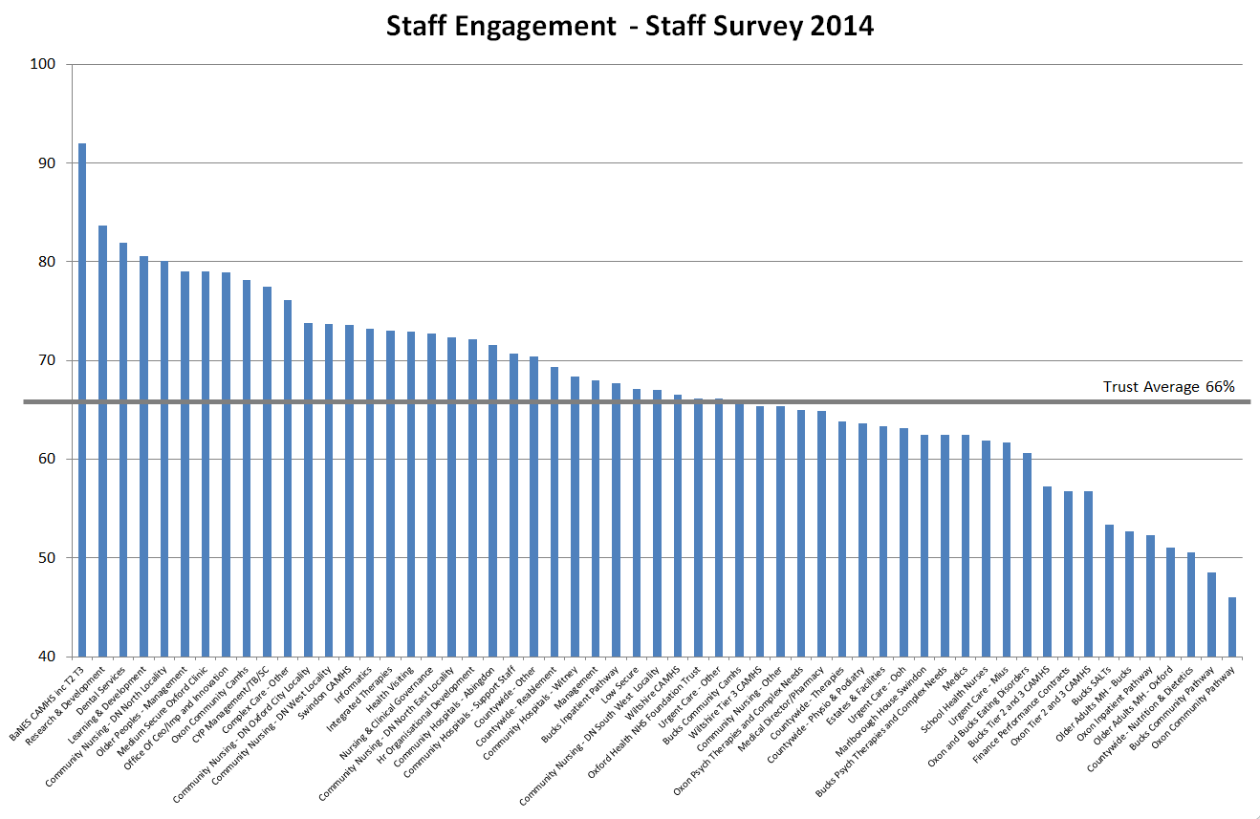

This graph gives an overview of the trust’s most and least engaged teams and shows the wide variation between them. Heads of Service and Senior Managers will take individual action and areas of good practice amongst teams needs to be reviewed and shared. The table below shows the score by individual team. (NB 80 on this chart is the equivalent of 4 on the previous chart. The trust average shown here is expressed as a simple average of the team scores)

**NHS Staff Engagement Score for OHFT (broken down by teams)**

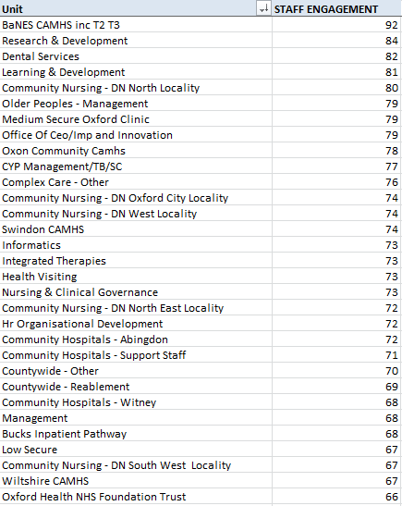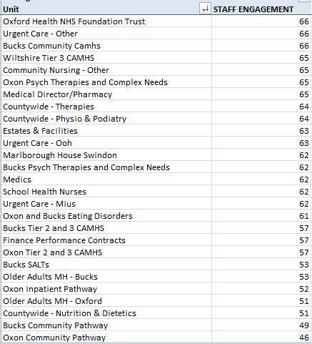

**Overall NHS Staff Engagement Score (broken down by teams)**

**Staff engagement framework**

Levels of staff engagement are usually measured through an overall score calculated from responses to a number of questions. Each of these questions represents a theme that is a key element of staff engagement. When looking at the trust-wide results, we looked at the core questions of staff engagement and used these well-established questions to group the relevant questions from the staff survey to create a breakdown of the overall engagement score.

The below table shows the 12 questions we used and also the themes they were linked with:

|  |  |
| --- | --- |
| **Questions** | **Theme** |
| The requirements and responsibility of my job are clear. | Clear expectations |
| I have adequate materials, supplies and equipment to do my work well. | Right tools for the job |
| I have the opportunities to use my skills to do my job well. | Opportunity to do best job |
| I frequently receive recognition for doing good work. | Recognition and praise |
| My immediate manager, or work colleagues, are supportive and take a positive interest in my health and wellbeing. | Feel cared about |
| I am supported and encouraged to learn and develop. | Encouraged to develop |
| My opinions and suggestions are valued. | My opinions count |
| The trust’s vision and values are important to me and my work. | Vision and values |
| My team and organisation are committed to providing quality services and care. | Commitment to quality |
| I have friends at work. | Friends at work |
| In the last 12 months, I have had my work and development reviewed. | Work is reviewed |
| In the last 12 months, I have had opportunities to learn and develop. | Opportunity to develop |

The graph overleaf shows the 12 themes and how the trust scored on each in 2014.

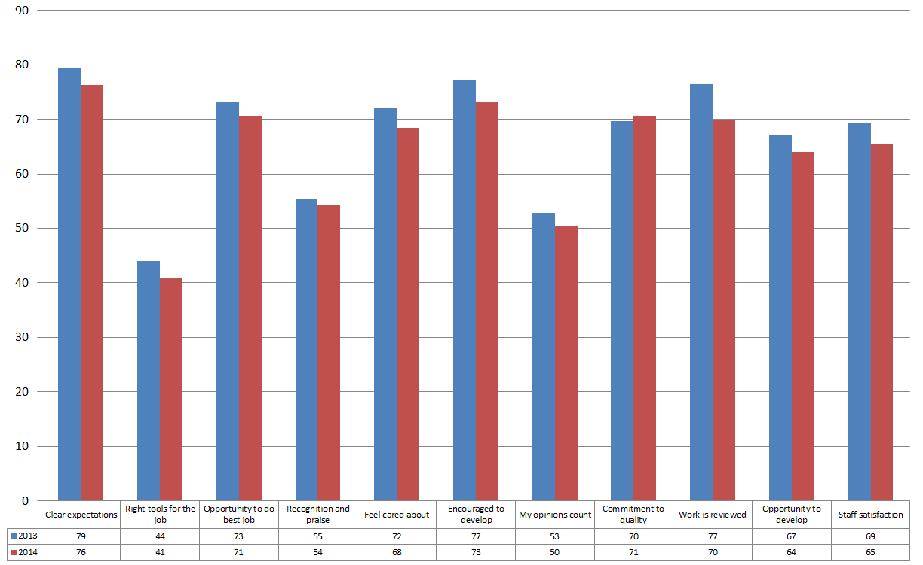

The results for each statement have generally decreased year on year and our lowest three areas are ‘right tools for the job, ‘my opinions count’ and ‘recognition and praise’. All themes are important and to reach an overall engagement score of 4 (80%) improvement is required in all, however, in developing the workforce strategy and HR business plans some priority must be given to these three low scoring themes.

**Staff Engagement – broken down by 12 key themes**

**Actions going forward**

There are two levels of action that the trust is taking in response to this year’s staff survey results. The first level of actions is focused on teams and their individual team scores from the set of 12 staff engagement themes and the individual questionnaire responses, the second level of actions being trust-wide and being developed around the 12 engagement themes.

**Team actions**

Below are examples of the actions that teams have taken from this year’s results:

Discussions with HR to compare against 2013 results and to identify areas for the focus of this year’s action plan based on the 5 CQC domains. Examples from last year were a focus on supporting staff to reduce working excessive hours via modelling best practice e.g. prompting staff to leave on time and the management of time-off-in-lieu (TOIL) and also the promotion of positive actions and good clinical outcomes at team meetings to share successes from within the Directorate.

Results have been shared with the senior management team and Heads of Services who are drilling down and focusing on hot spots.

**Trust-wide actions**

To ensure continuing progress and improvements, the Staff Health and Wellbeing Group incorporate the findings of the survey in to their annual action plan, which helps to shape the priorities of the group and ensures that they are addressing the key areas that staff feel most strongly about. This year’s priorities include taking action to prevent and reduce workplace stress and encouraging and enabling managers to support health and wellbeing at work.

The Trust is revising the current award and recognition scheme by joining up directorate initiatives and organising an annual awards ceremony. A survey was available for staff to complete and give their feedback and suggestions on the type of awards which would be offered, how relevant each award was to them and their team (if applicable) and also what the winners should receive. Staff interest and engagement with this process has been very positive.

The implementation of CareNotes will help to ensure that staffs have the right tools they need to do their roles well.

The staff survey and staff friends and family test are now standing items on the directorates’ quarterly performance meeting agendas.

**Staff Friends and Family Test (SFFT)**

The SFFT was introduced on 1st April 2014 for all trusts providing acute, community, ambulance and mental health services. The aims as announced by the Prime Minister are to encourage improvements in the service delivery – by ‘driving hospitals to raise their game’ and to increase transparency by enabling patients and the public to readily access and compare scores for different providers and services.

The test is administered every quarter, except quarter three where it is replaced by the NHS Staff Survey.

The test asks two questions with optional comment boxes: 'How likely are you to recommend this organisation to friends and family if they needed care or treatment?' and 'How likely are you to recommend this organisation to friends and family as a place to work?'

The response scale below is used for each of these questions:

|  |  |  |  |  |  |
| --- | --- | --- | --- | --- | --- |
| Extremely Likely | Likely | Neither Likely nor Unlikely | Unlikely | Extremely Unlikely | Don’t know |

**Response rates**

|  |  |  |
| --- | --- | --- |
| Quarter | Response Rate | Average response rate* |
| 1 | 6% | 11% |
| 2 | 12% | 16% |
| 3 | NHS Staff survey | |
| 4 | 18% | 16% |

*Average response from all NHS organisations that provide acute, community, ambulance and mental health services

The above chart shows that our response rate has been improving each quarter and that our most recent response rate was ahead of the national average.

**Year one summary FFT results**

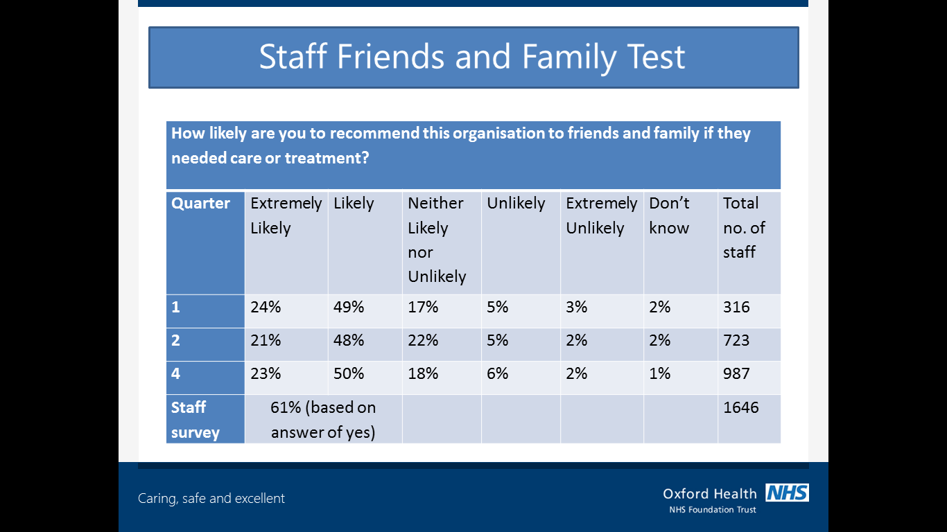

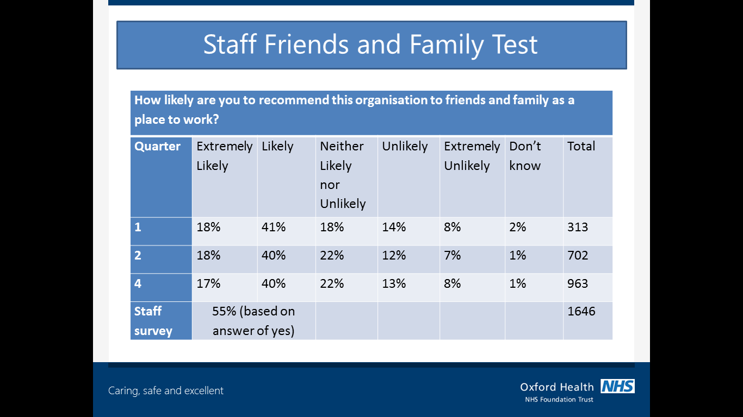

Responses have been noticeably consistent for each of the three FFT surveys and the equivalent national staff survey response is shown for comparison with the Likely/Unlikely response, which again is not out of line.

When selecting a response (from extremely likely to extremely unlikely), staff also have the opportunity to comment on their answers and give more detail surrounding their choices. The narrative can be broken down in themes (both positive and negative) which show the key areas that are important to staff:

**How likely are you to recommend this organisation to friends and family if they needed care or treatment?**

* High quality of care
* First hand / family / friend experience
* Resources and trust support
* Range of services / treatments
* Staff values and skills (to include staffing levels)

**How likely are you to recommend this organisation to friends and family as a place to work?**

* Supportive employer
* Learning and Development opportunities
* Wellbeing (to include stress and feeling valued)

**Additional questions (SFFT)**

In addition to the two set questions that are asked each quarter, three additional questions can be asked by individual organisations. Oxford Health NHS FT chose to ask additional questions in line with the established staff engagement theme questions.

Nine of these questions were added to the SFFT survey and spread across the quarters (as the third quarter was the staff survey).

The responses from these questions is shown on the next page.

**SFFT additional questions**

|  |  |  |  |  |  |  |  |
| --- | --- | --- | --- | --- | --- | --- | --- |
| **Quarter** | Question | Strongly agree | Agree | Neither agree nor disagree | Disagree | Disagree strongly | Total number of respondents |
| **1** | The requirements and responsibilities of my job are clear | 27% | 55% | 9% | 9% | 0% | 316 |
| **1** | I have adequate materials, supplies and equipment to do my job well | 16% | 48% | 11% | 20% | 5% |
| **1** | I have the opportunities to use my skills to do my job well | 27% | 47% | 12% | 12% | 3% |
| **2** | I frequently receive recognition for doing good work | 11% | 41% | 23% | 18% | 6% | 723 |
| **2** | My immediate manager or work colleagues are supportive and take a positive interest in my health and wellbeing | 30% | 43% | 17% | 7% | 3% |
| **2** | I am supported and encouraged to learn and develop | 22% | 41% | 21% | 10% | 6% |
| **4** | My opinions and suggestions are valued | 12% | 43% | 22% | 18% | 5% | 987 |
| **4** | The trust’s vision and values are important to me and my work | 17% | 54% | 21% | 6% | 2% |
| **4** | My team and organisation is committed to providing quality services and care | 24% | 50% | 17% | 7% | 1% |

These responses correlate quite closely with the equivalent engagement theme results reported for the 2014 national survey above.

**APPENDIX A**

**Key findings where the trust is in the worst 20% of trusts (areas for improvement)**

1. KF 1 – Percentage feeling satisfied with the quality of work and patient care they are able to deliver – **(71% - 2014) (74% – 2013)**
2. KF 3 – Work pressure felt by staff **(3.15 - 2014) (3.08 – 2013)**
3. KF 5 - Percentage working extra hours **(79% - 2014) (78% – 2013)**
4. KF 7 – Percentage appraised in the last 12 months **(82% - 2014) (86% – 2013)**
5. KF 12 – Percentage witnessing potentially harmful errors, near misses or incidents in the last month **(34% - 2014) (28% – 2013)**
6. KF 13 – Percentage reporting errors, near misses or incidents witnessed in the last month **(90% - 2014) (91% – 2013)**
7. KF 19 – Percentage experiencing harassment, bullying or abuse from staff in the last 12 months **(25% - 2014) (17% – 2013)**

**APPENDIX B**

**Key findings where the trust is better than average compared to similar trusts**

1. KF 16 – Percentage experiencing physical violence from patients, relatives or the public in the last 12 months **trust score 16% (below av. of 18%)**
2. KF 17 – Percentage experiencing physical violence from staff in the last 12 months **trust score 3% (on par with av. of 3%)**
3. KF 20 - Percentage feeling pressure in the last 3 months to attend work when feeling unwell **trust score 19% (below av. of 20%)**
4. KF 22 – Percentage able to contribute towards improvements at work **trust score 73% (above av. of 72%)**
5. KF 24 – Staff recommendation of the trust as a place to work to receive treatment **trust score 3.63 (above av. of 3.57)**
6. KF 27 – Percentage believing the trust provides equal opportunities for career progressions or promotion **trust score 88% (above av. of 86%)**
7. KF 29 – Percentage agreeing feedback from patients/service users is used to make informed decisions in their directorate/department **trust score 57% (above av. of 53%)**

**APPENDIX C**

**Breakdown of results when comparing our trust’s NHS staff engagement score against mental health / learning disability trusts and also other providers of NHS community health services.**

