Moisture lesion Diagnosis
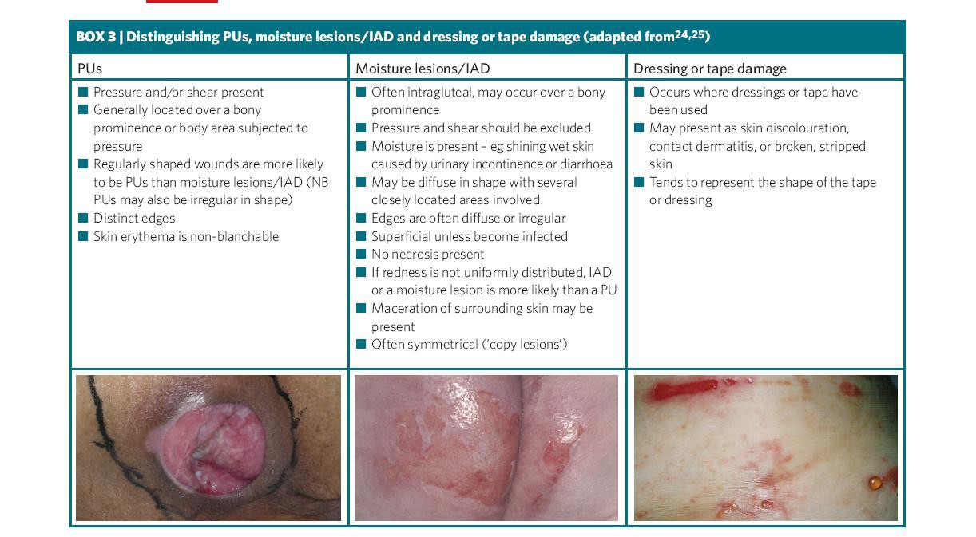

* IAD = incontinence associated dermatitis (Defloor, Schoonoven, Fletcher et al,
2007)
Contact Tissue Viability via email at tissueviability@oxfordhealth.nhs.uk (oxford health staff) or oxfordhealth@tissueviability.nhs.net (non- oxford health staff)
For further support and guidance

