wound PAIN ASSESSMENT & MANAGeMENT

Tissue Viability Service

What is pain?
An unpleasant sensation felt as a result of the brain’s response to disease or damage to the body (Brown, 2014).

What are the types of pain?
Pain falls under 2 main types: nociceptive & neuropathic pain.
- Nociceptive – usually arising from direct damage to tissue. Signals are picked up by sensory receptors which are then transmitted to the spinal cord and then the brain where they are interpreted as pain
- Neuropathic – caused by damage to or dysfunction of the nervous system which causes an abnormally strong response
It is important to determine which type of pain the patient is experiencing as they require different treatments (Brown, 2015).
Recognising Nociceptive Pain | Recognising Neuropathic Pain
- Described as ‘nagging’, ‘throbbing’, ‘gnawing’ | - Described as ‘pricking’, ‘tingling’, ‘pins & needles’, ‘stabbing, ‘shooting’
- Usually due to direct tissue damage or ischemia | - Skin or wound abnormally sensitive to touch
- Caused by inflammatory markers that occur on injury | - Pain may come on in sudden bursts for no apparent reason
- May be due to prolonged healing time | - The temperature in the painful area may deemed to have changed - ‘hot’ ‘burning’
(Adapted from White & Harding, 2006)
- HCPs should also consider that any new/unexpected or change in pain could be a sign of wound infection or ischemia

Pain Assessment
What should we be asking about the pain?
- Cause | - Location – pain over pressure points indicates first sign of damage | - Descriptors
- Pattern – onset, duration and frequency | - Intensity | - Aggravating and relieving factors

What is the impact of the pain on the patient’s quality of life?

For patients who are unable to verbalise their pain, look for non-verbal cues such as grimacing, guarding the area and restricted movement. It may also be useful to gather information from the primary caregiver (Herr, 2005).

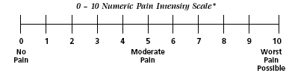

The type and intensity of wound pain experienced by patients is influenced by both physical and psychological factors

- Physical Factors – cause, site, and symptoms of the wound. Wound debridement, poor dressing technique, and use of inappropriate dressings.

- Psychological Factors – anxiety, stress, fear, and depression. These may cause sleep disturbance which further reduces pain tolerance (Mudge et al, 2008; Soon & Acton,2006).

Pain Management
Methods for managing wound pain can be pharmacological and non-pharmacological.
- Non-pharmacological therapies are often not explored but can be very effective when used alongside pharmacological methods and in those patients who are reluctant to take or do not tolerate analgesia (Brown, 2014).
Reduce anxiety – Talk to the patient about what pain they might expect prior to a dressing change and explain what measures are in place to minimise this pain. Patients who experience more pain than they expected will be more anxious about future dressing changes and this will have a negative impact on the pain they experience (Smith et al, 1997; Vingoe 1994).
Distraction therapy – Watching television, listening to music, chatting or other activities the patient enjoys. This helps them to switch their focus to something other than the pain and has shown to help reduce pain and provide emotional comfort (Williams & Irurita, 2004).
Aromatherapy – Essential oils can produce a sense of relaxation or may stimulate positive memories and feelings. They have been found to improve sleep pattern and wellbeing (Howarth 2002; Walsh & Radcliffe, 2002)
- Pharmacological - The appropriate use of analgesia both alone and in combination is key to minimising wound pain (Price et al, 2008). The WHO analgesic ladder is a step approach with upward titration of analgesics starting with non-opioids and progressing through mild and strong opioids (BMJ, 2016).

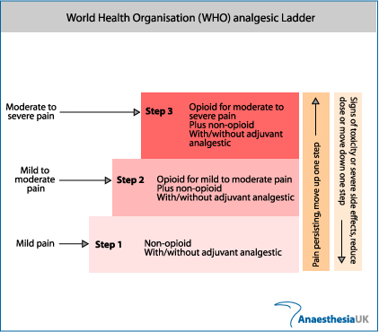

Neuropathic pain may respond to opioid analgesics but generally it is managed with a tricyclic antidepressant or certain antiepileptic drugs. Amitriptyline, pregablin and gabapentin are most commonly used (NICE, 2013)

In order to reduce wound pain, it’s important to ensure the wound is being dressed and managed appropriately:

- Infection – Treat promptly using AMBL tool for guidance

- Dressing trauma – Dressings can cause trauma to the wound bed if they adhere or dry out. Ensure a suitably moist, non-adherent product is used as the primary dressing (Upton & Solowiej, 2012).

- Exudate – Chronic wound exudate contains elevated levels of inflammatory mediators and proteases which cause pain when in contact with the skin. Exudate should be managed with appropriate absorbent products and a skin barrier product may also be required.

- Cleansing – Reported as one of the most painful experiences associated with wounds (Price et al, 2008). Wounds should only be cleansed to remove debris, particularly to the peri-wound. Ensure the water is warm (body temperature) as cold water has been reported to increase pain and warm water will help maintain blood flow to wound bed (MacFie et al, 2005).

- Compression therapy – Can cause damage such as ridges, pockets of oedema and open wounds when not applied correctly. Ensure staff applying compression are competent, wool padding is used to protect the limb, and assessment is being made at each dressing change for signs of damage.

- Ischaemia – Arterial insufficiency will result in increased pain. Patients with clinical signs of ischemia should be referred urgently to vascular.

If you are still unable to manage the pain, then please refer to the GP for support.

