Talley Quattro mattress
Guide to changing comfort setting.
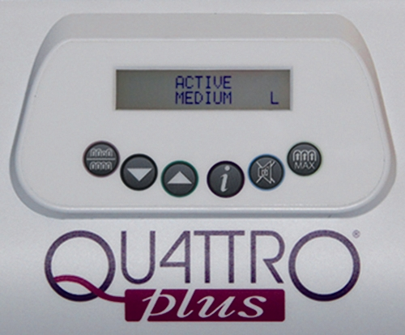

The default setting is Active Medium as shown in the picture above.
Therapy settings, either active (dynamic alternating) or low air loss,
Up and down arrows for scrolling through comfort settings
The mute and unlock button,
To unlock the buttons, press and hold this button until you hear an audible sound
To mute the alarm press once

Max inflate button
Fully inflates all cells creating a firm surface for care to be performed
L = locked sign- the buttons are locked
Information for engineers only

Mute/ Unlock
Press to silence and clear the alarm display.
Press and hold this button until a beep is heard to change the comfort settings and the L sign on the display screen vanishes, the unit will lock itself after 2 minutes from when the last button was pressed as a safety feature.

Therapy settings, this button changes the main treatment settings between active (alternating) and continuous low pressure. The display screen shows the therapy mode selected. To change therapy settings press the therapy setting button for 2 seconds until an audible tone is heard, the system will display “please wait” and requires approximately 2 minutes to change modes

These up and down arrows scroll through the comfort settings.
Soft | 0-45kg | 1-2
Medium | 46 – 115kg | 3-4
Firm | 116-200kg | 5-6
Seated- this mode is useful for patients who need to sit up in bed for other health reasons e.g. respiratory illnesses etc.

Max Inflate:
This inflates all the cells to maximum static mode for 15 minutes; this can be useful for repositioning. After pressing max inflate the system displays “please wait” followed by ready and a 5 second tone, when it has reached maximum pressure is achieved “MAX INFLATE shows on the display screen, after 15 minutes the system changes back to its previous setting.

CPR facility,
Located at the head of the bed on the right and side, identified with a mattress tag, turn dial anti clockwise to click from to it will click into place, to re inflate the mattress click back clockwise before inflating the mattress again.
If you are checking the mattress because of an alarm, check that the CPR facility is closed and locked.

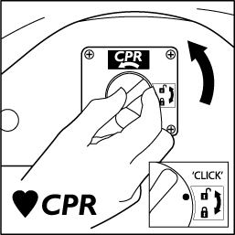

Power cut advice
In case of power failure, follow the instructions below to change the mattress into transport mode.
If the power cut is expected then use the max inflate button to full inflate the mattress, prior to disconnecting the hose (see fig 6). When maximum pressure is achieved detach the mattress air supply hose from the power unit by rotating the mattress hose connector anti-clockwise until the black lines align, and pull the mattress hose connector away
If the power cut is unexpected then disconnect the mattress hose as detailed below.
To detach the mattress air supply hose from the power unit by rotating the mattress hose connector anti-clockwise until the black lines align, and pull the mattress hose connector away (see below)
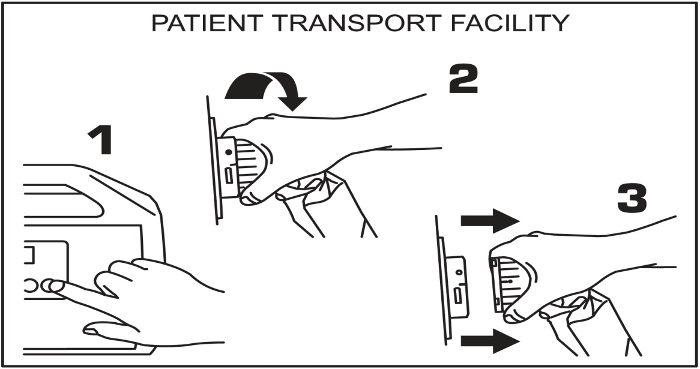

The mattress will remain inflated but without the alternating function; transport mode will support the patient for up to 12 hours depending on the patients’ weight.
To return the mattress to normal, reattach the hose to the pump and ensure that the pump is connected to the mains and the power is turned on. Ensure that the preferred mode is active and adjust as needed.

