

**Report to the Meeting of the**

**BOD 05/2016**(Agenda item: 8)

**Oxford Health NHS Foundation Trust**

**Board of Directors**

**27th January 2016**

**Quality and Safety Report**

**Quarterly Clinical Effectiveness Report**

**For: Information**

**Executive Summary**

This report provides a summary of the Trust’s position, primarily in Quarter 3 (October – December 2015) in relation to the Key Lines of Enquiry (KLOE) which are considered by the Trust’s Quality Sub-Committee - Effectiveness (QSCE).

The QSCE is now fully functioning and has reports from all meetings in relation to the Key Lines of Enquiry. The following issues are highlighted to the Board:

*Clinical audit*

The number of outstanding improvement plans from completed audits remains low and the progress reported previously continues. The current audit plan continues to be unmanageable with a number of audits behind schedule. An options appraisal paper has been completed which makes a number of suggestions regarding a possible change in approach in 2016/17.

There has been a significant reduction in the number of outstanding actions. Directorates continue to focus on completing these in a timely way.

Within the last quarter, 13 clinical audits have been completed and reported and two new audits were added in the last quarter and completed. A draft Standing Operating Procedure (SOP) has been developed and this will be finalised before the next meeting.

*Clinical Audit – Physical Health Care Issues*

Management of physical health continues to be a major issue. In response a project and action plan has been led by the Deputy Medical Director.

*Clinical Policies*

There has been considerable improvement in relation to clinical policies. It was confirmed at the last QSCE that there is currently one policy out of date, which is currently being finalised.

AIMS Accreditation

During Q3 we received confirmation that Ashurst PICU has received AIMS accreditation. This was the final clinical area in the adult mental health in-patient areas.

*Review of practice against**NICE guidance*

The QSCE remains confident that NICE guidance is being received and then disseminated to, and being processed by, Directorates. As of December 2015, there were a total of 372 NICE guidelines, standards, technology appraisals and interventional procedures which apply either directly or indirectly to the three clinical directorates. Due to the high number of guidance issued, there is varying assurance of full compliance in all areas.

All directorates are undertaking a gap analysis process, which has highlighted a number of issues and areas for improvement, including a current backlog in conducting a number of gap analyses. In addition the existing status of applicability needs to be revisited in line with service and contract changes.

In response a project plan is currently being devised with the support of Directorate Heads of Nursing, and will have clearly outlined targets to move to full compliance within a year. In support of this project a NICE implementation group with representation from all three directorates has been set up to oversee the process.

It is evident that services are currently struggling to cope with the workload associated with the NICE implementation process and the executive team are asked to consider the funding of a dedicated resource for the implementation of NICE.

*Mental Health Act*

During Quarter 3 the CQC conducted a total of 2 MHA inspections and raised a range of issues which required local actions. The issues raised by the CQC were as follows:

Statutory matters: AMHP reports: not always received but distance issues acknowledged, action taken to remind local authorities and obtain reports. IMHA services: This is a commissioning issue, action has been agreed to confirm with provider service level.

Rights: evidence of presentation, Consent and capacity: evidence of assessment,

Non-Statutory Matters: Care Plans: focused on treatment, action taken to increase breadth and patient involvement. Care Plan: recording patient views, action to align wellness and action recovery plans with care plan.

Medication Management

A new mechanism for distributing key DTG messages (DTG bulletin and Net Formulary website) to staff has been implemented. This has been well received.

There are concerns about lack of attendance / response in relation to the Medical Cases Sub-Group from some services which is delaying progress with some developments (training etc.) The Sub-Group has requested that this be escalated to DTG and QSCE.

The Innovation Sub-Group of DTG discussed a proposal from Dr Rupert McShane regarding the extended use of oral ketamine for treatment resistant depression. The QSCE has invited Dr. McShane to its next meeting for discussion and consideration. DTG supported this proposal and advised that this should be considered by QSCE for approval.

* Non-Medical Prescribing Sub-Group had advised that staff that use a NMP qualification should have this added to their job descriptions.
* A task and finish group will be established to agree which antimicrobial guidelines each clinical service in the trust should use.

*Learning and Development*

The new Care Certificate framework continues to be delivered as a taught 5 day programme for all HCAs and clinical support workers new to the Trust, and has been every 3 weeks since May 2015. To date approximately 175 staff have undertaken this preparation to-date. The overall programme takes 12 weeks to complete and competence is signed off in the clinical practice area. L&D are working with clinical areas to improve overall compliance rates and monitors the continuity of standards.

Increasing numbers of staff are now using the on line reporting system to record supervision activity. This process can be used for all types of supervision but management supervision is currently under reported. Monthly reminders are generated and sent by email to managers / supervisors to approve supervision activity.

Whilst awaiting the recruitment of a new fire officer the Health & Safety team are covering Corporate Induction and Inpatient training but are unable to provide sufficient fire awareness training places. National standards stipulate that staff should attend face to face training alternate years delivered by a qualified fire safety officer. This is currently being delivered from a virtual classroom. When appointed the new fire officer will be required to deliver training via the virtual classroom. In the interim arrangements are being made with Oxfordshire fire and rescue services to deliver classroom training.

There is a new national target of 95% which should be reached by 31st March 2015. The current position is 78% trained. L&D are targeting those out of date and are monitoring the uptake of training.

**Recommendation**

This report is for information.

**Author and Title:** **Susan Haynes, Head of Nursing; Sandra Parker, Clinical Audit Specialist; Rebecca Kelly, Learning from Incidents and Clinical Audit Lead; Mark Underwood, Head of Information Governance; Verity Gibbons Quality and Governance Lead (Older Peoples Services); Helen Bosley, Infection Prevention & Control Matron.**

**Lead Executive Director: Dr. Clive Meux, Medical Director.**

*A risk assessment has been undertaken around the legal issues that this paper presents and there are no issues that need to be referred to the Trust Solicitors.*

*This paper (including all appendices) has been assessed against the Freedom of Information Act and the following applies:*

*THIS PAPER MAY BE PUBLISHED UNDER FOI*

1. **Introduction**

The Key lines of enquiry (KLOE) for the Quality Sub-Committee Effectiveness (QSCE) are aimed at ensuring that relevant and current evidence-based guidance, standards, best practice and legislation are identified and used to develop how services, care and treatment are delivered.

The QSCE is responsible for ensuring that patients’ needs are assessed and that care and treatment is delivered in line with current legislation, standards and evidence-based guidance.

The focus of the QSCE is to seek assurance that the organisation is complaint with the KLOE which have been identified for the sub-committee. These are as follows:

* Are people’s needs assessed and care and treatment delivered, in line with current legislation, standards and evidence-based guidance?
* How are people’s care and treatment outcomes monitored and how do they compare with other similar services?
* Do staff have the skills, knowledge and experience to deliver effective care and treatment?
* How well do staff and services work together to deliver effective care and treatment?
* Do staff have all the information they need to deliver effective care and treatment to people who use services?
* Is people’s consent to care and treatment always sought in line with legislation and guidance?
* How are people supported to live healthier lives?
* Are people subject to the Mental Health Act 1983 (MHA) assessed, cared for and treated in line with the MHA and Code of Practice?

1. **Trust wide Clinical Audit**

The following report provides a summary of the full clinical audit report which has been considered by the Clinical Audit Group (CAG) on the 6th January 2016. This report gives a progress update against the following:

* Progress update against the trust wide audit plan for 2014/15
* Progress update against the trust wide audit plan for 2015/16 for audits scheduled to be undertaken during Quarter 1, Quarter 2 and Quarter 3
* Changes to the 2015/16 Trust wide audit plan
* Reported audits with no improvement plan in place
* Monitoring of actions from improvement plans
* Summary of the results from the clinical audits reported and rated since the last Clinical Audit Group meeting in January 2016
* Key themes arising from clinical audit

**2.1 Progress update against the Trust wide clinical audit plan for 2014/15**

There is one final audit still to report from the 2014/15 clinical audit plan. It is the National CQUIN audit of Cardio metabolic risk factors and the Trust has no control over when the report will be published. The audit report was scheduled by NHS England to be published in June 2015. This was embargoed due to the General Election and despite four attempts to request an update none has been forthcoming.

**2.2 Progress update against the trust wide audit plan for 2015/16 for audits scheduled to be undertaken during Quarter 1 and Quarter 2**

There have been concerns over the number of audits that are behind their scheduled time frame. At the end of quarter 3 there were a total of 16 audits behind schedule.

Table 1 provides a progress update on current audits in including highlighting those behind their scheduled time frame (excludes audits that have already been completed and reported in previous quarters).

|  |  |  |
| --- | --- | --- |
| **Quarter to be undertaken** | **Audit name** | **Progress update** |
| Bi-monthly reporting | Essential Standards | In progress and on schedule |
| 6 monthly reporting | Medicines Management - Quarterly reporting of rolling audit of safe and secure storage of Controlled Drugs | In progress– Q1 and Q2 included in this summary report |
| Quarterly reporting | Medicines Management - Quarterly Antimicrobial prescribing audit | Q2 included in this summary report. Q3 in progress and on schedule. |
| Quarterly reporting | Safety Thermometer Adult Mental Health - reduction in harms | In progress and on schedule |
| Quarterly reporting | Safety Thermometer Classic - reduction in harms | In progress and on schedule |
| Quarterly reporting | Infection Control Programme: annual infection control audits | In progress and on schedule |
| Quarterly reporting | Infection Control Programme: bi monthly hand hygiene audits | In progress and on schedule |
| Quarterly reporting | Sentinel Stroke National Audit Programme (SSNAP) | Q1 outstanding - in progress but behind schedule |
| Quarterly reporting | Community Hospitals documentation audit | Q1 & Q2 included in this summary report. Q3 in progress and on schedule |
| Quarterly reporting | Audit of MEWS – Older People | In progress and on schedule |
| Quarterly reporting | Track and Trigger | In progress and on schedule |
| Quarter 1 | Access to Healthcare for People with Learning Disabilities | In progress but behind schedule. To be analysed and completed mid-September. JR confirmed that audit has started. |
| Quarter 1 | Care standards for non CPA cases | In progress but behind schedule – issues with the transition from Carenotes. Due to start in Q4. |
| Quarter 1 | Audit of pressure ulcer management in Older People's Directorate (CHs, DNs & OAMH | In progress but behind schedule – currently at data collection stage across district nursing teams and ILT hubs. Due to report Jan 2016. |

*Table 1*

|  |  |  |
| --- | --- | --- |
| **Quarter to be undertaken** | **Audit name** | **Progress update** |
| Quarter 2 | National Audit of Diabetes | Data collection July 15 – Sept 15. Confirmation of participation required from OP directorate. |
| Quarter 2 | National Audit of Intermediate Care | Data collection May 15 – Sept 15. Confirmation of participation required from OP directorate. |
| Quarter 2 | Audit of MEWS – Trust-wide | In progress but behind schedule – Older People’s and some adult mental health wards completed |
| Quarter 2 | Seclusion | In progress but behind schedule – data collection in progress October to Jan. |
| Quarter 2 | Health Records | In progress but behind schedule – not yet started. Due to start in Q4. |
| Quarter 3 | Urgent Care telephone triage NQR4 | Confirmed at CAG on 6/1/16 that this audit was completed in Oct 15. Will be reported to the next CAG. |
| Quarter 3 | Do Not Attempt CPR (DNACPR) | Completed across the Older People’s directorate. Carried forward to Q3 as the audit needs to be completed across the other directorates. Not yet started. |
| Quarter 3 | Mental Capacity Act re-audit | Not yet started |
| Quarter 3 | Audit of the timeliness and quality of inpatient discharge summaries (MH) | Not yet started |
| Discharge letters to GPs from community hospitals | Not yet started |
| Quarter 3 | Re-audit of the prescribing and monitoring of patients on Insulin | Not yet started |
| Quarter 3 | Re-audit of the quality of prescribing for high risk medicines - Warfarin & Low Molecular Weight Heparin | Not yet started |
| Quarter 3 | CQUIN Mental Health - Cardio Metabolic assessment and treatment for Patients with psychoses | In progress and on schedule |
| Quarter 3 | National audit of Early Intervention in Psychosis | In progress and on schedule |
| Quarter 3 | Re-audit of Eliminating mixed sex accommodation – ward self-assessment of elements of Privacy & Dignity | Not yet started |

**2.3 Changes to the 2015/16 Trust wide audit plan**

**Audits to be removed from the 2015/16 audit plan**

Since the last report to the Sub-Committee: Effectiveness in October 2015 a total of 3 audits are to be removed from the 2015/16 audit plan. Table 2 below provides the details of the audits to be removed and the rationale.

|  |  |
| --- | --- |
| **Name of audit** | **Reason for removal from the 2015/16 audit plan** |
| Audit use of MUST or another nutrition screening tool | Carry forward to the 2016/17 Trust wide audit plan as a new nutrition and hydration policy is being implemented. The new policy picks up both malnutrition and overweight/obesity issues. Currently the Essential Standards audit in mental health provides some assurance around the assessment of nutrition as it currently audits if a nutritional needs assessment has been completed. The Community Hospitals Documentation Audit also provides some assurance as it reviews 3 questions relating to the use of the Malnutrition Universal Screening Tool (MUST). |
| Older People - CQUIN Mental Health – Dementia and Delirium | Following publication of the detail of the CQUIN it has been confirmed that this will not require a clinical audit and will be monitored as a performance target within the directorate. |
| Older People - CQUIN Urgent & Emergency Care | Following publication of the detail of the CQUIN it has been confirmed that this will not require a clinical audit and will be monitored as a performance target within the directorate. |

*Table 2*

**Audits to be added to the 2015/16 audit plan**

Since the last report to the Sub-Committee: Effectiveness in October 2015 there are two audits that need to be added to the 2015/16 audit plan. Table 3 below provides further details of the audits and the rationale.

|  |  |
| --- | --- |
| **Name of audit** | **Reason for inclusion on the 2015/16 audit plan** |
| Resuscitation Equipment Audit | The amended Resuscitation Policy was approved in July 2015 and includes changes to the regularity of checking resuscitation equipment and periodic equipment audits which will be carried out/led by the Senior Resuscitation Officer. Corporate audit support for this audit was discussed at CAG and due to the number of audits currently behind schedule it was suggested that support be requested from within the Older people’s directorate. |
| Pilot of the Safer Staffing Calculator Tool | The trust made a decision to be involved with the community mental health safer staffing national benchmark work to review and compare our staffing levels. The pilot was undertaken at South Oxon AMHT from 23/11/15 to 29/11/15 and Oxford City OAMH from 30/11/15 to 6/12/15. This was a significant piece of work for both the clinical staff and two of the Clinical Audit Specialists. |

*Table 3*

**2.4 Reported audits with no improvement plan in place**

It was previously reported to the Sub-Committee: Effectiveness in October 2015 that there were a total of 3 improvement plans that had not yet been completed and returned within the 6 week time frame, this figure has increased to 5 (relating to 2 audits).

Table 4 below provides a breakdown of the reported audits with no action plan in place.

|  |  |  |  |  |
| --- | --- | --- | --- | --- |
|  | **Older People** | **C&YP** | **Adult** | **Total** |
| Number of reported audits in date within the 6 week time frame for action planning | 2 | 1 | 2 | **6** |
| Number of reported audits that have past the completion timeframe of 6 weeks | 2 | 0 | 3 | **5** |
| Total | 4 | 1 | 5 | **11** |

*Table 4*

The 5 improvement memos past the completion time frame of 6 weeks relates to the following 2 audits:

1. CPA audit – Q1 outstanding for forensic wards & older adult mental health teams
2. Drug Chart Audit – outstanding for adult wards, forensic wards & older people

**2.5 Monitoring of actions from improvement plans**

The number of audit actions currently in date has reduced from 152 at the end of quarter 2 to 65 at the end of quarter 3. The number of out of date actions has decreased from 16 to 7 as shown in table 5 below.

|  |  |  |  |
| --- | --- | --- | --- |
| **Division** | **Total number of actions outstanding** | **Number of actions in date** | **Number of actions out of date** |
| Trust wide actions relating to all directorates | 18 | 17 | 1 |
| Adult Services | 32 | 32 | 0 |
| Older People’s Directorate | 12 | 9 | 3 |
| Children & Young People | 10 | 7 | 3 |
| **TOTAL** | **72** | **65** | **7** |

*Table 5* – number of out-of-date actions per directorate

**2.6 Classic Safety Thermometer**

One of the national programmes to support harm free care is the Safety Thermometer Classic harm prevalence audit. This is designed to ensure an organisation and its respective clinical teams are aware of the harm that their patients are experiencing by reviewing care indicators across key elements of harm:

* Pressure ulcers
* Falls
* Catheter-related UTIs
* VTE
* Optional locally determined elements e.g. cognitive screening/assessment

The Safety Thermometer approach moves from reviewing these patient harms/indicators by individual category to one which reviews the total level of harm for each patient, thus providing a basis for patient safety improvement work and the delivery of harm free care. The benefits of this approach are that it:

* Measures patients that are harm-free at the point of care in a systematic way
* Integrates measurement into daily routines
* Prompts front line teams to think differently and from a patient perspective
* Supports improvements in patient care and patient experience
* Prompts immediate actions by healthcare staff
* Allows measurement in any setting where care is being delivered

Teams are able to access their results, identify progress over time and compare results with other teams across the Trust, or with other organisations that submit data. There is, however, no facility to allow a benchmark comparison with individual teams in other organisations; indeed, many organisations are not analogous to Oxford Health, the programme embracing acute Trusts ads well as bodies outside of the NHS, such as care homes. A document from 2013, 'Delivering the NHS Safety Thermometer CQUIN', states “The NHS Safety Thermometer was not designed to compare organisations. It is an instrument that requires local discussion, interpretation and implementation. This inevitably means that methods of collection and interpretation of operational definitions vary considerable from site to site.

All results are presented as a percentage of patients seen by the services on the audit date. Caution should be applied when considering results for teams with low patient numbers: for example, for a service that audit only 5 patients in a month, such as Physio, a single patient with harm will affect the overall result by 20%. A spreadsheet containing full results, including the numbers of patients audited, is available in appendix 2.

In each case there is a national comparison, although it should be borne in mind that many participants will not be direct analogues of Oxford Health Foundation Trust, as detailed above.

As a point prevalence audit, Safety Thermometer has some constraints in that:

* Audited patients do not necessarily reflect trends for all patients on the caseload,
* All harms are counted, not necessarily those that occurred whilst under OH care (unless indicated by the word “new”)
* Long term caseload management means that certain patients will be counted in different months, despite the fact that there may have been no new harms, e.g. patients on the DN caseload who are receiving continuing treatment for pressure ulcers
* The audit solely identifies prevalence of harm, it does not address whether the Trust’s care could have prevented this harm, nor the efficacy of its management thereafter
* The audit counts catheterised patients that have a diagnosed UTI, but not those un-catheterised patients who might have developed a UTI (In community hospitals his data is collated using the Productive Ward dashboard)

**Executive Summary**

|  |  |  |  |  |
| --- | --- | --- | --- | --- |
| Audit Rating  (Highlight) | Excellent 95-100% | Good 80-94% | Requires Improvement 50-79% | Unacceptable  0-49% |

The Patient Safety Thermometer Classic is a point prevalence audit it is exempt from rating.

All 3 months in Q3 were below the mean regarding the prevalence of harm free care; however, all results in the past 12 months have been within the control limits.

The prevalence of pressure ulcers recorded in December was the highest for 24 months. However, the prevalence of new PUs (i.e. those developed within our services actually fell below the mean in December. Detailed information collected from submissions throughout 2015/16 indicates that the Trust records a high prevalence of PUs because the identification of category 2 PUs is more rigorous than in many other organisations. This could be perceived as a positive reflection on pressure area management in the Trust.

The audit continues to show that OHFT is above the national trend regarding VTE risk assessment completion, and the figure recorded in December is the highest in the past 24 months.

Many graphs may appear volatile, but the variations are minor: for example, the variance over 12 months relating to New UTIs is 0.77%.

Because this audit for the most part considers all harms, including those inherited by the Trust, and because even figures on new harms do not consider whether the harm was avoidable, this audit is not considered by the Directorate to be accurate as an indicator of patient care and therefore considers incidence data a more accurate source of data.

**Background**

The Safety Thermometer approach requires a snapshot real time survey of the national agreed harms for patients in a clinical team on a defined day; the survey should be completed on a monthly basis. The clinical teams and their grouping are nationally defined, the full breakdown of relevant teams can be found in Appendix 1.

The data is to be used locally to monitor patient harm and take action to address any concerns raised at a local level; also the Trust can use the aggregated data as the method to monitor and take action with regards to patient safety and as a source of Board Assurance.

The Care Quality Commission outcomes that this audit relates to are

* Is the service safe?
* Is the service effective?

**Methodology**

All relevant Older People’s Directorate services, as defined by the audit sponsors, have been completing the audit since January 2013. All patients seen by each team on a nationally defined monthly date are audited, with all relevant harms recorded; in-patient areas also identify whether a VTE risk assessment was completed if relevant.

The survey data is captured in an Excel spreadsheet supplied by the National Information Centre (NIC). The Trust is required to collate all team data and then submit each month to the NIC.

**Sample size**

The sample sizes vary each month, depending on the number of cases seen. Overall sample sizes for the months covered by this report are

October 2015 1041

November 2015 1091

December 2015 1101

The 12 month mean is 1075.

Individual service samples vary significantly in size. In November this ranged from 713 (District Nurses) to 5 (Community Nursing – Physic). Sample size data for each service is available in Appendix 2.

**Trust wide Results**

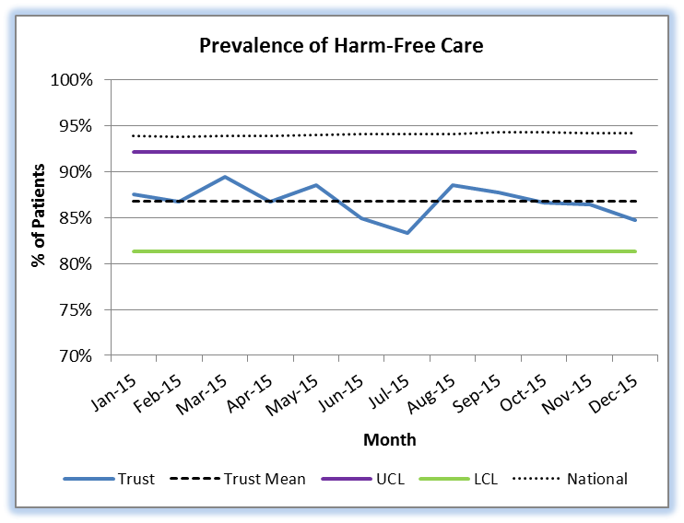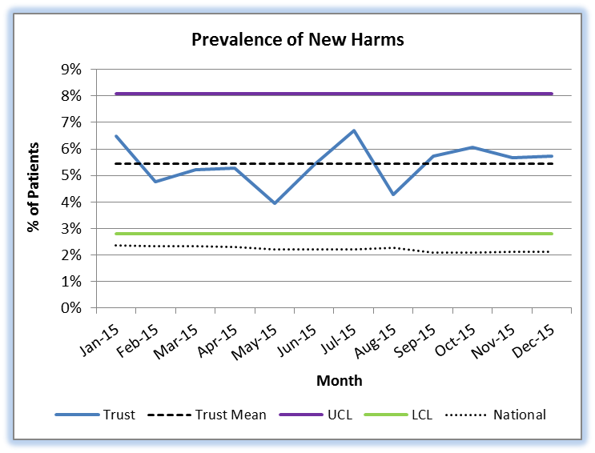

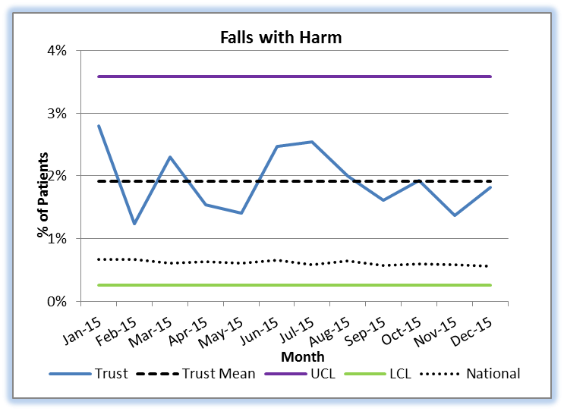

* Falls With Harm includes all harms from minor (1st aid, treatment, extra observations or medication) upwards.

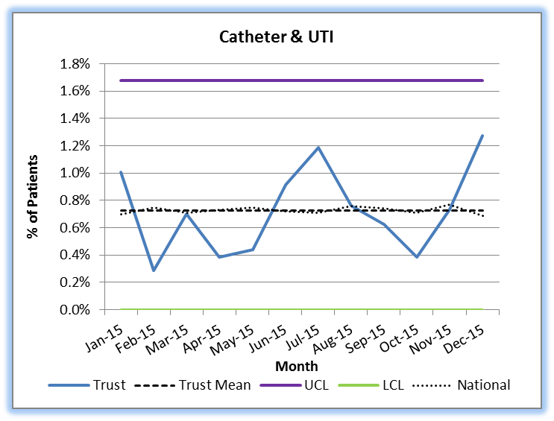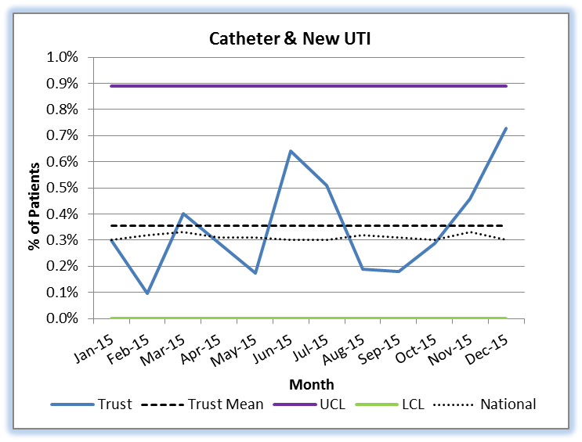

*Only UTIs that are currently being treated with antibiotics are counted. Catheters must be in place or have been in place within 3 days of the audit; only indwelling urethral urinary catheters are relevant, supra-pubic catheters and other stents are not counted.

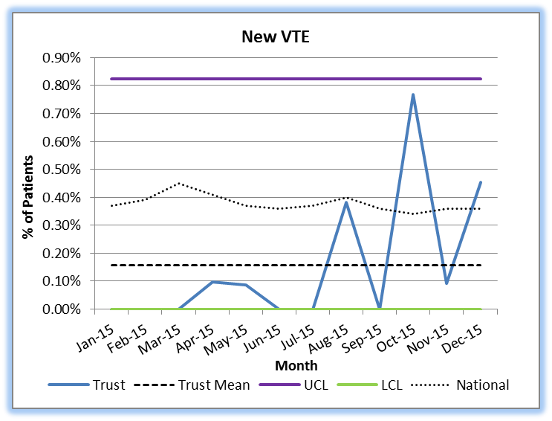 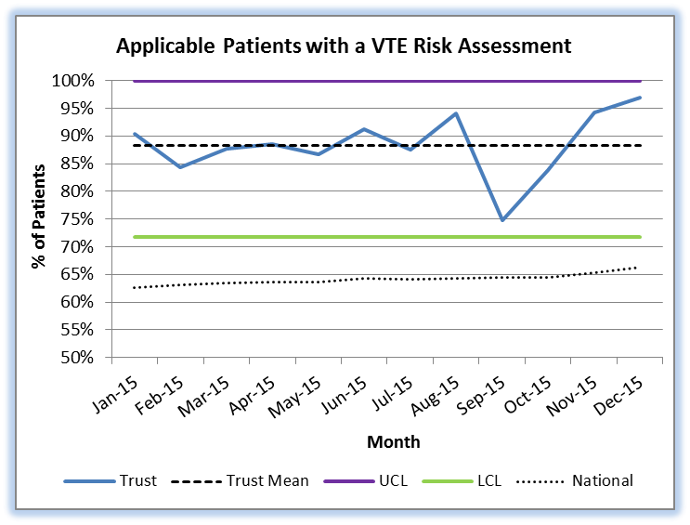

**Pressure Ulcers**

New Pressure Ulcers (Pus) are defined as those that have developed whilst the patient was under the care of the service, commonly referred to locally as “non-inherited” PUs. They are not necessarily recent wounds.

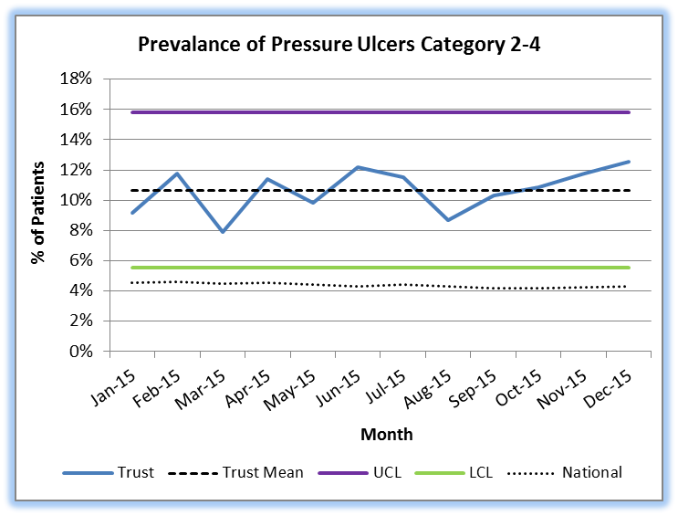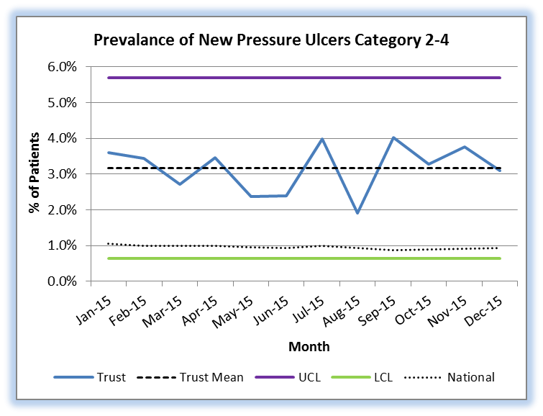

As can be seen in the charts above, the percentage of pressure ulcers recorded over the past 12 months has been above the national figure. The table below shows the split between categories 2 to 4 (category 1 PUs are not included in the audit) for Oxford Health, 3 neighbouring Community Trusts and the national figures for the whole of 1516 Q3.



This data shows that OH primarily differs from its peers in the number of catgeory2 PUs reported. The percentage of OH patients with category 3 and 4 PUs was higher than our peers in Q3, but by a far smaller percentage than those with category 2P PUs. This trend continues data collected in the previous 2 quarters.

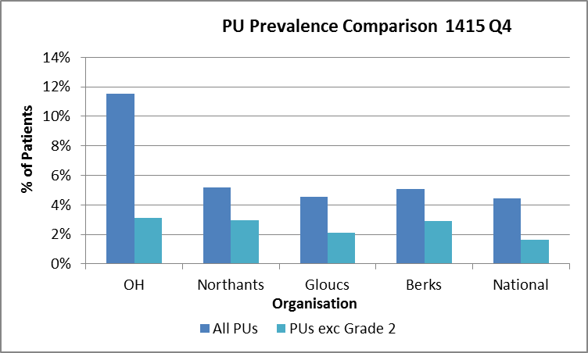 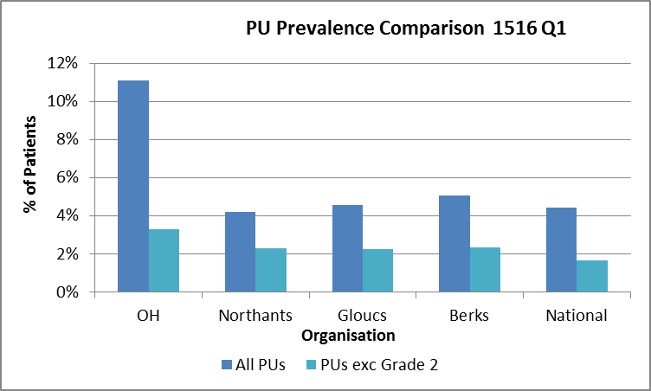

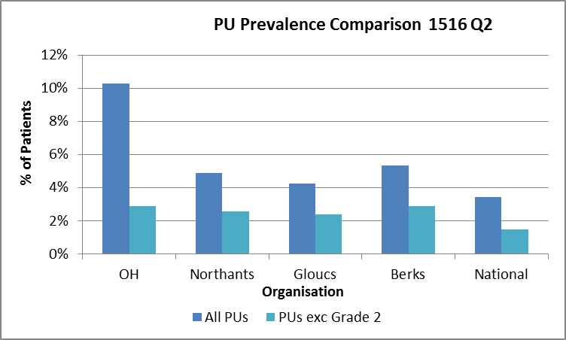 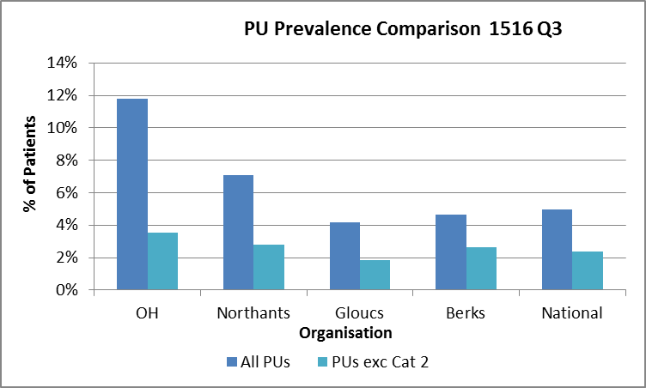

One possible interpretation is that OH staff clinicians are more effective at identifying category 2 PUs than their peers, and it is this vigilance that has influenced the high PU prevalence reported in the past. This information will continue to be collected throughout 2015-16.

It is useful to compare this with incidence data, which currently indicates that 1.51% of all PU incidents reported to date in 1516 by the Directorate were identified as Serious Incidents.

**Audit Rating**

|  |  |  |
| --- | --- | --- |
| **Standard %** | **Rating** | **Score** |
| 95-100% | Excellent | 1 |
| 80-94% | Good | 2 |
| 50-79% | Requires improvement | 3 |
| 0-49% | Unacceptable | 4 |

1. **NICE Guidance**

Implementation of NICE guidance

The Trust approach to the implementation of NICE guidance follows the principles set out in the NICE publication “*How to put NICE guidance into practice – a guide to implementation for organisations*” (NICE, 2005) with particular reference to the following key components:

* board support and clear leadership
* support from Clinical Governance and Risk Department to coordinate the process
* multidisciplinary committee structure to consider all new guidance
* systematic approach to financial planning
* systematic approach to implementing guidance
* evaluation and audit.

The Trust currently has robust systems in place for the identification of which NICE guidance/standards are of direct or indirect relevance to services (Appendix 1). New NICE guidelines, and updates to existing guidelines, are issued each month by NICE, through a monthly bulletin. The Medical Director and Head of Nursing review all of the guidelines and identify if the guidelines is of direct, indirect or no relevance to the organisation. This status is then sent through to all heads of nursing for verification.

All direct and indirect NICE guidance/standards are disseminated to clinical services via the Clinical Director who is asked to review these to determine which apply to which part of the services they provide and oversee implementation in their directorates.

Clinical directorates are then responsible for the implementation of the guidance, and after a period of six months are responsible for conducting a gap analysis to determine areas which do not comply. Where there is non-compliance with a new guideline then the relevant directorate is responsible for creating and monitoring an action plan. Where there are cost implications for implementation then this should be discussed with business managers and commissioners.

1. Current situation

As of December 2015, there were a total of 372 NICE guidelines, standards, technology appraisals and interventional procedures which apply either directly or indirectly to the three clinical directorates. Each of these guidelines has a number of separate standards or recommendations which clinical areas need to comply with.

Of the 372 guidelines, 142 have been identified as being of direct relevance to Trust services (these 37 are of direct relevance to adults, 25 to older adults and 75 in Children and Younger peoples services).

An up to date gap analysis has been conducted in each of the three directorates, which has shown that a considerable amount of work has been undertaken within clinical directorates and that there is a degree of assurance that services are either fully or partially compliant with a number of guidelines.

This process has however also highlighted a number of issues and areas for improvement. These include:

* A current backlog in conducting a number of gap analysis
* An up to date record had not been maintained by the clinical audit department (which has now been addressed)
* The existing status of applicability need to be revisited in line with service and contract changes
* Services are currently struggling to cope with the workload associated with the NICE implementation process.

1. Recommendations

The above position statement clearly outlines the need for a number of actions to be undertaken to move the Trust from its current position to fully compliant in all areas.

The recommendations for service changes are as follows:

* The development of a project plan in relation to the implementation of NICE guidance. This plan is currently being devised with the support of Directorate Heads of Nursing, and will have clearly outlined targets to move to full compliance within a year.
* The formation of a NICE implementation group which is chaired by a Head of nursing and a representative is present from all directorates to oversee the implementation of the project plan.
* Review of the role of the clinical audit team to ensure that up to date records are maintained.
* Directorates to ensure that there are NICE implementation leads in all areas.
* Consideration of a corporate dedicated resource for the implementation of NICE.

**4. Mental Health and Mental Capacity Acts**

**CQC Visits – Mental Health Act**

The information below outlines the 2 CQC MHA visits which have taken place since the last report. Although a range of positive comments were received, details of the issues of concern raised by the CQC following these visits together with our responses are detailed below:

|  |  |  |  |
| --- | --- | --- | --- |
| Date | Ward | Issue | Action |
| 27 November 2015 | Marlborough House, Swindon | IMHA services: commissioning issue,  Care Plan: recording patient views,  Rights: evidence of presentation,  Consent and capacity: evidence of assessment | To confirm with provider service level.  To align wellness and action recovery plans with care plan.  To respond to reminders, monitor, reflect and train.  To ensure clear recording and ensuring staff understand requirements. |
| 15 December  2015 | Cotswold House, Marlborough | AMHP reports: not always received but distance issues acknowledged,  Care Plans: focussed on treatment, | To remind local authorities and obtain reports.  Action taken to increase breadth and patient involvement |

The MHA/MCA Legislation Group is meeting monthly to increase efforts in improving compliance. All of the above issues have associated action plans in place which are being monitored by the Directorates.

**5. Infection Prevention and Control**

***Clostridium difficile***

There has been a case of *Clostridium difficile* infection (CDI) in December.

The health economy review meetings are held on the 2nd Monday of every month and will continue to review all cases for avoidablitity. Please note the December case will now discussed on 8th February 2016 as the January meeting has been cancelled.

Below is a summary of the review meetings for the cases in quarter 3:

|  |  |  |  |  |
| --- | --- | --- | --- | --- |
| Month | Location | Running total of cases | Avoidable/Unavoidable | Running total of avoidable |
| October 2015 | Ward 2 Abingdon | 4 | Unavoidable | 0 |
| Bicester | 5 | Unavoidable | 0 |
| November 2015 | City | 6 | Avoidable | 1 |
| December 2015 | Linfoot ward, Witney | 7 |  |  |

***MRSA bacteraemia/MSSA bacteraemia***

There have been no Trust attributable MRSA or MSSA bacteraemia cases in December.

***E.Coli bacteraemia***

There have been 2 community pre 48 hour E.Coli bacteraemias identified at EMUs in Abingdon and Witney. These are CCG cases and RCAs were completed.

**Outbreaks**

There have been no outbreaks to report in December.

**Aims for Older Adults Mental Health**

Work is ongoing within the AIMS Project Team within the directorate. The services are in the final process of completion of ‘starter’ paperwork and are liaising with the Royal College to arrange a launch workshop. Modern Matrons and Ward Managers continue to develop the action plan following the review of standards, combined with the drafting of an In-Patient Operational Protocol.

**MSNAP**

The service has been considering ways of ensuring MSNAP standards are maintained and embedded within practice.

The North Team have provided 3 further sets of evidence; the Royal College panel next sit on 20th Jan 2016, from which a final decision will be reached.

**Procedural Documents**

The guidelines for patient narratives have now been reviewed by information governance and the ethics committee. A discussion paper has been prepared to go back to the Taking Action from Patient Feedback group for final approval.

1. **Learning and Development**

**Care Certificate**

*The new Care Certificate* framework continues to be delivered as a taught 5 day programme for all HCAs and clinical support workers new to the trust. Programmes have run every 3 weeks since May 2015 and approx. 175 staff have undertaken this preparation to-date. The overall programme takes approximately 12 weeks to complete and competence is signed off in the clinical practice area. L&D are working with clinical areas to improve overall compliance rates and monitors the continuity of standards.

*Reporting Supervision* Increasing numbers of staff are now using the on line reporting system to record supervision activity. This process can be used for all types of supervision but management supervision is currently under reported. Monthly reminders are generated and sent by email to managers / supervisors to approve supervision activity.

**Fire Training:**

Whilst awaiting the recruitment of a new fire officer the Health & Safety team are covering Corporate Induction and Impatient training but are unable to provide sufficient fire awareness training places. National standards stipulate that staff should attend face to face training alternate years delivered by a qualified fire safety officer. This is currently being delivered from a vertical classroom. When appointed the new fire officer will be required to deliver training via the virtual classroom.

**Information Governance**

There is a new national target of 95% which should be reached by 31st March 2015. The current position is 78% trained.

**Action plan**. L&D are targeting those out of date and are monitoring the uptake of training.

**Pressure Damage.**

The target for training clinicians has increased from 90 – to 95% for all relevant staff by 31st March 2016.

**Action plan**. External training providers have been commissioned to work with the Tissue Viability team to ensure the consistency of delivery of appropriate training. L&D are currently working with TV and service areas to identify those who need to this training and to ensure they are booked onto session near to their clinical base.

**L&D move**

The L&D department moved to Unipart in November. The department had considerable IT internet and printing issues for 5 weeks leading up to Christmas. The problems are now fully resolved and the team are fully functional.

The PEACE team have now moved the gym at the Warneford and this is now their training centre.

The Resus team have also now moved to the farm House at the Warneford and deliver Resus training from the farm house. No data available at present to suggest that e change of venue has impacted on staff attendance rates.

1. **Medication Management**

The Drugs and Therapeutic Committee hashad good representation from all clinical services and CCGs and was quorate. The main areas discussed in Q3 included:

* New drugs approved for trust formulary – vortioxetine, lisdexamfetamine (for adults)
* Horizon scanning – new drugs in pipeline (e.g. guanfacin), emerging evidence (e.g. anti-inflammatory drugs in schizophrenia)
* Antibiotic prescribing and stewardship
* New NICE guidance relating to medicines
* Medicine safety and governance including policy updates, audits and incident reports.
* POMH audits and other clinical audits involving medicines – discussion about anticholinergic burden in older people and how to raise awareness of this and to record assessments of burden
* Innovative treatments – oral ketamine in treatment resistant depression

A new mechanism for distributing key DTG messages to staff has been well received (DTG bulletin and Net Formulary website).

* Revised Policy for Covert Administration of Medicines approved.

**Areas of unsatisfactory compliance/areas of risk**

* Medical Cases Sub-Group – concerns about lack of attendance / response from some services which is delaying progress with some developments (training etc.) The Sub-Group has requested that this be escalated to DTG and QSCE.
* DTG still requires a lay member representative.
* New format of BNF potentially causing issues with MHA documentation (BNF chapter numbering system removed) plus concerns nationally about format and a number of factual errors.

**Future Issues or concerns**

* The Innovation Sub-Group of DTG discussed a proposal from Dr Rupert McShane regarding the extended use of oral ketamine for treatment resistant depression. DTG supported this proposal and advised that this should be considered by QSCE for approval.
* Non-Medical Prescribing Sub-Group had advised that staff who use a NMP qualification should have this added to their job descriptions.
* A task and finish group will be established to agree which antimicrobial guidelines each clinical service in the trust should use.

**Recommendations**

* To note the highlight and escalation report and DTG Bulletin (attached)
* To support improved engagement with the Medical Gases Sub-Group
* To invite Dr McShane to next QSCE to present proposal regarding oral ketamine treatment