

**Paper BOD 124/2016**

(agenda item: 8)

# Report to the Meeting of the

# Oxford Health NHS Foundation Trust

# Board of Directors

**26 October 2016**

**Quality report: Patient Experience & Involvement**

**For Information**

**Executive Summary**

This quarterly report provides an update on patient experience and involvement projects within the Trust and a brief summary of the feedback we have received which tells us how it feels for patients to receive care, and how we have used this to work with people to improve their experience of receiving care and treatment.

Across our services the key and consistent areas for improvement fed back from service users, patients and carers continue to be:

* Patients want to **feel informed, be given options and take part in decision** (critical element: respect of patient centred values, preferences and expressed needs)
* Patients want to be provided with **good information** that is tailored to them and is timely, and they also want **staff to communicate clearly** with them (critical element: information, communication and education)
* **Families and carers want to be involved,** listened to and respected (critical element: Welcoming the involvement of family and friends)

Highlights of the report include:

**The patient experience feedback tender** has gone live and will close at the end of October with shortlisting, interviews and award of contract scheduled by December 2016.

**“I Want Great Care” pilot** is continuing to develop across the Trust with 5 new services added during September and multiple teams set up to begin using the system.

**Patient experience leads** in all 3 directorates have changed in the last 2 months due to changes in roles which has had an effect on consistency of information but new leads have been identified.

‘**Taking Action From Patient Feedback Group’** has agreed priorities for the patient experience strategy for year 1 and subsequent years. Please see attached information for further details. These will continue to be monitored through this group.

**Triangle of Care accreditation** update –trust wide work continues for developing training and carer specific information.

**Governor training** on Patient Experience and Involvement completed. Positive debate and feedback from attendees which can influence Governor involvement in patient experience feedback going forward.

**Community MH Survey 2016 draft results** have been published and presented to leads. Some emerging improvement themes from feedback included:

**Recommendation**

The Board is asked to note this report.

**Author and Title:** Donna Mackenzie, Patient Experience and Involvement Lead. Jane Kershaw, Acting Head of Quality and Safety

**Lead Executive Director:** Ros Alstead, Director of Nursing and Clinical Standards

1. **Introduction**

A quarterly report on patient’s experience is presented to the caring and responsive quality sub-committee and also the Board of Directors as part of the quality report (patient experience last presented Annual report in May 2016). An annual report also goes to the Quality Committee, last presented in July 2016.

The report focuses on updating the board on patient experience and involvement projects and workstreams and providing a summary of the feedback we have received which tells us how it feels for patients to receive care, and how we have used this to improve patient’s experience. The themes highlight the key areas for improvement identified in this report around communication and sharing information with patients and their families to enable joint decision making and involvement in care.

Feedback from patients, parents and carers is a very valuable source of information to measure patient experience however this report recognises that other sources for example activity data, clinical audit, staffing levels, incident data and staff feedback; are also important to measure and improve patients experience. The internal peer review programme continues to also be a useful source of feedback from patients and carers in addition to routine methods.

1. **Patient experience feedback tender**

The Patient Experience Feedback Tender is currently live with the aim:

“*The ability for all staff and services to be able to survey all service users and families and to be able to review and utilise the data at any time”*

The tender process will close at the end of October with shortlisting, interviews and award of contract scheduled by December 2016, when the existing contract ends

1. **Key development areas – update from February papers**

Below are the areas prioritised for development

1. Implementing the trust wide patient experience and involvement strategy.
2. Improving the reporting of feedback with our current external supplier (from electronic and postal sources) so that reports are more user-friendly and readily available at team, directorate and organisational level.
3. Improving the use and team ownership for responding to feedback posted on Patient Opinion, a public on-line feedback forum
4. Piloting software from a new external supplier called Iwantgreatcare which specialises in the use of on-line surveys and providing good quality reports

Below is a description of progress with each of the four development areas.

**4a. The Patient Experience and Involvement strategy**

The strategy was co-developed with patients, families/ carers and staff and finalised in April 2016 by the board of directors. The strategy outlines the key objectives around 3 domains identified as priorities by those involved in the development of the strategy; Person centred care, Involvement in services and Acting on feedback. The strategy is summarised in Appendix 1.

The trust wide ‘taking action on patient feedback’ group continues to be chaired by the Deputy Director of Nursing and meets quarterly. This group reports to the Caring and Responsive quality sub-committee with the purpose to;

* Monitor and give oversight on the objectives to deliver the patient experience strategy,
* to share good practice
* as a forum for services to demonstrate how they are using feedback to improve the patient experience.

The membership of the group includes service user/carer ‘Members’, staff and governors and work is continuing to further develop patient/carer member representatives at the meeting.

The group has had two workshops in May and July 16 to develop and prioritise a work plan for the next 3 years. This work plan has been agreed however further work is needed to identify the additional resources needed to fully deliver the strategy. A number of the actions in the work plan have started already, one of the key areas in year 1 is the re-tender of how we collect and report on feedback (see above). The work plan for year 1 objectives can be seen in Appendix 2.

Patient experience leads in all 3 directorates have changed in the last two months due to changes in roles which has had an effect on consistency of information but new leads have been identified to continue leading on implementing the strategy.

4b. **Improving and developing user friendly reports for teams on their feedback (CRT)**

A new survey app has been developed by the current external supplier and was made available to all teams from August 2016. Some further development work is ongoing with the provider following feedback from services about the level of data available and usability of the tool. This will continue up to the end of the contract on 31st Dec 2016.

4c. **Patient Opinion**

A pilot project started in September 2015 around the use of Patient Opinion which has now come to an end. The pilot to raise the profile of Patient Opinion as a feedback option for patients resulted in a small but not significant increase in feedback on the website with the ability for designated staff to respond to the feedback directly. Patients are still able to give feedback via patient opinion or NHS choices which is monitored and people are still responded to, although this is not directly by senior clinical staff.

4d. **Iwantgreatcare**

The IWGC pilot continues to expand across services within the Trust. 57 teams/ services now have access to the patient surveys online or can print these to give out paper surveys. The initial 6 month trial has been extended to inform and ensure continuity until the new patient experience feedback contract is in place (mentioned above).

Services included in the iwantgreatcare project;

* + - Respiratory/ pulmonary rehab service
    - District Nursing service
    - Community Hospitals
    - Tissue viability
    - Community Children and Adolescent Mental Health Teams
    - Dental service
    - Tuberculosis Nursing Service
    - Older people mental health wards
    - Older people Community Mental Health Teams
    - Urgent care; Minor Injury Units,Hospital at Home and Emergency EMU
    - GP OOH
    - Adult mental health wards
    - Adult Mental Health Teams

All services accessing IWGC are able to download their individual team reports as well as reports with information analysed by service line, care group, directorate or Trustwide.

The full September Trustwide report is shown in Appendix 3

**Trustwide summary:**

Average score against the set six questions asked across all services during September - **4.67/ 5**

Total number of responses this period - **178**

This table shows respondents age, gender, ethnicity and identified disabilities for September 2016

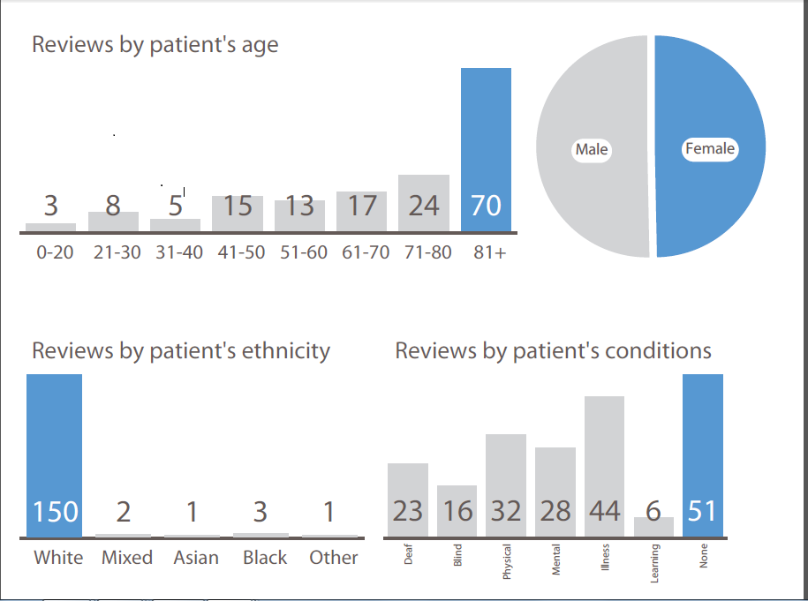

1. **Community Mental Health Survey 2016 Results**

|  |
| --- |
| The National Community Mental Health Survey was undertaken between February and June 2016 by an external contractor. |
| The sample for the survey was generated at random on the agreed national protocol from all clients on CPA and not on CPA who were seen between 1st September and 30th November 2015. |

The survey was completed by 253 service users, which is a response of 31% (above national average).

The draft feedback has been shared by the contractor and the results were presented to senior managers in the directorate in Oct 2016. The results will be published by the CQC shortly.

|  |
| --- |
| The Trust was rated within the top 20% in a number of areas and within the intermediate 60% of all 49 Trusts surveyed in 2016 by the same external contractor (this equates to 90% of other mental health trusts). There has been a significant improvement across many of the questions from the survey results in 2015 and 2014. |
|  |
| * 65.5% of service users say they feel they are seen often enough for their needs. |
| * 81.2% of service users said they had been told who was in charge of organising their care. * 98.2% said they knew how to contact this person if they had a concern about their care. These scores are in the top 20% of Trusts. * 82.4% of service users felt their care was organised to meet their needs.   Staff provided help and support for patients:  Finding and keep work – up 12% (to 51%)  Physical Health – up 13% (to 57%)  *\*Both above national average\**  There are six areas where the Trust is in the lower 20% but not significantly below national average and is not considered to be of concern.  These are where service users feel that communications need to be better, being given time and being involved, in particular, in decision making and aresimilar to SI and complaint themes**:**   * 76% said they were listened to carefully (slight decline from 2015 and slightly lower than average of most mental health trusts at 81%) * 68% said they felt involved in discussions in agreeing care (lower than average) * 72% said they felt involved in discussions in their care review meetings (lower than average). However positive on agreed the care they'll receive and had a formal review meeting in the last 12 months. * 70% said they know who to contact out of hours if in crisis (similar to last year and average of most mental health trusts)   Change to services has had a negative impact on their care - % up, although a lower number of respondents said they had experienced a change in care coordinator. |

Some emerging improvement themes have also been identified from the open comments given, which align to the rest of the results,

Access Communication

Waiting times for therapy Medication

Signposting Ease of contact

Information around expectations Ongoing support

Links with other organisations Information for Loved ones

**Word cloud from open comments responses from Community MH Survey results 2016**

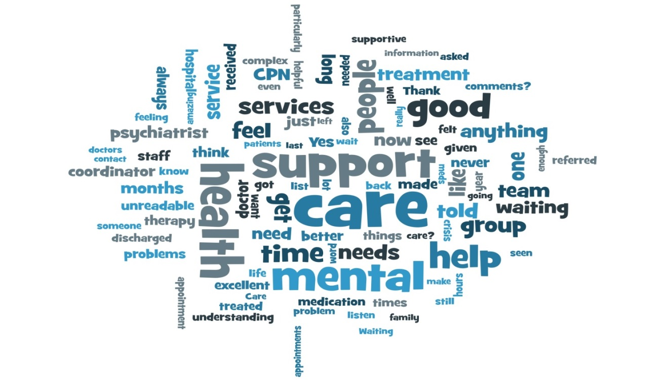

**Actions happening** The results overall are positive with improvements from last year and when compared with other mental health trusts, although some of the thresholds are quite low. As discussed the areas to continue to work on/ keep an eye on are those we are already aware of and working on. Some of the actions are detailed below.

* Work on the integration of psychological therapies into Adult Mental Health Teams –sessions on enhanced communication and listening to be included in workshops
* Staffing levels - vacancies/ high use of agency - trust wide strategic recruitment group, golden handshakes being reconsidered ,flexible hours, developing apprentices in clinical areas, looking at cost of living enhancements, and locally the directorate are enhancing local induction resources for agency staff.
* Reviewing the assessment end of the AMHT service model considering staff feedback/ experiences – future options for revisions to be taken forward
* Consider looking at standardising patient/ family surgeries across wards and AMHTs led by clinical leads to listen and resolve issues more quickly

1. **Recovery Colleges**

The trust, Buckinghamshire MIND and Buckinghamshire Adult Learning are working together to open the Buckinghamshire recovery college. The structures and planning behind setting up the college are well progressed with key leadership posts in place, and here has been good patient and carer involvement in the steering groups to set up the co-designed and co-delivered courses and to look at the promotion and advertising for the college. Two weeks of taster sessions at the Whiteleaf centre hub have been held, with a huge response for trainers both professional and people with lived experience, over 200 applications, and learning plans.  Courses range from recovery focus and psycho-educational to arts, crafts, gardening and living skills. The Oxfordshire recovery college continues to grow and the college is currently promoting new spring term courses.

1. **Triangle of Care**

In December 2015 the Carers Trust accredited the trust with two gold stars, the third (and last star) will be achieved when all mental health and community teams/ wards have completed the self-assessment and identified/ addressed any gaps. This has not yet been achieved by any Trust nationally. The Carers Strategy Forum continues to monitor progress and themes from the self-assessments, and work continues across the Trust to develop carer specific information within teams as well as training for staff around carer awareness and assessment in line with the triangle of care accreditation criteria. Carer awareness training has been rolled out to Adult Mental Health Teams in conjunction with Rethink following positive feedback from the pilot sessions and is near completion to be rolled out across the Older Adults and Children and Young People directorates.

The Directorate Carer Leads alongside Executive representative will attend the National Triangle of Care meeting in November to present an update of work over the past year and take part in the re-accreditation process to maintain the 2 star rating. In addition the trust is just starting a cross agency piece of work in Oxfordshire with carers to develop a carers charter.

1. **Summary of feedback**

Overwhelming the feedback we have received from patients, families and carers is very positive with patients reporting feeling cared for by staff and that as a result they highly value the service provided. However some people do not receive the positive experience we expect every person to have and therefore we have more work to do. The themes highlighted from complaints mirror the key areas for improvement identified from the feedback we receive, and are focused on communication and sharing information with patients and their families/carers to enable joint decision making and full involvement in care. Appendix 4 includes some examples of the actions which have been taken as the result of feedback over the last three months.

In response to the national set friends and family test question, how likely are you to recommend this ward/ team to friends and family if they needed similar care or treatment? Counting positive responses of extremely likely or likely. These results are submitted to NHS England on a monthly basis.

Apr 16 = 801/854 = 93.8%

May 16 = 999/1055= 94.7%

June 16 = 922/967= 95.3%

July 16 = 749/797 = 94%

Aug 16 = 527/558 = 94.4%

Sept 16 = 363/396* = 91.7%

YTD = 4361/4627 = 94.3%

* One of our external contractors has reported that there is very little data for postal surveys this month primarily due to timing issues and some major delays with various national surveys*

Last month a patient story was shared with the board of directors and council of governors from a mother about her son’s care. She raised a number of important issues relating to the quality of care and communication when care is shared and moved from one team to another or between agencies. Her story has helped to focus a series of work including the below, although we recognize more work is needed as this is also a common learning theme from SI investigations;

* + Buckinghamshire and Oxfordshire have set up CAMHS/ AMHT transition forums to discuss current people coming up to 17.5 year old to start planning earlier.
  + Buckinghamshire are appointing a joint commissioner for CAMHS and AMHT services
  + Buckinghamshire CAMHS have co-developed a new information leaflet for young people and parents about transition and planning for this
  + Staff supervision in CAMHS now includes looking at who in their caseload and coming up to 17.5 years old
  + The new Service Director for the adult mental health services brings extensive experience and knowledge of delivering and managing children’s services
  + There is national work looking at the transition age for children and adult services – this is challenging as it needs to be personalised to each individual and there are commissioning impacts

There is a recognised gap and difference in service provided between CAMHS and adult mental health services, again staff need to be supported and enabled to take a personalised approach

1. **Conclusion**

The report shares a progress update against the patient experience and involvement strategy 2016-2019, the areas of development being prioritised, progress from the Carers Strategy Forum, an update on the national community mental health survey and a summary of recent feedback.

Three key areas are identified for improvement, also reflected in complaints received and learning from SI investigations; these are:

* patients being involved in decisions and choices about their care
* wanting good information and clear communication, and
* patient’s families and carers feeling listened to and involved.

A range of examples of how services and teams have acted on feedback to improve patients experience over the last three months are shared in appendix 4.

**Appendix 1**



**Appendix 2**

**Patient Experience and Involvement Strategy Year 1 Key objectives**

|  |  |  |
| --- | --- | --- |
| **Aim** | **Objective** | **Action** |
| Person centred care | To ensure all people who use our services and their carers are involved and are valued as equal partners in the involvement activity. | Use the involvement ladder (Appendix 4) and the 4Pi National Involvement Standards (developed by the National Survivor User Network) to identify the level of patient involvement in Trust wide activities to role model expectations e.g. board meetings, training and education, serious incident investigations, complaints process, service developments, conferences and leadership programmes. Improvements to be identified following the exercise: a) The trust to explore staffs current beliefs in regard to involvement b) Complete a trust wide mapping of current involvement activities to establish a baseline measure to assess improvements and to share good practice. To also include an update of the mapping exercise of how services/ teams are collecting, sharing and using feedback |
|
| Developing of a designated budget for all services to use to pay for reimbursement of involvement work, so that funding does not potentially become a barrier to involvement |
| Develop a regular method for sharing and celebrating across teams and services excellent examples of person centred care, this could be a conference, learning event, emails, blogs, face book, tweet, periscope etc. |
| Identify teams/ services which could employ peer support workers, initiatives for staff to mentor patients, taking young people for work experience, apprentices, and use volunteers. Support these teams to fully utilise the benefits of these roles e.g. peer support worker training (possibly from a voluntary organisation), peer support worker networking events, set up a volunteer service to coordinate volunteering etc. |
| Develop a scheme to identify ‘beacon teams’ demonstrating good practice for all aspects of patient feedback/ involvement to spread to other teams so clearly demonstrating why good involvement ‘looks like’ |
| Improve engagement of patients and carers in care planning in all teams so that All patients, and where appropriate carers, are offered the opportunity to develop their care plan and risk assessment as part of working in partnership. All care plans are personalised and meet the individual’s need and identify clear goals | Directorate level care planning forums to be established to identify/ share good examples of care plans and areas for improvement across teams and professionals to improve the quality of care plans |
| Organise visits to other organisation to learn from them. |
| All projects for service redesign/ developments will include people who use our services from the planning stage | All service redesign project plans will undertake a patient involvement assessment to ensure involvement of patients takes place from the outset of any project |
| Involvement assessment tools for service developments to be developed and agreed. |
| Information will be provided in a format which is easily understandable, so enabling accessibility for all | Service leaflets will be available as easy read and in the most commonly used languages as identified by NHS England/and locally, where English is not the first language |
| When replacing signage for services, new signs will include easy read format and where appropriate, in languages additional to English |
| Assessment of the most appropriate methods for sharing information will be undertaken and should consider audio, visual, written, Braille, according to peoples individual needs |
| Patient involvement and /co-design of services | To increase the use of ‘social media’ and modern technology as a means of engaging and involving people better so that people can share their experiences | Develop both the internet and staff intranet patient experience and involvement site on OHFT web sites so that results and learning (at service level) from patient experiences are able to be shared |
| Report and publish feedback received quarterly and the actions taken as a result of the feedback at directorate and service level. |
| Develop both the internet and intranet patient experience and involvement pages on OHFT website so that the patient involvement activities are promoted e.g. using # on twitter |
| Show clearly and diagrammatically the tiers of management/ panels/boards that are responsible for the delivery of the strategy and commissioning of the Services. Their contact details should be shown. There should be a clear demonstration of the structure of management and how this sits in relationship to all of the patients, families and carers panels |
| To ensure those people who want to get involved are able to access information easily and in a format which they can understand | Information about involvement activities will be made available in a variety of places and in a range of ways. This will be updated regularly to promote involvement and to build a network e.g. social media, internet, newsletters, working closely with partner and voluntary organisations, discharge information etc….This will require a nominated person to maintain the information and details, contacts, purpose |
| Increase the amount of involvement activities offered and being taken up and peoples experiences of being involved, including focus groups to start the understanding | Introduce virtual/ actual ‘involvement centres’ across the trust to enable people to come and talk about involvement activities available and to share/ network with peers. It is important that we have consistency in the group |
| Work alongside trust membership team to implement new system and approach to increasing members and looking at how people ‘get involved’ in activities and developing services |
| To increase the number of people in involvement activities from the ‘harder to reach groups | Develop the use of demographic data to identify those harder to reach groups where we do not receive feedback |
| Explore with harder to reach groups how we can involve them better so that they have good experiences of care and can be involved as much as they wish |
| To work in closer partnership with voluntary /charitable agencies, who are experts by experience e.g. Personality Disorder Training & Emergence Charity , MIND, STARS, Age UK, Barnardos |
| Interview panels will include people who use or have used our services and carers, as equal partners | Scope adding ‘lived experience’ as desirable criteria in all job descriptions |
| Peer review visits will include people who have used our services as a normal part of the process | Peer review teams will include people who have used our services and will consider accessibility of information as part of their visits |
| Guidance, mentoring and training will be provided for those on the peer review teams. Ensuing confidentiality addressed. |
| Trust governors will be active participants in involvement activities/ peer review visits. Aim by end of 2018/19 that 40% of peer review visits will include governors. |
| Develop a structured framework and guidance for governors to use when undertaking ‘walk-rounds’ so enabling an assessment on experience, involvement and safety e.g. 15 step challenge |
| To explore development of a research/evidence based project (co-produced with patients and staff), based on the patient’s journey, working in partnership with patients, carers and families and partner organisations (e.g. OUH, BHT, OBU) so contributing to the national body of evidence in regards to patient experience and involvement |
| Acting on feedback | To increase the amount of feedback from patients and making changes for improvements based on the feedback | Embed the quality improvement approach (plan, do, study, act) to better demonstrate at service/ team level the changes made as a result of feedback and how this impacts on people’s future experiences. |
| Report and monitor how changes are impacting on peoples experiences using different formats. Reporting to be at least quarterly to the Board of Directors. |
| Review how the information from various sources of feedback is pulled together, presented and shared. Working to information being readily available at team/ service and trust wide level |
| Develop approaches to how we feedback results and actions taken to patients/ carers |
| Patient experience/ involvement champion to be identified in every team/ ward or cluster of teams. JD to be developed to define expectations of the role. |
| Every team/ ward to introduce a standing agenda item on their business meeting to discuss positive and negative feedback from patients/ carers and what improvements will be introduced |
| Complete external re-tender for patient experience contract (software and hardware) to support teams with collecting and receiving information in a user friendly format and in a variety of ways according to patient need. |
| Make positive and less positive feedback more readily available to teams and develop how information is published |

**Appendix 3**

**I Want Great Care Trust Wide report for September**

**Appendix 4**

**Examples of patient feedback and “You said, We did” from Directorates.**

Older Adults

*Dear Nurses and Carers, you really have been such wonderful people caring for me so very well whilst I’ve been your patient. Not only are you all very good at your jobs but you give the care with great sympathy, compassion and understanding, which I know seems so much to your patients. I shall miss all of you when I leave and will never forget your many kindnesses. I wish you all the very best for the future.*

**Ward 1 Abingdon**

*Just a few words for the nurse who attended and changed my dressing yesterday. All done efficiently and kindly. Us ’oldies’ are so lucky to have such a team that will attend our houses and administer help where it’s needed. Further visits anticipated, so here is further thanks in advance.*

**Kidlington, Exeter & Yarnton DNs**

**You Said / We Did examples**

***You Said:*** *It would be nice to have a communal garden like the one in Witney Hospital*

***We Did:*** *We have worked with estates and our garden will be regenerated in time for next year*

***You Said:*** *The nurses are busy, often rushing and sometimes I was getting up only just before lunch*

***We Did****: We have reviewed our morning routine to allow more time for the nurses to spend with patients*

***You Said:*** *My room was untidy and the wash hand basin was dirty*

***We Did:*** *We are working with the domestic team to monitor the cleanliness of rooms*

**City Community Hospital**

Adults

**Oxford City AMHT** – service users said they would like peer support workers (people with lived experience) to support them within the team.  The team are looking into how this can be done and what the practical steps to take would be to make this happen.

**Opal Rehabilitation in-patient service** – patients said they would like the multi-purpose room painted a brighter colour as the beige is dull and uninviting.  Patients were consulted and chose a pastel aqua colour which has now been completed.  Patients said they would like to have different activities available on the ward, activities that were put in place were – doing something different group, sports event sessions and mutual/peer support group.

Children and Young People

Feedback from parents said a parent/carer group would be helpful.

Action : We now have a parent group up and running now and aim to make it a rolling programme, offering a more formal structured session every 3-4 months as well as possibly more informal, supportive sessions more frequently. Feedback from first session was positive and we are exploring ways to encourage parents to attend.

Wherever we can, we have tried to be flexible and responded to seeing clients or professionals in place and time that is suitable for their needs. For example, seeing them closer to their home base, meeting in schools, or utilising rooms in hubs or CAMHS in their respective areas.

**Oxfordshire CAMHS**

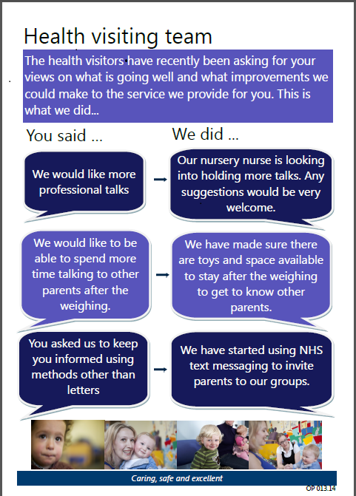Health Visiting Poster Aug 16

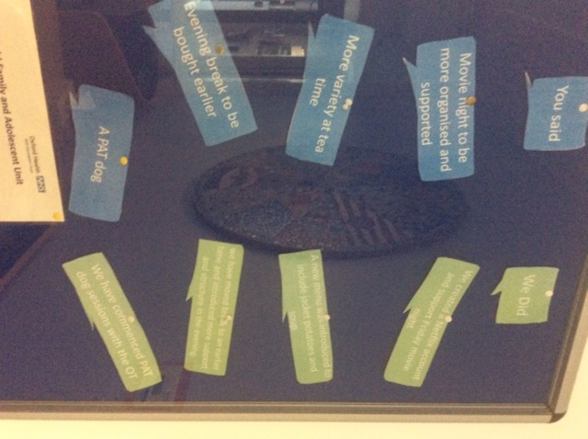

The Highfield Unit Notice board, August 2016