BOD 13/2016
(Agenda item: 16)

Report to the Meeting of the

Oxford Health NHS Foundation Trust

Board of Directors
27th January 2016
Research and Development

For: Information
Executive Summary
The report provides an overview of Research Activity within Oxford Health NHS FT. The R&D department continues to support high quality research across the organization and in collaboration with other organisations, predominantly the University of Oxford and Oxford University Hospitals.
The Oxford Academic Health Science Network (AHSN) continues to host three themes, Early intervention led by Prof Belinda Lennox and Sarah Amani, Anxiety and Depression led by Prof David Clark and Ineke Wolsey and Dementia led by Dr Rupert McShane which are expected to continue until March 2016.
The Oxford NIHR Collaboration in Leadership in Applied Health Research and Care (CLAHRC) led by Professor Richard Hobbs has made good progress since beginning in January 2014. The number of projects within Phase 1 (01/01/2014 – 31/03/2016) has increased by 68% from 19 to 32 projects. 30 publications have been generated from CLAHRC research to date. The CLAHRC has leveraged £1.5 million in external funding and £5.1 million in matched funding. In November 2015 the CLAHRC hosted a site visit from the NIHR and the Department of Health. The visit went extremely well and they were impressed with the progress the CLAHRC has made in all areas to date, in addition to the Annual Report for 2014 being received very well following submission in summer 2015.
The NIHR Diagnostic Evidence Co-operative (DEC) led by Dr Ann Van den Bruel within the Department of Primary Care at the University of Oxford has consolidated its expertise in diagnostic test evaluation and established important links both nationally and internationally with 17 formal interactions with external companies.
The NIHR Oxford cognitive health Clinical Research Facility (CRF) led by Professor John Geddes encompasses four sites across Oxford; Department of Experimental Psychology, the Charles Wolfson Clinical Neuroscience Facility at the John Radcliffe Hospital and the Warneford Hospital. It continues to undertake a wide range of both commercial and non-commercial research studies.

The NIHR are now requesting quarterly data on recruitment to research studies and publications from the infrastructure funding awards. The CLAHRC and DEC provide a combined report sent from Oxford Health NHS FT and the CRF is submitted in conjunction with the Oxford University Hospital NHS FT due to funding host arrangements.
R&D continues to develop with new structures and data capture mechanisms being established to streamline the set up of research within the Trust in line with the new Health Research Authority in trying to reduce duplication nationally for research applications. The Case Records Interactive Search (CRIS) system has received ethical approval and is being roll out of the system is in progress.
R&D is developing a Biomedical Research Centre Application in collaboration with the University of Oxford following the announcement in December 2015 and is closely supported by Oxford University Hospitals HNS FT. Progress is being made with Pre Qualifying Questionnaires submitted in February 2016 to harness the excellence science and collaborations.
R&D at the end of period 8 (November 2015) had generated a £26k favourable variance in budget with currently a small £9k favourable forecast outturn position predicted. This is reviewed and amended on a monthly basis to reflect changes, in particular those impacting on study start dates and recruitment activity.

Recommendation
No recommendations

Author and Title: Prof John Geddes, Director of R&D
Emma Stratful, Head of R&D

Lead Executive Director: Dr Clive Meux

Contents
1 Clinical Quality and Care 4
2 Networks and Collaborations 4
2.1 Oxford Academic Health Science Network (OAHSN) 4
2.1.1 Early Intervention Theme 4
2.1.2 Anxiety and Depression Theme 6
2.1.3 Dementia Theme 6
2.2 OXFORD NIHR Collaboration in Leadership in Applied Health Research and Care (CLAHRC) 9
2.2.1 CLAHRC Annual Stakeholder Symposium 9
2.2.2 NIHR Visit and Annual Report 10
2.3 NIHR Diagnostic Evidence Co-operative (DEC) 10
2.4 NIHR Oxford cognitive health Clinical Research Facility (CRF) 11
2.4.1 Reporting 11
2.4.2 Occupancy 11
2.4.3 Studies 11
2.4.4 Future studies 11
2.4.5 Collaborations 12
2.4.6 Renewal of CRF funding 12
2.5 NIHR BRC 12
2.6 NIHR CRN 13
3 Research Governance 13
3.1 R&D Governance Group 13
3.2 Contract Review Processes 14
3.3 R&D Data Capture Mechanisms 14
3.3.1 Expressions of Interest 14
3.3.2 Pipeline Meetings 14
3.3.3 HRA 14
3.3.4 R&D Data Capture 15
3.3.5 Monitoring and Auditing of research projects 15
3.3.6 Safety committee 15
3.4 New Meeting Structure 15
4 Studies and Participant Recruitment 16
4.1 Studies 16
4.2 Participant Recruitment 16
4.3 Grant applications 17
4.4 NIHR Metrics and Targets 17
5 Case Records Interactive Search (CRIS) 18
6 Finance 19
6.1 FY16 Performance 19
6.2 Research Capability Funding (RCF) 19
6.3 FY16 RCF Allocation 20
6.4 Clinical Research Facility (CRF) 20
6.5 Clinical Research Network: Thames Valley and South Midlands (CRN) 21
6.6 Financial Risks and Issues 21
6.6.1 R&D Income Summary FY17 21
6.7 Redundancy Costs 22
6.8 Study Report and Publication dates 22
6.9 Collaboration in Leadership in Applied Health Research and Care (CLAHRC) 22
6.9.1 CLAHRC Budgets 23
6.9.2 Performance 23
6.10 Oxford Academic Health Science Network (OAHSN) 24
7 Estates 24
8 Staffing 24
9 Communications 25
9.1 Trust R&D Website 25
9.2 Radio Interview 25
9.3 Research Open Day 16th December 2015 25

Clinical Quality and Care
Participation in research produces widespread benefits for patients and, more generally, improvements in quality of care. A Censuswide comsumer poll of 3,000 people in England, commissioned by the NIHR published data in September 2014 saying that 95% of those as responding stated that it is very important that the NHS carries out clinical research, with 85% or people agreeing that they would be very or somewhat willing to take part if they were diagnosed with a medical condition or disease. This accounted for the main factor that was most likely to motivate them into taking part, along with if a friend/family member was taken seriously ill and didn’t have the treatment they needed. The majority of those surveyed said that clinical research takes place within the NHS, Universities and Clinical Trials Units. Oxford health NHS FT has strong links to the University of Oxford, a thriving R&D department and Clinical Research Facility to enable high quality research to take place and provide opportunities for patients and carers.

Networks and Collaborations

Oxford Academic Health Science Network (OAHSN)
Oxford Health NHS FT is hosting three OAHSN themes;
- Early intervention led by Prof Belinda Lennox and Sarah Amani
- Anxiety and Depression led by Prof David Clark and Ineke Wolsey
- Dementia led by Dr Rupert McShane
The financial performance of these networks was combined with R&D on the monthly board report throughout FY15. From April 2015 they are being reported separately.

Early Intervention Theme
The Oxford AHSN EI Network are currently hosting the EIP Preparedness Programme for the South of England and the priority of the theme is the Early Intervention in Psychosis Access and Waiting Time Standards
It was originally set up to support Oxfordshire, Buckinghamshire, Berkshire and Milton Keynes providers and commissioners. Oxford AHSN’s Early Intervention Network’s work on EIP transformation led to a request to extend its EIP programme to the south of England to support 16 mental health trusts and 50 CCGs, shown below in implementing the EIP access and waiting time standards.
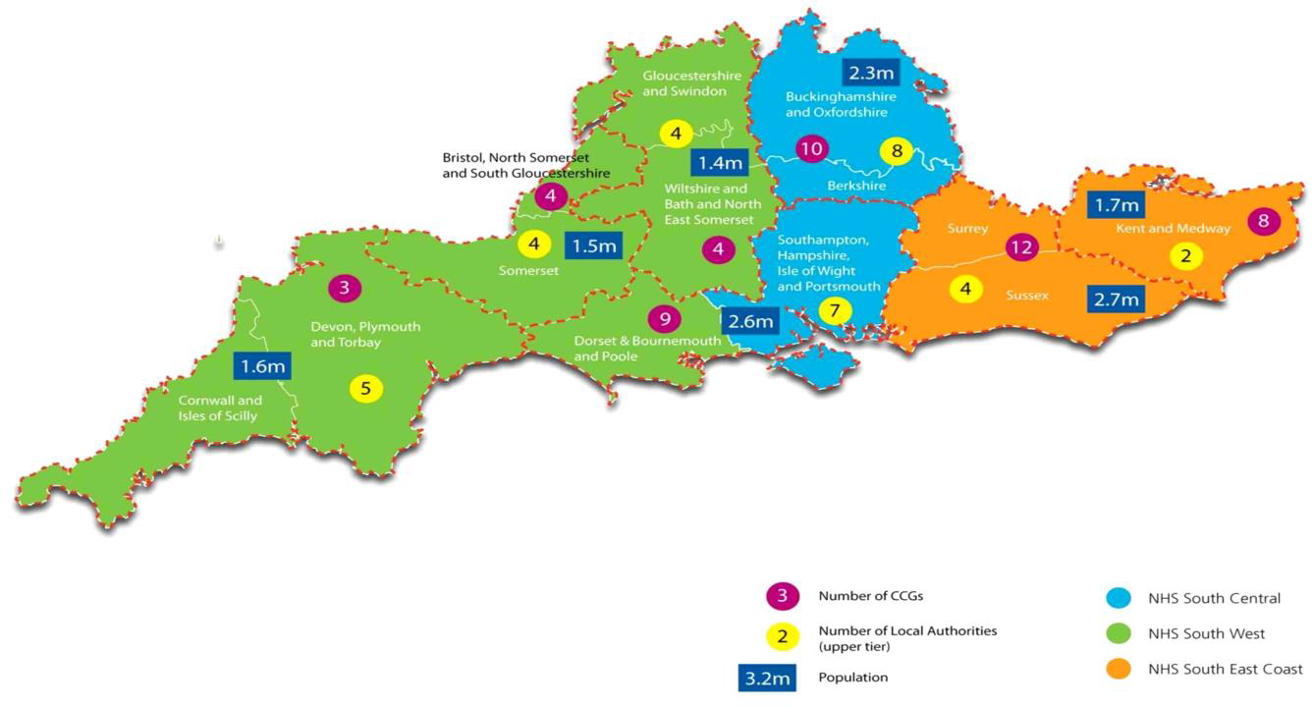

Objectives and Deliverables
- To raise awareness of the requirements of the EIP access and waiting time standards
  - South EIP Preparedness established http://time4recovery.com
  - ‘Five Things to Know About EIP by April 2016’ poster and postcards written
- To bring together local experts and establish quality improvement networks, ensuring effective linkage with existing networks of expertise.
  - South EIP Clinical Group established and meet monthly
  - South EIP Preparedness Programme Board established and meet bi-monthly
- To benchmark levels of demand, workforce competencies & establish baseline performance in constituent CCGs – including any inequities in financial investment, team structures and access relative to the psychosis incidence in the population.
  - EIP Matrix Self-Assessment Tool http://time4recovery.com/eip-matrix/
  - EIP Workforce, Performance & Outcomes Data Analysis
- To support CCGs and providers in developing local preparedness action plans to meet the EIP access and waiting time standards.
  - Organized five SDIP workshops
  - Developed example SDIPs
- To allocate targeted funding to accelerate the implementation & support workforce development programmes of work with Trusts and Health Education England.

Anxiety and Depression Theme
The Anxiety and Depression Network has been awarded a further two years funding to continue its work in improving patient outcomes and reducing variation in psychological treatments for common mental health disorders (Improving Access to Psychological Therapies - IAPT services).

Project 1: Enhancing recovery rates in IAPT services
All service leads within the AHSN areas (Bucks, Berks, Oxon, Beds and Milton Keynes), their deputies and data leads meet quarterly to explore in detail all performance data available, especially recovery rates. Based on this exploration, action plans were agreed and specific training and development activity has taken place to enhance recovery rates including ICD Coding Workshop (accurate problem descriptors/provisional diagnoses are needed to determine the correct treatment protocol to be offered and, with that, improve patient outcomes and recovery rates), PTSD workshop (offering advanced skills development as recovery rates for PTSD too low) and Behavioural Couples Therapy (to enable step 2 staff to undertake some basic couples interventions). The A&D Network achieved a 10% improvement in overall recovery rates (from 46% to 56%) during its first 18 months, at a time when national recovery rates remained static at 46%.

Dissemination of new service innovations
All services have adopted a new or newly adapted innovation over the past six months :Berks adapted Diabetes treatment for patients suffering with diabetes and/or depression or anxiety, Oxon started roll-out of COPD (but was interrupted when service out to tender), Bucks piloted Diabetes treatment, Milton Keynes has started CBT for Insomnia treatment, Luton has started with PPIPCare (Psychological Perspectives in Primary Care) training sessions. We have also now started a health economics evaluation of all completed pathfinder LTC projects (Diabetes, Heart2Heart, Breathe Well, MUS) which will be completed by July 2016.

Collecting Routine outcome Measures in CAMHs: CYP IAPT project
Children and Young People’s IAPT have now established a collaborative of all data managers and service managers for CAMHs services across our AHSN patch. Local performance data on completion of paired outcomes has been collected as the national data base (CORC) is not reliable or meaningful as yet. Following this it was an action plan agreed with all services in order to improve ROMs collection. A second download of data (nos of paired outcomes recorded) from all services to compare to baseline figures from earlier in the year is expected. Work continues with the CAMHS to resolve data collection issues (systems, culture) with the testing of a new data collection system started in December.

Dementia Theme

Unwarranted variation project
This project aims to address unwarranted variation within dementia services across Oxford AHSN area (Berkshire, Buckinghamshire, Milton Keynes and Oxfordshire). This has been achieved by means of Webinars including successful dementia network webinars. Over this period webinar topics have included fronto-temporal dementia, the value of brain imaging, Deprivation of Liberty safeguards, and home care for people living with dementia. A further programme of webinars is being developed.
Dr Jacqui Hussey from the Wokingham memory assessment service collated data including prescribing, diagnosis, referrals and clinic skill mix, which was presented at our event in September. The diagnostic boundary around Mild Cognitive Impairment was also addressed in a presentation and discussion by Dr Rupert McShane and Dr Simon Lovestone of OHFT. This will continue to be addressed this theme in the future.

Memory Services Accreditation
All of the OHFT memory clinics, and the Milton Keynes memory assessment service, were assessed under the Royal College of Psychiatrists’ Memory Services National Accreditation Programme (MSNAP). This work was facilitated by Maureen Cundell, a nurse from the Oxford City memory assessment clinic who was seconded two days a week to the Dementia Network. Maureen worked with the clinics preparing for accreditation, helping them to evidence standards and work on standards not currently met. Five of the six clinics received accreditation in October, with three of them deemed excellent, and a further clinic needed to submit more evidence on a handful of standards and it is hoped will be accredited in January. One of the key successes of Maureen’s approach was to facilitate collaboration between clinics by having them visit each others’ service to run ‘mock’ reviews.

Services for Young People with Dementia
The dementia clinical network has supported the Young People with Dementia (YPWD) service in West Berkshire and this has now achieved recurrent funding from the CCG. The service provides age appropriate activities for people with young onset dementia and respite for their carers. There is evidence to suggest that carer education and regular support can reduce carer stress and delays the person with YOD going into institutionalised care. There is also a specific dementia care advisor and an Admiral Nurse within the service. The network is now funding YPWD to run services in East Berkshire for a year to demonstrate the benefit in that area too.

Shared dementia event with Strategic Clinical Network
In September we collaborated with the Strategic Clinical Network to run a very successful Dementia Event attended by over 80 people. The agenda included talks on the following:
- Strategic Clinical Network projects, Dr Geoff Payne, Strategic Clinical Network
- Dementia training initiatives, Jacqueline Fairbairn-Platt, Health Education Thames Valley
- Post diagnostic support, Dr Stephanie Oldroyd
- Variations on a “dementia” theme – diagnosis and prescribing across the Thames Valley, Dr Jacqui Hussey
- End of Life Care for people with Dementia, Dr Barbara Barrie
- How to engage people with a fabulous piece of food theatre, Connie’s Colander
- YPWD and Young Dementia UK, Dr Jacqui Hussey and Mandy Blair
- Keynote workshop: Case based discussion of mild cognitive impairment and mixed dementia diagnosis: criteria and reliability, Professor Simon Lovestone

Successful bidding for Oxford AHSN Round 2 2016-18
Much energy in the last period has been directed to developing plans for the next two years and participating in AHSN’s Round 2 bidding process. The bid was successful and the dementia network has agreed funding until March 2018. The bid consisted largely of projects proposed by stakeholders, and the projects being taken forwards are:
- Reducing variation – identification and reduction of unwarranted variation across the AHSN area through further dementia webinars, addressing areas of variation demonstrated by Trust data, and working collaboratively to develop consensus best practice pathways, for example for fronto-temporal dementia.
- Memory clinic improvement work – includes consolidation of MSNAP process, preparation for reaccreditation, and working for improvement on particular topics, for example memory assessment for BME populations.
- Young onset dementia – addressing variation in services by the YPWD service offering training and week long shadowing opportunities to enable spread of this successful model to less-well served areas.
- Best practice network for care homes and in-reach teams – working with Jane Fossey and Lucy Garrod of OHFT, this project aims to establish a best practice network in the Thames Valley which is open to care homes and health care teams working with them to share the findings from the WHELD programme and develop a sustainable practice forum for best practice in care homes for a person-centred care approach with evidence-based social interventions.
- Best practice network for post-diagnostic support – working with Jane Fossey and Candy Stone of OHFT this project aims to build on the work the AHSN has already begun in its support of MSNAP accreditation by providing a forum in which services across the Thames Valley can identify best practice and share knowledge to improve the post diagnostic support offered to people with dementia and their families.
- Neuroreader feasibility – we received a proposal from Berkshire to introduce an automated process for interpreting MRI scans. In 2015-16 we carry out some preparation work, for example determining the numbers of patients who might benefit from this application.
- Patient reported outcome measures – we plan to work with Professor Ray Fitzpatrick of Nuffield College and the CLAHRC, looking at the applicability of his Long-term conditions questionnaire for people with mild or moderate dementia, and carers of people living with dementia.

OXFORD NIHR Collaboration in Leadership in Applied Health Research and Care (CLAHRC)
Since the NIHR CLAHRC Oxford began on January 1, 2014 the number of projects within Phase 1 (01/01/2014 – 31/03/2016) has increased by 68% from 19 to 32 projects. 30 publications have been generated from CLAHRC research to date. The CLAHRC has leveraged £1.5 million in external funding and £5.1 million in matched funding.
Training is an essential element of the CLAHRC: there are 8 ACF and 4 DPhil positions currently supported. In addition to the more traditional academic training routes there are currently 30 alumni of our bespoke ‘Change Management and Leadership in Healthcare’ programme developed in collaboration with Oxford Health NHS FT and the Said Business School. Knowledge Mobilisation Alumni include representatives from our stakeholder organisations. The course will be run for the third time in Autumn 2016. The aim of this initiative is not only to bridge a critical training gap between junior and senior management positions identified by our host organisation, but also to ensure ongoing training and support for these Knowledge Mobilisation Alumni by forming a network throughout our partner organisations. Allied Health Professional Training will be a focus throughout Phase 2 (01/04/2016 – 31/12/2018) of the CLAHRC and discussions began at the Stakeholder Symposium 2015 with HETV and Oxford Brookes University exploring how the CLAHRC can support this. A dedicated Training Lead will be appointed for Phase 2 of the CLAHRC.
As outlined in the original application, the CLAHRC is currently undertaking a mid-term review. A number of projects from Phase 1 were granted non-funded extensions or modest funded extensions to complete in Phase 2 by the CLAHRC Management Board.
£2.8 million was identified for new projects in Phase 2 and a call for applications has yielded 25 new high quality project submissions with a total of £4.8 million in funding requested for £5.7 million of supporting matched funding from partner organisations. These have now been externally peer reviewed and an External Phase 2 Funding Panel will meet on Friday January 8 to give the final funding decisions. It is not clear as yet how this will shape the structure of the CLAHRC for Phase 2, but the Board will be kept informed of any changes. Funding announcements will be made by the end of January. In addition to the new project proposals there are two Phase 2 adopted projects that do not require CLAHRC funding and it is anticipated that there will be an increase in the number of adopted projects throughout Phase 2.

CLAHRC Annual Stakeholder Symposium
The CLAHRC Annual Stakeholder Symposium 2015 was extremely successful with representation from most of our current and some potential new stakeholder organisations. A mixture of presentations, group activities and stakeholder lead workshops provided the perfect forum for forming new collaborations and informing CLAHRC future priority setting in line with the needs of our partner organisations.
Stakeholder Symposium Outputs and Impacts:
- Training. A collaboration formed at the Symposium will result in all ST3 trainee GP’s now receiving a one day Good Clinical Practice (GCP) training. Meaning that when they start work in a GP practice, that practice will automatically be ‘research ready’. Aim is to introduce a cultural shift in the adoption of research by the GP community from the bottom up, providing a platform for future research adoption and increasing the number of surgeries undertaking research across the whole of the Thames Valley.
- A collaboration formed at the Symposium, between the Oxford Deanery, Health Education Thames Valley and the CLAHRC, will result in six ST4 GP trainees per year undertaking a 6 month research project supported by the CLAHRC. The Oxford Deanery will provide the salaries for these trainees for the six month duration of the projects, which will provide matched funding for the CLAHRC.
- Industry. As a direct result of discussion at the Symposium Industry workshop, the AHSN, DEC, BRC and the CLAHRC are exploring new areas of industry collaboration, mapping CLAHRC research areas with current AHSN industry links and stakeholder priorities. These collaborations will aim to support the NHS to maximise positive patient outcomes and minimise risk and waste.

NIHR Visit and Annual Report
In November 2015 the CLAHRC hosted a site visit from the NIHR and the Department of Health. The visit went extremely well and they were impressed with the progress the CLAHRC has made in all areas to date, and the outputs from the Stakeholder Symposium.
The CLAHRC Annual Report for 2014 was very well received.

NIHR Diagnostic Evidence Co-operative (DEC)
The DEC has had 17 formal company interactions to date, most regarding cardiovascular tests (n=6), and infectious diseases (n=3).
In addition the DEC has collaborated with Innovate UK Small Business Research Initiative: on four 4 applications for funding, one of which has been successful, two unsuccessful and the fourth is pending a decision. The award is for a point-of-care test for COPD exacerbations in primary care, and worth approximately 150K. This is currently in the set up phase and contracts are pending
A paper has been written on Point-of-Care paper and submitted to Family Practice regarding diagnostic needs in primary care, specific to the UK.
The DEC has worked collaboratively with Oxfordshire CCG, in undertaking a survey of local GPs on their needs for point-of-care tests, with the results pending. Analyses are ongoing. In the meantime workshops are being organized for local GPS on the point-of-care tests.
The next Diagnostics Forum will be from 26-27 May 2016 at Lady Margaret Hall with the theme 'Disruptive Diagnostics'
The DEC has received positive feedback from NIHR on our previous annual report.
Ongoing projects include:
- an analysis of laboratory testing for heart failure in Oxfordshire
- a comparison of diagnostic accuracy of BNP testing in primary and secondary care
- a review of existing horizon scan reports on the level of evidence for new tests
- a review on diagnostic accuracy evidence informing health economic analyses

NIHR Oxford cognitive health Clinical Research Facility (CRF)

Reporting
From April 2015 the NIHR have requested quarterly updates on the number of studies ongoing across the fours sites of the CRF, including recruitment figures and publications. These reports are submitted via the OUH, where the funding is allocated. To date two quarterly returns have been submitted with summary data show below.
Quarter | Number of Studies | Number of Participants | Number of Publications
1 | 64 | 916 | 9
2 | 31 | 519 | 11
The number of studies and participants has reduced due to studies closing.

Occupancy
The occupancy metrics reported in the 2014/15 annual return reflected all four sites which make up the Oxford Cognitive Health Clinical Research Facility and the data for the non-Warneford sites is only collected annually. The Warneford CRF is the largest element of the Facility and at the end of the November 2015 its year to date occupancy stood at 45% compared to 44% for the similar point last year.

Studies
Over the past 6 months the Warneford site of the CRF has undertaken a mixture of commercial and non-commercial studies, with the majority of studies being non-commercial. However the commercial studies because of their high intensity of activity make up a large proportion of the visit numbers. Experimental medicine studies that have recently opened include Oxlith (CI John Geddes) and ‘BIODEP’ (CI Ed Bullmore Cambridge, multisite, local PI MJ Attenburrow). Both require high intensity activity and systematic collaboration across organization and are recruiting well. A further independent study ‘EULAST’ (local PI John Geddes, multisite) demonstrates a new model of CRF staff working in close collaboration with Trust clinical teams on site at team bases. This has enabled realistic recruitment which is going very well. With close collaboration with the CRN and the Trust (Andrew Molodynski and the team of embedded RAs) have developed participant recruitment systems have been developed and are proving effective and are showing increased engagement from trust clinicians in research.

Future studies
Currently there are two major new commercial studies in set (Janssen, PI Rupert Mc Shane) which will open in Q1 2016.
In addition the Warneford site of the CRF has attracted experimental medicine studies in dementia through collaboration with Professor Simon Lovestone. Two studies are in the set up phase one of which will need a very similar complex set up as achieved in the BIODEP study. These studies will in the first half of 2016.
A new collaboration, with Dr Molly Crocket from Experimental Psychology is in the process of feasibility assessment.
Discussions with the Sleep and Circadian Neuroscience Institute (SCNI) are also ongoing regarding the use of the sleep rooms at the Warneford CRF.

Collaborations
The CNC lab is working with 2 gaming companies (Artic Shores and White October) to develop a new screen of social cognition using animations, and with a software company Ounce who are developing the software for the tablet version of the OCS.
The CRF and P1Vital strategic partnership with our EU-funded Initial training Network, supports students on secondments regarding the contribution of advice on the development of clinical trials.
There is a strategic partnership with Isis Innovations who hold the copyright for our cognitive tests and with whom we are working to either licence our products or to development a spin-out company to roll out the commercial versions of the tests.
The strategic partnership with Ounce technology is to develop the software for the commercial, tablet version of the OCS (this will be part of a more general software platform called OCS-BRIDGE.

Renewal of CRF funding
The funding for the current CRF comes to an end in March 2017 and there is expectation that another round of funding will be announced for which there is anticipation that an application for funding will be submitted

NIHR BRC
A Trust wide BRC meeting was held in July to outline the benefits to members of the Trust of applying for a BRC along with an outline of the potential application process. A further meeting is in the planning for early 2016 with a wider group.
The Trust is working collaboratively with the University of Oxford in developing a bid for the third round of Biomedical Research Centre funding which was announced in December 2015. The rules are essentially the same as the previous call with the applications being from one NHS Trust and one University. Key dates include
- 15 February 2016: deadline for receipt of Pre Qualifying Questionnaire
- 6 June 2016: deadline for receipt of full applications
- July 2016: interviews
- September 2016: confirmation of successful NIHR BRCs.
- April 2017: Funding for selected NIHR BRCs commences
Conversations with the existing OUH/OU BRC have been very encouraging and there is collaborations planned for where themes and resources may overlap to reduce duplications.
The current strategy is to develop three age defined themes and the psychological treatments themes - and then to determine how the original cross cutting themes support them. The themes and theme leaders are:
- Protecting the developing brain, Professor Alan Stein
- Early intervention in adults, Professor Paul Harrison
- Preventing cognitive decline and dementia in older people, Professor Simon Lovestone
- Optimising and implementing precision psychological treatments, Professor David Clark

NIHR CRN
The NIHR CRN provide the Trust with funding for key positions within the Trust in addition to supporting a variety of research delivery staff employed within the organisations. The primary focus of the CRN is the support of research delivery for NIHR portfolio studies. Within Oxford Health NHS FT it remians to be integral part of the dementia and mental health research portfolio as part of Division 4, which is thriving within the trust and continues to grow in terms of study numbers, variety and complexity.
There is already a wide variety of adult mental health portfolio studies running in OHFT and a number of dementia studies but areas that are being considered for growth are in Early Intervention and Childrens and Young Persons services, with additional resources being invested. The joint investment by the trust and the CRN the clinical teams research assistant posts has proved to be a success, and has enabled key recruitment support on a variety of studies, never before experienced.
Additional areas for growth for dementia studies remain in repurposing drugs, for use in Alzheimer's, and a focus on improving the lives of carers of people with dementia, as well as phase 2 studies of novel drugs for dementia management and prevention.
It is also hoped that the CRN can aid in the development and support of non-mental health research within the services provided within the older adult directorate within the Trust.

Research Governance

R&D Governance Group
The R&D Governance group is established with a member of each of the clinical directorates now identified and attending quarterly meetings. The Group serves primarily as an assurance group to review research ongoing within the Trust. The Terms of Reference and membership is due to be reviewed within the next few months to take into account the new meetings structures within R&D.
A summary paper of the R&D Governance Group meetings are submitted to the Quality Sub Committee: Effectiveness

Contract Review Processes
The agreement between OHFT and OUH to undertake the review of non-standard or modified contracts from a legal perspective to ensure the Trust obligations are appropriate has been renewed due to the effective working practices this has demonstrated.

R&D Data Capture Mechanisms

Expressions of Interest
The Trust is regularly receives requests to ascertain whether it is interested or has the potential capacity or clinical service to deliver a research project. Once completed the sponsor will determine whether they want to pursue the setting up of the study within the Trust and will conduct a site visit to review facilities etc. Once the sponsor has satisfied their requirements it may lead to the set up and conduct of the study within the Trust. The graph below shows the number of expressions of interest for commercially and non-commercially sponsored studies that lead to study set up.
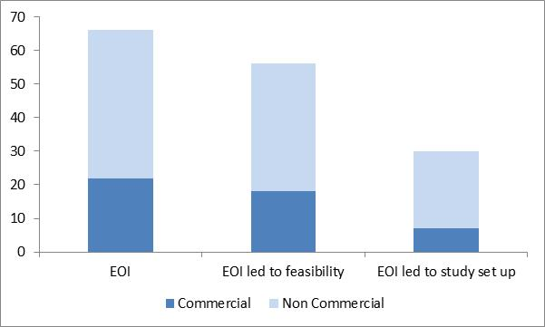

Pipeline Meetings
Internal R&D pipeline meetings continue to take place with 58 studies reviewed by pipeline group (13 commercial studies and 45 non-commercial studies) since 1st April 2015. The number of studies taken from pipeline to the feasibility group was 36 (7 commercial studies and 29 non-commercial studies). The number of studies approved by feasibility group during that period has been 29 (4 commercial studies and 25 non-commercial studies)

HRA
The HRA was established in December 2011 to protect and promote the interests of patients and the public in health research, and to streamline the regulation of research. The HRA aims to align the Research Ethics Committee (REC) approvals process with NHS R&D approvals, to reduce duplication by creating a single HRA assessment.
The process is being rolled out in a 5 step phase with the HRA taking responsibility for providing NHS permission for most research projects with the exception of CTIMPs and educational projects, which will be among the last to go through the new process. The expectation is that this process will be complete by March 2016 with the HRA providing NHS permission and REC approval for all research being conducted within an NHS setting from this point onwards. Once the process is complete individual Trusts will no longer be responsible for providing NHS permission to researchers but will instead be required to confirm capacity and capability to undertake research within their Trust for most research projects.
The HRA is working with stakeholders, including NHS Trusts, to ensure the process is collaborative and are improving and amending the process as the various phases are rolled out. Included in the changes will be a new UK Policy Framework for Health and Social Care Research will replace the Research Governance Framework. The new policy framework is due to be finalised and published by each of the UK health departments in 2016.
The new HRA approval process will increase expectation and responsibility on sponsors of research projects to ensure high-quality research is conducted in the NHS, which will require additional resources in order to meet this expectation. Trusts will be required to work closely with sponsors to agree capacity and capability to conduct research and to comply with NIHR contract requirements for delivering research.

R&D Data Capture
Oxford University Hospitals NHS FT, supported by the NIHR CRN, developed the Research Portfolio Management System (RPMS), a database capable of monitoring the lifecycle and recruitment of a research study. The RPMS runs on the OXNET server, a secure NHS server system. Data migration has been completed and is now fully operational within the Trust, although some data cleaning is still ongoing

Monitoring and Auditing of research projects
Due to workload and very limited resource within the R&D governance team it has not been possible to focus attention to the role-out of a robust monitoring and auditing process for hosted and sponsored research within the Trust. However, a number of studies have been identified as requiring a review of governance compliance and the hope is that the governance team will be able to commence the process of contacting and arranging visits with individual PIs within the next couple of months.

Safety committee
It was agreed at the last research Governance group meeting that rather than have a separate meeting to review adverse events related to research studies that a more streamline process of requesting information from researchers on an ongoing basis for review at the research governance group meetings was preferable. Requests for information are being included in letters informing researchers that they are able to start their studies within the Trust.

New Meeting Structure
The new meeting structure is working well with collective decisions on assessing the capacity and capability of the Trust in undertaking research studies. There has been engagement from the relative stakeholders including those from the CRN who are supporting the delivery of studies. It is hoped that these meetings will also be used to identify struggling studies therefore redirecting resource to where is it required.
It is hoped that this may be more inclusive of Trust clinical services and directorates over the next 12 to 18 months

Studies and Participant Recruitment

Studies
The number of research studies ongoing within the Trust at the end of October was 90, 56 pf which are adopted onto the NIHR portfolio. The graph below shows the increase in the number of portfolio studies over the last six years
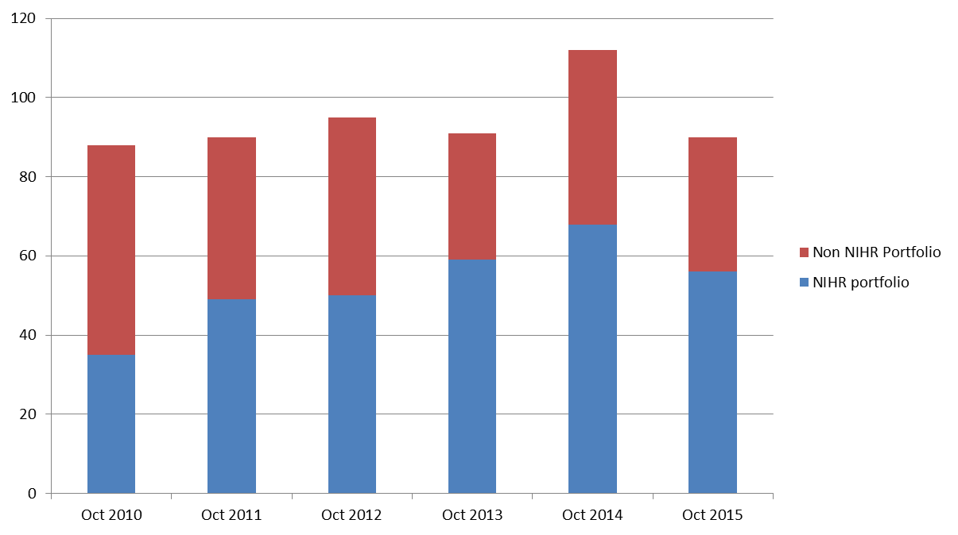

Participant Recruitment
The figure below shows the number of participants recruited to research studies over the past five years. The NIHR publishes league tables on an annual basis. Oxford Health NHS FT was ranked first nationally for the number of participants recruited to NIHR portfolio studies during 2014/2015.
Currently the number of participants recruited to NIHR portfolio studies for the first six months of 2015/2016 is 1115 and 253 participants into non portfolio studies. Data collection is ongoing on a quarterly basis.
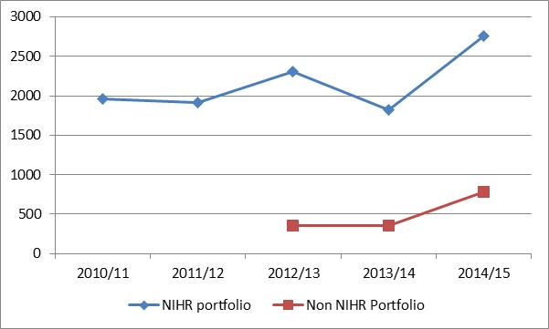

Grant applications
During the period April 2015 to November 2015 25 grant applications were submitted, of which 6 were successful, 9 unsuccessful and the outcome for 10 are yet to be advised. As at December 2015 a further 6 applications are being worked on for future submission. The applications submitted originated from the sources outlined in the table below.
Application Source
Trust (direct & sub-contracted) | 12
Department of Psychiatry | 9
Department of Primary Care | 2
Other | 2
Total | 25
Funding for these applications was sought from the organisations listed in the table below.
Funding Organisations (Direct & sub-contracted)
NIHR | 16
The Alzheimers Society | 3
MRC | 4
Other | 2
Total | 25
There was hope to appoint a grants officer to support the process of reviewing and supporting researchers with grant applications however due to funding constraints this has been put on hold.

NIHR Metrics and Targets
NHS organisations are expected to provide the NIHR with quarterly Performance Initiation and Delivery (PID) reports, detailing the number of studies that recruit the first participant into a clinical trial within 70 days of the organisation receiving a valid research application and the number of studies recruiting the expected number of participants (time to target).
The graph below details OHFT performance in these targets demonstrating an 85% success in initiating research within 70 days from the seven trials are included in the analysis. From the 11 trials analysed for the time to target metric only one study has met the target. The new meeting structure is supporting struggling studies it is expected that the results will filter through in due course when the studies come to an end (potentially in 12 to 18 months).
With the introduction of the HRA, the 70 day target will not be measured formally and it will be up to individual Trusts to determine and measure their own metrics. It has been agreed that OHFT will continue to aim for 70 days from when notification and a full research document set is received.
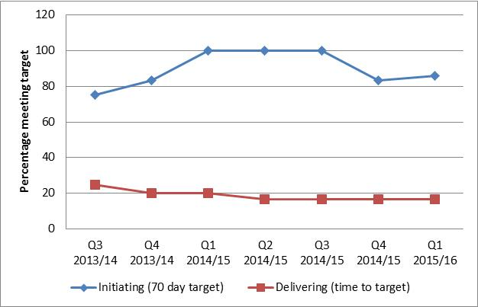
At the time of writing this report the NIHR had not published feedback figures for Q2 2015/2016

Case Records Interactive Search (CRIS)
The security model and information governance assurance framework documents were submitted to the research ethics committee (REC) and a meeting was held on 29th May 2015. The Trust received approval at the beginning of July 2015.
Promotion and roll out of CRIS began in November 2015 with an announcement in the weekly staff update, Trust Intranet and an announcement on the University of Oxford Department of Psychiatry Twitter page and their website. The CRIS coordinator (Tanya Smith) is currently working closely with researchers, Trust clinicians and the clinical audit team to further promote CRIS. A visit to Camden NHS Foundation Trust is planned for January to provide ideas following their successfully CRIS roll out to Trust clinicians and the subsequently increase in the number of service evaluation searches using CRIS.
Monthly CRIS oversight group meetings have been established which are attended monthly. The group is chaired by the Deputy Director of Nursing and Caldicott Guardian and is attended by the CRIS Coordinator, Director of IT, Head of Information Governance, Head of R&D, two Carer/patient representatives, representatives from the trust Clinical Directorates, Trust Audit Team and University. To date 4 applications to use the CRIS have been presented to the Oversight Group, three of which have been approved and one which is in a feasibility stage. To date CRIS users have access to a static data set from five years of Rio electronic health records and work is ongoing regarding the move to a live data set via CareNote.
The R&D website page is now live and contains direct links to the CRIS application form and information regarding the required process for gaining access to CRIS.
Consent for Contact is in progress, awaiting CareNotes to be updated so that this information can be captured, in accordance with the CRIS ethics application. The clinical teams will then be contacted regarding this process.

Finance
The Trust receives research funding from various commercial and non-commercial sources. These funding streams are outlined in the table below along with the amounts reflected the FY16 budget.
Source | Type | FY16
NIHR | Study income Department of Psychiatry & Trust | 167
NIHR | Study income Department of Primary Care | 280
NIHR | Clinical Research Facility | 717
NIHR | CLAHRC | 2,000
NIHR | RCF - Department of Psychiatry \ Trust \ CLAHRC | 1,115
NIHR | RCF - Department of Primary Care | 295
NIHR | RCF – OUH | 64
NIHR | NIHR Final Payments | 216
NIHR | Total | 4,853
CRN | TVCLRN \ CRN | 1,370
Other | Commercial, NIHR sub-contracted and other income | 515
 | Total | 6,738
The NIHR, Department of Health and CRN require the completion of detailed quarterly and annual returns to ensure all funding is used appropriately and within the year awarded. Any unused funding would need to be returned to the relevant funding organisation.

FY16 Performance
The FY16 R&D performance at the end of November 2015 had generated a contribution to overheads of £74k which compared to the budgeted contribution of £47k generated a favourable variance of £26k.
The R&D budgets have been spread equally across the year to support Trust-wide forecasting. The effect of this on the R&D performance is to cause a favourable Non-NIHR CRF income variance at month 8 (£28k) due to income from commercial studies being received earlier in the year than the equally phased budget. This variance is expected to reduce over the remaining 4 months of the year leaving R&D broadly in line with its budgeted full year contribution to overheads of £74k.

Research Capability Funding (RCF)
Research active NHS organisations receive RCF to enable them to meet some, or all, of the research-related component of the salary of their researchers and research support staff working on clinical and applied health research, where that component is not already provided by another funding source.
The annual RCF allocation combines a percentage of the NIHR funding received in the previous calendar year with an allowance for each Senior Investigator associated with Trust.

FY16 RCF Allocation
The FY16 RCF allocation was £1,410k and came from activity within the Trust (including the CLHRC) and Oxford University Department of Psychiatry and the Oxford University Department of Primary Care. The breakdown is shown in the table below:

FY16 | Department of Psychiatry \ Trust \ CLAHRC | Department of Primary Care | Total
Senior Investigators (SI) | Keith Hawton, Guy Goodwin, John Geddes, David Clarke, Charles Vincent, Simon Lovestone | Sue Ziebland, David Mant, Trisha Greenhalgh, Andrew Farmer
SI Funding (£75k) | £0.450m | £0.300m | £0.750m
2014 Funding | £2,271m | £.196m
Study Related RCF | £0.628m | £0.032m | £0.660m
Strategic contribution | £0.037m | (£0.037m) | -
Total RCF | £1,115m | £0.295m | £1,410m
The FY16 allocation shows an increase of £208k on the amount awarded for FY15, the changes are shown in the table below:

Type | FY15 (£k) | FY16 (£k) | Var (£k) | Comments
Studies & Infrastructure | 602 | 660 | 58 | £166k additional income related to the 2014 CLAHRC funding partly off-set by lower study income at a reduced funding rate
Senior Investigators | 600 | 750 | 150 | Three new Senior Investigators (David Mant, Trisha Greenhalgh, Andrew Farmer) have joined the Trust or changed their associated NHS organisation and one has been removed (Alastair Gray)
Total | 1,202 | 1,410 | 208

Clinical Research Facility (CRF)
The NIHR CRF encompasses activities taking place at the Department of Experimental Psychology (OxCADAT and OxCNC) and the Charles Wolfson Clinical Neuroscience Facility at the John Radcliffe Hospital as well as those on the Warneford site. The Warneford site CRF operates as one unit containing 8 clinical rooms, pharmacy, a meeting room and associated office space although it is funded from a combination of NIHR and non-NIHR sources as detail below.
 | FY16 Budget | FY16 Forecast | Variance
Expenditure | (940) | (940) | -
NIHR Funding (funding in place until Mar 2017) | 717 | 717 | -
CRN: TV SM annual funding | 204 | 204 | -
Total Non-NIHR income (detailed below) | 84 | 93 | 9
Total Income | 1,005 | 1,014 | 9
Contribution to overheads | 65 | 74 | 9
Margin after CRF accommodation and Finance support | 6% | 7%
The table below details the research income received from non-NIHR studies taking place within the CRF at the end of Period 8.
Study | Sponsor/Clinical Research Organisation | £k | Funding
Stem cells for Biological Assays of Novel drugs and predictive toxicology (STEMBANCC) | University of Oxford | 25 | Non-Commercial
European Long-acting Antipsychotics in Schizophrenia Trial (EULAST) | EU | 3 | Non-Commercial
A randomised, double-blind, placebo-controlled, single-dose, study of the efects of SEP 363856 and Amisulprode on bold-FMRI signal in healthy male and female volunteers with high or low schizotype characteristics | Sunovion | 37 | Industry Contract
Dendron led studies |  | 20 | Industry Contract
 | TOTAL | 84

Clinical Research Network: Thames Valley and South Midlands (CRN)
The budgeted FY16 funding from the CRN is £1,370k and is detailed in the table below:
Division | Specialty | FY16 Budget (£k)
Division 4 | Mental Health | 527
 | Dendron and Neurological disorders (Dendron) | 300
 | Division-wide (Division 4) | 192
Division 5 | Primary Care and Ageing | 337
Cross-Divisional |  | 14
Total |  | 1,370

Financial Risks and Issues

R&D Income Summary FY17
The level of research funding is predicted to drop by £559k in FY17 mainly due to reductions in RCF (£260k) following the completion of studies and NIHR Final Payments (£164k). This will reduce the Trusts flexibility and ability to potentially pump-prime certain areas of research.

Source | Type | FY16 | FY17 | Variance
NIHR | Study income Department of Psychiatry & Trust | 167 | 80 | (87)
NIHR | Study income Department of Primary Care | 280 | 247 | (33)
NIHR | Clinical Research Facility | 717 | 717 | -
NIHR | CLAHRC | 2,000 | 2,000 | -
NIHR | RCF - Department of Psychiatry \ Trust \ CLAHRC | 1,115 | 855 | (260)
NIHR | RCF - Department of Primary Care | 295 | 343 | 48
NIHR | RCF – OUH | 64 |  | (64)
NIHR | NIHR Final Payments | 216 | 52 | (164)
NIHR | Total | 4,853 | 4,294 | (559)
CRN | TVCLRN \ CRN | 1,370 | 1,370 | -
Other | Commercial, NIHR sub-contracted and other income | 515 | 515 | -
 | Total | 6,738 | 6,179 | (559)
Note: CRN & Commercial, NIHR sub-contracted and other income is assumed to remain constant but will be reviewed in detail as part of the FY17 budget process.

Redundancy Costs
Where staff are funded from time limited awards there is a potential redundancy risk. This is monitored along with HR to identify and mitigate the risk on a case-by-case basis.
CRN Governance Team Funding
There is currently some uncertainty concerning the level of future CRN funding for the Trust R&D Governance Team. The CRN Chief Operating Officer has been contacted on two occasions to seek guidance on the agreement for this with no response. The Head of R&D is in the process of trying to obtain clarification.

Study Report and Publication dates
A number of studies have or will come to an end between Oct 14 and Mar 16 where the NIHR contract allows the withholding of the final payments until reports have been produced and published. The effect of this is that costs will be incurred in a different financial year to that in which the income is received. Agreement was gained from the DH to fund these pressures from RCF allowing the final payment to be released in the following year on the condition that the funding is used for staff. This gave us more flexibility regarding the year in which the income was used.
It is planned to use these payments to support posts in the run up to the BRC application. The possibility of letting any unused funding drop to the Trust bottom line this year and the Trust setting a non-recurrent BRC Investment budget of a similar amount in FY17 to support the application has been discussed with senior members of the finance eteam.
The studies concerned are shown in the table below.
Study | Finishes | FY16 Income | FY17 Income | Comments
Octet | Oct 2014 | 57 |  | Payment received
Friends | Dec 2014 | 54 |  | Payment received
Octext | Dec 2014 |  | 71 | Report submission and payment dates agreed with the study team and NIHR
ECT |  | 20 |  | Payment received
Sleep |  | 17 |  | Payment received
Wheld |  |  | 102 | Study finishes 31st March 2016
Overheads |  | (16) | (16)
Total | Income | 132 | 158
BRC | Expenditure | (24) | (16)
Net |  | 108 | 158

Collaboration in Leadership in Applied Health Research and Care (CLAHRC)
In January 2014 the Trust began receiving funding from the NIHR in relation to the CLAHRC which is led by Professor Richard Hobbs from the University of Oxford, Department of Primary Care.

CLAHRC Budgets
Budgets have been approved and released to the Theme Leads for the first 2 ¼ years ending March 2016. It is planned that there will be a mid-term review by the Executive and Management Board before budgets are released for the final 2 ¾ years.

Performance
The actual and budgeted expenditure is shown in the table below (£k).

Theme | 2014/15 Actual | 2014/15 Actual | 2015/16 Forecast | 2016/17 Budget | 2017/18 Budget | 2018/19 Budget |  | Total
Better Management of Psychiatric comorbidities (Lead Mike Sharpe) | 185 | 161 | 370 | Allocation subject to mid-term review process
Health Behavior and Behavioral Interventions (Lead Sarah Lamb) | 180 | 168 | 336
Early Intervention and Service Innovation (Lead John Geddes) | 217 | 144 | 318
Patient Self-Management of Chronic Disease (Richard McManus) | 295 | 226 | 380
Patient experience and PROMS (Lead Ray Fitzpatrick) | 216 | 187 | 346
Central and Support Costs | 157 | 364 | 250
Total | 1,250 | 1,250 | 2,000 | 2,000 | 2,000 |  | 1,500 | 9,000

FY16 Performance
The forecast outturn position for each Theme is currently being confirmed with the lead to allow time to take any corrective action required before year end. To support this and to monitor performance monthly reports have been developed and are circulated to theme leads. There are currently no overspends forecast.
Mid-Term (Phase 2) Review
As part of the first stage of the mid-term review process the Management Board have approved funding for three phase 2 projects (£52k). A further 26 projects (£4.8m) will be considered by the external review panel in January 2016.
Matched Funding
A fundamental requirement of the CLAHRC is the need to demonstrate matched funding committed by other organisations which is linked to CLAHRC activities. In total this needs to be at least to the same level as the NIHR funding. Matched funding provides resources to support the proposed themes of research, implementation or a mix of both. Identification of Matched funding is an on-going process involving the CLAHRC Manager and the Head of R&D Finance. Based on current information the amounts shown in the application and the minimum required by the NIHR have been identified.
Matched Funding (£k) | 2013/14 | 2014/15 | 2015/16 | 2016/17 | 2017/18 | 2018/19 | Total
Matched Funding identified | 525 | 2,000 | 3,252
Minimum required by the NIHR | 250 | 1,250 | 2,000 |  |  |  | 9,000
Included within the application | 519 | 2,075 | 2,077 |  |  |  | 10,431

Oxford Academic Health Science Network (OAHSN)
Oxford Health is hosting three of the 9 OAHSN Clinical Networks. These are Dementia; Early Intervention in Mental Health; and Anxiety and Depression (detailed below).

Network | Lead | Total Award | End Date
Dementia | Dr Rupert McShane | Total £536k  £336k up to 31 March 16  Additional £200k has been agreed to fund the network until March 18 | March 2018
Early Intervention in MH | Prof Belinda Lennox | Total £433k  £210k up to 31 March 16  Additional £223k has been agreed to fund the network until March 18 | March 2018
Anxiety & Depression | Prof David Clark | Total £490k  £220k up until March 16  Additional £270k has been agreed to fund the network until March 18 | March 2018
The OASHN is seen as a clinical development rather than research and is reported separately in the finance report to the Board. The three networks hosted by the Trust are budgeted and forecast to breakeven

Estates
Following delays progress is being made to relocate a number of research staff, primarily from the CRN into office space next to the R&D department and a move is imminent. This will harness closer working relationships with the CRN in research study delivery.

Staffing
R&D struggled to recruit a suitable Band 7 sister to manage the Warneford CRN during which time clinical staff were supported by a Band 7 nurse working within the Trust for the CRN. Following various discussions with Trust senior nurses and the R&D department it was agreed that an experiences research practitioner would take on the role of the Lead Clinical Research Practitioner within the CRN and continue to be supported by the Band 7 CRN nurse. In addition a new post in collaboration with Brookes University is to be created to support research nurses in the delivery of research in addition to developing their own research studies.
The Research Governance Coordinator has resigned from her post to join the team of research assistants embedded within the clinical teams across the Trust. The post has been advertised and interviews scheduled for January 2016.

Communications

Trust R&D Website
A communications officer (Ruth Abraham), jointly appointed with the University of Oxford department of Psychiatry joined the Trust in July, working within the R&D department for one day per week. The focus of the last five month’s has been creating and launching a website that covers the R&D arm of the Trust for a wide audience, both within the Trust, for patients, carers, health care professionals, researchers and externally to collaborators and funders. Consultation was carried with key stakeholders within R&D and with the Trust’s central Communication Team to accommodate the diverse needs and purposes of the website, and also to ensure that it was in line with the Trust’s wider communications strategy.
The website has key strands: About Us, Research Themes, Making a difference, Researcher’s Toolkit, News, Participate and Our Team. These will act as a place to showcase the positive impacts of research, offer patients and carers the chance to express interest in becoming involved in future research or shaping the ways it is conducted, and offer comprehensive guidance to researchers to conducting research, and a porthole for submitting research proposals.
The website is now live with an official launch expected in February. Now that this hub is established it can be drawn upon and used to broaden communication to feed into the Trust’s Twitter and Facebook campaigns, internal communications, and share the research news with a broader community.

Radio Interview
Dr Andrew Molodynski featured on radio Oxford in October 2015 to promote World mental Health Day and raise awareness of the need for research, highlighting the success of one particular study (COFI) that has been supported by the team of research assistants embedded in the Trust.

Research Open Day 16th December 2015
A Research Day was held on 16th December 2015 and provided a platform for researchers from a range of backgrounds within OHFT to present their projects and experiences of mental health research. A variety of research topics were covered from completed research projects, to those in progress, difficult to recruit populations, clinician’s experiences of working on research projects, and developments within the wider research community. Presentations also included new initiatives such as the development of the R&D website, CRIS and future plans for the BRC. These themes were supported by a mix of presentations, posters, information and networking.
The audience for the day exceeded 85 people attending either sessions or the whole day from OHFT, OUH, Oxford University, service users and the public. Initial feedback has been very positive, further feedback will be provided via the trusts survey monkey account. This will enable us to fully assess the success of the day and to plan future research events.
Collaboration between the teams working within research and development, such as the clinical research facility, communications and the research assistants; working alongside the trust communications team, the department of psychiatry, OUH and the CRN are what made the day a success.
Some of the quotes received so far include:
‘loved everyone’s enthusiasm for improving healthcare’
‘presentation accessible to all’
‘well organised and inclusive’
‘a good day providing a good update on research going on in the trust’

Authors and Title: Professor John Geddes, Emma Stratful & Dr Clive Meux
Lead Executive Director: Dr Clive Meux

- A risk assessment has been undertaken around the legal issues that this paper presents and there are no issues that need to be referred to the Trust Solicitors.

- This paper (including all appendices) has been assessed against the Freedom of Information Act and the following applies:

- THIS PAPER MAY BE PUBLISHED UNDER FOI

- This paper provides assurance and evidence against various Care Quality Commission Outcomes

