

The Buckinghamshire Health and Wellbeing Campus

The Whiteleaf Centre Benefits Appraisal



Kelly Bark

Neil Flint

**Summary**

This report presents the findings of a review into the benefits anticipated in the Full Business Case for the new build facility on the former Manor House Site now called the Whiteleaf Centre, and generally the facilities on the newly established Buckinghamshire Health and Wellbeing Campus. The review has been undertaken in response to the Finance and Investment Committee request to identify whether the benefits as set out in the full business case (FBC) have been realised.

An appraisal has been undertaken to understand, in the context of the business case, what benefits were originally identified; what the background for these were; and if these have been realised. Information obtained has been cross referenced against the original business case, models of best practice, feedback from service users and commissioners and providers, as well as input from clinicians to understand what the requirements were and if this has been achieved.

This report highlights the 11 key benefits identified in the full business case, the background of these and the current status of realisation of these benefits. This report also provides items for further consideration with comprehensive strategies for implementation.

**Context**

The Whiteleaf Centre is located on what was the Manor House site along Bierton Road in Aylesbury (Buckinghamshire). The services occupying the new facility sit within the Adult and Older adult Clinical Directorates of Oxford Health NHS Foundation Trust. Prior to the completion of the Whiteleaf Centre, the services operated from 4 sites, which included Tindal Centre ­– Portland Ward, Kimmeridge Ward (adult acute wards), Complex Needs, Acute Day Hospital); Cambridge House (Aylesbury Vale AMHT, EI and Complex needs); John Hampden Unit – Harding Ward and Cromwell Ward (older adult mental health); and Mandalay House (rehabilitation ward) on the extremities of the Manor House site. Woodlands House a Low Secure forensic ward is also located on the site along with the Sue Nicholls Centre which was retained for children’s CAMHS and therapy services.

The geographic spread, and poor condition of the facilities which were not meeting modern design or dignity standards triggered the need to develop a facility to meet modern design build and CQC and care standards, enhance patient, carer and staff experience, maximise the potential for services to work collaboratively in a modern purpose built building and reduce site and travel costs.

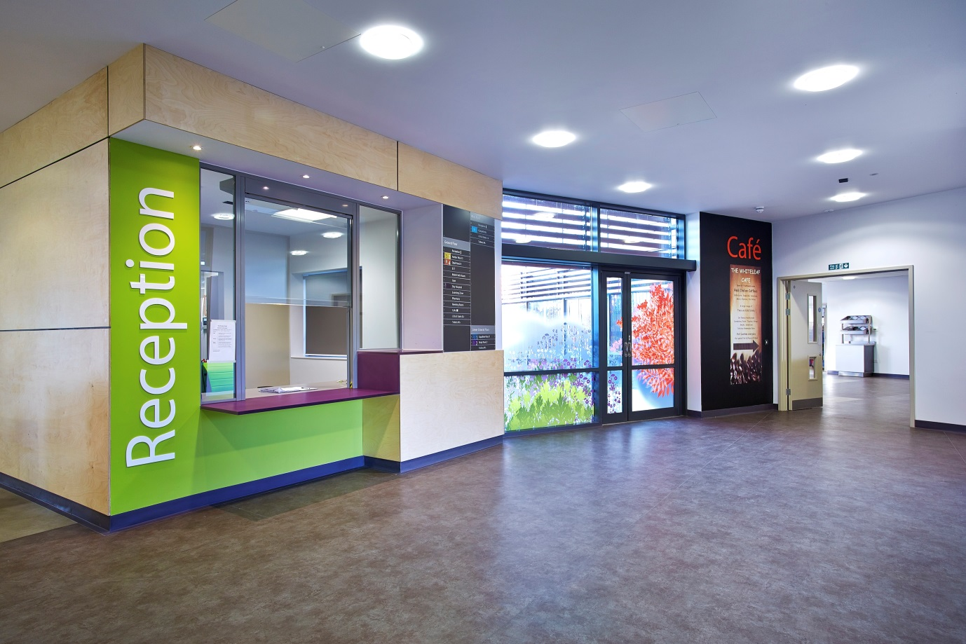

**Background**

The Oxford Health FT brief for the Whiteleaf Centre at the Buckinghamshire Health and Wellbeing Campus was to consolidate services into one site. The rationale for this was the community teams were on an isolated industrial estate, older adult wards were on the Stoke Mandeville and Tindal sites in poorly designed and outdated wards which were expensive to maintain and did not meet modern privacy and dignity standards, existing services which did not need re-providing were already on the Manor Hose site including Woodlands House and the Sue Nicholls Centre would benefit from additional services on site and with added educational and recreational facilities such as a cafe. Furthermore, investment to maintain and update such facilities, were not considered value for money. The concept of locating the services on a single site allowed for the different functions to share facilities and enhance patient pathways and communication between services. This is all fully reported in the Gateway 4 report (Appendix 7).

Oxford Heath FT wanted to make better use of its resources to maximise the provision of care that can be afforded and provide the opportunity to maintain or expand the services provided for local commissioners in Buckinghamshire. This had also been promised as part of a consultation upon acquiring Buckinghamshire Mental Health services in 2005 Putting People First.

Land disposal of the Tindal site and sections of the Manor Hose site was also part of the plan to part fund the development

**Findings**

It is nearly two years since the opening of the Whiteleaf Centre on the Buckinghamshire Health and Wellbeing Campus. The majority of Stakeholders including patients have been very positive about the new facility. Buckinghamshire Commissioners are very positive about the significantly improved environment meeting modern standards for patients, and the design and functionality of the resource building including the café and educational space. However the review has highlighted a relatively small number and few significant issues requiring further attention to understand if those benefits had been achieved and also recognised a number of successful initiatives deployed by the Service (locally and Directorate wide) that can be adopted and spread with other teams.

**Objectives for the new campus development and benefits realised.**

The objectives that provided guiding principles for the development of the Whiteleaf Centre and wider campus realised through the FBC and delivered through the project team and clinical directorates are summarised below.

**1. Co-locate and centralise facilities for mental health services replacing updated estate spread across three sites in Aylesbury**

Putting People First, was a (public consultation) in 2005 which ran over a 3 month period and focussed on the centralisation of services, bringing together wards, and adults and older adult community service onto one site. There were stipulations that where-ever the services were relocated to they had to provide good transportation links and assurances had to be made that the older adult component was supported as they were moving from the close proximity and support of a general hospital (Stoke Mandeville). The existing facilities were in a poor state environmentally, cost for maintenance was high and by consolidating the estate any cost savings would then be able to be spent on clinical delivery.

Objective 1 was achieved. The majority of services which were outlined for relocation in the Final Business Case were co-located on the Campus apart from the substance misuse services which are no longer provided by OHFT. The Campus proposal also included the relocation of Mandalay which was not envisaged in the original plan. Appendix 1 gives greater detail about the benefits realised.

**2. Improve operational effectiveness and efficiency, and facilitate more effective multi-agency/disciplinary working, through improved location or co-location of constituent services**

* Effectiveness and efficiency could be achieved by facilitating better MDT working. Running alongside the development was the necessity to develop new clinical models for adult, older adult mental health and complex needs and to not keep doing what we had always been doing. The new hospital design needed to support the new models and help to deliver improved experience and outcomes for patients. For example by co-locating community teams and wards it was anticipated that the Average Length of Stay could be reduced by closer working and collaboration. There was a drive to respond to poor service user feedback and poor feedback from CQC Mental Health Act Reports about the dormitory bedrooms affecting privacy and dignity and use of restricted practice and sharing seclusion rooms on the Tindal site. Multidisciplinary working on the wards has improved through colocation of office space and dedicated consultants working on the wards with collocated offices to all other disciplines.
* The design and layout has substantially improved the clinical environments and meet modern national standards for care and build. The redesign was an opportunity to bring together all parts of the health care system, social care and the voluntary sector through colocation in the building and through developing the new models of care, the thought behind this would enable services to reduce clinical risk by joint working and facilitate shared training and education.
* Average length of stay has reduced on Sapphire ward (male acute), Amber ward (older adult) and Opal ward (rehabilitation) wards since moving into the Whiteleaf Centre. However Ruby ward report an increase. This is due to two patients having lenghtly admissions (Appendix 2).
* All wards display a reduction in admission and discharge rates again this could be due to co-location of services and introduction of new clinical service models, throughput through beds has always been higher in Buckinghamshire compared to Oxfordhsire however there are other factors influencing this other than the new build. In older adults the new model of care has influenced a significant reduction in admissions and length of stay.

Objective 2 was broadly achieved – more detail is highlighted regarding design and layout is highlighted in Appendix 2.

**2a. Improve quality of services to patients and carers through an innovative design of accommodation within modern and compliant facilities**

The design was important in creating modern fit for purpose accommodation for inpatients, outpatients and staff. Clinical staff were actively involved the design stages and the Head of Acute Mental Health Services was seconded onto the design team. Architects were engaged that had previous experience of designing mental health facilities and they were encouraged to spend time in the old building to understand the challenges. The design team which included the architects visited other new builds to take away good ideas and learn from mistakes. Consideration was made for older adult patients when designing the outside space for their ward to have memory loops for patients to walk around safely and comfortably whilst having attractive foliage to look at that stimulate the senses.

* Feedback from service users and families report that the facility is welcoming and feels safe. There has been a reduction in complaints received through PALS, with a reduced number of complaints being about the environment (Appendix 3). They like having somewhere to go away from the ward to visit relatives as it normalises the visit.
* Feedback from the recruitment days held at the Whiteleaf have been very positive with some comments being; “the new build is a positive draw to working within Oxford Health”. “It says a lot about the Trust that they put the needs of the service users and their staff at a high priority”, “it would make me feel proud to work here”.
* Wards are starting to be enhanced by the introduction of art work developed by service users in conjunction with Artscape.
* Staffing levels were increased on the adult and older adult acute wards to 6,6,4 and the rehab ward to 5,5,4 to meet safer staffing of the new build. Older adult beds reduced from 2 wards to 1 and the rehabilitation ward moved in without need to significantly change the design or layout. Staffing levels in Amber ward were enhanced despite the growth in population and people living longer due to the efficiency of the older adult service and patient flow the service is managing with the 20 beds, with no ECRs needing to be made.
* There is an issue with the need for more female than male beds in Amber which may need some space to be converted in another part of the ward to loook after female patients so single sex standards are not breeched.
* Sickness, Recruitment and vacancy data provided by human resources show a decrease in sickness levels overall since staff moved into the new building, there has been an increase in recruitment in line with the reduction of vacancies (Appendix 4).
* National Staff survey results for staff working from the whitleaf centre are better than comparators working in Oxford. The environment is not the only issue affecting these ratings however it is likley to play a part.

Objective 2a has been achieved, there have been many patient, carer and staff benefits identified.

**3. Improve access (or better access) to therapeutic gardens and other outdoor space**

This benefit focusses on access to therapeutic and outdoor space. Landscapers were engaged early in the design process and they joined the design team meetings in order to fully understand the brief and the concepts the Trust were looking for. An essential component of the project brief focussed on all wards having access to adjacent ground floor garden space as the importance of outdoor space, particularly for inpatients is paramount for recovery.

* The older adult ward was fitted with handrails and bespoke signage to make it accessible to all.
* The café in the resource centre is open to patients, staff and visitors and has an easily accessible outside terrace. It provides a sunny, cheerful place to have lunch and coffee this facility is well used by patients, visitors and staff.

Objective 3 has been achieved. In Portland ward there was no outside space adjacent to the ward and garden space was poor at the John Hampden Unit. Access to safe outside space and fresh air is an important part of recovery. In addition the gardens are now smoke free which means they are not littered with cigarette ends which is more aesthetically pleasing and saves time not having to clear them up.

**4. Improve effectiveness and efficiency of staff including good sight lines within the ward areas**

This benefitfocusses on the effectiveness of the design to improve efficiencies for staff. Good lines of sight are vital particularly in a new provision that is much bigger than staff were used to.

* Staffing levels had to be increased per shift slightly but the design needed to optimise patient observation. This was achieved through redesign of services and was not an added cost to the Project.
* It was essential that staff were able to nurse patients safely but not over observe or be intrusive. The layout of the design coupled with a proportionate and risk measured approach to anti-ligature environments assisted this objective.

The objective was also achieved in the layout of the bedrooms, however the wards were larger and staff have had to adapt the way they work. Single ensuite bedrooms are the areas with the highest ligature risks particularly the door to the ensuite bathrooms where there are no sight lines for privacy and dignity unless a patient needs close observation. A soft door is being trialled in four different wards in OHFT to reduce this risk.

The two adult wards had prepared staff for the move better than the staff moving from Amber ward. This is probably due to the facility being over the road from Tindal and staff could easily go over through the commissioning period. Preparation for staff moving from further afield may need to be strengthened in future to minimise the difficulties the older adult staff had initially adapting to the size of the ward. This team were also combining two teams into one and this aspect needs to be given more attention in future.

**5. Flexibility of the estate which will allow the Trust to react relatively quickly and easily to future changes in clinical best practice and service function** ­**– focus on future proofing.**

We wanted to ensure we have a building that is fit for purpose for many years but is flexible enough to respond to service change. This proved to be vital as it had been planned to move two older adult wards – one dementia unit and one functional unit into Opal and Amber wards. The service needs changed and the older adult provision run an integrated ward and moved just one older adult ward into the Whiteleaf.

* The lack of customisation has been the biggest issue for older people. The flexible design has meant some aspects of the environment for older people was not as well adapted as it could have been, some adaptions were made prior to moving in and others continue to be done as staff get used to working in the building and identify equipment that would be beneficial the most recent example is the need for a call bell system.
* The enhanced focus on improving care pathways receiving length of stay led to the rehabilitation and recovery ward based in Stocklake moving to the Opal ward requiring no change to the environment so this then allowed the vacated rehab space to be used for a step down unit run by the voluntary sector – promoting options and integration with are 3rd sector partners. Comfort Care took over running and ownership of Mandalay. This produced a windfall capital receipt of 1.3m which is a significant benefit.
* The design is flexible so this objective was achieved, in future designs there needs to be more attention paid to the needs of the older person. Some patients and staff have found the very modern design and finish to be too stark, and signage within the wards needed to be improved in order to help particularly older patients find their way around the ward.

**6. Contribute to the delivery of the agreed, modern and efficient new clinical models of care for residents of Buckinghamshire**

**6a**. Adult mental health services including complex needs.

* It was important to take advantage of the move and not lose the opportunity to develop new models of care to compliment the modern purpose built facilities – we wanted to implement a new clinical model.
* We used the care clusters to be clear about our patient outcomes for inpatients and community patients. The inpatient clinical model focussed on improving pathways to reduce the length of admission, had bespoke areas to assess and treat patients, this also contributes toward achieving national recognised peer reviewed AIMS standards and accreditation (Accreditation for Inpatient Mental Health Services – Royal College of Psychiatrists).

**6b.** The new adult mental health teams comprised acute and treatment functions with 7 day working and extended hours. EIS remained a dedicated team.

**6c.** A new model for complex needs services was latterly agreed and re-sited in the Wing Centre on the Buckinghamshire Health and wellbeing Campus.

**6d.** The low secure facility at Woodlands House remained on site and patients and staff now have access to all the support facilities within the wider campus including the café, outpatient facilities, teaching and training facilities.

**6e.** A new model of care for older people

* Extended the reach and extended opening hours of the older adult mental health teams
* Added new model for Memory clinics.
* Reduced length of stay in inpatient wards for patients with functional and organic disorders. This has now been in place for over 12 months. Average length of stay has reduced significantly and the service is managing with a reduced number of beds.
* However pressure on female beds which led to the recent issue picked up in the CQC Report where female patients were in single ensuite rooms in the male corridor which is a breech of single sex guidance. This will need an adaptation to the building or technological solution to address. This is a result of the new model of care rather than a building issue.

The new model of care for older people was very ambitious and design solutions which may need adaptation to the building or technological solutions will be explored as solutions. This objective was met and significant benefit realised.

**6f.** Use of Charitable funds to enhance the environement.

* The Oxford Health Charity has utilised the Buckinghamshire Mental Health Fund to fund attractive art work, a stained glass window in the multi-faith centre and also purpose desinged sulptured wooden screens to enhance privacy for the entrances to Sapphire and Ruby ward. These funds have significantly improved the ambiance of the site using charitable funds where NHS funds could not be justified. These unique features together with the art and design features have significantly enhanced the environement and we are grateful to the charity.

**6g.** The children’s mental health and physical therapy services remained in the Sue Nicholls building which was retained on site rather than demolished.

**6h.** The substance misuse services were originally part of the redevelopment. However the moved to a new provider when a new contract was let and no longer required accommodation.

New models of care have undoubtedly been enhanced by the design of the Whiteleaf building and facilities, and other building such as the Wing Unit on the Campus site. Use of charitable funds has also enhanced service users and visitors experience.

**7. Create a focus for high quality teaching, training, education and research**.

The project team needed to ensure that the design incorporated facilities to deliver and encourage localised training, education and research.

* The conference suite was designed for both internal and external use.
* The IT training room and library facilitate training and learning locally which reduces time and money spent in travelling and back fill to services. More online IT training is taking place.
* The educational facilities are very well used and appreciated by OHFT staff and our partners Reduction in the amount of training taking place at the Sivatech with the only training held there currently being PMVA and Breakaway.
* The conference suite was designed for both internal and external use to reduce costs and generate income. Trust induction, manual handling and RESUS are all being held now in the conference suite. E-Learning is being carried out in the learning Zone and library this has led to a reduction in time and money spent in travelling and back fill.

This objective was been met the resource centre education facility, IT room, multi-faith room and café are very well used and appreciated.

**8. Make the most efficient use of resources. In particular contribute to the overall improvement in the Trust’s use of its land, estate and sustainability targets**.

Focussed on making sure the project team used the resources effectively with an emphasis on sustainability. From the beginning of the design the project team worked using BREEAM which is a design and assessment method to assist in producing sustainable buildings. It also crucially provided another source of external scrutiny ensuring the brief made optimum use of land which clearly identifies the land put aside for sale in the future to release funds. It is at the top of the site which means that if following the sale housing is built it won’t overlook the inpatient areas – maintaining the integrity of our site.

* We will also still have two access point to the site with an option to access from the bottom of the site if required at a later date – stops us feeling land locked.
* BREEAM excellent rating achieved (Building Research Establishment Environmental Assessment Method). The Whiteleaf achieved a score of 94% (Excellent) and has received their certificate.
* More services in original design, complied with original planning provision and able to utilise surplus land at the north of the site for housing thus generating income from the sale of the land. Planning SI06 Agreement has been completed and the land sale is in the process of being realised.
* There have been some difficulties achieving the cost neutral position in budgets. Estates and Facilities budgets in particular proved to be underestimated, and additional costs have been incurred in relation to cleaning and maintennace works, but this cost is overall reduced in comparison to the expenditure across John Hampden Unit, Cambridge House, Tindal Centre and Mandalay House. Additional funding was supported from buckinghamshire comissioners to cover the additional running costs.
* There have been substantial problems with the heating and ventilation systemfrom the outset. which has resulted in over the two coldest weeks and during the Christmas period in 2014 , a very small number of patients were finding their rooms too cold to sleep in. All wards were supplied with duvets and temperature monitoring of individual rooms was maintained. This has not recurred in winter 2015.
* However the overheating of kitchens and difficulty stabloising room temperatures remains an issue. The faults in the heating system have been worked on during the summer 2014. Keir have accepted the responsibility and further work is scheduled, however this remains the one major outstanding issue. Keir have accepted responsibility and will be bring in a re-engineered solution.Temporary working practices regarding the kitchen temperature involving restricting patient access meanwhile have been tolerated for too long and led to justifiable criticism upon CQC inspection.The practice issue should have been picked up on to support the escalation of a quicker resolution.
* There has also been an issue with the drainage and sewerage design which resulted in a bderoom in Opal room smelling of sewerage. This was identified shortly after the opening and remedial action to treat the affected area weekly was in place. The weekend prior to the inspection visit this did not take place as the member of the estates team was diverted into emergency activity. The issue was being permanently addresseeed by Keir the week of the inspection a permanent new drainege system to solve the issue has been put in place.
* There has been significant damage to our 136 suites incurred when two patients have been violent on separate occasions. This is also a practice issue as a very small number of patients will still need to be assessed in police stations if high levels of violence can be anticipated.A discreet access to 136 suites within wards 1, 2 and 3, for safe reception of disturbed patients and maintains their privacy and dignity as it means they do not need to go through the main resource centre. It should be noted however that the approved design standard was not as robust as hoped, and as a result a patient was able to kick the wash hand basin from its fixings. The estates department have now refitted all wash hand basins with stronger fixings to prevent this occurring again.
* The inner polycarbonate windows to the S136 suites were wrongly fitted. The maker of the window is well established and provides products to prisons. The installation was sub contracted. The wrong size window was delivered and installed. That said when told that the window had been breached, the Sales Director of the supplier said this was impossible and attended the unit the next day. The windows in all the seclusion and de-escalation rooms at Whiteleaf were found to be similarly wrongly fitted. They were replaced free of charge within four days of the call being made.
* The internal doors approved for installation are not of a traditional solid core design, and as a result patients have managed to break several of these doors.

Whilst benefits have been achieved however there are higher maintenance and running costs which were not planned for and there have been some notable snags. Temporary solutions and work-abounds have been in place until permanent fixes have been completed.

**9. Ensure the proposals are affordable and consistent with the Trust’s integrated Business Plan**

Capital expenditure for the Whiteleaf development was approved at £42.88m by the Finance and Investment Committee and managed very closely by the Project Team. The £42.88m was made up of £22m in build and equipping costs and £20.88m on design, retraction, demolition, professional fees and VAT. This was financed through a £28.2m loan, an anticipated £6.8m sale from surplus land and the balance from internally generated resources. The current sale which is anticipated at the end of the March is back to the level envisaged in the original business case.

This was achieved. The Whiteleaf was delivered at a final cost of £39.5m (after allowing for £0.5m of disposal costs in relation to the Manor/Tindal sites), which was under the budget approved by the FIC and Board by £3.4m.

**9a. The accurate estimation of running and ongoing maintenance costs was not achieved**

The approved business case recognised there would be increased operating costs in relation to the new facility and approved additional revenue expenditure of £464k pa. However, we are experiencing operating costs that are £249k higher than assumed in the business case in relation to staffing costs for housekeeping, nursing and porters. This may be attributed to the following:

* The business case was developed during 2010/11 and was not approved until January 2012, resulting in a significant time lapsed from business case approval and final design to scheme completion - the cost estimates were based on assumptions made at least two years ago and set at FY12 prices; an estimation of inflationary costs should have been made and continued to have been updated up until opening.
* It is difficult to estimate costs in some areas as they were developed using standard costs and due to external influences e.g. rates and utilities.
* Overly prudent assumptions regarding staffing levels in relation to housekeeping and portering, not sufficiently taking into account the configuration of the new building or confirmation of assumptions following final design sign-off.
* The Estates team had temporary leadership at this point which added to the weakness in estimation and lacked leadership with expertise at a senior level in designing very large capital projects.

**10. Minimise service disruption during implementation and the move**.

Ease of implementation and minimising disruption to services were key consideration of the project team. Services changes were required within the deadlines set by the project; this resulted in the project pioneering new methods of working that could be implemented strategically.

* Community mental health teams moved to hot-desking and a new clinical model. The design and build had to be completed within programme suitable to all areas of the business.
* Move packs were prepared and issued to key staff responsible for their ward/department and training followed for all staff to ensure a successful move and transition took place.
* Sue Nicholls and Woodlands continued to operate throughout the significant disruption of a major build with no major serious incidents arising.

This was a significant achievement. Interviews with project team members have identified a strong adherence to all these objectives throughout the development of the Whiteleaf. The objectives were also used to define the anticipated benefits that would measure the impact and success of the Whiteleaf Centre development. More detail on the benefits are outlined in the Appendices.

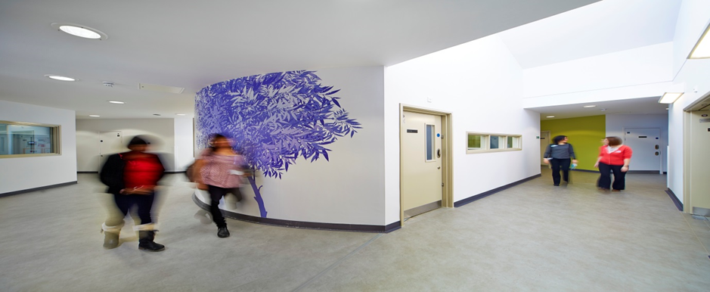

**Future Benefits**

There is a need to continue to realise some further benefits from the redevelopment on new service models.

1. Identify clear baseline measures in order to capture data to show starting off points this will assist to understand the benefit and if this is realised when measuring against the baseline
2. Capture feedback prior to development of services so that this can also be measured against outcomes and where services are now.
3. Consideration given to methods of monitoring benefits, initiation of data collection, division of surveys.
4. Follow up length of stay, occupancy, admissions and discharge data as necessary to account for the trends paying particular attention to Ruby where ALOS has increased since moving into the Whiteleaf. It may also be useful to look at ALOS, admissions and discharges in regard to the smoke-free programme.
5. Follow up on clinical service model and impact the building and its design has had on the delivery of the model against outcomes set by Directorate and commissioners. Comparison across the directorate the difference in delivery of the model within the 5 current AMHTs, what’s working well and if the facility the teams are operating from contributes to the differences.
6. To resolve the outstanding Estates and Facilities pressure and address the heating problems affecting ward bedrooms and kitchens. The sewerage problem has now been permanently fixed.

**Conclusion**

This review demonstrates that the majority of the benefits outlined in the original business case have been realised. Data has been received from HR and performance to demonstrate that there have been improvements in staff sickness, satisfaction, recruitment and length of stay. The remainder of the benefits, having been difficult to fully evaluate due to baseline data not being collected beforehand and also data not being collected. Patients and staff gave positive feedback about the new facility; that it is easily accessible, welcoming and very user friendly. Patient Led Assessment results – Whiteleaf had 100% for condition and appearance, although privacy and dignity score was less than Warneford & Littlemore (Appendix 5). This is being address with Artscape using screens and artwork to address privacy and dignity on and around the wards.

Having all the services located in one place has cut down on travelling between locations, reduced some maintenance costs due to a new and efficient running facility increased the interface between services promoting a whole systems working culture.

The new Campus has had continuing snagging problems which it was agreed to be managed on a day to day basis through estates and facilities upon closure of the Project Board. The Director of Estates in not unduly concerned about any outstanding other than the heating.

Since the close down of the Project Board in March 2014, there has not been clear sight of escalation of the continuing difficulties at Board level and this needs to be addressed with a monthly report in the COO’s Report until they are addressed and all closed. It also needs further consideration for future capital Projects as to when to formally close down the Project Board. There were also additional facilities cost pressures £249k which as the floor plan for cleaning has significantly increased. Flow of bed occupancy has been maintained with length of stay being reduced and discharges happening in a timely manner. There have been reports from some staff working in the hot-desking areas that due to noise levels it can be difficult to make calls to patients in privacy and promoting dignity but given the flexibility of the building these concerns are being managed creatively by reconsidering how the teams use their work spaces and rooms.

The design of the building has afforded patients greater space for recovery both within the building and within the carefully designed outdoor spaces. The design provides the opportunity to bring together all parts of the health care system, county council colleagues, social care and the voluntary sector both physically into the building and via the new clinical model. This would enable us to reduce clinical risk by joint working and facilitate shared training and education.

Attention to detail and design has meant that patients have two bedroom wings – all individual bedrooms with ensuites, centralised communal areas with easy safe access to gardens, spacious lounges, therapy spaces, and separate access to non-clinical areas such as ward round and family room, offices and rest room and facilities.

* As noted previously there are issues with the heating and ventilation design and installation. Keir have agreed to address this within an agreed timescale.
* There has been a notable reduction in incidents that have occurred within the Whiteleaf Centre compared to those recorded from the Tindal, John Hampden and Mandalay sites (Appendix 6). As noted there are some areas where the benefits have not been fully realised, so an action plan will be developed within the directorate and with the appropriate service leads to address these to ensure that the original aims and objectives of this new build are met as fully as we are able to.

At the official open day for the Whiteleaf positive feedback was received from HRH the Countess of Wessex giving praise of the building and its facilities stating “the Whiteleaf Centre offers state of the art facilities for mental health care and it is fantastic the centre is now open and serving the community of Buckinghamshire. We have also received positive feedback from David Lidington MP (Aylesbury) who serves in and around the surrounding areas of the Whiteleaf Centre. David Lidington MP attended the unit for the official opening of The Whiteleaf Centre, Buckinghamshire Health and Wellbeing Campus providing complimentary comments regarding the services being provided.

Overall the project should be deemed successful in delivering a scheme that has enhanced patient care and service delivery by meeting its outline aims and objectives within the original business case, it is a development fit for the twenty first century and is a significant asset for the population of Buckinghamshire and a sound investment for Oxford Health FT for the future.

**Appendix 0**

|  |  |  |
| --- | --- | --- |
| **Benefits** | **Status** | **Evidence** |
| **1.** Co-location of inpatient, day care and community services to improve integration and multi-agency working. Delivery of agreed strategy within “Putting People First”. Delivery of Trust business strategy including improved services and comprehensive packages of care. Delivery of services which are sustainable within the Trust’s overall business plan. | Complete | Signed plans and schedule of accommodation. Agreement for proposal following “Putting People First” public consultation. Implementation of the new clinical service model.  Achieved for children’s’, adult, older adult services and complex needs. Appendix 1 gives more detail. |
| **2.** Delivery of Directorate service development strategy and model of care. Achieving target/benchmark lengths of stay and occupancy levels. Contributes to local delivery of the Trust’s ICT strategy. | Complete | Signed plans and schedule of accommodation. Operational policies in place. Overall reduction in length of stay. Signed IT project input and IT strategy. |
| **3.** Improved access to services for patients, family and staff. DDA compliance and approved service user access. | Complete | Signed schedule of accommodation plus floor plans and commissioning prior to moving in. Feedback from service users and carers – “easily accessible, reception and café area are welcoming, a place I feel happy to meet visitors now.” Contract from Kier and professional team. There have been a small number of complaints about the environment and care which have been addressed. |
| **4.** Improved morale resulting from modern and efficient service delivery and working environment. Suitable environment for users and visitors including one which promotes engagement of users and their families. Increased attraction to Trust for prospective staff. | Complete | There are no surveys thus far that capture this data specifically. Staff survey information is available, demonstrating Buckinghamshire mental health adult services are more positive compared with similar services in Oxfordshire. Data from HR showed there was a decrease in WTE sickness across the Whiteleaf services and more staff were recruited into posts. Feedback from the recruitment days held at the Whiteleaf has been very positive. |
| **5.** Efficient ward staffing levels sufficient to deliver the agreed models of care. Standardisation of ward staffing levels to compliment delivery of model of care. Provision of sufficient capacity to respond to demand (including the impact of the growing, aging population). Designed-in Flexibility of internal layout and expansion to meet emerging best practice and changes in demand whilst complying with planning conditions. | Complete | Staffing levels were increased on all the wards. Matrons lead three ward teams. Flexibility in design, Older adult beds reduced from two wards to one; there are some lessons for designing older adult environments to learn. Rehab ward moved in without need to change design or layout. Planning permission compliance was obtained. |
| **6.** Improved quality of care through delivery of agreed service models within suitable accommodation. Delivery of high quality design. Improved and appropriate clinical adjacencies that benefit both patient/users and staff | Complete | Signed schedule, increased patient and staff satisfaction with regards to clinical care but whether this is directly linked to the design or accommodation the survey does not capture this data. Annual Health Check being carried out through Peer review annual CQC MHA visits and AIMS accreditation process of reviewing standards. |
| **7.** Improved training for staff through improved/appropriate facilities, appropriate staffing levels, supervision and support | Complete | Reduction in use of the Sivatech facility. Increase use of the conference room and learning zone for training. |
| **8.** Optimised estate running costs, achieve national and local sustainability targets. Optimum use of land and estate, maximised capital receipt from the release of agreed sites and facilities. Achieve national and local sustainability targets. Achieve BREEAM excellent rating, demonstrating a sustainable environmental provision. | Complete | BREEAM excellent rating achieved (Building Research Establishment Environmental. Assessment Method) BREEAM certificate as evidence. Used only land required and in compliance with planning permission. |
| **9**. Deliver estimated revenue savings as part of the overall financial package. Property maintenance requirements minimised and eased where possible | Complete | There have been changes to requirements due to meeting demand, however overall costs are reduced. Property maintenance requirements have not reduced, and costs incurred have exceeded planned expenditure to date causing a budget pressure. |
| **10**. Continued Acute Services access to mental health opinion, advice and support. Health and Safety compliant. | Complete | PIRLS in place and contract all agreed. Signed schedule or accommodation plus floor plans and commissioning prior to moving in. |
| **11.** Ensure local compliance with relevant consumerism standards, particularly patient privacy and dignity; and compliant with mixed sex standards. | Complete | Signed schedule or accommodation, services and leads signed these off. 2 of the 4 wards are mixed sex and technically comply with those standards set out in AIMS and CQC so long as environments are clinically managed to these standards. |

**Appendix 1**

**Figure 1** – staff satisfaction feedback received from the real time feedback devices used to capture feedback.

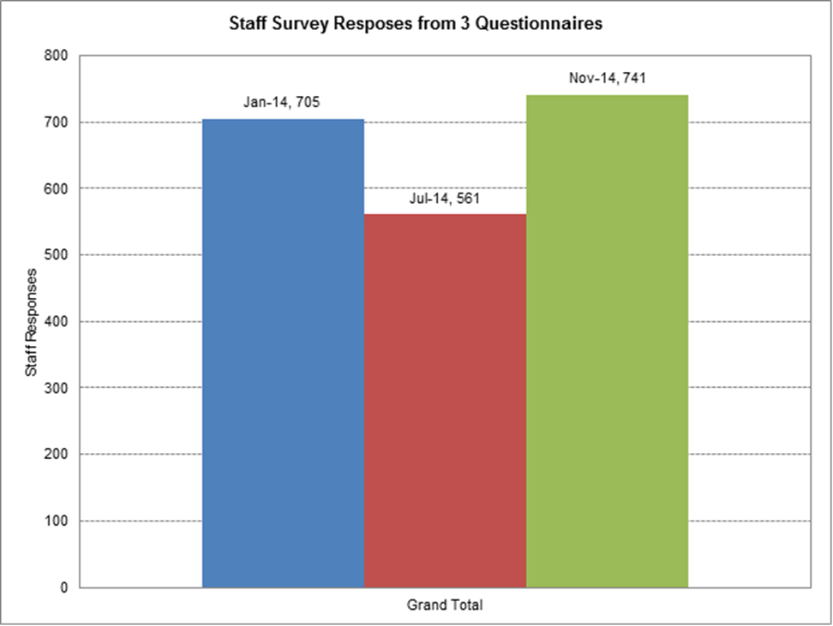

**Appendix 2**

The table below refers to benefit 2. This displays the ALOS for Portland and Ruby, with Ruby’s ALOS for the period 17 days more than Portland.  However, Ruby’s LOS figure for July 2014 was particularly high (see table further below) – if July 2014 is not taken into account, then the overall ALOS figure for the period would be 38 days.  Two patient were discharged from Ruby in July 2014 who had very lengthy admissions, one of 1,000 days and one of 1,646 days. This may account for the increase we have seen since Ruby moving into the Whiteleaf Health and Wellbeing Campus.

**Figure 2** – Length of stay data Ruby (Portland) Ward

|  |  |  |  |
| --- | --- | --- | --- |
| **Ward Name** | **Discharge Length of Stay (LoS) days** | **Discharge Count** | **Average Length of Stay** |
| Portland ward discharges (Apr13-Mar14) | 9036 | 221 | 41 |
| Ruby ward discharges (Mar14 - Feb15) | 9994 | 172 | 58 |
| ***Change*** | ***+958*** | ***-49*** | ***+17*** |

|  |  |  |  |  |
| --- | --- | --- | --- | --- |
|  | **Ward Name** | **Discharge Length of Stay (LoS) days** | **Discharge Count** | **Average Length of Stay** |
| Mar-14 | B Adult Ruby Ward | 101 | 7 | 14 |
| Apr-14 | B Adult Ruby Ward | 310 | 11 | 28 |
| May-14 | B Adult Ruby Ward | 844 | 24 | 35 |
| Jun-14 | B Adult Ruby Ward | 281 | 14 | 20 |
| Jul-14 | B Adult Ruby Ward | 3,502 | 20 | 175 |
| Aug-14 | B Adult Ruby Ward | 313 | 12 | 26 |
| Sep-14 | B Adult Ruby Ward | 1,051 | 20 | 53 |
| Oct-14 | B Adult Ruby Ward | 551 | 16 | 34 |
| Nov-14 | B Adult Ruby Ward | 1,136 | 15 | 76 |
| Dec-14 | B Adult Ruby Ward | 795 | 13 | 61 |
| Jan-15 | B Adult Ruby Ward | 377 | 13 | 29 |
| Feb-15 | B Adult Ruby Ward | 733 | 7 | 105 |
|  | **TOTAL** | **9994** | **172** | **58** |

**Figure 3** – Length of Stay data – Opal (Mandalay) and Sapphire (Kimmeridge)

|  |  |  |  |  |
| --- | --- | --- | --- | --- |
| **Period Summaries** | | | | |
| Ward Name | Period | Discharge Length of Stay (LoS) days | Discharge Count | Average Length of Stay |
| **Mandalay** | **April - Feb 14** | **3.221** | **11** | **293** |
| Average | 460 | 2 | 293 |
| **Opal** | **Mar 14 - Feb 15** | **1850** | **7** | **264** |
| Average | 370 | 1 | 264 |
| **Kimmeridge** | **April - Feb 14** | **15.099** | **225** | **67** |
| Average | 1,373 | 20 | 67 |
| **Sapphire** | **Mar 14 - Feb 15** | **11590** | **235** | **49** |
| Average | 966 | 20 | 49 |

The table above depicts the average length of stay prior to the move into the Whiteleaf and after. It clearly demonstrates there has been a decrease in average length of stays for both the male acute ward and the rehabilitation ward.

**Figure 4** – Length of Stay data – Cromwell (John Hampden unit – Cromwell & Harding wards) and Amber**.**

|  |  |  |  |  |  |
| --- | --- | --- | --- | --- | --- |
| **B Older Adult Cromwell** | | | | | |
| Month Name | Discharge Length of Stay (LoS) days | Discharge Count | Average Length of Stay | Monthly Median Length of Stay | Mode LoS |
| Apr-13 | 440 | 3 | 147 | 106 | 16 |
| May-13 | 569 | 4 | 142 | 123 |  |
| Jun-13 | 665 | 5 | 133 | 97 |  |
| Jul-13 | 384 | 2 | 192 | 192 |  |
| Aug-13 | 694 | 5 | 139 | 112 |  |
| Sep-13 | 499 | 8 | 62 | 42 |  |
| Oct-13 | 682 | 6 | 114 | 74 |  |
| Nov-13 | 740 | 8 | 93 | 40 |  |
| Dec-13 | 129 | 3 | 43 | 20 |  |
| Jan-14 | 73 | 2 | 37 | 37 |  |
| Feb-14 | 287 | 2 | 144 | 144 |  |
| **Total** | **5,162** | **48** | **108** | **90** | **16** |
| **Average** | **469** | **4** | **108** | **90** | **16** |

|  |  |  |  |  |  |
| --- | --- | --- | --- | --- | --- |
| **B Older Adult Amber Ward** | | | | | |
| Month Name | Discharge Length of Stay (LoS) days | Discharge Count | Average Length of Stay | Monthly Median Length of Stay | Mode LoS |
| Feb-14 |  |  |  |  |  |
| Mar-14 |  |  |  |  |  |
| Apr-14 |  |  |  |  |  |
| May-14 |  |  |  |  |  |
| Jun-14 |  |  |  |  |  |
| Jul-14 |  |  |  |  |  |
| Aug-14 |  |  |  |  |  |
| Sep-14 |  |  |  |  |  |
| Oct-14 | 381 | 4 | 95 | 97 | 21 |
| Nov-14 | 534 | 8 | 67 | 16 |  |
| Dec-14 | 455 | 8 | 57 | 26 |  |
| Jan-15 | 358 | 8 | 45 | 46 |  |
| Feb-15 | 191 | 4 | 48 | 45 |  |
| **Total** | **1,919** | **32** | **60** | **46** | **21** |
| **Average** | **384** | **6** | **60** | **46** | **21** |

The average lengths of stay for the older adult wards before and after the Whiteleaf move are displayed in the tables above. The data for these are held within the Older Adults Directorate so some of the data for Amber ward has been difficult to retrieve; the 2 wards at The John Hampden unit were merged and renamed to Cromwell. It demonstrates that the Older Adult Ward has also had a reduction in length of stay and increase in discharge count if you take into account the same period across both wards.

**Appendix 3**

**Whiteleaf Centre - Patient Experience and Complaints Comparisons**

I have looked at a year’s worth of complaints prior to moving to the Whiteleaf Centre in March 2014. During that time, we had received 20 complaints relating to the wards at the Tindal Centre (7 = Kimmeridge, 1 = Mandalay House and 12 = Portland Ward).  In looking at the complaints relating to Kimmeridge Ward, one related to being discharged too early and one related to a bed not being available.  Two also had issues relating to the environment.  In looking at the complaints about Portland Ward, two related to issues around being discharged too early and a ward transfer. Four complaints were about staff attitude.  The complaint about Mandalay House related to loss of property.

Since moving to the Whiteleaf Centre, we have received 10 complaints, which is a reduction compared to the previous year. Of these, four related to Amber Ward, two related to Ruby Ward and four related to Sapphire Ward. Two of the complaints made about Amber Ward related to environmental issues (one of the cases had 100 issues raised within the letter of complaint).  Of the cases related to Ruby Ward, one cases related to a poor discharge and the other related to physical health care needs not being met (i.e. staff did not arrange for an x-ray to be undertaken). Four complaints related to Sapphire Ward and two cases related to medication issues, one case related to a breach of confidentiality and one related to cancellation of leave.

**Appendix 4**

See attachment for sickness, vacancies and recruitment figures comparable between Tindal, Mandalay and John Hampden unit and Amber, Opal, Ruby and Sapphire.



**Appendix 5**

Place Results 2014

Whiteleaf Visit 20th March 2014 for all Areas including Sapphire, Ruby and Amber Ward

|  |  |  |  |  |
| --- | --- | --- | --- | --- |
| Site | Cleanliness Score | Food Score | Privacy & Dignity Score | Condition Appearance & Maintenance Score |
| Townslands Hospital | 98.68% | 91.48% | 81.06% | 97.47% |
| Bicester Community Hospital | 98.33% | 95.39% | 78.45% | 96.25% |
| Didcot Community Hospital | 97.06% | 95.13% | 89.94% | 96.84% |
| Oxford City Community Hospital | 92.61% | 90.13% | 89.29% | 96.21% |
| Wallingford Community Hospital | 97.35% | 95.39% | 85.23% | 96.88% |
| Wantage Community Hospital | 97.65% | 92.65% | 85.11% | 98.47% |
| Witney Community Hospital | 98.34% | 68.34% | 89.23% | 98.53% |
| Abingdon Community Hospital | 96.84% | 89.19% | 86.89% | 97.46% |
| Fiennes Centre | 98.83% | 95.18% | 86.11% | 97.62% |
| Littlemore Hospital | 95.80% | 90.13% | 93.50% | 97.09% |
| Warneford Hospital | 97.50% | 90.87% | 93.06% | 95.81% |
| Fulbrook Centre | 98.04% | 94.60% | 91.67% | 98.82% |
| Cotswold House, Savanake Hospital | 97.44% | 94.68% | 92.71% | 92.86% |
| Marlborough House, Eaglestone | 97.12% | 95.38% | 91.67% | 98.84% |
| Whiteleaf | 98.69% | 91.60% | 92.17% | 100.00% |
| Mandalay House, Aylesbury | 98.10% | 93.41% | 89.00% | 98.41% |
| Swindon Community & Inpatient Child & Adolescent Mental Health | 96.07% | 95.60% | 90.71% | 97.62% |

**Appendix 6**

The Excel spreadsheets below show clear evidence there has been a reduction in incidents on the wards following the move into The Whiteleaf Centre. The total number of incidents for Tindal, John Hampden and Mandalay is 1300, this can be broken down as follows; 410 Portland, 129 Mandalay, 345 Kimmeridge, 220 Harding, 186 Cromwell (combined total 406). The total for The Whiteleaf Centre is 1071, this can be broken down as follows; 439 Ruby, 61 Opal, 227 Amber, 344 Sapphire. Although ruby had an increase this was attributed to higher self- harm incidents, reduction in AWOL and Violence, where as in Portland this was violence, AWOL and self -harm in roughly equal proportions. Sapphire shows a slight overall reduction with the majority of those reductions coming from AWOL and violent incidents. Amber and Opal both show clear reductions in their incidents levels both wards reducing their incident rates by half.

 

**Appendix 7**

