BOD 39/2016
(Agenda item: 13)

Report to the Meeting of the

Oxford Health NHS Foundation Trust

Board of Directors

23 March 2016

Workforce Performance Report (including Staff Survey results)– March 2016

For Information

This report and the attached information shows the position on the workforce performance indicators as at the end of March 2016, except for sickness absence which is a month in arrears.

Overall, staff turnover, the ability to recruit the required numbers at the required speed and the consequential impact on the high usage of temporary staff resource remains the main concern and hence the focus of high levels of activity.

Headline KPIs

Bank & Agency Spend %: 7.10% TARGET: 5.00%

Bank & Agency spend decreased in February to fall from a peak of 7.41% in January to 7.10%. Reductions in Agency spend were most noticeable in Oxon Assessment Teams, Informatics and MSK Physiotherapy. The introduction of the Agency Framework would seem to be having the desired effect of reducing spend from the peak of 7.63% in September 2015.

Vacancy % Rate: 10.08% TARGET: 9.00%

The Vacancy rate increased slightly to 10.08% in February but the rate has remained steady over the past three months at about 10%. Whilst Adult and Older Directorates saw an increase in the vacancy rate, this was offset by a decline in Corporate and Children & Young People. Resourcing continue to work closely with managers in attempting to fill posts particularly in difficult to fill units such as Inpatients.

Trust Turnover % Rate: 14.12% TARGET: 12.00%

The Turnover rate has decreased over the last two months to stand at 14.12%. Children & Young People and Corporate have seen a reduction in turnover whilst Older People’s and Adult Directorates have seen an increase. Individual Directorates are establishing workforce work streams to take forward initiatives to improve recruitment and retention whilst Resourcing have held open days to attract qualified staff.

The high rate of Turnover will prolong the high requirement for agency staff and continue to challenge recruitment in a difficult labour market.

Sickness Absence % Rate: 4.29% TARGET: 3.50%

Sickness increased slightly to 4.29% in February compared to 4.21% in January. The increase in sickness since October is driven by the winter surge of short-term cold and flu absence. ‘Anxiety and Stress’ has shown a consistent decline and would appear to result from HR activity on long-term sickness cases through the Capability – Health process.

Anxiety/Stress/Depression/Other Psychiatric illnesses continue to be the highest reported reason for sickness absence followed by musculoskeletal and gastrointestinal problems.

Other actions taken include:
- Stress awareness courses were held on 5th and 29th February in partnership with S&P Care.
- Proactive Health promotion visits increased and additional satellite clinics implemented and well received
- Proactive walk through and workplace assessments (not to be confused with DSE assessments) in response to teams relocating.

Flu vaccination uptake has reduced this year to 50.3% from 56.4% despite an increase in available clinics across all sites, the ability to have vaccine externally at a local chemist and agreements with OUH, Buckingham Hospital and GWH to enable vaccination at all their Occupational Health clinics. This decline is in line with that seen for local and national trusts and GP practices.

Recruitment Activity

Apprenticeships

Following a successful recruitment pilot in September for Business and Administration Apprentices, we are now rolling out the apprenticeship programme trust wide.

We held apprenticeship assessment days in February and March for Business & Administration as well as Clinical apprentices. We have recruited 11 young apprentices to start the programme on the 11th April 2016.

We will be holding another assessment centre in August 2016.

Careers Event

We held an event aimed at young people who are considering a career in the NHS on the 10th February. This was very well attended by approximately seventy young people and was a successful evening.

Open Days

We held an Open Day on 6 February at Abingdon Hospital aimed at recruiting clinical staff for the Older People’s Directorate. This was well attended particularly by people looking for HCA roles with some fifty people attending.
We also held an Open Day on 27 February for the Highfield Unit to attract Children’s mental health nurses. 28 people attended and from this, 3 Staff Nurse candidates are being interviewed on the 24th March and 5 HCA candidates on the 11th April.

Work Experience

We are working with the Learning & Development team to hold two taster weeks for young people during the summer, these will be a week long programme that will involve an introduction to the NHS (how it works, the different services, partnership working etc) followed by three days of work shadowing in various areas before the final day of evaluation/next steps.
For this pilot the weeks will be based in Oxford, if this proves to be successful we will then look at rolling it out the following year to cover Bucks, Wilts and BaNES.

National & Local Recruitment Events

We are compiling a calendar of national and local events so that we have time to organise and assess the suitability and associated costs of Service Reps attending the events.

School Careers Events

We will increase our presence at local school careers events with representatives from our services to publicise the benefits/rewards of a career in OHFT and the NHS.

Health & Wellbeing

OHFT won the Most Active Workplace Award for 2015 for the second year in a row, based on innovative ways of engaging staff in physical activity.

Physical Wellbeing

Bike User Group breakfasts have taken place at locations throughout the organisation during the last quarter – coinciding with National Cycle to Work day.
Oxonbikes previously located at Chancellor Court are in the process of being moved to Redbridge park and ride. There is a cycle route from Redbridge to Littlemore which will enable staff relocating to Littlemore to park at Redbridge and cycle in to Littlemore.
Additional funding has been acquired from an external source to fund ElectricBikes to help support staff who are not regular cyclists.

Emotional & Psychological Wellbeing

There are now mindfulness sessions taking place (by invitation) at various meetings across the organisation to introduce teams to the concept. There are plans in place to roll out taster sessions for staff to book onto. This will include practical exercises for possible use by staff groups for example at team meetings or at the beginning or end of reflective practise.

Organisational Wellbeing

The first Health & Wellbeing Champions networking session took place during December. Positive outcomes were; A newly created Purpose Statement and the creation of an online network for champions to discuss and exchange ideas. There are a total of 54 Champions across the organisation, with representation from each Directorate – a further event will take place in April 2016.

Directorate Performance

Older People’s Directorate

Turnover: 14.97% v 12.0% Trust Target

- District Nursing Services in Older People’s Directorate in which turnover/retention has been a concern, have developed support for new entrants. It is hoped that in addition to enhancing the induction of new staff members this will aid retention and therefore reduce turnover.

Sickness: 5.52% v 3.5% Trust Target

- Although the trend has increased since the summer (and has increased since last month), there has been an overall reduction in sickness absence. HR continue to work with managers to manage attendance. There are currently 26 formal sickness cases.
- The trend in Older People’s Directorate is rising again after a significant reduction in summer 2015. This appears to follow a cyclical trend in the Directorate (reductions in sickness absence during the summer and then returning to around the 5.5% level). The most recent workforce reports show that Stress / Anxiety / Psychiatric illness is the biggest single cause of absence in Older People’s Directorate (22%). The Directorate has the highest number of staff members in formal absence management processes and this includes staff who have frequent short term absence issues (Bradford Factor); the HR team continue work to support operational managers with absence management processes.

Bank and Agency: 7.4% v 5.0% Trust Target

- Bank & agency use has increased since last month, presumably in line with the increase in sickness absence and vacancy rate. Due to a shortage of domiciliary care workers, sessional arrangements are being developed in the Oxfordshire Reablement Service alongside the OUH’s SHDS service.
- This increased in January driven by MSK Physiotherapy, Podiatry and the Out Of Hours Medical Service.
- Significant spend on agency has been costed to the Winter Pressure cost centre by Older People’s Directorate services. However the correlation between Directorate vacancy rate, sickness absence levels and agency spend has to be noted. Increased agency use has been reported in some of the community hospitals in response to increases in bed numbers.
Vacancy

- In Older People’s Directorate there are high levels of vacancies in some therapist roles. Additionally, Witney Community Hospital will be increasing staffing to re-open the temporarily closed ward and there are also large numbers of live vacancies in Abingdon Community Hospital.
Medical Staffing

- A locum consultant has recently been recruited which will see a significant reduction in agency costs. A vacancy is currently being recruited to for a specialty Doctor. There is no long term sickness.

Children & Young People Directorate

Turnover: 13.52% v 12.0% Trust Target

- Turnover % remains above Trust target and has increased slightly since September.

Sickness: 3.33% v 3.5% Trust Target

- As part of actions to reduce sickness levels the CYP Directorate is developing an approach to the high levels of ‘Anxiety and Stress’ using the model of six key contributors as researched by the Health, Safety and Wellbeing Partnership. Examples of this are triangulating sickness data against turnover. We will also look to analyse data by age/disability/ethnicity/sex/sexual orientation with a view to identifying any trends that merit further investigation.

- Focusing on ‘Anxiety and Stress’, the CYP management has also highlighted the control demand aspect specifically around the issue with CareNotes. A balanced approach to communications and number of meetings has been adopted – for example a weekly email will be circulated to staff to update on key issues andk ey meetings taking place on one day will be trialed. The Directorate is also aware that anxiety is being felt by staff with regard to the upcoming review of all services and recent experiences of outsourcing and service transfers. To minimise the impact on staff we are working closely with commissioners to seek preferred provider status and rolling out tried and tested service delivery models.

Bank and Agency: 7.1% v 5.0% Trust Target

- Inpatient units have been using non agency framework suppliers and this practice is being targeted to replace the non-framework supply with Framework Agency workers.
- The Resourcing Department is working closely with recruitment managers, in particular, meeting with the Modern Matron at Highfield Oxford in the next 2 weeks to discuss vacancies.
- There are recruitment difficulties within the consultant group – OSCA – for which there is a national shortage of Consultants. The proposal is to over recruit in this area, and also look at skill mixing within the Consultant /Specialty doctor group. Clinical Director is leading this project.

Medical Staffing

- There is an overall reduction in spend per locum as a result of moving to the new framework and the agency price caps, however the number of locums now required has increased overall costs.

Agency Spend at Highfield Oxford

- Agency spend at the Highfield is linked to vacancies, a recent increase in short term sickness and significant acuity challenges. The unit still has ongoing relationships with non-framework agencies, with permission being sought prior to their use, due to unavailability of appropriate staff, however they have recently established some good relationships with framework agency staff and are in weekly liaison with Staffing Solutions to feedback on their experiences.
- The unit is currently looking to recruit approx. 6 WTE Staff Nurses and 8 WTE Health Care Assistants, which is in line with the level of agency spend. The unit hosted a recruitment open day on the 27th February. Turnover is currently approximately 17%, with 2 leavers in December. This is in line with some of the other inpatient units within CYP, e.g. Cotswold House Marlborough = 22%, Marlborough House Swindon = 19%

Medical Recruitment

Vacancies- 6.5
- Abingdon CAMHS, 0.8 WTE
- Witney CAMHS, 1.0 WTE
- Oxford CAMHS, 1.0 WTE
- Swindon CAMHS, 0.8 WTE
- Melksham CAMHS, 2.0 WTE
- Salisbury CAMHS, 0.9 WTE

Locum Usage-
 | Location/team | Hours pw
Consultant | Melksham | 40
Consultant | Orchard House, High Wycombe | 40
Consultant | Orchard House, High Wycombe | 32
Consultant | Clockhouse, Abingdon | 32
Staff Grade | Marlborough House, Swindon | 24
Consultant | Swindon Comm CAMHS | 32
Consultant | Oxford City - BBH (ASD Pathway) | 16
Consultant | Oxford City - BBH | 24

Adult Services Directorate

Turnover: 15.09% v 12.0% Trust Target

- The Turnover rate plateaued at 15.01% in December, 15.03% in January and 15.09% in February.
- A Careers Open day for qualified staff was held at the Warneford on January 12th. 58 candidates attended and although major advertising was done in Nursing publications and websites the breakdown of attendees was 11 Nurses, 12 Social Worker and 21 O/Ts with the remainder looking for unqualified positions. The majority of attendees were currently students qualifying later this year. All of the nurses have been either offered roles or have interviews set up in the next few days. Discussions are ongoing regarding additional roles for S/Ws and O/Ts where there are currently no vacancies.
- An advert is out to Band 5 inpatient staff in MH to step up to the Band 6 Deputy ward manager role for 12 months with the option of returning to their substantive post if the role is not to their liking or if we consider they would be more effective as a Band 5. Specific training will be given in the first 9 months to develop staff in the role. We have 5 roles to fill and this will create 5 Band 5 vacancies.
- In the first 2016 tranche of apprentices for the Trust, 2 roles were offered for Business & Administration roles in Adult MH but of the 4 candidates who attended none of them lived in the locality of the vacancies.
- A School event was being held on 12th February and MH had a stand. A Careers day is being held in Aylesbury for Student Nurses attending Bedfordshire University and qualifying shortly. Approximately 20 candidates will attend and will be encouraged to attend interviews for Band 5 roles the following week. MH is attending a Social Workers career’s day for Buckinghamshire New University in March.

Sickness: 3.81% v 3.5% Trust Target

- All long term cases are being managed with the support of Occupational Health and the number of cases being managed through a formal process has increased. The Adult Directorate has seen a decline in sickness levels this month however it remains above target. All staff who have hit the triggers for sickness absence are being reviewed and HR are working with managers locally to ensure that formal processes are being followed.

Bank & Agency: 9.0% v 5.0% Trust Target

- Agency spend is increasing, particularly in Thames House, Oxford City and Chiltern AMHT’s. Chiltern are having difficulty recruiting Band 6 Social Workers and are covering vacancies with long lines of work through agencies. Oxford City recruited 3 staff from the Open day who are currently going through employment checks.
- Significant spend on agency can be noted across the Inpatient areas of the Adult Directorate. The wards are carrying high levels of vacancies and recruitment to these remains an issue with turnover rates indicative that staff are leaving as quickly as they are being recruited. Staff are using annual leave prior to March 31st which has caused additional pressure in some areas. Patient acuity is high (Thames House) requiring additional staffing numbers achievable only through agency use. The Oxford EIS service has recently extended their hours and recruitment is ongoing to fill vacancies resulting from this. They are also covering sickness absence through this same route.

Vacancy

- In Adults Directorate there are high levels of vacancies across the Inpatient areas in nursing roles as described below. The Directorate is also targeting the recruitment of Social Workers, through Open Days and specific advertising, in Chiltern (Bucks South) due to a number of vacancies for this profession.

Medical Recruitment

- There is less activity in Adults with one consultant vacancy in Chiltern AMHT, 0.8 WTE and an agency locum providing cover.
- There is a full time specialty Doctor vacancy on Ashurst, at interview stage but an NHS locum until August.

Corporate

Turnover October 11.77% V 12.0% Trust Target

- Turnover has reduced to below the Trust target to stand at 11.77%.

Sickness January 4.0% V 3.5% Trust Target

- The overall trend is improving, however the trainee doctor staff group continues to present a challenge, particularly with long term sickness. Key areas requiring further improvement have been identified and are being worked through currently. Sickness absence is being managed in line with current trust policy and is focusing on; ensuring line managers and supervisors are clear on roles and responsibilities, developing and coaching managers to ensure they are confident in the management of absence and transparent team level ‘dashboards’ enabling focused planning to support in teams or departments of concern.

Bank & Agency October 4.1% V 5.0% Trust Target

- OPS have the biggest challenge in the use of temporary staffing. They are currently working to fill substantive vacancies which will considerably reduce their use of temporary staff. High levels of scrutiny remain essential in this area. OPS currently have 8 posts that are at various stages of the recruitment process which will provide a stable base at the operational level of the department. The next phase of this project will be to consider the supervisory level posts and recruit substantively at this level.
- Estates and Facilities are recruiting to 17 posts (within soft facilities) currently which should reduce their reliance on temporary staff.

NHS STAFF SURVEY 2015

NHS Staff Survey

The NHS National Staff Survey 2015 was carried out between October and December 2015.

This year the trust has commissioned The Picker Institute to survey our employees and to analyse the resulting data. The Picker Institute works with trusts directly, and also work with the NHS to produce national data.

The national data that Picker provides is weighted so that the occupational group profile of the organisation reflects that of a typical organisation of its type. The national data is useful in giving an overall picture of the organisation. By working with Picker directly we will also be able to produce locality level reports that will allow our managers to take action and plan initiatives within their teams and departments. These reports will be available towards the end of March 2016.

Response Rate

The trust took the opportunity to survey its entire staff group, the majority of which were submitted by email (2% by paper) as we did last year. 2,526 staff members chose to complete the survey giving a response rate of 48.1% compared to 32% in 2014.

Response rate by Directorate | 2015
Adult | 43.4%
Children & Young People | 52.4%
Older People | 45.4%
Corporate | 55.3%

Overall Trust Position

Have we improved since the 2014 survey?
We can compare 60 questions which were used in both the 2014 and 2015 staff survey.
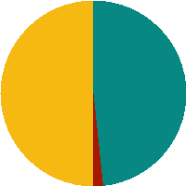
Significantly BETTER on 29 questions
Significantly WORSE on 1 question
The scores show no significant difference on 30 questions

How did we compare to other similar trusts?
See Appendix A for details of organisations that are included within our chosen group of ‘combined mental health, learning disability & community trusts’.
Staff Engagement Score

The staff engagement score is calculated using nine questions relating to three key areas of staff engagement: Advocacy, Involvement and Motivation.

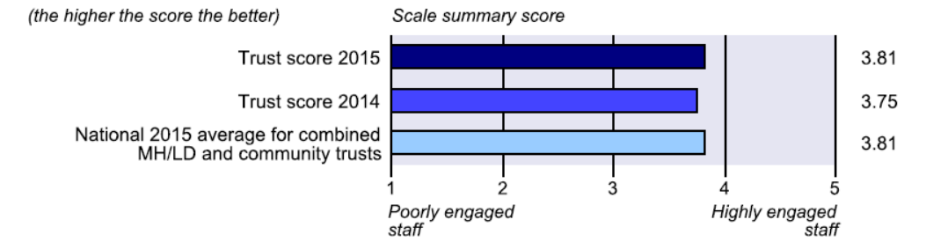

NB. These results are weighted to compare ‘like for like’ staff group to that of the national grouping of ‘combined mental health, learning disability & community trusts’.

Analysis of data relating to this score shows that there has been an improvement in the area of Advocacy and Motivation and no improvement in the area of Involvement (KF7). Overall the staff engagement score has improved and sees an upward trend since 2012.

It was acknowledged in the recent CQC report in the Well Led domain that we are making progress in the area of involvement with our senior leaders. The report stated that
- The visions and values of the trust were transparent across all services and linked well with local objectives.
- Staff were able to clearly articulate the trust vision and values.
- The chief executive has a rolling programme of visits and staff engagement meeting called ‘talk to Stuart’.

Where have we been most successful?

The top 5 scores are:

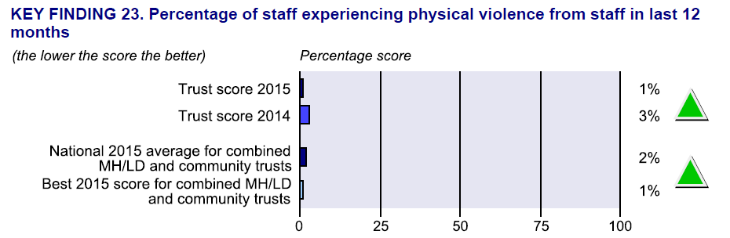
An improvement on last years score, and equal to the best score for our grouping.

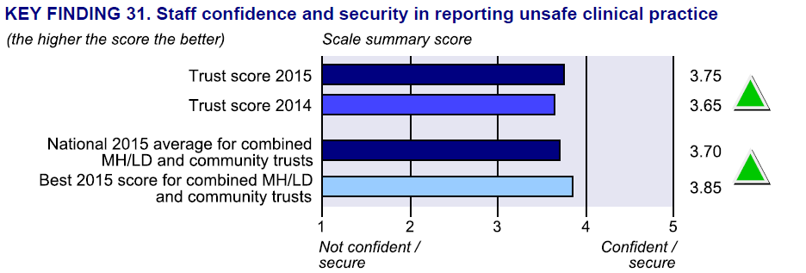
An improvement on last years score and above average for our grouping.

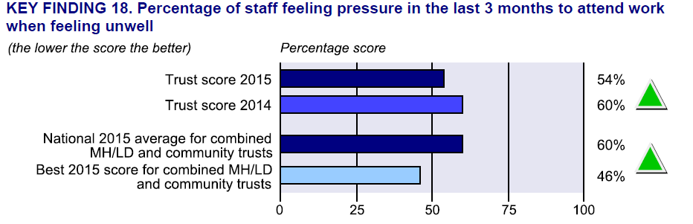
An improvement on last years score and above average for our grouping.

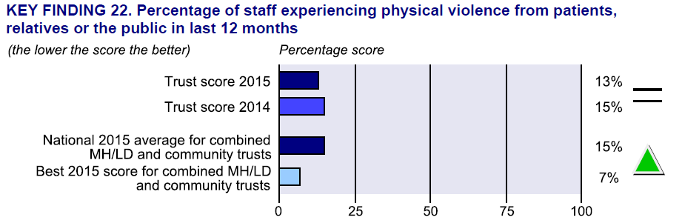
No statistically significant change based on last years score, nevertheless an above average score for our grouping.

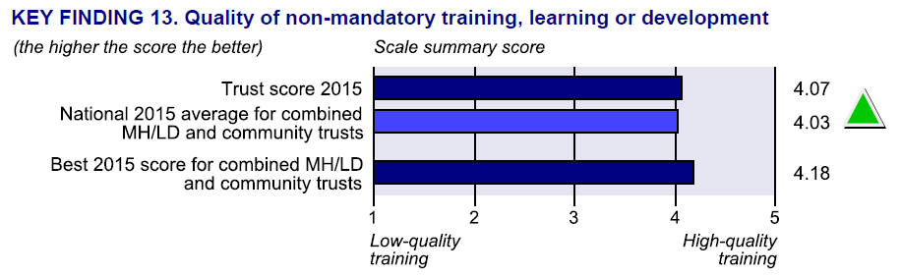
This is a new question in 2015. The score is above average in our grouping.

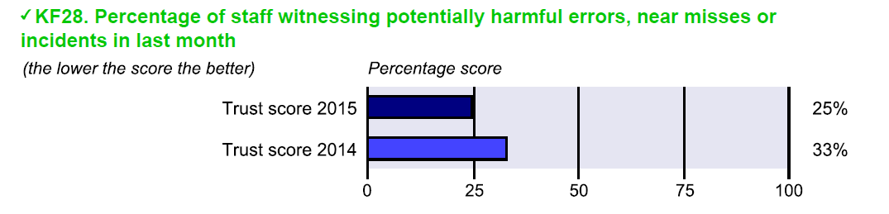
The biggest local improvements are in the following areas:

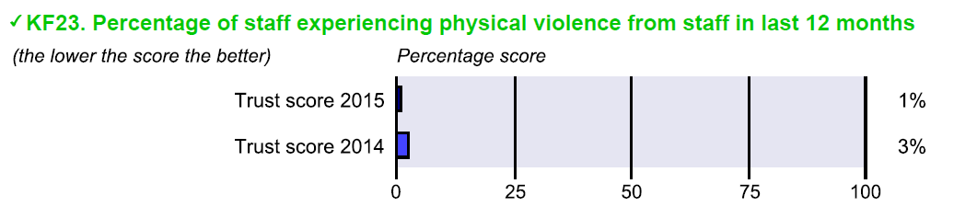
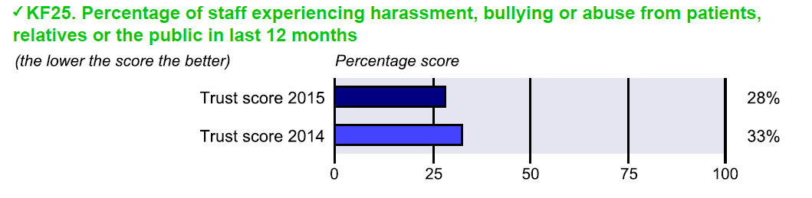
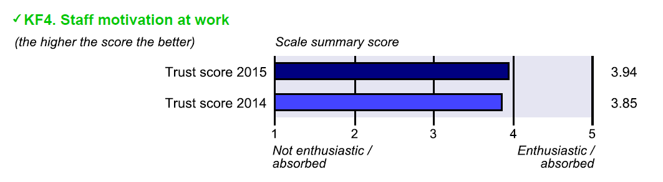
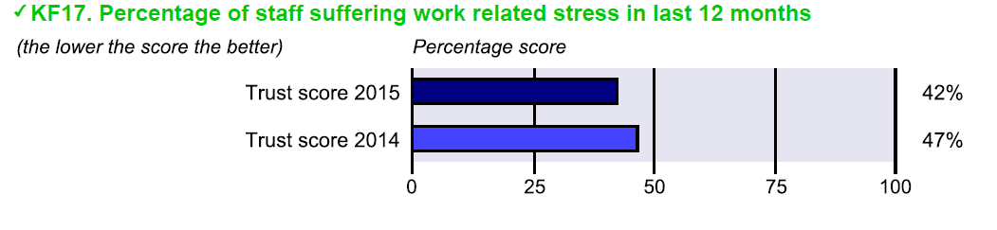
NB. Work Related stress remains a big challenge for the Trust**

Where we should focus our attention for 2016?

The bottom 5 scores;

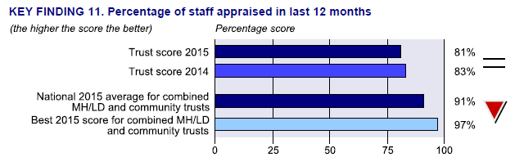
What have we done so far?

Current locally recorded results from the Online Training Records system.

The Workforce strategy has a key priority for 2016 relating to performance. This will see a new PDR system and process focused on:
- Structured content
  - Values/behaviours, objectives – team and individual, competencies, development needs, wellbeing conversation, overall evaluation score
- Systemised process
  - PDR date is OHFT employment date – dates tracked and notified
  - Structured PDR is consistent and is stored in a central database
  - Simplified core competency framework within appraisal linked to job description
  - Appraisee and appraisor have access
- Output value
  - All staff will have a formal annual discussion about values/behaviours and health & wellbeing – reinforce engagement
  - OHFT and team objectives will be reinforced in the PDR discussion
  - System will capture service / Directorate / OHFT training requirements
  - Combine training needs analysis, personal development and career progression
  - Scoring allows for first cut talent management review
  - Pay increments will be linked to PDR score – incentive to perform well

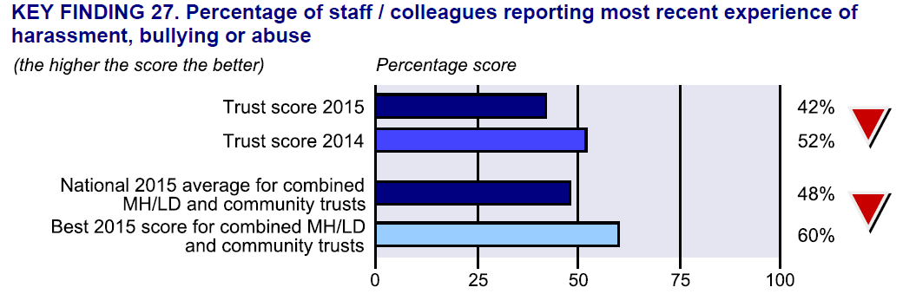

We have set up a Mediation service to resolve conflict an early stage and support formal processes.

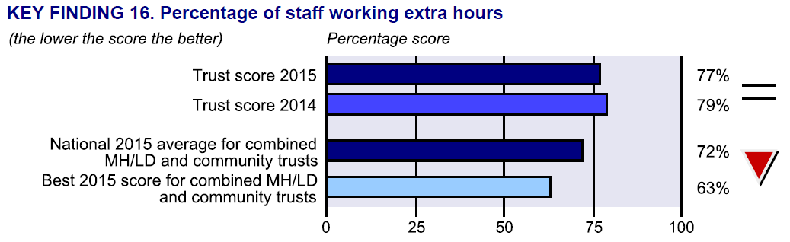

An Internal bank of temporary staff with enhanced rates of pay is being set up.

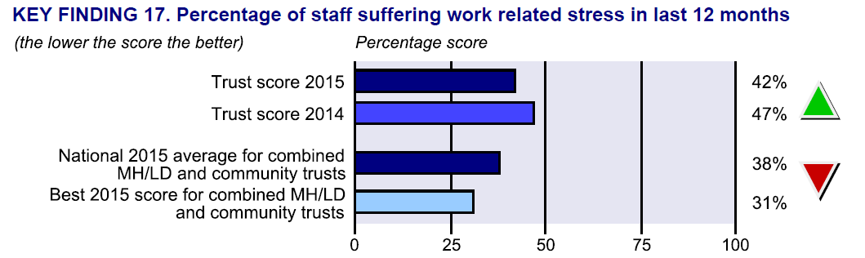
This score has improved compared to last years score with an above average score in our grouping.

What have we done so far?

In 2015, the top five reasons for sickness month on month are:

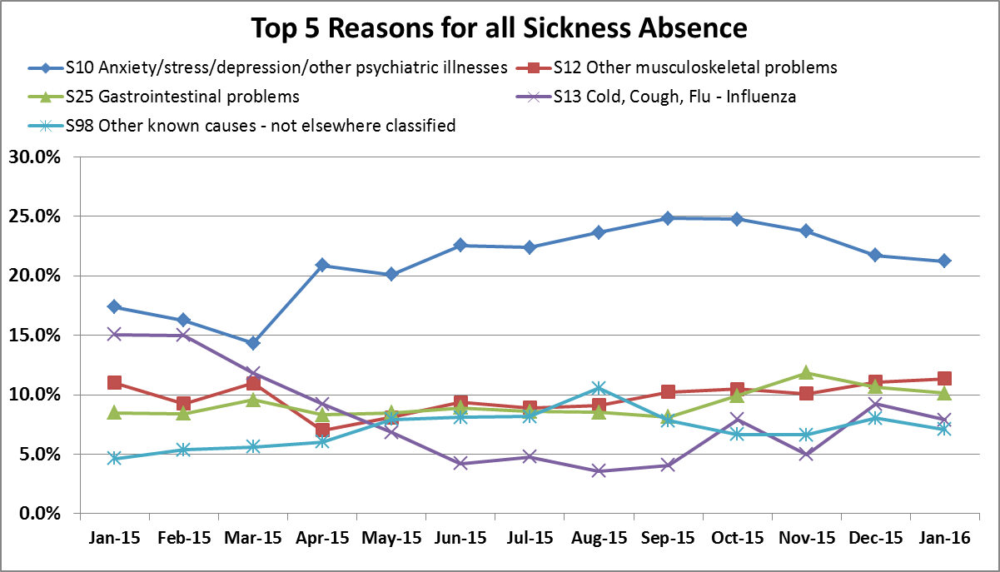

We are currently running a series of stress management workshops focused on resilience and stress management strategies, which will be reviewed following completion of the pilot. In addition, there is an Employee Assistance Programme being considered by the Trust which will allow staff to access support via a telephone service and (if appropriate) face to face support. This is in addition to a counselling service that is offered by our in house Occupational Health & Wellbeing and mindfulness sessions that form part of our induction and regularly feature on various team meetings.

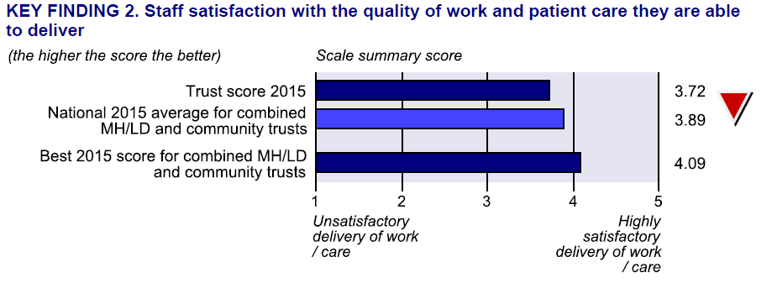

What’s next?

National Staff Survey results were published during week commencing 22nd February 2016 at which point we were able to see how we compare nationally to our chosen grouping – Community & Mental Health Trusts.

A communication plan has been developed on how results will be communicated to staff, which has been agreed with the communications team and includes an organisational narrative comparing us to our peers and will signpost Directorates (and teams) to a bespoke report providing local data for Directorates (and teams) to be able to formulate their own local action plans and initiatives.

The overall results will be accessible to all staff in a variety of formats to include pages on the intranet, posters and infographics.

The OHFT Leaders Conference, took place on 10th March and included an interactive session where OHFT leaders had the first opportunity to discuss organisational level results.

In addition a workshop where the Health & Wellbeing Action Group met and agreed objectives and actions relating to the Health & Wellbeing section of the Staff Survey took place on 26th February 2016.

Local reports (Directorate and team level) will be made available by the end of March 2016. These local reports will group data allowing managers and their teams to see where their biggest challenges lie and enabling them to move to formulate action plans quickly without having to waste valuable time in analysing data. The groupings are:

- Clear expectations/Right tools for the job
- Opportunity to do best job
- Recognition for good work
- Support and positive interest in my wellbeing
- Fairness/Harrassment/Speaking up
- Learning/Development/Appraisal
- My opinions and suggestions are valued
- Team and OHFT commitment to quality care
- Staff satisfaction with work

The data will be presented in the form of spider charts such as the example below:

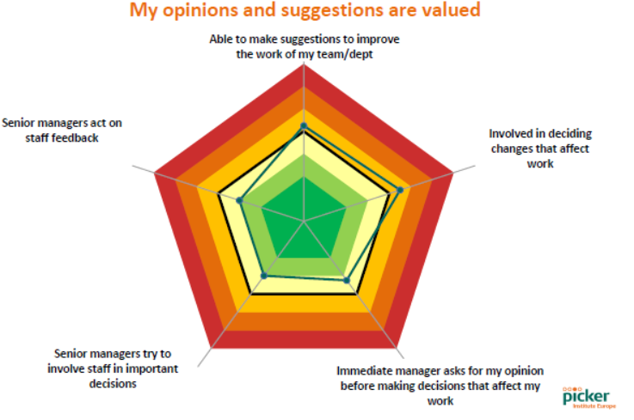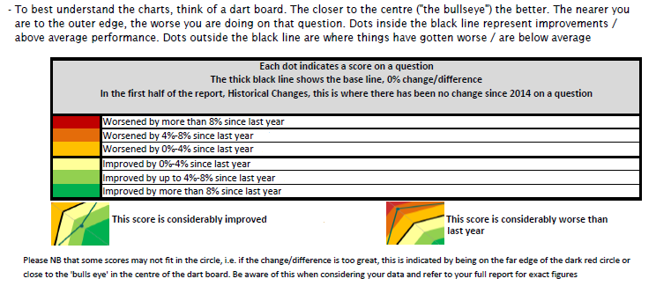

The charts present the Directorate/team level data compared to the overall organisation position.

Whilst these reports will be available via the Managers Portal, there will also be a series of presentations and Roadshows to support managers in creating their own local plans and initiatives.

Appendix A

The national grouping includes the following NHS trusts:
Organisation Name
Solent NHS Trust
Worcestershire Health and Care NHS Trust
Oxford Health NHS Foundation Trust
North East London NHS Foundation Trust
Dorset Healthcare University NHS Foundation Trust
Somerset Partnership NHS Foundation Trust
Nottinghamshire Healthcare NHS Foundation Trust
Cornwall Partnership NHS Foundation Trust
Cumbria Partnership NHS Foundation Trust
Northamptonshire Healthcare NHS Foundation Trust
Oxleas NHS Foundation Trust
Barnet, Enfield And Haringey Mental Health NHS Trust
Cambridgeshire and Peterborough NHS Foundation Trust
Pennine Care NHS Foundation Trust
Leicestershire Partnership NHS Trust
5 Boroughs Partnership NHS Foundation Trust
Humber NHS Foundation Trust
Southern Health NHS Foundation Trust
Lancashire Care NHS Foundation Trust
East London NHS Foundation Trust
South Essex Partnership University NHS Foundation Trust
Berkshire Healthcare NHS Foundation Trust
Cheshire and Wirral Partnership NHS Foundation Trust
Rotherham Doncaster and South Humber NHS Foundation Trust
South West Yorkshire Partnership NHS Foundation Trust
Derbyshire Healthcare NHS Foundation Trust
Coventry And Warwickshire Partnership NHS Trust
Bradford District Care NHS Foundation Trust
Black Country Partnership NHS Foundation Trust

Appendix B

Further detail
The Trust has improved significantly on the following questions:
 |  | 2014 | 2015
2a | Never/rarely look forward to going to work | 15 % | 10 %
2b | Never/rarely enthusiastic about my job | 8 % | 4 %
2c | Never/rarely does time pass quickly when I am working | 5 % | 3 %
3a | Do not always know what work responsibilities are | 10 % | 8 %
4a | Opportunities to show initiative infrequent in my role | 12 % | 10 %
5f | Dissatisfied with extent organisation values my work | 31 % | 28 %
5g | Dissatisfied with my level of pay | 44 % | 39 %
7a | Immediate manager does not encourage team working | 12 % | 8 %
7d | Immediate manager does not ask for my opinion | 23 % | 19 %
7f | Immediate manager does not take a positive interest in my health & well-being | 16 % | 10 %
8b | Communication between senior management and staff is not effective | 35 % | 30 %
8c | Senior managers do not try to involve staff in important decisions | 41 % | 35 %
8d | Senior managers do not act on staff feedback | 36 % | 30 %
9c | Felt unwell due to work related stress in last 12 months | 48 % | 43 %
9d | In last 3 months, have come to work despite not feeling well enough to perform duties | 64 % | 57 %
11a | In last month, saw errors/near misses/incidents that could hurt staff | 22 % | 15 %
11b | In last month, saw errors/near misses/incidents that could hurt patients | 29 % | 21 %
13a | Do not know how to report unsafe clinical practice | 7 % | 5 %
13b | Would not feel secure raising concerns about unsafe clinical practice | 10 % | 8 %
13c | Would not feel confident that organisation would address concerns about unsafe clinical practice | 13 % | 10 %
14a | Physical violence from patients/service users, their relatives or other members of the public | 16 % | 13 %
15a | Harassment, bullying or abuse from patients/service users, their relatives or members of the public | 33 % | 29 %
17a | Discrimination from patients / service users, their relatives or other members of the public | 6 % | 4 %
17b | Discrimination from manager / team leader or other colleagues | 9 % | 7 %
21a | Care of patients is not organisation's top priority | 13 % | 10 %
21b | Organisation does not act on concerns raised by patients/service users | 6 % | 4 %
21d | If friend/relative needed treatment would not be happy with standard of care provided by organisation | 13 % | 10 %
22a | No patient/service user feedback collected within directorate/department | 6 % | 4 %
22b | Do not receive regular updates on patient/service user feedback in my directorate/department | 24 % | 19 %

The Trust has worsened significantly on the following questions:
 |  | 2014 | 2015
15d+ | Last experience of harassment/bullying/abuse not reported | 40 % | 49 %

Recommendation

The Board is asked to note the report for information.

Author and Title: Jayne Halford, Deputy Director of HR

Lead Executive Director: Mike McEnaney, Director of Finance

[Drafting Note: The following statements must be attached to every report]
- A risk assessment has been undertaken around the legal issues that this paper presents and there are no issues that need to be referred to the Trust Solicitors.

- This paper (including all appendices) has been assessed against the Freedom of Information Act and the following applies: [delete as appropriate]

- THIS PAPER MAY BE PUBLISHED UNDER FOI

- This paper provides assurance and evidence against the Care Quality Commission Outcome: [Input Outcome number – i.e. 12,13,14]

