

Report to the Meeting of the

Oxford Health NHS Foundation Trust
Board of Directors
BOD 65/2016
(Agenda item: 9)

25th May 2016
Quality Report: Patient Experience 2015/16
For: Information

Executive Summary
This annual report for 2015/16 provides a summary of the feedback we have received which tells us how it feels for patients to receive care, and how we have used this to work with people to improve their experience of receiving care and treatment.

The trust is very committed to ensuring patients are at the centre of everything we do and aim for, and to keep developing how we work better together by involving people at all levels of decision making and by recognising and respecting the valuable contribution we all make, which includes patients, carers/ families and staff. How we continue to improve patients, families and carers experiences remains a key priority for the trust in 2016/17 (included in the trusts business strategy and quality account).

Across our services the key and consistent areas for improvement fed back from service users, patients and carers are grouped around the relational aspects of care delivered by individual staff:
- Families and carers want to be more involved, listened to and respected
- Patients want to feel informed, be given options and be supported to make decisions which affect them.
- Patients want to be provided with good information that is tailored to them and is timely
- Patients want staff to communicate clearly with them

We also recognise that the approach we take to involving patients, families and carers needs to be more consistent across the organisation, and that it needs to be tailored and appropriate to the individual and the variety of services we provide.

Whilst there is much good practice already, we have been working on the development of a new patient involvement and experience strategy since November 2015 co-developed with patients, families/ carers and staff to identify and drive the improvements we need to make in 2016/17.

Recommendation
The Board is asked to note this report.

Author and Title: Mandy McKendry, Patient Experience and Involvement Project Lead and Jane Kershaw, Acting Head of Quality and Safety

Lead Executive Director: Ros Alstead, Director of Nursing and Clinical Standards

A risk assessment has been undertaken around the legal issues that this paper presents and there are no issues that need to be referred to the Trust Solicitors.

“Seeking and acting on patient feedback is key to improving the quality of healthcare services and putting patients at the centre of everything we do.”

- Introduction
This annual report for 2015/16 provides a summary of the feedback we have received which tells us how it feels for patients to receive care, and how we have used this to work with people to improve their experience of receiving care and treatment. No document can truly convey the breadth of work taking place across the trust or reflect the dedicated work and improvements that take place every day. However the report gives a picture of our commitment to working in partnership and asking, listening and using feedback from people who use our services, their families and carers so we can make improvements and changes which make a difference.

The trust is very committed to ensuring patients are at the centre of everything we do and aim for, and to keep developing how we work better together by involving people at all levels of decision making and by recognising and respecting the valuable contribution we all make, which includes patients, carers/ families and staff. To ensure this focus is maintained the Board of Directors on a monthly basis has a patient/ family story to start their meeting. How we continue to improve patients, families and carers experiences remains a key priority for the trust in 2016/17.

We recognise that the approach we take to involving patients, families and carers needs to be more consistent across the organisation, and also that it needs to be tailored and appropriate to the individual and the variety of services we provide. Whilst there is much good practice already, we have been working on the development of a new patient involvement and experience strategy since November 2015 co-developed with patients, families/ carers and staff which will be finalised in April 2016.

The report is split into the following sub-sections;
- Summary of feedback about services
- Summary of how we involve people
- CQC national quality standards
- Patient experience strategy 2013-2016 (current strategy)
- Key development areas
  - patient involvement and experience strategy
  - improved reporting from current contractor
  - Increasing use of patient opinion
  - trialling software from iwantgreatcare
- Other developments in 2015/16
- Feedback from carers
- National community mental health survey 2015
- Results to the trust wide core questions
- Patient Friends and Family Test (FFT): how likely are you to recommend the service...?
- External audit findings (relating to patient FFT)
- Staff and patient experiences
- Themes from complaints/concerns and implementation of actions
- How we are acting on the feedback received
- Overall themes for improvement

- Summary of feedback about services
Feedback from the people who use our services, families and carers is a very valuable source of information to measure experience and the quality of services. The Trust uses a range of methods to collect feedback from patients, families and carers. Every service asks proactively for feedback to make improvements. The types of method used are dependent on the service and include:

- Structured local and national surveys via electronic, telephone and paper methods
- Face to face interviews, using volunteers to visit inpatients, patient councils, patient stories, patient advice and liaison service surgeries, focus groups, use of talking mats
- Filming/ recording patients talking about their experiences
- Static methods i.e. comment boxes and visitor books
- Improvement approaches e.g. 15 step challenges, mystery shoppers, peer review visits
- Achieving external accreditations
- National programmes with patient survey/ interview aspects e.g. clinical audit
- Social media platforms e.g. patient opinion, NHS Choices

Overwhelming the feedback received from patients, families and carers is very positive with patients reporting feeling cared for by staff and that as a result they highly value the service provided. In 2015/16- 94% of patients told us they were extremely likely or likely to recommend our services to a friend or family member if they needed them. However some people do not receive the positive experience we expect every person to have and therefore we have more work to do. The themes highlighted from complaints mirror the key areas for improvement identified from the feedback we receive, are focused on communication and sharing information with patients and their families/ carers to enable joint decision making and full involvement in care.

Through research the NHS National Quality Board (NQB) developed the NHS patient experience framework (2012) which provides a list of the elements/ domains that patient reported are critical to have a positive experience, see appendix 1. We have used the elements to a positive experience to analyse the feedback we receive and to identify the key areas for improvement. Our patients, parents and carers report it is the relational rather than the functional ‘transactional’ aspects of their care that matter most to them. Relational aspects of care include feeling listened to or informed, receiving individualised treatment, attitude of staff, good communication, emotional support, respect, empathy, involvement in decisions and good information provision. The importance of relational aspects to patients is supported by the feedback we have received and quite often this is where patients identify areas for improvement.

- Summary of how we involve people
There are already many existing examples across the trust of excellent involvement in individual care and in developing services. However the new strategy from 2016/17 identifies the trusts aim to improve the consistency of this involvement across services and ensure every person has the same opportunities and benefits of being involved. Some of the involvement work we carry out is through leading and attending established groups which bring people together to review and develop services, examples of groups include; ‘friends of wards’; patient councils; family and carer events on forensic wards; ‘Have Your Say’ groups: patient/ service user and carer forums linked to each adult mental health team: patient participation groups at Luther Street GP, empowerment, training and recovery groups in the Complex Needs service, Article 12 young people and parent groups and there are trust wide as well as directorate learning and sharing events for staff and patients. This is also supported by working closely with our local Health Watch organisations who regularly share themes of the feedback they receive and outcomes of studies looking into particular aspects of care. We look forward to continuing to develop these relationships which alongside the Council of Governors hold us to account to improve services for local people.

Each of the recent service changes and remodeling have involved and only been possible with the support of patients, families and carers, examples of these include;

- Remodeling the adult mental health services and support with developing the Oxfordshire Mental Health Partnership
- Developing a new CAMHS service model in Buckinghamshire
- Helping to redesign the Musculoskeletal Physiotherapy Service
- Development of recovery colleges in Oxfordshire and Buckinghamshire

Additionally people who have or are using our services have been involved in the delivery or have taken the lead in a number of training events and involvement activities, some examples include;

- People with Personality disorders talked about their experiences at a recent urgent care training event attended by GPs, medical staff and nursing teams.
- The older peoples directorate hosted a sharing learning event where patient stories were used to highlight their experiences
- The children’s and young people’s directorate (CYP) have made training videos for children and young people and for the staff
- Young people and parents have developed a dedicated website 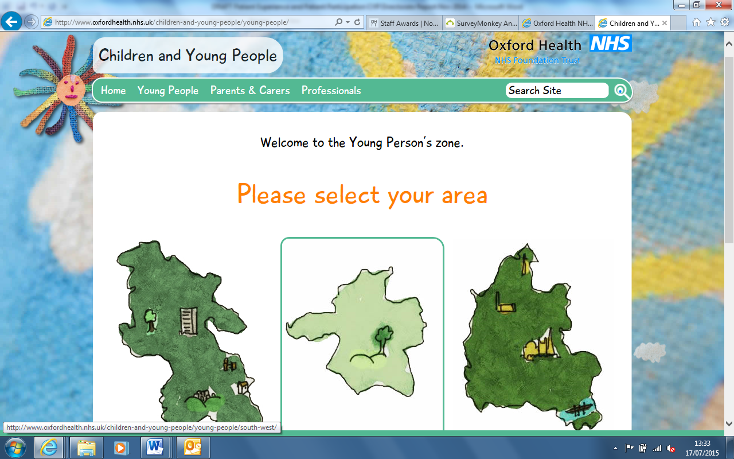 http://www.oxfordhealth.nhs.uk/children-and-young-people/
- Adults have been involved in joining visits to teams as part of the peer review programme.
- The eating disorder inpatient team invited patients to help lead some of the staff away day
- There has been work around on two key initiatives around embedding personalised care; one project is working with Thames Valley Strategic Clinical Network looking at application in primary care and then also applying personalised care planning within the Integrated Locality Teams. The second project for improving the personalisation of care was being supported by the Kings College as part of an improvement project for the older persons nurse fellowship. This was implemented within one of the District Nurse teams to support patients to identify their goals, ‘what helps and hinders’ them with their health problems so informing the nurses about the development of their care plans. The results of this project were positive and have been shared widely at the Linking leader’s conference.
- Maria Goldson (Programme Lead) has initiated a piece of work to develop the first edition of the magazine ‘Being Well. Relaxation and Reflection’. This has successfully been co-produced by the Chiltern Adult Mental Health Teams Wellbeing Programme with service users, carers and other partner organisations – Bucks MIND, Bucks Adult Learning, Haleacre Unit, the Valley Centre and Harlow House Day Hospital and is a collection of short stories, lyrics, photographs and drawings.
- The peer review programme within the trust includes patient and carers on the peer teams.

- CQC national quality standards
Rightly the CQC have put what patients (and staff) experience at the centre of their new regulatory approach. Within the CQCs five questions to assessing the quality of a service, patient experience falls under
a) Are we Well Led? looking at whether the mechanisms and leadership are in place to support and enable services to collect and review feedback, and
b) Are we Caring and Are we Responsive? looking at the themes from feedback received and how are we acting and learning from this.

Much work has been undertaken to improve patient’s experiences and involvement and the recent inspection from the CQC found across the vast majority of services good evidence of staff interacting well with the people who use our services, demonstrating caring, empathetic and respectful attitudes towards them.
Patient and carer feedback was largely positive and complimentary about staff and the care they received. In some services caring was rated as outstanding.; Luther Street medical practice, specialist community mental health services for children and young people and community health services for children, young people and families were identified as those areas being outstanding. These services showed passion, enthusiasm and received overwhelmingly positive feedback. They also demonstrated high levels of patient involvement.

An example of this caring approach is recently (11.4.16) in a discussion on the Jeremy Vine show about end of life care. A listener from Bicester phoned in and spoke about the time her partner was poorly and dying. She went on to say how great the district nurses were in supporting her partner to die at home and the support she received. She talked about the ‘wonderful district nurse’ walking 4 miles in the snow to get to the house to deliver care and she said she couldn’t praise them enough. However it was identified during the inspection that in some other services there was limited evidence that care plans had been developed with people and were truly person centred. This is a key area for improvement and is a large component of the newly developed patient involvement and experience strategy.

- Patient experience strategy 2013-2016 (current strategy)
Fourteen objectives were developed to implement the current strategy. The actions identified have been met although as work as progressed further actions have been identified so for some of the objectives there is continued work happening which has been included in the new and revised strategy currently being approved. The objectives and the progress made against them can be seen in Appendix 2.

We have a trust wide group called the ‘taking action on patient feedback’ chaired by the Deputy Director of Nursing and is accountable to the caring and responsive quality sub-committee. This group currently meets quarterly however the members, including those people who use our services identified that this should be increased to bi-monthly, with the purpose of; leading on the objectives in the patient (involvement and) experience strategy, to share good practice and as a forum for services to demonstrate how they are using feedback to improve the patient experience. The last meeting was held on the 30th March 2016 and welcomed new members to the group. This group now includes six members from the public/ current or ex-patients who provided positive feedback about the meeting and the intention is to further explore the purpose and focus of this group and update the terms of reference. As the group and its new members develop it is envisaged that the running of this meeting will be co-chaired. Every meeting is opened by the sharing of a patient or carers story so we ensure we are regularly listening to a real account of someone accessing and using the services provided.

- Key development areas
Since August 2015 the trust identified four key areas of development to support the achievement of the current and future strategy. The development areas are;

- Developing and consulting on a trust wide patient involvement and experience strategy.
- Improving the reporting of feedback (from electronic and postal sources) so that reports are more user friendly and readily available at team, directorate and organisational level.
- Improving the use of and the team ownership for responding on the Patient Opinion on-line feedback forum: an independently hosted social media web platform.
- Piloting software from a new company called Iwantgreatcare which specialises in the use of on-line surveys and providing good quality reports of the feedback received.

A description of the progress to date within each of these areas is detailed below.

- Developing our new Patient Involvement and Experience Strategy
The Trust’s overall strategic plan 2014-2019 has at its heart a focus on patients. This manifests in the plan with the third aim clearly stating that the strategy is to “fully involve patients and carers in their care”, and three of the spokes in the ‘strategic wheel’ focusing on patients; their experiences, their outcomes, and working with them to achieve the health outcomes that they want.

As an integrated care organisation, we offer physical and mental health and social care to a wide range of care groups with very different needs and circumstances. For example, what works in community hospitals or urgent care may not be the same for adult mental health, older people’s or children’s services. We believe that a range of involvement and engagement approaches is required, while working with the philosophy that ‘care is a joint endeavor’ is reflected in the newly developed patient involvement and experience strategy.

We recognise that the approach we take to involving patients, service users and carers needs to be of a consistent standard across the organisation, and also that it needs to be tailored and appropriate to the individual and the variety of services we provide. Whilst there is much good practice already, we have embarked on developing a new patient involvement and experience strategy to be in place from 2016/17 which has been co-produced with patients, carers and staff in order to ensure it is meaningful and ‘fit for purpose’. The new strategy builds on and be brought together with elements of the current patient experience strategy, to provide a more comprehensive cohesive strategic approach to patient involvement, engagement and experience.

The trust would like every person who receives care or treatment to be able to say;
"I can plan my care with people who work together to understand me and my carer(s),
allow me control and bring together services to achieve the outcomes important to me."
(National Voices, May 2013)

During the public workshops held in December 2015 and January 2016 to develop this strategy a number of people commented that professionals need to ‘just ask me’ about when and how I want to be involved in both my care and in the development of services. This phrase is not to suggest that people should wait to be asked but many people who use our services suggested that professionals need to feel less anxious about asking. This phrase is therefore permission from the public for staff to approach them to ask for help. Therefore this simple phrase has become the strap line for the strategy.

At the workshops three main aims were identified as key areas of focus in order to build on the positive improvements already being made.
- Person centred care
- Acting on feedback
- Involvement in services

These aims have a number of objectives and actions against them which can be seen in more detail in the strategy. The board of directors agreed the new strategy in April 2016. Following this a workshop to develop the detail of the work plan for the strategy is being held in May 2016 and a launch event will be arranged in partnership with those people who helped to develop it. The full strategy as well as a summary and easy read version will be published shortly.

Improving patient feedback
The current three year contract was awarded in 2013/14 to two external companies (Customer Research Technology and Patient Perspective) who provide software and hardware for electronic surveys (used on-line and on kiosks and handheld devices), printing/ posting of paper surveys as well as resource to carry out interviews and focus groups with patients. The majority of services in the trust use this central patient experience contract to collect feedback. The current contract does not include any managed reporting, whereby the external company provide and circulate regular reports. The current provider’s contract is due to expire on 31st December 2016. As we move forward in the tendering process for a new contract the following projects were developed
- Improving and developing user friendly reports for teams on their feedback from the current provider
- Piloting patient opinion in 6 teams
- Piloting I wantgreatcare in 10 services

- CRT/patient perspective
The trust does not pay for any managed reporting at the moment in the current three year patient experience contract; directorates are running their own reports from our contractors websites on feedback received and sending this to services. This has been identified as an area for improvement as information is not being provided to teams in a routinely, timely or user friendly format. At the same time as running a trial with iwantgreatcare (mentioned below), we have asked our lead contractor, Customer Research Technology, to develop easy to use team and directorate reports for 4 services.

Meetings have been held to explore new report formats which will enable teams to maximise the use of the patient feedback. A dashboard has been developed and shared with teams who have suggested this format is preferable to how they currently receive the information. The services are now being mapped against the devices used across the trust.

- Patient Opinion
Patient opinion is an independent feedback website, enabling patients to share their experiences of healthcare services. In addition to web based reporting, Patient Opinion provide freepost leaflets for services users so that those people who are not confident with web based reporting are equally able to provide feedback. The leaflets are coded to the service site so enabling teams to be informed once feedback has been received. Additionally there is a free phone number for those people who would prefer to tell their story. This is then entered onto the Web site by the company making this an easy, cost effective and efficient tool for hearing from and engaging with patients.

During the 6 months pilot the use of Patient Opinion was to be trialed in six teams. Five pilot sites have been included and the sixth team has yet to be agreed upon due to a number of challenges expressed within the teams approached. Team managers have been supported to self-manage the responses in regard to the feedback which has been left. By taking ownership of the feedback and sharing this at team meetings it is envisaged that teams will identify and action improvements to their service. To date the initial pilot sites include – Urgent care in Abingdon, Re-ablement SE locality, Health Visitors, City and North East AMHT and Street Triage. Other teams have been approached but have yet to confirm their participation.

Since the commencement of the pilot project in September 2015 there has been 46 stories submitted which have been viewed on Patient Opinion 4,589 times in all.
Examples of the stories entered onto the site are given below:

- When I got wheeled in to the Abingdon Minor Injuries ward I was greeted warmly by very cheerful staff and very helpful with the form I had to fill in. Due to the number of patients, I had to wait quite a while, but due to the other patients the staff and the rugby world cup, it wasn't so bad!

- I was made to feel by the team and especially the consultant that I was just wasting their time. The consultant was patronising and at one appointment thought I was a completely different patient. I was made to feel like a complete waste of time. I felt any decisions or opinions I had on my care were completely disregarded. The consultant never listed to what I had to say and always did the complete opposite

- We visited the Bicester first aid unit recently where we were seen very quickly by some excellent staff. The nurse was very thorough and very helpful. She referred my daughter for an X-Ray at Witney minor injuries unit as Bicester don't have X-Ray facilities which is a shame for such a new hospital.

The services where stories have been told are identified below.
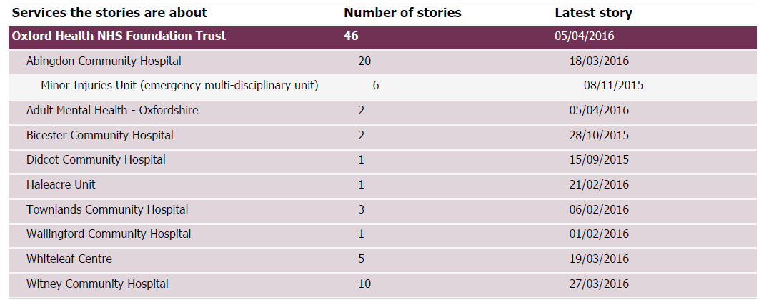

The most common words identified within these stories have been identified are listed below.

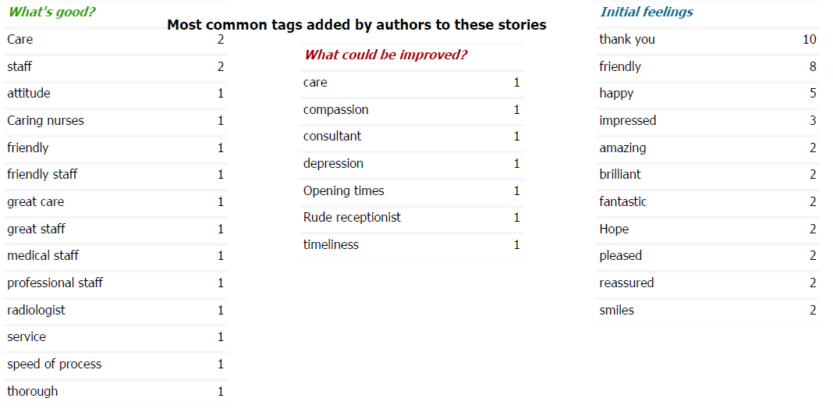
Much of the current feedback on the Patient Opinion web site to date has been transported from NHS choices 78% NHS Choices and 12% Patient Opinion. The urgent care/Out of Hours team have been proactive in promoting this both within the service and on their face book page and are now keen to try iwantgreatcare as there is a sense that they will achieve an increase in the amount of feedback received, particularly in relation to the friends and family test.

The company have been supportive and offered to visit teams and services to help with the promotion of this and a project evaluation is being undertaken within the teams who have been using this platform for collecting patient feedback.

To ensure the feedback left on Patient Opinion is responded to in a timely manner we have set a standard that all feedback comments will receive a response within three days. The response rates will be included in further reports as will any actions we have taken where concerns have been raised. To date all stories left have been responded to within the agreed time scales (three days)

Whilst we are improving our mechanisms for enabling feedback the challenge remains that people need to use them. The Patient Opinion web address is included on both urgent care and health visitors face book pages and the adult mental health teams are including this on the text messages and appointment letters. There is the ability to place a widget on the Trust website, however this has not been done to date as we are waiting to consider our preferred provider at the tendering process but there may be benefits in adding this now to enable easy access for feedback.

- Iwantgreatcare
The trust started a 6 month trial in January 2016 with iwantgreatcare to inform a re-tender of the patient experience contract which ends on 31st December 2016... Iwantgreatcare provide software to create on-line surveys to be used on our own devices or patients devices i.e. ipads, mobile phones and paper surveys. The real benefit with working with iwantgreatcare is to develop managed reporting of feedback received from patients, parents, carers and families. The company has lots of experience and expertise in reporting and presenting information. The following services/teams are participating in this pilot:
- District Nursing: Abingdon, Faringdon, Benson, Wallingford, East Oxford, Burford, Broadshires and Bampton, Kidlington, Didcot Health centre, Woodlands and Oaktree, Wantage,
- Urgent Care- Abingdon EMU, Witney EMU, Hospital at Home
- Older adults inpatients mental health- Amber ward
- Older adults CMHT: City and North East with a request from the OAMH team in the North keen to be included.
- Community Hospitals: Bicester, Didcot and Witney with the other community hospitals to have this in place by July 2016
- Dental Clinics : Bicester, Witney
- Oxford TB services: Children and Adults
- CAMHS – North Oxford, Oxfordshire OSCA
- Respiratory Services: Pulmonary Rehab
- Tissue Viability:
- Adults in patients : Phoenix ward. Plans are underway to start extending this to the other inpatient wards.
The surveys are standardised and consist of 5 key questions including the Friend and Family Test (FFT) with
text boxes for additional comments. A star rating of 0-5 stars is used to rate our services. Reports are available at organisational, directorate service and individual team level and are easily accessible by teams. Going forward there is the potential that the organisational reports can be developed to so that a dashboard view is available if required.

Since the commencement of the project in January 2016, over 500 responses have been received, listed by service below.

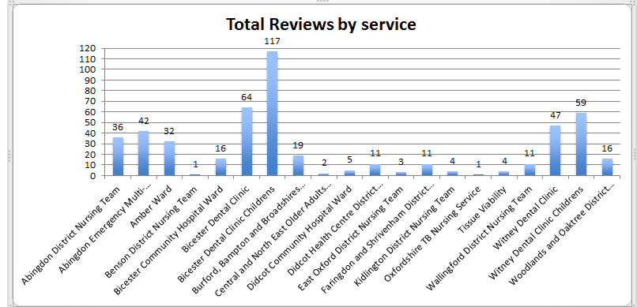

The majority of feedback has been left using the paper surveys however during the initial phase of the pilot there was an issue with the ipad app which resulted in the app failing to install. This has now been resolved and the amount of feedback using the app is increasing. The below graph indicates how people have rated our services using the 5 star ratings.

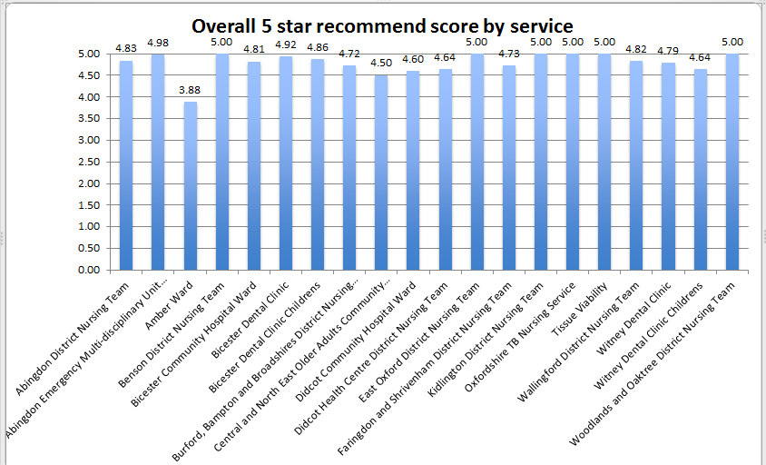

In addition to the star ratings people can leave comments, the majority of which have been positive, some examples are below:
- I liked the hoover in my mouth. ( dental services)
- I was very happy with the treatment I received. The dentist XXX was very thorough and kept me informed as well as understanding what to expect.
- Talked me through everything. Were friendly, stopped when I asked.
- I stayed at Sandford as well but everything was Superior at Whiteleaf.
- I will give you all 10/10 because I think that you are all marvellous.
- My dad seems safe and well and his physical condition seems to have improved greatly while he has been here.

There have been suggestions as to where improvements can be made:
- ‘Overall the care is good. Communication could be better between myself and the staff as I don't feel I always know what to expect this having been my first experience of a mental health hospital. I don't always feel I know we what is going on’.

- ‘I have only given 4 stars for the involvement question as the district nurses are constrained to what they can try within their service. I have been through all the treatments that they can provide and would like to try some complimentary therapies that the district nurse would need to carry out however it was difficult to discuss this with the appropriate people and for this to be arranged.
I feel that the district nurses service is Superb, all the people that I have I countered that the people are very friendly and supportive. I do feel that sometimes they are at their limit for their knowledge, I would welcome some further clear evidence of further treatments being found and explored.’

We now need to improve how we report back to patients the changes we are making so closing the feedback loop. This is challenging for some services for example those services which only see patients in their own homes.

Early evaluations of the projects, which have looked at ease of use, feedback figures and staff engagement would suggest that iwantgreatcare has greater resonance with staff however costing and formal tender processes need to be completed.

- Other developments in 2015/16
In addition to the above four areas the following has also been completed in 2015/16;

- Reviewing the Service User and Carer Payment and Reimbursement for Involvement Policy.
- Developing guidance for teams on the use and collection of patient narratives/stories.
- Developing how we collect and use feedback from more hard to reach groups and communities (previous strategy objective 14). An initial review of responses to our current surveys shows that whilst we collect this data the feedback responses are low. Meetings are being planned to reach out to these groups so that we can explore how we can do this better.

8. Feedback from carers
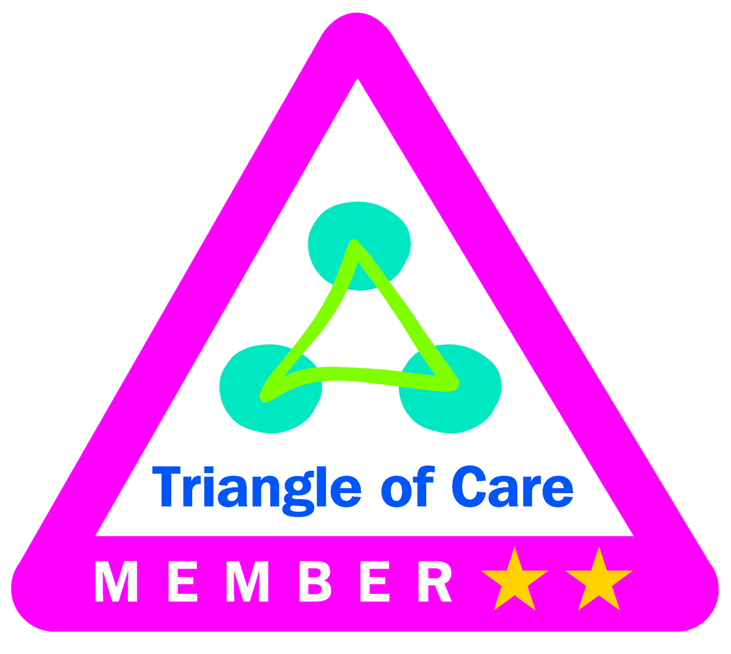The trust has been a member of the national triangle of care scheme since May 2014, recognising the importance of carers, families, patients and staff. The teams have been working hard over the last year to implement and demonstrate meeting the national carer standards within the triangle of care. Carers and voluntary organisations have been involved in the process from the start and their feedback has been important to identifying and monitoring actions. So far over 40 self-assessments at team/ ward level have been completed, these have mostly been across mental health services including community and inpatient teams. Following the self-assessments local actions have been taken for example; identifying carer/ think family leads in teams, establishing carer lead forums, reviewing information given out by teams, recognising the changing role of parents/ carers in the transition planning from children and adult services, and setting up new carer groups.

In December 2015 the Carers Trust accredited the trust with two gold stars, the third (and last star) will be achieved when all teams/ wards have completed the self-assessment and identified/ addressed any gaps. The Carers Strategy Forum with representatives from carers, continues to monitor progress and themes from the self-assessments, and is leading on two trust wide pieces of work around;

- Developing staff Carers Awareness Training. Rethink and Carers have co-designed the training and will co-deliver this with other voluntary organisations. The first pilot session was delivered in Dec 2015 with more pilots being delivered in January-February 2016. The pilots will be evaluated before training is rolled out.

- Review of information provided to carers on the trusts internet website and given out by clinical teams. Each directorate has started to review the information given out. The review of the internet information will be led by the trusts web strategy group. This work is at an early stage.

We have maintained this as an objective for 2016/17 as we work towards our third star and ensure the actions we identified are implemented and show an impact in the feedback received from carers.

9. National community mental health survey 2015
The results of the 2015 survey have been presented previously so are not repeated in detail in this report. In comparison to 2014 about 20 of the questions were the same, 13 worse and 3 better. Where results seem to have got worse this is mostly because patients have moved from saying yes definitely to yes to some extent. There was significant service remodelling in 2015 e.g. a move to a seven day a week service, the introduction of the Oxfordshire Mental Health Partnership with five third sector organisations, the developed of a recovery college, alliance work with Oxford University Hospitals NHS FT to join up urgent care for older people and the introduction of integrated locality teams to coordinate older people services. All of these changes fell after the 2015 survey period based on patients who received care from September to November 2014, so we hope to see the impact of these changes and improvements in the 2016 survey results. The 2016 national survey is now underway and we should receive the draft results in August 2016. The response rate for the Trust is 25% as of, 3rd May. The response rates for this survey are identified nationally as:
.
· 1 Trust has response rates between 35% and 40%
· 5 Trusts have response rates between 30% and 34%
· 19 Trusts have response rates between 25% and 29%
· 17 Trusts have response rates between 20% and 24%
· 5 Trusts have response rates between 15% and 19%
· 2 Trusts have response rates between 10% and 14%

The key areas of focus for 2016 continued to be on improving how we involve patients and their families feel in their own care and treatment choices which are a key element in the new patient involvement and experience strategy.

Some of the actions being taken include;

Adult Directorate – training and continued work to embed the recovery star across community and inpatient wards, the introduction of a recovery college in Buckinghamshire hopefully from May 2016 (the Oxfordshire college is already up and running), establishment of patient experience leads in each team and a 6 monthly sharing and networking event for leads, further work to develop how carer feedback is captured and continue work to implement the actions identified from the carers triangle of care assessments.

Older People Directorate – review of the local patient experience group in the directorate, all system partners moving to using the same ‘knowing me’ form, acting on the recommendations from the memory service external accreditation achieved in Oct 2015, roll out the revised memory service model, develop screening as part of in-reach into care homes, further roll out dementia friendly communities, achieve the external accreditation for the older people mental health wards and continue work to implement the actions identified from the carers triangle of care assessments.

10.Results to the Trust wide Core Questions
The trust uses four core questions, these were identified as important to our patients and link to the critical relational aspects of care as defined by the NHS patient experience framework. The questions are being included in the majority of paper and electronic patient surveys across mental health and physical healthcare services both with inpatients and patients being seen in a community setting.

Following a piece of work by Oxfordshire Health Watch on dignity in care, we have been consulting on changing one of the current four core questions used across all surveys (the remaining three questions asking about involvement, information and would you recommend the service will stay the same). The proposal was to change the question relating to trust and confidence to a question around how a person’s dignity has been respected. The proposed new question is based on a question used in other national surveys so has been tested already with patients and was discussed at the trust wide taking action on patient feedback group in January 2016 and the caring and responsive quality sub-committee in February 2016. The new question was approved at Trust Board in February 2016 and is being rolled out.

Below are some highlights of the feedback we have received in 2015/16 showing an improving trend but at a slower pace than we would wish. Samples of some of the actions we have taken as a result of feedback are provided later in the report.

11. Patient Friends and Family Test (FFT): how likely are you to recommend the service...?
Meeting national requirements
NHS England set out an expectation that all NHS services will introduce the patient FFT question and that this will be in place from 1st January 2015 for mental health and community health services. The guidance published in July 2014 did not specify the methodology for introducing the FFT question, therefore the trust took the approach from May 2014 to start introducing the national FFT question as one of the four trust wide core questions across all formal patient and parent surveys whether completed on paper or electronically. This was felt to be a sustainable approach so that the question is integrated into existing surveys and reporting mechanisms.

In line with the national requirements all patient facing services are asking the FFT question. In the majority of cases this is as part of a longer survey but asked as the first question using the exact national wording. The frequency of asking patients for feedback varies depending on the setting, service and patients; however this will continue to be under review.

Monthly reporting on FFT results to NHS England started in February 2015, the trusts results submitted nationally are shown below in tables 2 and 3. In April 2016, 802 people (94%) responded that they would be extremely likely or likely to recommend our services. This is the highest number of responses during the previous 12 months.

FFT Results
Across the variety of services provided by the trust from April 2015 to March 2016, 94 % of people who have answered the FFT question (n= 6442 ) have said they are extremely likely or likely to recommend the service they received. The following responses to the Friends and Family test are shared below based on how they are submitted to NHS England, split by mental health and community physical healthcare services.

Mental health services (defined nationally)
Note. This includes don’t know answers in the denominator.
Month of data | Number of responses | Extremely Likely to recommend | Likely to recommend | Combined extremely likely and likely to recommend
April 2015 | 365 | 60% | 30% | 90%
May 2015 | 282 | 72% | 23% | 95%
June 2015 | 264 | 64% | 28% | 92%
July 2015 | 492 | 59% | 30% | 89%
August 2015 | 301 | 64% | 26% | 91%
September 2015 | 174 | 61% | 31% | 94%
October 2015 | 255 | 54% | 36% | 91%
November 2015 | 182 | 66% | 25% | 91%
December 2015 | 173 | 57% | 36% | 93%
January 2016 | 188 | 50% | 36% | 87%
February 2016 | 239 | 48% | 30% | 78%
March 2016 | 165 | 54% | 31% | 89%

Community health services (defined nationally)
Note. This includes don’t know answers in the denominator.
Month of data | Number of responses | Extremely Likely to recommend | Likely to recommend | Combined extremely likely and likely to recommend
April 2015 | 359 | 69% | 25% | 94%
May 2015 | 237 | 77% | 21% | 98%
June 2015 | 155 | 78% | 17% | 95%
July 2015 | 409 | 72% | 21% | 93%
August | 82 | 76% | 22% | 98%
September 2015 | 191 | 69% | 26% | 95%
October 2015 | 487 | 83% | 13% | 95%
November 2015 | 169 | 70% | 25% | 95%
December 2015 | 427 | 68% | 24% | 92%
January 2016 | 228 | 76% | 18% | 94%
February 2016 | 532 | 76% | 17% | 94%
March 2016 | 573 | 66% | 26% | 94%

In addition to the figures there has been 2841 open comments left in response to the question-‘why would you recommend?’ 401 of these comments were generated from iwantgreatcare. Since commencing the pilot project for iwantgreatcare the comments for some of the teams where surveys have previously been challenging to provide has progressed. For example Tissue viability are now able to ask people for feedback directly after their visit using the IPAD, whereas previously a survey will have been sent and clients may have confused the provider of the service with district nursing.

An example of the response the tissue viability is now able to collect is given below:
- My support from Tissue Viability now takes the form of regular reviews of the progress of my condition and the treatment plan agreed between the TV expert, the supporting practice nurse and me. My first examination was particularly memorable. The initial fact find phase did not lead immediately into preparation of a treatment plan but into a discussion of my own preferences for treatment options and expectations of what outcomes would be most desirable (it is worth pointing out that my condition is with me for life, so a simple "Get healed" is not an available objective).TV will from time to time offer information about new techniques or care products that they have discovered which might be relevant to my own circumstances. Again a three party review will examine whether the news offers a way to improve my own and, if so, we may introduce it in a controlled manner supported as necessary by more frequent reviews with TV. This is an excellent and dedicated service. The only potential that occurs immediately is for opportunities to be made for a wider spectrum of community-based care professionals to hear at first hand about the service's latest activity and progress and then consider whether other long term patients under attendees' care could benefit from their involvement.

Pulmonary rehabilitation as a small, county wide service has very recently joined the pilot for using iwantgreatcare. This will enable them to collect more targeted information about their service in response to the FFT question and the other four standardized questions relating to dignity, being involved, informed and kindness of staff.

12. External audit findings (relating to patient FFT)
The external auditors reviewed the reporting and data quality for the patient FFT question in March 2015, although they found the calculation and reported figures correct, they made recommendations to put further systems in place to test the data provided by our contractors. The following actions were agreed and all have been completed in 2015/16.

- Action: Contractors to use a revised excel template for reporting results against the trust wide key questions each month to include unique identifiers for testing.
- Action: Contactor will date stamp each postcard and postal survey on arrival from 5th June 2015 (in addition to recording scanned date) following testing a decision about carrying on will be made between PP and OH.
- Action: Quarterly testing of data for postal surveys against hard copies of surveys.
- Action: quarterly testing of electronic data to review day and date response received, time of response appropriate to service, where responses are being received from to ensure all devices are being fully utilised.
- Action: Contractor and trust to identify a cut-off date for including responses in reports, 90 days is used at the moment but this might not be appropriate for all services.
- Action: Check kiosk 43 is reporting an accurate date and time.
- Action: Contractor to add parameters to all 30 handheld devices and 2 kiosks so that responses received outside the following times are quarantined and not reported– 07:30-18:30 Mon to Friday.

13. Staff and Patient Experiences
The quality of relationships between staff and patients (described as the relational aspects of care) are a key factor to a patient’s experience, and the areas for improvement show the importance of getting this right to be able to achieve a positive experience. We recognise the link between patient experience and staff well-being and have developed plans as part of the workforce strategy to ensure we continue to work on improving staff well-being.

The spiritual and pastoral care team provide a range of services to staff and patients for example;
- Individual religious spiritual and pastoral support in hospitals and in the community
- Exploring your Spiritual Side groups across the Trust
- Religious services on a weekly basis at Warneford Hospital and Whiteleaf Centre
- Group or individual staff support or supervision
- Staff debriefing after a critical incident.
- Links with external faith communities to ensure that particular religious needs can be met during a time of care or on discharge to ensure continuity of support and inclusion
- Consultation on religious, spiritual and ethical matters
- Counselling
- Reflective practice, Wellbeing and Mindfulness
- Mediation
- Training and development including induction training
- End of Life Care.

In 2015/17 the team has supported over 3,500 patients and 2073 staff, some detail of the patient’s contacts is below.
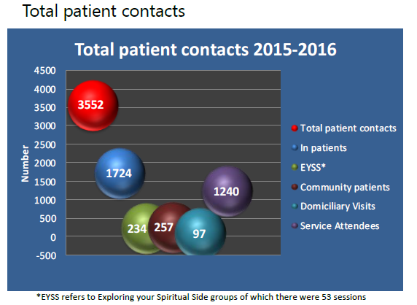

14. Themes from complaints/concerns and implementation of actions
How we manage and respond to concerns
The trust works hard to support and be open to concerns raised by patients, families and carers as we see this as an important way to hear about people’s experiences and to drive service improvements. We have separate information leaflets about how to make a complaint and/ or raise a concern, and also in every teams service information leaflet there is a section about how to raise any concerns. All new staff receive a session on the importance of listening and learning from concerns and this is supported by additional training around customer service skills and how to investigate a complaint.

The Patient Advice and Liaison Service (PALS) visits every inpatient ward on at least a monthly basis, in addition to ad hoc requests and visits by independent advocacy groups, to promote the support available to patients, listen to what is working well and any issues, and take forward any actions required.

Concerns can be raised in a number of ways and the complainant is always asked how they want their concerns to be handled and to agree a reasonable timescale. All concerns are taken seriously and on a regular basis our Chief Executive reviews a random selection of complaints and we have recently re-introduced complaint panel reviews where a senior group look at how a complaint was managed to identify any learning and areas for improvement. On a weekly basis all complaints are reviewed and discussed by a senior group of clinicians and on a quarterly basis an analysis of the number and themes from complaints as well as actions taken are reported to the Board of Directors We ask complainants about their level of satisfaction with the complaint process following the completion of an investigation to continue to develop our processes and approach.

The CQC in their recent comprehensive inspection were very positive about the trusts complaint procedure and processes covering all services, noting good information being available on how to make a complaint, patients reporting they knew how to raise concerns and make a complaints, patients feeling confident that staff would listen to their concerns and that changes were made as a result.
The internal auditors also reviewed our complaints process in 2015/16 and found there was an established robust system for the management of complaints although some minor areas for improvement were noted for example improving the completeness and quality of actions following complaint investigations. This may provide an opportunity for people who have had cause to complain to be more actively involved in the action planning and sharing the learning.

Themes
Between 1st April 2015 and 31st March 2016, the Trust received 214 complaints (excluding withdrawn complaints). This is compared to 209 complaints received in the previous year. During this period of time, 20 complaints were withdrawn by complainants and were resolved informally. If a complaint is re-opened, because the complainant is dissatisfied with the response and outcome of the investigation into their concerns, this is not counted as a new complaint case but a continuation of the initial complaint registered. Over half of the complaints we receive are from families, carers and parents (see objective 4.2a about the work to improve the experiences of families, carers and parents). On average about 60% of complaints have 1 or more concern upheld.

Of the 214 complaints received, 168 complaint investigations have been completed; from the complete complaint cases 244 actions have been identified. Of the 244 actions, 183 (75%) have been completed within time and 61 (25%) actions are due to be completed over the next couple of months. The trust shares learning from complaints (alongside incidents and clinical audits) in a number of ways however we recognise this is an area for more development.

The primary reason for complaints (which were either upheld or not upheld) received across the Trust in 2015/16 were:
- All aspects of clinical treatment (91)
- Attitude/ behaviour of members of staff (33)
- Poor/inappropriate communication/information sharing (31)
- Appointments/referrals (15)
- Admission, discharge and transfer (12)
- Confidentiality (9)
- Medical records (8)
- Matters relating to the use of the Mental Health Act (3)
- Complaints handling (2)
- Environment/facilities (2)
- Patients property (2)
- Service provision (5)
- Sexual conduct by another patient (1)

In addition to the formal complaints process the trust monitors and takes action on informal concerns. The number of informal concerns has increased by 300 from last year. The numbers per month are identified in appendix 4. Going forward the patient experience report is to include the number of concerns which will help inform areas for improvement and the learning across all directorates and will be part of the ‘you said we did’ improvements . Examples of some of the verbal feedback obtained from these surgeries are provided in appendix 3. The majority of feedback is positive however there are recurrences of some comments by more than one person. The issues which are raised in the PALS Surgeries are logged, followed up with the ward/ team manager to identify actions and monitored until completed.

The main theme from complaints and informal concerns is poor communication closely linked with staff attitude/behaviour. People tell us they do not feel heard or listened to and want to be more involved with what is happening with their care or their family members care. There are three consistent areas for improvements identified across services from more general feedback received, complaints and informal concerns, these are; patients being involved in decisions and choices about their care, wanting good information and clear communication, and patient’s families and carers feeling listened to and involved.

A fuller analysis of the complaints, concerns and compliments received and actions taken as a consequence are included in the annual published complaints report.

15. How we are acting on the feedback received
The table on the next page shares some examples of the actions taken in the last 12 months across our services. It is encouraging our staff have reported in the national staff survey for 2015 an improvement from 2014 in how they feel they are effectively using patient feedback.
Examples of the actions taken in the last 12 months across our services (2015/16)

Directorate (service) | You Said | We Did
Children and Young People Directorate
Children’s community nursing | A parent voiced concern that staff caring for her child (who was being discharged after a life threatening period in JR.) would not be able to recognise his signs of pain, especially as he returned to school. The child has limited mobility and is a non-verbal communicator of limited cognitive development hence the ability to monitor and manage pain or discomfort is at risk of being more challenging | The Poppy (Pain assessment) tool was written as a result of these concerns being expressed. Other tools were considered...then adapted and finally came the Poppy tool.
Eating disorder service | You wanted to be more involved in how to improve and support the service to develop. | Young people were invited to run part of the staff away day to help identify service developments. Young people identified the following areas for improvement; information, giving people hope, use of technology and having more films made by and for patients.
Eating disorder service | More information about condition and treatment available | The patient information guide came from a patient led group; booklets are in each patient’s bedroom.
Eating disorder service | Patient raised concerns over the use of bank staff that were unfamiliar with the ward procedures hence did struggle to give the support patients would like | A staff film was developed by patients on what support would be helpful.
Eating disorder service | Patient have raised that they wanted more involvement in the decision making during the clinical team meetings | A new system is about to be implemented giving each patient a time slot to attend the clinical team meeting if they wish
CAMHS inpatient ward | Young people requested animal visits on the unit | A qualified PAT dog now visits the unit with fantastic feedback from young people.
Health visiting | Not always responding timely to messages left | Answerphone message recorded was changed for all bases and a consistent system for allocating messages to health visitors was set up.  We have worked on improving the consistency of health visitors up to 8 weeks so clients can keep the same visitor where requested.
Health visiting | We would like to be able to spend more time talking to other parents after the weighing. | We have made sure there are toys and space available to stay after the weighing to get to know other parents.
Health visiting | You asked us to keep you informed using methods other than letters | We have started using NHS text messaging to invite parents to our groups.
Children’s speech and language service | Timeliness of reviews and lack of written assessment/ goals following recent therapy sessions | Agreed a new protocol so that parents can request written feedback by letter or email after each therapy session.
Children’s speech and language service | Parents and nursery key workers did not feel involved in decision making or the child’s therapy | The team now meet routinely with the nursery key workers and are regularly talking about how to improve involving parents in each team meeting. The team have also continued to develop handouts giving practical information for both the child and supporting parent.
Children’s integrated therapies | A child really wanted to be able to access the swimming pool | The therapist met the child and parent at a local swimming pool to provide support
Children’s integrated therapies | Children would like more practical demonstrations during the physical disability training | The ratio of theory to practical input into the training was changed to include more physical demonstrations
Children’s integrated therapies | Parents fed back difficulty with timing and location of appointments clashing with work | The therapists have arranged to have appointments in alternative locations and on different days.
Children’s integrated therapies | As a SENCo I would like a training package for newly appointed teaching assistants. | Therapists delivered training to new teaching assistants which enabled a quicker discharge as the assistants had the necessary skills to support them. Plus some lunchtime Q&A drop in sessions have been provided by the team to support assistants and teachers.
Children’s integrated therapies | We would like more resources supporting therapy activities in the communication group and to increase our understanding of the difficulties our children have and how we can support them | Detailed parents pack sent to parents at the end of the course. Also allowed an hour long slot on the last day of the course for parent to feedback and raise any concerns
Dental service | Request to have music played in waiting areas | Licences purchased to re-install music in all clinics
CAMHS community service | The original name for the sexual harm clinic could ‘put people off from accessing the service’. | Service users have re-named (to Horizon) and developed information for a new sexual harm service.
CAMHS community service | You said there was a limited information from service users about “what to expect from CAMHS” | A Letter written by Young people in CAMHS has been added to the GP system in Buckinghamshire. This can be printed off and given to a young person by the GP at time of writing the referral to CAMHS in order to introduce CAMHS and signpost to further information.
CAMHS community service | We should be involved in the recruitment of staff | Young people and parents are being more involved in staff recruitment
CAMHS community service | Feedback about tone and wording of initial invite and assessment letters. | Changes have been made to improve the tone and wording of the letters. Further service wide work to be undertaken to include adding the new children’s website details.
CAMHS community service | The parents and carers attending the autism workshops said they would like to incorporate time to discuss medication | A medic now attends at least the end of each workshop to allow time for questions.
Adult Directorate
Forensic service | The ward information leaflets were out of date | The leaflets were updated, with the help of patients from both wards, who have contributed towards the cover designs, and provided suggestions on the content.
Forensic service | It would be helpful to set up a social group in the restore café. | Staff have supported this and are helping to create a social group at the cafe.
Forensic service | Some of the ward areas are unkempt and need re-decorating. | We have started to redevelop the quiet lounge and patient communal areas. Art work is being added to brighten the space and make it more appealing; the room will also be redecorated and new furniture purchased. The patients are being involved in choosing the colours and furniture for the area. The garden was also identified as an area of improvement, to support this work we have asked Restore if they can support the ward and provide gardening workshops so the patients can help create a more therapeutic and welcoming garden areas.
Forensic service | Feedback from patients involved in the film based focus groups around developing their skills | Started a skills based group aimed at supporting patients in working with their care teams (co-production). Patients are evaluating the group as they go and we hope this group will become peer led in the future.
Emergency department psychiatric service | Don’t always receive the written safety/ discharge plan | The safety/ discharge plan template has been updated to incorporate an emergency contact number and a new form has been developed for carers. The team have discussed the use of how to use this plan therapeutically and effectively and this will be monitored by the team manager based on patient feedback.
Luther street homeless GP | Patients have made a number of suggestions about the physical environment. | The team have de-cluttered the noticeboards, put up a multi-lingual welcome sign and staff photo board, upholstered the wooden benches in reception, a magazine rack with improved reading material content & re-painted the mental health practitioner room.
Luther street homeless GP | Repeated concerns from people feeling intimidated by those drinking, using and committing crime and other anti-social behaviours outside the front door. | The team have identified funds to get internal and external CCTV fitted.
Adult acute, rehab and PICU wards | Not enough information on conditions / treatment | The team have introduced a number of leaflets on medication and conditions which can be made available to patients upon request. Patients will be asked at each review if they feel they know enough about their treatment plan or if they would like more information.
Adult acute, rehab and PICU wards | Would like to see your consultant more | The ward have highlighted when the consultants will be available for ward round and informed patients that they can arrange times outside of this if they would like to talk to someone.
Adult acute, rehab and PICU wards | The TV is always on the music channel and there is not enough opportunities to watch programmes: | The team have introduced a schedule on a weekly basis so that the patients can plan what they would like to watch over the week
Adult acute, rehab and PICU wards | Some of the curtains need repairing and are not fitted correctly | The team have contacted the facilities team who have scheduled this work in to take place.
Adult acute, rehab and PICU wards | Carers reported that they had received less than a days’ notice of relatives discharge and only 77% were satisfied with the support they received during their relatives/person they cared for admission | The team have introduced a support system for carers which involve the named nurse making contact with the main identified carer on a weekly basis. This is to offer support and for carers to be able to communicate any concerns or positive progress.
Adult acute, rehab and PICU wards | The noise from doors closing especially and the ward office door was continually disturbing patients. | We have now fitted a self-closing bracket to the door which allows the door to close softly and quietly which has helped reduce noise.
Adult acute, rehab and PICU wards | More information about condition and treatment available | The patient information guide came from a patient led group; booklets are in each patient’s bedroom.
Adult acute, rehab and PICU wards | Patient raised concerns over the use of bank staff that were unfamiliar with the ward procedures hence did struggle to give the support patients would like | A staff film was developed by patients on what support would be helpful.
Adult acute, rehab and PICU wards | Patient have raised that they wanted more involvement in the decision making during the clinical team meetings | A new system is about to be implemented giving each patient a time slot to attend the clinical team meeting if they wish
Adult acute, rehab and PICU wards | We would like to be able to spend more time talking to other parents after the weighing. | We have made sure there are toys and space available to stay after the weighing to get to know other parents.
Adult acute, rehab and PICU wards | You asked us to keep you informed using methods other than letters | We have started using NHS text messaging to invite parents to our groups.
Older People Directorate
Falls service | Patients fed back they struggled to find the falls clinic | We put up signs to direct people
Diabetes service | Difficult to find venue | The map has been altered and more directions given
Diabetes service | The venue was noisy for last half an hour | Established that dancing classes were being held on certain afternoons and we are now avoiding having the sessions at the same time.
 | The programme is too basic for someone who has had diabetes for a long time. | We are re-starting to deliver D4W which is more advanced in July.
 | Admin needs to be improved. I had no info in advance - had to phone for details - was told I would receive a text but didn't - then the trainers thought it was booked for afternoon. | The patient called the office to inform us that she had not received the confirmation letter, as it was too close to the session it was not possible to send her another letter but we confirmed her mobile number and text her a reminder. We have record that the number she provided was included in the reminder text we sent to everybody who attended that session.
District nursing service | Patients state that they don’t always know when their next visit will be | Patients are asked on first visit what time of day they prefer to be visited i.e. morning/afternoon/no preference. This is then documented on care notes and within patients own written.
Older people community mental health teams | Carer fed back her concern about a lack of follow up when staff are off sick | An unplanned absence procedure has been created for staff. Carers are now contacted and follow up expedited
Older people community mental health teams | Patients commented that they did not know how to leave the building | Additional signage has been provided for the ‘Exits’ immediately after patients leave the clinic rooms to leave the building
Older people community mental health teams | Cognitive Stimulation Therapy requested | Some staff have completed specialist training, and have run a successful taster session.
Older people community mental health teams | Memory Clinic patients asked for appointment reminders | Patients are now phoned in advance of appointments to remind them
Older people community mental health teams | The doors are too heavy and it is difficult to walk safely down the corridor | We contacted estates and safety rails are going to be fitted
Older adults mental health in patients | Sometimes I feel that there are not enough staff on the ward as every night time the lounge is not monitored and there are other patients moving or climbing on furniture which others then have to find staff to deal with the situation. | The ward manager has implemented a new way of working to ensure a member of staff is allocated to the lounge at all times.
Older adults mental health in patients | Someone entered my room without knocking, this shouldn't happen, they should wait for permission | All staff have been reminded that they must always knock before entering a patient’s room. All staff will now be expected to attend the customer training.
Minor Injury Units | The waiting times vary and can be long with not much communication about where you are in the queue | We reviewed data for last 3 years to understand peak demand times by location. The data supported the views of staff locally. As a result the number of staff on rotas at peak times e.g. Monday morning were increased and staffing skill mix was varied in the evening to compensate as this is a quieter time (although still in line with NICE guidance for emergency departments). As a result waiting times have reduced, feedback has been positive from patients and staff.  All staff to identify on whiteboard and communicate waiting times to all patients who are visiting in the OOH period. We are currently reviewing why we have long waiting times – looking at arrival, complexity of patients and staff.  The service also tweet waiting times by site so that people are aware and can choose which site to visit.
Minor Injury Units | Feedback received about attitude and friendliness of staff | The service has chosen to establish a patient experience group of all grades of clinicians to try to understand our service from patient perspective in more detail. The group will develop a bespoke program and observations to feedback to staff in particular reference to meeting/greeting/first impression communication.
Physical Disability Physiotherapy Service | We would like to exercise in a group environment | Recently began a 6 week “Exercise and Education course” for patients with neurological disability. The first 2 courses have been completed and the feedback from the participants has been very positive.
Physical Disability Physiotherapy Service | People said they had not received the right amount of information about their condition or care | Increased the availability of pre-printed information from charitable organisations e.g.: MS Trust.  All clinicians to have a stock of agreed information to carry with them to provide for patients  Administrator to order and monitor stocks
Emergency Multidisciplinary Unit | More information on diagnosis, treatment, who is named nurse/ medic and follow up requested | We developed a discharge information form that is completed for patients each time they are in EMU.  We added wipe clean forms to each bed to put up who the named nurse and medic is for each patient.
Respiratory service | Clearer/more detailed information  Better liaison with Dietetics  More Physiotherapy input in pulmonary rehab group | Improved visual aids in the “Understanding your Lung Condition” talk, and in process of updating other disease-specific information. Team have reviewed “Energy Conservation” talk with Occupational Therapy and updated service leaflets.  The team have established a clear referral routine to the Dietetics service  Re-arranged staffing of the group so that there is greater physiotherapy presence
Community hospital service | Feedback from families was that they didn’t always understand the terminology that was being used | There is now a terminology board for relatives explaining the problems following a stroke.  Leaflets have been made readily available
Community hospital service | Feedback from patients that the ward was too noisy at night | Ward are exploring the installation of a night call bell system to reduce the volume
Community hospital service | You wanted to use Wifi on the ward | Contacted IT and arranged guest Wifi access for all patients
Podiatry | Patients commented that there was limited appointment availability and a delay in getting an appointment. | Now organising running evening / weekend clinics  Introducing more multi-chair clinics  From April 16 an extra appointment slot will be added to each clinic

16. Overall themes for improvement
A large amount of positive feedback has been received about each service. The consistent themes for improvement across the trust relate to the relational aspects of care and fall into three of the critical elements for a positive experience. The themes are as follows:

- Patients want to feel more informed, be given options and take part in decision (critical element: respect of patient centred values, preferences and expressed needs)

- Patients want to be provided with good information that is tailored to them and is timely, and they also want staff to communicate clearly with them (critical element: information, communication and education)

- Families and carers want to be involved, listened to and respected (critical element: Welcoming the involvement of family and friends)

Themes identified from patient/ parent feedback also correlate to the themes identified through complaints. An important next step is to share good practice across teams and services so that this drives up improvement across the trust. The new patient involvement and experience strategy to be launched shortly in 2016 identifies the steps we plan to take to tackle the above areas for improvement.
APPENDICES
Appendix 1. NHS patient experience framework

Through research the NHS National Quality Board (NQB) has summarised what patients, parents and carers say matters the most to them whilst being treated. Patients reported that it is the relational rather than the functional ‘transactional’ aspects of their care that matters most to them. Relational aspects of care include feeling listened to or informed, receiving individualised treatment, attitude of staff, good communication, emotional support, respect, empathy, involvement in decisions and good information provision.

The NQB developed the NHS patient experience framework (2012) which provides an evidence-based list of the elements that patient reported are critical to have a positive experience, these are:

Critical elements to a positive experience | Aspect of care
- Respect of patient centred values, preferences and expressed needs including cultural issues, dignity, privacy and independence and shared decision making | Relational
- Coordination and integration of care across and within services | Functional
- Information, communication and education on diagnosis, treatment, progress and processes of care to facilitate autonomy, self-care and health promotion | Relational
- Physical comfort including help with daily living, pain management, and the cleanliness, comfort and safety of the physical environment | Functional
- Emotional support and alleviation of fear and anxiety about diagnosis, treatment, and the impact of illness on their lives | Relational
- Welcoming the involvement of family and friends in decision making and awareness of their needs as care givers. | Relational
- Transition and continuity including coordination, planning and support to ease transitions, as well as information that will help patients care for themselves away from a clinical setting | Relational
- Access to care including ease of access and waiting times at each stage through their treatment | Functional

Appendix 2. Patient Experience Strategy Objectives 2013-2016

The following 14 objectives have been developed to implement the strategy, developed through consultation in 2013, a review of the Trusts current position, and the use of a self-assessment tool to help Trusts use patient experience feedback to promote improvements in services (Institute for Innovation and Improvement, 2012).

Aim |  | Objective | Actions | Progress
Use feedback to make improvements in the way care is delivered | 1 | Set up a Trust wide Patient Feedback to Improve Care Group | This group will be responsible for:  - Overseeing the implementation of the objectives set out in the strategy  - Triangulation of feedback from the multiple approaches being used  - Overseeing actions are taken as a result of feedback and these are published  - Maintaining a central list of the different methods being used in each service to collect feedback.  - Promotion of the strategy and the work carried out by the group | Completed.  ToR established, meeting notes and reporting into service and estates QIC, and now the new caring and responsive quality sub-committee.
 | 2 | The existing Trust wide questions to be implemented across all feedback mechanisms as far as possible to enable comparisons as a high level indicator of patient experience (Appendix 2) | Include agreed questions in all surveys. Review annually. | Completed.  Four trust wide core questions reviewed in April/ May 2014 and one question was changed from overall how satisfied to the national friends and family test question. National reporting against FFT question started from mid-Feb 2015. The majority of services are asking the core questions. Following up on a report from Health watch we will ensure the dignity question will become one of the trust wide core questions. The question in regards to trust and confidence is to be replaced by:  Do you feel you have been treated with respect and dignity?  Yes definitely  Yes to some extent  No  Don’t know/ can’t remember  This has been agreed at Trust Board and the current surveys are in the process of being amended to ensure they reflect the updated requirements. This will also help to monitor areas, identified in the CQC inspection as not treating people with dignity and respect
 | 3 | Publish the results and actions taken from complaints | Develop the monitoring and follow up of actions identified from complaint investigations, and improve how information about upheld complaints and the actions taken are published (recommendation from Mid Staffordshire NHS FT) | Complete  Quarterly report on complaints presented to board of directors and published with papers. Improved system introduced to monitor actions and escalate when past deadline.  Outstanding action to summarise themes and actions taken from complaints and put this on the Trusts website. From June 2014 all complainants have been asked for consent to publish an anonymised summary of their complaint, outcome and actions. See areas for development for update.  This work will be further progressed as we develop our website. The complaints team are now collecting consent from people who are in agreement for their complaint to be anonymised and used in this manner
Giving staff the support and resources to ensure good care and a positive patient experience | 4 | Engagement with staff and promotion of the importance of listening and responding | Review with front line staff how they would like to be engaged, involved and empowered so that they encourage patients to give feedback, can listen to feedback, identify and take action to make service improvements. | Complete  Some examples: email from CEO in Dec 2014. Set as one of trusts objectives in strategic plan 2014-2019. Working on improving how feedback is shared back with teams and patients. A number of teams have a regular item on their team business meeting. The membership of the trust wide taking action on patient feedback group has been reviewed to include staff from all professions. Introduction of a staff annual award around improving patient experiences. The Trust is piloting web based reporting where staff are able to develop their own feedback reports using near real time feedback and work is on-going with our current providers to develop dashboards to enable clinicians to quickly review there feedback and develop plans for change, if required.
 | 5 | Agree and promote a set of clear standards for staff that constitute good care | Agree and promote a set of trust wide care standards applicable for all staff | Complete In progress  Across 2013 and 2014 a series of customer care training has been delivered to staff from a range of services. In 2014/15 a recruitment/ staff behaviour framework was developed, consulted on and implemented aligned to the trusts three values of caring, safe and excellent. The behaviour framework is very similar to agreeing a set of care standards and expectations. In light of the above work already carried out a small sub-team (6 staff) with representatives from the trust taking action on patient feedback group were asked to look at how we can get a better understanding of what customer care means to staff and what are the barriers to delivering excellent customer care every time. The members of the sub-team carried out over 30 semi structured interviews with staff covering different professions and non-clinical staff working in inpatient and community settings. All staff understood the term customer care and described their passion to try and provide patient centred care, all could describe the important elements of excellent customer care however felt they were not able to provide excellent customer care all the time. The following themes and recommendations were shared with the group:  - Write some prompts for teams about what to consider and think about around the softer elements of customer care  - Consider how customer care can be part of supervision and looking at the development of reflective groups i.e. Schwartz Centre Rounds (http://www.kingsfund.org.uk/projects/schwartz-center-rounds)  - Look at developing customer care training for administrators (and good examples provided to show where specific training provided i.e. around dementia awareness, how this helped administrators)  - Look at developing access to ‘difficult conversation’ training for clinical staff  - Develop the information about services on the intranet etc... so that different teams can easily understand what each other do and how to make a referral  - Services have identified specific areas to develop e.g. buddy annual leave systems  Raise profile, value and recognition around customer care (celebrate good practice)  A number of involvement activities have been undertaken both with patients and staff. The ideas, comments and thoughts will be used to inform the involvement strategy. Raising awareness of Awareness the FFT is happening during meetings and other planned activity. This has been highlighted with the patient experience leads and will be included in the monthly announcements. The NHS England runs an annual FFT award for those who have collected the most feedback and made positive improvements accordingly. The videos of achievement are available and will be shared widely with staff and consideration as to our Trust entering this award next year will be decided.
 | 6 | Develop staff competence in interpreting information | Identify training and specific staff to complete training to develop competence.  Improve the quality of information shared with teams to review a patients experience and identify actions for improvement. | Completed  Patient experience leads identified within each directorate, with a role to ensure feedback is shared with teams regularly and in an appropriate format.  Work has been undertaken to improve the information sent to teams. Further work is required on the format and frequency and looking at how to bring together a wide range of feedback.  Two separate training sessions have been delivered by our contractor on using the reporting software and how teams can use information.  Projects are in place with CRT and iwantgreatecare to provide improved reporting formats so that teams receive the information in a style which will maximise the use of the data provided.  The approach of ‘you said, we did’ is now being used more by teams. Further work is needed to support and assist teams to develop SMART(er) action plans. A piece of work has been completed to develop and trial a generic integrated action plan to bring together a team’s actions regardless of source if from patient feedback, incidents, complaints, clinical audit etc.. One template with guidance has been finalised and circulated to all team and ward managers. The clinical directorate SMTs are also supporting the implementing and use of the integrated action plan and the plan is all teams will be using the new format from the end of Oct 2015. The approach of ‘you said, we did’ is now being used more by teams
 | 7 | Develop staff competency in identifying key solutions and writing SMART actions | Identify training and specific staff to complete training to develop competence. | Completed  . A piece of work has been completed to develop and trial a generic integrated action plan to bring together a team’s actions regardless of source if from patient feedback, incidents, complaints, clinical audit etc.. One template with guidance has been finalised and circulated to all team and ward managers. The clinical directorate SMTs are also supporting the implementing and use of the integrated action plan and the plan is all teams will be using the new format from the end of Oct 2015.
 | 8 | Develop clinician level feedback | Identify which services and how they will start to collect and report on clinician level feedback from 2014/15. | Completed  A number of services are now collecting clinician level feedback e.g. IAPT, Luther street practice, CAMHS, consultant psychiatrists across the AMHTs/ CMHTs. Further services have plans to start collecting in 2015/16 e.g. PDPS.
Share with patients and the public how their feedback has contributed to improvements | 9 | Demonstrate the impact of improvements following feedback | At least quarterly feedback of results and actions being taken to staff, patients and the general public. | In progress.  Quarterly report on complaints and also patient experience presented to board of directors and published with papers. Some teams and wards are displaying what they are doing as a result of feedback on local noticeboards, information leaflets and local websites.  Initial plans have been made to progress the intranet and internet patient experience pages. This was planned for October 2015 however it was felt it would be more appropriate to wait whilst we consulted on the involvement strategy so enabling people to be involved with this. This piece of work has been identified as a key area of development so that service users can become more involved.
Provide opportunity for every patient to give feedback | 10 | All teams to be offering patients the opportunity to feedback about their experiences on a continuous basis | Ensure every service collects and uses feedback from patients at least once in the year. | Completed.  Every service in the trust is collecting patient/ parent feedback. All high volume services have a monthly or continuous survey method. Ensuring either all or an appropriate sample of patients are proactively offered the opportunity to give feedback is reviewed annually. The board range of mechanisms being used is listed centrally and many of the approaches are supported by a central contract providing electronic and postal surveys as well as face to face interviews. The range of mechanisms continues to grow and develop. Every directorate reports on changes being taken as a result of feedback each quarter and at least once over a year every service shares what they are doing.
Provide opportunity for every patient to give feedback | 11 | Streamline patient surveys in use | Review number of surveys to ensure the same patient group are not being asked to complete multiple surveys. | Completed.  Work was carried out to amalgamate multiple surveys being used within the same service.
Provide opportunity for every patient to give feedback | 12 | Postal surveys to be developed along care pathways within the Trust. | 2013/14: the DoH are working with the Trust to pilot surveying 1000 patients along their care pathway in mental health services.  2013/14: the Oxfordshire Community Services Division are piloting collecting feedback from patients along a pathway.  Following evaluation of the above two surveys in 2013/14, objectives for 2014/15 and 2015/16 to be agreed. | Completed  Surveys along two pathways were completed in 2013/14 and one pathway in 2014/15.  We continue to review where pathway surveys may be most appropriate.
Provide opportunity for every patient to give feedback | 13 | Explore different methods of collecting feedback | Continue to build on approaches to collecting feedback to improve the range of users who share their experiences and to improve the response rates. | Completed  Services continue to develop innovative approaches to collecting feedback; this will always be an ongoing objective. In 2014/15 the following mechanisms have been used; talking mats with people with learning disabilities, patient stories, roll out of the friends and family test, peer review visits, semi structured telephone interviews, use of volunteers to carry out face to face interviews, postcards, 15 step challenge etc.. A central list is kept of the main approaches being used by service. The use of Patient opinion as an on line web reporting mechanism is being piloted with six teams and software from iwantgreatcare is now underway. The use of social media as both a feedback mechanism and engagement tool is being piloted with Urgent Care and is progressing well.
Provide opportunity for every patient to give feedback | 14 | Conduct an equality analysis | Each year complete an equality analysis to identify any particular groups or sections of the communities we serve who are not reached effectively by the current approaches to collect patient feedback. | Completed  Meeting scheduled with the Equality and Diversity lead for early September 2015 to develop the analysis tool and develop plans to take place.  Following this review and the recent Equality Analysis Report it is evident that there is under representation of a number of minority groups when collecting patient’s feedback. We are looking at ways to address this and will be part of our involvement strategy.

Appendix 3: Examples of feedback following PALS surgeries

Abingdon Ward 2
The food is good and the staff ate attentive. It is good the ward has plenty of wheelchairs to go around and room for visitors to come and sit with me. Pt X asked if he could be provided with plenty of notice when he is going to be discharged, I informed him I would pass this request on.
Everything is lovely, you must not grumble as it doesn’t get you anywhere. The physio is doing me good, I feel I have come on leaps and bounds. The food is good and I am treated very kindly.
There has been a mess up about my bed and I don’t know whose slippers were on it- couldn't give more info on this matter but stated he feels better and hopes to be home soon.
I am very happy on this ward, it is not too full like at the JR and I am getting plenty of rest and sleep well. All staff are helpful and nice, the food is good.
It is wonderful here, all staff are wonderful.
I feel in a bad way, got ready for my operation today and it didn't happen as it got cancelled at short notice and I am not sure why. I have just been told to speak to my son but it is my body and I should be told the reason why. My son is also in hospital today so I won’t find out what is going on till the weekend. Otherwise all good, food is excellent and everyone nice.

Bicester Community Hospital
‘We always get looked after, they are very good to us here’
I have no gripes, it is a very good hospital, I was apprehensive when I got here but it’s very good’
‘It’s very good, I am well looked after, they are spoiling me I won’t want to go back’
‘The care is good, yes it is ok here’
‘They are very good, they seem to have a lot on their plates but they are wonderful’
‘It’s alright, I can’t pick anyone out in particular, because it would be favouring one over another when they are all good’
‘They’ve done well for me here, its lovely’
‘You’ve got pleasant surroundings here, nice food as well’
‘I like the hospital and the service and I like the food, the food is very good’
They’re nice people here’
‘I have been very, very pleased, they (staff) are all fine, they don’t worry about anything, they are always in good spirits’
It has gone very well for me, the care has been very good’ I am getting discharged today’
‘They are excellent, absolutely excellent, I have been too other hospitals but they don’t compare with here’

Wantage Community Hospital
It’s all good. Foods fine. Staff really brilliant. Great banter. Some a bit cheeky.
Treated very well really. Staff treating me well and considerate. Very good food.
Absolutely no complaints. Food okay, not too bad. Staff very good and polite.
All excellent. Cannot fault staff. Food good. Met doctors at first but lately not as much.
All very good. Staff very nice. Food very good. Visitors find the staff very helpful.
Been on ward couple of days and all fine. Everything about the ward was explained when admitted. TH did state he is very far from home and visitors and friends find it awkward to visit.
This place is wonderful. Everything is absolutely wonderful. Staff are really wonderful and kind. Always cheerful and patient. The place is just spotless. Food is brilliant. Porridge lovely. Meat is lovely as well as the veg. Cannot fault the ward or the staff.
All good here. Really kind and fed well no idea when she will be discharged and would like to know
The staff are very good and kind

Didcot Community Hospital
I am looking forward to going home today but I have enjoyed stay. The food is lovely and ward is nice and clean.
I am not keen on the hospital food that is provided here as it is just basic, bland and has no taste. The nursing staff are very nice and I sleep well due to it being quite at night.
Been moved out of side room tomorrow which I am looking forward to. The food is ok, it is certainly better than what you get at the JR.
The meal portions are too much, but it is good. I have requested to receive smaller portions but they are still big. I have been weighed today and I am 8 stone. looking forward to going home soon.
All ok, in pain with my knees though but pain relief is being provided.
Bit confused but had a nice chat with him.

Harlow House Day Hospital (Now at Valley Centre)
Staff are good and they do their best
The new facilities are good
I don’t find the groups very relevant, I know they are supposed to help me but it may be my mind frame at the moment
Would be nice to go out for some walks now the weather is good
The room needs some pictures in as the walls are bland at present
It is a shame we don’t get hot meals here and are just provided with sandwiches- even the cheese and crackers have been taken away
Staff are all very friendly. All ok, have been coming for a while and I find everything helpful. I enjoy doing the crosswords and word searches
All staff are great and I enjoy the group work. I try to get involved with everything and am really pushing myself.
I have only been coming for a couple of days so feel I can’t really comment on anything but I have found my first couple of days ok.
I am a bit up and down at the moment so you have to bear with me. I enjoy the arts and crafts we do here, I find it relaxing
This is fantastic here, I find it really relaxing, safe and everyone is really friendly (staff and service users). I have experienced poor communication at the Haleacre Unit which is a shame. I asked more around this and pt said she will call to speak to her key worker and leave a message and it is not returned and then when she calls back she establishes her key worker is not in. Pt went on to say it is strange how she can speak to the night team all night for support and then can’t speak to anyone during the day. She added that the system that is in place for messages is not working and feels this is a big down fall. I asked pt if she would be happy for me to pass this on and she agreed I could

Sapphire Ward
Pt then informed me he is impressed with the ward environment and how good the staff are. He went on to tell me that he enjoys using the activity room and all the patients get on well.
I would really like to go home as I think I would be better off there. I do get on well with staff but they seem to keep changing and I struggle to keep up with them.
I have enjoyed using the activity room and it is nice is it always open. I have done some art work.
Glyme Ward
‘It can be good on here, it’s alright’
Enquirer commenting on stomach pains that he'd had last night.
Enquirer informed PALS that he had stomach pains last night; enquirer said it felt like he was giving birth, really hurting. PALS asked the enquirer if he'd informed anyone about this, enquirer said not, it was agreed that PALS could mention this to the Ward Manager.

Amber Ward
I want to get back to my wife. I am moving back to Oxford today which I wasn’t too happy about but have calmed down now about this. The food lovely and my weight is good at the moment and staff are beautiful.
I don't enjoy food as quite fussy eater so my husband brings in things for me to eat but I do enjoy the soup. I haven’t been here for long and am not well today so not really with it.
ok and everything is ok on the ward
I really enjoy being on the ward, there is so much going on. I get involved with activities- showed me the art work for the Chinese New Year and other bits that patients have been working on. Staff are lovely and caring.

Lambourn
staff on the Unit are supportive and that he is hoping to be discharged from the Unit in coming weeks (8 weeks).
find groups helpful on the Unit and likes to attend to help and learn more English.
settling in well.

Cherwell Ward
everything is ok
happy being on the ward but did add that there are a couple of challenging patients on the ward at present. the food is good. All staff work hard.
extremely good, always on time. Bedroom nice, bath excellent. Only niggle having room locked up but understand why this is done.
I have not been here so getting used to being on the ward. The food is good and I enjoy the activities.

City Community
Absolutely ok. Nothing to grumble about. Staff wonderful. Food fine. Can’t fault at all. Everyone is kind and thats what you want most in a hospital. Everyone is friendly.
Bedroom 9- JM I was unable to ask about ward
Wonderful ward. Staff wonderful as are nursing and care team. Single room is wonderful temperature can be controlled. Much better than the JR. Food is a real issue. Food boring. Teatime is the same every single day. Same sandwiches every day. No salads. A salad option would be nice. Alternative to sandwiches are beans. It’s lovely quiet and peaceful on the ward. Physio is the best.
doesn’t wish to say because ward is short staffed. On the whole they treat her good. Been on ward ten days after hip operation at Trauma in JR. This ward is very, very clean.
Very good here. Good food. Nurses are very good. Bit hectic at times.
Bedroom 4 with staff
Can’t find her clothes. They get mixed in with other patients. Its slapdash how the clothes are mixed up.
Everybody is very helpful. Likes plain food. Doesn’t like fancy food. Staff look after pt in a lovely way. Well looked after.

Appendix 4: The number of concerns identified by PALS during 2015/16

 | April 15 | May | June | July | August | September | October | November | December | January | February | March 16 | Total
 | 0 | 0 | 0 | 1 | 0 | 0 | 0 | 0 | 0 | 1 | 0 | 0 | 2
 | 34 | 50 | 32 | 18 | 12 | 20 | 14 | 27 | 14 | 27 | 23 | 25 | 296
 | 11 | 14 | 16 | 8 | 5 | 3 | 10 | 6 | 7 | 2 | 6 | 7 | 95
 | 62 | 57 | 45 | 59 | 48 | 61 | 70 | 55 | 50 | 63 | 69 | 92 | 731
 | 0 | 1 | 0 | 0 | 0 | 0 | 0 | 0 | 0 | 0 | 1 | 7 | 9
 | 8 | 16 | 20 | 13 | 14 | 19 | 16 | 14 | 9 | 19 | 21 | 33 | 202
 | 0 | 0 | 24 | 31 | 11 | 32 | 39 | 22 | 31 | 41 | 59 | 0 | 290
 | 0 | 0 | 6 | 23 | 15 | 17 | 0 | 0 | 0 | 0 | 0 | 0 | 61
 | 0 | 0 | 0 | 0 | 0 | 0 | 4 | 0 | 0 | 0 | 0 | 0 | 4
 | 3 | 0 | 0 | 0 | 0 | 0 | 0 | 0 | 0 | 0 | 0 | 0 | 3
Total | 118 | 138 | 143 | 153 | 105 | 152 | 153 | 124 | 111 | 153 | 179 | 164 | 1693

