Older People’s Directorate COO Report – Month 9 Supporting Information

Service | Ref | Measure | Target | Actual | Trend | Impact | Action and Resolution Timescale
OPMH Inpatients  &  Comm  Hospitals | N/A | Number of Serious Incidents | 0 | 2 |  | Patient harm | 2 SIs reported in M9 and RCAs are in progress. The incidents can be summarised as follows:  • Incident 62379 (SI 98), Amber Ward, Unwitnessed fall leading to fractured neck of femur. The IR identified concerns relating to the implementation of a falls care plan and a delayed medical review.  • Incident 63363, DN Wallingford, Pressure Ulcer Cat 3. The IR identified lapses in pressure area checks and the follow up of an agreed care plan including use of pressure relieving equipment.
District Nursing  &  Comm Hospitals | N/A | Acquired category 3 & 4 Pressure Ulcers (PUs) | <35 per month | 31 |  | Patient harm | 15 cat 3 acquired PUs were reported in M9. Lapses in care only identified in 1 case; reported as an SI.  8 incidents for SE&SE and 5 for C&NE- there were no outliers; appropriate care was implemented in 7/8 and 5/5 cases respectively. 2 for Community Hospitals- Witney/Abingdon.  16 cat 4 acquired PUs were reported in M9. No lapses in care were identified based on the completed IR’s. 8 incidents for SE&SE, 4 for C&NE, 4 for N&W- there were no outliers; appropriate care was implemented in all cases.
Out of Hours | NQR  10  B8 | OOH urgent triage (walk in) - time to triage; <20 mins of arrival | 95% | 58% |  | Extended waiting time possibly resulting in delayed care | OOHs continues to work closely with OCCG and reports monthly re unmet KPIs, capacity planning and winter resilience. Recruitment is in progress. Receptionists have been reminded to allocate the first available appointment to urgent walk-ins. GPs have also been reminded of all NQR targets
Out of Hours | NQR 10  B9 | OOH non- urgent triage (walk in) - time to triage; <60 mins of arrival | 95% | 82% |  | Extended waiting time possibly resulting in delayed care | OOHs continues to work closely with OCCG and reports monthly re unmet KPIs, capacity planning and winter resilience. Recruitment is in progress. Receptionists have been reminded to allocate the first available appointment to urgent walk-ins. GPs have also been reminded of all NQR targets
Out of Hours | NQR 12  B10 | OOH urgent F/F base visit appt within 2 hours of triage | 95% | 74% |  | Extended waiting time possibly resulting in delayed care
Out of Hours | NQR7  B6 | OOH percentage of unfilled shifts; ability to match capacity with demand | 2% | 13% |  | Extended waiting time possibly resulting in delayed care. | New GPs and Band 7 specialists are/have been recruited into the service to meet demand. An improvement trajectory for attainment of all under achieving NQRs has been requested by the CCG.
Comm Hosp (CH) | C11 | Delayed Transfers of Care (DTOC); snapshot number | 17 | 45 |  | Delays adversely impact the whole system pathway and patient flow. This will affect the acute trust’s ability to admit, ED and beyond | The service has noticed increased complexity including increased waits for specialised placement; particularly EMI NH. There has also been an unprecedented increase in HART delays since Oct, together with reduced social capacity in parts of the county. A weekly performance dashboard has been created to monitor performance for DTOC, ALOS and overall bed activity, which is scrutinised weekly by SMT
Comm Hosp (CH) | D31 | Stroke therapy; 85% of patients receive at least 45 minutes of each therapy (physio, OT and SLT) they can tolerate, at least 5 days per week | 85% | 0% |  | Without adequate therapy input it is unlikely the patient will reach optimum functioning ability post stroke rehab, may have a longer LOS and encounter readmissions. | Trajectory is likely to remain under target for the foreseeable future subject to the current pathway and therapy staffing levels (approx. half the national average). OH has recommended a complete review of the stroke pathway and awaits a response from OCCG. A comprehensive therapy review is underway covering all Community Hospital therapies incl. Stroke. The full outcome is due in March. An interim report will be available. Discussions have taken place with OCCG regarding moving to a single site, however, this needs to be aligned to the consultation. An additional staff member has been recruited and the service is making best use of capacity across sites.
MSK Physio | D8b | % patients will wait no longer than 12 weeks to first appointment offered | 95% | 88% |  | Extended waits for assessment and treatment, patient dissatisfaction, condition exacerbation | Performance has declined following the withdrawal of additional funding in April. The service is endeavouring to manage over activity by way of a reduced new patient to follow up ratio, however this falls below national benchmarking. Referral patterns for more complex referrals (i.e. trauma) have increased which is further exacerbating the capacity issue. The service is currently out to tender including the hub, currently provided by the OUHFT (NOC)

CYP Directorate-COO Supporting Information-Month 9

Service | Measure | Target | Actual | YTD | Trend | Narrative/Action
Oxon CAMHS | Percentage of routine referrals assessed within 12 weeks | 75% | 70% (Dec) | 39% | 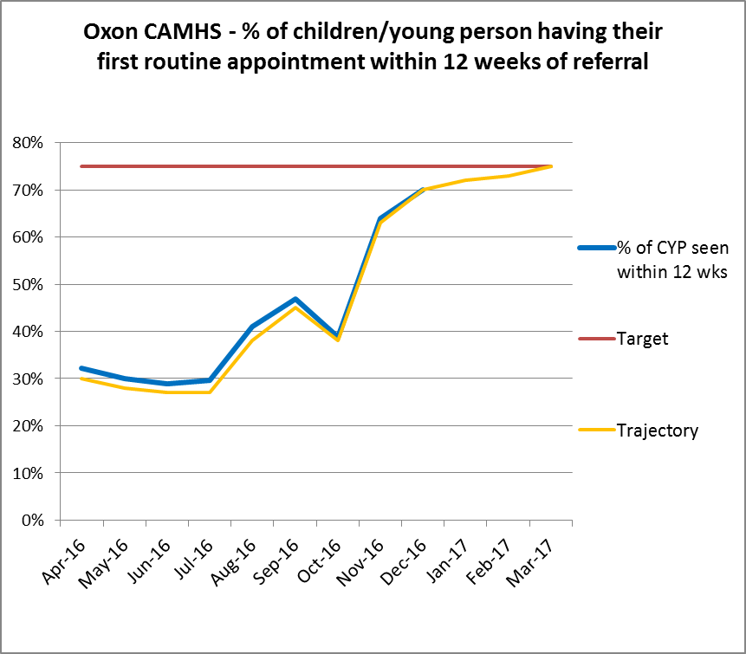 | Oxfordshire CAMHS service’s performance against its 12 week referral to first appointment KPI for routine referrals continues to remain below target.  For Month 9 the service achieved 70% against a 75% target. A Waiting list paper is submitted monthly to OCCG detailing all actions in place to improve performance. The service continues to see 100% of emergency referrals within 24 hours and 100% of urgent referrals within 2 weeks.
Bucks CAMHS | Percentage of relevant up-to-date with Mandatory CCCS training. | 100% | 66%  (Dec) | 62% | 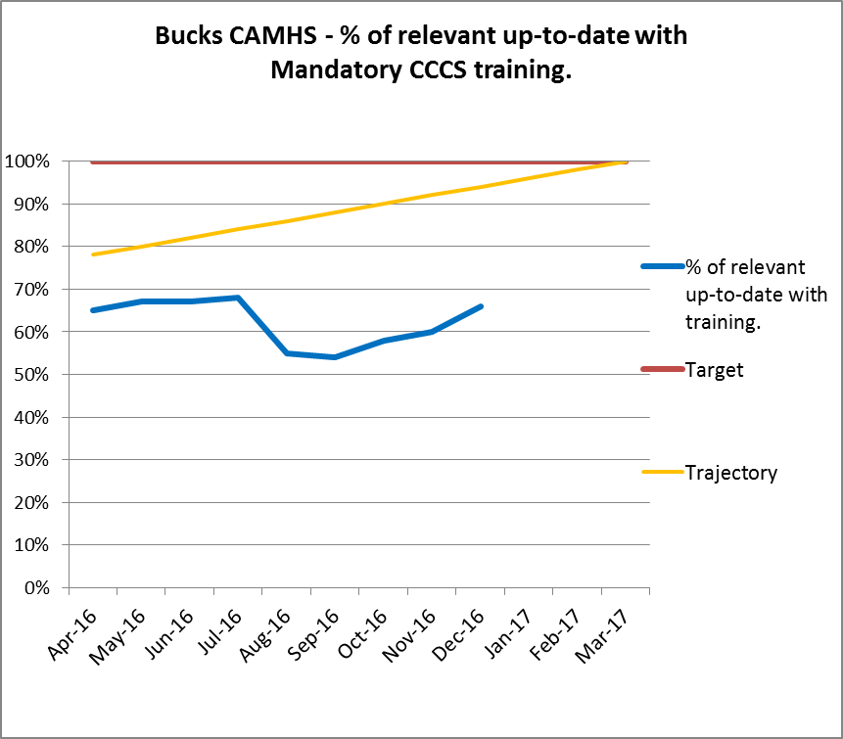 | Bucks CAMHS Clinical Care Competencies and Skills (CCCS) training is @ 66% against a target of 100%, main areas of underperformance are:  Dementia, Dual diagnosis, Medicines & MH Skills  All teams have action plans in place to address their underperformance.
Bucks CAMHS | Percentage of relevant up-to-date with Mandatory PPST training. | 100% | 77%  (Dec) | 72% | 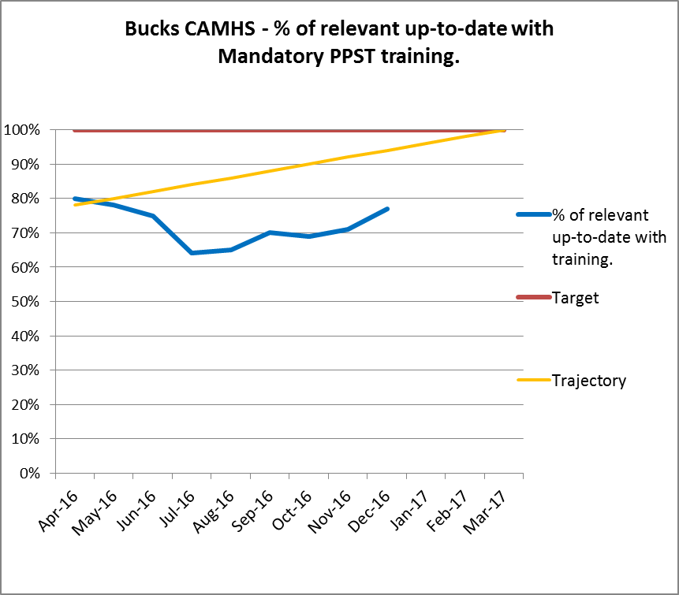 | Bucks CAMHS PPST Training is @ 77% against a target of 100%, main areas of underperformance are:  Infection Control, Resus, Fire Awareness, Safeguarding.  All teams have action plans in place to address underperformance.
Bucks ED | Number of Referrals | 13% increase from 15-16 | 149 Referrals Received (Dec YTD) |  | 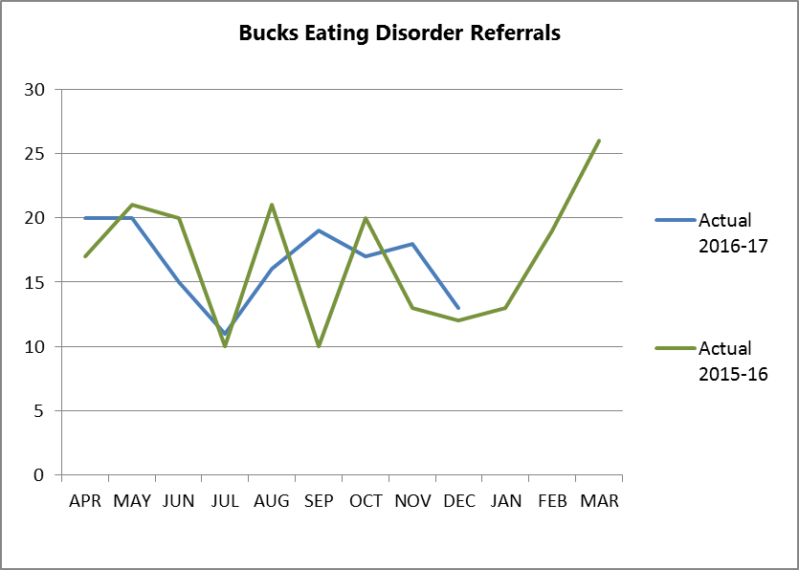 | 13% increase in referrals for Bucks Adult Eating Disorders for 16-17 compared to 15-16, over performing against contracted activity target by 19% YTD.  Despite the over performance for activity the service have long waits of up to 18 months for CBT-E, this service is commissioned as part of the Bucks CCG Block Contract and needs extra funding to meet current and future demand.

Adults Directorate-COO Supporting Information-Month 9

Service | Measure | Target | Actual | YTD | Trend | Narrative/Action
Aylesbury Schedule 4 | 95% people will have cluster review within the timescales specified by the cluster package | 95% | 79% |  | Risk that patient care is not being reviewed frequently enough to manage changing needs.  Potential for financial penalty and reduced future funding. Bucks CCG are scrutinising our financial returns which show high costs ascribed to ‘no cluster’ category (cluster 99). Potentially, they could allocate funds towards areas of high activity. | Head of Service, Service manager and performance teams and working with the Clinical teams to improve their clustering activity.  Clinical teams are being sent fortnightly spreadsheets showing both people with cluster reviews coming up and people who have not been assigned a cluster are being sent to the teams. 2 months to improvement (March 2016 data).
Chiltern Schedule 4 |  |  | 70%
Oxford Schedule 4 | Patients referred to EDPS seen within timeframe | 95% | 83% (JR)  79%  (HGH) |  | Delays to patients receiving care. Potential for CCG  to issue performance notice. | Analysis of the breaches times show that they fall at particular times of day and week; HoS and SM reviewing the staffing structure to ensure adequate cover.  Clarifying with EDPS staff about proper reporting of ‘breaches’ – may be reporting higher numbers than technical breaches (i.e. when a delay is due to patient illness). 3 months to improvement (end April 2017 data)
Aylesbury Schedule 4 | Carers within cluster group 4-17 will report satisfaction with the level of support to the person they care for | 90% | No returns |  | Risk to patient care through lack of carers’ influence.  Risk of contract performance notice. |  | A comprehensive Carer engagement plan has been developed to improve the consistency of the feedback collection from carers across all services, and to ensure that new carers are invited to give feedback about their experience.  A patient carer experience lead is being recruited for the Adult Directorate to champion carer engagement in service improvement.  Significant improvements to carer feedback collection expected within 6 months (June 2017 data) with events being planned using the ‘you said we did’ framework during carers week in June.  *M9 Reduced responses in December as a result of closure of CRT.
Chiltern Schedule 4 |  |  |  | Reported quarterly:  June: 25%  Sept: 90%  Dec: 67%

Service | Measure | Target | M9 | Trend
Oxford OBC Schedule 4 | Access and waiting time standard for early  intervention in psychosis (EIP) services – % of  people experiencing first episode psychosis will  be treated with a NICE-approved care package  within two weeks of referral.* | 50% | 60% | *Single Oversight Framework measure
Chiltern Schedule 4 | The proportion of people that wait 6 weeks or less from referral to entering a course of IAPT treatment against the number of people who finish a course of treatment in the reporting period* | 75% | 99% | *Single Oversight Framework measure
Aylesbury Schedule 4 |  |  |  | *Single Oversight Framework measure
Aylesbury Schedule 4 | The proportion of people that wait 18 weeks or less from referral to entering a course of IAPT treatment against the number of people who finish a course of treatment in the reporting period.* | 95% | 99% | *Single Oversight Framework measure
Oxford OBC Incentivised Measures | % of service users in paid employment, undertaking a structured education or training programme or undertaking structured voluntary activity* | 50% | 46% | *Single Oversight Framework measure
Forensics Schedule 4 | Number of staff who received safeguarding vulnerable adults training | 90% | LSU 95%  MSU 95%

LSU = Low Secure Inpatient Unit
MSU = Medium Secure Inpatient Unit
CCCS = Clinical Care Competencies and Skills

