

# Report to the Meeting of the

**BOD 111/2017**  
(Agenda item: 10)

# Oxford Health NHS Foundation Trust

# Board of Directors

# 27 September 2017

# INPATIENT SAFER STAFFING Staffing 19th June to 13th August 2017

**For: Information**

**Executive Summary**

**Introduction**

The purpose of this paper is to provide a report of the actual staffing levels to the Board of Directors. There is a national requirement on providers to be transparent on our monitoring and reporting of in-patient staffing levels. Ensuring sufficient staffing levels are in place is crucial to deliver safe, effective and high quality care.

The data within the report will outline the staffing levels (for both registered and unregistered nursing staff) on each ward. These figures will be measured against the required figures on a shift by shift basis for two 4 week periods: 19th June to 16th July 2017 and 17th July to 13th August 2017.

The paper will also provide information in relation to:

* Evenlode staffing levels
* Recruitment and Retention work
* Rollout of the SafeCare acuity and demand data collection module on Health Roster.
* OHFT’s involvement in NHSI Carter 90 day rapid improvement programme with the aim of improving efficiency and productivity of e-rostering by ensuring the right staff are in the right place at the right time to align with patient needs.

**Recommendations**

The Board is asked to note:

* The processes in place to ensure safe staffing levels on all the wards in the organisation, those wards where there are concerns and the actions being taken to ensure safe staffing including project work and wider recruitment and retention work.

**Author and Title:** Kate Riddle, Interim Deputy Director of Nursing and Clinical Standards

**Lead Executive Director:** Ros Alstead, Director of Nursing and Clinical Standards

*A risk assessment has been undertaken around the legal issues that this paper presents and there are no issues that need to be referred to the Trust Solicitors. This paper links to all of the five CQC Domains.*

**Inpatient Safer Staffing**

Period: 19th June to 13th August 2017

**Introduction**

This is the report to the Board of Directors outlining the staffing levels (registered and unregistered) on each ward against their required need on a shift by shift basis. This report covers the 8 week period: 19th June to 16th July 2017 and 17th July to 13th August 2017.

In addition there is information about other work that is in progress in relation to staffing:

* Evenlode staffing levels
* Recruitment and Retention
* Roll of SafeCare acuity and demand data collection module on Health Roster.
* Trust involvement in NHSI Carter 90 day rapid improvement programme with the aim of improving efficiency and productivity of e-rostering by ensuring the right staff are in the right place at the right time to align with patient needs.

This report will be published on our website with a link from NHS Choices website.

**Management of Staffing Levels**

Anescalation process for the management of staff shortages is in place within each clinical area, in order to manage staffing safely on a shift by shift basis. As part of this process, senior clinical staff are providing appropriate support to ward teams as and when required. In addition, senior ward staff and immediate team managers review ward staffing levels on an on-going basis; shift by shift basis, and where there are changes in patient acuity. Ward Matrons review staffing daily as a minimum and more frequently where required.

In-patient staffing levels continue to be reported every week and discussed within the Weekly Review Meeting (WRM), which takes place each Monday morning. Appendix 1 in the body of the report summarises the staffing position for the reporting period.

In order to ensure that staffing levels are under continual review, every ward undertakes a range of immediate actions on a daily basis to ensure safe staffing levels are maintained appropriate to the needs of patients. These actions include booking staff via staffing solutions via bank or agency, revising rotas, moving staff between wards and utilising additional staff that are not include in the ward numbers as required.

**Summary position of inpatients ward staffing levels (Period 13/06/17- 13/08/17)**

Appendix 1 shows the staffing levels for all wards by ward for the time period 19th June 2017 to 13th August 2017, together with figures for the previous 4 week period. The data presented includes details of staffing by shifts and also details of skill mix, agency, sickness and vacancy figures. The thresholds presented in the table are measured against trust/ national targets and used to highlight particular wards for further review.

During the month 19th June –July 16th 2017, staffing levels on seven wards did not meet the required 85% of planned hours: Chaffron, Glyme, Kingfisher, Phoenix, Sandford, Vaughan Thomas and Wenric wards. This was the same number of wards as the previous month.

During the month 17Th July – 13th August 2017

Staffing levels on nine wards did not meet the required 85% of planned hours. These were Chaffron, Glyme, Phoenix, Sandford, Vaughn Thomas, Ruby, Ashurst, Lambourne House and Cotswold House Oxford

Staffing levels on Glyme, Sandford and Vaughn Thomas have not met the required 85% for three consecutive months.

The chart below outlines the % of shifts that were unfilled over the period 13/02/17- 13/081/7. This was at 9% or above for 13 weeks of this 26 week time period.

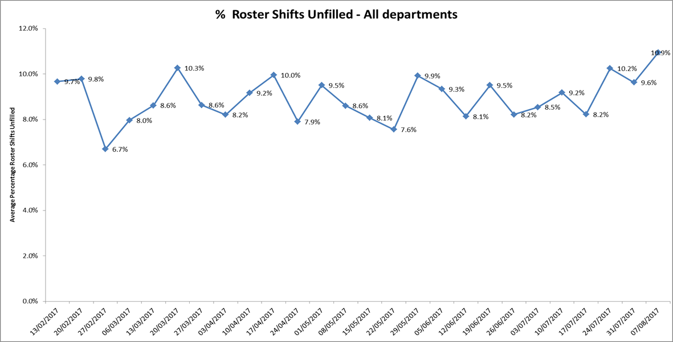It has been confirmed that throughout this eight week period all wards were staffed to achieve safe staffing levels; however this continued to be achieved in some wards by our staff working additional hours and shifts, the high use of flexible or bank staff both from the trusts internal bank ‘staffing solutions’ and agency staff. Where there is high use of agency staff, the aim is to use long lines of agency cover which provides continuity of care and staff.

**Threshold targets**

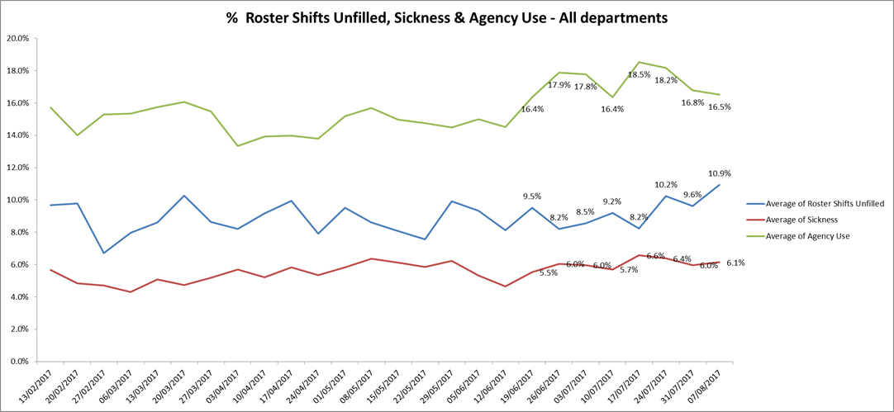There are agreed threshold targets: 50 % registered skill mix, agency usage target is 5%, sickness 3.5%. Table 2 below shows that these targets are not being achieved across all the wards.

**More detail on key wards with high % above threshold targets is included in the charts below.**

**Adult Directorate ward**

**Ruby ward** Agency use peaked at 57.3% and then reduced to 30.2% over the two months. Unfilled shifts ranged from 14.2% to 24%. Sickness levels peaked at 13.8% and then reduced to 7.9%. Work is planned to increase long lines of agency staff within the unit to reduce unfilled shifts and increasing staffing consistency.

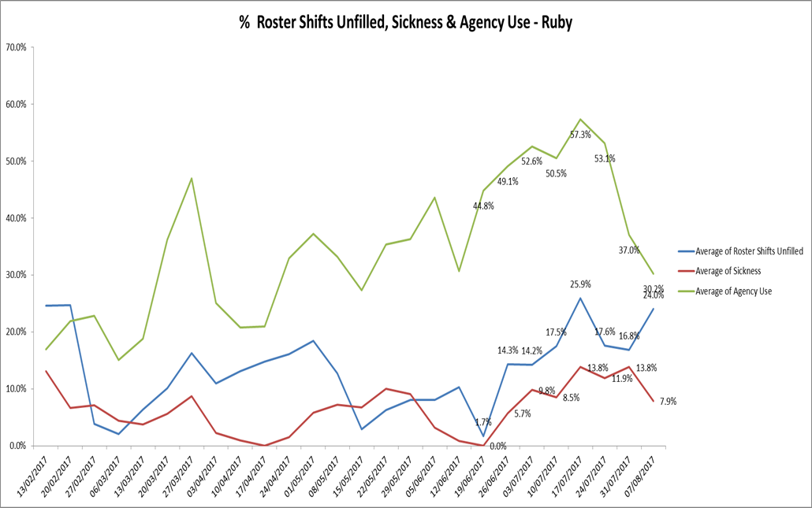

**Sapphire ward**

Agency use peaked at 26.5%, sickness increased to 11.1% and unfilled shifts increased to 15.3%. Work is planned to increase long lines of agency staff within the unit to reduce unfilled shifts and increasing staffing consistency.

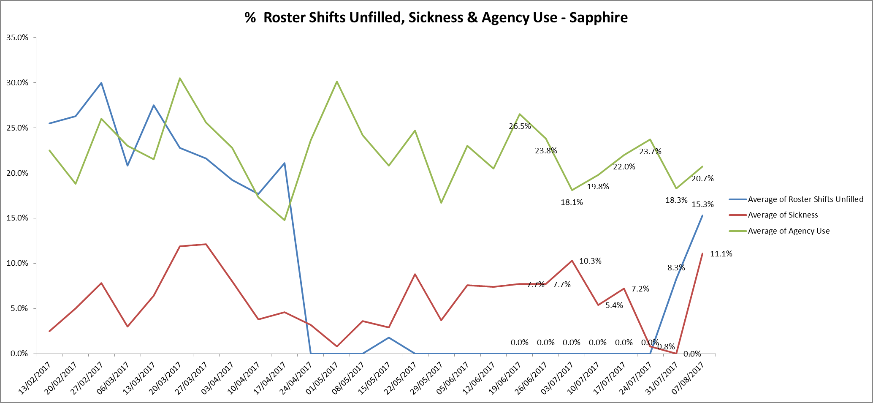

**Vaughn Thomas ward**

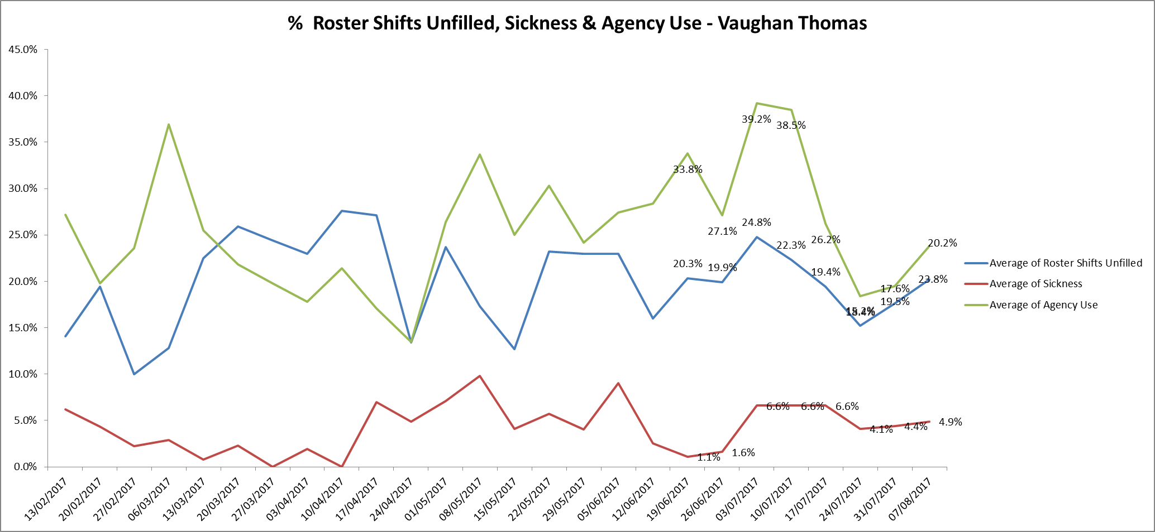Agency use peaked at 39.2% during this reporting period but unfilled shifts remained at above 20% throughout. Sickness levels increased to 6.6% but there was a slight reduction in the last week to 4.9%.

**Phoenix ward**

Agency use peaked at 30% and has reduced to 17.1%. Unfilled roster shifts have remained above 10% throughout this reporting period. Sickness peaked at 14.1% but has reduced to 0%

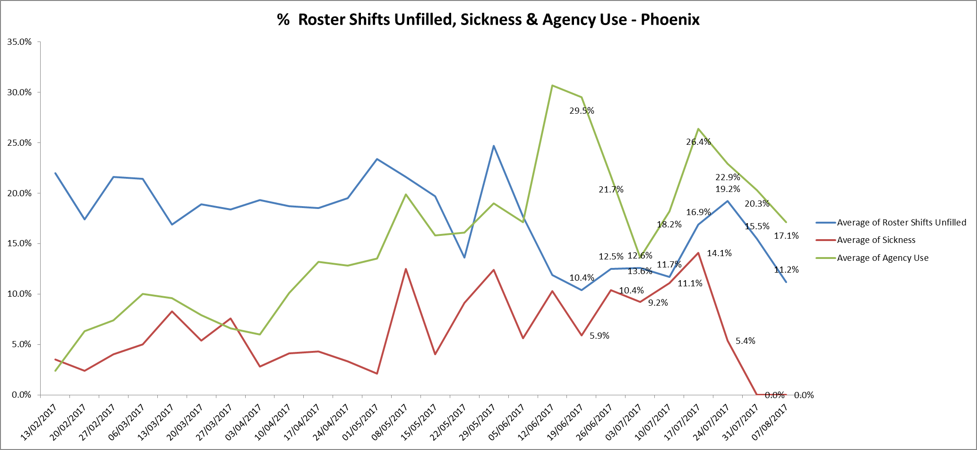

**Older adults**

**Sandford Ward** Agency use was above 20% throughout this reporting period and peaked at 37.5%. Unfilled shifts were above 15% throughout. Sickness rates have reduced to 4.4%. Only 20-22% of the rota is filled by substantive staff

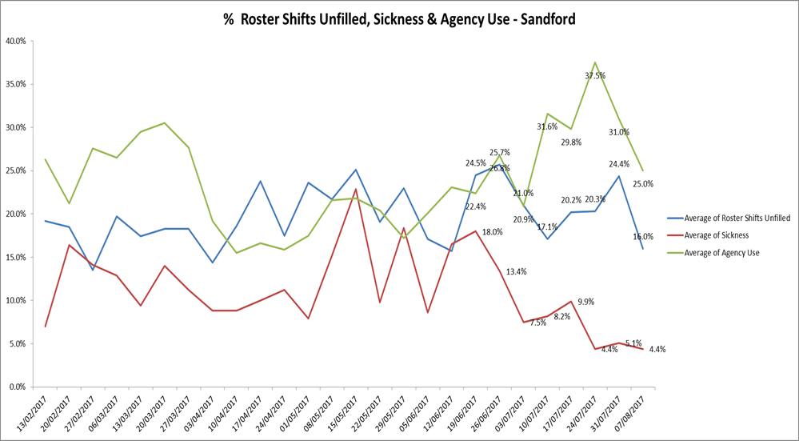

**Children and Young Peoples Services**

**Highfield Unit.**

Agency use has been above 25% throughout this period, this is linked to vacancies and patient acuity. Unfilled roster shifts remained above 10% and sickness has increased to 6.7%

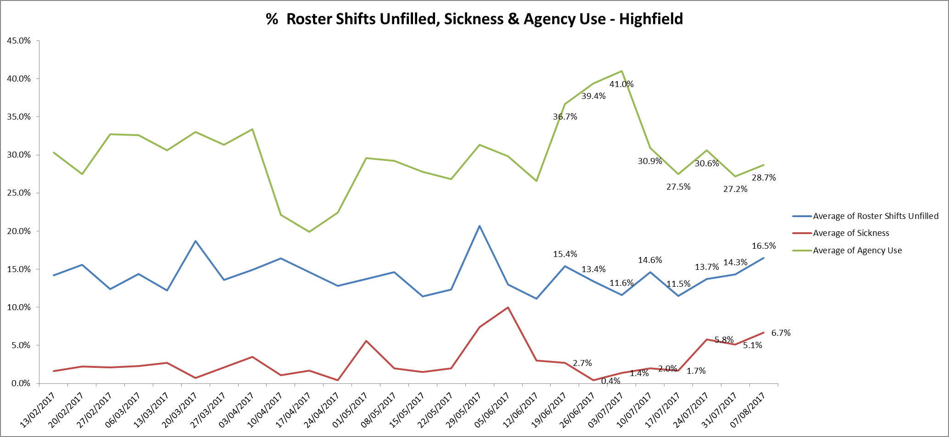

**Forensic wards**

**Watling ward.**

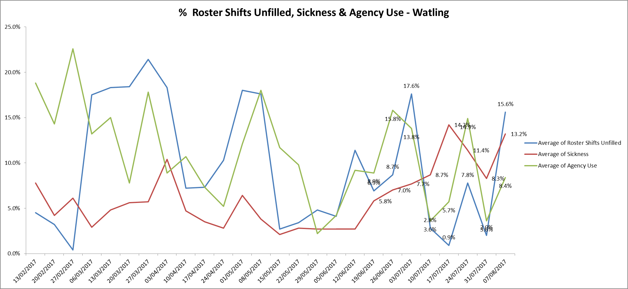Throughout this period the unfilled shifts fluctuated significantly from 17.6% to 0.9%. This will be reviewed by the Head of Nursing to clarify this fluctuation .Agency use reflected this trend. Sickness increased from 5.8% to 14.9% with a slight reduction to 13.2% in the week of 07.08.17.

**Wenric ward**

Agency use peaked at 29.2% and unfilled shifts remained above 13% throughout the period. Sickness levels increased from 6.5% to 10.9% peaking at 13.7% in the week of 26.06.17

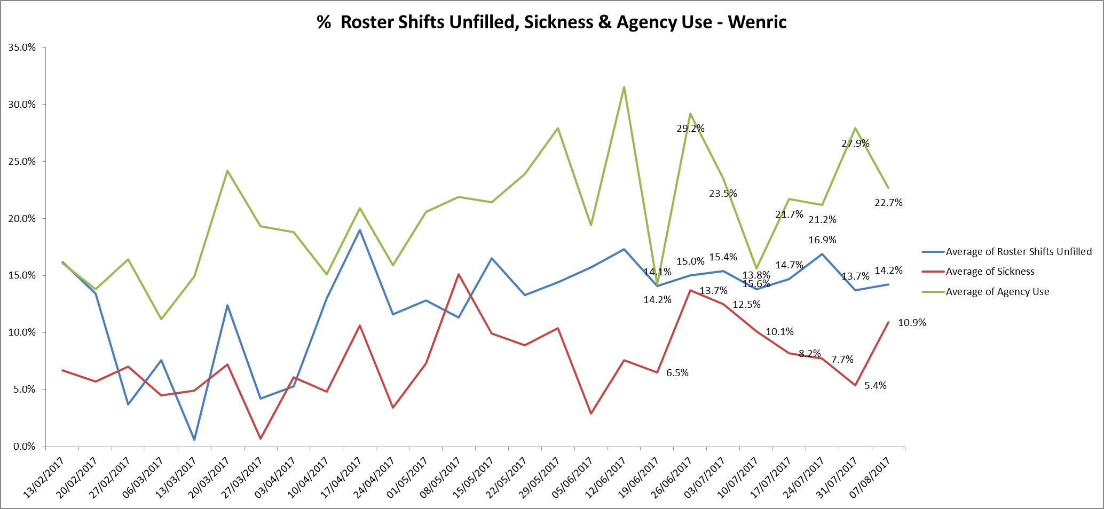

**Registered skill mix**

Nine wards have achieved 50% or more registered skill mix staff. Eighteen wards were between 35- 50%.Five wards were below 35% in the period 17th July - 13th August as follows:

* Ashurst 24.4%
* Allen 33.5%
* Kennet 34.2%
* Ruby 27.7%
* 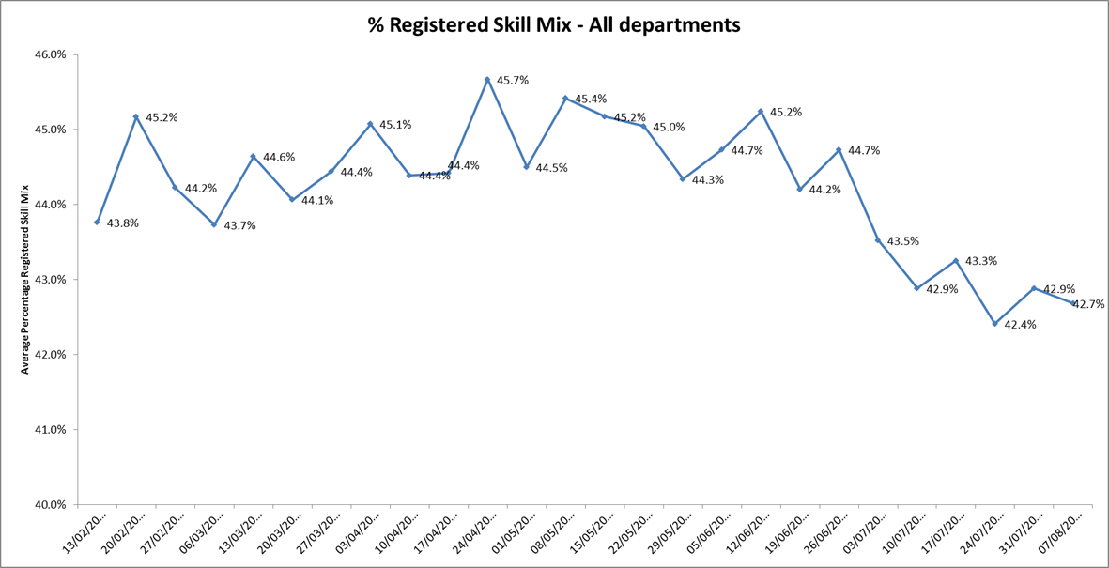Watling 28.3%

**Evenlode**

Oxford Health became the provider of this service on 1st July 2017. The ward is not currently on Health Roster so a narrative is provided on staffing levels

For the period 1st July 2017- 7th September 2017, the expected/ planned staffing levels for the ward have been: 6 staff on early and late shifts, and 4 on nights. All shifts to have at least one Registered Nurse. During this period, Registered Nurse cover has been provided for all shifts, and all night shifts have had the planned 4 staff on duty.

The staffing position for the day shifts is detailed below by month. The expected staffing level of 6 staff has not always been achieved however the ward is not full (9 patients are on the ward) and the acuity has been low due to limited new admissions (3 new admissions since March 2017).

The staffing model for the ward is currently being reviewed. At present the ward has two RN vacancies both of which have been appointed to and we are waiting for the new member of staff to start.

The staffing position for each ward is reported into the weekly clinical review meeting chaired by an Executive Director or Deputy and any concerns escalated. The e-rostering system is due to be rolled out on Evenlode ward in November 2017 so between now and then an exception report from the ward is being given on a weekly basis.

July 2017 day shifts n=62

39 shifts (63%) staffed as planned to 6 staff

20 shifts (32%) had 5 staff on duty

3 shifts (5%) had 4 staff on duty

Agency staff used on 1 day shift and 12 night shifts

August 2017 day shifts n=62

31 (50%) staffed as planned to 6 staff

25 (40%) had 5 staff on duty

6 (10%) had 4 staff on duty

Agency staff used on 7 day shifts and 14 night shifts.

September 2017 1st – 7th n=14

7 (50%) staffed as planned to 6 staff

4 (29%) had 5 on duty

3 (21%) had 4 on duty

**Recruitment and retention work.**

Key actions are in place to increase nursing recruitment:

* On-going attendance to recruitment fairs
* Highlighting the opportunity for other nursing disciplines including RGN and LD nurses.
* Working with long line agency staff to try and move them across to substantive contracts.
* Linking with Brookes students and teaching within the programme
* Working with Oxford University Hospitals Trust to increase recruitment of student nurses post registration across all disciplines.

Retention actions

• Appointing performance roles to release ward managers for clinical leadership. This is being recruited to in the adults’ acute service and being explored in forensic services. .

• Focus to maintain forums like reflective practice / training sessions etc. which aid retention

• Forensic induction for new starters

• Preceptorship group programme- reviewing this to strengthen support and ongoing continuing professional development in year two post-graduation.

• Promotion of the learning opportunities (nurse associate / apprenticeship roles)

Regular reviews of workforce issues, with particular focus on recruitment and retention, are taking place. The reviews are developing some of the ideas from the “50 Questions” and developing them into proposals that can be costed and evaluated. The aim is to enable the Trust Executive to decide which proposals could be taken forward into HR strategy.

Over the coming months we will be introducing new incentives and rewards to encourage more people to work with us. This month we launched the ‘Recommend a Friend’ scheme offering £300 to staff who successfully introduce people to both staff and bank roles.

Alongside that we have launched the ‘Bank with Us’ scheme which seeks to greatly increase the number of Flexible workers available to work through Staffing Solutions, our in house bank. This is offering improved rates for experienced substantive staff to enable them to be paid at their substantive rate of pay for bank shifts (e.g. a band 6 will be paid at that rate for doing band 5 shifts), and pay for Pure Flexible Workers now has 3 pay points to reward workers for their experience. There is also a £300 bonus to entice Agency Workers across to Staffing Solutions.

Recruitment of Flexible Workers has now moved to the core recruitment team and additional posts are in place to support increased recruitment activity supporting “Bank with Us.”

We have an ambitious target to recruit around 800 people trust-wide in order to provide double the number of hours currently provided by flexible workers by March 2018. This includes substantive staff working extra shifts and ‘pure’ flexible workers. It’s a challenging target which will be monitored over the coming months.

The Government recently announced that an additional 21,000 mental health nurses, consultants and therapists would be recruited across the NHS workforce. Trusts expect to be contacted about the detail behind this during October or November 2017.

**SafeCare project roll out update.**

This is an additional module to the Workforce management system which will provide the Trust with more detailed information beyond current Health Roster dataset and will measure Care Hour Per Patient Day (CHPPD) which will need to be submitted to NHSI weekly from April 2018.

Through completion of three times a day patient census, staff will capture actual patient numbers by acuity and dependency using Dependency and Acuity Models. These are based on the Hurst dependency model with some adaptations reflect our inpatient services.

This will enable

* Wards and managers to action day-to-day staffing movements
* Review of staffing levels and see if these match the demand.
* Production of reports to identify trends and causes, highlighting changes needed to ensure safe staffing levels
* Clear visibility of staffing issues Trust wide where staffing does not match the required patient demand for in nursing hours, skills, temporary staff usage and charge cover.
* Improved planning of longer-term resource and establishment needs.

**Current status**

There is a rolling programme to train staff on inpatient units have been trained and some wards are now live collecting patient census data, inputting this into SafeCare and updating their staffing information through SafeCare.

Feedback from some of the staff evidenced that

* They understood and appreciated the rationale for capturing the census data
* They could already see benefits to be gained from the information.

The roll out across all Adult mental health, Older Adult, CAMHs, Eating Disorder and Community Hospitals is in progress with an expected completion date of end of October 2017.

**Further actions**

Our two Eating Disorder wards have engaged in acuity data collection work with South Staffordshire & Shropshire Healthcare NHS Foundation Trust who has been commissioned by Health Education England to lead a project working with Keith Hurst to produce a workforce tool specific for mental health. The work being undertaken for Eating Disorders is new; there is no data which currently exists for this speciality.

**Next steps**

Senior Managers to be upskilled in SafeCare and the information available.

A bi-annual process for review of Safe Staffing and demand templates to be agreed.

Operational oversight process for staffing issues to be defined in each directorate.

A review process to be agreed to ensure consistency and appropriateness of dependency model application across units.

To agree the processes, roles and responsibilities for gathering, reviewing and reporting data from floor to board. This work is linked to the Carter 90 day Improvement programme which is described below.

**NHSI Carter 90 day Rapid Improvement Programme**

Lord Carter is leading a review for NHSI into community and mental health Trusts, building on the approach of the Carter Report on Operational productivity and performance in NHS acute hospitals.

The review aims to identify:

• How organisations in mental health and community Trusts operate.

• ‘What good looks like’.

• ‘What approaches to improving productivity and efficiency are already in place and the opportunities to drive these further’

• ‘What metrics and indicators are required to support the development of the model for these sectors’

As part of this work Oxford Health is one of 23 Trusts participating in a 90 day rapid improvement programme with the aim of improving efficiency and productivity of e-rostering by ensuring the right staff are in the right place at the right time to align with patient needs.

Our improvement aim is to improve roster approval and publication times supporting our staff to plan their work and home life.

Through the improvement of rostering practice it is anticipated over time that the following benefits will be gained:

* Increased staff satisfaction and well-being by:
  + Ensuring the right staff are in the right time reducing work related stress.
  + Staff knowing sufficiently in advance their working arrangements enabling them to plan their home life.
  + Reducing levels of agency staffing and increasing levels of substantive employees and bank workers who are familiar with the units and ways of working making easier for all on the shift.
  + Where possible meeting the flexible needs of our staff.
  + Consistent management of working hours across all staffing groups.
* Increased patient and carer’s satisfaction by ensuring staffing levels meet patient demand.
* Improved efficiency and savings through:
  + Better management of unavailability and hours worked.
  + Better management of demand versus staffing levels.
  + Reduced agency use.

Oxford Health has been asked to present its improvement work to the rest of the cohort on September 15th 2017 and at NHSI’s Roadshow where they are presenting the emerging findings from Lord Carter’s review into community and mental health trusts in October.

Appendix 1

Tables1 & 2 All Metrics Roster Period June 16th – August 13th 2017

Data source: electronic rostering system



