CYP Directorate-COO Supporting Information-Month 10
R | Areas requiring improvement

Service | Ref | Measure | Target | Actual | Trend | Impact | Action and resolution timescale
LQR OCCG | C2c | Prevent | 90% | 70% | 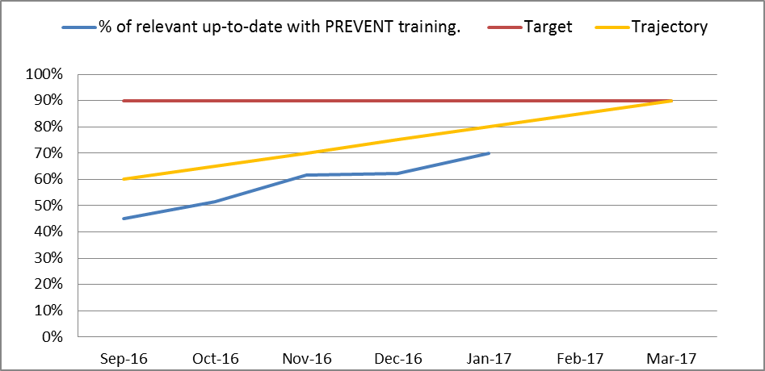 | Possible failure to adequately protect against radicalisation | Prevent is one of 4 courses that forms KPI C2 which has an overall target of 90%.  124/176 staff are compliant. CYP is targeting non-compliant individuals and supporting staff with time to complete training, Limited training courses are currently available for existing staff-CYP have used an internal prevent trainer to deliver some courses.
LQR OCCG | C2b | Mental Capacity | 90% | 76% | 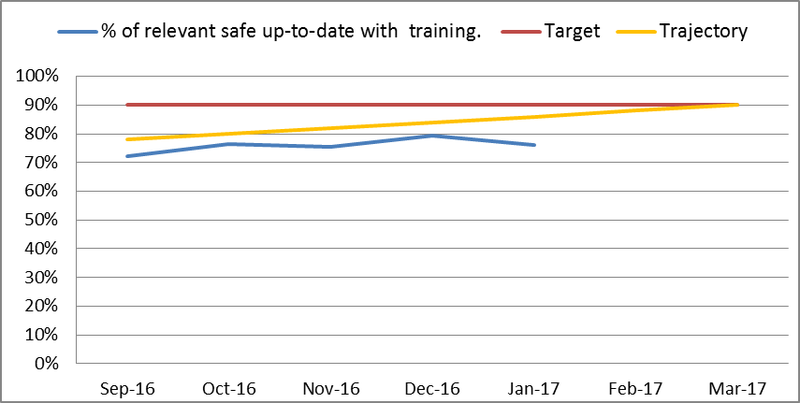 | Possible failure of staff awareness of the Mental Capacity Act. | Mental Capacity is one of 4 courses that form KPI C2 which has an overall target of 90%.  65/85 staff are compliant. CYP is targeting non-compliant individuals and supporting staff with time to complete training.
LQR- OCCG | C7 | CAMHS -% of clinic letters that are sent back to GPs within 10 working days | 95% | 79% |  | Delay in GPs receiving essential information which could result in patient harm | The January audit shows improved performance. North Oxon CAMHS community team have improved - a new consultant locum started early February. The South community team have significantly increased performance by 57% from previous month. Learning Disability currently has gaps in administration - vacancy is out for advert. We have enlisted some pooled administration support for the team on an interim basis. The average length of time taken to send the letter following the appointment was 4.4 days; an improvement on last month and <10 day standard
LQR- OCCG | C7 | ED -% of letters that are sent back to GPs within 10 working days | 95% | 63% |  | Delay in GPs receiving essential information which could result in patient harm | For Month 10 performance 14/16 letters were sent to GP within 10 days, the % is only based on 16 letters, the service has an action plan in place to address their underperformance.

G | Areas of positive performance/improvement

Service | Ref | Measure | Target | Actual | Trend | Impact | Action and resolution timescale
Health Visiting | PAF | % of mothers who received an antenatal contact with a Health Visitor (CQUIN) | 62% | 71.7% | 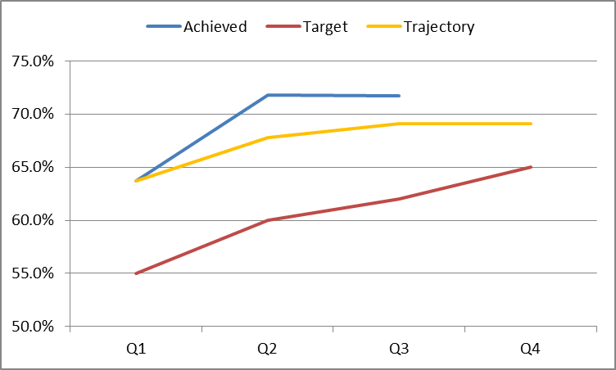 | Early contact with mothers ensures a smooth transition between Midwifery and HV Service | The Service has consistently achieved the CQUIN for Q1, Q2 & Q3 and are on target to achieve this for Q4
Health Visiting | PAF | % of mothers with a 6-8 Week Maternal Mental Health Completion | 93% | 96.9% | 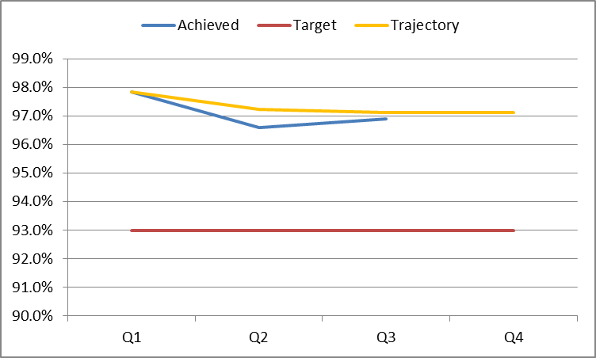 | Mothers are receiving a timely Post Natal Mood assessment | The Health Visiting Service are consistently achieving well above the 93% KPI and are on target to achieve this for Q4
Health Visiting | PAF | Percentage of children who did receive a 1 year review | 93% | 94.4% | 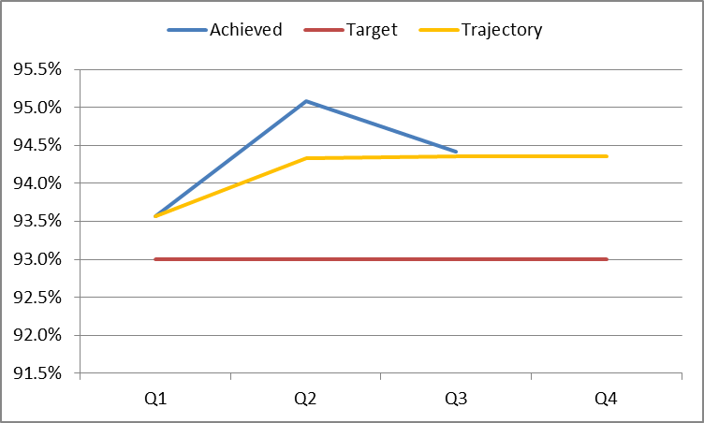 | Babies are receiving a timely 1 Year ASQ assessment and review | The Health Visiting Service are consistently achieving well above the 93% KPI and are on target to achieve this for Q4
Health Visiting | PAF | Percentage of children who did receive a 2-2.5 year review | 93% | 94.9% | 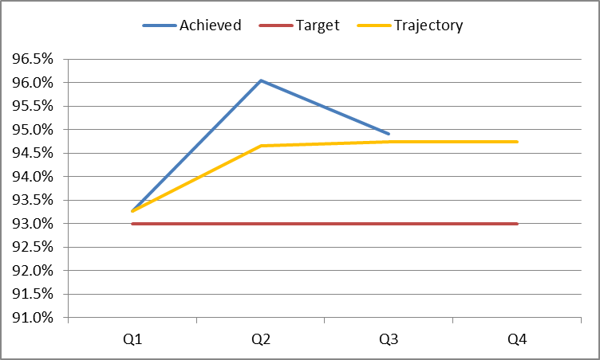 | Babies are receiving a timely 2 -2.5 Year ASQ assessment and review | The Health Visiting Service are consistently achieving well above the 93% KPI and are on target to achieve this for Q4

Older Peoples Directorate-COO Supporting Information-Month 10

R | Areas requiring improvement

Service | Ref | Measure | Target | Actual | Trend | Impact | Action and Resolution Timescale
Out of Hours | NQR  10  B8 | OOH urgent triage (walk in) - time to triage; <20 mins of arrival | 95% | 49% |  | Extended waiting time possibly resulting in delayed care | NQR10 B8 and B9. The service is attempting to recruit HCA/ENAs to undertake an initial assessment of all walk ins so that this can be recorded as the initial triage. A more senior clinician will look over the data gathered and decide when a patient should be seen. Unfortunately this will be likely to increase the number of walk ins as they will learn that they will be seen within 15 minutes or so. Patients should be advised that they can only access the OOHs service via 111.  NQR 12 B10. This target was set when all patients were triaged first by a GP who allocated urgency. The urgency is now set by 111 and we know that the threshold is much lower so achieving the target will be more difficult as the numbers are higher. 111 have to make an appointment within 2 hours so if they talk to a patient at 1000, deem them urgent and make an appt. at 1145 they hit their target. If we are running 15 minutes late at 1145 we miss ours or 111 deem the patient urgent and there are no appointments within 2 hrs they pass them to us to find an appt. This requires doubling up on appointments or re-triaging by a GP.  Activity in December was 30% higher (11,113 contacts) than the April-November average (8509 contacts), however, this is in line with the profiled activity plan and consistent with previous years’ trends.
Out of Hours | NQR 10  B9 | OOH non- urgent triage (walk in) - time to triage; <60 mins of arrival | 95% | 80% |  | Extended waiting time possibly resulting in delayed care
Out of Hours | NQR 12  B10 | OOH urgent F/F base visit appt within 2 hours of triage | 95% | 74% |  | Extended waiting time possibly resulting in delayed care
Out of Hours | NQR7  B6 | OOH percentage of unfilled shifts; ability to match capacity with demand | 2% | 6% |  | Extended waiting time possibly resulting in delayed care.
Comm  Hospitals | LQR C11 | Delayed Transfers of Care (DTOC); snapshot number | 15 | 51 |  | Delays adversely impact the whole system pathway and patient flow. This will affect the acute trust’s ability to admit, ED and beyond | The service has noticed increased complexity including increased waits for specialised placement; particularly EMI NH. There has also been an unprecedented and unrelenting increase in HART delays since Oct, together with reduced social capacity in parts of the county. A weekly performance dashboard has been created to monitor performance for DTOC, ALOS and overall bed activity, which is scrutinised weekly by SMT

G | Areas of positive performance/improvement

Service | Ref | Measure | Target | Actual | Trend | Impact | Action and Resolution Timescale
Adult SaLT | CS D10 | % of patients who are classified as “urgent swallow” to be offered assessment within two working days of referral received. | 95% | 100% |  | Responsive care to patients in urgent need. | Despite capacity challenges faced by the service last year, the service has sustained performance against this indicator this year above target.
MIU | D11 | % of patients attending MIU must be seen, treated, admitted, transferred or discharged in under four hours. | 95% | 99% |  | Responsive patient care | The service performs well against the 4 hour target achieving 99% in January and 98% compliance YTD
Single Point of Access | D12 | % of patients requiring immediate care are assessed and the required service is mobilised to attend to the patient <4 hours | 95% | 100% |  | Responsive patient care and support to whole system patient flow | The service performs consistently well against the 4 hour target achieving 98% compliance YTD and 100% in January
Emergency MDT Unit (EMU) | D20a | Patients referred are seen, or contacted as appropriate, within 2 hours | 90% | 100% |  | Responsive patient care and support to whole system/admission avoidance | Since implementation of the KPI in September, the service has consistently achieved 100% against a 90% target

Adults of Working Age Directorate-COO Supporting Information-Month 10

R | Red Indicators

Contract | Ref | Measure | Target | Actual | Trend | Impact | Action and Resolution Timescale
Oxford Schedule 4 | 1 | Patients referred to EDPS seen within timeframe | 95% | 85%  JR  83%  HGH |  | Delays to patients receiving care. Potential for CCG to issue performance notice. | Clarifying with EDPS staff about proper reporting of ‘breaches’ – may be reporting higher numbers than technical breaches (i.e. when a delay is due to patient illness).  New action plan being developed.  3 months to improvement (end April 2017 data)
Oxford OBC Schedule 4 | 9 | Urgent referrals 7 consecutive days for assessment. | 95% | 85% |  | There is a risk of delayed access to services for patients needing urgent attention.  Potential contract performance notice. | A number of breaches are over the Christmas period – patients cancelled and the team had no capacity to re-book within timescale (a number of patients cancelled, or DNA 2/3 appointments during this time).  There were capacity issues within the teams - City increased its staffing in an attempt to complete assessments within timeframe. The North AMHT is due to move to the Full FACT model from Monday 20/2/17 which should improve capacity for completing assessments, as it has in the South
Chiltern Schedule 4 | Local 27 | EIP 2 week treatment referral | 50% | 0% |  | Concern around the financial implications | Single Oversight Framework measure  Refers to two new patients not assessed within 2 weeks. Query re one of the breaches was valid as one was admitted to an inpatient ward and therefore treated by a different team. Work required to raise profile of the targets with the team and the quality reasons. Service manager will be scrutinising referrals
Chiltern Schedule 4 | Pr04ii | Urgent referrals 7 consecutive days for assessment. | 95% | 61% |  | Risk of delayed access to services for patients needing urgent attention.  Potential contract notice | SMs and HoS working with clinical teams to understand the underlying issues.  Some concern that urgent referrals are being made inappropriately from primary care, which make numbers look worse than they should.  Improvement within 2 months due to complexity of issues (April 2017 data).

G/A | Areas of positive performance/improvement

Contract | Ref | Measure | Target | Actual | Trend | Impact | Action and Resolution Timescale
Oxford OBC Incentivised Schedule 4 |  | 50% of service users in paid employment, undertaking a structured education or training programme or voluntary activity | 50% | 50% |  |  | The directorate has made continued and significant improvement since the start of the year achieving the target for the first time in January.
Chiltern CCG Schedule 4 |  | People in cluster 4-17 will have self-defined & self reported social inclusion measures within their CPA | 90% | 78% |  |  | The directorate has made significant improvements since September against this measure and is on course to meet the target by year end.
Aylesbury Vale CCG Schedule 4 |  | People in cluster 4-17 will have self-defined & self reported social inclusion measures within their CPA | 90% | 77% |  |  | The directorate has made significant improvements against this measure over the last month with performance improving by over 20% in month. The directorate intends to continue this positive work.

