

**BOD 16/2017**

(agenda item: 8)

# Report to the Meeting of the

# Oxford Health NHS Foundation Trust

# Board of Directors

**22nd February 2017**

**Quality report: Patient Experience & Involvement**

**For Information**

**Executive Summary**

This quarterly report provides an update on patient experience and involvement projects within the Trust and a brief summary of the feedback we have received which tells us how it feels for patients to receive care, and how we have used this to work with people to improve their experience of receiving care and treatment.

Across our services the key and consistent areas for improvement fed back from service users, patients and carers continue to be:

* Patients want to **feel informed, be given options and take part in decisions about their care** (critical element: respect of patient centred values, preferences and expressed needs)
* Patients want to be provided with **good information** that is tailored to them and is timely, and they also want **staff to communicate clearly** with them (critical element: information, communication and education)
* **Families and carers want to be involved,** listened to and respected as part of their loved ones care (critical element: Welcoming the involvement of family and friends)

Highlights of the report include:

**The patient experience feedback tender** was halted in December 2016 without awarding a contract. A new process will begin after a re-evaluation of priorities to further develop the specification around clinician level feedback and benchmarking opportunities.

**“I Want Great Care”** patient experience feedback mechanism is successfully being rolled out across the Trust, as a single and consistent mechanism.

**Patient experience and Involvement Strategy** update on implementation of strategy objectives.

‘**Taking Action From Patient Feedback Group’** continues to oversee the patient experience strategy objectives for year 1. Please see Appendix 2 for a progress update against the strategy objectives. These will continue to be monitored through this group.

**Focus on patient experience feedback** from 3 different areas across the Trust.

**Recovery Colleges** (*action update*) Recovery College representatives have been invited to present to the Board at the next Adult Directorate Patient Story scheduled for March 2017, to give more detail on current activity. (*action from the 25 May 2016 Board meeting*);

**Transition between services** (from children’s to adult services) – to consider whether patient experience reporting can demonstrate and start to track some progress on resolving issues of transition between services and communication with carers and service users (*action from the 27 July 2016 Board meeting*)

**Recommendation**

The Board is asked to note this report and support identifying the outstanding funds required to fully deliver the patient experience and involvement strategy between now and March 2019.

**Author and Title:** Donna Mackenzie, Patient Experience and Involvement Manager

Jane Kershaw, Head of Quality Governance

**Lead Executive Director:** Ros Alstead, Director of Nursing and Clinical Standards

1. **Introduction**

A report on patient’s experience is presented to the caring and responsive quality sub-committee (last report January 2017) and also the Board of Directors as part of the quality report (patient experience last presented Annual report in Oct 2016). An annual report also goes to the Quality Committee, last presented in July 2016.

The reports focus on updating the board on patient experience and involvement projects and work streams and providing a summary of the feedback we have received which tells us how it feels for patients to receive care, and how we have used this to improve patient’s experience. The themes highlight the key areas for improvement identified in this report around communication and sharing information with patients and their families to enable joint decision making and involvement in care.

Feedback from patients, parents, families and carers is a very valuable source of information to measure patient experience however this report recognises that other sources for example activity data, clinical audit, staffing levels, incident data and staff feedback; are also important to measure and improve patients experience. The internal peer review programme continues to also be a useful source of feedback from patients and carers in addition to routine methods.

1. **Patient experience feedback tender**

The patient feedback tendering process was halted by the Executive Team in December 16; whilst the service specification is developed further to ensure we have the right partner to work with over the next three years. The focus will be on clinician level capture/ reporting, benchmarking capacity and simplicity of reports for teams and the use of electronic mechanisms as much as possible.

Whilst a second tendering process is started the contract with “iwantgreatcare” (iwgc) has been extended and the provision of services by the company expanded for nine months from 1st January to 30th September 2017.

There are some additional elements being trialed in the nine months including a reporting dashboard (as well as the current linear reports), and linking clinician level feedback on the iwgc public site with survey results. All services are being supported to move to using the iwgc software and approach to collect patient/ carer feedback.

The previous contracts with the external companies, Patient Perspective and Customer Research Technology, were ended on 31st Dec 2016 and rental hardware has been returned.

1. **Key development areas – update**

Below are the areas prioritised for development;

1. Implementing the trust wide patient experience and involvement strategy.
2. Iwantgreatcare implementation

Below is a description of progress with each of the development areas.

**4a. The Patient Experience and Involvement strategy**

The approved strategy which was co-developed with patients, families/ carers and staff is approaching its first complete year as it was launched in April 2016. The strategy outlines the key objectives around 3 domains identified as priorities by those involved in the development of the strategy; Person centred care, Involvement in services and Acting on feedback. The strategy is summarised in Appendix 1.

The trust wide ‘taking action on patient feedback’ group continues to be chaired by the Deputy Director of Nursing and meets bi-monthly. This group reports to the Caring and Responsive quality sub-committee with the purpose to;

* Monitor and give oversight on the objectives to deliver the patient experience strategy,
* to share good practice
* as a forum for clinical services to demonstrate how they are using feedback to improve the patient experience.

The membership of the group includes service user/carer called ‘Members’, staff and governors and work is continuing to further develop patient/carer member representatives at the meeting.

The group met in January and November 2016 and have a number of project groups live working on individual objectives from within the strategy. The updated work plan with progress for year 1 objectives can be seen in Appendix 2. Initial progress was slow however momentum has developed over the last 6 months.

A challenge of the strategy work plan continues to be identification of the additional resources agreed and needed to fully deliver the aims and outcomes of the strategy.

We have identified directorate patient experience leads now who are working effectively with services to embed iwgc, support local reporting and identify areas for quality improvement.

4b. **Iwantgreatcare (iwgc)**

The contract with iwgc has been extended to ensure continuity until the new patient experience feedback contract is in place (mentioned above). The Iwgc contract extension has expanded and now covers the majority of services within the Trust with the exception of those who have a commissioning requirement/CQUIN/KPI around a certain question which is not part of the question set currently available through iwgc. 144 teams/ services now have access to the patient surveys online or can print these to give out paper surveys.

This includes:

* 74 teams/services from Older People’s Directorate
* 14 teams/ services from Adult Directorate
* 56 teams/ services from Children & Young People’s Directorate

Services not yet set up or currently on using iwantgreatcare include those listed below. Over the coming months we will be working with these services to develop their use of the system.

* + - District Nursing Teams (x22 teams)
    - MSK Physiotherapy
    - PDPS
    - Phlebotomy
    - Adult SLT
    - Complex Needs Service
    - Children’s Integrated Therapies
    - Health visiting service
    - School Health Nursing Service
    - Luther street

The fixed question set in Iwgc surveys includes the following questions:

1.a “How likely are you to recommend our service to a friend or family member if they needed similar care or treatment?”

1.b “What was great about your care? What could be improved? *(open comments box for free text responses)*

1. “Were you treated with respect and dignity?”
2. “Did you feel involved enough in decisions about your care and treatment?”
3. “Did you receive timely information about your care and treatment?”
4. “Were you treated well by the staff looking after you?”
5. “Was the location suitable for your needs?”

These are displayed on the app like this;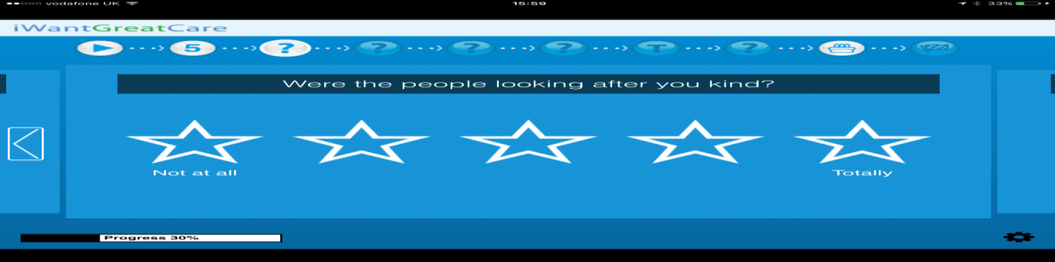

Or via paper copies on a variant of this form;

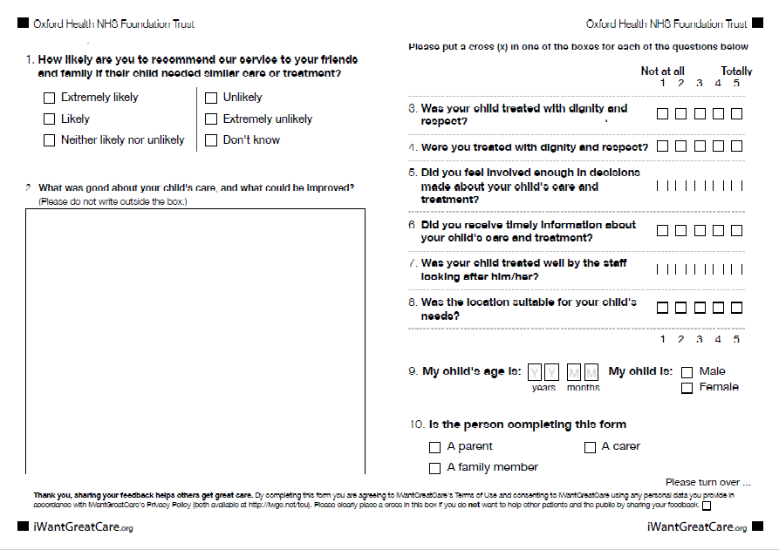

All services accessing Iwgc are able to download surveys in easy read format and age appropriate format *for childrens services* as well as their individual team reports by month. All Iwgc reports are available with information analysed by team, service line, care group, Directorate or Trust wide.

The full January Trust wide report is shown in Appendix 3

**Trust wide summary:**

|  |  |  |  |  |
| --- | --- | --- | --- | --- |
|  | **October**  **2016** | **November 2016** | **December**  **2016** | **January**  **2017** |
| Average score (*against the 6 questions asked across all services)* | **4.78** | **4.82** | **4.76** | **4.68** |
| Total number of responses on Iwgc | **362** | **409** | **206** | **325** |
| Total responses collected from other surveys *(not included in average score)* | **Not available** | **Not available** | **162\*** | **272\*** |
| Total survey responses | **n/a** | **n/a** | **368** | **597** |

**\*This data includes responses counted by survey monkey only.**

Overall the Trust have received 1,975 responses since starting to use Iwgc as a pilot in Jan 2016 with an overall average score of 4.76 out of 5 across all the questions asked.

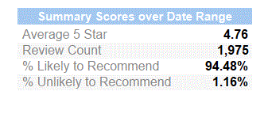

1. **Adult Mental Health Carers Survey**

|  |
| --- |
| The Adult Directorate also conduct a separate survey for all Carers accessing Mental Health Services across Oxfordshire and Buckinghamshire in line with commissioning requirements. |

The survey is available via an online link on the Trust wide site as well as in all mental health teams and our five partner organisations (as part of the mental health partnership in Oxfordshire).

80 carers have responded to the survey since 1st January 2017 with a number of improvement comments and accolades. The feedback will be used to inform carers work within the directorate. Below is a summary of some of the results.

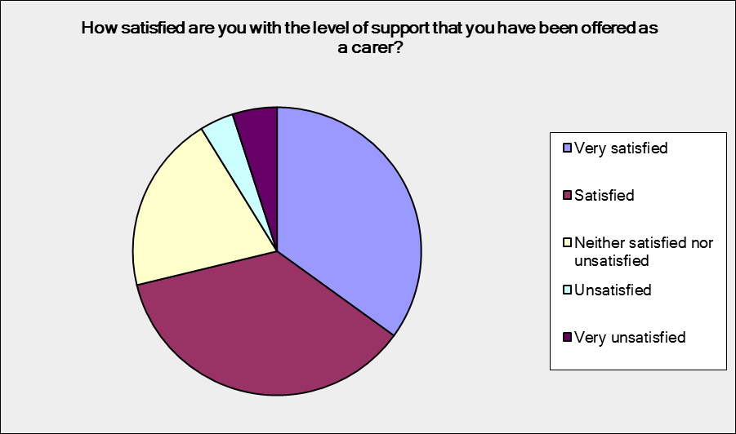

**Table showing results from level of support offered for carers.**

.

|  |  |  |
| --- | --- | --- |
| **How satisfied are you with the level of support that you have been offered as a carer?** | | |
| **Answer Options** | **Response Percent** | **Response Count** |
| Very satisfied | 35.0% | 28 |
| Satisfied | 36.3% | 29 |
| Neither satisfied nor unsatisfied | 20.0% | 16 |
| Unsatisfied | 3.8% | 3 |
| Very unsatisfied | 5.0% | 4 |
| ***answered question*** | | **80** |

1. **Recovery Colleges**

The Buckinghamshire recovery college, collaboration between the trust, Buckinghamshire MIND and Buckinghamshire Adult Learning was formally opened in January 2017. Courses range from recovery focus and psycho-educational to arts, crafts, gardening and living skills. The Oxfordshire recovery college continues to grow and the college is currently promoting new spring term courses.

1. **Triangle of Care**

In December 2015 the Carers Trust accredited the trust with two gold stars, the third (and last star) will be achieved when all mental health and community teams/ wards have completed the self-assessment and identified/ addressed any gaps. This has not yet been achieved by any Trust nationally.

The Directorate Carer Leads alongside Executive representative attended the National Triangle of Care meeting in November 2016 to present an update of work over the past year and take part in the re-accreditation process to maintain the 2 star rating. The Carers Strategy Forum continues to monitor progress and themes from the self-assessments, and work continues across the Trust to develop carer specific information within teams as well as training for staff around carer awareness and assessment in line with the triangle of care accreditation criteria. Carer awareness training has been rolled out to staff across adult mental health services in conjunction with Rethink following positive feedback from the pilot sessions and is being rolled out across the Older Adults directorate. The Children and Young People directorate first training session is being held in March 2017.

In addition the trust has started a cross agency piece of work in Oxfordshire with carers to develop a carers statement of intent/ charter.

1. **Summary of feedback**

Overwhelming the feedback we have received from patients, families and carers is very positive with patients reporting feeling cared for by staff and that as a result they highly value the service provided. However some people do not receive the positive experience we expect every person to have and therefore we have more work to do. The themes highlighted from complaints mirror the key areas for improvement identified from the feedback we receive, and are focused on communication and sharing information with patients and their families/carers to enable joint decision making and full involvement in care.

1. **Friends and Family Test**

The results to the national friends and family test question (FFT), how likely are you to recommend this ward/ team to friends and family if they needed similar care or treatment? Are shown below. These results are submitted to NHS England on a monthly basis.

This graph shows that the responses from the FFT question have improved steadily for community services from February 2016 at 93.6% to January 2017 at 97.0%.

It also shows that Mental Health Services positive responses dipped in November 2016 and remained lower into December 2016 and January 2017. We will continue to keep an eye and understand whether this appears as a trend. The Mental Health response rate also dipped during November/December 2016 and this may be due to change in contract and patient experience feedback mechanism to iwgc.



**Month                                  Community                                                                        Mental Health**

February                              498/ 532 = 93.6%                                                              186/239 = 77.8%

March                                   536/573 = 93.5%                                                               147/ 165 = 89.0%

April                                       633/ 674 = 93.9%                                                              168/ 189 = 88.8%

May                                       857/ 912 = 94.0%                                                              155/ 173 = 89.5%

June                                      526/ 556 = 94.6%                                                              123/ 139 = 88.5%

July                                        639/ 684 = 93.4%                                                              110/ 122 = 90.2%

August                                  487/ 517 = 94.2%                                                              82/ 88   = 93.2%

September                         219/ 229 = 95.6%                                                              128/ 141 = 90.8%

October                               646/ 682 = 94.7%                                                              235/ 253 = 92.9%

November                          376/ 391 = 96.4%                                                              71/94   =  75.5%

December                             267/277 = 96.4%                                                             61/ 76  =  80.3%

January 2017                    424/437 = 97.0%                                                          119/150=79.3%

1. **Adult Community Mental Health Survey**

The National Community Mental Health Survey for 2017 starts in February 2017 and runs until June 2017.

The survey will be sent to a random sample of patients who have had more than one contact with a community mental health service aged 18 and over (no limit) and have an address in the UK. The Survey questions are similar to 2016 and are sent to 850 services users out of a possible 4869 who accessed services between 1st Sept-30th Nov 2016. (*The sample excludes specialist services e.g. drug and alcohol, forensic, and IAPT and current inpatients.)*

A full evaluation of the results will be made available as soon as they are published in December 2017

1. **Focus on services**

This report is being developed to provide a focus on a range of services each quarter to give greater detail on feedback received and action taken as a result at a team, ward or service level.

Below is information about Buckinghamshire CAMHS, an adult mental health ward and the District Nursing service.

**Buckinghamshire CAMHS- Children and Young People’s Services**

Buckinghamshire CAMHS have been using online questionnaires, designed alongside young people from their participation group, to collect patient experience feedback since June 2016. These surveys are available via clinicians ipads and in waiting areas at their 2 main bases, Harlow House and Sue Nichols Centre.

The survey asks 23 questions and 106 young people have responded between October 2016 and January 2017. There is a separate survey available for carers which has received 28 responses

Feedback of things that are liked about the service can be grouped mainly around the 3 domains of Effective, Caring and Safe with young people leaving the below statements:

* I like feeling heard and understood
* It is private, one on one and I felt safe and understood
* EVERYTHING, they were a big help
* Trustworthy
* Friendly, helpful
* Range of advice and help given
* Helpful, I was in control of the decisions made
* I like having my buddy visit me at school where I am comfortable
* I felt like the buddy wanted to help me not just because it was her job
* Caring people, confidential
* How I could call if I needed help
* I felt safe
* The ease of use of the service
* It is flexible
* Practical help, tailed to our situation
* Actually listens
* More casual which made me feel more relaxed and able to share my feelings
* Having regular sessions, be able to be collected from home and seen where I wanted to be seen. Relaxed and not a clinical environment
* Being seen at home, feeling comfortable with the person
* It has improved a lot since my previous experience with the service

**Things not liked about the service?**

ENVIRONMENT

* The seats cause backache
* More games x 2 comments
* Clinical feel to the place
* Noise from outside
* Waiting rooms are a bit boring
* The waiting rooms x 2 comments
* Two couches for the waiting areas
* Make the rooms more colourful and welcoming

COMMUNICATION

* Telling me they are going to do something and still not been done after a month
* Unachievable goals
* My opinion not as valued as my parents
* Not much feedback given to my mum
* Better communication needed

REFERRALS

* Referral time x 8 comments
* Lack of contact whilst waiting
* Assessments arranged quicker

**Main themes emerging from quality improvement feedback.**

* Waiting areas
* Referral times/quicker assessment process
* Communication
* More rather than longer sessions
* Improve resources used in sessions
* More games/toys
* Flexibility of appointments

The graph below shows the results for the FFT question. 74 0f the 106 young people answered positively with 10 answering “neither likely nor unlikely” and a further 9 answering “don’t know”.

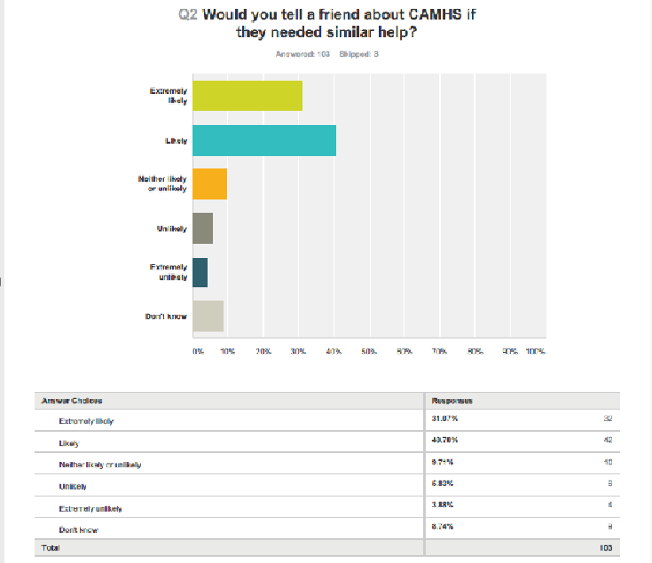

**Do you feel that you have been treated with respect?** 81 young peopleanswered yes and 2 said no. There have been a high number of young people who have skipped this question which may be because of the wording used or because it is late in the question set at number 19 in the survey.

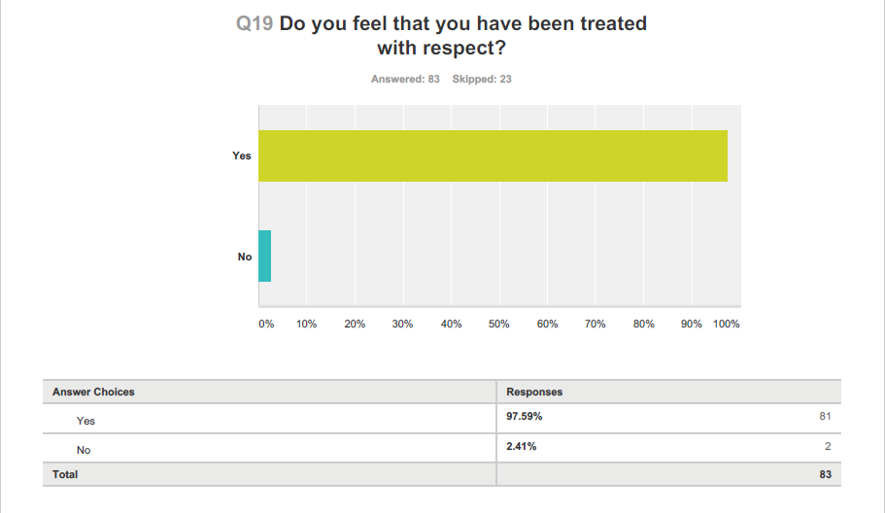

**What Buckinghamshire CAMHS are doing about it:**

Harlow House waiting area re-design – young people have worked on designing a new waiting area with the theme of homely and welcoming. Young people have included comment boards to share young people’s comments and experience of the service, comfortable and colourful furniture. Art work has been produced by young people for the space featuring positive quotes to inspire children and young people visiting. (see pictures).

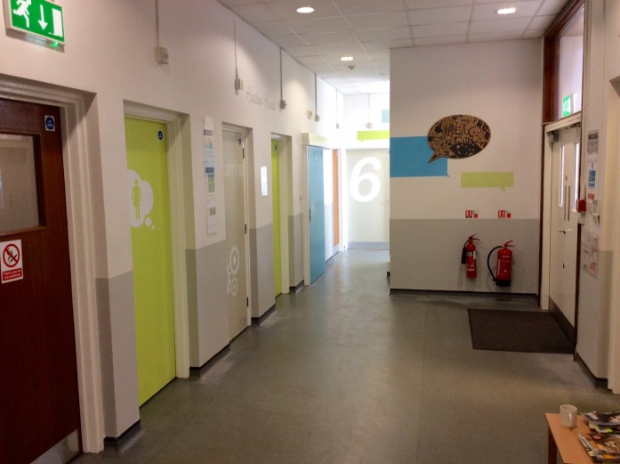 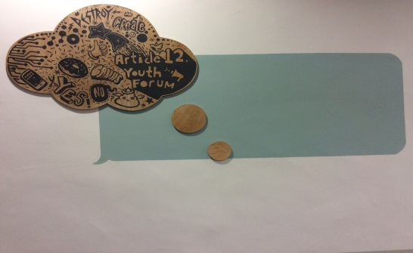

Discussed confidentiality and information sharing with the Single Point of Access to check permissions on CareNotes when sending out letters.

We are developing a forum for parents who are receiving support from our Neuro team at CAMHS. We plan to consult with parents on how best to communicate and offer support whilst waiting for an assessment.

For young people who feel that the support they’ve received is too short, where possible, we are offering a Barnardo’s volunteer for children and young people needing additional support at the end of their allocated sessions with their Buddy.

**Phoenix Ward - Adult Directorate**

Phoenix Ward started using Iwgc in July 2016 and has received 64 responses to date. The overall average % of those likely to recommend is 73.44%.

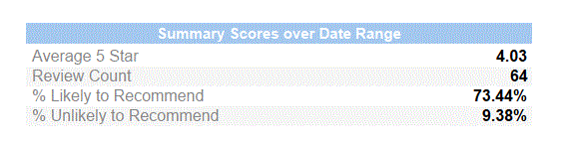

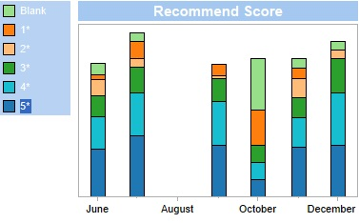

The FFT question shows that between October and December 2016 the positive responses have increased steadily where 5* is extremely likely to recommend and 4* is likely to recommend. There were no “extremely unlikely” responses in December 2016.*There were no responses in August 2016*

The average score across the questions show that the ward scored between 4 and 4.5 stars out of 5 about information, involvement and for the FFT question. They score between 4.6 and 4.8 out of 5 stars for dignity and staff questions.

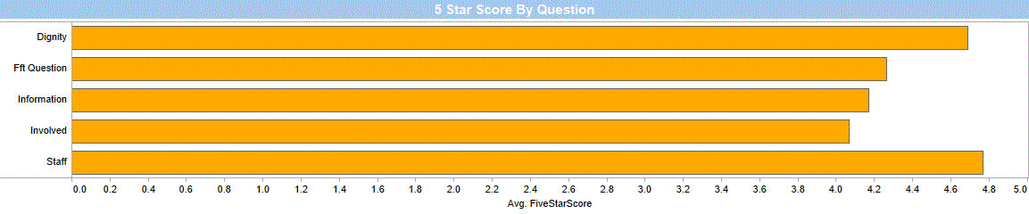

**Main themes emerging from quality improvement feedback.**

* Lack of physical activities
* Communication

This word cloud shows the most regularly used words as larger and the colour indicates positive or negative response with green as positive shading to red to indicate negative.

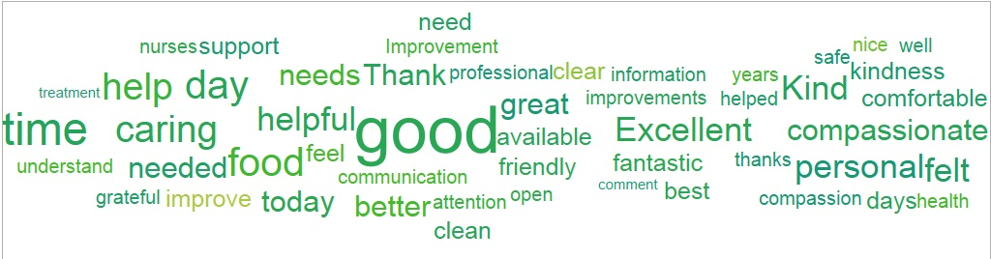

**Who is responding?**

The majority of those responding are patients (77%), with 11% identifying themselves as family and 3% of carers. The remainder did not identify who they were.

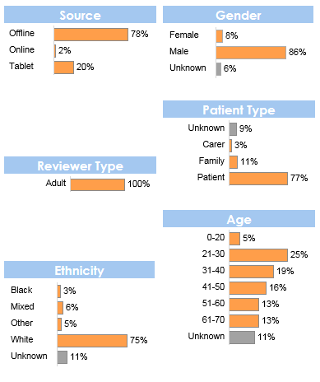

**Some comments from Phoenix ward feedback.**

* I was at an all time low and needed professional help. I managed to get a bed on Phoenix ward . it was the best thing that could of happened to me.
* It went good today. Good care
* Good conscientious care
* Good groups to spend time more positively
* Good food as well
* Need to leave quickly to get cigarettes
* During my stay in Phoenix ward I found the ward very compassionate and caring. I always felt comfortable with them and they made me comfortable when I was anxious.
* Thank you
* Great Care. All staff are always helpful

The ward are looking to develop further involvement work with the help of the Adult Directorate Patient Experience and Involvement Lead once they are in post

**District Nursing - Older People’s Directorate**

The District Nursing Service started using Iwgc in a number of their localities from January 2016. There are currently 14 teams using the surveys with the remaining teams aiming to be included by the end of February 2017.

To date 228 people have responded with an average score across all 6 questions of 4.88 out of 5 stars.

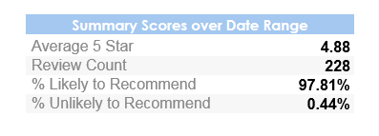

The FFT question shows that a consistently high percentage of people respond positively, answering “extremely likely” (5*) or “likely” (4*). This consistency is shown across the different teams as well as across the period of time. *There have been no responses in December 2016 or January 2017.*

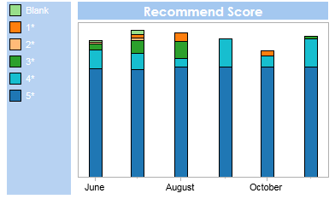

The average score across the questions show that the teams score between 4.6-5 out of 5 stars for all 6 questions.

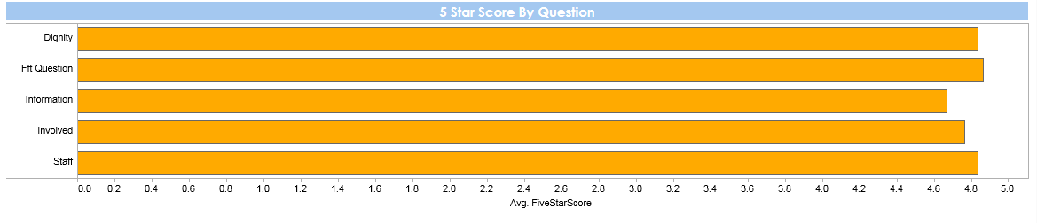

**Who is responding?**

The majority of those responding are patients (75%), with 12% identifying themselves as family and 10% of carers. The remainder did not identify who they were.

The number of female respondents (64%) is higher that the number of male respondents (34%).

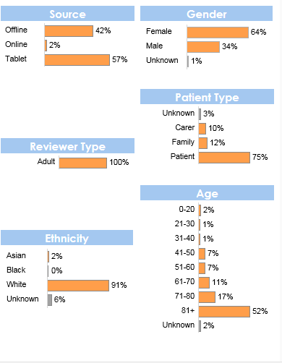

**Comments received for the District Nursing teams include:**

* I think the care I received is as good as it can get. I have never had problems they all do a wonderful job
* District nurses are reliable and the quality of care is very good.
* They are always available if we need you and the communication is good.
* All the nurses have been very good. No problems.
* My care was very good, the only downside is that you don't know exactly what time a nurse is coming to your house
* I found that the nurses were very good in the care of me, very compassionate and understand. In my circumstances I don't think anything can be improved

This word cloud shows the most regularly used words as larger and the colour indicates positive or negative response with green as positive shading to red to indicate negative.

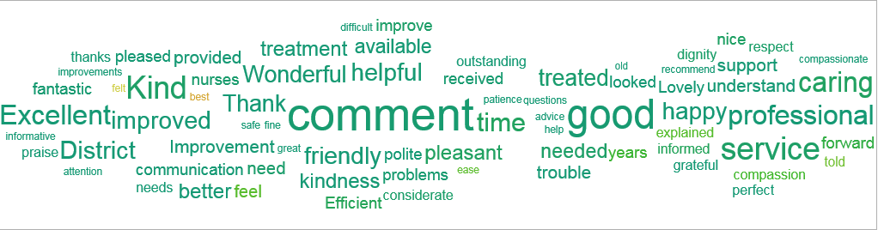

**What are the District Nurses doing?**

Peer reviews have identified staffing challenges especially within the district nursing teams; more work is required to ensure teams are aware the directorate/Trust recognises the challenges and has/ is taking steps to address these in order to continue to provide a high level of quality of care and patient experience satisfaction.

1. **Conclusion**

The report shares a progress update against the patient experience and involvement strategy 2016-2019, the areas of development being prioritised, progress from the Carers Strategy Forum, an update on the national community mental health survey and a summary of recent feedback.

Three key areas are identified for improvement, also reflected in complaints received and learning from SI investigations; these are:

* patients being involved in decisions and choices about their care
* patients wanting good information and clear communication, and
* patient’s families and carers feeling listened to and involved in their loved ones care.

**Appendix 1**



**Appendix 2**

**Patient Experience and Involvement Strategy Year 1 Key objectives**

| **Objective** | **Action** | **Progress update - January 2017** | **RAG** |
| --- | --- | --- | --- |
| To ensure all people who use our services and their carers are involved and are valued as equal partners in the involvement activity. | Use the involvement ladder (Appendix 4) and the 4Pi National Involvement Standards (developed by the National Survivor User Network) to identify the level of patient involvement in Trust wide activities to role model expectations e.g. board meetings, training and education, serious incident investigations, complaints process, service developments, conferences and leadership programmes. Improvements to be identified following the exercise: a) The trust to explore staffs current beliefs in regard to involvement b) Complete a trust wide mapping of current involvement activities to establish a baseline measure to assess improvements and to share good practice. To also include an update of the mapping exercise of how services/ teams are collecting, sharing and using feedback | Mapping completed in 2016 to identify involvement across the trust. Think about questionnaire, focus on accountability (where does it go) and open comments available. Show the different levels of involvement. What are the challenges? Not what you'd like to be doing, what are you doing? |  |
|
| Developing of a designated budget for all services to use to pay for reimbursement of involvement work, so that funding does not potentially become a barrier to involvement |  |  |
| Develop a regular method for sharing and celebrating across teams and services excellent examples of person centred care, this could be a conference, learning event, emails, blogs, face book, tweet, periscope etc. | Development of Involvement webpages, regular area of Insight magazine and Patient experience Social media hastag #OHFTgetinvolved |  |
| Identify teams/ services which could employ peer support workers, initiatives for staff to mentor patients, taking young people for work experience, apprentices, and use volunteers. Support these teams to fully utilise the benefits of these roles e.g. peer support worker training (possibly from a voluntary organisation), peer support worker networking events, set up a volunteer service to coordinate volunteering etc. |  |  |
| Develop a scheme to identify ‘beacon teams’ demonstrating good practice for all aspects of patient feedback/ involvement to spread to other teams so clearly demonstrating why good involvement ‘looks like’ |  |  |
| Improve engagement of patients and carers in care planning in all teams so that All patients, and where appropriate carers, are offered the opportunity to develop their care plan and risk assessment as part of working in partnership. All care plans are personalised and meet the individual’s need and identify clear goals | Directorate level care planning forums to be established to identify/ share good examples of care plans and areas for improvement across teams and professionals to improve the quality of care plans |  |  |
| Organise visits to other organisation to learn from them. | In 2016;   * Visit to Northampton NHS Trust. * NHS Elect event on Patient Experience. |  |
| All projects for service redesign/ developments will include people who use our services from the planning stage | All service redesign project plans will undertake a patient involvement assessment to ensure involvement of patients takes place from the outset of any project |  |  |
| Involvement assessment tools for service developments to be developed and agreed. |  |  |
| Information will be provided in a format which is easily understandable, so enabling accessibility for all | Service leaflets will be available as easy read and in the most commonly used languages as identified by NHS England/and locally, where English is not the first language |  |  |
| When replacing signage for services, new signs will include easy read format and where appropriate, in languages additional to English |  |  |
| Assessment of the most appropriate methods for sharing information will be undertaken and should consider audio, visual, written, Braille, according to peoples individual needs |  |  |
| To increase the use of ‘social media’ and modern technology as a means of engaging and involving people better so that people can share their experiences | Develop both the internet and staff intranet patient experience and involvement site on OHFT web sites so that results and learning (at service level) from patient experiences are able to be shared | Development of Involvement pages started by TAPF group |  |
| Report and publish feedback received quarterly and the actions taken as a result of the feedback at directorate and service level. | Developing as part of the website Involvement pages and magazine |  |
| Develop both the internet and intranet patient experience and involvement pages on OHFT website so that the patient involvement activities are promoted e.g. using # on twitter | OHFT Patient Experience hastag in development |  |
| Show clearly and diagrammatically the tiers of management/ panels/boards that are responsible for the delivery of the strategy and commissioning of the Services. Their contact details should be shown. There should be a clear demonstration of the structure of management and how this sits in relationship to all of the patients, families and carers panels | Started. |  |
| To ensure those people who want to get involved are able to access information easily and in a format which they can understand | Information about involvement activities will be made available in a variety of places and in a range of ways. This will be updated regularly to promote involvement and to build a network e.g. social media, internet, newsletters, working closely with partner and voluntary organisations, discharge information etc….This will require a nominated person to maintain the information and details, contacts, purpose | Development of Involvement webpages, regular area of Insight magazine and Patient experience Social media hastag |  |
| Increase the amount of involvement activities offered and being taken up and peoples experiences of being involved, including focus groups to start the understanding | Introduce virtual/ actual ‘involvement centres’ across the trust to enable people to come and talk about involvement activities available and to share/ network with peers. It is important that we have consistency in the group |  |  |
| Work alongside trust membership team to implement new system and approach to increasing members and looking at how people ‘get involved’ in activities and developing services | work started with membership team and PE team to look at system use |  |
| To increase the number of people in involvement activities from the ‘harder to reach groups | Develop the use of demographic data to identify those harder to reach groups where we do not receive feedback |  |  |
| Explore with harder to reach groups how we can involve them better so that they have good experiences of care and can be involved as much as they wish |  |  |
| To work in closer partnership with voluntary /charitable agencies, who are experts by experience e.g. Personality Disorder Training & Emergence Charity , MIND, STARS, Age UK, Barnardos |  |  |
| Interview panels will include people who use or have used our services and carers, as equal partners | Scope adding ‘lived experience’ as desirable criteria in all job descriptions | HR discussion needed |  |
| Peer review visits will include people who have used our services as a normal part of the process | Peer review teams will include people who have used our services and will consider accessibility of information as part of their visits | Ad hoc patients, service users and carers have been part of peer review teams. |  |
| Guidance, mentoring and training will be provided for those on the peer review teams. Ensuing confidentiality addressed. |  |  |
| Trust governors will be active participants in involvement activities/ peer review visits. Aim by end of 2018/19 that 40% of peer review visits will include governors. |  |  |
| Develop a structured framework and guidance for governors to use when undertaking ‘walk-rounds’ so enabling an assessment on experience, involvement and safety e.g. 15 step challenge |  |  |
| To explore development of a research/evidence based project (co-produced with patients and staff), based on the patient’s journey, working in partnership with patients, carers and families and partner organisations (e.g. OUH, BHT, OBU) so contributing to the national body of evidence in regards to patient experience and involvement |  |  |
| To increase the amount of feedback from patients and making changes for improvements based on the feedback | Embed the quality improvement approach (plan, do, study, act) to better demonstrate at service/ team level the changes made as a result of feedback and how this impacts on people’s future experiences. |  |  |
| Report and monitor how changes are impacting on peoples experiences using different formats. Reporting to be at least quarterly to the Board of Directors. | In place quarterly |  |
| Review how the information from various sources of feedback is pulled together, presented and shared. Working to information being readily available at team/ service and trust wide level | Moving to a single mechanism for collecting and reporting feedback has started. |  |
| Develop approaches to how we feedback results and actions taken to patients/ carers |  |  |
| Patient experience/ involvement champion to be identified in every team/ ward or cluster of teams. JD to be developed to define expectations of the role. | In progress |  |
| Every team/ ward to introduce a standing agenda item on their business meeting to discuss positive and negative feedback from patients/ carers and what improvements will be introduced | In progress |  |
| Complete external re-tender for patient experience contract (software and hardware) to support teams with collecting and receiving information in a user friendly format and in a variety of ways according to patient need. | Tendering process started from Sept but halted in Dec 2016. Current contract with iwgc extended for 9 month while service specification further developed. |  |
| Make positive and less positive feedback more readily available to teams and develop how information is published |  |  |

**Appendix 3**

**I Want Great Care Trust Wide report for January**