Report to the Meeting of the

Oxford Health NHS Foundation Trust

Board of Directors
BOD 30/2017
(Agenda item: 9)

2017

Inpatient Safer Staffing Report
For Information

Introduction
This is the monthly report to the Board of Directors presenting the actual staff levels (registered and unregistered) on each ward against their required need on a shift by shift basis for the 4 week period from 30th January to the 26th February 2017.

The national requirements on providers around being transparent on our monitoring and reporting staffing levels is continuing to increase. Ensuring sufficient staffing levels are in place is crucial to deliver safe, effective and high quality care.

Management of Staffing Levels
The monitoring of staffing levels by ward continue to be monitored by senior staff on a weekly basis.. Table 1 summarises the staffing position by ward, and each ward continues to take a range of immediate actions on a daily basis in order to ensure safe staffing levels are maintained appropriate to the needs of patients.

Whilst wards maintained minimum staffing levels in order to remain safe to deliver patient care, seven wards were identified as having the most difficulties in achieving expected staffing levels on every shift. The seven wards identified as struggling were; Chaffron, Highfield, Phoenix, Ruby, Sandford, Sapphire and Vaughan Thomas. Ashurst PICU, Highfield unit and Sandford ward.

The main reason wards have been unable to fully staff every shift continue to be mainly due to the recruitment and retention of staff, with some areas having more difficulties in relation to vacancies than others. These areas are highlighted in the report.

Recommendations
The Board is asked to note:
- The processes in place to ensure safe staffing levels on all the wards in the organisation, those wards where there are concerns and the actions being taken to ensure safe staffing

Author and Title: Susan Haynes, Deputy Director of Nursing and Clinical Standards
Lead Executive Director: Ros Alstead, Director of Nursing and Clinical Standards

A risk assessment has been undertaken around the legal issues that this paper presents and there are no issues that need to be referred to the Trust Solicitors. This paper links to all of the five CQC Domains.

Inpatient Safer Staffing
Period: 5th December to 1st January 2017
Introduction
This is a monthly report to the Board of Directors presenting the actual staff levels (registered and unregistered) on each ward against their required need on a shift by shift basis for a 4 week period from 30th January to 26th February 2017 .

This report will be published on our website with a link from NHS Choices website.

Management of Staffing Levels
Each service have escalation processes in place in order to manage staffing safely on a shift by shift basis, with senior staff giving appropriate support to ward teams. Senior ward staff and immediate managers continually review ward staffing levels on a shift by shift basis and during the shift where there are changes in patient acuity. Matrons review staffing daily as a minimum and these figures are reviewed weekly by the Heads of Nursing, Deputy Director and Director of Nursing to ensure there is an appropriate level and skill mix of nursing staff, to match the acuity and needs of patients in order to provide safe and effective care.

In order to support the management of both staffing and acuity, the Trust has recently purchased ‘Safecare’, which is an additional module of the Workforce Management System that will be implemented across all inpatient units. SafeCare enables simple real-time updating of the roster via an iPad and the comparison of staffing levels and skill mix to actual patient demand.
Teams and managers will then be able to view the staffing situation across similar units, and make real time clinical decisions whilst the system provides accurate data to help predict future required staffing levels. It is anticipated that the implementation will commence in April 2017 at which point a full project plan will be developed.
Staffing update 30/01/17 – 26/02/17
Throughout February 2017 all wards were staffed to achieve safe staffing levels; however this continues to be achieved in some wards by our staff working additional hours and shifts, the high use of temporary staff both from the trusts internal bank ‘staffing solutions’ and external agencies, and reducing beds on some wards. Wantage Community Hospital ward was temporarily closed in early July 2016 and remains closed at the time of reporting.

There has been an improvement in the recruitment in of Band 5 nurses in Community Hospitals, however staff turnover remains high. In addition the levels of acuity and dependency of both sub-acute and rehabilitation patients continue to increase and it has been challenging to staff wards without the use of agency. Recruitment of therapists also remains a challenge.

Older Adults Mental Health in patient wards are reporting an increased incidence of violence and aggression and this appears to be impacting on bank and agency fill rates which are poor particularly on Sandford ward. The Heads of Nursing are addressing this through involvement in the agency contract meetings. There are a number of interviews set up for Sandford ward and consideration is being given to staffing levels at the Fulbrook Centre as part of budget setting.

The CQC Inspection of Out of Hours services has highlighted the need to identify mechanisms to report safer staffing in out of hours through to the Weekly Review Meeting and for Out of Hours to be considered as part of Allocate development.
.

Summary Position
Table 1 below shows the staffing levels by ward for 30th January to 26th February 2017 compared to the previous 4 and 8 week period. This includes a breakdown by day/ night shifts, alongside skill mix, agency, sickness and vacancy figures. The thresholds indicated are based on trust/ national targets and used to highlight particular wards for further review.

During the reporting period seven wards were highlighted as having fallen below 85% of shifts filled to the required numbers during this period; this is an increase of one ward from the previous report. The seven wards which fell below the threshold are Glyme, Chaffron, Phoenix, Ruby, and Sapphire (which were all reported last month), plus Cotswold House (Oxford) and Sandford ward. .

For each of the highlighted wards two trend graphs are used below to show performance over time (regarding the % of roster shifts unfilled and % agency usage) on a week by week basis from 30th January to 26th February 2017.

Cotswold House (Oxon):
The overall number of shifts which were fully staffed was 82.2%) –worse than the previous month when the figure was 85.9%. The ward used more unregistered staff (with only 38.9% of shifts meeting the required 50% registered to unregistered ratio), and employed people from agencies (5.6% average agency use) to meet vacancies. The overall vacancies are currently are 3.5 WTE.

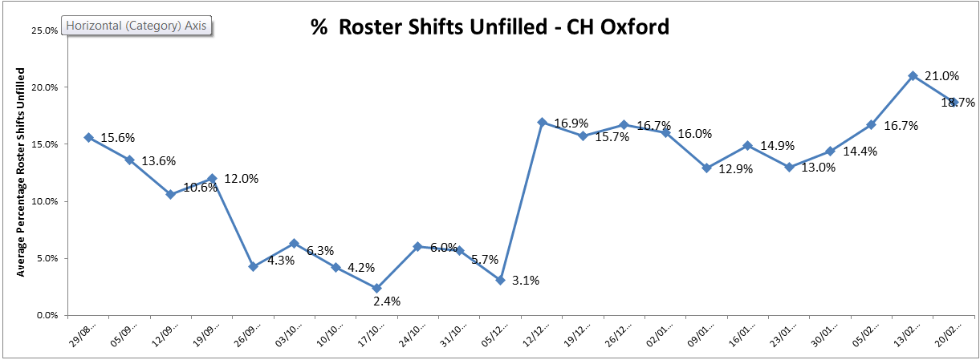
Table 1: Cotswold House (Oxon) – Shifts unfilled

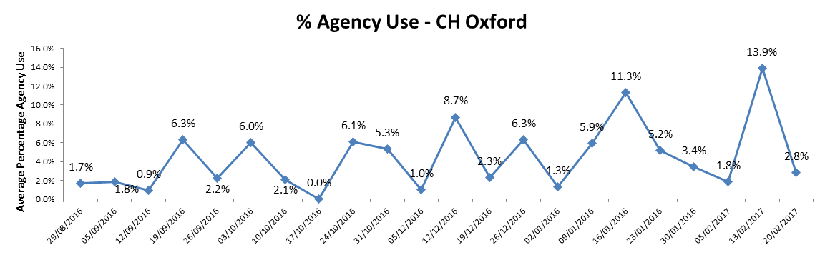

Chaffron Ward: overall 81.9% of shifts were fully staffed, which is an increase in staffing of 0.6% from the previous month. The figures shown for by registered and unregistered nurses indicate that show the ward has continue to struggle with registered nurse cover, (47% compared with 47.7 % shifts registered last month), and sickness has remained high, although this has decreased from 13.1% to 6.2%. During the reported period there was no use of agency cover.

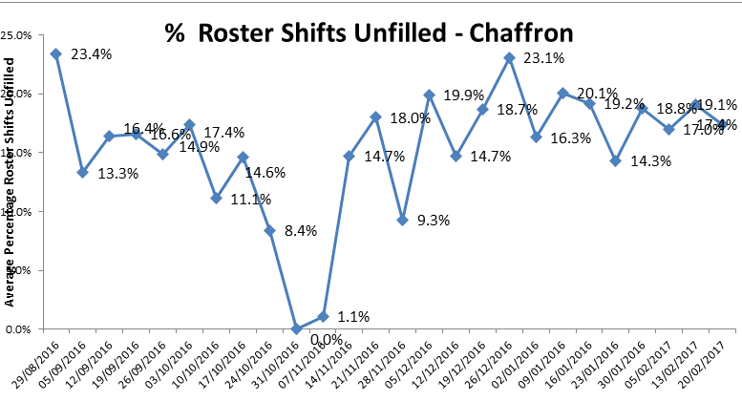

Table 3: Chaffron Ward – Shifts unfilled

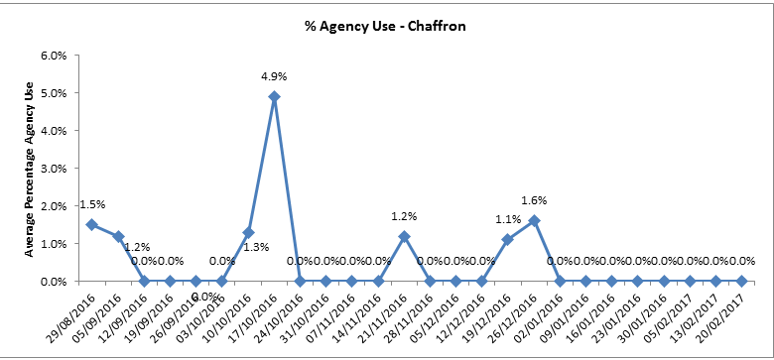
Table 4: Chaffron Ward – Agency Usage

Glyme Ward - (overall 79% of shifts were fully staffed, which is a further reduction of 3% from last month when the figure was 82%. The ward has used more unregistered staff (with 43.4% of shifts covered by registered nurses, a reduction of 1.8% registered cover from last month). The percentage agency use during this period was 1.5 % (an increase of 1%) and the sickness rate has reduced from 5.0%. to 4.4%

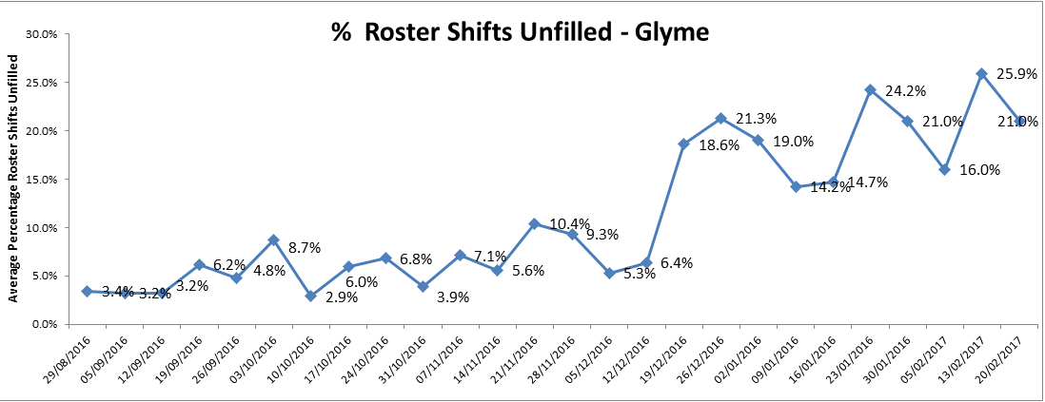
Table 5: Glyme Ward – Shifts unfilled

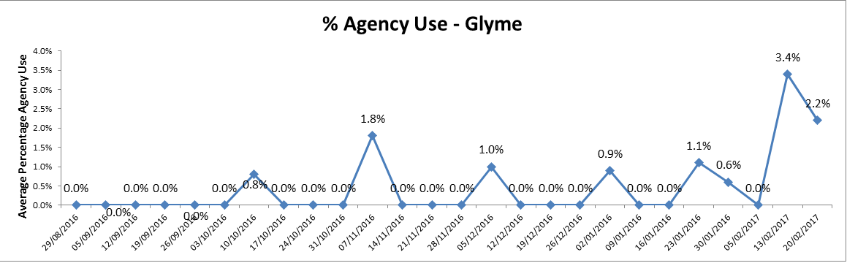
Table 6: Glyme Ward – Agency Usage

Phoenix ward- The overall number of shifts which were fully staffed was 80.8% a slight reduction from last month when the figure was 81%. The number of shifts with registered cover was 54.4%, and ward has reduced less agency (4.7%) a reduction of 7.1%. The overall sickness on the ward is 4.5% and the current number of vacancies are 8 WTE – an increase of 0.5WTE).

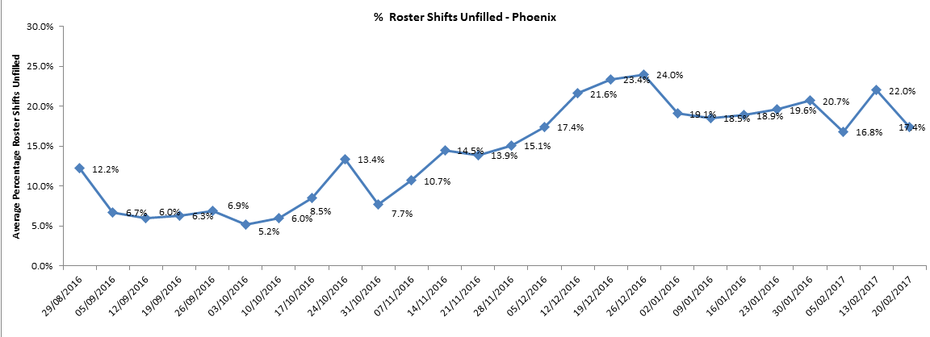
Table 7: Phoenix Ward – Shifts unfilled

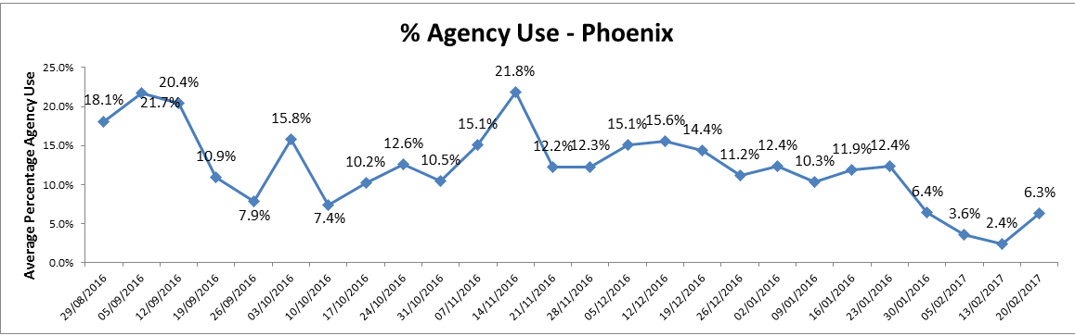
Table 8: Phoenix – Agency Usage

Ruby Ward: Overall 76.8% of shifts were fully staffed. This is an increase of 1.8% from last month, when the figure was 75%. The ward has used more unregistered to unregistered staff (with 41.5% of shifts meeting the required 50% registered to unregistered ratio), and employed people on long working lines from agencies (25.4% average agency use), which is a decrease of 5.3% in agency usage from last month to meet vacancies. The sickness rate on Ruby is currently 11.2% and the overall vacancies are currently 9.3WTE (a reduction of 0.8% from last month when the figure was 10.1WTE).

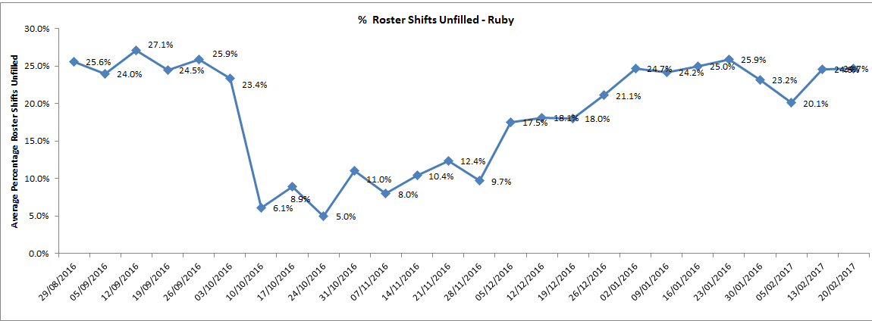
Table 9: Ruby Ward – Shifts unfilled

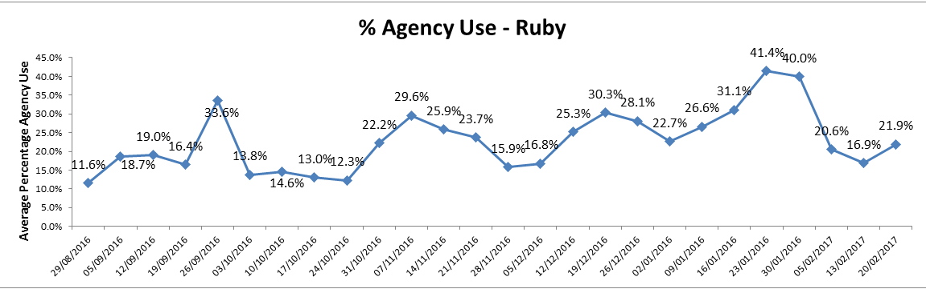
Table 10: Ruby Ward –Agency Usage

Sapphire Ward: The overall number of shifts which were fully staffed was 75.2% (the lowest rate this month) which is a reduction of 5.5% from last month when the figure was 80.7%. The ward used more unregistered staff (with only 43% of shifts meeting the required 50% registered to unregistered ratio), and employed people on long working lines from agencies (22.6% which is an increase of 1.5% from last month when the figure was 21.1% average agency use). The overall vacancies are currently are 13.1WTE, a further increase of 1.5WTE from last month.

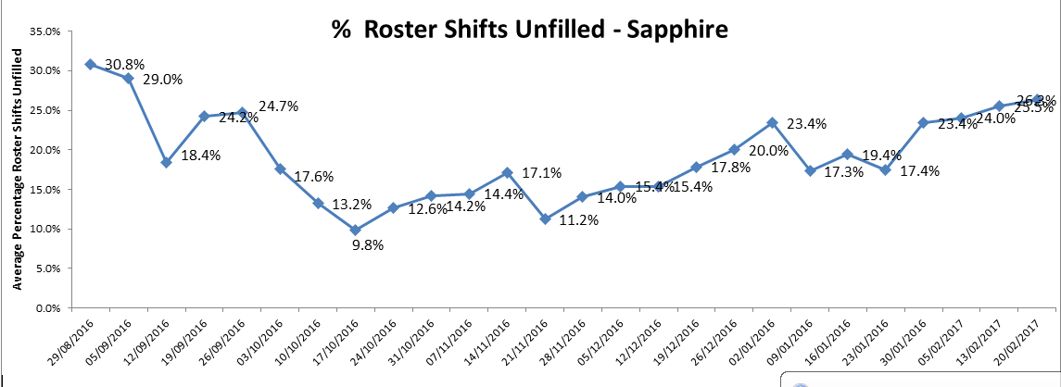
Table 11: Sapphire Ward – Shifts unfilled

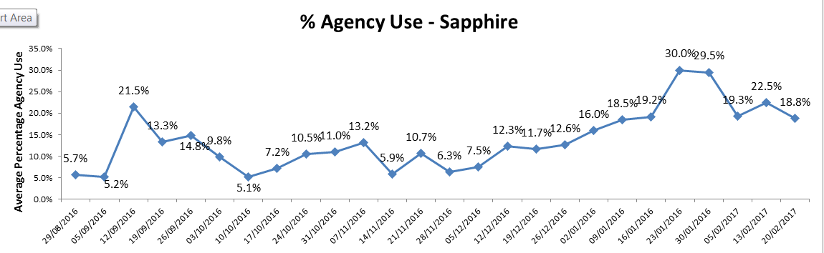
Table 12: Sapphire Ward –Agency Usage

Sandford Ward: The overall number of shifts which was 81.1% which is a reduction of 6.4% from the previous month when the figure was 87.5%). The ward used more unregistered staff (with only 43% of shifts meeting the required 50% registered to unregistered ratio), and employed people on long working lines from agencies (22.6% which is an increase of 1.5% from last month when the figure was 21.1% average agency use). The overall vacancies are currently are 13.1, a further increase of 1.5 from last month and the sickness rate was 12.4% - the highest this month.

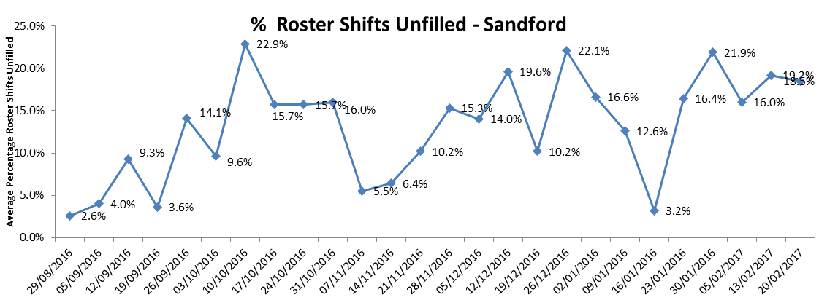
Table 13: Sandford Ward – Shifts unfilled

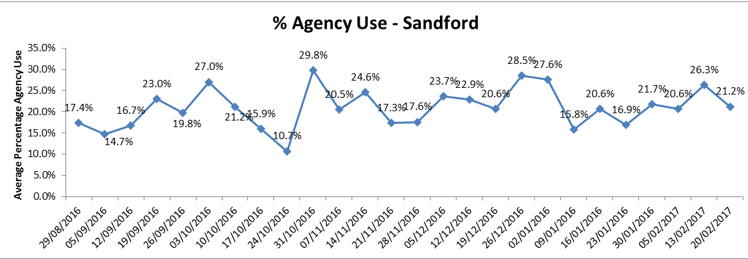
Table 14: Sandford Ward –Agency Usage

Other wards to note that have either high vacancies or unfilled shifts (below 90%) which require high percentages of agency staffing (above Trust target of 5%) are as follows:

- Abingdon Ward 1 (5.1 vacancies and 14.6% agency use)
- Abingdon Ward 2 ( 10.5 vacancies and 23.3% agency use)
- Allen ward (13.6% vacancies and 29.2% agency use)
- Amber (11.1 vacancies and 13.9% agency use)
- City (10.1 vacancies and 20.9% agency use)
- Highfield (18 vacancies and 31.9 % agency use. Registered nurse skill mix 35.7% the lowest registered nurse cover rate this month)
- Kestrel ward (18.8 vacancies – the highest number this month and 43.8% agency use – the highest percentage of agency usage this month)
- Kingfisher ward (14.2 vacancies and 28.7% agency use)
- Linfoot Witney (9.8 vacancies and 19.5% agency use)
- Marlborough House Swindon ward (7.4% vacancies and 26.1% agency use)
- Vaughan Thomas (9.1 vacancies and 15.6% agency use)
- St Leonards Wallingford (27.8% agency)
- Wenric (8.3 vacancies and 14.8% agency use)
- Watling (10.3 vacancies and 15.1% agency use)
- Wallingford (25.6% agency use).
- St Leonards (21.9% agency use)
- Wintle (8.1 vacancies)

Table 1. Staffing 30th January 2017 to 17th February17

Data source: electronic rostering system

 | % of shifts filled against required numbers (highlighted amber if less than 85%)
 | Latest 4 week period - 30th Jan to 26th Feb 17 | Latest 4 week period - 2nd Jan 17 to 29th Jan 17 | 4 week period - 5th Dec 16 to 1st Jan 17 |  | Latest 4 week period - Jan 30th to Feb 26th 2017
Ward |  |  |  |  | % Registered day shifts filled by nurses (submitted to NHS England) | % Unregistered day shifts filled by nurses (submitted to NHS England) | % Registered night shift filled by nurses (submitted to NHS England) | % Unregistered night shifts filled by nurses (submitted to NHS England) |  | % Registered Skill Mix (target 50% or more) |  | % Agency Use  (thresholds based on Trust targets, 5%) |  | % Sickness  (thresholds based on Trust targets, 3.5%) | Vacancies Vs Budget (WTE)  (thresholds based on Trust targets, 9%)
Abingdon Ward 1 | 97.3% | 94.4% | 99.8% |  | 100% | 112% | 100% | 98% |  | 50.8% |  | 14.6% |  | 2.9% | 5.1
Abingdon Ward 2 | 99.0% | 98.4% | 97.2% |  | 107% | 94% | 100% | 100% |  | 49.0% |  | 15.3% |  | 5.8% | 10.5
Allen | 92.8% | 94.1% | 92.2% |  | 91% | 95% | 99% | 97% |  | 50.7% |  | 23.3% |  | 6.3% | 13.6
Amber | 93.6% | 93.5% | 96.9% |  | 94% | 101% | 100% | 100% |  | 40.3% |  | 13.9% |  | 8.1% | 11.1
Ashurst (PICU) | 93.7% | 91.7% | 89.4% |  | 85% | 110% | 94% | 105% |  | 40.3% |  | 27.0% |  | 7.5% | 14.7
Bicester | 98.8% | 98.1% | 99.8% |  | 103% | 90% | 100% | 100% |  | 53.8% |  | 3.0% |  | 12.3% | 3.9
Cotswold House Marlborough | 95.0% | 99.7% | 91.2% |  | 97% | 101% | 126% | 87% |  | 46.8% |  | 6.8% |  | 0.7% | 8
Cotswold House Oxford | 82.2% | 85.9% | 86.8% |  | 100% | 96% | 97% | 98% |  | 38.9% |  | 5.6% |  | 4.1% | 3.5
Chaffron | 81.9% | 82.5% | 80.9% |  | 135% | 68% | 100% | 100% |  | 47.0% |  | 0.0% |  | 6.2% | 3.7
Cherwell | 89.0% | 91.4% | 92.3% |  | 84% | 97% | 95% | 103% |  | 44.0% |  | 10.1% |  | 5.4% | 4.2
City | 92.2% | 98.7% | 98.6% |  | 90% | 98% | 100% | 100% |  | 49.4% |  | 20.9% |  | 1.9% | 10.1
Didcot | 95.7% | 98.3% | 99.2% |  | 105% | 93% | 98% | 98% |  | 52.6% |  | 9.8% |  | 3.8% | 0.2
Glyme | 79.0% | 82.0% | 86.6% |  | 93% | 84% | 61% | 179% |  | 43.4% |  | 1.5% |  | 4.0% | 4.4
Highfield (CAMHS) | 85.6% | 84.0% | 79.6% |  | 87% | 103% | 135% | 88% |  | 35.7% |  | 31.9% |  | 1.4% | 18
Kennet | 97.8% | 98.4% | 98.1% |  | 99% | 98% | 100% | 100% |  | 37.3% |  | 5.3% |  | 1.2% | 5.1
Kestrel | 94.6% | 91.8% | 88.9% |  | 141% | 82% | 95% | 95% |  | 36.7% |  | 43.8% |  | 5.8% | 18.8
Kingfisher | 86.9% | 87.5% | 86.7% |  | 116% | 76% | 113% | 85% |  | 41.3% |  | 28.7% |  | 9.5% | 14.2
Lambourne House | 94.6% | 86.8% | 94.2% |  | 100% | 96% | 100% | 100% |  | 45.4% |  | 0.4% |  | 0.9% | 0.8
Linfoot Witney | 98.2% | 97.5% | 96.0% |  | 98% | 95% | 99% | 101% |  | 51.6% |  | 19.5% |  | 5.6% | 9.8
Marlborough House Swindon (CAMHS) | 98.0% | 98.2% | 93.8% |  | 104% | 100% | 99% | 100% |  | 45.9% |  | 26.1% |  | 5.9% | 7.4
Opal (Rehabilitation) | 92.5% | 90.1% | 87.9% |  | 75% | 100% | 73% | 122% |  | 42.9% |  | 3.1% |  | 8.1% | 7.7
Phoenix | 80.8% | 81.0% | 78.4% |  | 102% | 89% | 98% | 97% |  | 54.4% |  | 4.7% |  | 4.5% | 8.5
Ruby | 76.8% | 75.0% | 81.3% |  | 75% | 96% | 69% | 98% |  | 41.5% |  | 25.4% |  | 11.2% | 9.3
Sandford | 81.1% | 87.5% | 83.5% |  | 75% | 94% | 95% | 102% |  | 45.7% |  | 22.4% |  | 12.4% | 12.1
Sapphire | 75.2% | 80.7% | 82.9% |  | 69% | 92% | 66% | 135% |  | 43.0% |  | 22.6% |  | 2.9% | 13.1
Vaughan Thomas | 86.2% | 89.0% | 84.0% |  | 79% | 103% | 89% | 108% |  | 40.3% |  | 22.0% |  | 6.4% | 9.1
St Leonards Wallingford | 98.0% | 99.0% | 95.1% |  | 99% | 98% | 101% | 102% |  | 45.0% |  | 27.8% |  | 4.2% | 0
Watling | 95.3% | 92.7% | 96.4% |  | 98% | 100% | 102% | 101% |  | 27.0% |  | 15.1% |  | 6.4% | 10.3
Wenric | 86.6% | 95.4% | 87.5% |  | 121% | 88% | 99% | 108% |  | 41.0% |  | 14.8% |  | 7.6% | 8.6
Wenrisc Witney | 96.0% | 93.8% | 88.5% |  | 95% | 92% | 100% | 100% |  | 57.5% |  | 3.9% |  | 6.0% | 6.6
Wintle | 98.2% | 94.8% | 95.0% |  | 70% | 131% | 101% | 101% |  | 43.3% |  | 4.2% |  | 2.3% | 8.1
Woodlands | 98.2% | 98.6% | 98.2% |  | 102% | 98% | 113% | 89% |  | 47.3% |  | 0.7% |  | 6.2% | 3.8

