**Single Oversight Framework February 2017**

**Performance Summary**

**Introduction**

NHS Improvement (NHSI) implemented the Single Oversight Framework (SOF) on 1 October 2016 and this replaces Monitor’s Risk Assessment Framework. The framework follows five themes:

* Quality of Care (safe, effective, caring and responsive)
* Finance and use of resources
* Operational Performance
* Strategic change
* Leadership and improvement capability (well led)

The five themes are linked but not identical to those of the Care Quality Commission (CQC). The CQCs questions do not yet incorporate use of resources.

By focussing on these five themes NHSI will support providers to attain and/or maintain a CQC ‘good’ or ‘outstanding’ rating and to identify where providers may benefit from, or require improvement support across a range of areas.

This report focusses on the Quality and Operational Indicators. Although important in the overall framework, NHSI do not consider these to be priority metrics. These metrics will be used by Regional Teams as part of a suite of information to take a broader view of performance. For monitoring purposes they will not have thresholds attached to them (unless indicated) and therefore any small change in performance would not change Trust segmentation.

**In the majority of cases NHSI will be sourcing Trust performance data from publicly available sources e.g. CQC, NHS Digital, NHS England, Unify. Oxford Health NHS Foundation Trust (OHFT) will no longer be required to directly submit data nationally for performance management.**

**February Performance Summary**

The majority of the indicators do not have targets/thresholds. To provide a sense of Trust performance, where information is available the published performance has been set against the overall position for England.

There are 21 indicators that have been reported on. Current performance is 71%.



|  |  |
| --- | --- |
| **R** | **OHFT Overall Indicator Rating** |

**February Performance Summary**

The timing of when information is published varies across the indicators. Some Nationally published information is only currently available up to October 2016.

The table below shows the month of the latest information available and the performance based on that month.





**AREAS OF UNDERPERFORMANCE**

|  |  |  |
| --- | --- | --- |
| **Measure** | **Target** | **Performance** |
| Staff Turnover | 12% | 15.0% |

In February, internally OHFT reported turnover as 15.0% (12 month position) which is 25% above the Trusts internal target of 12%. The single biggest reason given for staff leaving the Trust or moving internally is promotion/better prospects.

National data has been identified and is currently being worked through to understand the calculations used and identify and understand any differences.

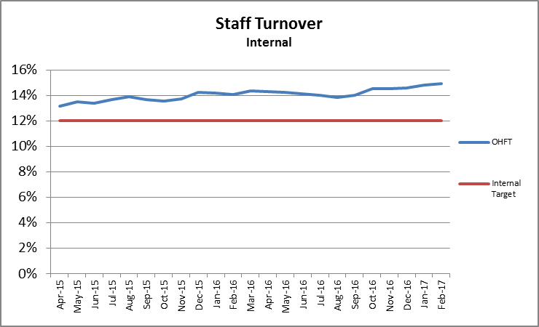

|  |  |  |
| --- | --- | --- |
| **Measure** | **Target** | **Performance** |
| Proportion of Temporary staff | No target | 3.05% |

There were a couple of miscoding errors identified last month causing the proportion of temporary staff to increase to 31.63%. The errors have been rectified bringing the year to date position down to 3.05%.

|  |  |  |
| --- | --- | --- |
| **Measure** | **Target** | **Performance** |
| Mental Health Friends and Family Test - % positive | England Average 85.4% | 81.3% |

Performance in January increased by 1% on the December position but remains below the national average. With the exception of February 2016, OHFT’s performance has consistently been above the national average. It is thought that the drop in performance was due Teams being unsure about data collection due to a proposed change in supplier.

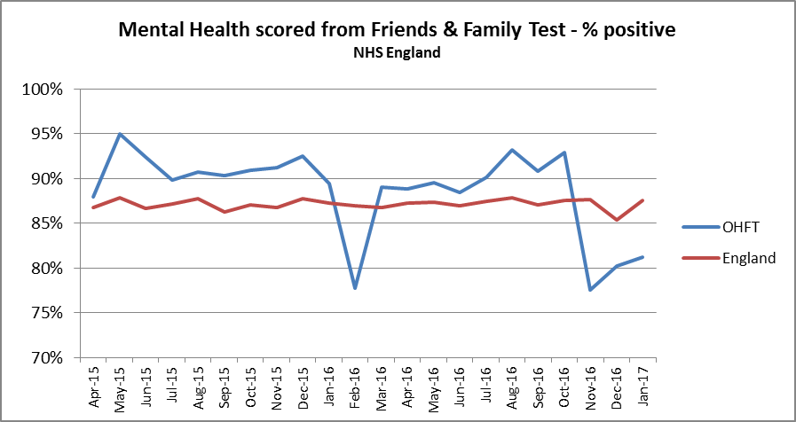

|  |  |  |
| --- | --- | --- |
| **Measure** | **Target** | **Performance** |
| % of clients in settled accommodation | England Average 58.4% | 48.0% |

There was a decrease of 1.3% in performance between October and November. The Information Team continue to work with Advanced Healthcare to ensure the completeness of the Mental Health Services Data Set (MHSDS) submission.

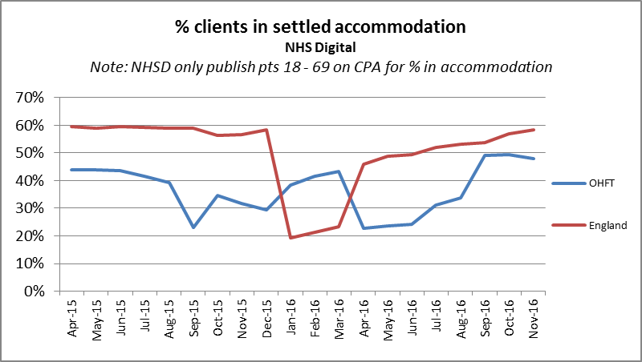

|  |  |  |
| --- | --- | --- |
| **Measure** | **Target** | **Performance** |
| Priority Metric % coded (Ethnicity, Employment (Adults only), Accommodation (Adults only), | 85% | 36.3% |

This metric is measuring data completeness for the three data items detailed above.

Performance increased by 0.1% between October and November. The England average has been included for an illustration of how the rest of the country is performing.

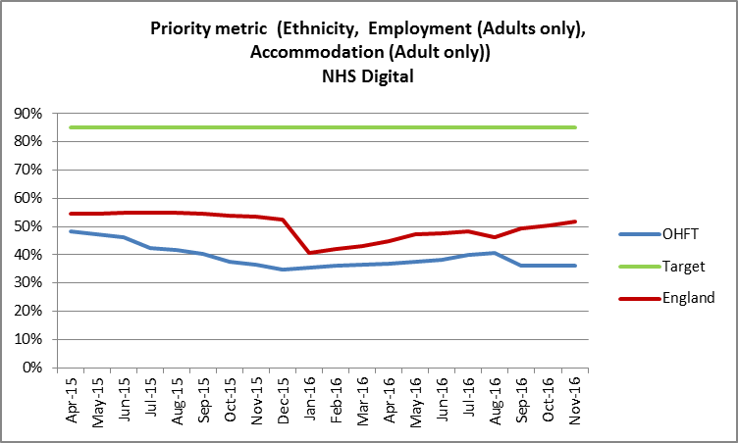

The Information Team continue to work with Advanced Healthcare to ensure the completeness of the MHSDS submission.