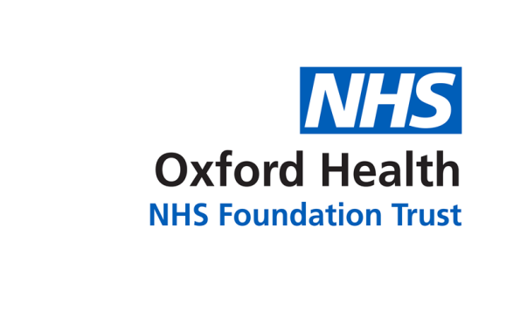

**BOD 64/2017**

(Agenda item: 9)

# Report to the Meeting of the

# Oxford Health NHS Foundation Trust

# Board of Directors

**24th May 2017**

**Quality report: Patient Experience & Involvement**

**For Information**

**Executive Summary**

The report focuses on updating the board on a quarterly basis on the patient experience and involvement work happening across the trust and providing a summary of the feedback we have received which tells us how it feels for patients to receive care, and how we have used this to improve patient’s experience. This report covers; an update on progress with the strategy, roll out of iwgc, feedback from patients from a range of sources including formal complaints, an update on the trust’s external accreditation with the Carers Trust, the launch of the Buckinghamshire recovery college and the most recent internal audit findings.

The main area for improvement from the feedback received is around communication and sharing information with patients and their families to enable joint decision making and involvement in care. This will be the focus of the work plan from the strategy this year.

**Recommendation**

The Board is asked to note this report and to support the Executive Team to identify the additional funding required to support the three year patient experience and involvement strategy between now and March 2019.

**Author and Title:** Jane Kershaw, Head of Quality Governance

**Lead Executive Director:** Ros Alstead, Director of Nursing and Clinical Standards

1. **Introduction**

The report focuses on updating the board on a quarterly basis on the patient experience and involvement work happening across the trust and providing a summary of the feedback we have received which tells us how it feels for patients to receive care, and how we have used this to improve patient’s experience. The themes highlight the key areas for improvement identified in this report around communication and sharing information with patients and their families to enable joint decision making and involvement in care.

Feedback from patients, parents, families and carers is a very valuable source of information to measure patient experience however this report recognises that other sources for example activity data, clinical audit, staffing levels, incident data and staff feedback; are also important to measure and improve patients experience. The trusts internal peer review programme continues to also be a useful source of feedback from patients and carers in addition to routine methods.

1. **Patient Experience and Involvement Strategy**

The funding and resources required to deliver the three year strategy approved in April 2016 have not been fully identified and appointments to new posts have taken time to fill in 2016/17 which has meant not all the objectives planned in year 1 have been achieved. 36 actions were identified in the strategy for 2016/17; this has proved very ambitious with 15 actions started and 2 actions fully completed. The group has focused on;

* + Improving how we collect feedback (see update on iwgc)
  + Developing guidance for staff and patients on being involved in staff interviews
  + Developing a best practice toolkit for involving patients in activities
  + Reviewing and developing the content and look of information on the trusts website

The following achievements have been made in 2016/17;

* The ‘Taking Action on Patient Feedback Group’, consisting of patients and staff, had two workshops in May and July 16 to develop and prioritise a work plan to deliver the new strategy. The group has met quarterly and at each meeting reviewed progress with the strategy’s work plan. At the last meeting on 8th March 2017 the group focused on the objectives to;
  + Review the proposed developments for the new trust website to help inform the format and content to be more patient centred and friendly to navigate. This was the first of more planned stages to consult on the new pages and the changes are likely to be incremental in 2017/18.
  + Develop a new patient experience and involvement page to be on the trusts website, a draft page was reviewed and further comments made.
* A new standardised feedback mechanism has been introduced across all services, giving staff direct access to feedback in a timely way (see update on iwgc)
* A patient story is shared at the board of directors meeting monthly, over the year the board has heard about the experiences of patients and their families receiving care from 10 different services.
* Examples of involvement include;
  + Young people have worked on designing and creating artwork for a new waiting area in a clinic.
  + The family nurse partnership service has worked with young mothers and fathers to produce a series of films to promote the service to new clients.
  + A number of patients from across the trust have been involved in the recruitment of staff including service director and lead for patient and carer experience.
  + Patients and their carers with lived experience of dementia have been involved in raising dementia awareness and a patient jointly chaired a patient and staff workshop to start the develop of a new trust-wide dementia strategy.
  + Staff have taken part on the patient leader programme whereby patients and senior staff learn together and then are paired up to work jointly to take forward a strategic change.
  + Employing peer support workers in adult mental health teams.

The next steps for 2017/18, aligned with the trust’s annual quality report/ account are to;

* Re-prioritse the work plan for the strategy for year 2 based on not achieving all the actions identified for year 1.
* To focus on improving how we communicate and share information with patients and their families/carers to enable joint decision making and full involvement in care.
* Transfer the provision of the Oxfordshire community learning disability services and look at how to improve the service provided with patients and their families
* Co-develop a new trust-wide dementia strategy
* Review, implement and evaluate a revised care plan for older people at the end of their life.
* Develop palliative care provided to children and their families.
* Improve transitions between care pathways across ages for example children to adult services

1. **‘I Want Great Care’**

‘I want great care’ (iwgc) a new standardised feedback mechanism has been introduced across the majority of services in 2016/17 (with contracts for two other providers ending in December 2016), giving staff easier access to feedback in a timely way. Iwgc produces one simple report showing the number of responses and level of satisfaction by team. The trust has also improved the structure and responsibility for patient experience and involvement, as part of the revised patient experience and involvement strategy. The structure includes a permanent trust-wide patient experience manager and in each clinical directorate a dedicated role for patient experience and involvement. Each month the trust-wide patient experience manager monitors, explores any reasons and reports on response rates and satisfaction levels by team. The Caring and Responsive quality sub-committee also receives a quarterly report on feedback received. The trust-wide patient experience manager is working with iwgc to develop the wording of the questions, increasing the range of easy read options, looking at developing dementia friendly survey options, and reviewing the answer options for some questions e.g. gender.

227 individual teams have been set up and trained to use iwgc. A formal launch event is planned on 31st May 2017 for teams. A limited number of services continue to utilise other collection methods e.g. survey monkey, due to local commissioning requirements. A summary of the results from iwgc are below.

1. **Survey results**

Overwhelmingly the feedback we have received directly and the feedback shared by the CQC and Health watch organisations from patients, families and carers is very positive with patients reporting feeling cared for by staff and that as a result they highly value the service provided. The CQC inspections have rated the trust as Good for the caring domain, with all service lines achieving Good with the exception of three service lines achieving outstanding (children’s services, children and adolescent community mental health teams and Luther Street homeless GP practice).



However some people do not receive the positive experience we expect every person to have and therefore we have more work to do. The themes highlighted from complaints mirror the key areas for improvement identified from the feedback we receive, and are focused on communication and sharing information with patients and their families/carers to enable joint decision making and full involvement in care.

In addition the most recent CQC inspection of the GP out of hours services in November 2016 highlighted the following areas relating to improving patient’s experiences; at one base conversations in the consulting rooms could be overheard in the waiting room, hearing loops were not available at two of the bases if required, and external signposting at three bases is unclear. For each area an action plan is in place and the details have been shared with the CQC.

Below is a summary of the feedback received over the last 12 months, looking at; would patients recommend the service, how safe do patients feel, how patients score six key experience questions[1] and the results of the 2016 national community mental health patient survey.



*Feedback received from April 2016-March 2017, as reported monthly to NHS England. Physical health services n=6448, mental health services n=1718*

The level of recommendation is lower for patients being seen by mental health services, in line with the national trend. The trust’s local information shows there is no significant trend or change in the % of positive/ negative response to the FFT question in 2016/17, although the response rate has varied in year, shown in the below graph, mostly as a result of a change in mechanism to how feedback is collected (moving to iwgc). When we have a higher response rate the overall % of positive responses also increases.



The feedback from mental health patients about how safe they feel[2]is shown in the below graph, averaging around 90% saying yes they feel safe.

The national community mental health survey results for 2016 reported 71% of patients (n=233) had an overall good experience, compared to the trust’s performance of 68% in 2015. In 2016 the survey results to the same question for 49 other mental health trusts ranged from 61% (lowest trust score) - 75% (highest trust score). The fieldwork for the 2017 survey is due to finish in June 2017.

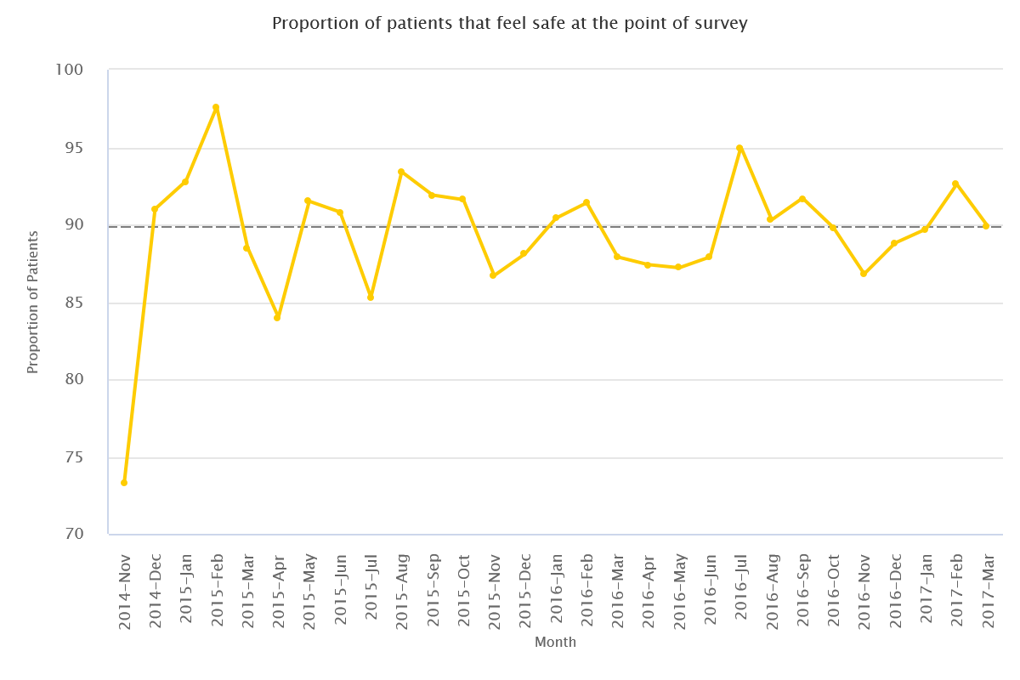

The average score of satisfaction and number of responses collected through iwgc is shown in the table and graph below.

|  | **October**  **2016** | **November 2016** | **December**  **2016** | **January**  **2017** | **February 2017** | **March 2017** |
| --- | --- | --- | --- | --- | --- | --- |
| Average score (iwgc - *against the 6 questions asked across all services)* | 4.78 | 4.82 | 4.76 | 4.68 | 4.75 | 4.66 |
| Total responses collected from other surveys *(not included in average score)* | Not available | Not available | 162* | 272* | 421* | 485* |
| Total survey responses | n/a | n/a | 368 | 597 | 716 | 961 |

*This data includes responses counted by survey monkey, dentistry and diabetic local surveys only.



The amount of data being collected is now increasing and the data is continuing to be utilised locally to influence the development of ‘you said, we did’ actions and also to shape the involvement agenda by generating conversations and awareness of people’s needs including development of information in an array of formats, changes to clinics timings or locations and specific training on identified topics.

In the 2016 national staff survey results, asking staff how effectively they use patient feedback, the trust has maintained good performance in this area from 2015 and is still in the top 20% of trusts nationally (see diagram below)



1. **Trust-wide information on formal complaints**

In 2016/17 the trust received 213 complaints which is similar to the previous year when 211 complaints were received. The number of complaints received by quarter is broken down as follows; 54 complaints in Quarter One (April to June 2016), 61 complaints were received in Quarter Two (July to September 2016), 46 complaints in Quarter Three (October to December 2016) and 52 complaints were received in Quarter Four (January to March 2017). 100% of the complaints received in 2016/17 were acknowledged by the Complaints & PALS Team within the NHS Complaints Regulations (2009) of three working days.

All complaints are graded using the NPSA risk matrix with a rating of green, yellow, orange or red. From the 213 complaints received, 154 (72%) were graded green, 38 (8%) were graded yellow; 12 (6%) complaints were graded orange and 9 (4%) complaints were graded red.

The primary category of concerns raised relates to “all aspects of clinical care”; the main issues being around insufficient care in the community (36), medication issues (17) and issues relating to diagnosis. At least 60% of complaints (either primary or secondary concerns) have concerns relating to communication or staff attitude/behaviour.

Of the complaints which have been investigated and responded to (n=170), 52% had at least one concern/ element upheld. After the investigation into each complaint, if there are any upheld elements or any improvements in practice identified, then a complaints improvement plan is developed by the investigating officer in liaison with the relevant service manager/ward manager. The majority of the actions being taken are to address how staff communicate and share information with patients and their families to enable joint decision making and involvement in care. The completion of actions is monitored centrally and escalated as required.

1. **Triangle of Care[3] external accreditation**

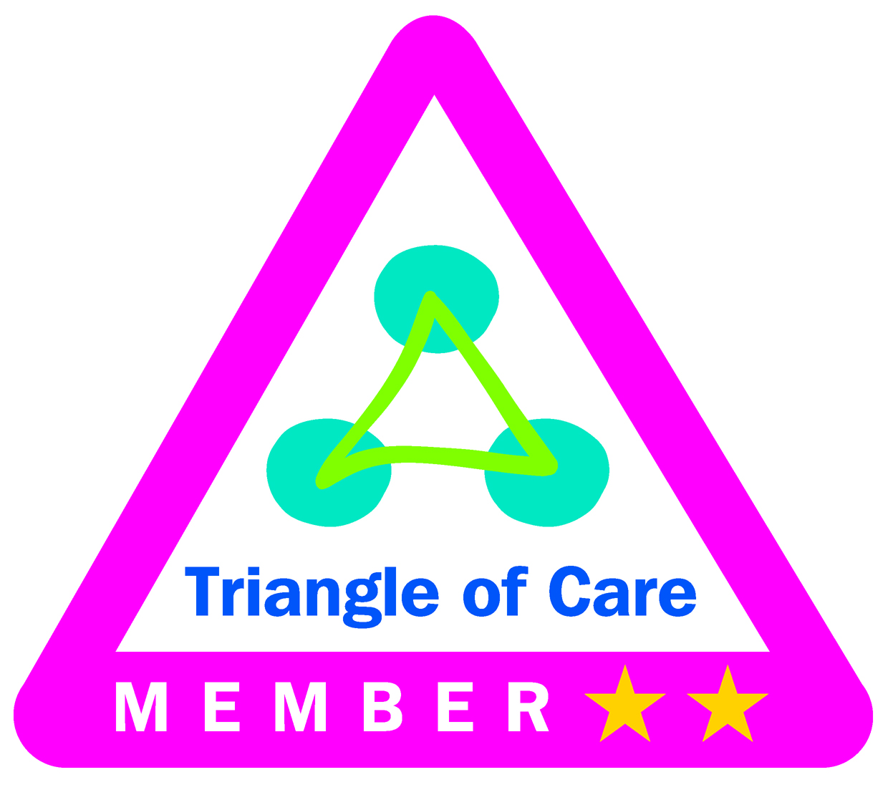

In 2016/17 the following improvements were achieved, overseen by the Carers Strategy Forum;

* The trust’s external accreditation was reviewed by the Carers Trust and other NHS trusts at a regional meeting in November 2016 and renewed. This demonstrates the services have achieved/ provided assurance of working towards the national standards.
* All the mental health inpatient and community teams have reviewed progress with their self-assessments against the national standards and identified where they need to improve next.
* Some of the physical healthcare teams have completed a baseline self-assessment.
* Trust-wide carer awareness training was piloted and rolled out for all staff across adult and older people’s mental health services from November 2016. The training has been designed with and delivered by Rethink (a mental health charity). In addition carer awareness training specifically for staff working in children’s mental health and physical health services was introduced in March 2017. Feedback around both training courses is positive.
* The trust is participating in work with Oxfordshire carers, Oxford University Hospitals NHS Foundation Trust, Oxfordshire County Council, Oxfordshire voluntary organisations and our commissioner to develop cross organisational principles and expectations around working with and involving carers and families in their loved ones’ care. This shared list of principles and expectations will be finalised by summer 2017.
* Information given to carers has been reviewed which has led to the following actions; a standardised carers’ information handbook has been developed with carers by the adult mental health services and will be introduced in 2017/18, the children’s inpatient wards have reviewed and amended their carer packs.

The next steps for 2017/18 are for;

* All physical healthcare services to complete a baseline self-assessment.
* Linking leader conferences in June 2017 will be focused on improving carer’s experiences, which coincides with national carers week (12-18th June).
* Trust-wide carers strategy to be refreshed and launched in June 2017.

1. **Buckinghamshire recovery college**

The trust, Mental Health Foundation, Buckinghamshire MIND, University of Bedfordshire and Buckinghamshire Adult Learning have worked together to open and run the Buckinghamshire recovery college. The college takes an educational approach to mental health recovery and is run by people with experience or who live with a mental health illness. All courses delivered at the college are for patients, staff and visitors, and all courses are co-designed and co-delivered between a patient and a staff member. The Oxfordshire recovery college opened in September 2015 continues to grow.

In 2016/17;

* The Buckinghamshire recovery college was successfully launched in January 2017
* Taster courses were run before the launch of the college and full courses started in March 2017.
* To date over 50 sessions have been run with over 250 students now enrolled.

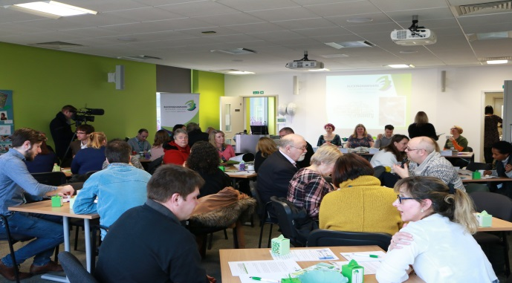

*Picture from the launch event for the Buckinghamshire Recovery College*

1. **Internal audit results**

An internal audit was carried out in March 2017 by Tiaa to review the processes and governance around patient/ carer experience and involvement as well as public engagement. The key findings noted positives around the trusts commitment and clear objectives as detailed in the patient experience and involvement strategy and carer’s strategy, as well as the well-established peer review programme involving patients to be part of the review team. The areas for development were identified as;

* Complete development and launch of a membership engagement strategy to include a mapping exercise of stakeholders and how they wish to receive communication
* Progress with the patient experience and involvement strategy has been slower than planned, reasons identified above. Work plan to be reviewed with identified leads.
* Improve how patient experience and involvement leads/ champions share information and good practice
* More consideration of barriers to involvement, to hear from and involve a wider range of patients including those harder to engage
* Carers strategy to be revised in 2017/18
* Review the membership of the Carers Strategy Forum
* The Older People Directorate to review the membership of the patient experience and involvement group to promote patients attending and all services to be represented

Actions with leads and timescales have been identified for each area.

1. **Conclusion**

This update provides a summary of the work achieved around patient experience and involvement in 2016/17. The report covers; an update on progress with the strategy, roll out of iwgc, feedback from patients from a range of sources including formal complaints, an update on the trust’s external accreditation with the Carers Trust, the launch of the Buckinghamshire recovery college and the most recent internal audit findings.

The main area for improvement from the feedback received is around communication and sharing information with patients and their families to enable joint decision making and involvement in care. This will be the focus of the work plan from the strategy this year. The board is asked to support the Executive Team to identify the additional funding required to support the three year patient experience and involvement strategy.

1. The six questions are around; would you recommend the service (FFT), dignity and respect, involvement in decisions, receiving timely information, and being treated with kindness and compassion.
2. Source mental health safety thermometer audit which is based on all adults of working age and forensic patients who are an inpatient or seen by a community team on a particular day each month
3. The triangle is each patient, their carer/ family and professionals. This concept was developed by the Carers Trust.