BOD 70/2017
Agenda item15

Report to the Meeting of the

Oxford Health NHS Foundation Trust

Board of Directors

24th May 2017

Monthly Performance Report

For: Information

Executive Summary

The monthly performance report provides an overall view of the Trusts performance against both national and local (contracted) indicators. In April 2017 (Month 1), the Trust either met or exceeded 89% of the 921 performance indicators reported.

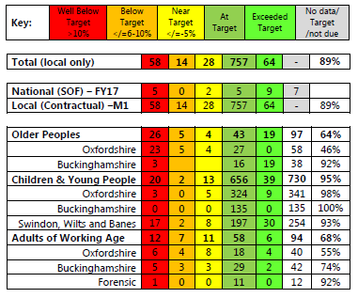

Selected Highlights:

In April 2017 (Month 1):

- The Adults Directorate reported 68% achievement against their local performance indicators which is a slight decrease from March 2017 (Month 11).

- The Older Peoples Directorate reported 64% achievement against their local performance indicators. This is a significant decrease from the 82% reported in March 2017 and is due in the main to the non-reporting of 10 indicators where data is currently being validated.

- The CYP Directorate reported a 95% achievement against their local performance indicators. This is a slight decrease from the performance achieved in March 2017. The number of red rated indicators has increased from 17 to 20.

- Despite the majority of performance indicators being consistently achieved each month, the Trust continues to underperform in a small number of key areas: These include:

  - The Out of Hours Services. This is due to a number of factors including the ongoing issue of GP availability. The Trusts Executive Team has asked for an independent review to be carried out and the results are expected to be known in 2 – 3 months’ time.

  - Delayed Transfers of Care (DTOC) continue to be an issue across the system. The KPI’s for DTOC and Length of Stay (LOS) are still being negotiated with the commissioners. This is to reflect the significant delays experienced as a result of the HART Service capacity issues.

  - Stroke Therapy Patients. The indicators for this area need to be reviewed as the Trust is providing therapy services, but not consistently over the 5 day period as set out within the target.

  - WRAP (Prevent) Training across all Directorates. Work continues to identify those staff that require training and additional courses have been arranged.

  - CAMHS 4 week and 8 week waiting times (in particular, Swindon, Wiltshire & BaNES). The services continue to fully achieve the 12 week waiting times and further work to address the 4 and 8 week waiting times is now planned as part of the new contract.

  - There continues to be a reduction in the number of ‘hidden waits’ at step 3 reported in Improving Access to Psychological Therapies (IAPT). Since November 2016, the waiting times have reduced from 23 weeks to 10 weeks.

  - Timescales for Care Reviews in Aylesbury continue to be below target. Additional actions are now being taken to improve this position.

Recommendation

The Board of Directors is asked to review and note the monthly Board performance report.

Author and Title: Martyn Ward – Interim Director of Performance

Lead Executive Director: Dominic Hardisty

