Report to the Meeting of the

Oxford Health NHS Foundation Trust
BOD 96/2017
(Agenda item: 9)

Board of Directors
26 July 2017
Staffing 22nd May to 18th June 2017

Inpatient Safer Staffing Report
For Information
Introduction
The purpose of this paper is to provide a report of the actual staffing levels to the Board of Directors. The data within the report will outline the staffing levels (for both registered and unregistered nursing staff) on each ward. These figures will be measured against the required figures on a shift by shift basis for a 4 week period from 22nd May to the 18th June 2017. The paper will also provide details of agency usage against the 5% cap, together with sickness and vacancy rates for all in-patient areas.

There is a national requirement on providers to be transparent on our monitoring and reporting of in-patient staffing levels. Ensuring sufficient staffing levels are in place is crucial to deliver safe, effective and high quality care.

Management of Staffing Levels
In-patient staffing levels continue to be reported every week within the Weekly Review Meeting (WRM). Table 1 in the body of the report summarises the staffing position for the month for each ward.
In order to ensure that staffing levels are under continual review, each ward undertakes a range of immediate actions on a daily basis in order to ensure that safe staffing levels are maintained which are appropriate to the needs of patients. These actions include moving staff between wards, booking staff via staffing solutions via bank or agency, revising rotas, and utilising additional staff that are not include in the ward numbers as required.

During the reported month, seven wards did not meet the required 85% staffing levels. This is an increase of one ward from the previous month when the number of wards who did not reach 85% staffing or over was 6. The seven wards identified as not meeting above 85% staffing cover were Chaffron, Glyme, Kingfisher, Phoenix, Sandford, Vaughan Thomas and Wenric wards. More detail of the staffing issues for on each of these ward areas is provided in the main body of the report.

There are a number of reasons why wards have been unable to fully staff every shift, a number of which are detailed in the report. Reasons include staff sickness rates, patient acuity levels and additional tasks (e.g. patient escorts); however recruitment difficulties continue to be a major risk for the Trust.

Recommendations
The Board is asked to note:
- The processes in place to ensure safe staffing levels on all the wards in the organisation, those wards where there are concerns and the actions being taken to ensure safe staffing

Author and Title: Susan Haynes, Deputy Director of Nursing and Clinical Standards
Lead Executive Director: Ros Alstead, Director of Nursing and Clinical Standards

A risk assessment has been undertaken around the legal issues that this paper presents and there are no issues that need to be referred to the Trust Solicitors. This paper links to all of the five CQC Domains.

Inpatient Safer Staffing
Period: 22nd May to 18th June 2017
Introduction
This is the monthly report to the Board of Directors outlining the staffing levels (registered and unregistered) on each ward against their required need on a shift by shift basis for a 4 week period from 22nd May to 18th June 2017.

This report will be published on our website with a link from NHS Choices website.

Management of Staffing Levels

An escalation process for the management of staff shortages is in place within each clinical area, in order to manage staffing safely on a shift by shift basis. As part of this process, senior clinical staff provide appropriate support to ward teams as and when required. In addition, senior ward staff and immediate team managers review ward staffing levels on an on-going basis; shift by shift basis, and where there are changes in patient acuity. Ward Matrons review staffing daily as a minimum and more frequently where required.

In-patient staffing levels continue to be reported every week and discussed within the Weekly Review Meeting (WRM), which takes place each Monday morning. Table 1 in the body of the report summarises the staffing position for the month for each ward.

In order to ensure that staffing levels are under continual review, every ward undertakes a range of immediate actions on a daily basis to ensure safe staffing levels are maintained appropriate to the needs of patients. These actions include booking staff via staffing solutions via bank or agency, revising rotas, moving staff between wards and utilising additional staff that are not include in the ward numbers as required.

During the month 22nd May to 18th June 2017, seven wards did not meet the required 85% staffing levels. This is an increase of one ward from the previous month when the number of wards who did not reach 85% staffing or over was 6.

The six wards identified as not meeting above 85% staffing cover were Chaffron, Glyme, Kingfisher, Phoenix, Sandford, Vaughan Thomas and Wenric wards. More detail of the staffing issues for on each of these ward areas is provided in this report.

It has been confirmed that throughout the four week period all wards were staffed to achieve safe staffing levels; however this continued to be achieved in some wards by our staff working additional hours and shifts, the high use of temporary staff both from the trusts internal bank ‘staffing solutions’ and external agencies. Where there is high use of agency this is generally long term use of agency cover (especially in forensic services) which provides continuity of care.

SafeCare
In order to assist nursing staff to improve the day to day management of staffing levels, the Trust has recently approved the adoption of the SafeCare IT solution in order to provide live staffing data in the hands of ward managers, matrons, senior nurses and ops. This will clearly show how safe each ward is on a shift-by-shift basis.

SafeCare is a module of the Workforce Management System through which patient acuity and dependency data is input as well as other patient related tasks. Staffing information can also be updated easily and in real time. Based on this information the system calculates how many hours are required to care for patients (CHPPD, Care Hours Per Patient Day) and compares this to the number of hours of care that are available from rostered staff. This enables the Trust to identify if a unit is staff correctly or is under or overstaffed based on actual patients’ needs and to plan long term requirements.
Four Phase 1 units are going live on the SafeCare System week commencing 17 July with the remaining units live by the end of October.
Summary Position
Table 1 below shows the staffing levels by ward for the time period 22nd May to 18th June 2017, together with figures for the previous 4 and 8 week period. The data presented includes details of staffing by shifts and also details of skill mix, agency, sickness and vacancy figures. The thresholds presented in the table are measured against trust/ national targets and used to highlight particular wards for further review.

During the reporting period seven wards were highlighted as having fallen below 85% of shifts filled to the required numbers during this period (one less than last month); this is a decrease of one ward from the previous report. The seven wards which fell below the threshold are Chaffron, Glyme, Kingfisher, Phoenix, Sandford, Wenric and Vaughan Thomas wards.

Adult Directorate
Forensic Services
Chaffron Ward: overall 83.9% of shifts on Chaffron ward were fully staffed, which is an increase of 3.4% from the previous month, and sickness has decreased from 9.6% to 4.7%. During the reported period there was no use of agency cover.

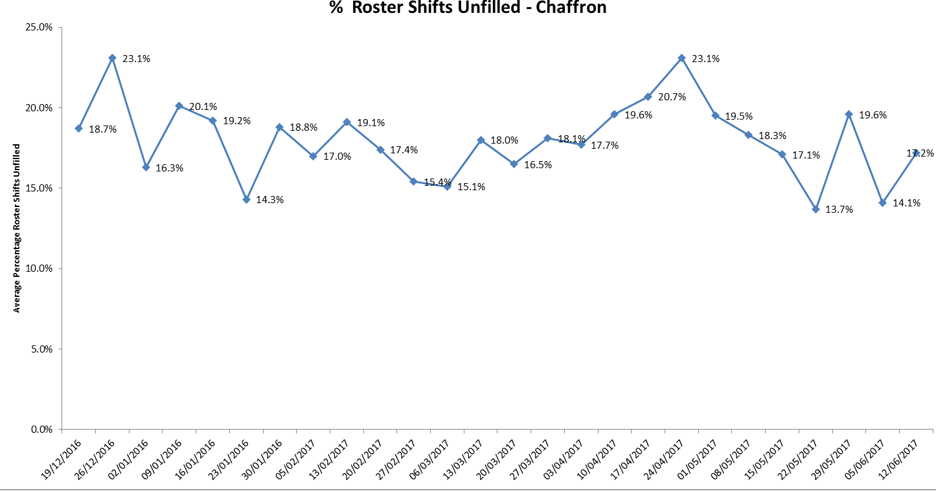

Glyme Ward - overall 81.7% of shifts were fully staffed, which was a 0.5% increase from last month. The ward has used more unregistered staff (with 43.4% of shifts covered by registered nurses which is a decrease of 1.8% in registered cover from last month). The ward currently has 4.4 WTE vacancies, and sickness has reduced to 3.2%.
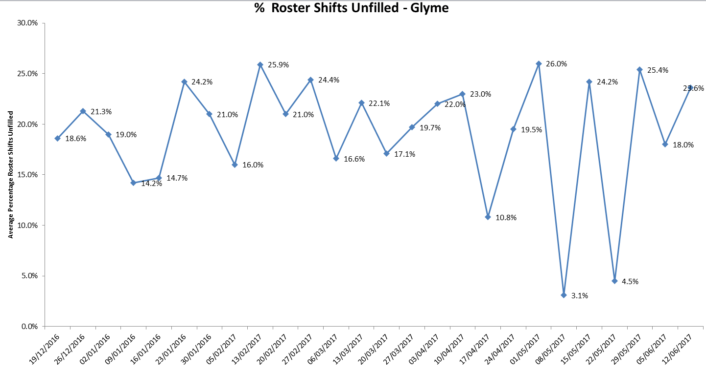

Kingfisher: overall 79.3% of shifts were fully staffed, a decrease of 9.8% from last month. The ward used more registered to unregistered staff (with only 36.6% staff being registered), and has employed some 24.6% average agency use. The sickness rate is currently 12.1%, and the overall vacancies are currently 12.7 WTE.

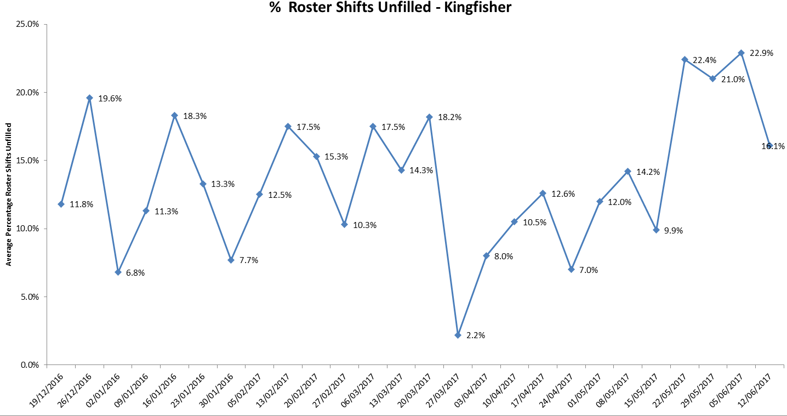

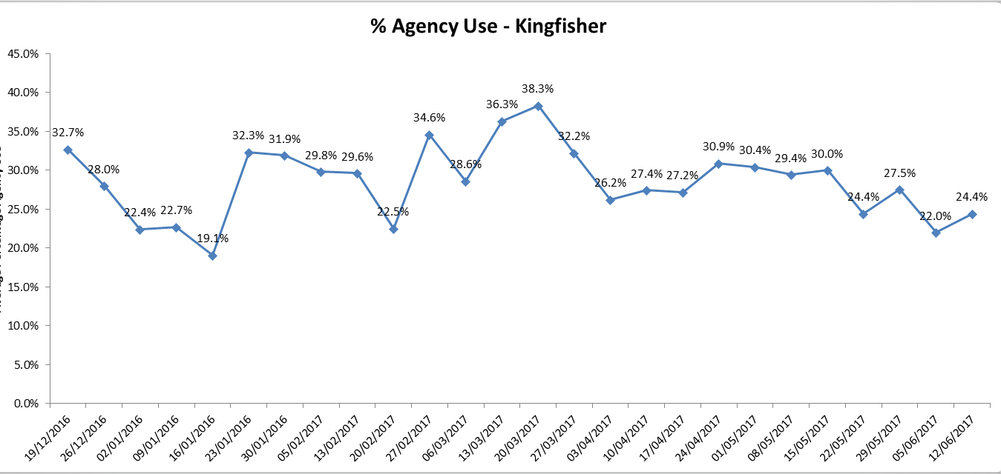
Wenric Ward: overall 84.8% of shifts were fully staffed; a decrease of 2% from last month and the ward has employed some 25.6% agency use. The sickness rate is currently 7.5%, and the overall vacancies are currently 11.7 WTE.

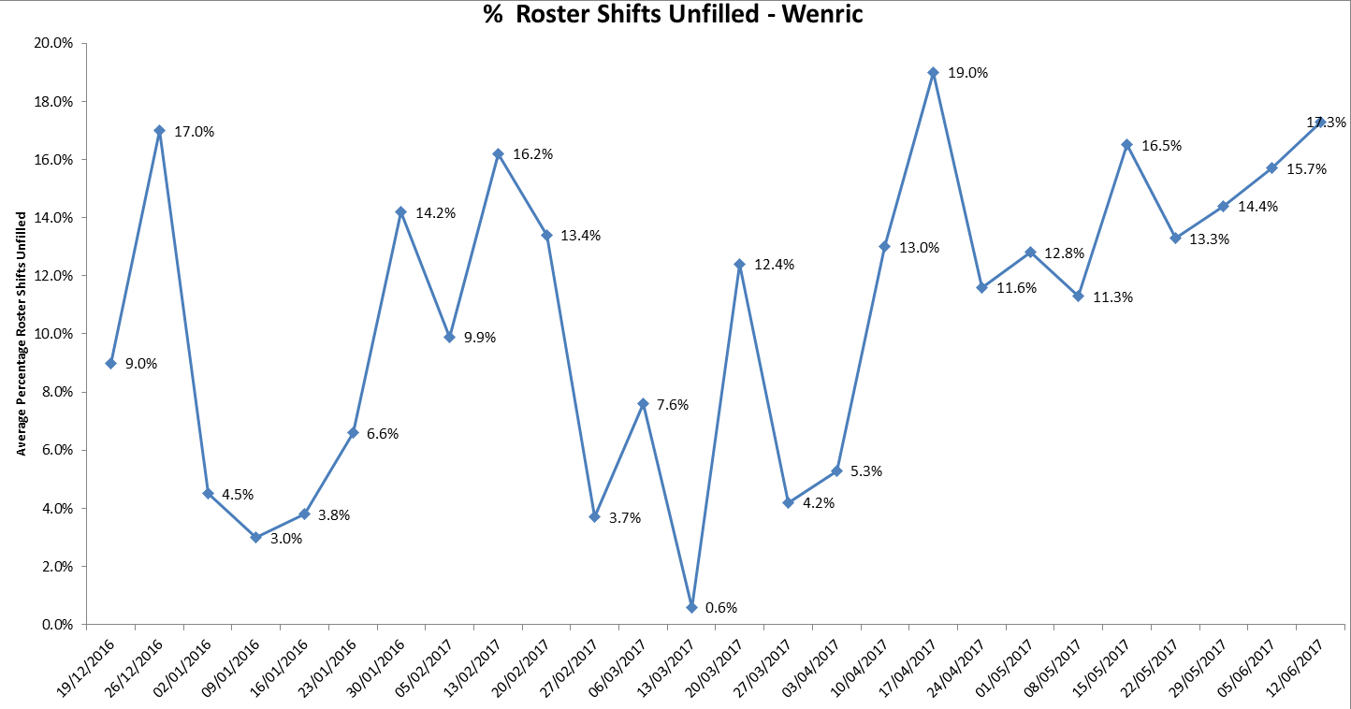

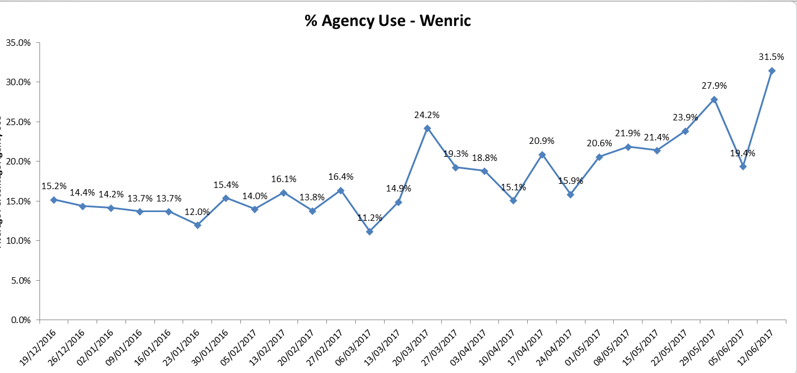

Phoenix Ward: overall 83.1% of shifts were fully staffed, an increase of 4.1% % from last month. The ward has employed some 21.1% agency use, an increase of 4.6%. The sickness rate on Phoenix is currently 9.3% (which is an increase of 3.9% from last month), and the overall vacancies are currently 12 WTE (an increase of 0.9WTE from last month).

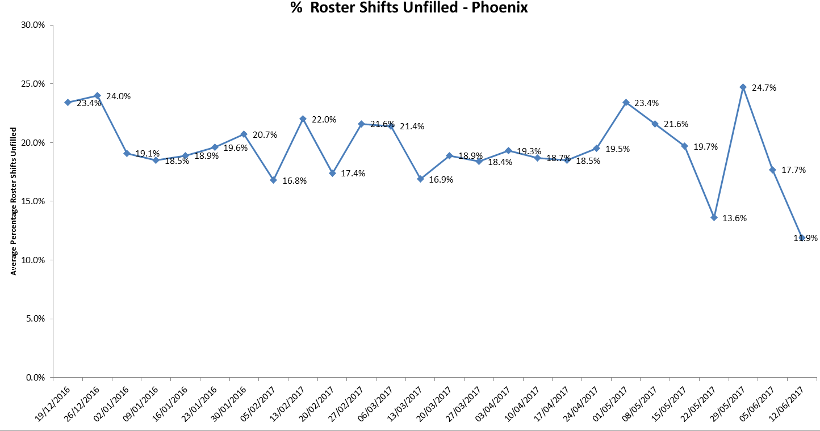

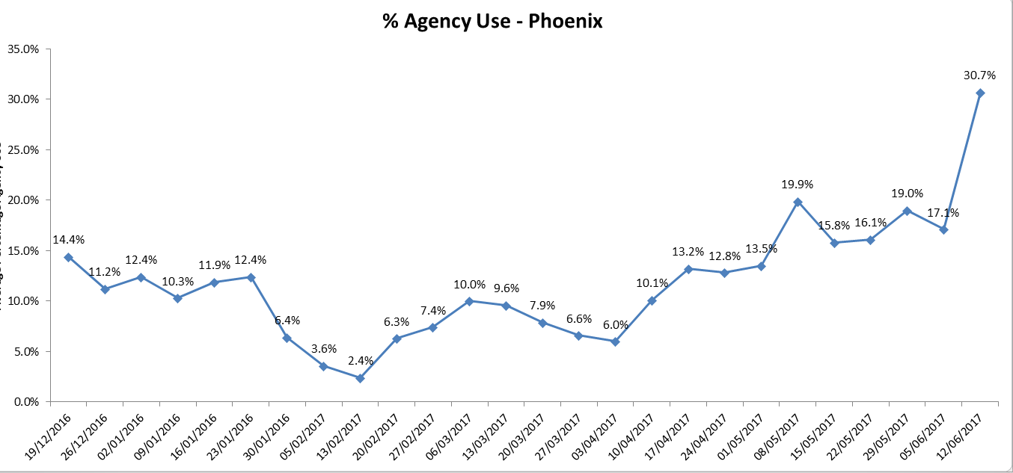

Vaughan Thomas Ward: overall 78.8% of shifts were fully staffed – a decrease of 3.3 from last month. The ward has used more unregistered to unregistered staff (with only 36.9% of shifts meeting the aspired 50% registered to unregistered ratio The ward has employed nurse agency cover (27.7% average agency use – an increase of 2.5%) and currently has 13.6 WTE vacancies.

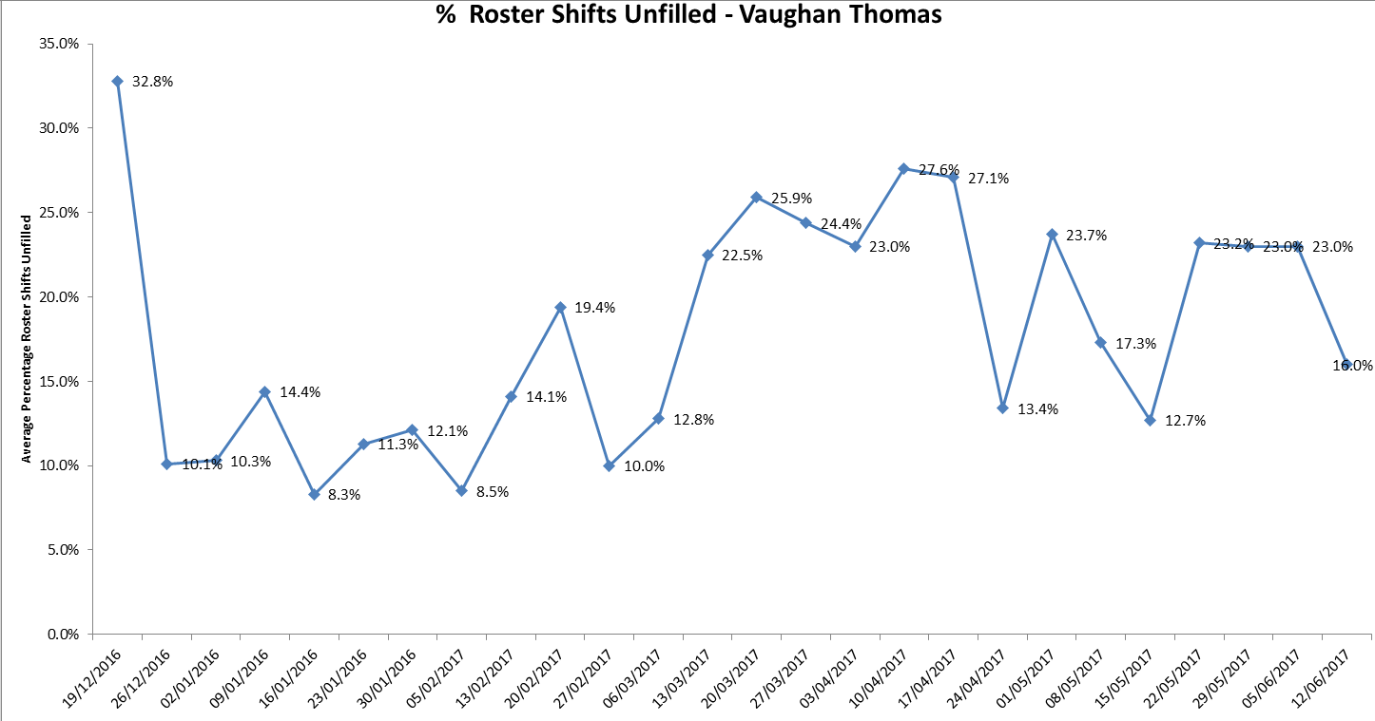

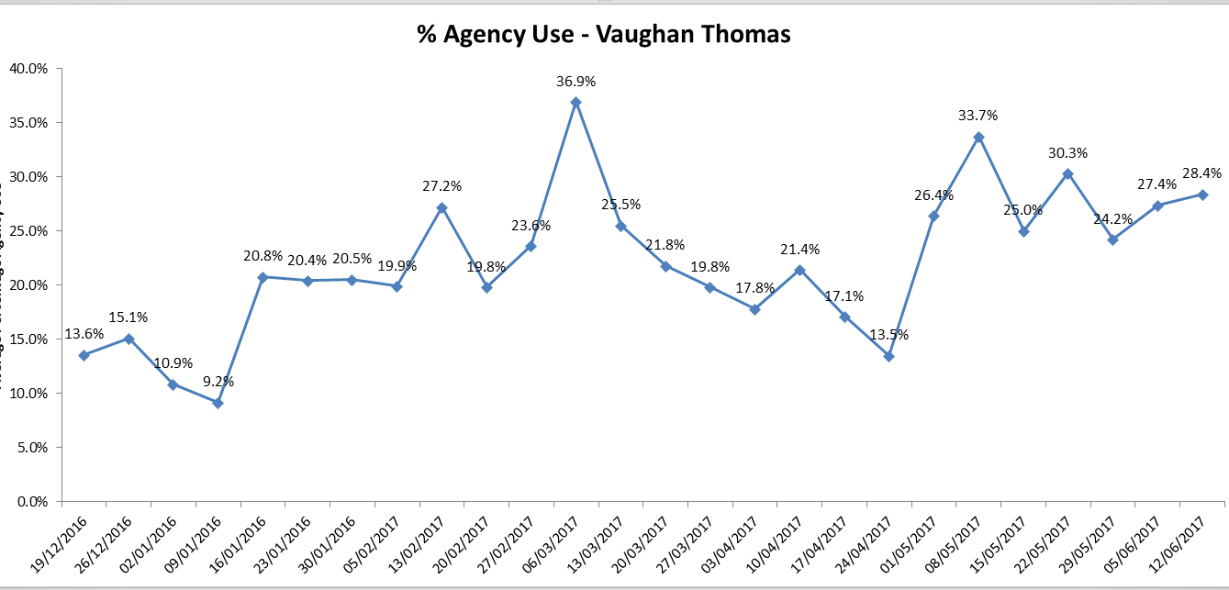
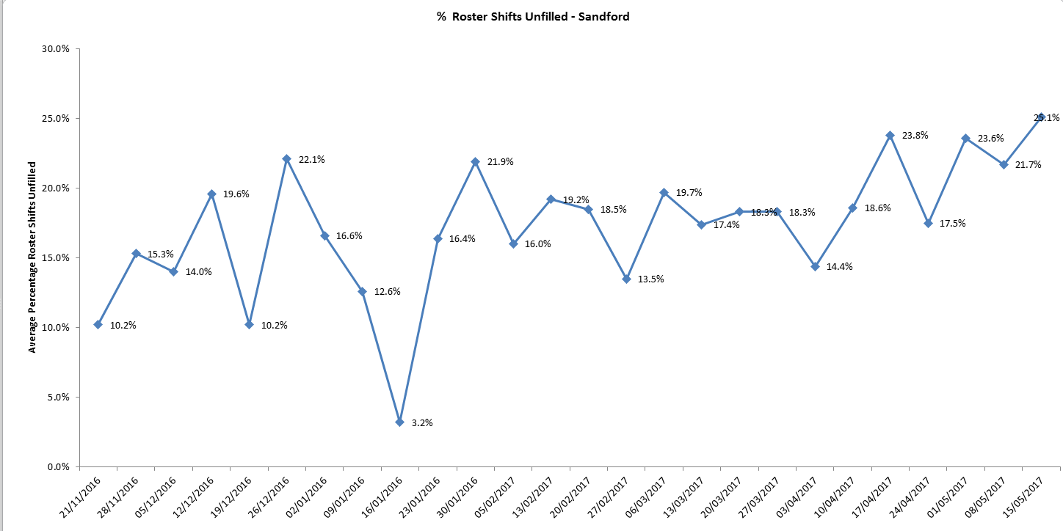
Older Adult Directorate
Sandford Ward: overall 81.3% of shifts were fully staffed – An increase of 3.3% from last month. The ward has used more unregistered to unregistered staff (with only 45.3% of shifts meeting the aspired 50% registered to unregistered ratio). The ward has employed nurse agency cover (20.3% average agency use), sickness is at 13.3% (the highest reported this month)and currently has 9.2 WTE vacancies.

Threshold targets
There are agreed threshold targets for ward staffing levels. For agency usage the target is 5%, sickness 3.5% and vacancies 9%. Wards not mentioned above which are performing adversely against these targets are can be viewed in table 1.

The areas of highest concern are as follows:

- Allen ward - Agency use – 26.6% and 14.9 WTE vacancies
- Amber ward - Agency use –26.6%, sickness 7.3% and 10.3WTE vacancies
- Ashurst ward - Agency use – 36.3%, and 15.5 WTE vacancies
- Bicester Community Hospital –sickness 12.5%
- City Community Hospital - Agency use – 12.4%, and 9.7WTE vacancies
- Cherwell - sickness 6.2% and 5.2 WTE vacancies
- Highfield CAMHS –Agency use –28.6%, and 21.9 WTE vacancies (the highest number this month).
- Kennet ward - –Agency use –13.5%, sickness 4.8% and 9.4 WTE vacancies.
- Kestral ward - Agency use –42.6% and 16.6 WTE vacancies
- Linfoot ward Witney - Agency use – 11.2%, and 17.3 WTE vacancies
- Marlborough House Swindon (CAMHS) - Agency use –12.3% and 7.4 WTE vacancies
- Opal Ward – sickness 4.8% and 9 vacancies
- Ruby Ward - - Agency use –36.9% (highest percentage again this month), sickness 13.3% and 9.2 WTE vacancies
- Sapphire – Agency use – 21.2% and 9.7 WTE vacancies
- St Leonards Wallingford – 11.3 vacancies
- Watling - Agency use –12.2%, sickness 6.1% and 13.1 WTE vacancies
- Wenrisc Witney – vacancies 5% sickness and 6.3 WTE.
- Wintle - Agency use –15.3% vacancies, 6.9% sickness and 8.8 WTE.

Recruitment

Last month there were a total of 285.2WTE vacancies across the 32 in-patient ward areas. This is a mean average of 8.9 vacancies per ward. Operational managers and working in partnership with HR in order to ensure a coordinated approach top recruitment and retention across the organisation. In addition an initial meeting has been held with the OUH in order to look at joint initiatives and approaches across the county.

.

Table 1.

 | % of shifts filled against required numbers (highlighted amber if less than 85%)
 | Latest 4 week period - 22nd May to 18th June 2017 | 4 week period - 24th April to 21st May 2017 | 4 week period - 27th March to 23rd April 2017 |  | Latest 4 week period - May 22nd to June 18th 2017
Ward |  |  |  |  | % Registered day shifts filled by nurses (submitted to NHS England) | % Unregistered day shifts filled by nurses (submitted to NHS England) | % Registered night shift filled by nurses (submitted to NHS England) | % Unregistered night shifts filled by nurses (submitted to NHS England) |  | % Registered Skill Mix (target 50% or more) |  | % Agency Use  (thresholds based on Trust targets, 5%) | % Sickness  (thresholds based on Trust targets, 3.5%) | Vacancies Vs Budget (WTE)  (thresholds based on Trust targets, 9%)
Abingdon Ward 1 | 97.0% | 97.7% | 99.4% |  | 70% | 95% | 82% | 105% |  | 50.0% |  | 11.5% | 5.1% | 4.9
Abingdon Ward 2 | 97.5% | 99.4% | 98.2% |  | 81% | 97% | 91% | 100% |  | 57.3% |  | 11.0% | 4.3% | 6.4
Allen | 89.5% | 91.3% | 91.6% |  | 103% | 95% | 100% | 102% |  | 42.5% |  | 26.6% | 1.8% | 14.9
Amber | 92.2% | 87.7% | 93.6% |  | 96% | 100% | 100% | 100% |  | 41.3% |  | 11.6% | 7.3% | 10.3
Ashurst (PICU) | 93.7% | 95.6% | 94.8% |  | 98% | 93% | 109% | 87% |  | 30.6% |  | 36.3% | 3.2% | 15.5
Bicester | 99.6% | 99.5% | 98.5% |  | 98% | 100% | 100% | 99% |  | 53.2% |  | 4.4% | 12.5% | 3.3
Cotswold House Marlborough | 93.8% | 93.9% | 94.5% |  | 100% | 104% | 102% | 98% |  | 47.6% |  | 5.4% | 2.2% | 6.7
Cotswold House Oxford | 85.9% | 84.8% | 81.2% |  | 99% | 98% | 100% | 100% |  | 38.6% |  | 9.6% | 0.9% | 5.4
Chaffron | 83.9% | 80.5% | 81.0% |  | 101% | 100% | 100% | 100% |  | 49.2% |  | 0.0% | 4.7% | 5.8
Cherwell | 88.6% | 85.9% | 91.1% |  | 93% | 93% | 96% | 97% |  | 45.7% |  | 7.2% | 6.2% | 5.2
City | 96.8% | 97.6% | 99.2% |  | 92% | 89% | 100% | 100% |  | 51.4% |  | 12.4% | 1.5% | 9.7
Didcot | 98.9% | 99.3% | 99.7% |  | 82% | 93% | 98% | 100% |  | 52.3% |  | 4.5% | 3.0% | 0.5
Glyme | 81.7% | 81.2% | 80.7% |  | 96% | 94% | 97% | 102% |  | 43.4% |  | 0.6% | 3.2% | 4.4
Highfield (CAMHS) | 85.7% | 86.9% | 85.1% |  | 67% | 107% | 89% | 101% |  | 34.1% |  | 28.6% | 5.6% | 21.9
Kennet | 96.4% | 95.1% | 97.2% |  | 68% | 126% | 94% | 100% |  | 36.1% |  | 13.5% | 4.8% | 9.4
Kestrel | 89.8% | 90.9% | 96.1% |  | 74% | 113% | 81% | 111% |  | 36.6% |  | 42.6% | 5.8% | 16.6
Kingfisher | 79.3% | 89.1% | 91.4% |  | 83% | 102% | 84% | 114% |  | 37.6% |  | 24.6% | 12.1% | 12.7
Lambourne House | 90.3% | 97.1% | 85.2% |  | 87% | 117% | 92% | 108% |  | 50.2% |  | 0.3% | 1.9% | 0.8
Linfoot Witney | 94.8% | 98.8% | 98.3% |  | 91% | 95% | 99% | 96% |  | 55.0% |  | 11.2% | 11.3% | 7.3
Marlborough House Swindon (CAMHS) | 95.6% | 95.2% | 97.4% |  | 98% | 84% | 79% | 101% |  | 55.1% |  | 12.3% | 2.6% | 7.4
Opal (Rehabilitation) | 96.3% | 95.8% | 95.3% |  | 103% | 87% | 94% | 86% |  | 46.9% |  | 2.3% | 4.8% | 9
Phoenix | 83.1% | 79.0% | 81.3% |  | 99% | 93% | 100% | 100% |  | 49.9% |  | 21.1% | 9.3% | 12
Ruby | 91.8% | 86.9% | 86.1% |  | 109% | 92% | 107% | 93% |  | 33.5% |  | 36.9% | 5.8% | 10.2
Sandford | 81.3% | 78.0% | 81.3% |  | 107% | 92% | 91% | 109% |  | 45.3% |  | 20.3% | 13.3% | 9.2
Sapphire | 100.0% | 99.5% | 80.1% |  | 104% | 98% | 100% | 100% |  | 40.4% |  | 21.2% | 6.9% | 9.7
Vaughan Thomas | 78.8% | 83.1% | 74.5% |  | 138% | 68% | 118% | 82% |  | 36.9% |  | 27.7% | 5.3% | 13.6
St Leonards Wallingford | 94.9% | 96.0% | 97.7% |  | 87% | 84% | 67% | 160% |  | 53.2% |  | 22.2% | 6.0% | 2.8
Watling | 93.8% | 87.4% | 85.9% |  | 109% | 92% | 100% | 100% |  | 31.9% |  | 6.5% | 2.7% | 11.3
Wenric | 84.8% | 86.8% | 89.4% |  | 96% | 92% | 111% | 95% |  | 38.3% |  | 25.6% | 7.5% | 11.7
Wenrisc Witney | 92.9% | 93.5% | 93.2% |  | 105% | 89% | 100% | 100% |  | 59.1% |  | 2.6% | 5.0% | 6.3
Wintle | 92.1% | 92.7% | 92.8% |  | 86% | 103% | 96% | 98% |  | 44.6% |  | 7.9% | 5.7% | 9.1
Woodlands | 98.0% | 98.0% | 98.1% |  | 104% | 96% | 99% | 97% |  | 45.9% |  | 2.9% | 4.0% | 4.9

Data source: electronic rostering system

